Supplementary Table 1. Missing Data and Multiple Imputation Details
Variables | Total | Missing Count | Missing Proportion (%) | Imputation Times
Demographic
Age | 16055 | 0 | 0 | 0
Gender | 16055 | 0 | 0 | 0
Vital signs
Heart Rate | 16055 | 0 | 0 | 0
Mbp | 16055 | 5 | 0.031 | 5
Resp Rate | 16055 | 5 | 0.031 | 5
Temperature | 16055 | 533 | 3.3 | 5
Spo2 | 16055 | 5 | 0.03 | 5
Comorbidities
Sepsis | 16055 | 0 | 0 | 0
Myocardial Infarct | 16055 | 0 | 0 | 0
Cerebrovascular Disease | 16055 | 0 | 0 | 0
Chronic Pulmonary Disease | 16055 | 0 | 0 | 0
Diabetes | 16055 | 0 | 0 | 0
Malignant Cancer | 16055 | 0 | 0 | 0
Laboratory tests
Bicarbonate | 16055 | 0 | 0 | 0
INR | 16055 | 909 | 5.6 | 5
Pt | 16055 | 909 | 5.6 | 5
Ptt | 16055 | 909 | 5.6 | 5
Chloride | 16055 | 989 | 6.1 | 5
Aniongap | 16055 | 1 | 0.006 | 5
Calcium | 16055 | 1811 | 11.6 | 5
Bun | 16055 | 7 | 0.04 | 5
Potassium | 16055 | 6 | 0.04 | 5
Sodium | 16055 | 0 | 0 | 0
Glucose | 16055 | 0 | 0 | 0
Creatinine | 16055 | 1 | 0.006 | 5
Neutrophils Abs | 16055 | 9 | 0.056 | 5
Monocytes Abs | 16055 | 9 | 0.056 | 5
Lymphocytes Abs | 16055 | 0 | 0 | 0
WBC | 16055 | 0 | 0 | 0
RDW | 16055 | 9 | 0.056 | 5
Platelet | 16055 | 12 | 0.075 | 5
Hemoglobin | 16055 | 4 | 0.025 | 5
Disease severity score
SOFA | 16055 | 0 | 0 | 0
SAPSII | 16055 | 0 | 0 | 0
GCS | 16055 | 3 | 0.019 | 5
CCI | 16055 | 0 | 0 | 0
APSIII | 16055 | 0 | 0 | 0
LODS | 16055 | 0 | 0 | 0
OASIS | 16055 | 0 | 0 | 0
Intervention |  |  |  | 0
Ventilation | 16055 | 0 | 0 | 0
Propofol | 16055 | 0 | 0 | 0
Midazolam | 16055 | 0 | 0 | 0
Vasoactive | 16055 | 0 | 0 | 0
Outcomes
Los Icu | 16055 | 0 | 0 | 0
Delirium | 16055 | 0 | 0 | 0
28-day mortality | 16055 | 0 | 0 | 0
90-day mortality | 16055 | 0 | 0 | 0
365-day mortality | 16055 | 0 | 0 | 0

Supplementary Table 2. Variance Inflation Factor (VIF) Values for All Variables
Variables | VIF
Age | 2.284
Heart rate | 1.464
Mbp | 1.176
Resp rate | 1.310
Temperature_ | 1.230
SPO2 | 1.200
Bicarbonate | 4.255
INR | 18.809
PT | 18.938
PTT | 1.068
Chloride | 8.684
Aniongap | 4.517
Calcium | 1.313
BUN | 2.604
Potassium | 1.198
Sodium | 5.555
Creatinine | 2.187
Neutrophils Abs | 1.529
Monocytes Abs | 1.177
WBC | 1.440
RDW | 1.405
Platelet | 1.311
Hemoglobin | 1.498
SOFA | 1.481
SAPSII | 5.603
GCS | 1.456
CCI | 2.138
APSIII | 3.572
LODS | 3.744
OASIS | 2.210
GLR | 1.099

Supplementary Table 3. Variance Inflation Factor (VIF) Values of the Remaining Variables After Excluding Three Variables with VIF > 5 (PT, Chloride, and SAPSII)
Variables | VIF
Age | 1.927
Heart rate_ | 1.463
Mbp | 1.167
Resp rate | 1.298
Temperature_ | 1.222
SPO2 | 1.196
Bicarbonate | 1.533
INR | 1.123
PTT | 1.065
Aniongap | 1.912
Calcium | 1.284
BUN | 2.601
Potassium | 1.182
Sodium | 1.110
Creatinine | 2.163
Neutrophils Abs_ | 1.527
Monocytes Abs | 1.170
WBC | 1.433
RDW | 1.398
Platelet | 1.306
Hemoglobin | 1.487
SOFA | 1.472
GCS | 1.419
CCI | 2.006
APSIII | 3.295
LODS | 2.936
OASIS | 2.048
GLR | 1.095

Supplementary Table 4. Distribution of ICU types by delirium status.
Variables | Total  (n = 16055) | No-Delirium  (n = 13699) | Delirium  (n = 2356) | P
ICU unit type |  |  |  | <0.001
CCU | 1720 | 1502 (87.3) | 218(12.7)
CVICU | 5415 | 4987 (92.1) | 428(7.9)
TSICU | 1261 | 1006 (79.8) | 255(20.2)
MICU | 2802 | 2138 (76.3) | 664(23.1)
SICU | 1254 | 991 (79.0) | 263 (21.0)
MICU/SICU | 2909 | 2515 (86.5) | 394 (13.5)
Neuro SICU | 144 | 103 (71.5) | 41 (28.5)
Neuro Stepdown | 115 | 95 (82.6) | 20 (17.4)
Neuro Intermediate | 435 | 362 (83.2) | 73 (16.8)

Supplementary Table 5. Sensitivity Analysis Excluding Early (<24 h) ICU Deaths: Association Between GLR and Delirium
Categories | model 1  OR(95%CI) | P-value | model 2  OR(95%CI) | P-value | model 3  OR(95%CI) | P-value | model 4  OR(95%CI) | P-value
continuous variable | 1.01 (1.01 ~ 1.01) | <0.001 | 1.01 (1.01 ~ 1.01) | <0.001 | 1.01 (1.01 ~ 1.01) | <0.001 | 1.01 (1.01 ~ 1.01) | <0.001
Quartile
Q1 | Reference |  | Reference |  | Reference |  | Reference
Q2 | 1.31 (1.13 ~ 1.52) | <0.001 | 1.19 (1.02 ~ 1.40) | 0.027 | 1.22 (1.05 ~ 1.44) | 0.011 | 1.33 (1.12 ~ 1.58) | 0.001
Q3 | 2.13 (1.85 ~ 2.45) | <0.001 | 1.65 (1.42 ~ 1.91) | <0.001 | 1.67 (1.43 ~ 1.95) | <0.001 | 2.04 (1.73 ~ 2.41) | <0.001
Q4 | 3.16 (2.76 ~ 3.61) | <0.001 | 2.03 (1.75 ~ 2.35) | <0.001 | 2.08 (1.78~ 2.43) | <0.001 | 2.52 (2.12 ~ 2.99) | <0.001
P for trend |  | <0.001 |  | <0.001 |  | <0.001 |  | <0.001
Model 1 is the base model, which includes only the GLR variable.
Model 2 expands upon Model 1 by adjusting for additional variables, including age, gender, heart rate, mean blood pressure, respiratory rate, temperature, oxygen saturation, sepsis, myocardial infarction, cerebrovascular disease, chronic pulmonary disease, diabetes and malignancy
Model 3 further adjusts Model 2 by adding laboratory test results-related variables, including bicarbonate, INR, PTT, aniongap, calcium, Bun, Potassium, Sodium, creatinine, neutrophils abs, monocytes abs, WBC, RDW, Platelet.
Model 4 was developed by further adjusting Model 3 for disease severity scores and clinical interventions, including SOFA, GCS, CCI, APSIII, LODS, OASIS, as well as the use of mechanical ventilation, propofol, midazolam, and vasoactive drugs.

Supplementary Table 6. Comparison of model performance and global fit indices across six nested multivariable models.
Model | Log-Likelihood | AIC | BIC | LRT-P-value
Model A | -4883.09 | 9842.17 | 10134.16 | < 0.001
Model B | -4882.77 | 9843.54 | 10143.2 | < 0.001
Model C | -4762.75 | 9603.49 | 9903.16 | < 0.001
Model D | -4801.08 | 9680.16 | 9979.83 | < 0.001
Model E | -4729.59 | 9537.19 | 9836.85 | < 0.001
Model F | -4705.9 | 9495.81 | 9818.53 | Reference
Model A (Base Model): The base model adjusted for GLR and a comprehensive set of 36 clinical covariates, including demographics (age, gender), vital signs (heart rate, MBP, respiratory rate, temperature, and SpO2), comorbidities (sepsis, myocardial infarction, cerebrovascular disease, chronic pulmonary disease, diabetes, malignancy, and CCI), laboratory parameters (bicarbonate, INR, PTT, anion gap, calcium, BUN, potassium, sodium, creatinine, absolute neutrophil/monocyte counts, WBC, RDW, and platelets), and clinical interventions/status (GCS, mechanical ventilation, and use of propofol, midazolam, or vasoactive drugs).
Model B: Model A + SOFA.
Model C: Model A + APS III .
Model D: Model A + OASIS .
Model E: Model A + LODS .
Model F (Full Saturated Model): Model A + SOFA + APS III + OASIS + LODS.

Supplementary Table 7. Model performance diagnostics and robustness analysis of GLR across different clinical adjustment strategies.
Model | Q1 OR  (95% CI) | Q2 OR (95% CI) | Q3 OR (95% CI) | Q4 OR (95% CI) | P for trend
Model A | 1.00 (Ref) | 1.38 (1.17-1.63) | 2.16 (1.83-2.54) | 2.84 (2.37-3.39) | < 0.001
 | P-value | P<0.001 | P<0.001 | P<0.001
Model B | 1.00 (Ref) | 1.38 (1.17-1.63) | 2.16 (1.83-2.56) | 2.84 (2.38-3.41) | < 0.001
 | P-value | P<0.001 | P<0.001 | P<0.001
Model C | 1.00 (Ref) | 1.35 (1.14-1.59) | 2.09 (1.77-2.47) | 2.68 (2.23-3.21) | < 0.001
 | P-value | P<0.001 | P<0.001 | P<0.001
Model D | 1.00 (Ref) | 1.35 (1.14-1.60) | 2.06 (1.75-2.44) | 2.68 (2.24-3.21) | < 0.001
 | P-value | P<0.001 | P<0.001 | P<0.001
Model E | 1.00 (Ref) | 1.36 (1.15-1.61) | 2.11 (1.79-2.50) | 2.68 (2.24-3.220) | < 0.001
 | P-value | P<0.001 | P<0.001 | P<0.001
Model F | 1.00 (Ref) | 1.32 (1.12-1.57) | 2.03 (1.72-2.39) | 2.51 (2.12-2.98) | < 0.001
 | P-value | P=0.001 | P<0.001 | P<0.001
Note: For detailed definitions of models and variables, refer to Supplementary Table 6.

Supplementary Figure 1. Comparison of six predictive models evaluating the independent effect of GLR on delirium. (A) ROC curves: Discrimination for models A through F. (B) Calibration curves: Agreement between predicted and observed risks for models A through F. Note: Covariate adjustments for models A–F are the same as those in Supplementary Table 6.
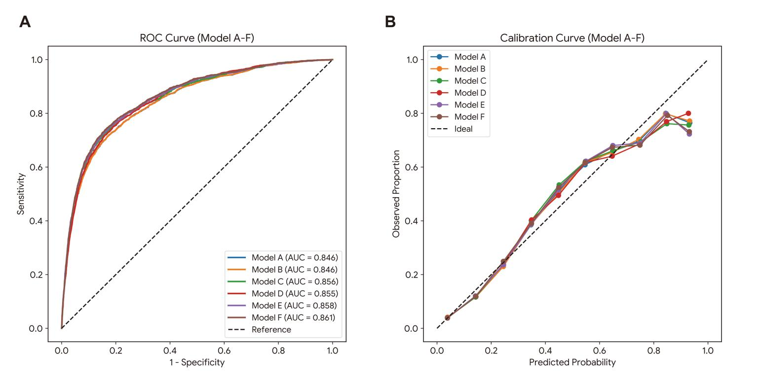

Supplementary Figure 2. Calibration Curve for the Prediction of Delirium in ICU Patients
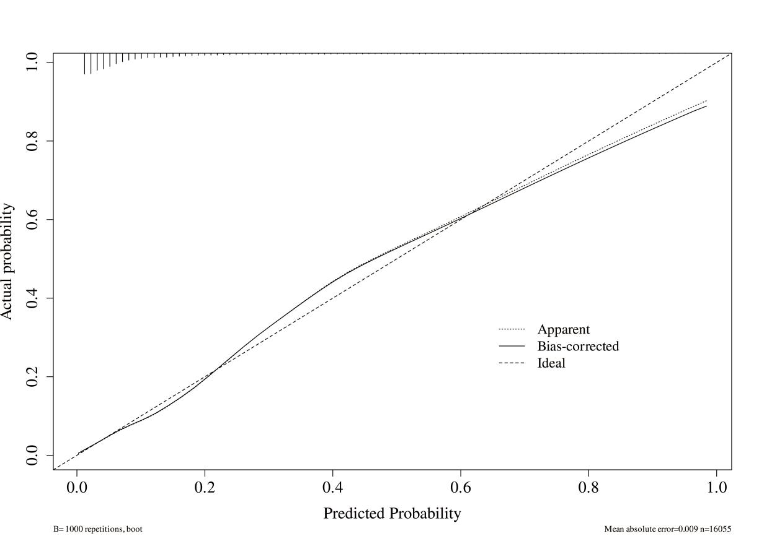

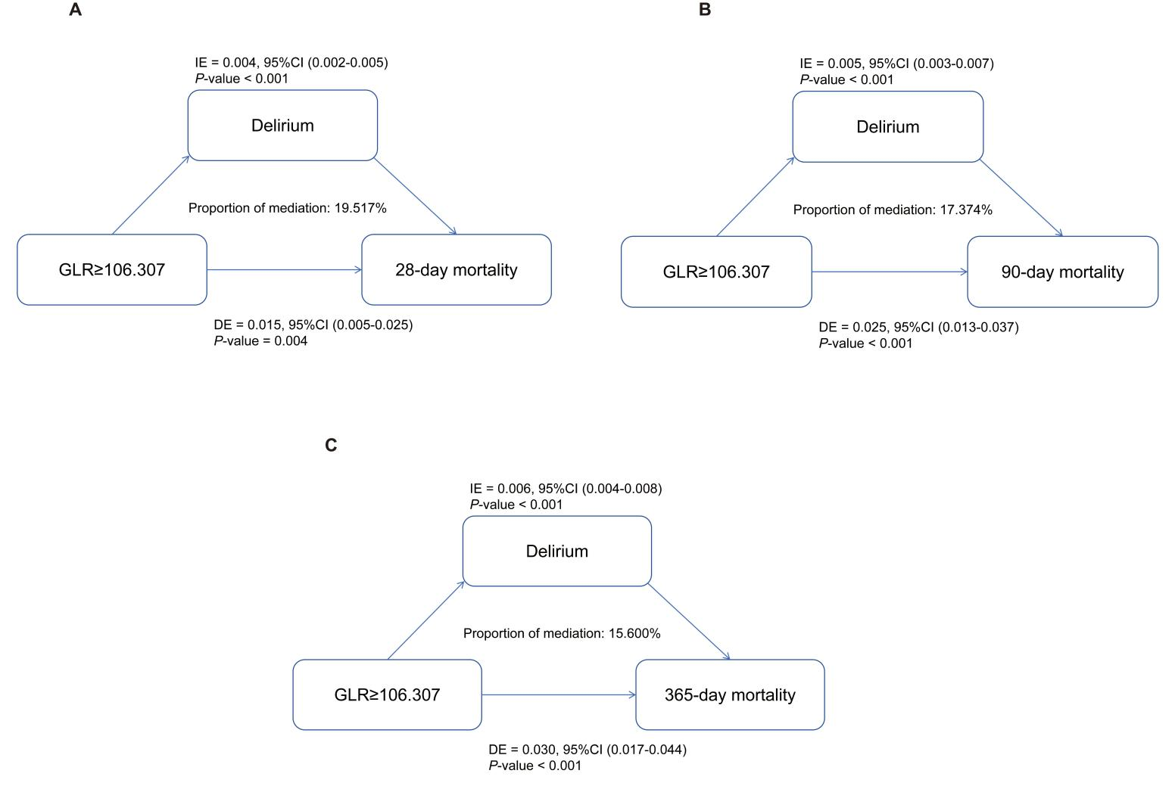
Supplementary Figure 3. Mediation Analysis Excluding Patients Who Died Within 24 Hours of ICU Admission

