Supporting Information
Synthesis, Characterization, Biological Evaluation, and Molecular Modeling of Novel Nimesulide Urea Derivatives as Potential MetAP2 Inhibitors
Özgür Yılmaz^{a,b*}, Yağmur Biliz^{a,c}, Elif Kuloğlu^{a,d},Kübra Arancı^{a,e,f}, Ömer Erdoğan^{g}, Özge Çevik^{h}, Müfide Karahasanoğluª, Naz Mina Mert Şahin^{i}, Ayşe Buse Çakırª, Bilge Tuzcu^{a,b,j}, Kemal Yelekçi^{i},
Ş. Güniz Küçükgüzel^{k}
ªTUBITAK Marmara Research Center, Gebze, Kocaeli 41470, Turkiye
^{b}Department of Pharmaceutical Chemistry, Faculty of Pharmacy, Istanbul University, Istanbul, 34116, Turkiye
^{c}Department of Chemical Engineering, Faculty of Engineering and Natural Sciences, Istanbul Health and Technology University, Istanbul, 34275, Turkiye
^{d}Department of Chemistry, Faculty of Art and Science, Bursa Uludağ University, Bursa, 16059 Turkiye
^{e}Department of Bioengineering, Faculty of Engineering, Marmara University, 34854,Istanbul, Turkiye
^{f}Center for Nanotechnology &amp; Biomaterials Application and Research (NBUAM), Marmara University, Turkiye
^{g}Department of Biochemistry, School of Medicine , Gaziantep Islam Science and Technology University, Gaziantep, 27010, Turkiye
^{h}Department of Biochemistry, School of Medicine , Aydın Adnan Menderes University, Aydın, 09010, Turkiye
^{i}Department of Molecular Biology and Genetics, Faculty of Engineering and Natural Sciences, Kadir Has University, Istanbul 34083, Turkiye
^{j}Department of Pharmaceutical Chemistry, Istanbul Kent University, Faculty of Pharmacy, Kagithane/Istanbul, Turkiye
^{k}Department of Pharmaceutical Chemistry, Faculty of Pharmacy, Fenerbahçe University, Atasehir, Istanbul 34758, Turkiye

*Corresponding authors. yilmaz.ozgur@tubitak.gov.tr

Contents
FTIR, MS and NMR Spectra of synthesized compound (2)...................................... | S2
FTIR, MS and NMR Spectra of synthesized compound (3a-l).................................. | S4
Molecular Modeling and Docking Studies………………………………………… | S29

Copies of the FTIR, HRMS, ¹H NMR and ¹³C NMR spectra of synthesized N-(4-Amino-2-phenoxy-phenyl)-methanesulfonamide (2)

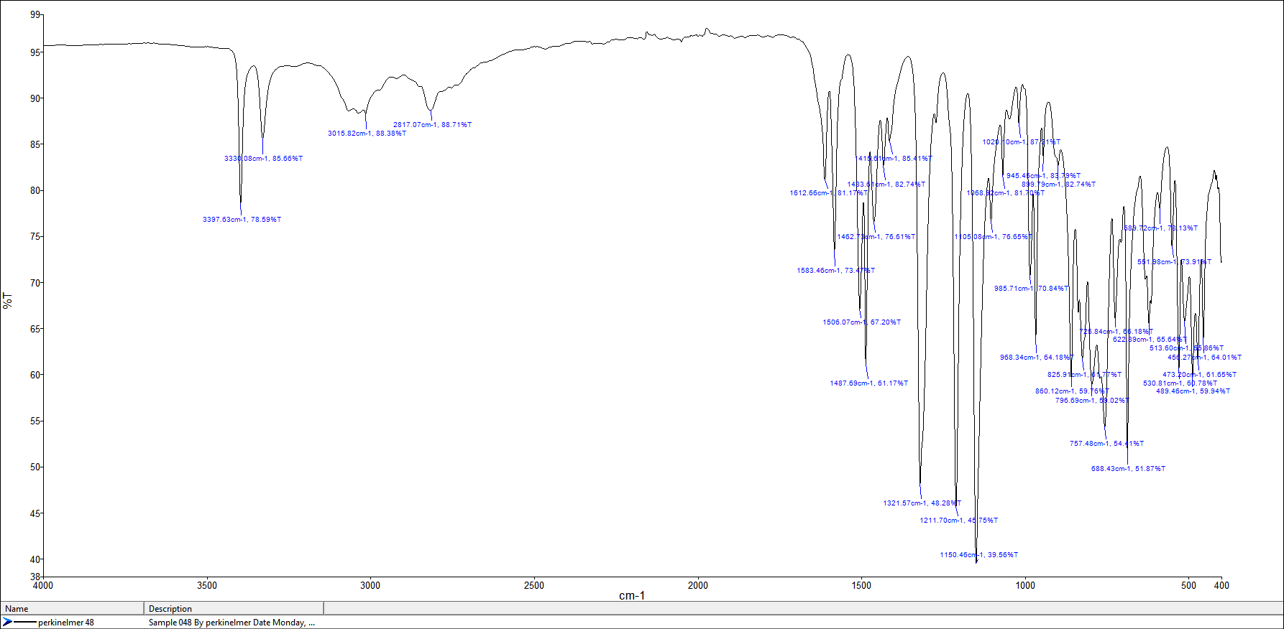
Fig. S1. FTIR spectrum of 2

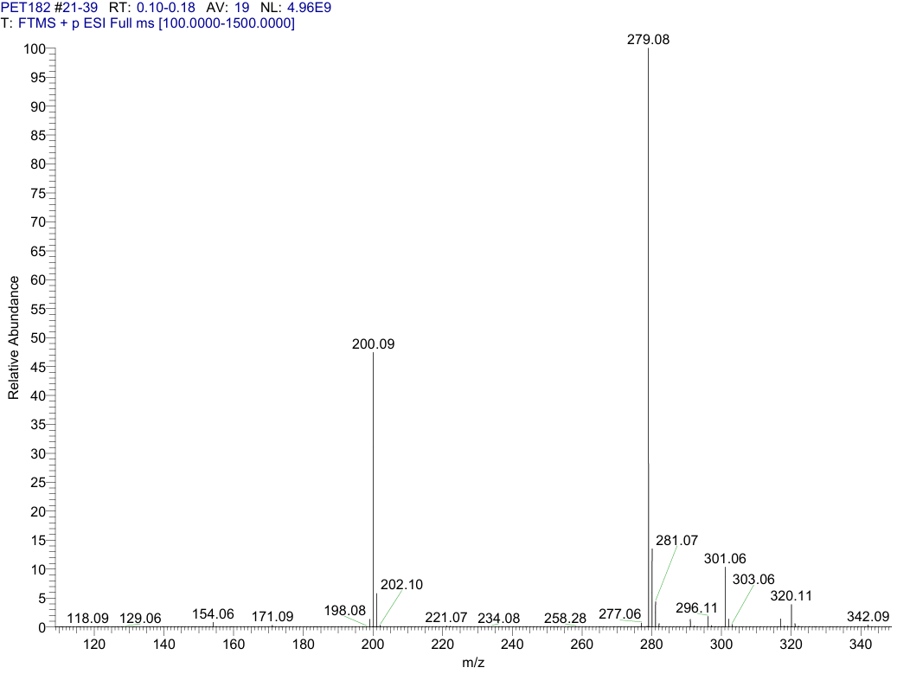
Fig. S2. HRMS (ESI-Orbitrap) spectrum of compound 2.

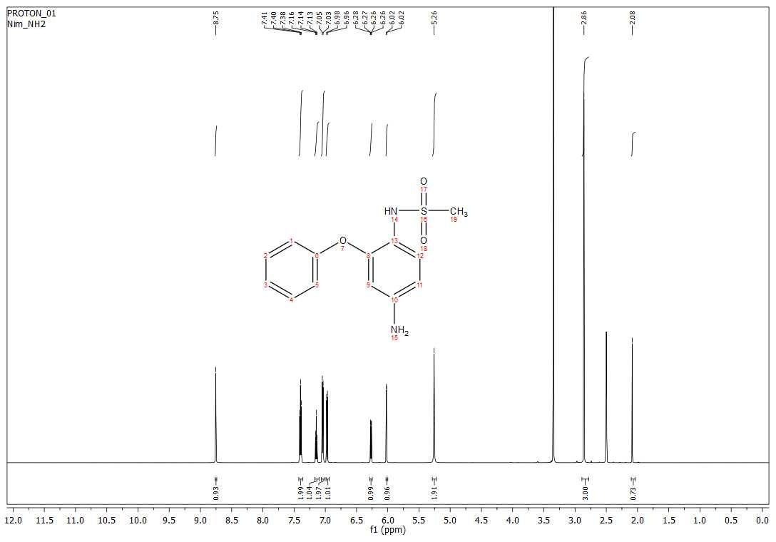

Fig. S3. ¹H NMR spectrum (600 MHz, DMSO) of 2
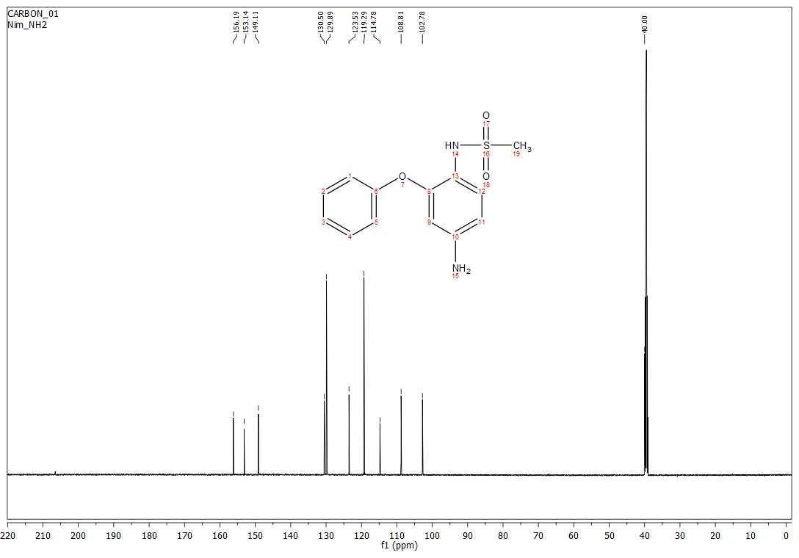

Fig. S4. ¹³C NMR spectrum (150 MHz, DMSO) of 2.
Copies of the FTIR, HRMS, ¹H NMR and ¹³C NMR spectra of synthesized N-[4-[3-(2-Chloro-ethyl)-ureido]-2-phenoxy-phenyl]-methanesulfonamide (3a)
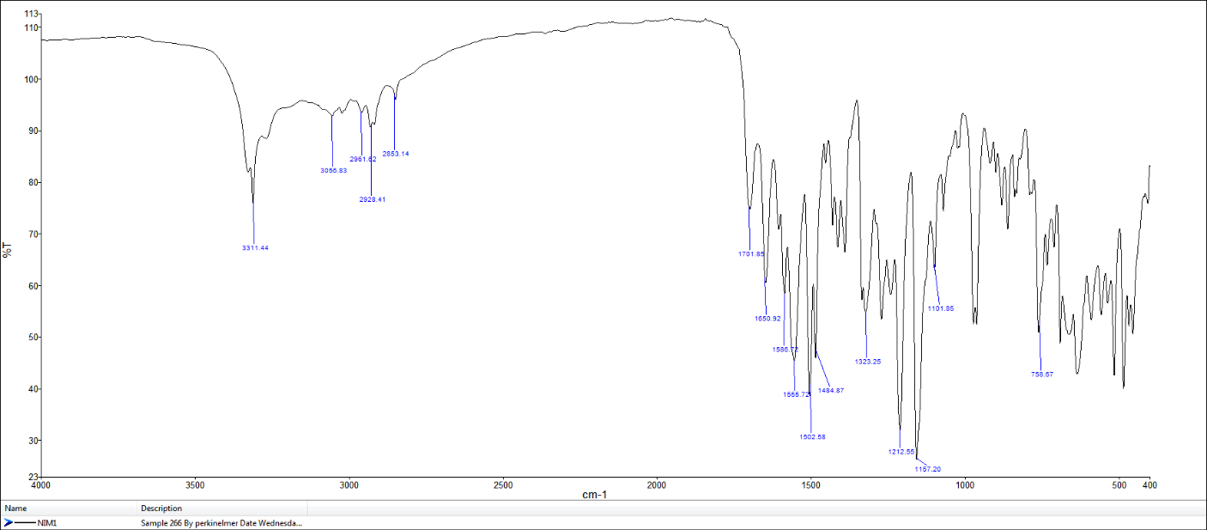
Fig. S5. FTIR spectrum of 3a

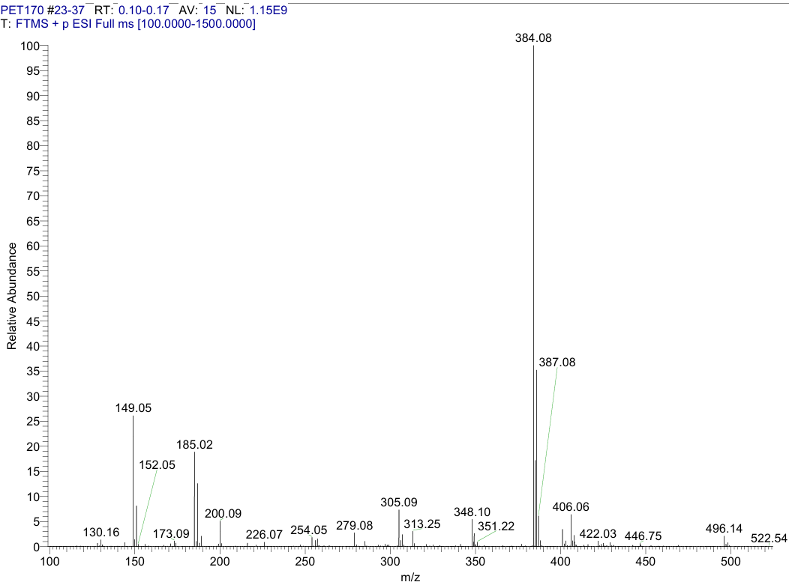

Fig. S6. HRMS (ESI-Orbitrap) spectrum of compound 3a.

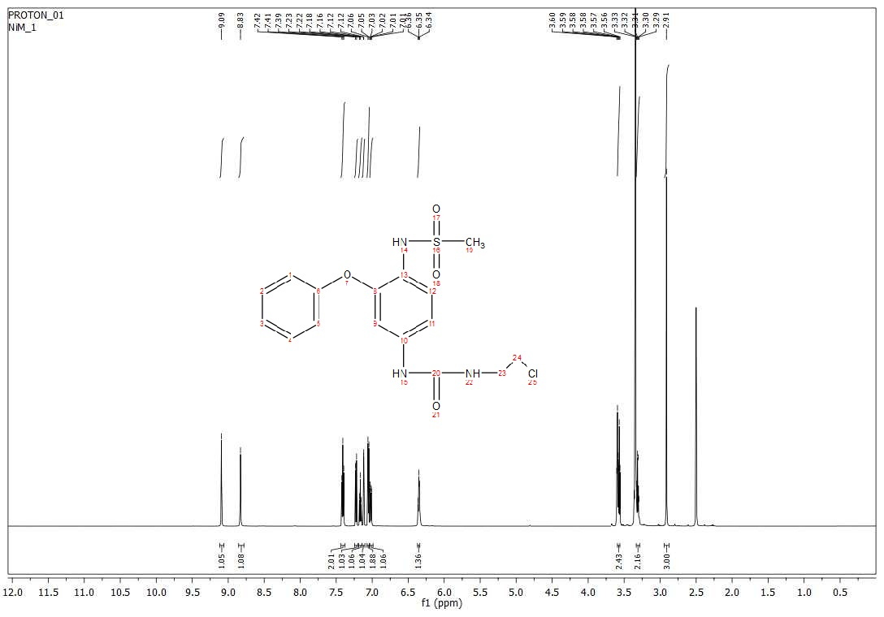
Fig. S7. ¹H NMR spectrum (600 MHz, DMSO) of 3a

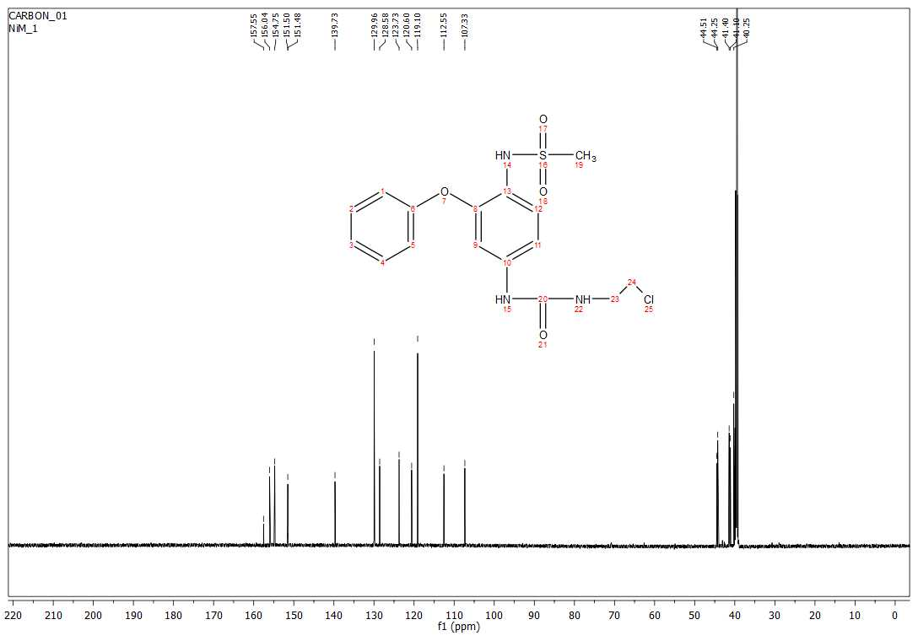
Fig. S8. ¹³C NMR spectrum (150 MHz, DMSO) of 3a.

Copies of the IR, HRMS, ¹H NMR and ¹³C NMR spectra of synthesized N-[4-(3-Ethyl-ureido)-2-phenoxy-phenyl]-methanesulfonamide (3b)
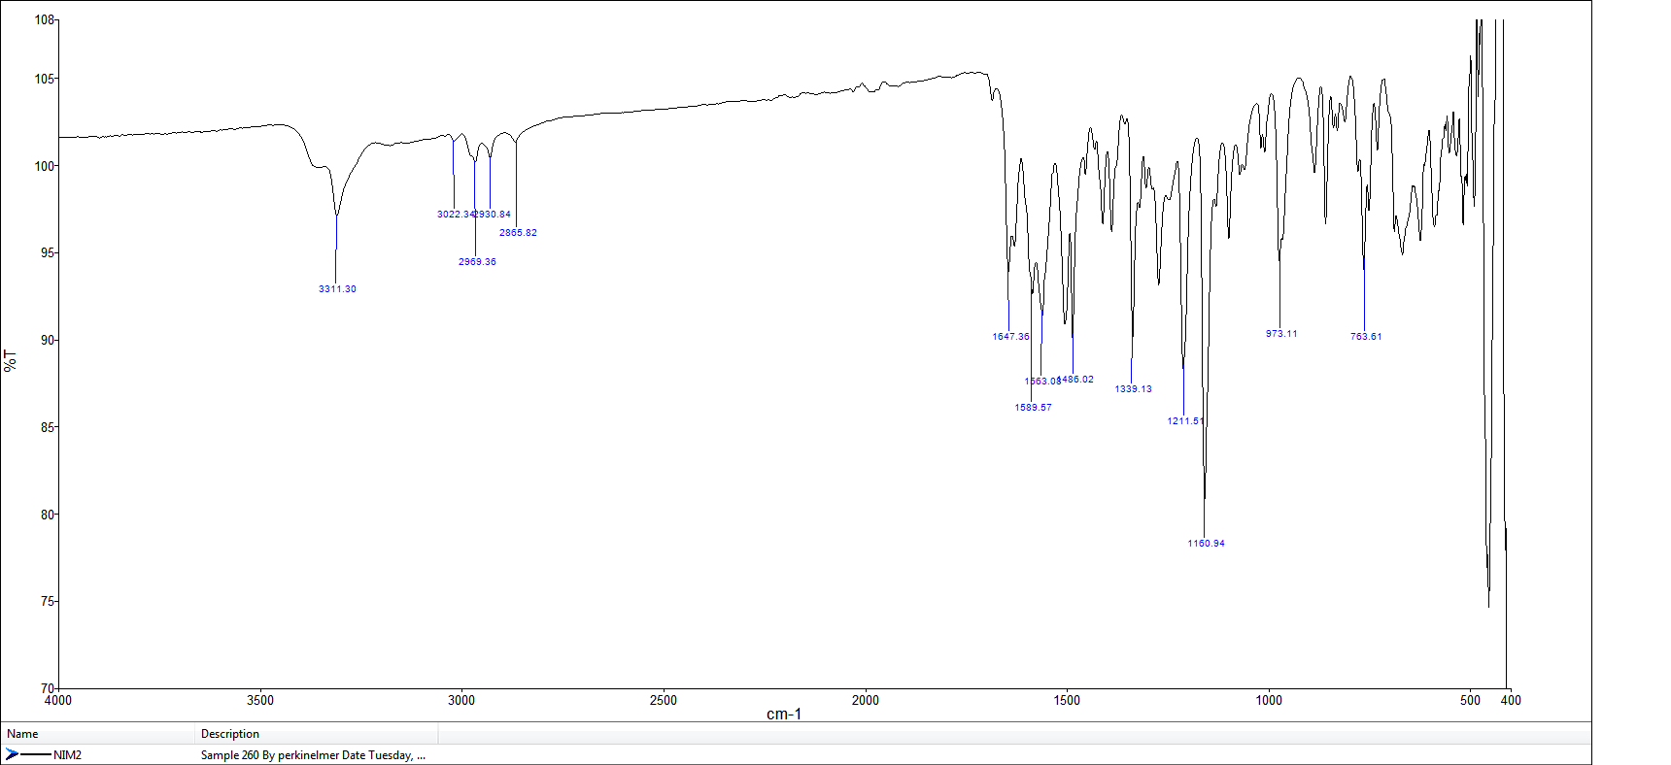

Fig. S9. FTIR spectrum of 3b

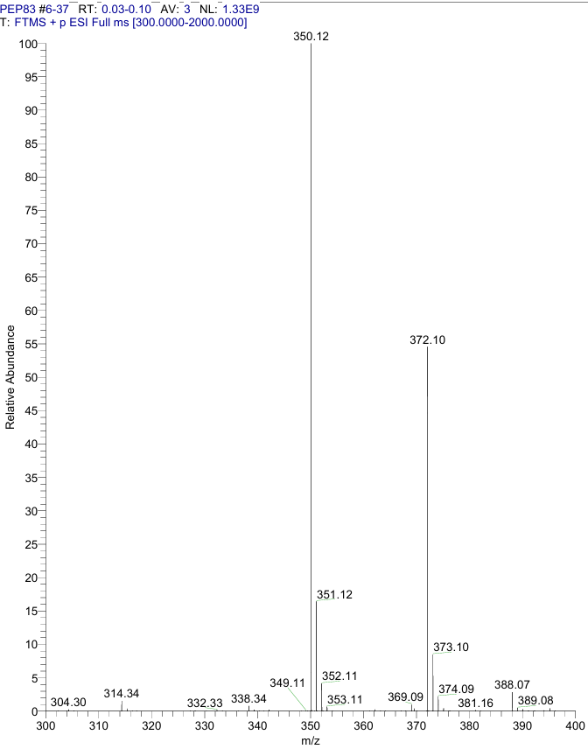

Fig. S10. HRMS (ESI-Orbitrap) spectrum of compound 3b.

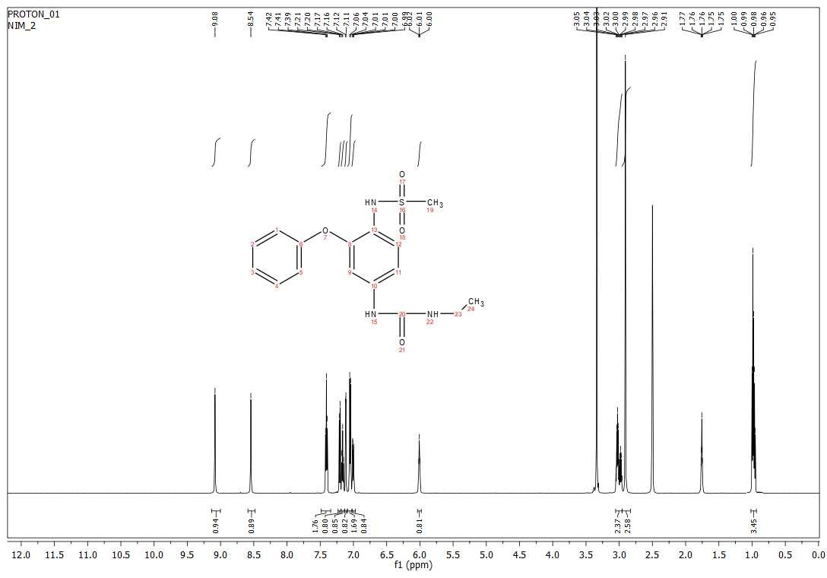
Fig. S11. ¹H NMR spectrum (600 MHz, DMSO) of 3b.

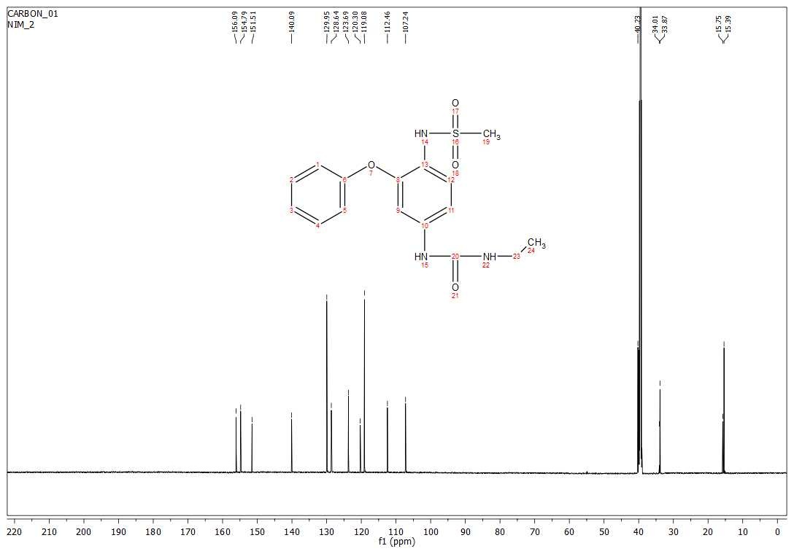
Fig. S12. ¹³C NMR spectrum (150 MHz, DMSO) of 3b.
Copies of the FTIR, HRMS, ¹H NMR and ¹³C NMR spectra of synthesized N-[2-Phenoxy-4-(3-propyl-ureido)-phenyl]-methanesulfonamide (3c)

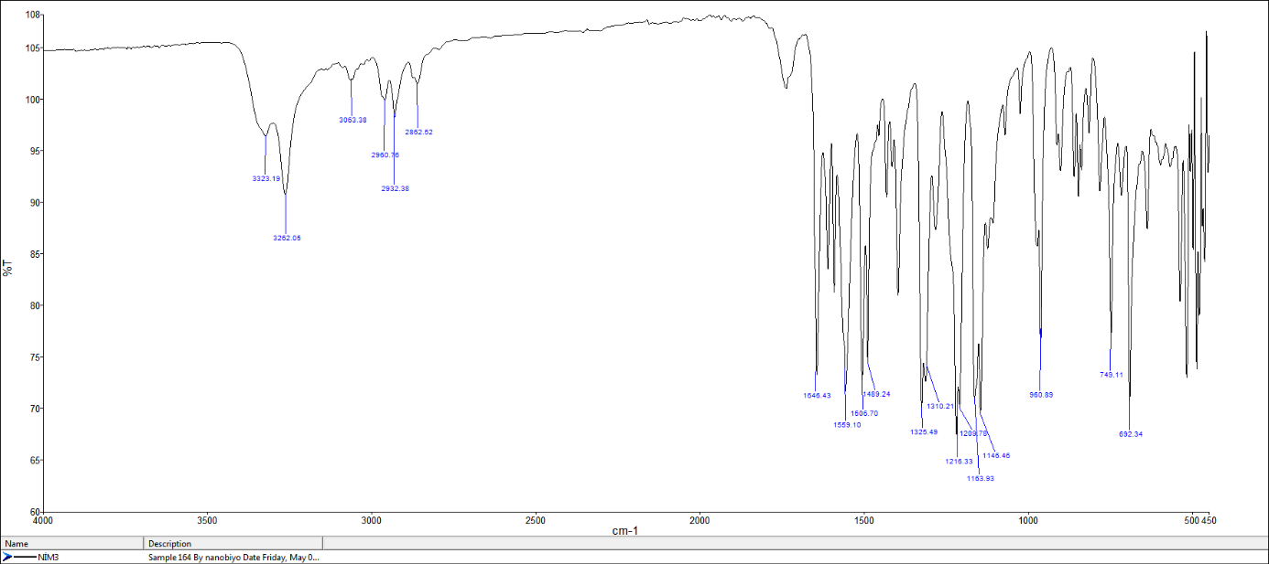
Fig. S13. FTIR spectrum of 3c
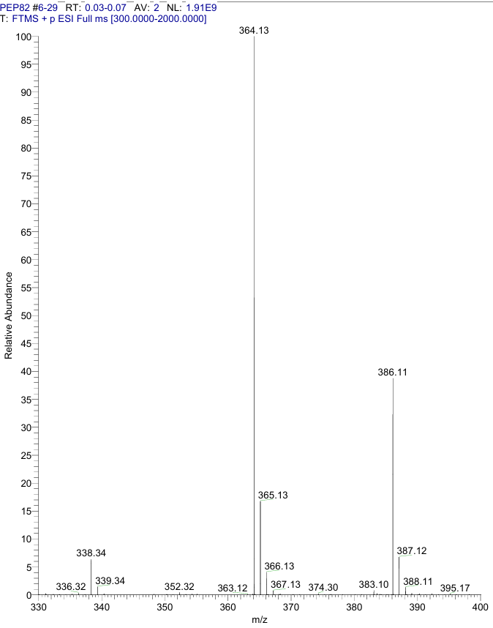
Fig. S14. HRMS (ESI-Orbitrap) spectrum of compound 3c
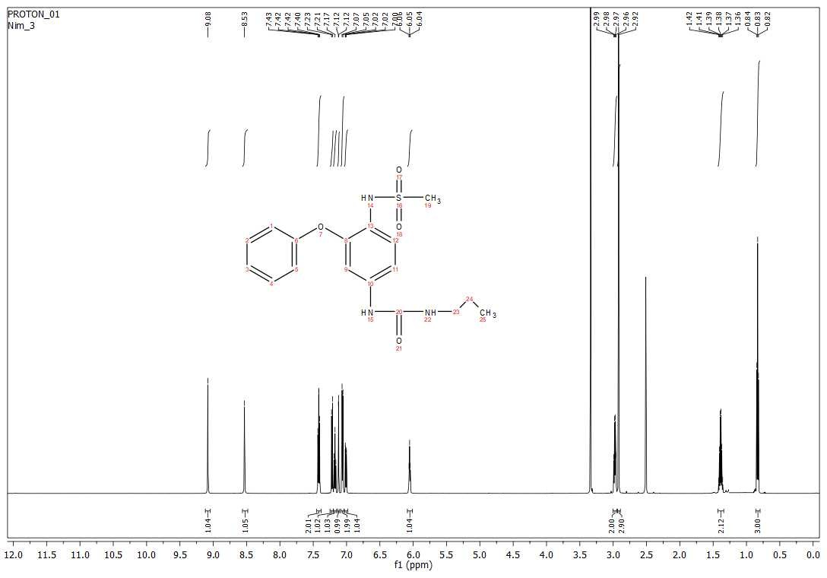
Fig. S15. ¹H NMR spectrum (600 MHz, DMSO) of 3c.
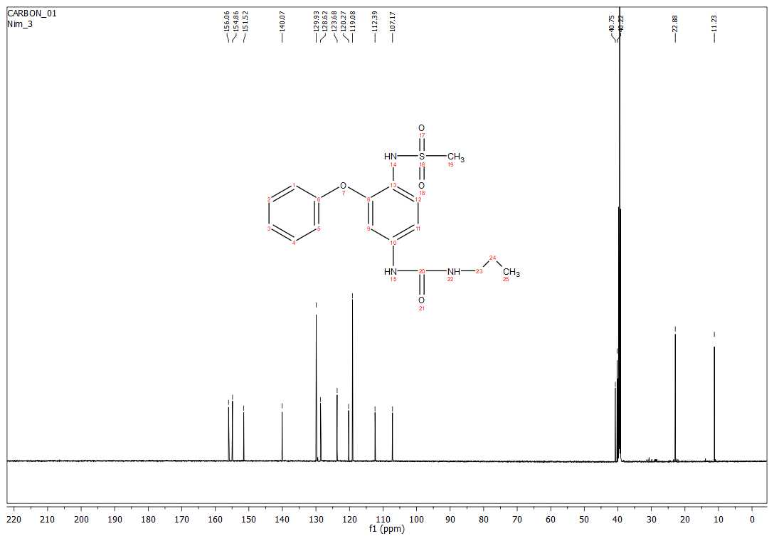
Fig. S16. ¹³C NMR spectrum (150 MHz, DMSO) of 3c.
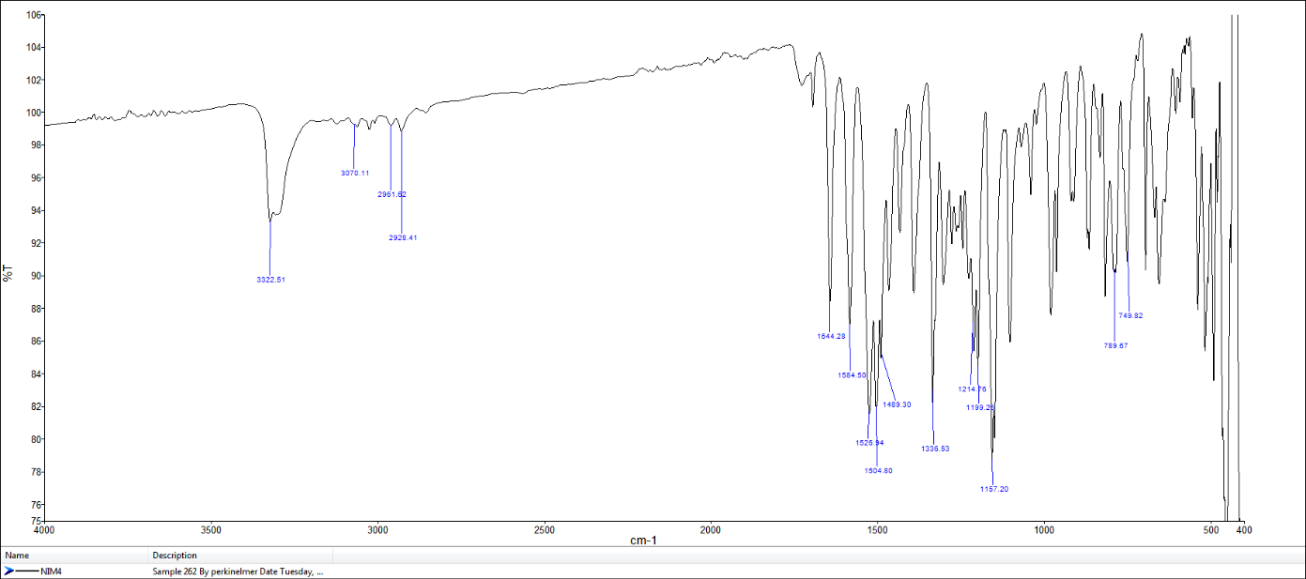
Copies of the FTIR, HRMS, ¹H NMR and ¹³C NMR spectra of synthesized N-[4-[3-(2,4-Dichloro-phenyl)-ureido]-2-phenoxy-phenyl]-methanesulfonamide (3d)

Fig. S17. FTIR spectrum of 3d

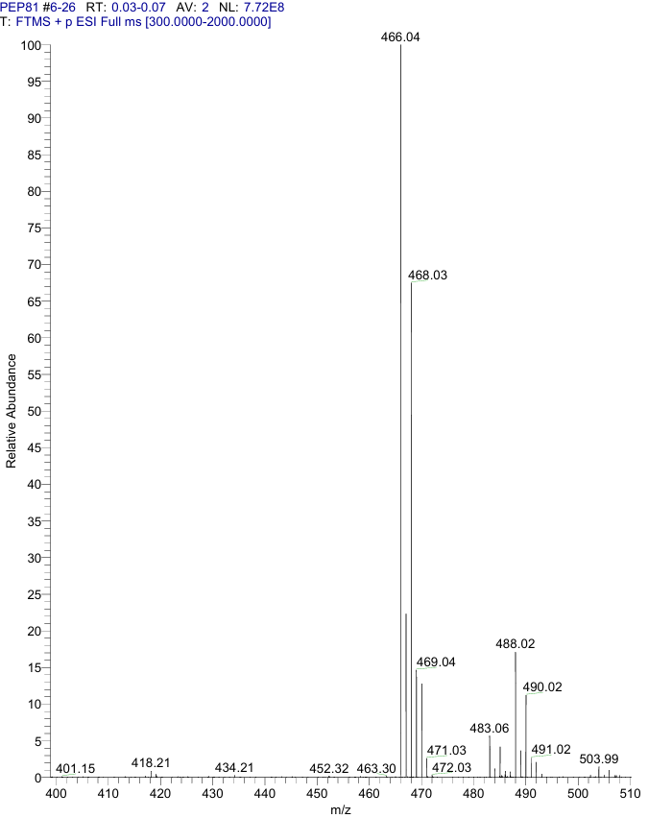

Fig. S18. HRMS (ESI-Orbitrap) spectrum of compound 3d
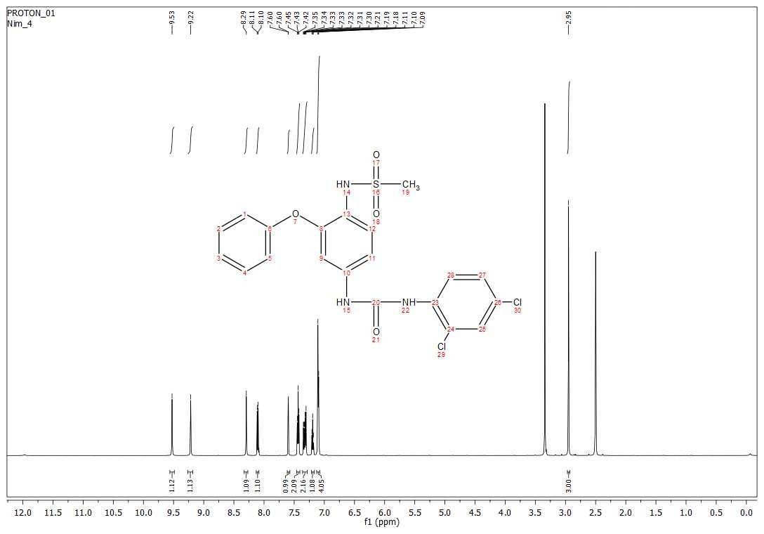
Fig. S19. ¹H NMR spectrum (600 MHz, DMSO) of 3d

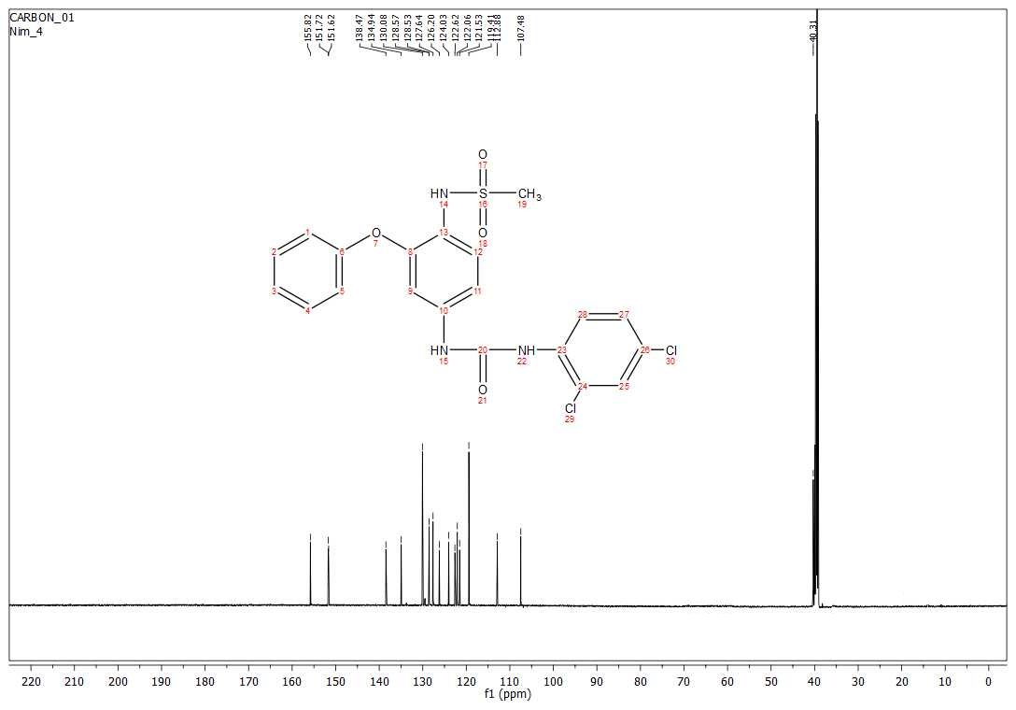
Fig. S20. ¹³C NMR spectrum (150 MHz, DMSO) of 3d.

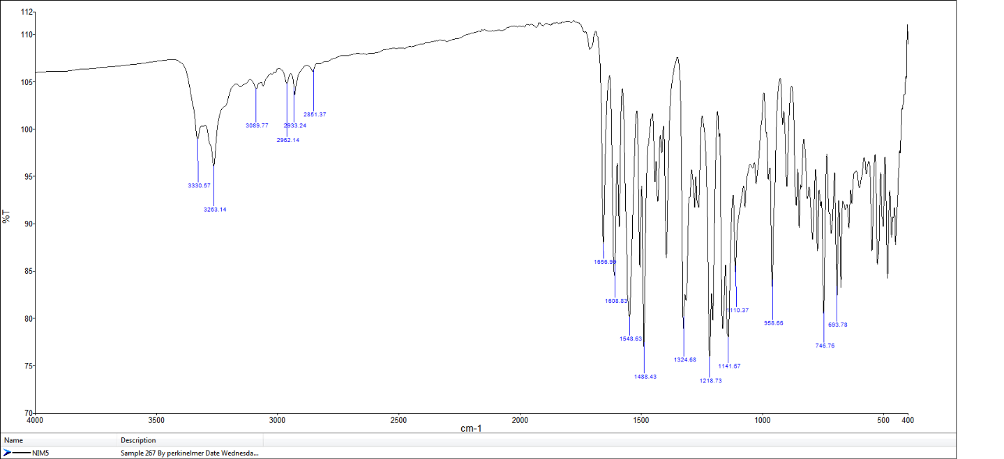
Copies of the FTIR, HRMS, ¹H NMR and ¹³C NMR spectra of synthesized N-[4-[3-(3-Fluoro-phenyl)-ureido]-2-phenoxy-phenyl]-methanesulfonamide (3e)

Fig. S21. FTIR spectrum of 3e

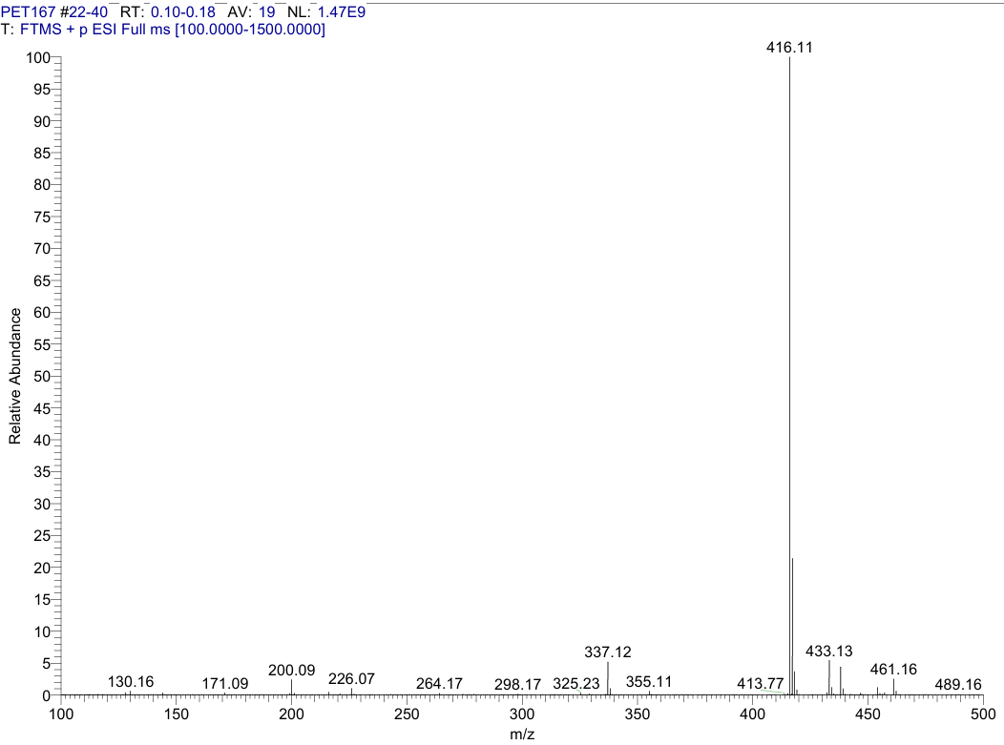

Fig. S22. HRMS (ESI-Orbitrap) spectrum of compound 3e

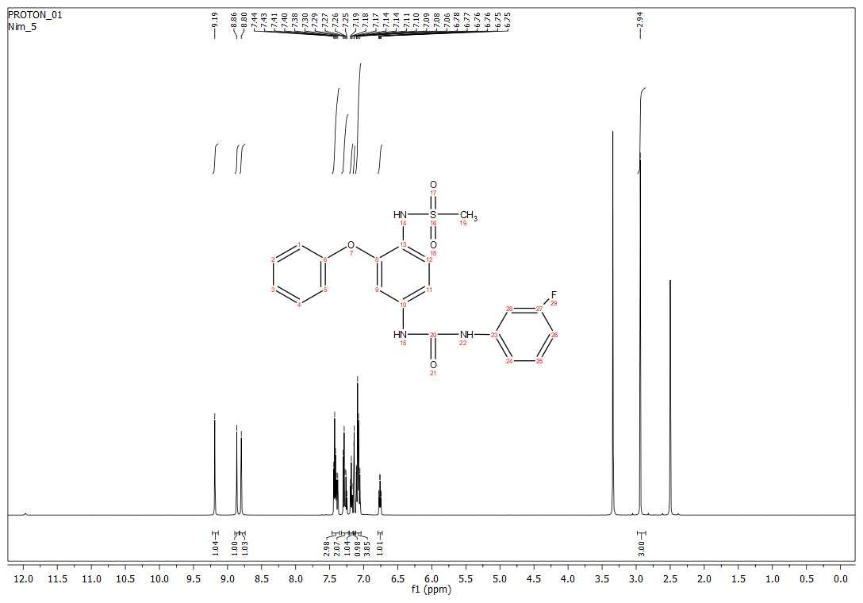
Fig. S23. ¹H NMR spectrum (600 MHz, DMSO) of 3e

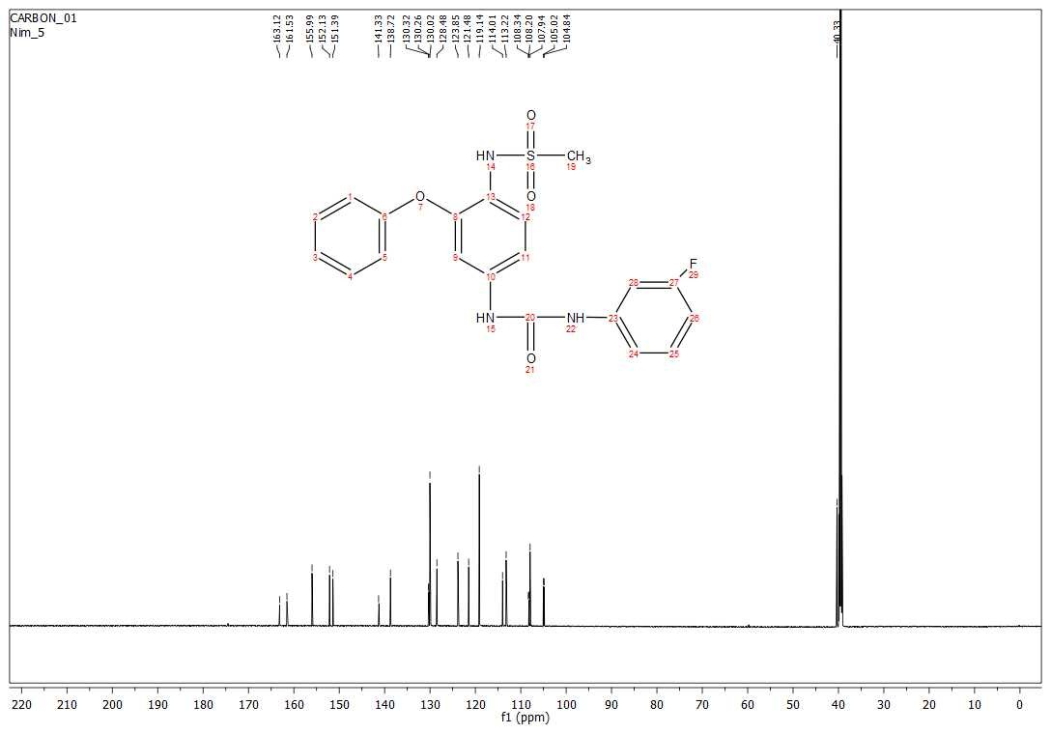
Fig. S24. ¹³C NMR spectrum (150 MHz, DMSO) of 3e.

Copies of the FTIR, HRMS, ¹H NMR and ¹³C NMR spectra of synthesized N-{4-[3-(4-Fluoro-phenyl)-ureido]-2-phenoxy-phenyl}-methanesulfonamide (3f)
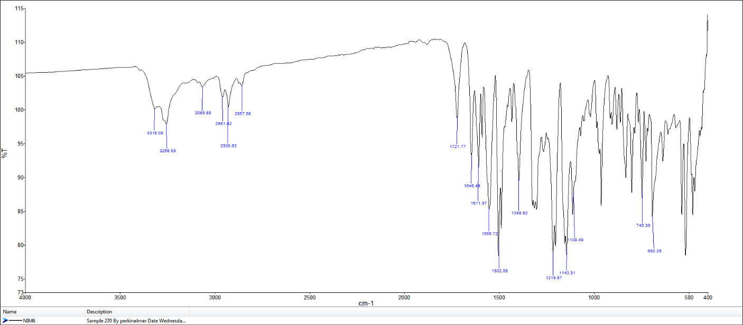
Fig. S25. FTIR spectrum of 3f

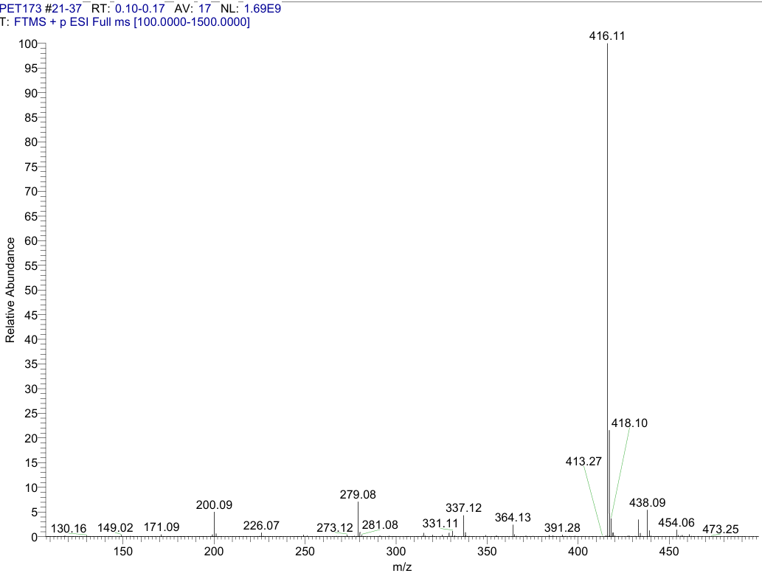
Fig. S26. HRMS (ESI-Orbitrap) spectrum of compound 3f.

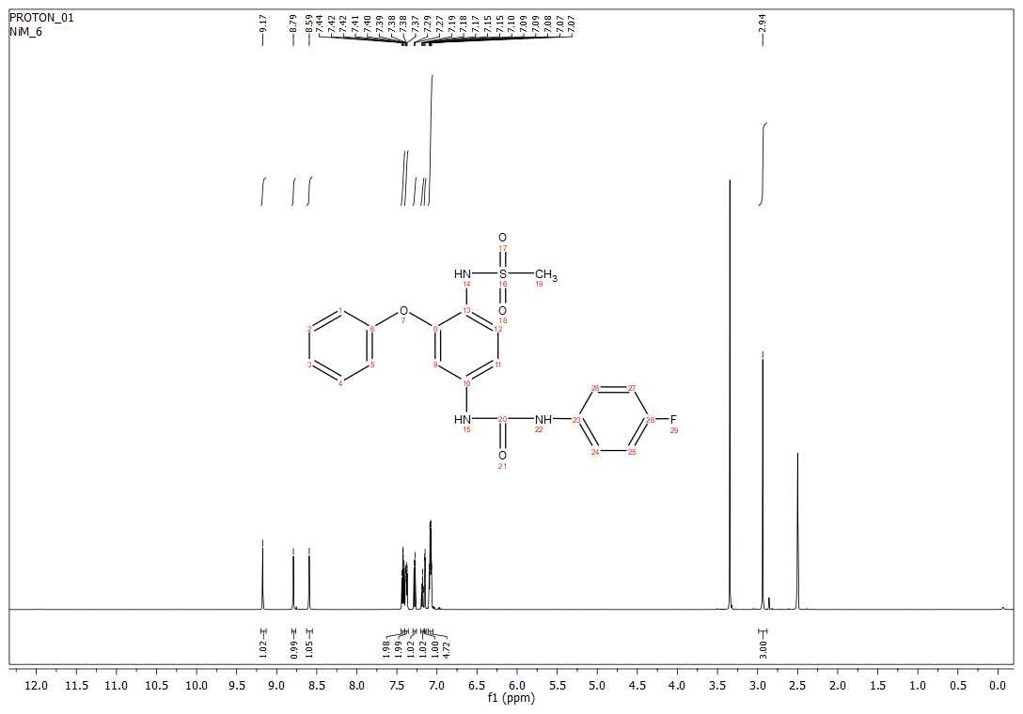
Fig. S27. ¹H NMR spectrum (600 MHz, DMSO) of 3f.
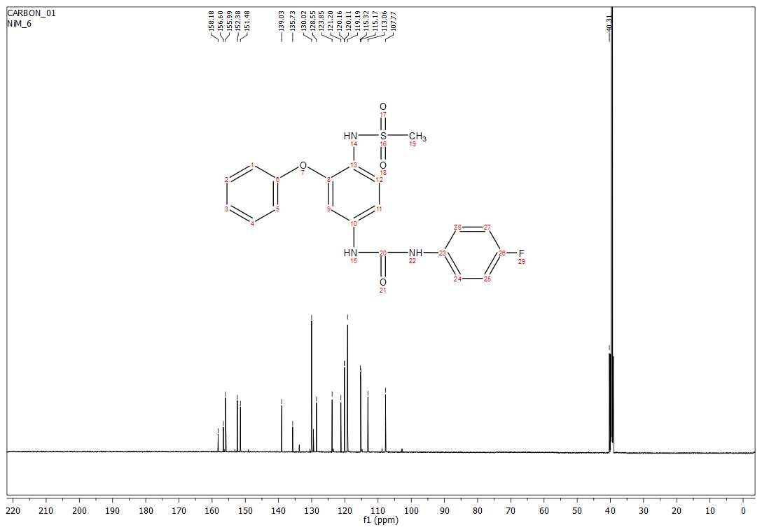
Fig. S28. ¹³C NMR spectrum (150 MHz, DMSO) of 3f.

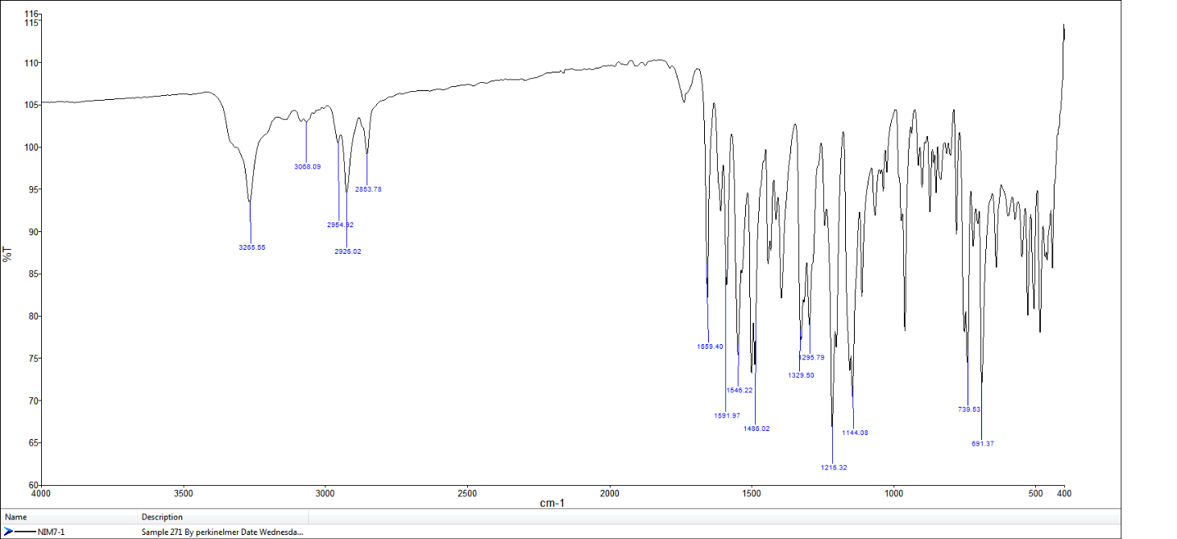
Copies of the FTIR, HRMS, ¹H NMR and ¹³C NMR spectra of synthesized N-{4-[3-(2-Chloro-phenyl)-ureido]-2-phenoxy-phenyl}-methanesulfonamide (3g)

Fig. S29. FTIR spectrum of 3g

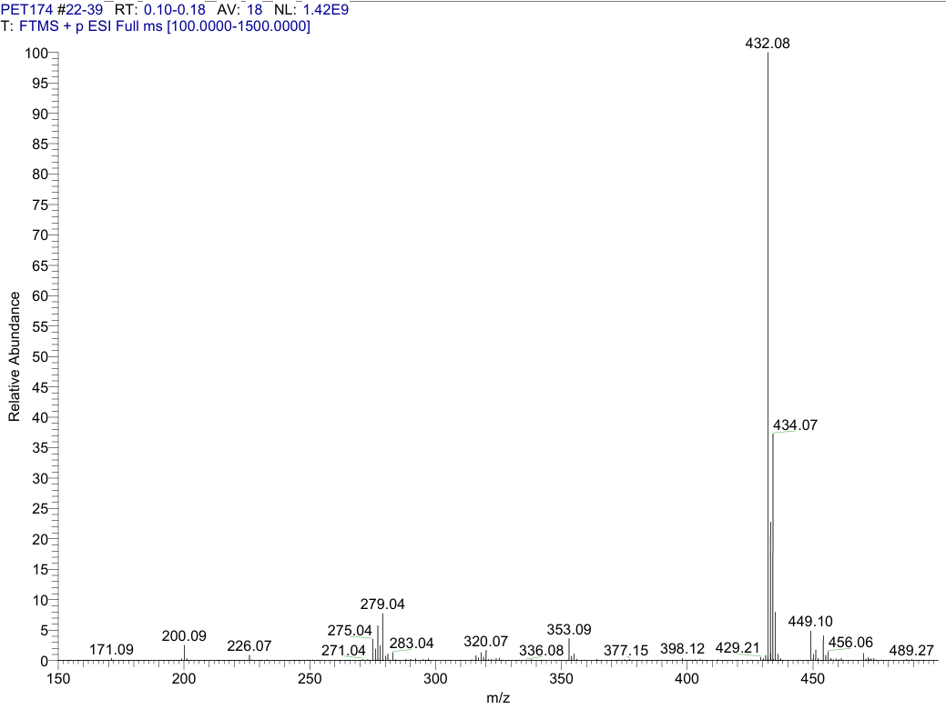
Fig. S30. HRMS (ESI-Orbitrap) spectrum of compound 3g

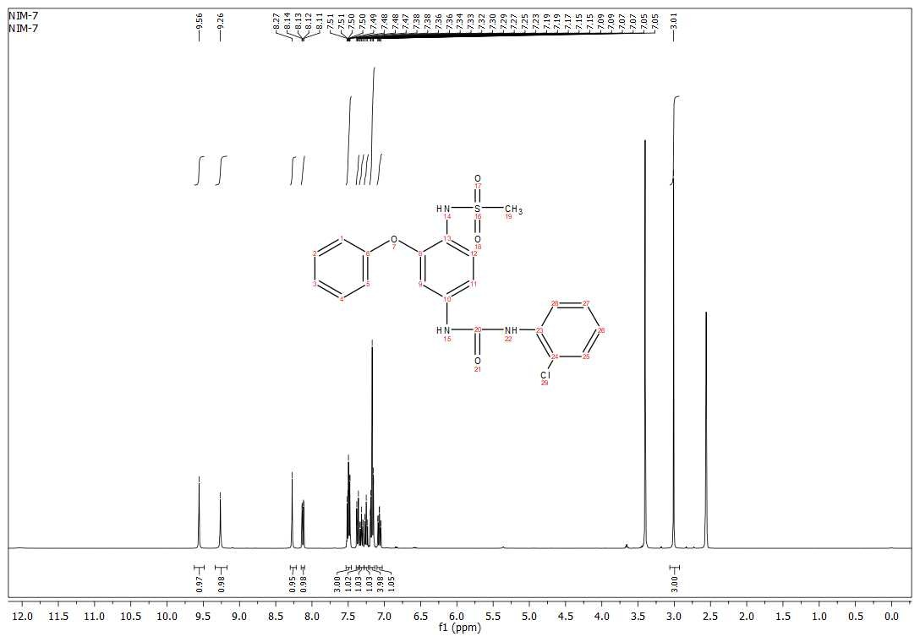
Fig. S31. ¹H NMR spectrum (600 MHz, DMSO) of 3g.
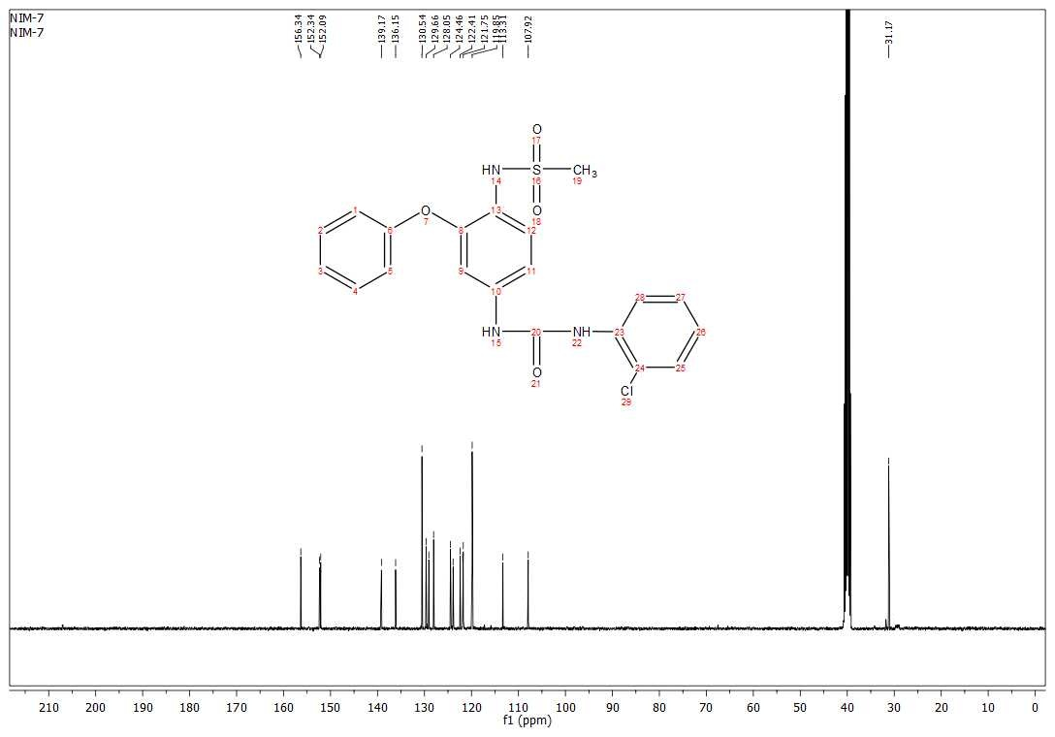
Fig. S32. ¹³C NMR spectrum (150 MHz, DMSO) of 3g.

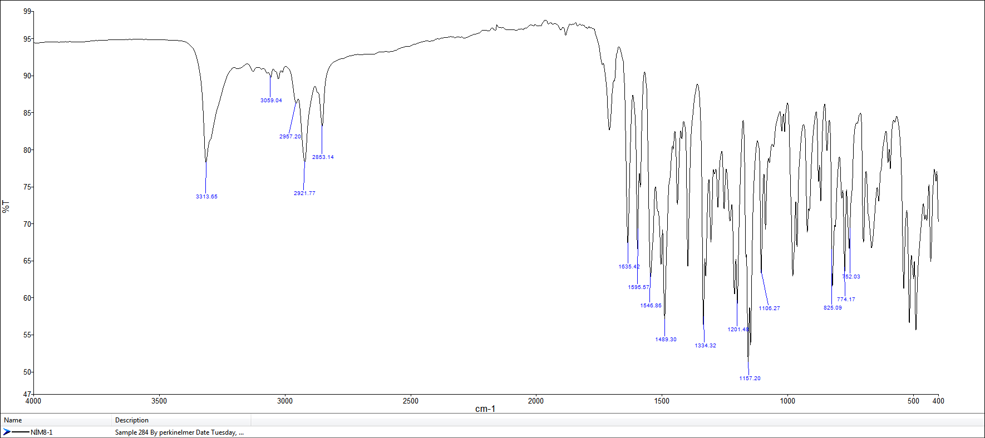
Copies of the FTIR, HRMS, ¹H NMR and ¹³C NMR spectra of synthesized N-{4-[3-(4-Chloro-phenyl)-ureido]-2-phenoxy-phenyl}-methanesulfonamide (3h)

Fig. S33. FTIR spectrum of 3h

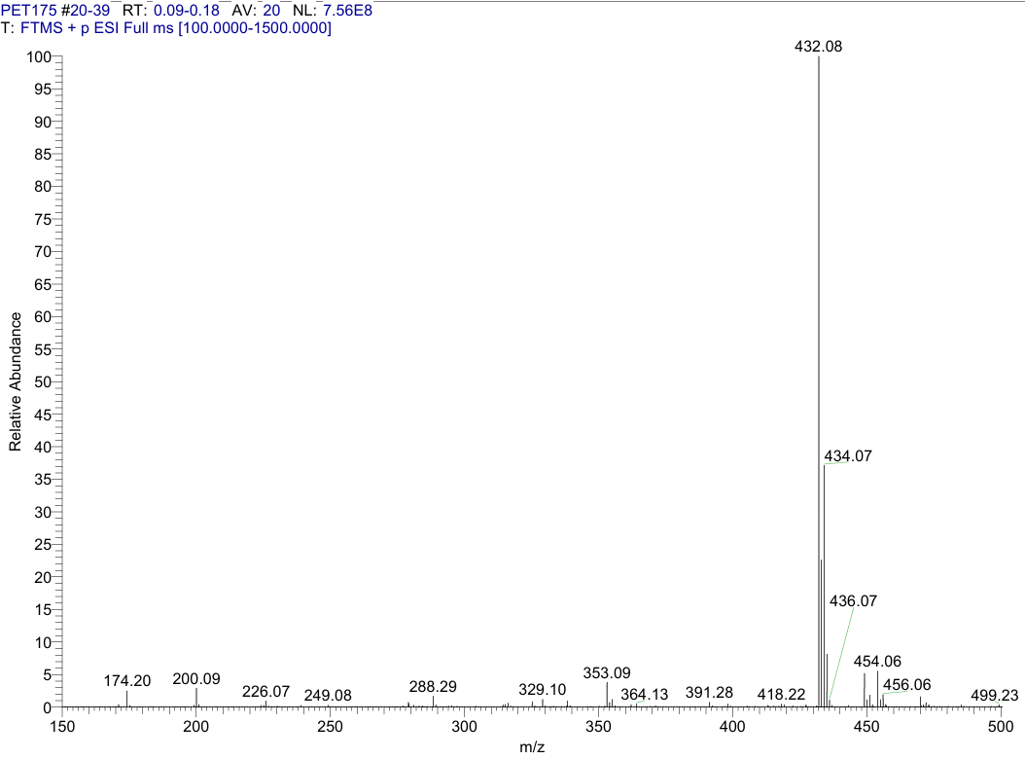

Fig. S34. HRMS (ESI-Orbitrap) spectrum of compound 3h

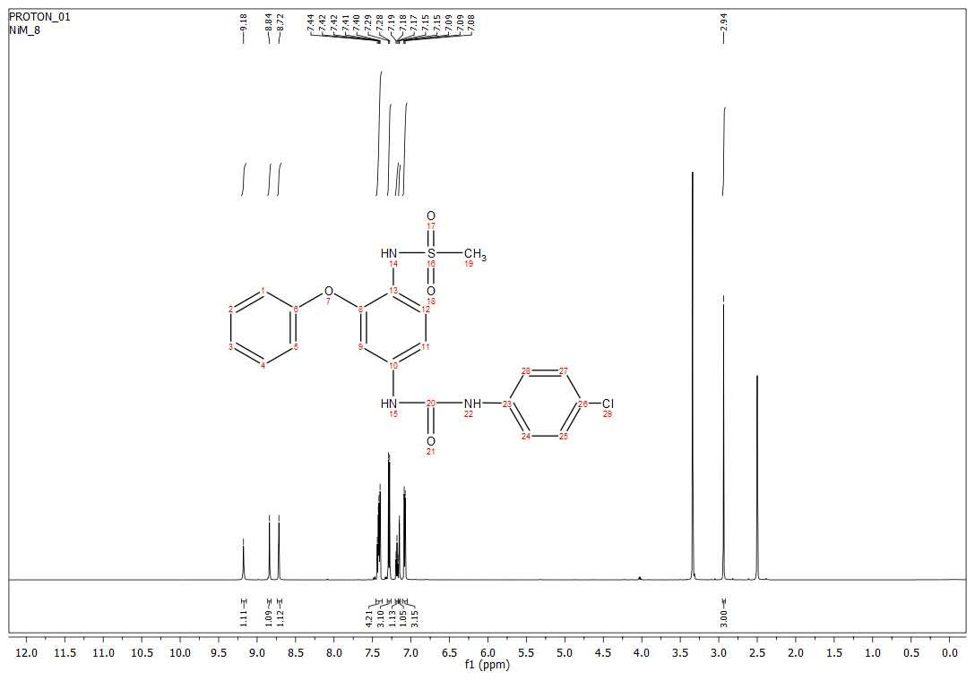
Fig. S35. ¹H NMR spectrum (600 MHz, DMSO) of 3h.
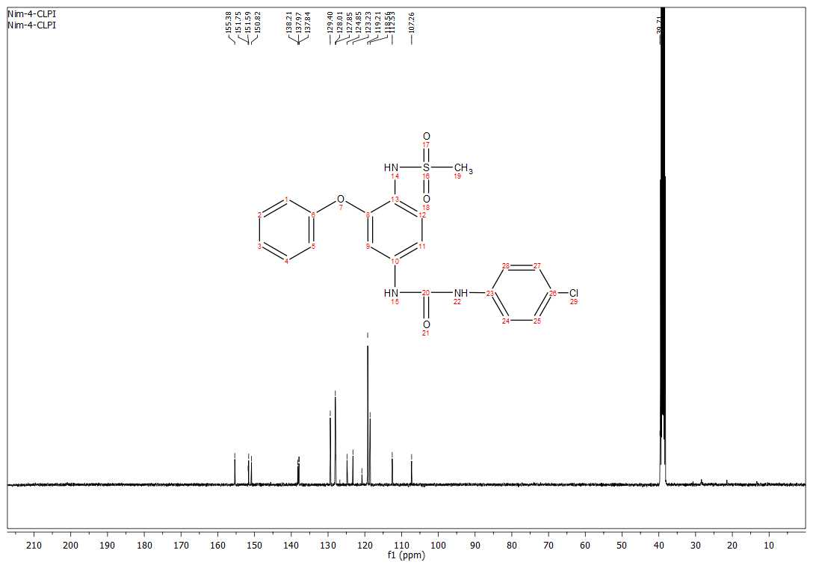
Fig. S36. ¹³C NMR spectrum (150 MHz, DMSO) of 3h.

Copies of the FTIR, HRMS, ¹H NMR and ¹³C NMR spectra of synthesized N-[2-Phenoxy-4-(3-phenyl-ureido)-phenyl]-methanesulfonamide (3i)
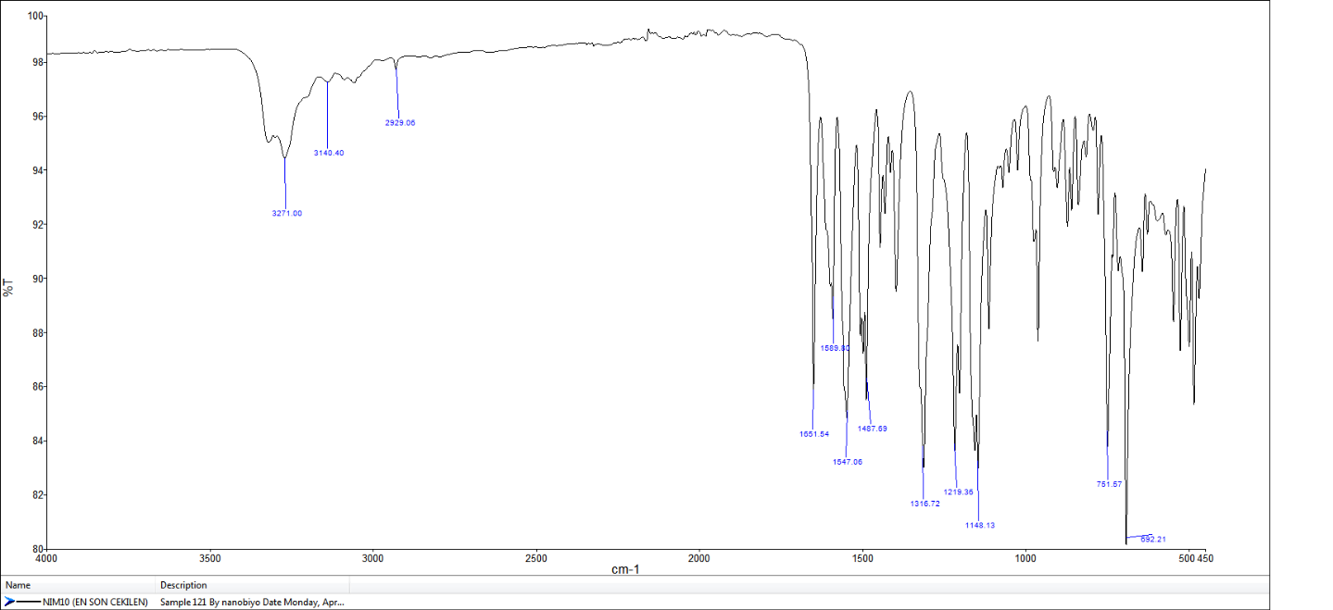

Fig. S37. FTIR spectrum of 3i

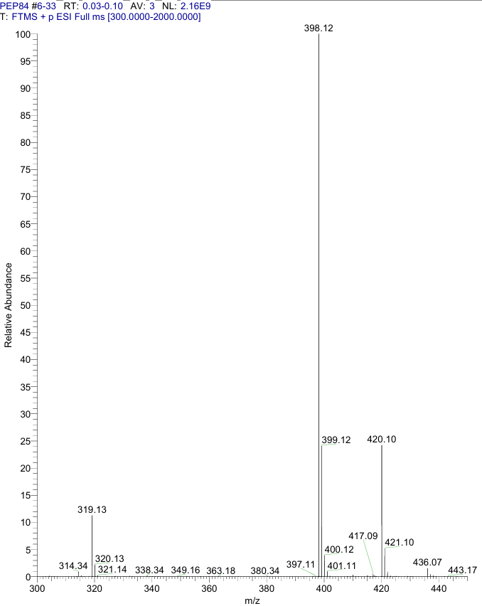
Fig. S38. HRMS (ESI-Orbitrap) spectrum of compound 3i
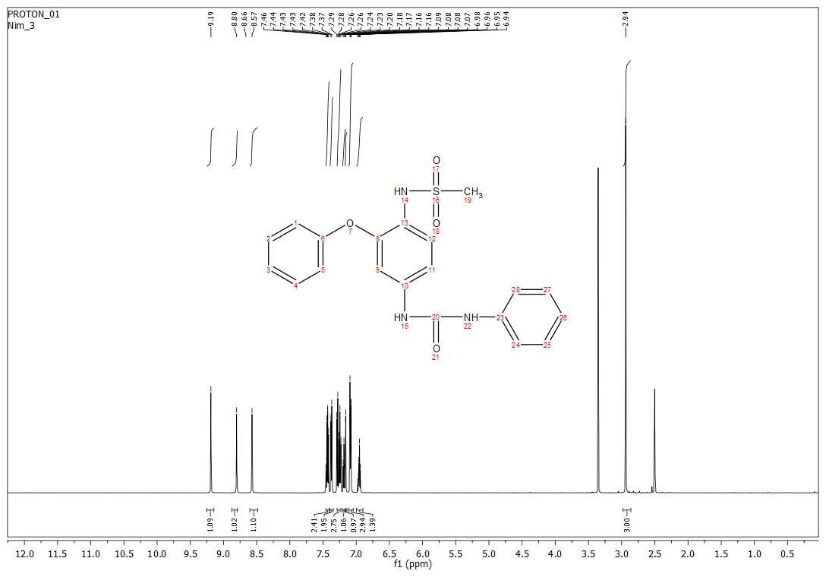
Fig. S39. ¹H NMR spectrum (600 MHz, DMSO) of 3i.

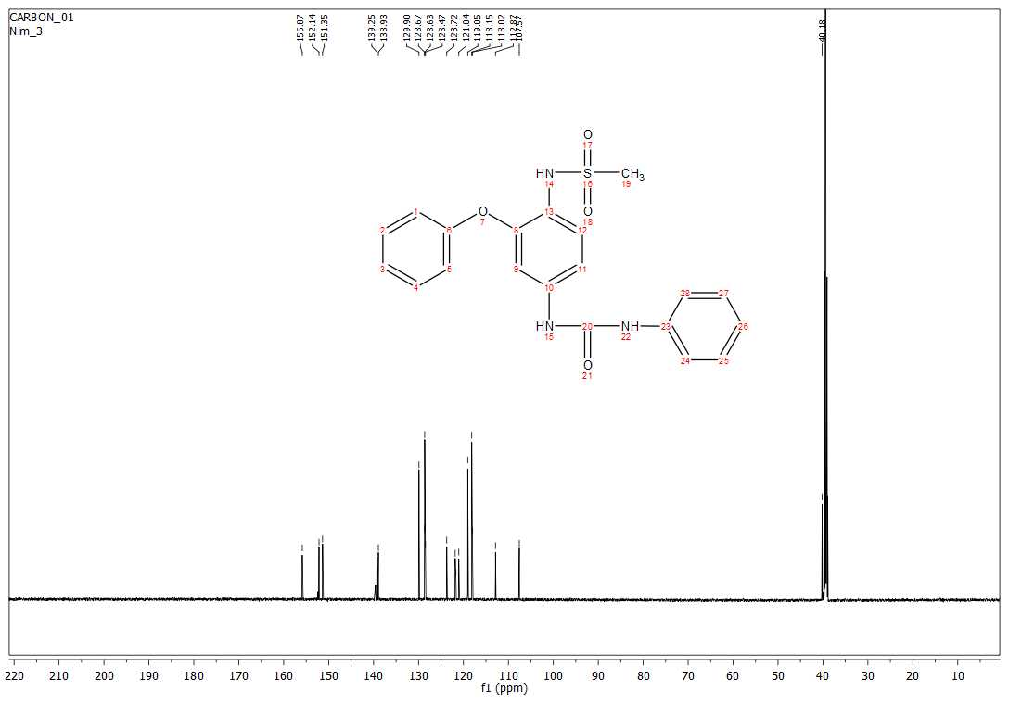
Fig. S40. ¹³C NMR spectrum (150 MHz, DMSO) of 3i.

Copies of the FTIR, HRMS, ¹H NMR and ¹³C NMR spectra of synthesized N-[4-(3-Benzyl-ureido)-2-phenoxy-phenyl]-methanesulfonamide (3j)
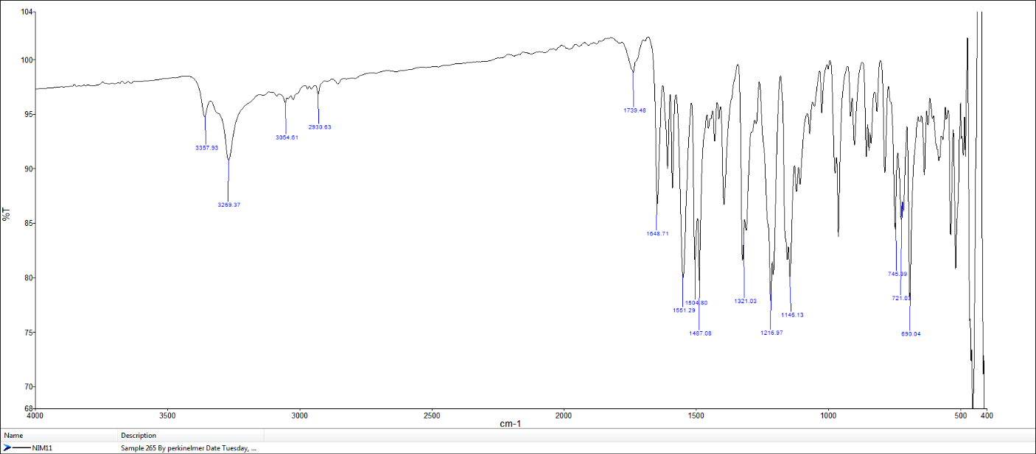
Fig. S41. FTIR spectrum of 3j.
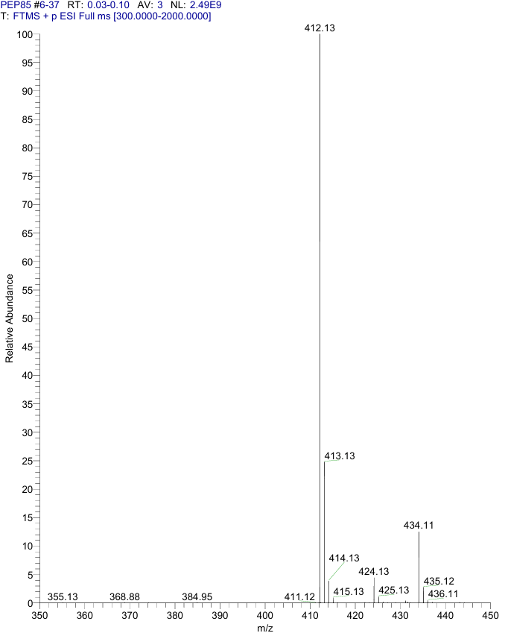

Fig. S42. HRMS (ESI-Orbitrap) spectrum of compound 3j.
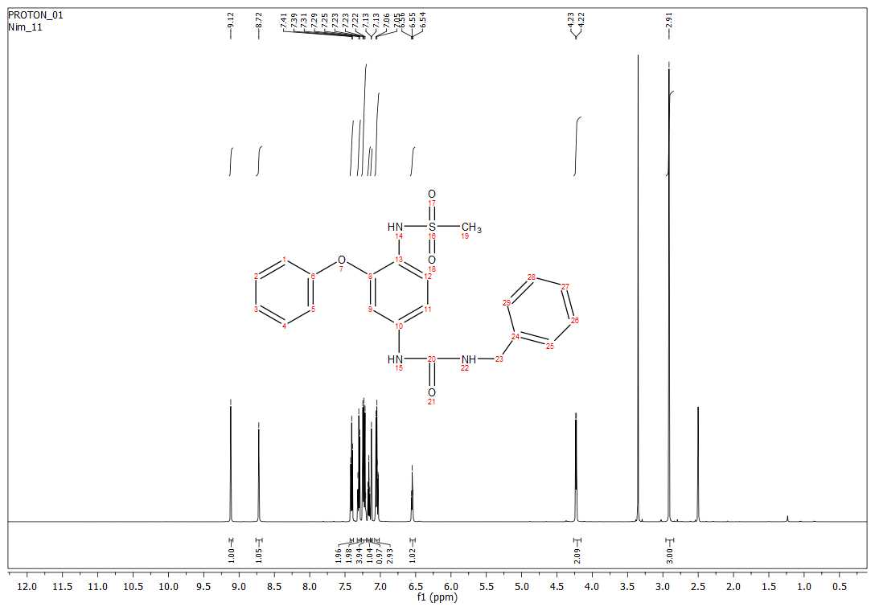
Fig. S43. ¹H NMR spectrum (600 MHz, DMSO) of 3j.
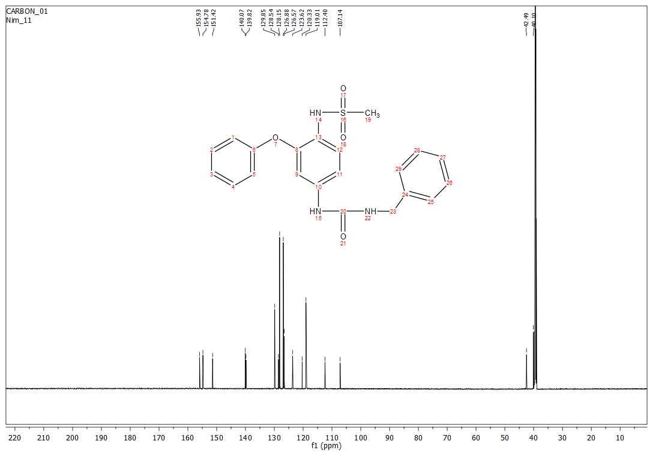
Fig. S44. ¹³C NMR spectrum (150 MHz, DMSO) of 3j.

Copies of the FTIR, HRMS, ¹H NMR and ¹³C NMR spectra of synthesized N-{4-[3-(4-Methoxy-phenyl)-ureido]-2-phenoxy-phenyl}-methanesulfonamide (3k)
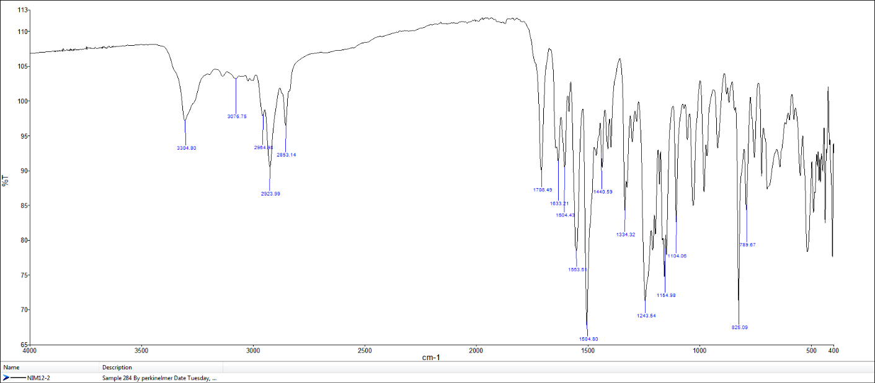

Fig. S45. FTIR spectrum of 3k.

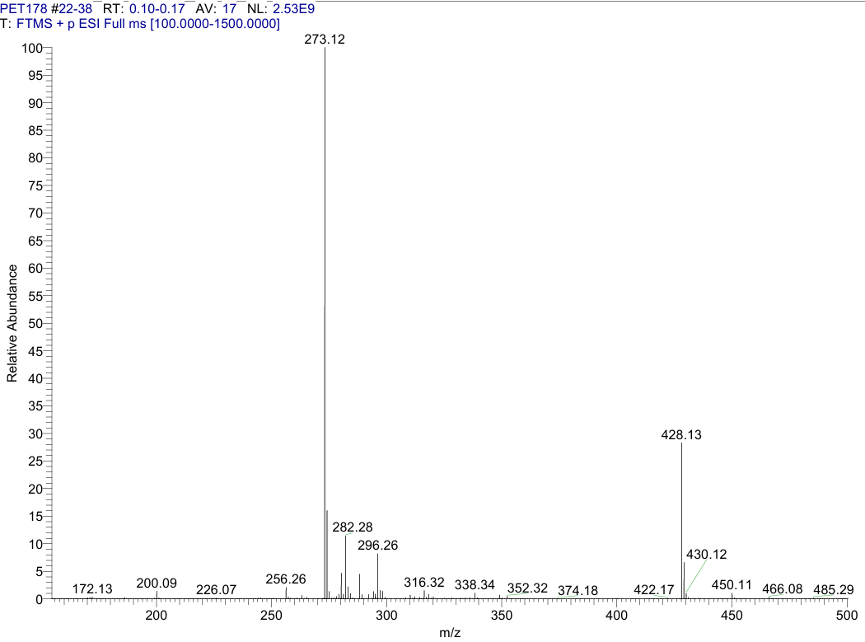

Fig. S46. HRMS (ESI-Orbitrap) spectrum of compound 3k.
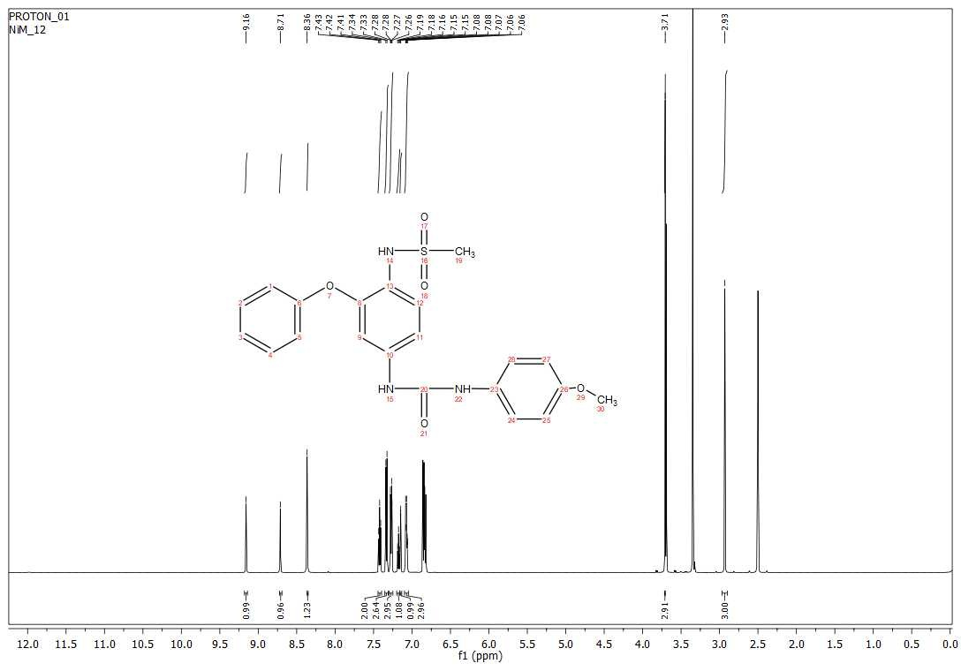
Fig. S47. ¹H NMR spectrum (600 MHz, DMSO) of 3k

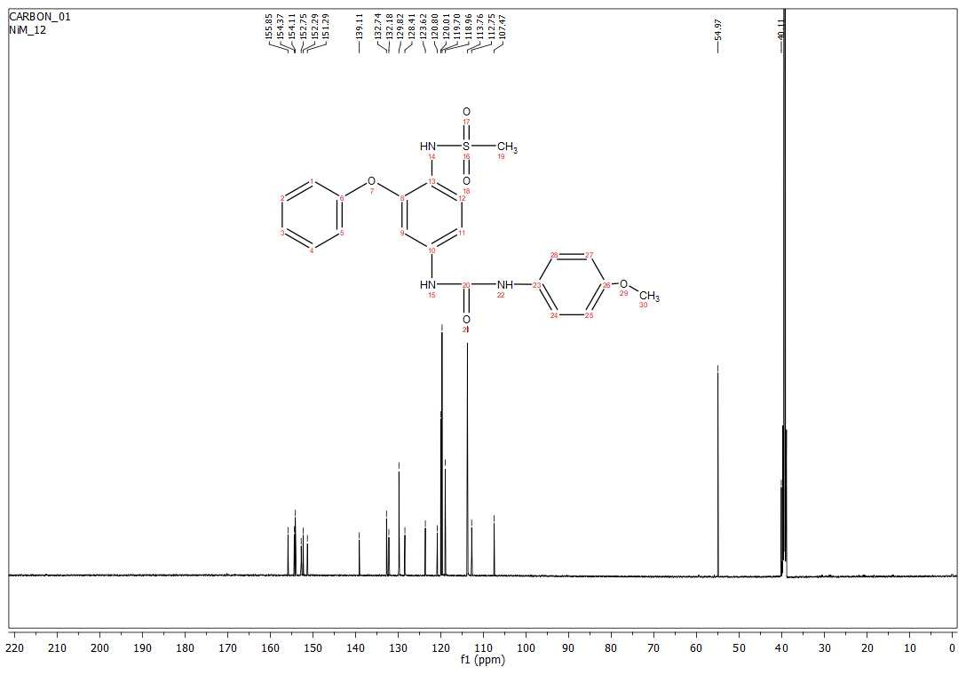
Fig. S48. ¹³C NMR spectrum (150 MHz, DMSO) of 3k.

Copies of the FTIR, HRMS, ¹H NMR and ¹³C NMR spectra of synthesized N-[4-(3-Phenethyl-ureido)-2-phenoxy-phenyl]-methanesulfonamide (3l)
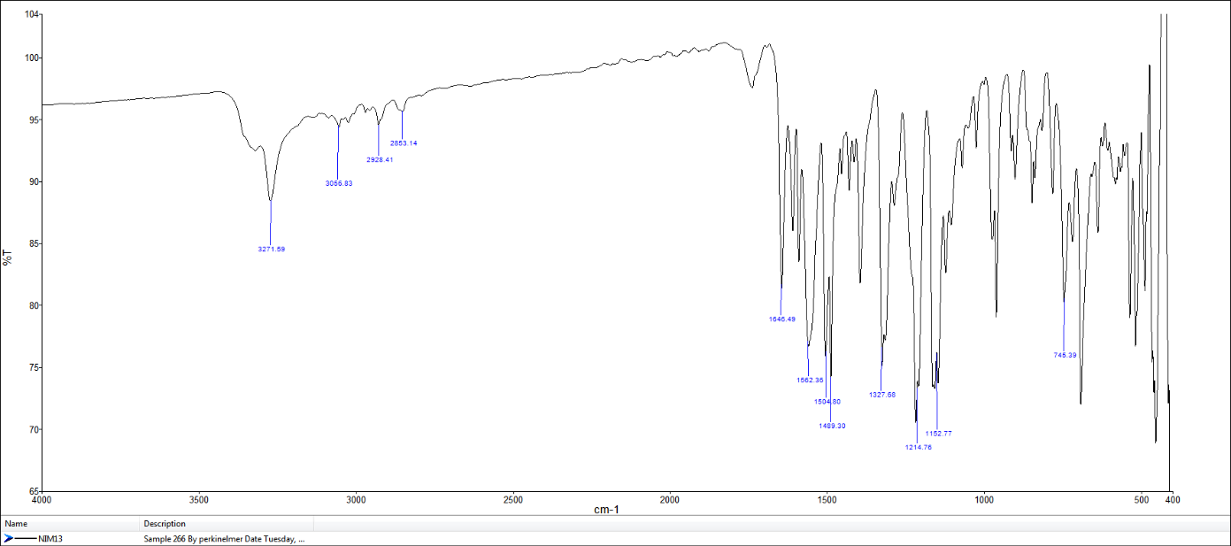

Fig. S49. FTIR spectrum of 3l.
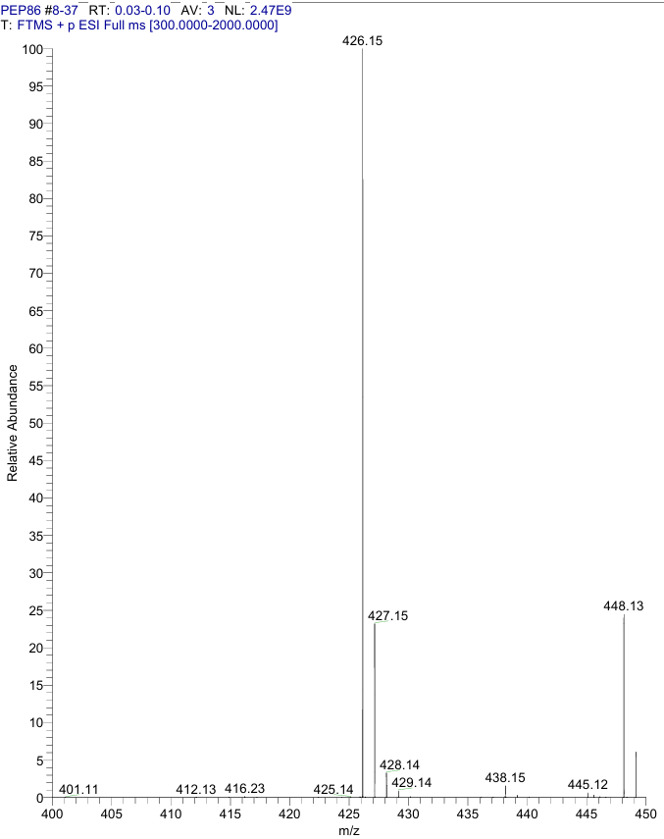

Fig. S50. HRMS (ESI-Orbitrap) spectrum of compound 3l.
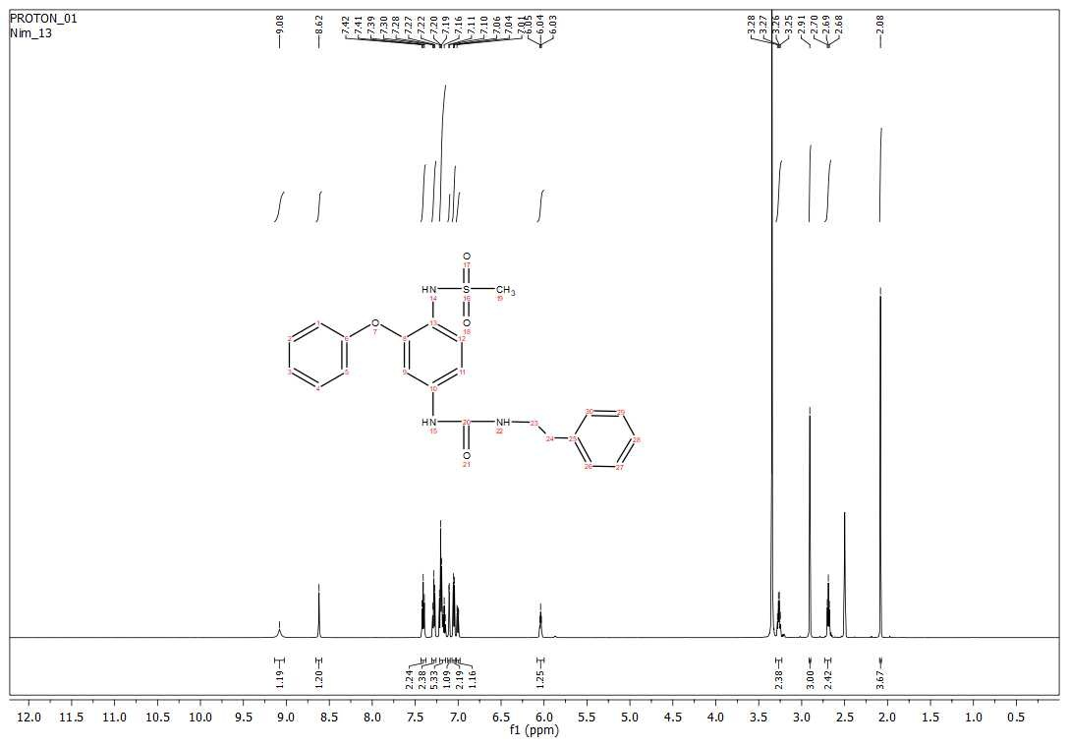
Fig. S51. ¹H NMR spectrum (600 MHz, DMSO) of 3l

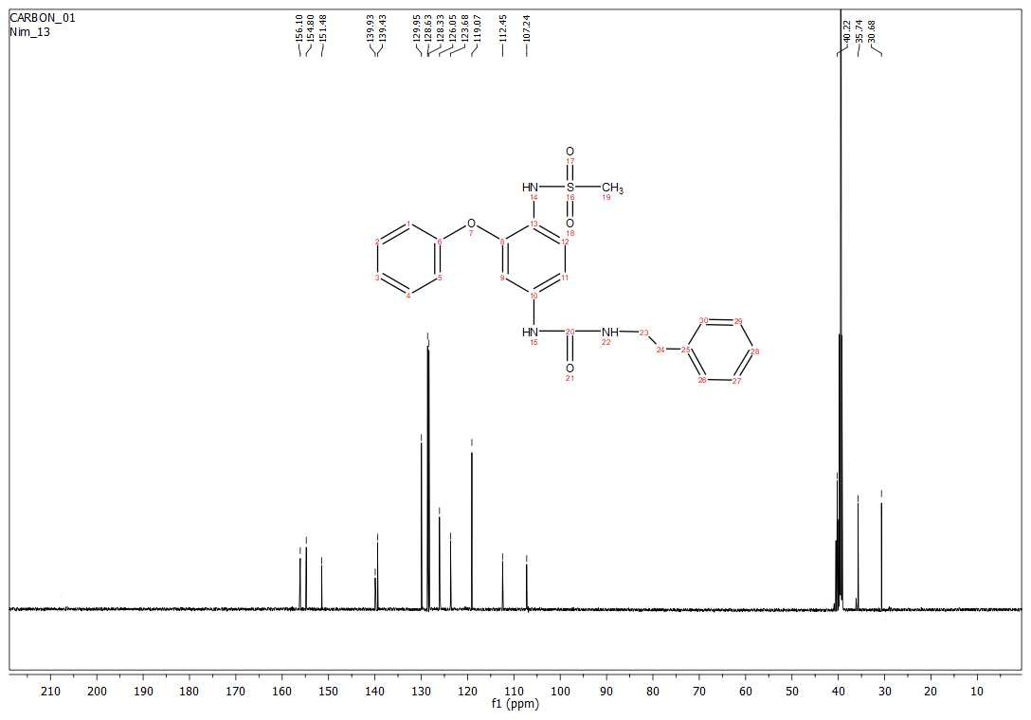
Fig. S52. ¹³C NMR spectrum (150 MHz, DMSO) of 3l.

Molecular Modeling and Docking Studies
COX1: The X-ray crystallographic structure of PDB ID:1Q4G, resolution 2.00Å and COX-2: PDB ID:3NT1, resolution 1.73Å were retrieved from the protein data bank (https://www.rcsb.org/). All the co-crystallized ligands, water molecules, and ions were removed, but the HEM group was kept in the COX1 and COX2 proteins. COX-1 and COX-2 proteins were prepared with BIOVIA DS Studio's "Protein Preparation" protocol, and the ligands 3i, 3j, and 3l were prepared with the "Prepare ligands" protocol.
COX-1 and COX-2 protein PDB files were converted to PDBQT format with ADT Tools, and AutoDock VINA was executed one by one. COX-1 and COX-2 protein PDB files were converted to PDBQT format with ADT Tools, and AutoDock VINA was executed one by one.
The detailed procedures for ligand and enzyme preparations were reported elsewhere²². The computational docking experiment was carried out for all three compounds, 3i, 3j, and 3l, and the results were presented in Table S1.
Proteins | MetAP2 Protein |  | COX1 |  | COX2
Comp. No | Free energy of binding (kcal/mol) | Inhibition Constant, Ki  (nanoMol) | Free energy of binding (kcal/mol) | Inhibition Constant, Ki  (nanoMol) | Free energy of binding (kcal/mol) | Inhibition Constant, Ki  (nanoMol)
3i | -8.0 | 0.737 | -9.0 | 250 | -9.9 | 54
3j | -7.9 | 1.50 | -9.4 | 130 | -8.9 | 300
3l | -7.8 | 1.73 | -10.4 | 23 | -8.6 | 490

Table S1 . Calculated molecular docking scores (ΔG, kcal/mol) and inhibition constants (Kᵢ, µM) of compounds 3i, 3j and 3l.

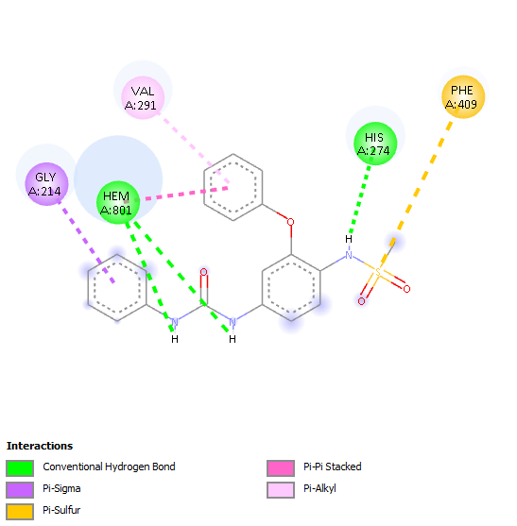  COX1-3i | 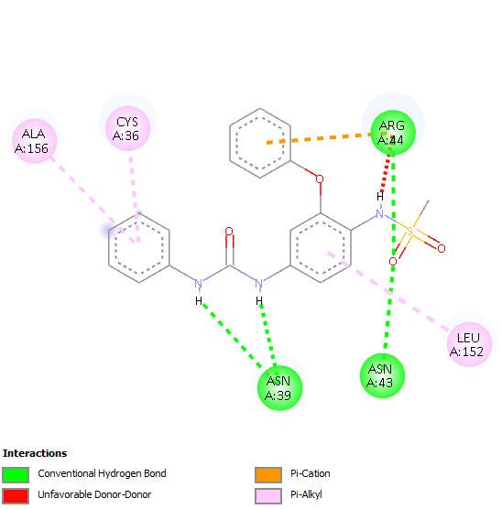  COX2-3i
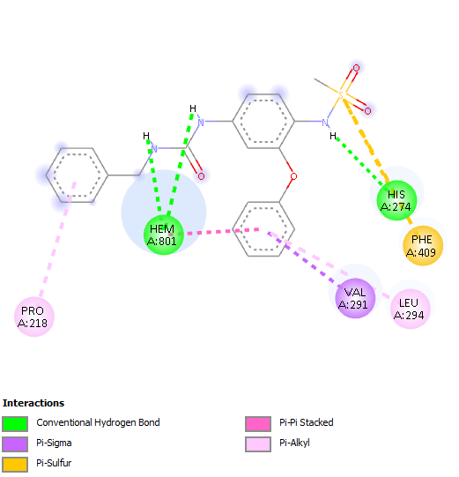  COX1-3j | 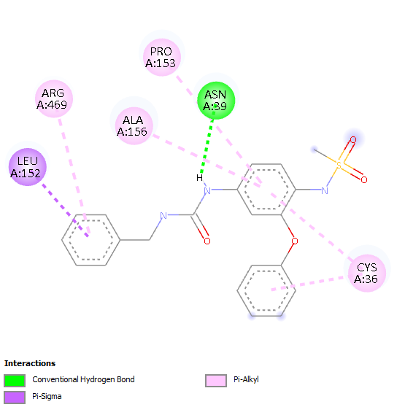  COX2-3j
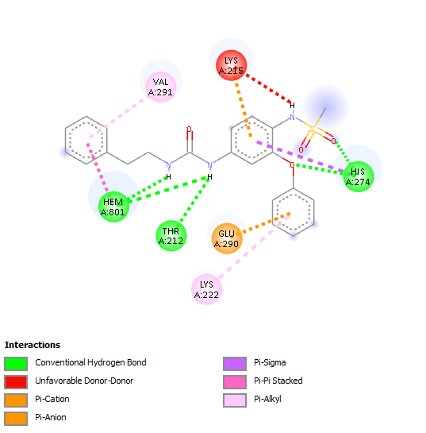  COX1-3l | 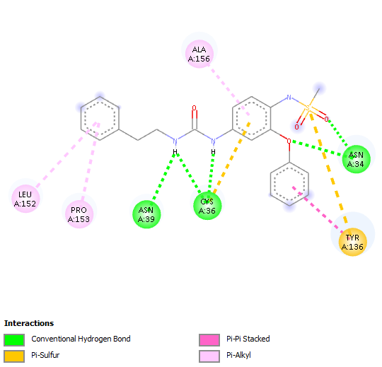  COX2-3l

Table S2. The 2D interaction networks of compounds 3i, 3j, and 3l docked into the active sites of COX-1 and COX-2, highlighting key amino acid residue interactions.

