Article

A refined chronology of the Naumann’s elephant (Palaeoloxodon naumanni) provides a new insight on factors of their extinction

Authors: Soichiro Kusaka, Yuichiro Nishioka, Jun Kimura, Akira Iwase, Kazuki Morisaki

Supplementary information

1. Comparison of collagen extraction methods
2. Evaluation of diagenetic effects
3. Materials older than 38 k cal BP
4. Radiocarbon dates of Upper Palaeolithic sites
5. R code
6. References

1. Comparison of collagen extraction methods
1.1 Collagen extraction
Dating of fossils earlier than 50 k years has been conducted using radiocarbon dating on bone collagen extracted by gelatinization^{[1]}. The alkali wash, demineralization, and gelatinization procedures can remove most of the humic and fulvic acid contamination from fossils. Contamination was evaluated based on the criteria of collagen yield and C/N ratio^{[2,3]}. The ordinary gelatinization method reduces the contaminants in bone collagen; however, a very small amount of modern carbon contaminants can substantially affect the radiocarbon dates, particularly in older material from around 50–30 k BP^{[4,5]}. Many unreliable radiocarbon dates of the Late Pleistocene have been published^{[6]}. This is because of the introduction of AMS and the progress of collagen extraction methods for fossil bone. Research on the collection of reported radiocarbon dates on fossils from the Late Pleistocene has been evaluated^{[7-9]}.
The ultrafiltration method can separate high molecular weight collagen (> 30 kDa) from low-molecular-weight collagen (< 30 kDa^{[10]}). Radiocarbon dates by the ultrafiltration method older than previous dates by the gelatinization method have been reported for fossils of the Late Pleistocene^{[11-13]}. Re-assessments with ultrafiltration on bones from the Middle and Late Palaeolithic in Western Europe have also revealed older dates^{[14,15]}. Another case study using the ultrafiltration method evaluated mammal fossils from the Late Pleistocene in Ireland^{[16]}. On the other hand, molecular-level radiocarbon dating extracted using XAD resin has revealed the first arrival of humans in North America^{[17,18]}. Compound-specific radiocarbon dating was conducted to achieve an accurate estimate of fossil collagen^{[19,20]}. However, a proper method to remove contaminants is required to reveal the dates of samples in the Late Pleistocene.
The present study used both the gelatinization and ultrafiltration methods to extract collagen from Naumann’s elephant (Supplementary Fig. S1). High-molecular-weight collagen (> 30 kDa, GL fraction) was used to interpret the dates of fossils, and low-molecular-weight collagen (< 30 kDa, GS fraction) and water-soluble collagen (S fraction) were also measured. The radiocarbon dates using the ultrafiltration method were compared with those of previous studies.
The contaminated components of fossil collagen are expected to be humic substances from the Late Pleistocene sediments. The humic substances include fulvic acid (dissolves in alkali and acid solutions), humic acid (dissolves in alkali solutions), and humin (does not dissolve in alkali and acid solutions)^{[21]}. Most of the fulvic and humic acids can be removed by the gelatinization method. The ultrafiltration method can remove low-molecular-weight humic substances but not collagen-humic cross-link complexes^{[19,22]}. Another possible contaminant is dissolved organic carbon from seawater in the case of salvaged samples. Most dissolved organic carbon shows a low molecular weight^{[23]}. As dissolved organic carbon usually shows a low molecular weight, the ultrafiltration method would be effective in removing these contaminants.
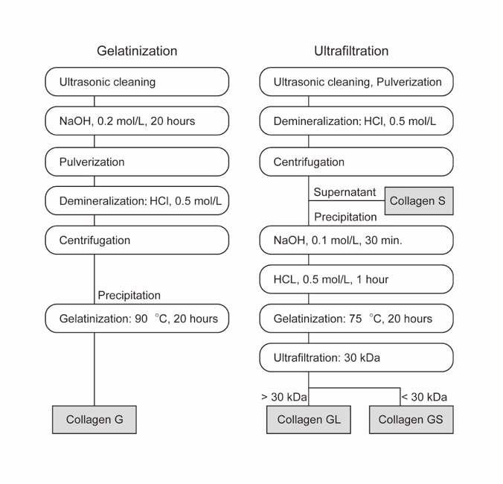
Supplementary Fig. S1. Collagen extraction using the gelatinization and ultrafiltration methods.

1.2 Re-dating of reported material
A molar fossil salvaged from the Uwa sea area off Ehime Prefecture (LN-1) was dated to 41.1 k BP in the GL fraction, which was older than GS and S fractions by 1.4 k years (Supplementary Table S1). Previous studies have reported 29.2 k BP with the gelatinization method without alkali wash and 43.9 k BP with the XAD method^{[24,25]}. The salvaged fossil might have been contaminated by dissolved organic matter in seawater or soil organics from Late Pleistocene sediments. In a previous study, earlier dates were reported for the sample with alkali wash. This fossil might have been contaminated by carbon with older dates^{[24]}. The radiocarbon dates of the samples from around 50–40 k BP would be severely affected by sample treatment, the background level of carbon in experiments, and radiocarbon measurements. Although we accept the date of the XAD method, the date of the GL fraction is also a good estimate of the age of the sample.
A molar fossil salvaged from the Japan Sea off Shimane Prefecture (LN-2) was dated to 42.7 k BP in the GL fraction. The dates of the GL and GS fractions showed similar values, but the S fraction showed an earlier date by about 6.7 k BP. The S fraction was a soluble collagen before alkali wash and gelatinization and would be largely affected by diagenetic effects. A previous study reported the date of 29 k BP with the demineralization method without alkali wash and gelatinization^{[26]}. The collagen extraction method could have a substantial effect on the radiocarbon dates (a difference of as much as 13.7 k years).
A molar fossil salvaged from the Japan Sea near Oki Island off Shimane Prefecture (LN-3) was dated to 33.1 k BP in the GL fraction. There were no remains in the GS and S fractions, suggesting that large molecular weight collagen was preserved in the specimen. The date of the GL fraction was about 5 k years older than that obtained using the gelatinization method^{[27]}.
Three molar fossils from a limestone cave in Shikkari in Aomori Prefecture were analysed. One molar fossil (LN-4) exhibited a date of 33.8 k BP in the GL fraction, and the difference in dates between the GL and GS fractions was small. High molecular weight collagen was preserved in the specimens, and the preservation state was good. The S fraction showed a high C/N ratio, indicating problems from diagenetic effects. The date of the GL fraction was 2.6 k years older than the previous date obtained using the gelatinization method^{[28]}. The good preservation of collagen would have demonstrated a small difference in radiocarbon dates between the two methods.
The molar fossil (LN-5) gave sufficient collagen only in the GL fraction, and was dated to 31.7 k BP. The collagen yield of the GL fraction was higher than 1%, but the yields were relatively low. The S fraction showed a high C/N ratio and low nitrogen content. The date of the GL fraction was 8.6 k years older than that reported in a previous study^{[28]}. The radiocarbon date of this sample was the youngest among the dates of Naumann’s elephant and largely affected the estimate of the extinction date by the CRIWM method.
The molar fossil (LN-6) was dated to 34.4 k BP in the GL fraction. There was insufficient collagen in the GS and S fractions for radiocarbon dating. The date of the GL fraction was 8.6 k years older than that reported in a previous study^{[28]}.
In sum, the re-dating of reported dates of Naumann’s elephant presented 42.7–31.7 k BP with the ultrafiltration method. Previous studies used the gelatinization method without alkali wash for collagen extraction. Furthermore, some reports did not describe a detailed collagen extraction method or the collagen yield and carbon and nitrogen contents, which makes it difficult to evaluate the results of the radiocarbon dates of Naumann’s elephant. The results of the present study indicate that the collagen yields and C/N ratios of the extracted collagen were within the range of the criteria of collagen preservation^{[2,3]}. Ultrafiltration would remove small molecular contaminants that would show younger dates^{[10]}. Thus, the results of this study with ultrafiltration would be proper estimates of the true ages of the specimens. However, the ultrafiltration method cannot remove high-molecular-weight contaminants; therefore, an additional test with compound-specific radiocarbon dating would be a good practice in future research.

1.3 Materials from Imabari City in Ehime Prefecture
This study also focused on Naumann’s elephant fossils salvaged from the Seto Inland Sea near Imabari City in Ehime Prefecture (Supplementary Fig. S2 and S3). The fossils were occasionally salvaged in a wire net for bottom trawling in the sea east of Hakata Island. Fossils were collected in the Murakami Kaizoku Museum, but no palaeontological research was conducted on the specimens. The Seto Inland Sea, which was submerged as a result of sea level rise during the Holocene^{[29]}, is surrounded by Honshu, Shikoku, and Kyushu Islands. The sea depth is 30 m on average. The bottom of the sea of eastern Hakata Island is deepened by a rapid current in a narrow strait, and the sediment layers of the Late Pleistocene are exposed (sea depth 65–45 m^{[29]}). The Upper Palaeolithic site of Kanegasaki is at the eastern edge of Hakata Island, and knives of granite from 30–19 k cal BP have been excavated^{[30]}. Thus, this is a proper area for testing the coexistence of humans and Naumann’s elephant.
Collagen was extracted using the ultrafiltration and gelatinization methods. A total of 21 specimens were used for collagen extraction, six of which gave well-preserved collagen with yields > 1% (Supplementary Table S2). The remaining 15 samples with low collagen yields are also listed in Supplementary Table S3.
Mandible bone (U030) was dated to older than 50 k BP in the GL, GS, and S fractions. The collagen G fraction (gelatinization method) was dated to 45.8 k BP, which implies that the gelatinization method cannot fully remove contamination from diagenetic young carbon. The true age of this specimen would be older than 50 k BP, above the detection limit of radiocarbon dating.
Tibia bone (U011) was dated to 47.3 k BP, and the GL fraction showed older dates than the GS and S fractions. The date of the GL fraction was 4.8 k years older than collagen G. The calibrated age range was on the limit of calibration. The true age of this specimen would be older than 47.8 k cal BP.
Radius bone (U048) was dated to 46.9 k BP in the GL fraction. The date of the GL fraction was 6.4 k years older than collagen G, which suggests that the ultrafiltration method could remove degraded collagen and young carbon contaminants.
Atlas bone (U055) was dated to 43.1 k BP in the GL fraction. The date of the GL fraction was older than that of the GS and S fractions. The date of the GL fraction was 9.4 k years older than that of collagen G in this study.
Dentine from a molar (U019) gave a collagen yield > 1% using the gelatinization method and was accepted as well-preserved collagen, even though it had low collagen yields using the ultrafiltration method. The GL fraction was dated to 42.1 k BP, 4.7 k years older than collagen G.
A bone fragment (U038) gave only the date of the GL fraction (38.2 k BP). This age was the youngest among the samples from Imabari City. The date of collagen G was 2.4 k years younger than that of the GL fraction.
Naumann’s elephant samples from Imabari City in Ehime Prefecture were dated to 53.5–38.2 k BP. The GL fraction showed older dates than that of the GS fraction by 1.8 ± 1.1 k years and that of the S fraction by 0.65 ± 4.1 k years. The earlier dates in the GS and S fractions indicate that they contain low-molecular-weight contaminants.
The GL fraction showed older ages than collagen G by 5.9 ± 2.5 k years, suggesting that the collagen extraction method largely affects the results of radiocarbon dates. Ultrafiltration can separate long-chained collagen (> 30 kDa) from short, fragmented collagen^{[10]}. Collagen originally has a molecular weight of around 100 kDa, and is fragmented over time through sedimentation. Well-preserved collagen would have a large molecular weight. In the GS fraction, carbon from dissolved organic carbon from seawater or terrestrial organic carbon from the Late Pleistocene sediments might be contaminated. Another source of contamination is glycerol (ca. 30 k BP) on the ultrafilter, which can be mostly removed by washing before use^{[31,32]}. A very small amount of glycerol might contaminate the GS fraction.
Calibrated radiocarbon dates of GL collagen were plotted using IntCal20 (Supplementary Fig. S4). The two sigma probabilities of the calibrated dates were dated to 2–0.7 k years. The sample U038 showed a small range of about 400 years, which is likely the result of a sharp change in the calibration curve at around 4.2 k cal BP^{[33]}. The U011 and U048 samples exhibited a large estimated range of about 6 k years, near the limit of the calibration curve.
In sum, the dates of Naumann’s elephant, salvaged from the Seto Inland Sea off Imabari City, would be older than 42.6–42.2 k cal BP. Thus, the radiocarbon dates do not support the coexistence of Naumann’s elephant and humans inferred from the Kanegasaki Site (ca. 30–19 k cal BP^{[30]}) in the Imabari area. The dates of Naumann’s elephant were even older than the arrival time of humans, based on dates of Upper Palaeolithic sites in the Japanese Archipelago.
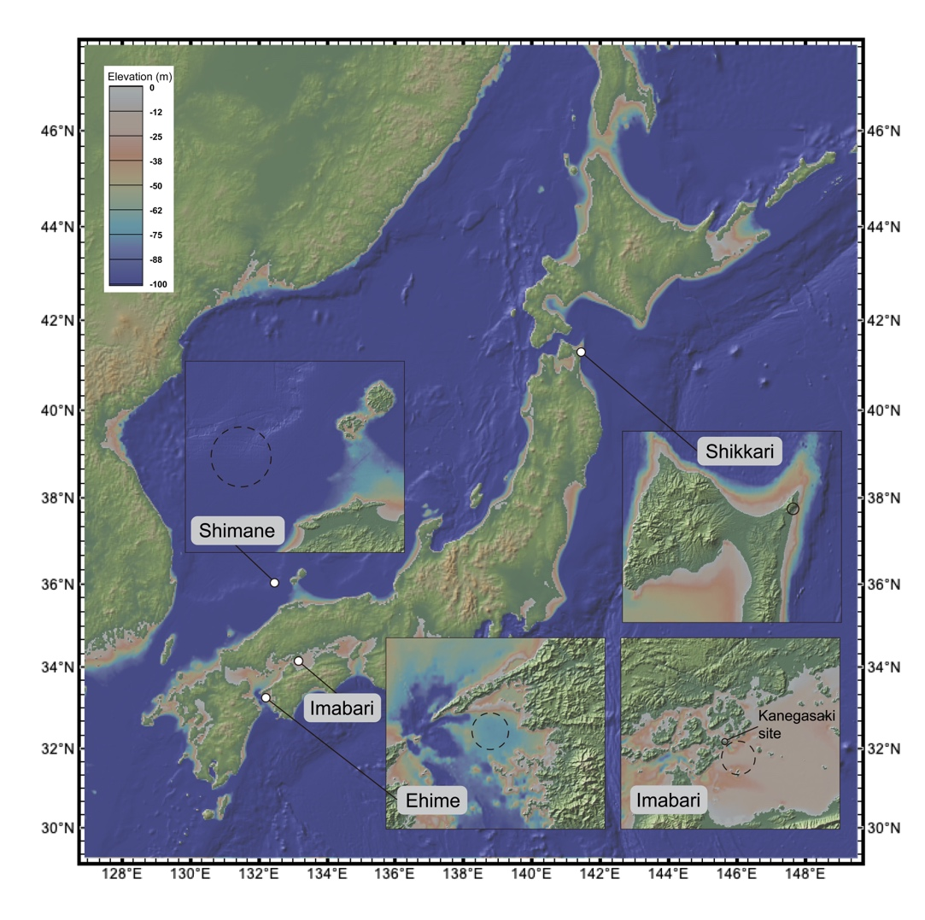
Supplementary Fig. S2. Map of sites of Naumann’s elephant fossils. Dashed circles indicate the sea area where fossils were salvaged. The figure was made using GeoMapApp (www.geomapapp.org) / CC BY / CC BY^{[34]}.
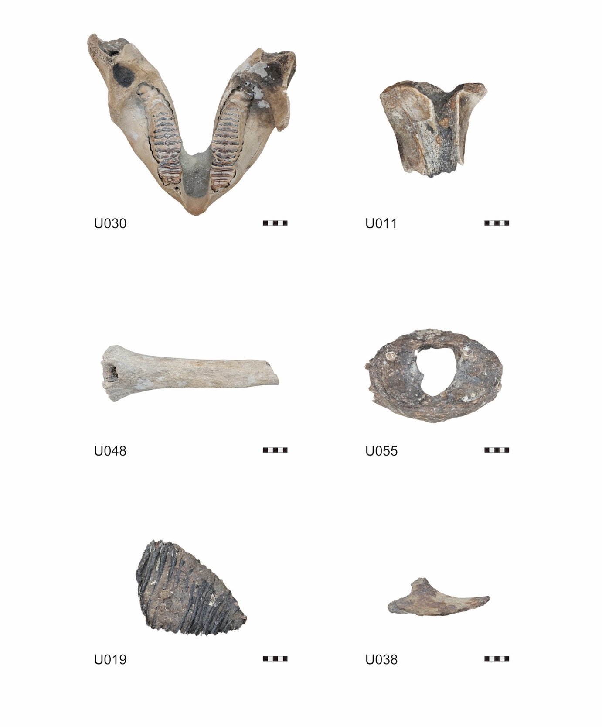
Supplementary Fig. S3. Fossil specimens of Naumann’s elephant from Imabari City, Ehime Prefecture. Scale bar: 5 cm.

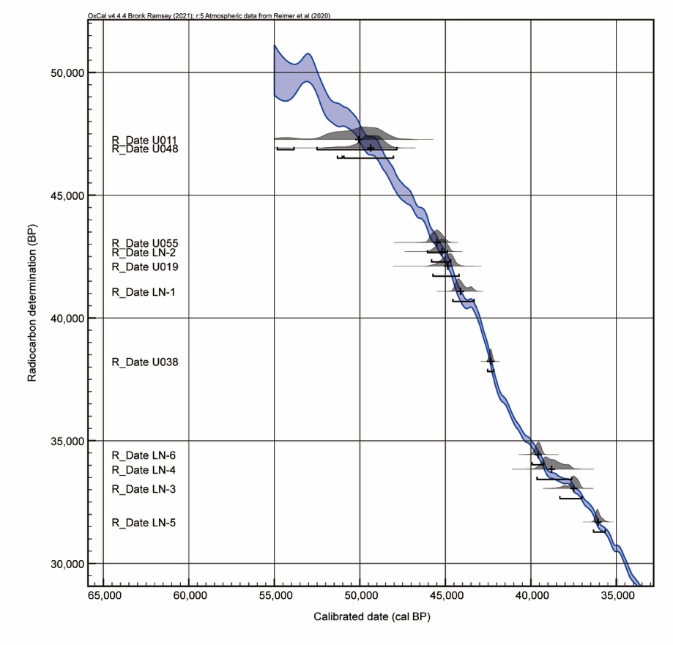
Supplementary Fig. S4. Calibrated radiocarbon dates of Naumann’s elephant fossils with the IntCal20 curve^{[35]}.

2. Evaluation of diagenetic effects
To estimate the effect of contamination in each collagen fraction, the percentages of contaminated carbon were calculated. Percent modern carbon (pMC) was calculated using the following formula^{[36]}.
The half-life of Libby is calculated as follows:
λ_{L} = 1/8033 yr^{–1}
Radiocarbon date (T_{14C-years}) is calculated by using the amount of ¹⁴C at AD 1950 (A_{ON}) and that of the sample (A_{SN}).
T_{14C-years} = –8033 ln(A_{SN}/A_{ON})
pMC = A_{SN}/A_{ON} × 100%
The pMC is reduced by half after a half-life of 5568 BP. It is hypothesized that the sample is contaminated by small percentages of modern carbon (pMC = 100%). The radiocarbon date curves against contaminated radiocarbon dates with percentages of 0.1%, 0.5%, 1%, and 2% were plotted^{[5]} (Supplementary Fig. S5). The curve with contaminated radiocarbon with 1% fossilized carbon (pMC = 0%) was also plotted.
Radiocarbon dates of the GL fraction were hypothesized to be the actual ages of the sample, and the dates of the GS and S fractions and collagen G were plotted against the dates of the GL fraction. The percentages of contaminated modern carbon in each fraction were calculated using the following formula:
P_{contamination} = (pMC_{X} – pMC_{GL}) / (100 – pMC_{GL}) × 100%
where pMC_{GL} is the pMC of the GL fraction and pMC_{X} is the pMC of the GS or S fraction and collagen G.
The percentages of contamination against the GL fraction were from 0.2% to –0.1% in the GS fraction and from 0.6% to –0.1% in the S fraction (Supplementary Fig. S5). The percentages of contamination in collagen G of the samples from Imabari City ranged from 1.0% to 0.2%. The percentages of contamination in collagen G in previous studies ranged from 3.4% to –0.2%.
The ultrafiltration method removes contaminated carbon from small molecular weight collagen and contaminated small molecular organics because most of the GS fraction shows a positive percentage of contamination. The percentages of contamination in collagen G were < 1%. However, the measured age with 1% contamination of modern carbon on the sample of 44 k BP was 10 k years earlier than the actual age. This would theoretically mean that collagen extraction methods sensitively affect the measured radiocarbon dates. On the other hand, the effect of the contamination of fossil carbon would be small: the difference between the measured and actual ages was about 300 years with 1% fossil carbon at 44 k BP.

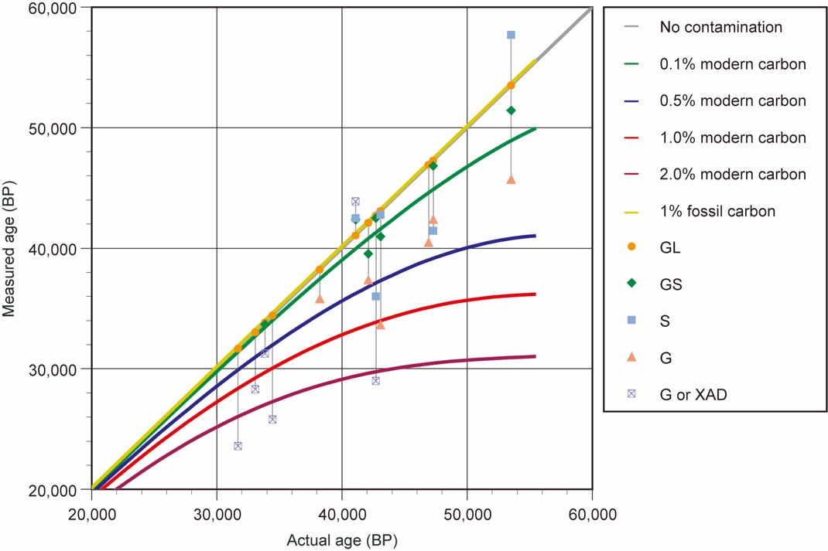
Supplementary Fig. S5. Radiocarbon dates of collagen fractions of Naumann’s elephant. Theoretical curves of modern carbon and fossil carbon are plotted. The radiocarbon dates of each fraction are plotted against the dates of the GL fraction.

3. Materials older than 38 k cal BP
The reported radiocarbon dates older than 38 k cal BP from an existing compiled list^{[7]} were evaluated to estimate the time of the extinction of Naumann’s elephant. The region was restricted to Honshu and Shikoku Islands. The collagen yield should be > 1%^{[3]}, and the C/N ratio within 2.9–3.6^{[2]}. Seven radiocarbon dates were selected (Supplementary Table S4). Because these samples showed older dates than the arrival time of humans, re-dating was not conducted.
A fossil sample salvaged from the Seto Inland Sea off Yamaguchi Prefecture gave 38.3 k BP using the ordinary gelatinization method^{[37]}. The other six samples were the dates of fossils excavated from the Tategahana site of Lake Nojiri in Nagano Prefecture^{[38,39]}. The samples showed radiocarbon dates older than 40.8 k BP. Collagen was also extracted using the gelatinization method. One sample was older than 50 k cal BP and therefore excluded from the statistical analysis.
A total of 16 samples of radiocarbon dates (10 from the GL fraction in this study and the six samples mentioned above) yielded an estimated extinction date of 34.1–32.7 k (median: 33.5 k) cal BP using the CRIWM method. The median was about 500 years older than that of the 10 samples of the GL fraction. The addition of the six samples from previous studies did not show a significant change in the estimated time of the extinction of Naumann’s elephant.

4. Radiocarbon dates of Upper Palaeolithic sites
Curves of the summed probability distributions (SPDs) of radiocarbon dates from archaeological sites can be considered as a proxy of population change through time^{[40,41]}. To evaluate the coexistence of Upper Palaeolithic humans and Naumann’s elephant, radiocarbon dates of charcoal from Upper Palaeolithic sites were compiled. The radiocarbon database of the National Museum of Japanese History was used to collect data^{[42]}. The region was restricted to Paleo-Honshu Island (Honshu, Shikoku, and Kyushu islands), and radiocarbon dates earlier than 20 k BP were selected.
The database includes 494 dates from 100 sites (Supplementary Fig. S6). The data were evaluated using the rcarbon package in R^{[43]}. The IntCal20 calibration curve was used to calculate calibrated dates^{[35]}.
When there are many measured dates at a site, there are misleading peaks in SPDs that are unrelated to population change. This phenomenon was reduced by using a bin that aggregates several dates into one range of dates in the rcarbon calculation^{[43]}. The bins were calculated with a cut-off value (h = 200 years), and the SPDs were consequently plotted from 38 to 24 k cal BP.
The cut-off value of the bin can affect the SPD peaks. This effect was tested with the binsense formula in rcarbon (range: h = 0–500; Supplementary Fig. S7). Particularly, a peak at 28 k cal BP varied with the cut-off value, but the overall SPD trend remained the same throughout the range of the cut-off value.
Next, the SPDs were plotted by the five regions of Tohoku, Kanto, Chubu, Chugoku, and Kyushu (Supplementary Fig. S8). Because only one site was included in the Kinki region, the site was included in the Chugoku region. A lot of early Upper Palaeolithic dates were included in the Kanto, Chubu, and Kyushu regions. Subsequently, the SPD intensities were increased in the Tohoku and Chugoku regions. Overall, the SPD intensities increased through 39–35 k cal BP and then fluctuated through time. The SPDs of 16 Naumann’s elephant samples divided by region were also plotted. The samples from the Ehime Prefecture are included in the Chugoku region. The radiocarbon dates of Naumann’s elephant after the arrival of humans are found in the Tohoku and Chugoku regions. This indicates a spatiotemporal difference between Naumann’s elephant and human activity during 40–35 k cal BP.
A sharp decline in SPD intensity at 31 k cal BP was found in the Kyushu and Chubu regions. After that, the intensity increased in Kyushu and Chubu. The decrease and increase in SPD might be related to the population changes according to the cold climate from MIS3 to MIS2. This time is known as the cold climate of Heinrich event 3 (H3) or the environmental deterioration with the fall of AT tephra^{[44]}.
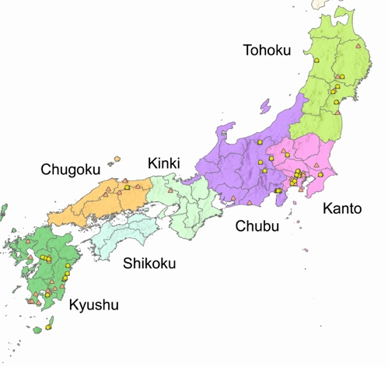
Supplementary Fig. S6. Site locations and regions of Upper Palaeolithic sites plotted using ArcGIS. The base map used the Digital Map (Basic Geospatial Information) of the Geospatial Information Authority of Japan and City-level boundaries of Japan by ESRI ([c] Esri Japan). Yellow circles indicate the sites before 33 k cal BP, and orange triangles indicate the sites after 33 k cal BP.

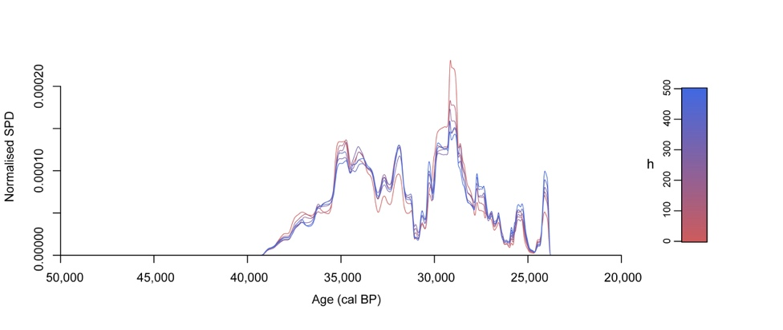
Supplementary Fig. S7. Variation of SPDs with the range of h (0–500) in the binsense function.

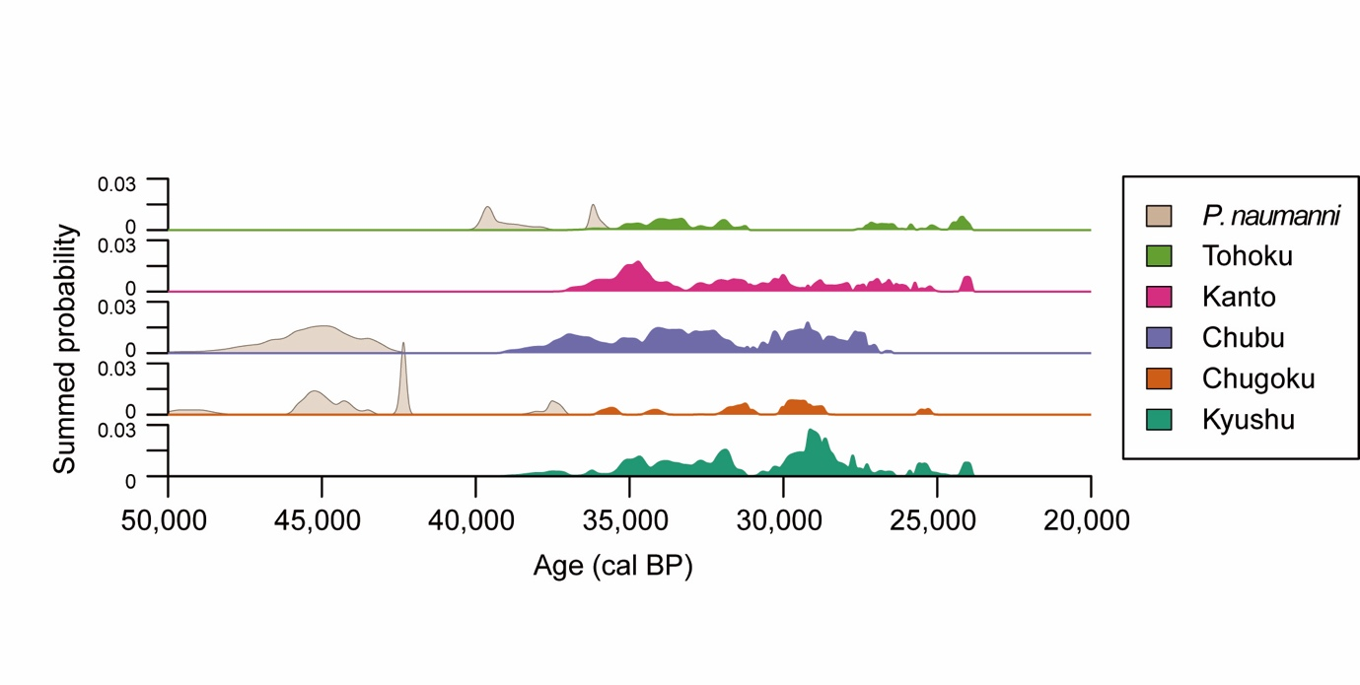
Supplementary Fig. S8. Summed probability distributions (SPDs) of the Upper Palaeolithic sites and 16 Naumann’s elephant samples divided into five regions. The probability of Naumann’s elephant is five times greater than that of the Upper Palaeolithic sites.

5. R code

# read packages
library(readr)
library(rcarbon)
library(Rextinct)

# prepare a csv data of Palaeoloxodon naumanni (ex., dates.csv) in the data folder of the R Project.
fossil <- read_csv("data/dates.csv")

# calcultate calibrated dates
fossil.cal <- rcarbon::calibrate(x = fossil$dates, errors = fossil$error, normalised = FALSE, verbose = FALSE)

# calculate spd
fossil.cal.spd = spd(fossil.cal, timeRange=c(50000,20000))
plot(fossil.cal.spd)

# run criwm
Rextinct::criwm("data/dates.csv")

# Calculation of SPD of dates from archaeological sites
# read the list of radiocarbon dates
list <- read_csv("data/Sites.csv")
list$region <- factor(list$region, levels = c("Kyushu", "Chugoku", "Chubu", "Kanto", "Tohoku"))

# Prepare binned group list (h = 200^{[45]})
cal.bins <- rcarbon::binPrep(sites = list$site, ages = list$dates, h = 200)

# calcultate calibrated list
cal <- rcarbon::calibrate(x = list$dates, errors = list$error, normalised = FALSE, verbose = FALSE)

# calculate binned spd
cal.spd.bins = spd(cal, bins=cal.bins, timeRange=c(50000,20000))

# plot binned spd
plot(cal.spd.bins)

# test the effect of bin
binsense(x=cal,y=list$site,h=seq(0,500,100),timeRange=c(50000,20000))

# plot stacked view
stacked.spd=stackspd(x=cal,group=list$region,timeRange=c(50000,20000),bins=cal.bins,runm=50,verbos=FALSE)
par(mfrow=c(2,1))
plot(stacked.spd,type='stacked')
plot(stacked.spd,type='multipanel')

# run criwm for arrival time
Rextinct::criwm("data/Sites.csv", signor_lipps = "arr")

6. References

1 Longin, R. New method of collagen extraction for radiocarbon dating. Nature 230, 241–242 (1971).
2 DeNiro, M. J. Postmortem preservation and alteration of in vivo bone collagen isotope ratios in relation to palaeodietary reconstruction. Nature 317, 806–809 (1985).
3 van Klinken, G. J. Bone collagen quality indicators for palaeodietary and radiocarbon measurements. J. Archaeol. Sci. 26, 687–695 (1999).
4 Talamo, S., Fewlass, H., Maria, R. & Jaouen, K. “Here we go again”: the inspection of collagen extraction protocols for ¹⁴C dating and palaeodietary analysis. STAR: Sci. Technol. Archaeol. Res. 7, 62–77 (2021).
5 Wood, R. From revolution to convention: the past, present and future of radiocarbon dating. J. Archaeol. Sci. 56, 61–72 (2015).
6 van der Plicht, J. & Palstra, S. W. L. Radiocarbon and mammoth bones: what's in a date. Quat. Int. 406, 246–251 (2016).
7 Iwase, A., Hashizume, J., Izuho, M., Takahashi, K. & Sato, H. Timing of megafaunal extinction in the late Late Pleistocene on the Japanese Archipelago. Quat. Int. 255, 114–124 (2012).
8 Pettitt, P. B., Davies, W., Gamble, C. S. & Richards, M. B. Palaeolithic radiocarbon chronology: quantifying our confidence beyond two half-lives. J. Archaeol. Sci. 30, 1685–1693 (2003).
9 Turvey, S. T., Tong, H., Stuart, A. J. & Lister, A. M. Holocene survival of Late Pleistocene megafauna in China: a critical review of the evidence. Quat. Sci. Rev. 76, 156–166 (2013).
10 Brown, T. A., Nelson, D. E., Vogel, J. S. & Southon, J. R. Improved collagen extraction by modified longin method. Radiocarbon 30, 171–177 (1988).
11 Higham, T. European Middle and Upper Palaeolithic radiocarbon dates are often older than they look: problems with previous dates and some remedies. Antiquity 85, 235–249 (2011).
12 Jacobi, R. M., Higham, T. F. G. & Ramsey, C. B. AMS radiocarbon dating of Middle and Upper Palaeolithic bone in the British Isles: improved reliability using ultrafiltration. J. Quat. Sci. 21, 557–573 (2006).
13 Wood, R. E. et al. Radiocarbon dating casts doubt on the late chronology of the Middle to Upper Palaeolithic transition in southern Iberia. Proc. Natl. Acad. Sci. U.S.A. 110, 2781–2786 (2013).
14 Higham, T. et al. The timing and spatiotemporal patterning of Neanderthal disappearance. Nature 512, 306–309 (2014).
15 Mellars, P. A new radiocarbon revolution and the dispersal of modern humans in Eurasia. Nature 439, 931–935 (2006).
16 Carden, R. F., Higham, T. F. G. & Woodman, P. C. A reconsideration of the radiocarbon dating of the Marine Isotope Stage 3 fauna from southern Ireland. Boreas 49, 674–684 (2020).
17 Deviese, T. et al. Increasing accuracy for the radiocarbon dating of sites occupied by the first Americans. Quat. Sci. Rev. 198, 171–180 (2018).
18 Waters, M. R. et al. Pre-Clovis Mastodon Hunting 13,800 Years Ago at the Manis Site, Washington. Science 334, 351–353 (2011).
19 Herrando-Pérez, S. Bone need not remain an elephant in the room for radiocarbon dating. R. Soc. Open Sci. 8, 201351, 10.1098/rsos.201351 (2021).
20 Marom, A., McCullagh, J. S. O., Higham, T. F. G. & Hedges, R. E. M. Hydroxyproline dating: experiments on the ¹⁴C analysis of contaminated and low-collagen bones. Radiocarbon 55, 698–708 (2013).
21 Zavarzina, A. G., Danchenko, N. N., Demin, V. V., Artemyeva, Z. S. & Kogut, B. M. Humic substances: hypotheses and reality (a review). Eurasian Soil Science 54, 1826–1854 (2021).
22 Minami, M., Sakata, K., Takigami, M., Nagaoka, T. & Nakamura, T. Ultrafiltration pretreatment for ¹⁴C dating of fossil bones from archaeological sites in Japan. Radiocarbon 55, 481–490 (2013).
23 Kepkay, P. E., Niven, S. E. H. & Milligan, T. G. Low molecular weight and colloidal DOC production during a phytoplankton bloom. Mar. Ecol. Prog. Ser. 100, 233–244 (1993).
24 Minami, M., Muto, H. & Nakamura, T. Chemical techniques to extract organic fractions from fossil bones for accurate ¹⁴C dating. Nucl. Instrum. Methods Phys. Res., Sect. B. 223–224, 302–307 (2004).
25 Nakamura, T. et al. AMS ¹⁴C Age of collagen separated from a molar fossil of Naumann’s elephant collected from the Uwa-sea, Ehime prefecture. Sum. Res. AMS Nagoya Univ., 286–297, (in Japanese) (1998).
26 Akiyama, M., Kamei, T. & Nakai, N. ¹⁴C ages of Naumann's elephant Palaeoloxodon naumanni (Makiyama) from the sea bottom off the San'in district in the Sea of Japan by accelerator mass spectrometry (Datum). Earth Sci. 42, 29–31, (in Japanese) (1988).
27 Takahashi, K. Fossils of Naumann’s elephant submerged from the seafloor of Oki islands. Cult. Assets of Oki Isl. 33, 45–53, (in Japanese) (2016).
28 Takahashi, K., Shimaguchi, T. & Kamiya, H. Palaeoloxodon naumanni fossils from Shikkari, Higashi-doori, Shimokita-gun, Aomori Prefecture, Japan and its AMS ¹⁴C dating. J. Fossil Res. 39, 21–27, (in Japanese) (2006).
29 Yasuhara, M. Holocene ostracod palaeobiogeography of the Seto Inland Sea, Japan: impact of opening of the strait. J. Micropalaeontol. 27, 111–116 (2008).
30 Morisaki, K., Izuho, M. & Ferguson, J. R. Non-Destructive energy dispersive X-ray fluorescence sourcing of glassy andesite and basalt artifacts in Upper Paleolithic southwestern Japan: A preliminary assessment. J. Archaeol. Sci. Rep. 57, 104589, 10.1016/j.jasrep.2024.104589 (2024).
31 Brock, F., Ramsey, C. B. & Higham, T. Quality assurance of ultrafiltered bone dating. Radiocarbon 49, 187–192 (2007).
32 Ramsey, C. B., Higham, T., Bowles, A. & Hedges, R. Improvements to the pretreatment of bone at Oxford. Radiocarbon 46, 155–163 (2004).
33 Bard, E. et al. Extended dilation of the radiocarbon time scale between 40,000 and 48,000 y BP and the overlap between Neanderthals and Homo sapiens. Proc. Natl. Acad. Sci. U.S.A. 117, 21005–21007 (2020).
34 Ryan, W. B. F. et al. Global Multi‐Resolution Topography synthesis. Geochem. Geophys. Geosyst. 10, 10.1029/2008gc002332 (2009).
35 Reimer, P. J. et al. The IntCal20 northern hemisphere radiocarbon age calibration curve (0–55 cal kBP). Radiocarbon 62, 725–757 (2020).
36 Stenström, K., Skog, G., Georgiadou, E., Genberg, J. & Mellström, A. A guide to radiocarbon units and calculations. (LUNFD6(NFFR-3111)/1-17/(2011)) (2011).
37 Kitagawa, H. et al. in Abstracts, Annual Meeting, Palaeontol. Soc. Japan (ed. Palaeontol. Soc. Japan) 25, (in Japanese) (Palaeontol. Soc. Japan, 2009).
38 Nakai, N. et al. AMS radiocarbon ages of mammal fossils from Lake Nojiriko, Nagano pref. and environmental changes during the last glacial age. Sum. Res. AMS Nagoya Univ. 2, 26–39 (1991).
39 Sawada, K. et al. ¹⁴C dating of the Nojiri-ko Formation using accelerator mass spectrometry. Earth Sci. 46, 133–142 (1992).
40 Timpson, A. et al. Reconstructing regional population fluctuations in the European Neolithic using radiocarbon dates: a new case-study using an improved method. J. Archaeol. Sci. 52, 549–557 (2014).
41 Crema, E. R., Habu, J., Kobayashi, K. & Madella, M. Summed probability distribution of ¹⁴C dates suggests regional divergences in the population dynamics of the Jomon period in Eastern Japan. PLoS ONE 11, e0154809, 10.1371/journal.pone.0154809 (2016).
42 Kudo, Y., Sakamoto, M. & Hakozaki, M. Approach for creating database of the radiocarbon dates published on the archaeological research reports in Japan. Bull. Natn. Mus. Jap. Hist. 212, 251–266, (in Japanese) (2018).
43 Crema, E. R. & Bevan, A. Inference from large sets of radiocarbon dates: software and methods. Radiocarbon 63, 23–39 (2021).
44 Smith, V. C. et al. Identification and correlation of visible tephras in the Lake Suigetsu SG06 sedimentary archive, Japan: chronostratigraphic markers for synchronising of east Asian/west Pacific palaeoclimatic records across the last 150 ka. Quat. Sci. Rev. 67, 121–137 (2013).
45 Prates, L. & Perez, S. I. Late Pleistocene South American megafaunal extinctions associated with rise of Fishtail points and human population. Nat. Commun. 12, 2175, 10.1038/s41467-021-22506-4 (2021).
46 Minami, M. & Nakamura, T. AMS ¹⁴C age of a Molar fossil of Naumann’s elephant-with XAD-2 resin-. Sum. Res. AMS Nagoya Univ. 10, 139–148, (in Japanese) (1999).

Supplementary Table S1. Results of radiocarbon dating on Naumann’s elephant fossils and dates from previous studies^{[24-28,46]}.
List No. | Species | Site (Prefecture) | Specimen No. | Element | Pretreatment | Col % | C % | N % | C/N | ¹⁴C No. | ¹⁴C age (BP) | Calibrated age (cal BP, 2σ) | Calibrated age (Median) | Ref.
LN-1 | Palaeoloxodon naumanni | Uwa sea (off Natori, Ehime) | - | M3 (Dentine) | GL | 4.4 | 41.9 | 15.1 | 3.2 | PLD-53971 | 41,080±290 | 44600–43300 | 44,100 | This study
 |  |  |  |  | GS | 1.4 | 38.5 | 14.2 | 3.2 | PLD-53972 | 42,340±290 | - | - | This study
 |  |  |  |  | S | 1.1 | 49.7 | 17.8 | 3.3 | PLD-53973 | 42,510±290 | - | - | This study
 |  |  |  |  | XAD | - | 26.4 | - | - | - | 43,870±450 | - | - | [24]
 |  |  |  |  | G | 1.2 | - | - | 3.2 | NUTA-5722 | 29,200±870 | - | - | [25]
 |  |  |  |  | S | 1.5 | - | - | 3.2 | NUTA-5723 | 24,880±580 | - | - | [25]
 |  |  |  |  | XAD | 1.2 | - | - | 3.0 | NUTA-5945 | 27,580±490 | - | - | [46]
LN-2 | Palaeoloxodon naumanni | Japan sea (off Hinomisaki, Shimane) | Kyoto No.2 | Incisor (Dentine) | GL | 14.4 | 41.5 | 15.3 | 3.2 | PLD-53968 | 42,700±300 | 45850–44650 | 45,200 | This study
 |  |  |  |  | GS | 2.3 | 35.4 | 13.0 | 3.2 | PLD-53969 | 42,500±300 | - | - | This study
 |  |  |  |  | S | 1.0 | 37.5 | 13.4 | 3.3 | PLD-53970 | 36,020±180 | - | - | This study
 |  |  |  |  | Without gelatinization | 3.4 | - | - | - | NUTA-477 | 29,000±300 | - | - | [26]
LN-3 | Palaeoloxodon naumanni | Japan sea (off Oki Island, Shimane) | - | M3 (Dentine) | GL | 8.7 | 43.9 | 15.8 | 3.2 | PLD-53974 | 33,060±140 | 38350–37000 | 37,500 | This study
 |  |  |  |  | GS | 0.7 | 32.2 | 11.2 | 3.4 | - | - | - | - | This study
 |  |  |  |  | S | 0.0 | - | - | - | - | - | - | - | This study
 |  |  |  |  | G | - | 3.4 | - | 3.4 | PLD-28663 | 28,290±90 | - | - | [27]
LN-4 | Palaeoloxodon naumanni | Shikkari (Aomori) | AOPM1975-1 | M2 or 3 (Dentine) | GL | 6.3 | 43.8 | 15.5 | 3.3 | PLD-54511 | 33,840±340 | 39650–37650 | 38,800 | This study
 |  |  |  |  | GS | 1.2 | 37.7 | 13.5 | 3.3 | PLD-54512 | 33,670±330 | - | - | This study
 |  |  |  |  | S | 0.3 | 37.8 | 11.0 | 4.0 | - | - | - | - | This study
 |  |  |  |  | G | - | - | - | - | IAAA-52429 | 31,270±160 | - | - | [28]
LN-5 | Palaeoloxodon naumanni | Shikkari (Aomori) | AOPM1975-5 | M2 (Dentine) | GL | 1.0 | 39.4 | 13.8 | 3.3 | PLD-54513 | 31,690±130 | 36350–35650 | 36,050 | This study
 |  |  |  |  | GS | 0.4 | 35.3 | 12.6 | 3.3 | - | - | - | - | This study
 |  |  |  |  | S | 0.2 | 35.2 | 6.2 | 6.6 | - | - | - | - | This study
 |  |  |  |  | G | - | - | - | - | IAAA-52431 | 23,600±130 | - | - | [28]
LN-6 | Palaeoloxodon naumanni | Shikkari (Aomori) | AOPM1975-7 | M2 or 3 (Dentine) | GL | 3.8 | 43.0 | 15.3 | 3.3 | PLD-54514 | 34,440±160 | 39950–39250 | 39,600 | This study
 |  |  |  |  | GS | 0.6 | 38.0 | 12.6 | 3.5 | - | - | - | - | This study
 |  |  |  |  | S | 0.1 | - | - | - | - | - | - | - | This study
 |  |  |  |  | G | - | - | - | - | IAAA-52430 | 25,780±120 | - | - | [28]

Supplementary Table S2. Results of radiocarbon dating of Naumann’s elephant fossils salvaged from the Seto Inland Sea near Imabari City, Ehime Prefecture.
Sample No. | Species | Element | Pretreatment | Col % | C % | N % | C/N | ¹⁴C No. | ¹⁴C age (BP) | Calibrated age (cal BP, 2σ) | Calibrated age (Median)
U030 | Palaeoloxodon naumanni | Mandible | GL | 2.1 | 40.9 | 14.4 | 3.3 | PLD-50669 | 53,510±880 | 55,550–51,850* | 53,600*
 |  |  | GS | 1.7 | 38.6 | 13.8 | 3.3 | PLD-50670 | 51,420±700 | - | -
 |  |  | S | 3.5 | 43.3 | 16.6 | 3.1 | PLD-50671 | 57,700±1390 | - | -
 |  |  | G | 5.1 | 47.1 | 16.6 | 3.3 | PLD-54857 | 45,750±700 | - | -
U011 | Palaeoloxodon naumanni | Tibia (proximal) | GL | 1.8 | 38.3 | 15.5 | 2.9 | PLD-49293 | 47,270±900 | 54,850–47,800* | 50,050*
 |  |  | GS | 1.3 | 29.7 | 12.4 | 2.9 | PLD-49294 | 46,820±830 | - | -
 |  |  | S | 2.0 | 42.7 | 18.3 | 2.7 | PLD-49292 | 41,440±460 | - | -
 |  |  | G | 6.5 | 42.8 | 16.5 | 3.0 | PLD-49295 | 42,420±500 | - | -
U048 | Palaeoloxodon naumanni | Radius | GL | 3.9 | 41.8 | 16.5 | 3.0 | PLD-50676 | 46,920±450 | 51,350–48,000 | 49,350
 |  |  | GS | 1.4 | 35.2 | 12.7 | 3.2 | - | - | - | -
 |  |  | S | 1.2 | 42.9 | 15.6 | 3.2 | - | - | - | -
 |  |  | G | 6.9 | 43.8 | 15.4 | 3.3 | PLD-54858 | 40,510±390 | - | -
U055 | Palaeoloxodon naumanni | Atlas | GL | 1.8 | 40.1 | 16.0 | 3.0 | PLD-50673 | 43,070±320 | 46,050–44,850 | 45,500
 |  |  | GS | 1.1 | 29.3 | 11.0 | 3.1 | PLD-50674 | 40,970±270 | - | -
 |  |  | S | 0.7 | 41.0 | 15.4 | 3.1 | PLD-50675 | 42,760±280 | - | -
 |  |  | G | 2.9 | 42.2 | 14.4 | 3.4 | PLD-54859 | 33,690±200 | - | -
U019 | Palaeoloxodon naumanni | M3 (Dentine) | GL | 0.5 | 35.1 | 11.6 | 3.5 | PLD-49296 | 42,110±500 | 45,750–44,200 | 44,850
 |  |  | GS | 0.3 | 23.8 | 8.5 | 3.3 | PLD-49297 | 39,530±390 | - | -
 |  |  | S | 0.2 | 35.8 | 9.8 | 4.3 | - | - | - | -
 |  |  | G | 1.3 | 33.8 | 11.5 | 3.4 | PLD-49298 | 37,390±290 | - | -
U038 | Palaeoloxodon naumanni | Bone fragment | GL | 2.0 | 41.2 | 14.6 | 3.3 | PLD-50672 | 38,230±210 | 42,550–42,150 | 42,350
 |  |  | GS | 1.0 | 38.1 | 15.4 | 2.9 | - | - | - | -
 |  |  | S | 0.2 | 39.3 | 13.1 | 3.5 | - | - | - | -
 |  |  | G | 1.5 | 38.3 | 14.2 | 3.1 | PLD-56659 | 35,850±170 | - | -
*Out of the range of calibration curve.

Supplementary Table S3. Results of collagen extraction of Naumann’s elephant fossils salvaged from the Seto Inland Sea near Imabari City, Ehime Prefecture.
Sample No. | Species | Element | Collagen yield* (%)
U001 | Palaeoloxodon naumanni | molar dentine | 0.1
U008 | Palaeoloxodon naumanni | incisor dentine | 0.0
U009 | Palaeoloxodon naumanni | incisor dentine | 0.3
U010 | Palaeoloxodon naumanni | femur bone | 0.1
U014 | Palaeoloxodon naumanni | limb bone | 0.1
U020 | Palaeoloxodon naumanni | incisor dentine | 0.2
U032 | Palaeoloxodon naumanni | incisor dentine | 0.1
U039 | Palaeoloxodon naumanni | humerus bone | 0.5
U042 | Palaeoloxodon naumanni | molar dentine | 0.1
U043 | Palaeoloxodon naumanni | mandibular bone | 0.0
U044 | Palaeoloxodon naumanni | rib bone | 0.1
U046 | Palaeoloxodon naumanni | molar dentine | 0.0
U047 | Palaeoloxodon naumanni | humerus bone | 0.7
U049 | Palaeoloxodon naumanni | rib bone | 0.0
U077 | Palaeoloxodon naumanni | molar dentine | 0.1
*Total of GL, GS and S in ultrafiltration method.

Supplementary Table S4. Radiocarbon dates of Naumann’s elephant fossils older than 38 k cal BP^{[37-39]}.
List No. | Species | Site | Prefecture | Element | Pretreatment | Col % | C/N | ¹⁴C No. | ¹⁴C age (BP) | Calibrated age (cal BP, 2σ, from) | Calibrated age (cal BP, 2σ, to) | Calibrated age (Median) | Ref.
LN-7 | Palaeoloxodon naumanni | The Inland Sea (Off Islands of Towa machi) | Yamaguchi | Molar | G | 1.9 | 3.0 | PLD-8999 | 38280±260 | 42600 | 42150 | 42350 | [37]
LN-8 | Palaeoloxodon naumanni | Lake Nojiri | Nagano | Molar | G | 2.5 | 3.6 | NUTA-1280 | 40770±1200 | 46050 | 42450 | 43950 | [38]
LN-9 | Palaeoloxodon naumanni | Lake Nojiri | Nagano | Molar | G | 1.4 | 3.5 | NUTA-1282 | 41520±1020 | 46250 | 42850 | 44450 | [38]
LN-10 | Palaeoloxodon naumanni | Lake Nojiri | Nagano | Molar | G | 4.2 | 3.4 | NUTA-1283 | 42520±990 | 47500 | 43400 | 45300 | [38]
LN-11 | Palaeoloxodon naumanni | Lake Nojiri | Nagano | Molar | G | 2.2 | 3.5 | NUTA-1268 | 43310±1200 | 48850 | 44100 | 46000 | [38]
LN-12 | Palaeoloxodon naumanni | Lake Nojiri | Nagano | Molar | G | 2.9 | 3.5 | NUTA-1279 | 45810±1290 | 54350* | 45700* | 48550* | [38]
LN-13 | Palaeoloxodon naumanni | Lake Nojiri | Nagano | Molar | G | ＜3.5 | 3.5 | – | 43520±1340 | 49850 | 44150 | 46300 | [39]
*Out of the range of calibration curve.

