Optimal Post-Transfusion Hemoglobin Targets in Critically Ill Patients: A Machine Learning–Based Causal Inference Analysis

Min Woo Kang, Soojeong Yun, Seung Min Song, Ji Eun Kim, Hyo Jin Kim, Eun Jung Cho, Gang Jee Ko, Young Joo Kwon, and Shin Young Ahn

Supplementary Table S1-5
Supplementary Figure S1-5
Supplementary Table S1. Missing values in Medical Information Mart for Intensive Care-IV
Variable | Missing proportion (%)
Protein | 96.66
CRP | 96.55
Height | 47.01
Albumin | 46.90
ALT | 29.54
AST | 28.49
Total bilirubin | 27.82
pH | 18.52
Lactate | 17.17
Weight | 11.48
aPTT | 4.77
PT INR | 4.39
Temperature | 1.35
Calcium | 0.38
SpO₂ | 0.27
SBP | 0.11
DBP | 0.05
WBC | 0.05
Platelet | 0.05
Bicarbonate | 0.03
eGFR | 0.03
Heart rate | 0.03
Anion gap | 0.03
Sodium | 0.03
Potassium | 0.03
Creatinine | 0.03
Abbreviation: CRP, C-reactive protein; ALT, alanine aminotransferase; AST, aspartate aminotransferase; aPTT, activated partial thromboplastin time; PT INR, prothrombin time international normalized ratio; SpO₂, saturation of peripheral oxygen; SBP, systolic blood pressure; DBP diastolic blood pressure; WBC, white blood cell; eGFR, estimated glomerular filtration rate.

Supplementary Table S2. Missing values in eICU
Variable | Missing proportion (%)
CRP | 97.16
Temperature | 87.43
SBP | 64.19
DBP | 64.02
Average DBP | 63.47
Average SBP | 63.42
Lactate | 48.12
pH | 43.08
aPTT | 35.03
Total bilirubin | 28.35
ALT | 25.9
Protein | 25.83
AST | 24.84
Albumin | 21.85
PT INR | 17.8
Antion gap | 4.11
Bicarbonate | 3.71
Weight | 3.24
eGFR | 3.22
Baseline eGFR | 3.12
Age | 2.90
SpO₂ | 2.42
Calcium | 1.48
Heart rate | 0.93
Platelet | 0.91
Height | 0.85
WBC | 0.34
Creatinine | 0.32
BUN | 0.32
Chloride | 0.21
Baseline creatinine | 0.21
Sodium | 0.15
Potassium | 0.11
Abbreviation: CRP, C-reactive protein; SBP, systolic blood pressure; DBP diastolic blood pressure; aPTT, activated partial thromboplastin time; ALT, alanine aminotransferase; AST, aspartate aminotransferase; PT INR, prothrombin time international normalized ratio; eGFR, estimated glomerular filtration rate; SpO₂, saturation of peripheral oxygen; WBC, white blood cell; BUN, blood urea nitrogen.

Supplementary Table S3. Complete list of baseline covariates, definitions, and summary methods
Variable | Definition | Unit | Summary
Demographic characteristics
Age | Age at ICU admission | Years | —
Sex | Biological sex | Male/Female | —
Weight | Body weight at admission | kg | —
Height | Body height at admission | cm | —
Vital signs (first 24 hours)
Heart rate | Maximum heart rate | beats/min | Maximum
SBP | Minimum systolic blood pressure | mmHg | Minimum
DBP | Minimum diastolic blood pressure | mmHg | Minimum
Average SBP | 24-hour average systolic blood pressure | mmHg | —
Average DBP | 24-hour average diastolic blood pressure | mmHg | —
Temperature | Maximum body temperature | °C | Maximum
SpO₂ | Minimum peripheral oxygen saturation | % | Minimum
Respiratory support
Mechanical ventilation | Use of invasive mechanical ventilation | Yes/No | —
FiO₂ | Maximum fraction of inspired oxygen | % | Maximum
Laboratory measurements (first 24 hours)
Initial hemoglobin | Nadir pre-transfusion hemoglobin within 24 h of ICU admission | g/dL | Minimum
Creatinine | Maximum serum creatinine | mg/dL | Maximum
eGFR | Minimum estimated glomerular filtration rate (CKD-EPI equation) | mL/min/1.73 m² | Minimum
Baseline creatinine | Lowest creatinine within 6 months pre-ICU (or initial ICU value if unavailable) | mg/dL | —
Baseline eGFR | eGFR derived from baseline creatinine | mL/min/1.73 m² | —
AST | Maximum aspartate aminotransferase | U/L | Maximum
ALT | Maximum alanine aminotransferase | U/L | Maximum
Total bilirubin | Maximum total bilirubin | mg/dL | Maximum
WBC | Maximum white blood cell count | 10³/µL | Maximum
Platelet | Minimum platelet count | 10³/µL | Minimum
Calcium | Maximum serum calcium | mg/dL | Maximum
pH | Minimum arterial pH | — | Minimum
Bicarbonate | Minimum serum bicarbonate | mmol/L | Minimum
Anion gap | Maximum anion gap | mmol/L | Maximum
BUN | Maximum blood urea nitrogen | mg/dL | Maximum
Sodium | Minimum serum sodium | mmol/L | Minimum
Potassium | Maximum serum potassium | mmol/L | Maximum
Chloride | Minimum serum chloride | mmol/L | Minimum
PT–INR | Maximum prothrombin time–international normalized ratio | — | Maximum
aPTT | Maximum activated partial thromboplastin time | sec | Maximum
Lactate | Maximum serum lactate | mmol/L | Maximum
Vasoactive and inotropic agents (first 24 hours)
Norepinephrine | Maximum infusion rate | mcg/kg/min | Maximum
Dopamine | Maximum infusion rate | mcg/kg/min | Maximum
Epinephrine | Maximum infusion rate | mcg/kg/min | Maximum
Vasopressin | Maximum infusion rate | units/hr | Maximum
Dobutamine | Maximum infusion rate | mcg/kg/min | Maximum
Comorbidities (ICD-9/10 codes)
CKD | Chronic kidney disease | Yes/No | —
ESKD | End-stage kidney disease | Yes/No | —
MI | Myocardial infarction | Yes/No | —
CHF | Congestive heart failure | Yes/No | —
PVD | Peripheral vascular disease | Yes/No | —
CVD | Cerebrovascular disease | Yes/No | —
Hypertension | Hypertension | Yes/No | —
Diabetes | Diabetes mellitus | Yes/No | —
Chronic liver disease | Chronic liver disease | Yes/No | —
Other
Non-cardiac surgery | Receipt of non-cardiac surgery within 3 days of ICU admission | Yes/No | —
RRT | Renal replacement therapy within 48 hours | Yes/No | —
Abbreviations: ICU, intensive care unit; SBP, systolic blood pressure; DBP, diastolic blood pressure; SpO₂, peripheral oxygen saturation; FiO₂, fraction of inspired oxygen; eGFR, estimated glomerular filtration rate; CKD-EPI, Chronic Kidney Disease Epidemiology Collaboration; AST, aspartate aminotransferase; ALT, alanine aminotransferase; WBC, white blood cell; BUN, blood urea nitrogen; PT–INR, prothrombin time–international normalized ratio; aPTT, activated partial thromboplastin time; CKD, chronic kidney disease; ESKD, end-stage kidney disease; MI, myocardial infarction; CHF, congestive heart failure; PVD, peripheral vascular disease; CVD, cerebrovascular disease; RRT, renal replacement therapy; ICD, International Classification of Diseases.

Supplementary Table S4. Baseline characteristics of train and test data
Variable | Train  (N = 3339) | Test  (N = 371) | p-value
Age (years) | 63.76 ± 15.43 | 62.97 ± 16.07 | 0.355
Weight (kg) | 77.60 ± 19.63 | 77.42 ± 22.42 | 0.868
Heart rate (beats/min) | 113.94 ± 21.63 | 115.33 ± 22.08 | 0.242
SBP (mmHg) | 82.69 ± 15.44 | 83.16 ± 15.36 | 0.58
DBP (mmHg) | 40.42 ± 9.94 | 40.08 ± 9.95 | 0.531
Temperature (°C) | 37.57 ± 0.75 | 37.63 ± 0.79 | 0.161
SpO₂ (%) | 89.70 ± 7.42 | 89.61 ± 6.91 | 0.824
Average SBP (mmHg) | 114.09 ± 15.33 | 114.67 ± 15.04 | 0.488
Average DBP (mmHg) | 59.55 ± 9.85 | 59.60 ± 10.36 | 0.923
FiO₂ (%) | 53.97 ± 30.90 | 57.53 ± 31.04 | 0.035
WBC (10³/µL) | 15.64 ± 16.16 | 16.13 ± 10.76 | 0.569
Initial hemoglobin (g/dL) | 6.80 ± 0.80 | 6.85 ± 0.74 | 0.297
Platele (10³/µL) | 165.34 ± 125.66 | 173.77 ± 126.10 | 0.220
ALT (U/L) | 138.19 ± 460.47 | 149.62 ± 670.45 | 0.667
AST (U/L) | 249.27 ± 894.70 | 320.30 ± 1914.33 | 0.213
Total bilirubin (mg/dL) | 2.92 ± 6.05 | 2.98 ± 5.67 | 0.871
Calcium (mg/dL) | 8.57 ± 1.11 | 8.49 ± 1.12 | 0.219
pH | 7.32 ± 0.11 | 7.31 ± 0.10 | 0.549
Bicarbonate (mmol/L) | 20.22 ± 5.10 | 20.45 ± 4.86 | 0.390
Anion gap (mmol/L) | 17.09 ± 5.35 | 16.96 ± 4.86 | 0.649
BUN (mg/dL) | 41.01 ± 30.23 | 40.36 ± 29.51 | 0.694
Creatinine (mg/dL) | 2.13 ± 2.18 | 2.09 ± 2.22 | 0.754
Sodium (mmol/L) | 135.73 ± 5.89 | 135.58 ± 5.81 | 0.657
Potassium (mmol/L) | 4.70 ± 0.84 | 4.70 ± 0.75 | 0.910
Chloride (mmol/L) | 101.17 ± 7.18 | 101.08 ± 7.00 | 0.818
PT INR | 1.87 ± 1.15 | 1.85 ± 1.21 | 0.84
aPTT (sec) | 51.03 ± 33.83 | 50.96 ± 35.00 | 0.968
Lactate (mmol/L) | 3.06 ± 2.71 | 3.26 ± 2.77 | 0.188
Baseline creatinine (mg/dL) | 1.71 ± 1.97 | 1.65 ± 1.83 | 0.535
eGFR (mL/min/1.73 m²) | 55.20 ± 35.26 | 55.21 ± 35.13 | 0.997
Baseline eGFR (mL/min/1.73 m²) | 67.22 ± 37.73 | 65.72 ± 36.44 | 0.464
Norepinephrine (mcg/kg/min) | 0.05 ± 0.15 | 0.04 ± 0.10 | 0.413
Dopamine (mcg/kg/min) | 0.16 ± 1.29 | 0.38 ± 2.28 | 0.005
Epinephrine (mcg/kg/min) | 0.00 ± 0.05 | 0.00 ± 0.05 | 0.732
Vasopressin (units/hr) | 0.27 ± 0.84 | 0.29 ± 0.78 | 0.659
Dobutamine (mcg/kg/min) | 0.05 ± 0.49 | 0.05 ± 0.42 | 0.869
Target hemoglobin (g/dL) | 8.96 ± 1.26 | 9.14 ± 1.38 | 0.012
Male | 1773 (53.1%) | 174 (46.9%) | >0.999
RRT within 48 hours | 80 (2.4%) | 8 (2.2%) | >0.999
Mechanical ventilation | 1829 (54.8%) | 229 (61.7%) | >0.999
Chronic kidney disease | 774 (23.2%) | 88 (23.7%) | >0.999
End-stage kidney disease | 277 (8.3%) | 32 (8.6%) | >0.999
Myocardial infarction | 585 (17.5%) | 71 (19.1%) | >0.999
Congestive heart failure | 1073 (32.1%) | 114 (30.7%) | >0.999
Peripheral vascular disease | 512 (15.3%) | 67 (18.1%) | >0.999
Cerebrovascular disease | 401 (12.0%) | 52 (14.0%) | >0.999
Chronic liver disease | 883 (26.4%) | 104 (28.0%) | >0.999
Diabetes | 1118 (33.5%) | 117 (31.5%) | >0.999
Hypertension | 1445 (43.3%) | 164 (44.2%) | >0.999
Non-cardiac surgery | 480 (14.4%) | 63 (17.0%) | >0.999
In-hospital mortality | 602 (18.0%) | 67 (18.1%) | >0.999
Abbreviation: SBP, systolic blood pressure; DBP diastolic blood pressure; SpO₂, saturation of peripheral oxygen; FiO₂, fraction of inspired oxygen; WBC, white blood cell; ALT, alanine aminotransferase; AST, aspartate aminotransferase; BUN, blood urea nitrogen; PT INR, prothrombin time international normalized ratio; aPTT, activated partial thromboplastin time; eGFR, estimated glomerular filtration rate; RRT, renal replacement therapy.

Supplementary Table S5. Model performance metrics in test and external validation data
Metric | Test | External validation
NN-PEHE | 0.5134 | 0.4752
AUROC | 0.7667 | 0.7655
Accuracy | 0.8329 | 0.8813
Brier score | 0.1249 | 0.0954
Abbreviation: NN-PEHE, nearest‐neighbor precision in estimating heterogeneous effects; AUROC, area under the receiver operating characteristic curve.
Supplementary Figure S1. Flow diagram of patient selection and study design

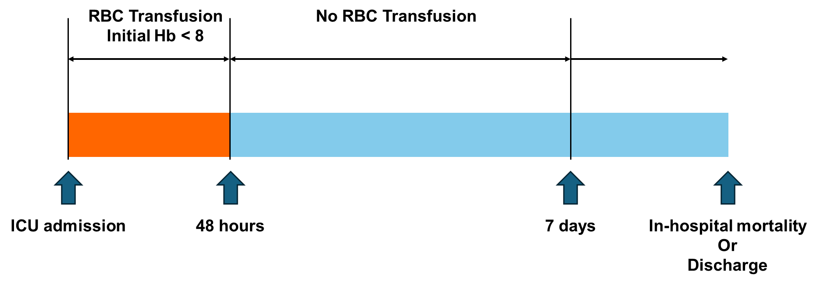
Supplementary Figure S2. Directed acyclic graph illustrating the assumed causal structure and potential for post-treatment bias. BP, blood pressure.
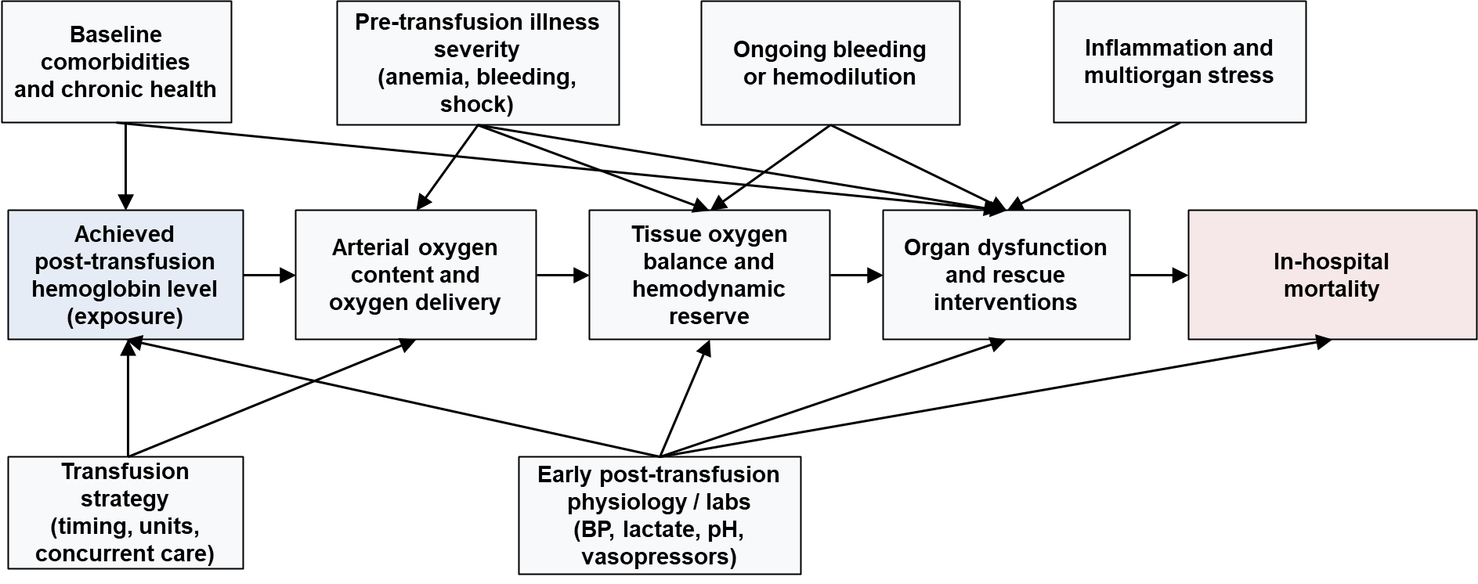

Supplementary Figure S3. Treatment-effect curves for post-transfusion hemoglobin re-centered on the individualized optimal hemoglobin level, with 95% confidence intervals. Hb, hemoglobin.
(A) Train data
(B) Internal validation
(C) External validation
Supplementary Figure S4. Average treatment effect curves for post-transfusion hemoglobin targets stratified by comorbidity and initial hemoglobin strata. Hb, hemoglobin; CKD, chronic kidney disease; ESKD, end-stage kidney disease; MI, myocardial infarction; CHF, congestive heart failure; HTN, hypertension; (A), Chronic kidney disease. (B), End-stage kidney disease. (C), Initial hemoglobin. (D), Myocardial infarction. (E), Congestive heart failure. (F), Hypertension. (G), Diabetes.
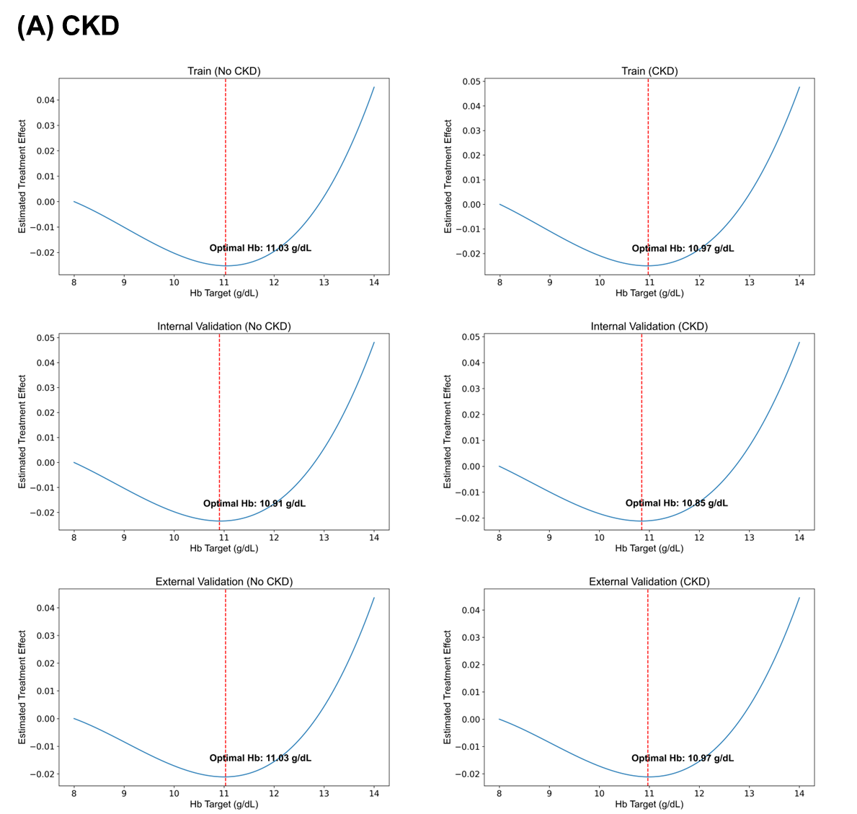
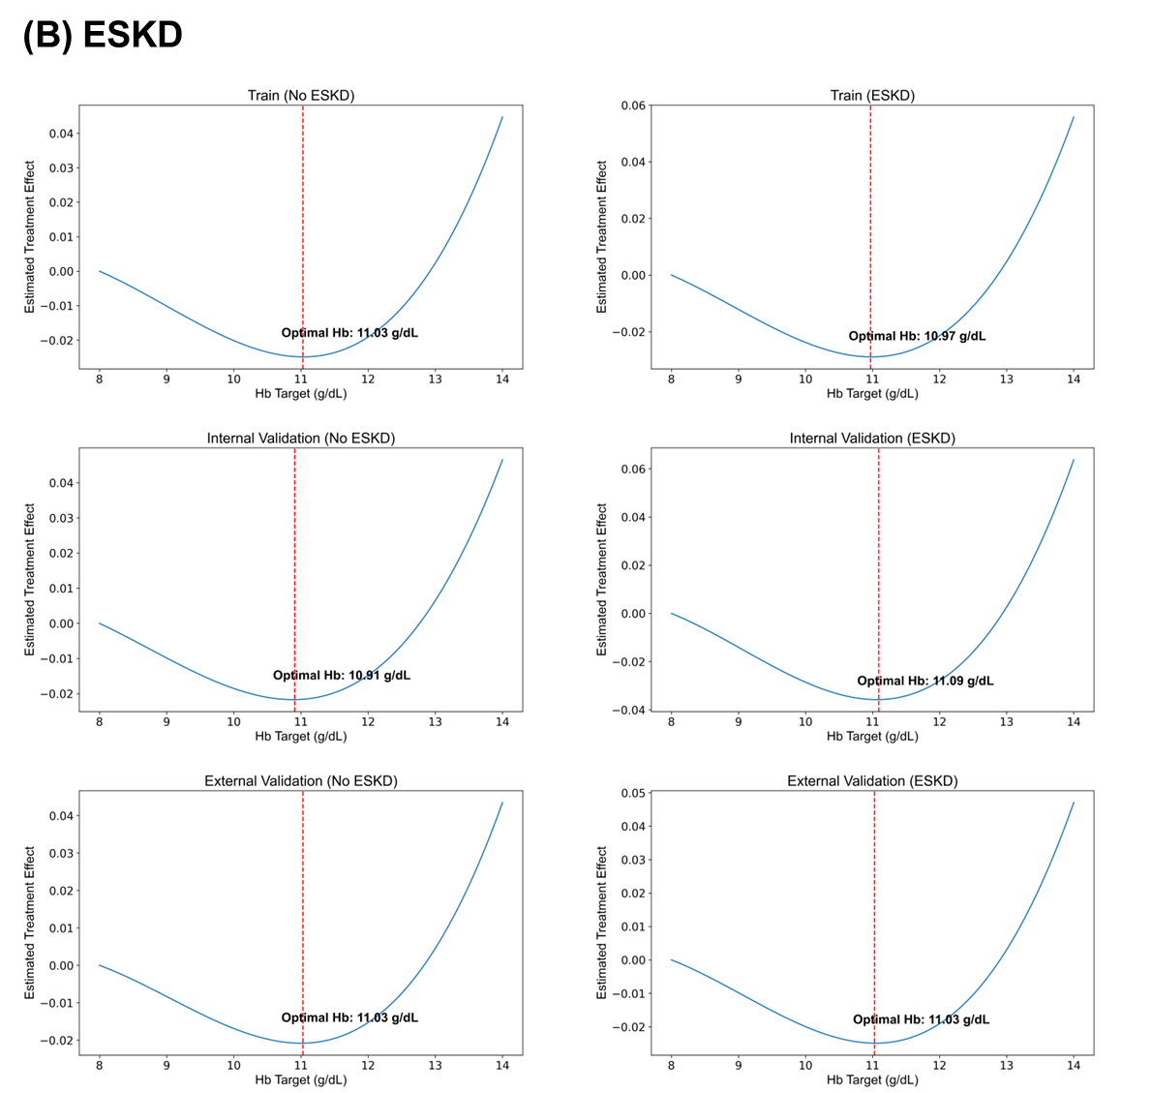
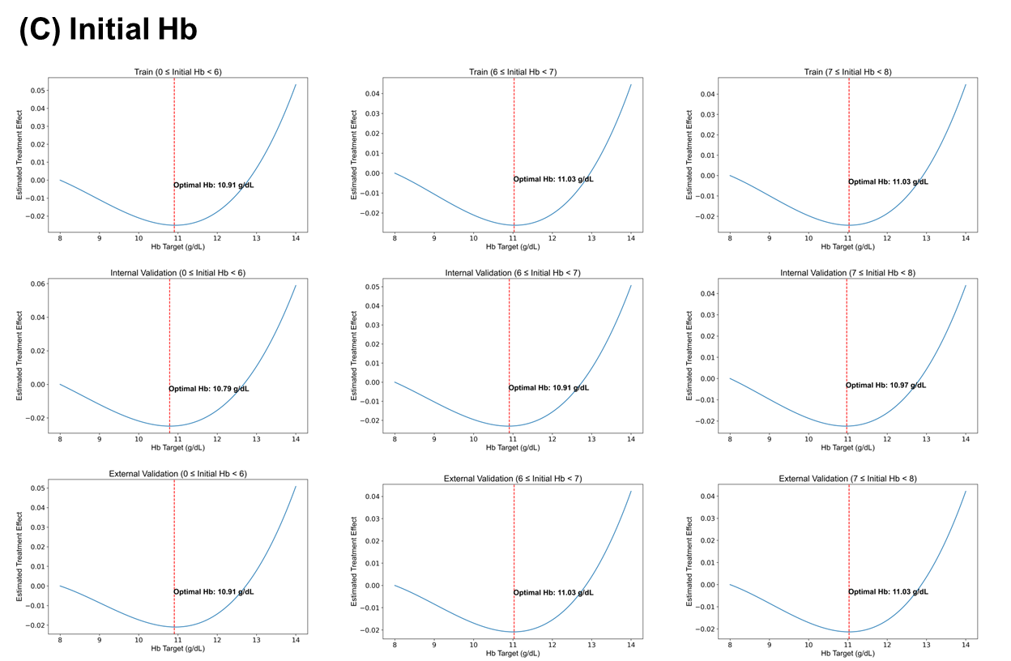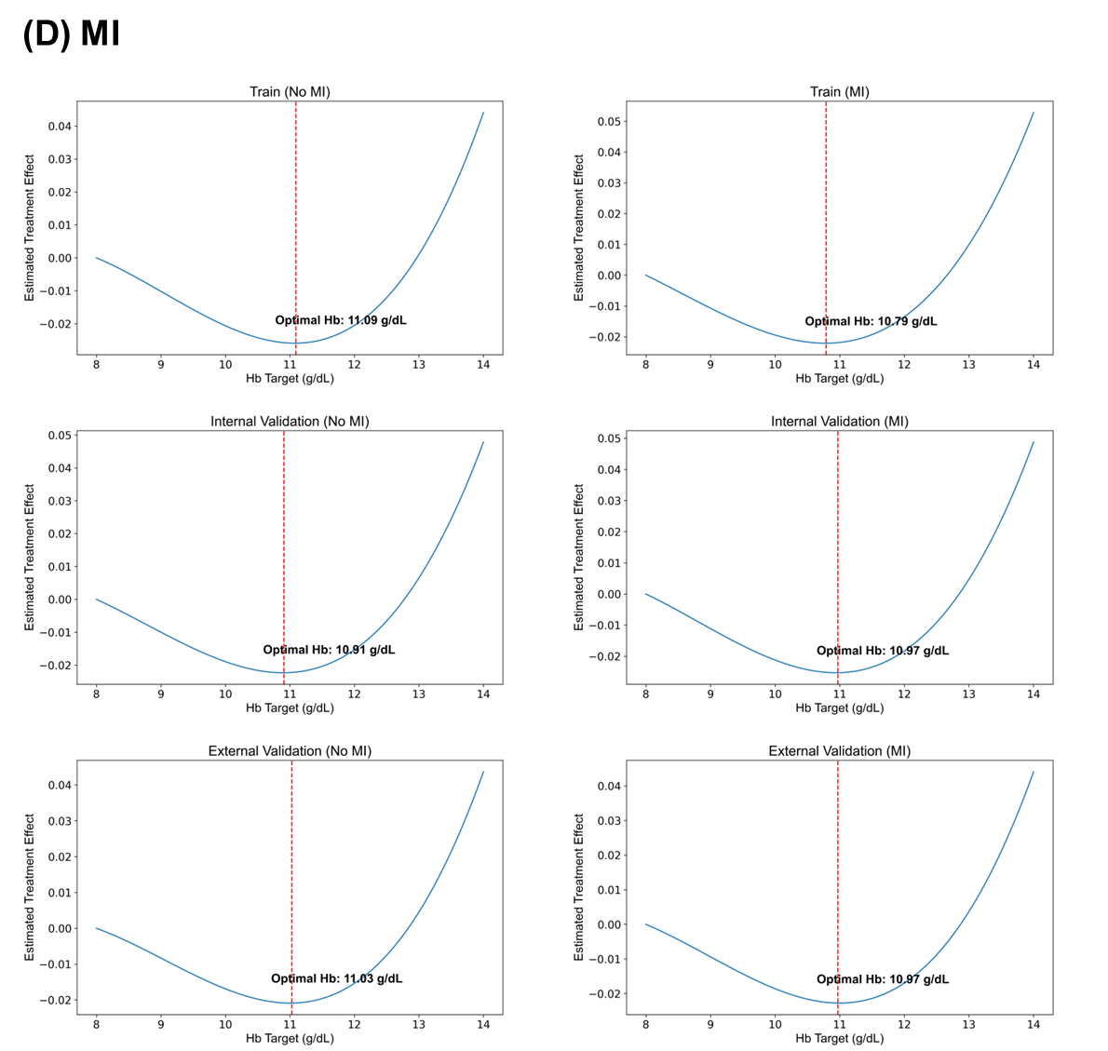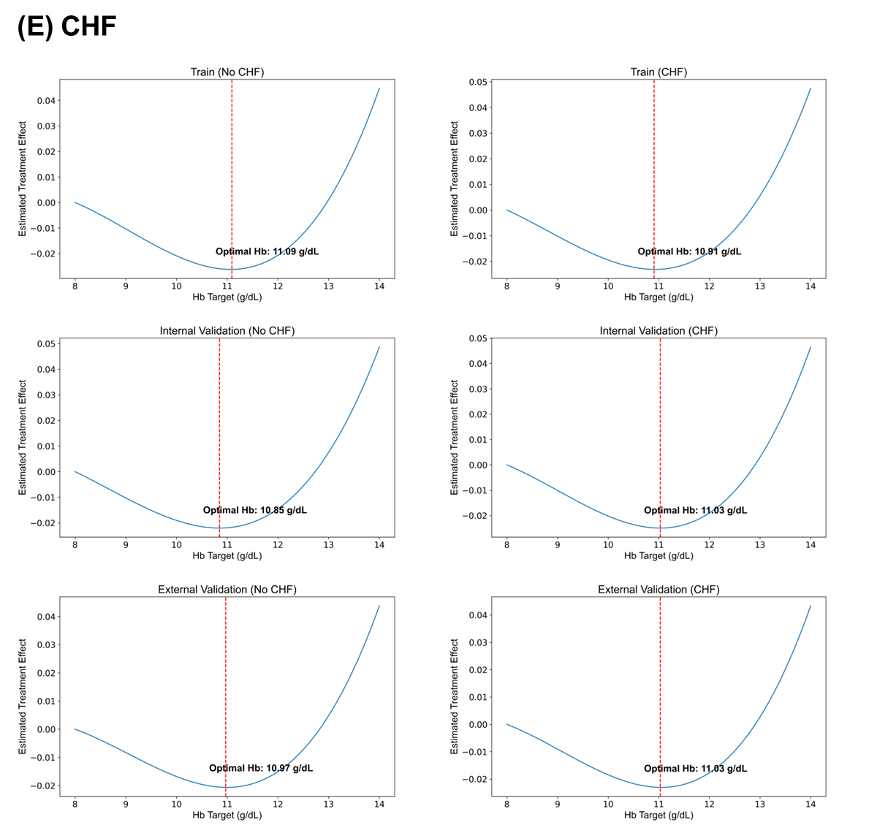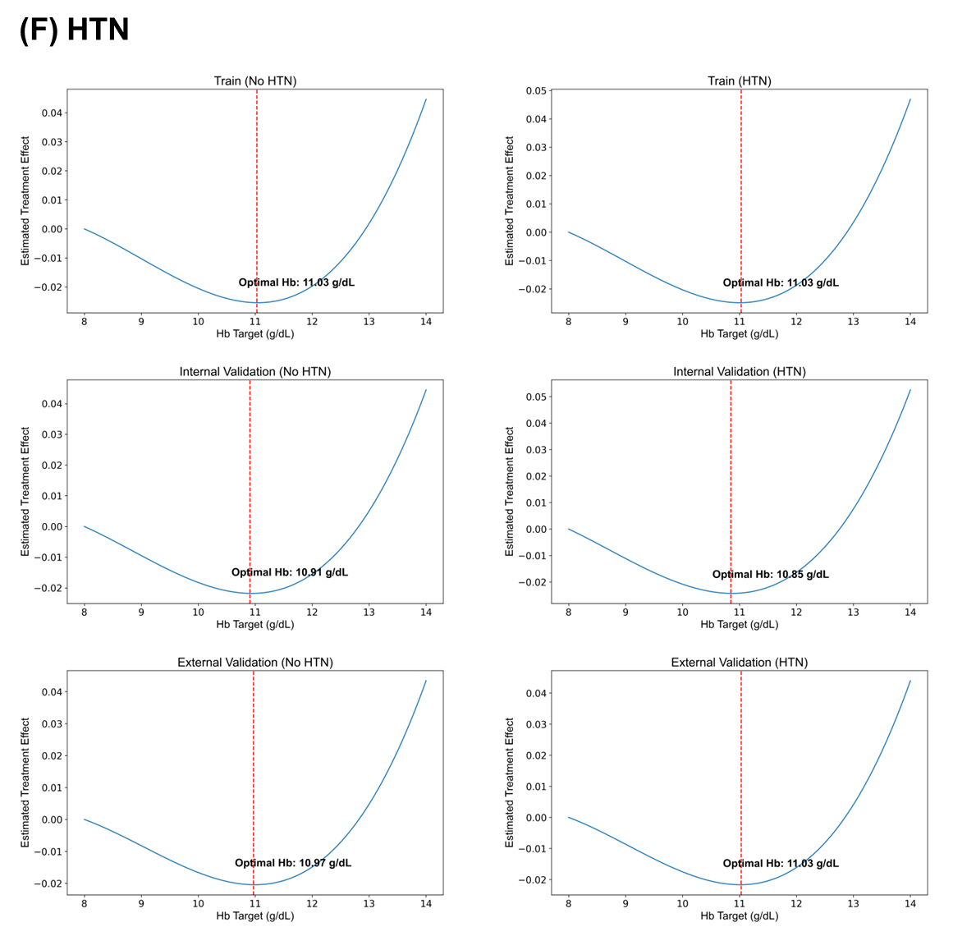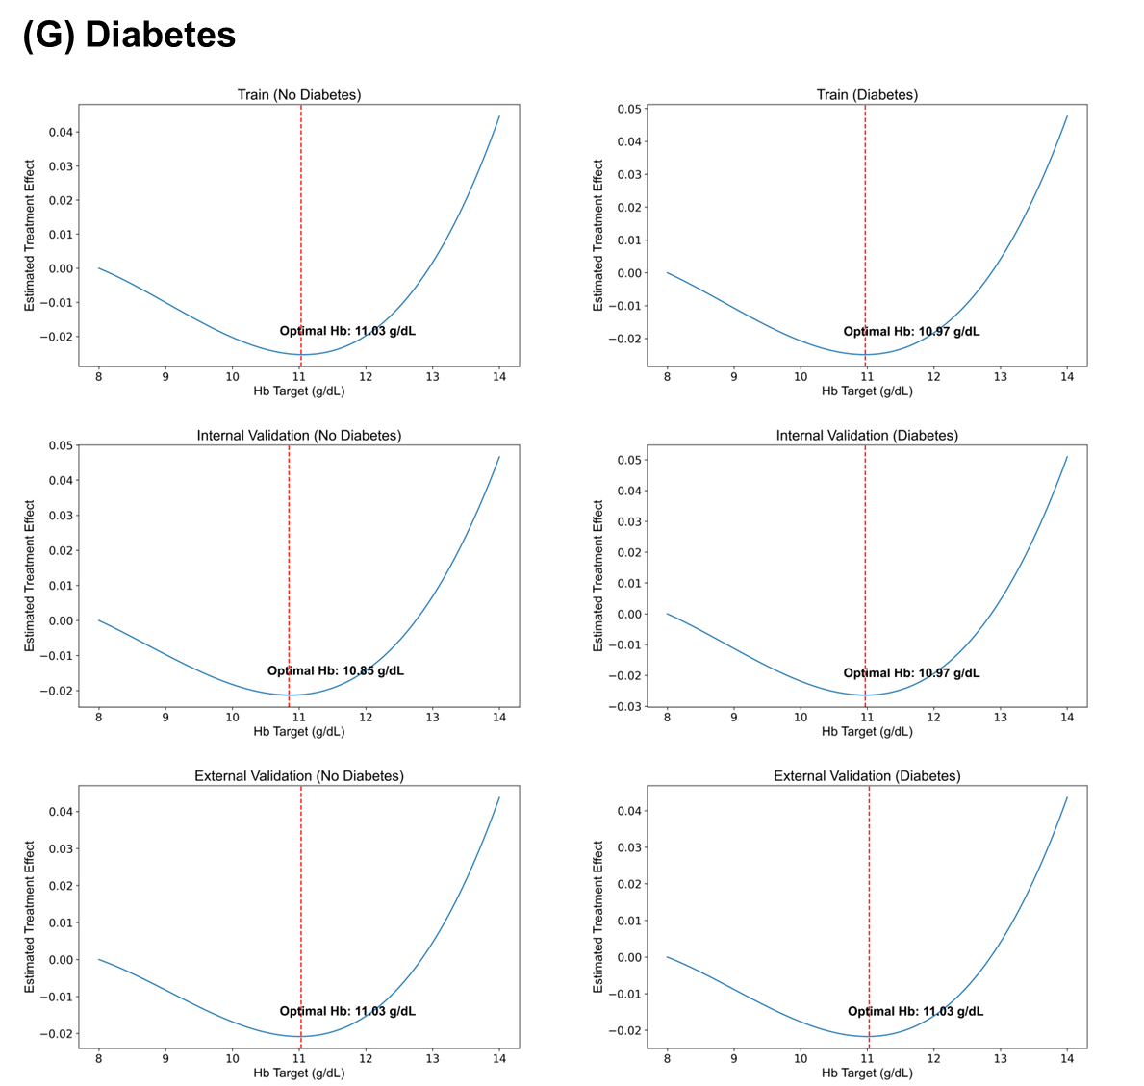
Supplementary Figure S5. Forest plot of multivariable logistic regression predicting individualized optimal hemoglobin targets below 10 g/dL. SBP, systolic blood pressure; DBP diastolic blood pressure; SpO₂, saturation of peripheral oxygen; FiO₂, fraction of inspired oxygen; RRT, renal replacement therapy; WBC, white blood cell; ALT, alanine aminotransferase; AST, aspartate aminotransferase; BUN, blood urea nitrogen; PT INR, prothrombin time international normalized ratio; aPTT, activated partial thromboplastin time; eGFR, estimated glomerular filtration rate; CKD, chronic kidney disease; ESKD, end-stage kidney disease.
(A) Train data

(B) Internal validation
(C) External validation data

