Tailoring Copper Content in High-Entropy Oxides for Enhanced Water Oxidation Catalysis
Seyedsaeed Mehrabi-Kalajahi*¹, Seyed Amir Hossein Vasigh¹, Hassan Yousefi Bavili², Behrouz Shaabani*¹, Maryam Badri¹, Shadab Akbarpour¹, Sama Maghoul¹, Alexei Vagov³, Ahmad Ostovari Moghaddam³, Mikhail A. Varfolomeev⁴
¹Faculty of Chemistry, Department of Inorganic Chemistry, University of Tabriz, Tabriz, Iran
²Department of Chemical & Biomolecular Engineering, University of Houston, Houston, TX, 77204, USA
³HSE University, 101000 Moscow, Russia
⁴Department of Petroleum Engineering, Kazan Federal University, Kazan 420008, Russia
*Corresponding authors
*(S.Mehrabi-Kalajahi) E-mail:ss.mehrabikalajahi@gmail.com
*(B. Shaabani) E-mail: shaabani.b@gmail.com, shaabani@tabrizu.ac.ir

AFM Instrumentation
Surface topography measurements were performed using a BIRISK model Atomic Force Microscope, developed by Ara Pajouhesh Company (Iran).
AFM Analysis of HEO‒Cu 40%
Atomic Force Microscopy (AFM) was employed to analyze the surface topography of HEO‒Cu 40%. The AFM data, collected in tapping mode over a 5 µm × 5 µm scan area, revealed a heterogeneous surface with notable roughness and dispersed nanoscale features. The 2D and 3D topographic images show numerous protrusions distributed across the surface, with a maximum height variation of approximately 38.1 nm, as indicated by the polynomial fit. These surface features are likely associated with crystalline domains, secondary phases, or copper-rich agglomerates formed during synthesis. A cross-sectional profile along the X-direction indicates height fluctuations exceeding 160 nm, suggesting the presence of localized asperities. This surface morphology shows a relatively high surface roughness, which is evidenced by the surface roughness and increased surface area that results from electrocatalytic activity.
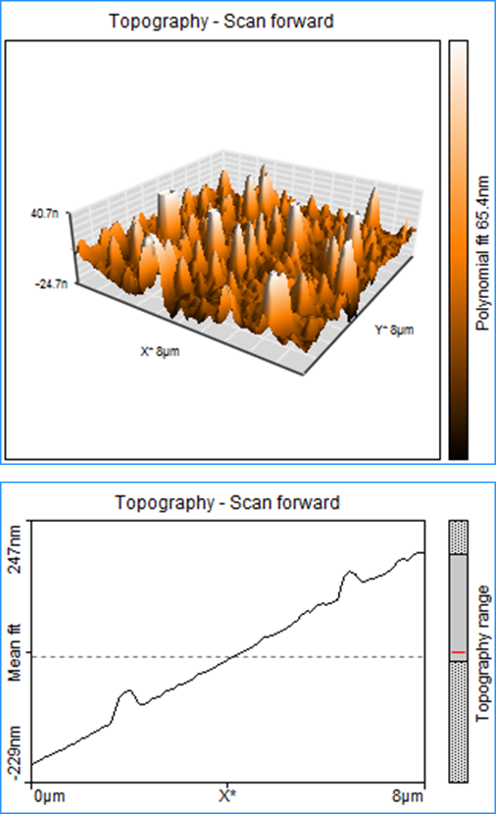
Figure S1. 3D surface topography by AFM, and AFM thickness profile of HEO‒Cu 40% nanocomposite.
Table S1. Co, Ni, Fe, Mn, and Cu ratios in HEOs as obtained by ICP-MS.
Sample(s) | Percentage (Atom, %)
Sample(s) | Co | Ni | Fe | Mn | Cu
HEO‒Cu 20% | 19.23 | 20.12 | 19.85 | 20.47 | 20.33
HEO‒Cu 30% | 17.84 | 17.79 | 17.25 | 17.54 | 29.58
HEO‒Cu 40% | 15.29 | 15.69 | 14.72 | 14.89 | 39.41
HEO‒Cu 50% | 12.73 | 12.64 | 12.67 | 12.58 | 49.38
HEO‒Cu 60% | 10.14 | 10.09 | 9.99 | 10.04 | 59.74

Table S2. Comparison of Electrocatalytic Activity for Oxygen Evolution Reaction (OER).
Catalyst | Tafel slope  mV/dec | Electrolyte | Reference
Ir nanoparticles | 64 | - | 1
Cobalt Polyoxometalate | 148 | NaPi/NaNO₃ | 2
α‑MnO2/FeCo-LDH | 70.4 | KOH | 3
La(CrMnFeCoNi)O₃ | 78.6 | KOH | 4
CoFerrite | 72.7 | KOH | 5
Co_{0.9}Ni_{0.1}Ferrite | 81.1 | KOH | 5
NiFeOH/CoSx | 121.3 | KOH | 6
NiFeOH | 134.6 | KOH | 6
CoSx | 132.1 | KOH | 6
La(FeCoCuTiNiMnMgSnZn)O₃−rGO | 81.9 | KOH | 7
(CoFeMnCuNiCr)₃O₄−rGO | 86 | KOH | 8
HEO–Cu 40%/NF | 64.5 | KOH | This work

Table S3. Calculated fitting values of the equivalent circuit elements for the different catalysts.
Sample Name | Charge transfer resistance  (Rct (Ω)) | Ohmic  Resistance  (Rs (Ω)) | Constant Phase Element (CPEdl-T) | Constant Phase Element (CPEdl-P)
NF | 212.83 | 7.98 | 2.13 ×10⁻⁷ | 0.61
HEO_Cu 20%/NF | 177.25 | 7.11 | 1.76 ×10⁻⁶ | 0.70
HEO_Cu 30%/NF | 158.40 | 5.30 | 1.57 ×10⁻⁶ | 0.79
HEO_Cu 40%/NF | 82.81 | 4.31 | 2.73 ×10⁻⁶ | 0.93
HEO_Cu 50%/NF | 114.81 | 4.42 | 1.14 ×10⁻⁶ | 0.88
HEO_Cu 60%/NF | 119.91 | 4.65 | 1.18 ×10⁻⁶ | 0.87

References:
- Reier, T. et al. Electrocatalytic Oxygen Evolution Reaction (OER) on Ru, Ir, and Pt Catalysts: A Comparative Study of Nanoparticles and Bulk Materials. ACS Catalysis 2, 1765–1772 (2012).
- Soriano-López, J. et al. Cobalt Polyoxometalates as Heterogeneous Water Oxidation Catalysts. Inorganic Chemistry 52, 4753–4755 (2013).
- Shahparast, S. et al. α-MnO₂/FeCo-LDH on Nickel Foam as an Efficient Electrocatalyst for Water Oxidation. ACS Omega 8, 1702–1709 (2023).
- Nguyen, T. X. et al. Advanced High Entropy Perovskite Oxide Electrocatalyst for Oxygen Evolution Reaction. Adv. Funct. Mater. 31, 2101632 (2021).
- Chamani, S. et al. Microwave-Assisted Auto-Combustion Synthesis of Binary/Ternary CoₓNi₁₋ₓFe₂O₄ for Electrochemical Hydrogen and Oxygen Evolution. ACS Omega 6, 33024–33032 (2021).
- Bose, R. et al. High performance multicomponent bifunctional catalysts for overall water splitting. J. Mater. Chem. A 8, 13795–13805 (2020).
- Moghaddam A.O. et al. Synergistic Multimetal Effects in a High-Entropy Perovskite Oxide Anchored on Reduced Graphene Oxide for Accelerated Water Oxidation. The Journal of Physical Chemistry Letters, (2026).
- Mehrabi-Kalajahi, S. et al. High Entropy (CoFeMnCuNiCr)₃O₄ Nanoparticles Anchored on Graphene-Based Supports for High-Performance Oxygen Evolution Electrocatalysis. ACS Appl. Energy Mater. 8, 8524–8531 (2025).

