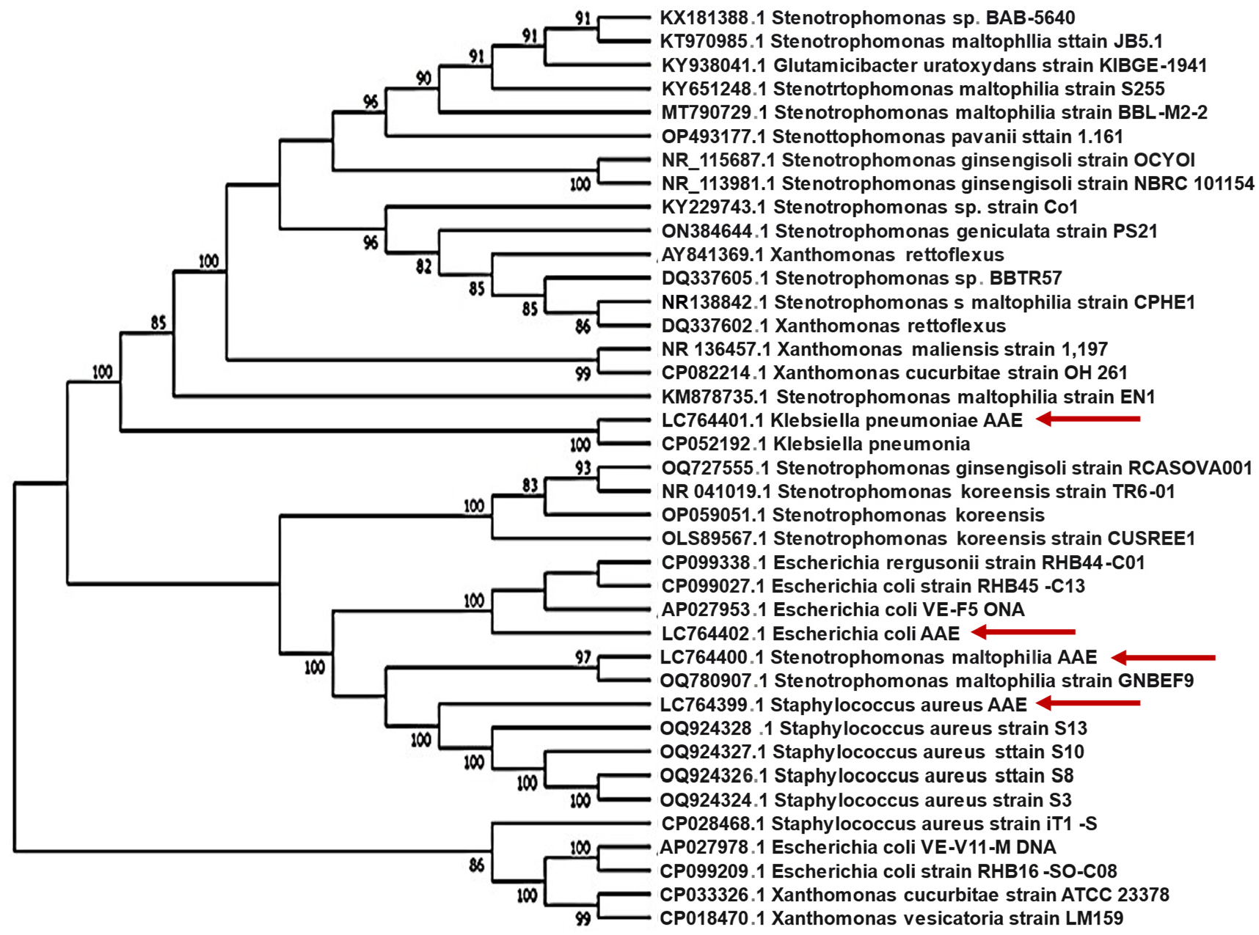

Figure S1. Phylogenetic relationships of bacterial isolates based on 16S rRNA gene sequence analysis. The tree was constructed using the neighbor-joining method in MEGA 11, with bootstrap values >70 indicated. Isolates sequenced in this study are marked with red arrows.

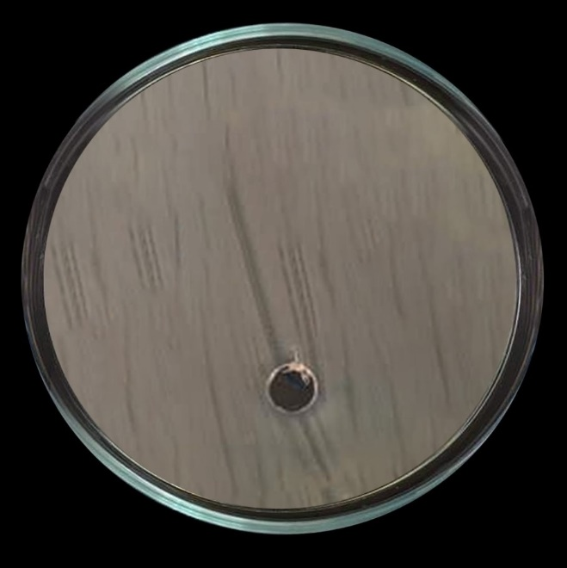 | 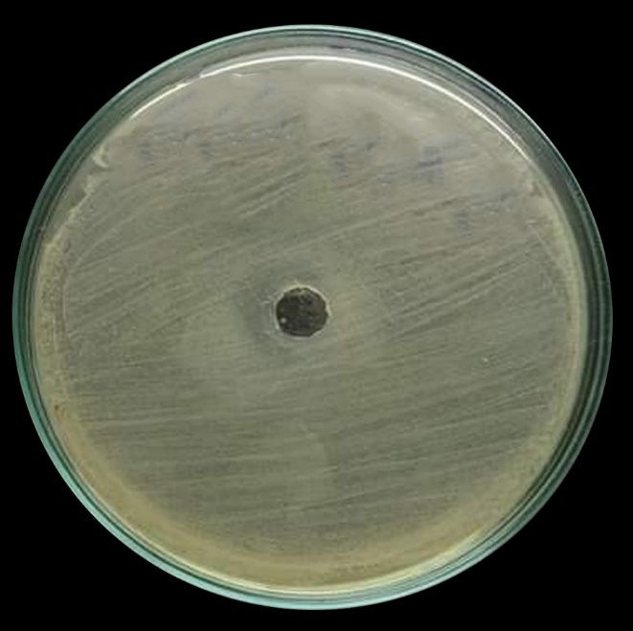
E. coli | MRSA
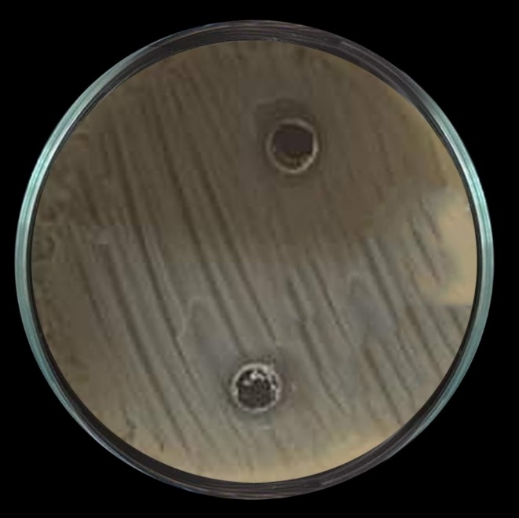 | 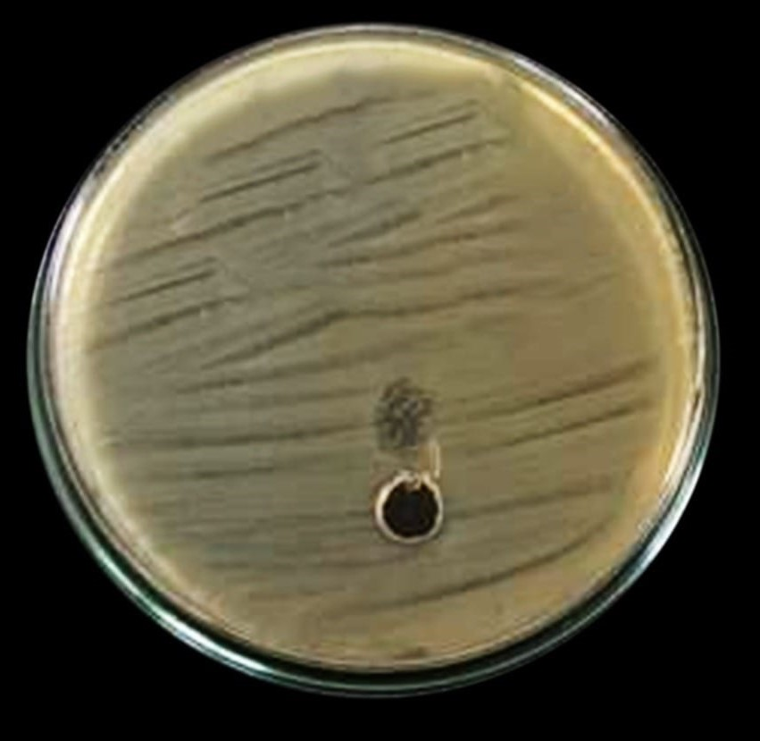
K. pneumoniae | S. maltophilia
Figure S2: Representative photos of these 5% DMSO negative control against the tested bacterial strains.

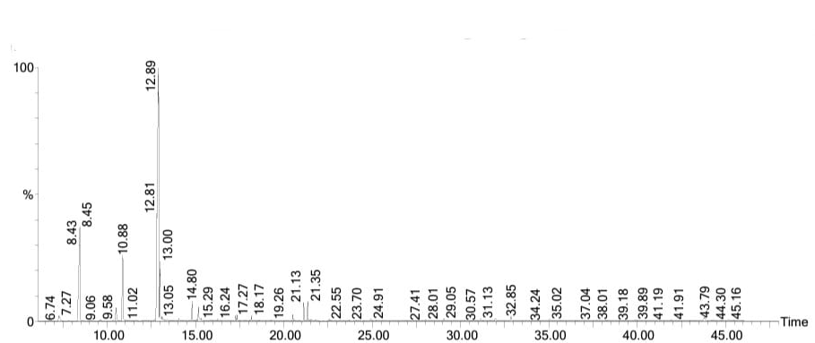
Figure S3. GC–MS chromatograph of acetone extract of Organum syriacum.

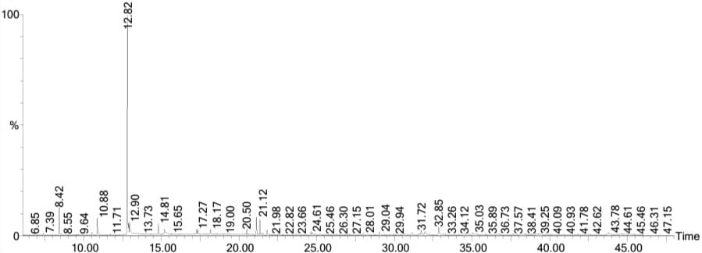
Figure S4. GC-MS chromatograph of ethanolic extract of Organum syriacum.

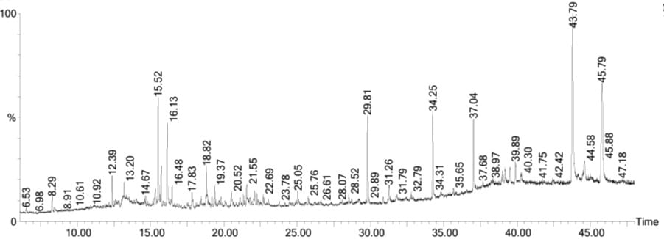
Figure S5. GC–MS chromatograph of acetone extract of Salix alba.

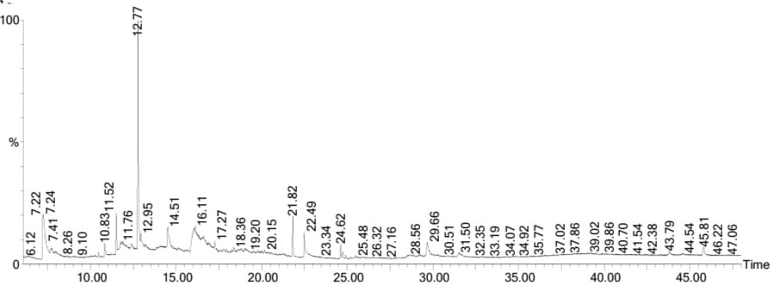
Figure S6. GC–MS chromatograph of ethanolic extract of Salix alba.

