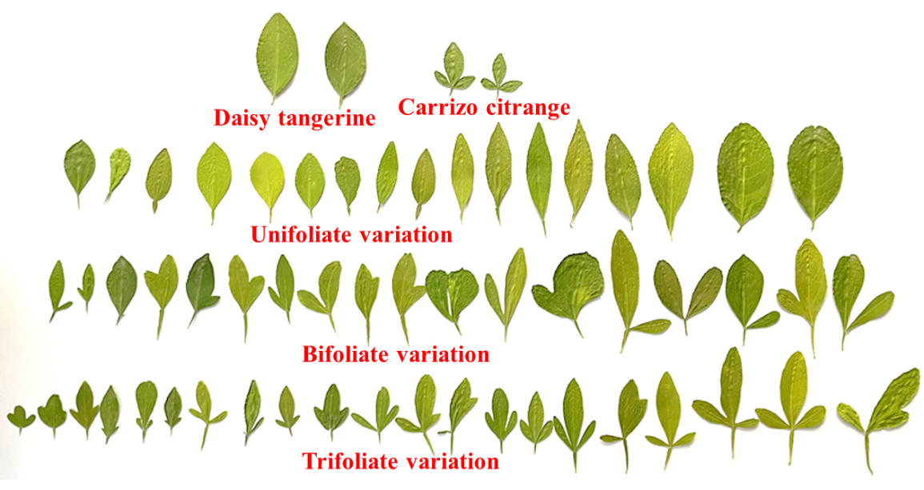
Supplementary Fig. 1 Leaf variation (Unifoliate, Bifoliate, Trifoliate) in ‘Daisy’ tangerine (♀) × Carrizo citrange (♂) F₁ population
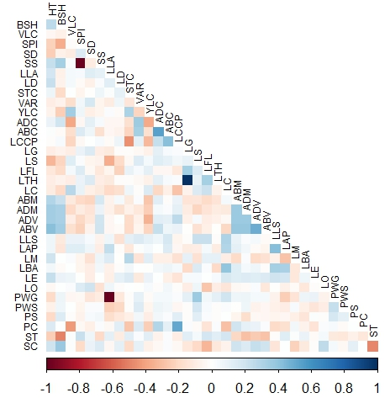
Supplementary Fig. 2 Correlation studies among morphological traits (qualitative) based on Pearson correlation matrix with heatmap. The blue area indicates a positive correlation between the two traits, and the brown area indicates a negative correlation between the two traits. Habitus (HT), Branch shape (BSH), Vegetative life cycle (VLC), Glandular spots on branches (GSB), Hairs on branches (HB), Spine (SPI), Spine Density (SD), Spine shape (SS), Glad spots on leaves (GSL), Leaf arrangement (LA), Leaf lamina attachment (LLA), Leaf division (LD), Shoot tip surface (STS), Shoot tip colour (STC), Leaf blade (LB), Stipule (STI), Variegation (VAR), Young leaf colour (YLC), Leaf blade colour comparison (LBCC), Adaxial colour (ADC), Abaxial colour (ABC), Lamina colour compared to petiole (LCCP), Leaf glossiness (LG), Leaf surface (LS), Leaf flexibility (LFL), Leaf thickness (LTH), Leaf fragrance (LFR), Leaf venation (LV), Abaxial midrib (ABM), Adaxial midrib (ADM), Adaxial vein (ADV), Abaxial vein (ABV), Leaf phyllotaxy (LP), Leaf lamina shape (LLS), Leaf apex (LAP), Leaf margin (LM), Leaf base (LBA), Leaf edge (LE), Leaf orientation (LO), Junction petiole and lamina (JPL), Petiole wing (PWG), Petiole wing shape (PWS), Petiole shape (PS), Petiole colour (PC), Petiole (PET), Stem type (ST), Stem colour (SC)
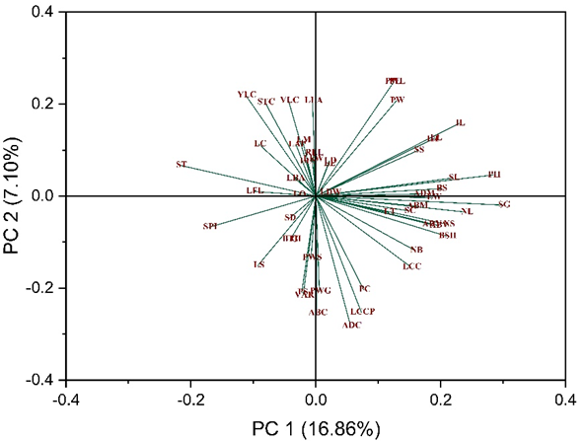
Supplementary Fig. 3 Two-dimensional PCA (Principal Component Analysis) plot of F₁ citrus hybrids derived from ‘Daisy’ tangerine (♀) × Carrizo citrange (♂). Habitus (HT), Branch shape (BSH), Vegetative life cycle (VLC), Glandular spots on branches (GSB), Hairs on branches (HB), Spine (SPI), Spine Density (SD), Spine shape (SS), Glad spots on leaves (GSL), Leaf arrangement (LA), Leaf lamina attachment (LLA), Leaf division (LD), Shoot tip surface (STS), Shoot tip colour (STC), Leaf blade (LB), Stipule (STI), Variegation (VAR), Young leaf colour (YLC), Leaf blade colour comparison (LBCC), Adaxial colour (ADC), Abaxial colour (ABC), Lamina colour compared to petiole (LCCP), Leaf glossiness (LG), Leaf surface (LS), Leaf flexibility (LFL), Leaf thickness (LTH), Leaf fragrance (LFR), Leaf venation (LV), Abaxial midrib (ABM), Adaxial midrib (ADM), Adaxial vein (ADV), Abaxial vein (ABV), Leaf phyllotaxy (LP), Leaf lamina shape (LLS), Leaf apex (LAP), Leaf margin (LM), Leaf base (LBA), Leaf edge (LE), Leaf orientation (LO), Junction petiole and lamina (JPL), Petiole wing (PWG), Petiole wing shape (PWS), Petiole shape (PS), Petiole colour (PC), Petiole (PET), Stem type (ST), Stem colour (SC), Lamina length (LL), Lamina width (LW), Ratio=Lamina length /Lamina length (RLL), Petiole wing length (PWL), Petiole width (PW), Petiole length (PL), Leaf thickness (LT), No of Leaves (NL), Leaf fresh weight (LFW), Leaf dry weight (LDW), Leaf chlorophyll content (LCC), Spine length (SL), No of Spines (NS), Branch size (BS), No of Branches (NB), Internodal length (IL), Plant Height (PH) and Stem girth (SG)

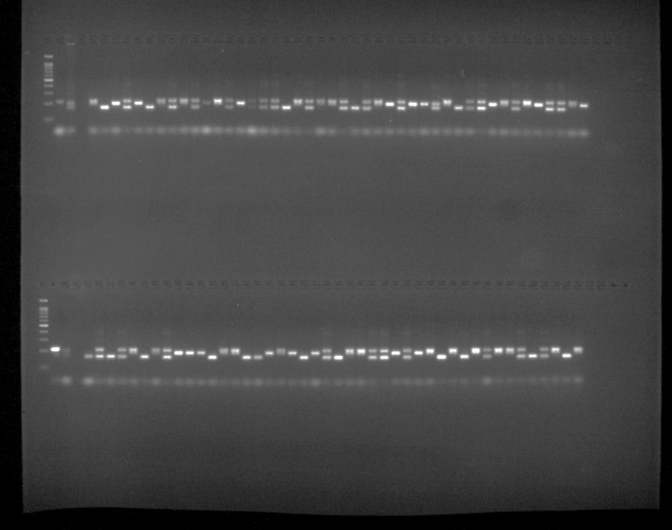
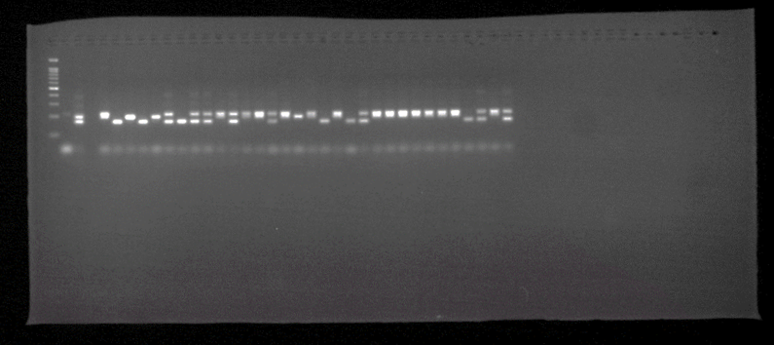
Supplementary Fig. 4 Representative gel image of SSR marker (HvSSRCS-14) amplification on 3% agarose gel.
First lane: first well: Ladder (100 bp), second well: ‘Daisy’ tangerine (♀), third well: Carrizo citrange (♂), fourth well: Negative control, fifth well to forty-eight well: hybrids (H1 to H44)
Second lane: first well: Ladder (100 bp), second well: ‘Daisy’ tangerine (♀), third well: Carrizo citrange (♂), fourth well: Negative control, fifth well to forty-eight well: hybrids (H45 to H88)
Third lane: first well: Ladder (100 bp), second well: ‘Daisy’ tangerine (♀), third well: Carrizo citrange (♂), fourth well: Negative control, fifth well to thirty-six well: hybrids (H89 to H120)

