Evolutionary Dynamics of Coxsackievirus A24 Variant Associated with Acute Hemorrhagic Conjunctivitis in Brazil
Raiana Scerni Machado^{1,2}; Dennis Maletich Junqueira³; Edivaldo Costa Sousa Júnior⁴; Fernando Neto Tavares⁵; Ivanildo Pedro de Sousa Junior^{1*}.
- Fundação Oswaldo Cruz-Fiocruz, Instituto Oswaldo Cruz, Laboratório de Virologia e Parasitologia Molecular, Rio de Janeiro, Brasil;
- Programa de Pós-Graduação em Medicina Tropical, Instituto Oswaldo Cruz, Fundação Oswaldo Cruz, Rio de Janeiro, Brasil;
- Programa de Pós-Graduação em Ciências Biológicas: Bioquímica Toxicológica, Laboratório de Bioinformática e Evolução Viral (Labevir), Universidade Federal de Santa Maria (UFSM), Santa Maria, Rio Grande do Sul, Brasil;
- Instituto Evandro Chagas, Secretaria de Vigilância em Saúde, Ministério da Saúde, Seção de Parasitologia, Ananindeua, Pará, Brasil;
- Instituto Evandro Chagas, Secretaria de Vigilância em Saúde, Ministério da Saúde, Laboratório de Referência Regional em Enteroviroses, Ananindeua, Pará, Brasil.

*Corresponding author: Ivanildo Pedro de Sousa Junior. E-mail: ivanildo.sousa@ioc.fiocruz.br

Supplementary Information

Table S1. Dataset used for phylogenetic and phylodynamic analyses of the VP1 region of CVA24v.
Acession number | Collection date | Location | Genotype | Reference | Dataset
D90457/EH24_70 | 1970 | Singapore | I | Supanaranond et al., 1982 | 1,2
EF015037 | 1987 | Jamaica | II | Brown et al., 2009 | 1,2
EF015038 | 1987 | Brazil | II | Brown et al., 2009 | 1,2
GU983190 | 1987 | Brazil | II | Tavares et al., 2011 | 1,2
EF015039 | 1993 | Dominican | III | Brown et al., 2009 | 1,2
EF015040 | 1998 | UnitedStates | III | Brown et al., 2009 | 1,2
JN228097 | 2004 | Korea | IV | Unpublished | 1,2
KF725085 | 2002 | Malaysia | IV | Zocher et al., 2014 | 1,2
AY876912 | 2002 | China | IV | Unpublished | 1,2
AB901481 | 2002 | Taiwan | IV | Unpublished | 1,2
AB901483 | 2002 | Taiwan | IV | Unpublished | 1,2
AB901482 | 2002 | Taiwan | IV | Unpublished | 1,2
AB901484 | 2002 | Taiwan | IV | Unpublished | 1,2
AB901485 | 2002 | Taiwan | IV | Unpublished | 1,2
AB901486 | 2003 | Taiwan | IV | Unpublished | 1,2
GU983170 | 2003 | Brazil-PR | IV | Tavares et al., 2011 | 1,2
GU983179 | 2003 | Brazil-CE | IV | Tavares et al., 2011 | 1,2
GU983182 | 2003 | Brazil-CE | IV | Tavares et al., 2011 | 1,2
GU983183 | 2003 | Brazil-CE | IV | Tavares et al., 2011 | 1,2
GU983189 | 2003 | Brazil-PA | IV | Tavares et al., 2011 | 1,2
AY876913 | 2002 | China | IV | Unpublished | 1,2
GU983192 | 2004 | Brazil-RJ | IV | Tavares et al., 2011 | 1,2
GU983197 | 2004 | Brazil-RJ | IV | Tavares et al., 2012 | 1,2
GU983194 | 2004 | Brazil-RJ | IV | Tavares et al., 2013 | 1,2
GU983193 | 2004 | Brazil-RJ | IV | Tavares et al., 2014 | 1,2
GU983196 | 2004 | Brazil-RJ | IV | Tavares et al., 2015 | 1,2
GU983202 | 2005 | Brazil-ES | IV | Tavares et al., 2016 | 1,2
GU983199 | 2005 | Brazil-ES | IV | Tavares et al., 2017 | 1,2
GU983200 | 2005 | Brazil-ES | IV | Tavares et al., 2018 | 1,2
GU983186 | 2003 | Brazil-RS | IV | Tavares et al., 2019 | 1,2
GU983187 | 2003 | Brazil-RS | IV | Tavares et al., 2020 | 1,2
GU983184 | 2003 | Brazil-CE | IV | Tavares et al., 2021 | 1,2
EU162074 | 2004 | Spain | IV | Cabrerizo et al, 2008 | 1,2
EU162076 | 2004 | Spain | IV | Cabrerizo et al, 2008 | 1,2
EU162072 | 2004 | Spain | IV | Cabrerizo et al, 2008 | 1,2
EU162073 | 2004 | Spain | IV | Cabrerizo et al, 2008 | 1,2
EU162070 | 2004 | Spain | IV | Cabrerizo et al, 2008 | 1,2
EU162069 | 2004 | Spain | IV | Cabrerizo et al, 2008 | 1,2
GQ329725 | 2003 | China | IV | Unpublished | 1,2
DQ443001 | 2005 | Singapore | IV | Yeo et al., 2007 | 1,2
DQ443002 | 2005 | Singapore | IV | Yeo et al., 2007 | 1,2
GU477584 | 2007 | India | IV | Unpublished | 1,2
GU477582 | 2007 | India | IV | Unpublished | 1,2
GU477583 | 2007 | India | IV | Unpublished | 1,2
FJ868371 | 2006 | Australia | IV | Zhou et al., 2010 | 1,2
AB901487 | 2007 | Taiwan | IV | Unpublished | 1,2
AB901489 | 2008 | Taiwan | IV | Unpublished | 1,2
AB901490 | 2008 | Taiwan | IV | Unpublished | 1,2
AB901488 | 2007 | Taiwan | IV | Unpublished | 1,2
GU477576 | 2007 | India | IV | Unpublished | 1,2
GU477580 | 2007 | India | IV | Unpublished | 1,2
GU477577 | 2007 | India | IV | Unpublished | 1,2
GU477573 | 2007 | India | IV | Unpublished | 1,2
GU477574 | 2007 | India | IV | Unpublished | 1,2
GU983206 | 2009 | Brazil-PE | IV | Tavares et al., 2011 | 1,2
GU983205 | 2009 | Brazil-PE | IV | Tavares et al., 2011 | 1,2
GU983204 | 2009 | Brazil-PE | IV | Tavares et al., 2011 | 1,2
MK989721 | 2010 | Kenya | IV | Unpublished | 1,2
EU596583 | 2007 | China | IV | Unpublished | 1,2
JF742578 | 2007 | China | IV | Unpublished | 1,2
JF742579 | 2007 | China | IV | Unpublished | 1,2
GQ429279 | 2007 | China | IV | Unpublished | 1,2
EU596584 | 2007 | China | IV | Yeo et al., 2010 | 1,2
EU596586 | 2007 | China | IV | Yeo et al., 2010 | 1,2
EU596587 | 2007 | China | IV | Yeo et al., 2010 | 1,2
EU596581 | 2007 | China | IV | Yan et al., 2010 | 1,2
GQ429280 | 2008 | China | IV | Unpublished | 1,2
GQ429287 | 2008 | China | IV | Unpublished | 1,2
JX417879 | 2008 | Gabon | IV | Sadeuh-Mba et al., 2013 | 1,2
MF189567 | 2017 | Uganda | IV | Unpublished | 1,2
MG880745 | 2017 | Mexico | IV | Unpublished | 1,2
MG880748 | 2017 | Mexico | IV | Unpublished | 1,2
MG880751 | 2017 | Mexico | IV | Unpublished | 1,2
MG880747 | 2017 | Mexico | IV | Unpublished | 1,2
MG880749 | 2017 | Mexico | IV | Unpublished | 1,2
MF419263 | 2017 | French Guiana | IV | Enfissi et al., 2017 | 1,2
MG557561 | 2017 | French Guiana | IV | Enfissi et al., 2017 | 1,2
MH778634 | 2017 | Brazil-PA | IV | Sousa et al., 2019 | 1,2
MG557562 | 2017 | French Guiana | IV | Unpublished | 1,2
MH778635 | 2017 | Brazil-PA | IV | Sousa et al., 2019 | 1,2
MH778636 | 2018 | Brazil-RJ | IV | Sousa et al., 2019 | 1,2
MG557563 | 2017 | French Guiana | IV | Enfissi et al., 2017 | 1,2
MH778637 | 2018 | Brazil-RJ | IV | Sousa et al., 2019 | 1,2
MH778639 | 2018 | Brazil-RJ | IV | Sousa et al., 2020 | 1,2
MH778633 | 2018 | Brazil-GO | IV | Sousa et al., 2021 | 1,2
MH778632 | 2018 | Brazil-GO | IV | Sousa et al., 2022 | 1,2
MH778631 | 2018 | Brazil-GO | IV | Sousa et al., 2023 | 1,2
MH778644 | 2018 | Brazil-RJ | IV | Sousa et al., 2024 | 1,2
MH778645 | 2018 | Brazil-RJ | IV | Sousa et al., 2025 | 1,2
MH778638 | 2018 | Brazil-RJ | IV | Sousa et al., 2026 | 1,2
MH778641 | 2018 | Brazil-RJ | IV | Sousa et al., 2027 | 1,2
MH778643 | 2018 | Brazil-RJ | IV | Sousa et al., 2028 | 1,2
MH778630 | 2018 | Brazil-GO | IV | Sousa et al., 2029 | 1,2
MH778640 | 2018 | Brazil-RJ | IV | Sousa et al., 2030 | 1,2
MH778642 | 2018 | Brazil-RJ | IV | Sousa et al., 2031 | 1,2
160083 | 2020 | Brazil-PA | IV | Unpublished | 1,2
AB901479 | 2000 | Taiwan | V | Unpublished | 1,2
AB901480 | 2001 | Taiwan | V | Unpublished | 1,2
AB901476 | 1986 | Taiwan | VI | Unpublished | 1,2
AB901473 | 1985 | Taiwan | VI | Unpublished | 1,2
AB901474 | 1985 | Taiwan | VI | Unpublished | 1,2
AB901475 | 1986 | Taiwan | VI | Unpublished | 1,2
AB901478 | 1986 | Taiwan | VI | Unpublished | 1,2
AB901477 | 1986 | Taiwan | VI | Unpublished | 1,2
MZ171084 | 1994 | China | VII | Li et al., 2022 | 1,2
OM386811 | 1995 | China | VII | Chen et al., 2022 | 2
OM386809 | 1994 | China | VII | Chen et al., 2022 | 2
OM386810 | 1994 | China | VII | Chen et al., 2022 | 2
MZ171082 | 1994 | China | VII | Li et al., 2022 | 2
MZ171086 | 1994 | China | VII | Li et al., 2022 | 2
OM386812 | 1997 | China | VII | Chen et al., 2022 | 2
MZ171079 | 1988 | China | VIII | Li et al., 2022 | 1,2
OM386801 | 1988 | China | VIII | Chen et al., 2022 | 2
MZ171074 | 1988 | China | VIII | Li et al., 2022 | 1,2
MZ171080 | 1988 | China | VIII | Li et al., 2022 | 2

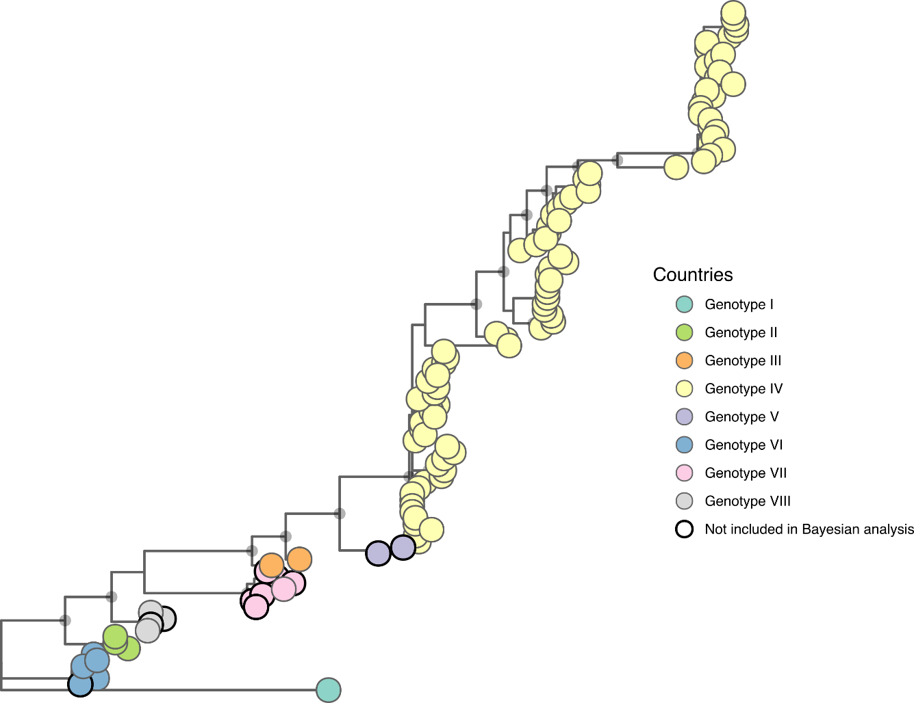
Supplementary Figure S1. Phylogenetic analysis of CVA24v based on 115 complete VP1 gene sequences using the Maximum Likelihood (ML) method. Branches of the tree are marked with circles representing support values, indicating the reliability of the genotype clusters shown. Genotypes I to VIII are represented by distinct colors. Sequences with circles highlighted in bold were not included in the Bayesian analysis.

References
1. Supanaranond, K. et al. The complete nucleotide sequence of a variant of Coxsackievirus A24, an agent causing acute hemorrhagic conjunctivitis. Virus Genes 6, 149–158 (1992).
2. Brown, B. A. et al. Resolving ambiguities in genetic typing of human enterovirus species C clinical isolates and identification of enterovirus 96, 99 and 102. Journal of General Virology 90, 1713–1723 (2009).
3. Tavares, F. N. et al. Molecular characterization and phylogenetic study of coxsackievirus A24v causing outbreaks of acute hemorrhagic conjunctivitis (AHC) in Brazil. PLoS One 6, (2011).
4. Zocher, G. et al. A sialic acid binding site in a human picornavirus. PLoS Pathogens 10, e1004401 (2014).
5. Cabrerizo, M. et al. Molecular characterization of a coxsackievirus A24 variant that caused an outbreak of acute haemorrhagic conjunctivitis in Spain, 2004. Journal of Clinical Virology 43, 323–327 (2008).
6. Yeo, D. S. et al. Molecular identification of coxsackievirus A24 variant, isolated from an outbreak of acute hemorrhagic conjunctivitis in Singapore in 2005. Archives of Virology 152, 2005–2016 (2007).
7. Zhou, F. et al. Molecular identification and analysis of nonserotypeable human enteroviruses. Journal of Clinical Microbiology 48, 1276–1282 (2010).
8. Sadeuh-Mba, S. A. et al. High frequency and diversity of species C enteroviruses in Cameroon and neighboring countries. Journal of Clinical Microbiology 51, 759–770 (2013).
9. Enfissi, A. et al. Coxsackievirus A24 variant associated with acute haemorrhagic conjunctivitis cases, French Guiana, 2017. Intervirology 60, 271–275 (2017).
10. Sousa, I. P. et al. Re-emergence of a coxsackievirus A24 variant causing acute hemorrhagic conjunctivitis in Brazil from 2017 to 2018. Arch Virol 164, 1181–1185 (2019).
11. Li, J. et al. Molecular analysis of Coxsackievirus A24 variant isolates from three outbreaks of acute hemorrhagic conjunctivitis in 1988, 1994 and 2007 in Beijing, China. Virologica Sinica 37, 168–176 (2022).
12. Chen, P. et al. Evolutionary phylogeography reveals novel genotypes of coxsackievirus A24 variant and updates the spatiotemporal dynamics in the population with acute hemorrhagic conjunctivitis. International Journal of Infectious Diseases 124, 227–239 (2022).

