Supplementary Material
Probing the diversity in dairy cattle reticulorumen temperature for adaptation selection
A.K. Shirley, P.C. Thomson, A. Chlingaryan, C.E.F. Clark

Supplementary Figures
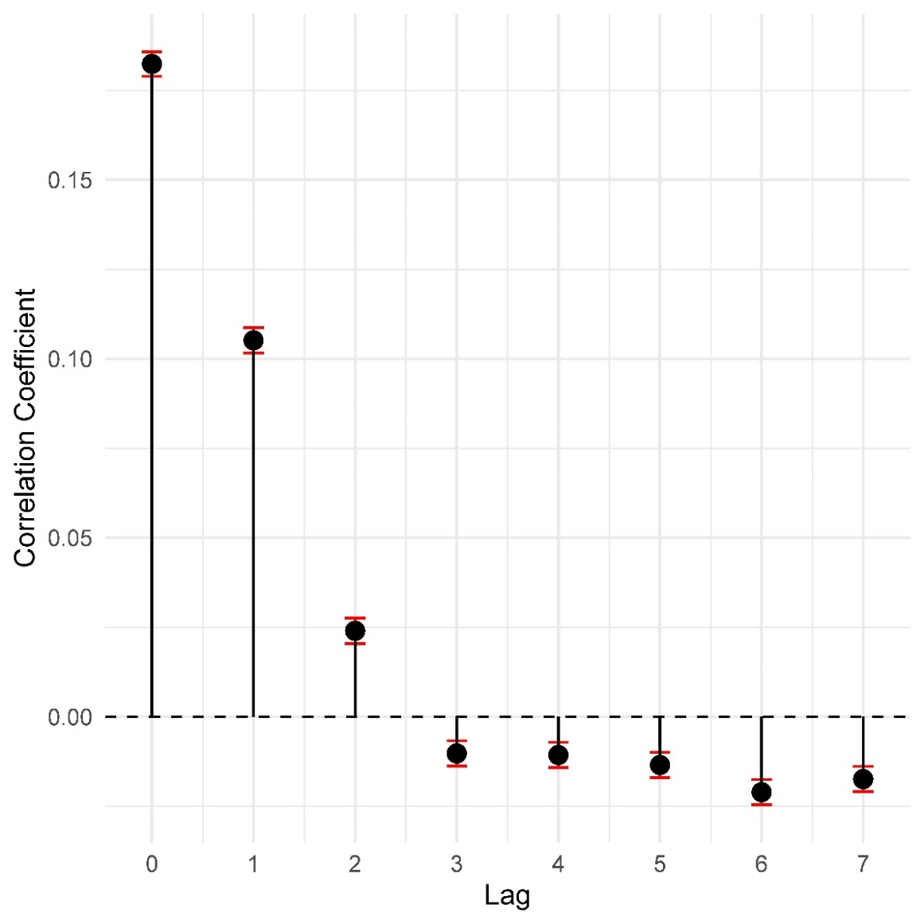

Supplementary Figure S1. Cross-correlation plot between reticulorumen temperature and temperature humidity index (decomposed residual deviations of THI_{max}) for lags up to 7 days. Bars represent 95% confidence intervals.
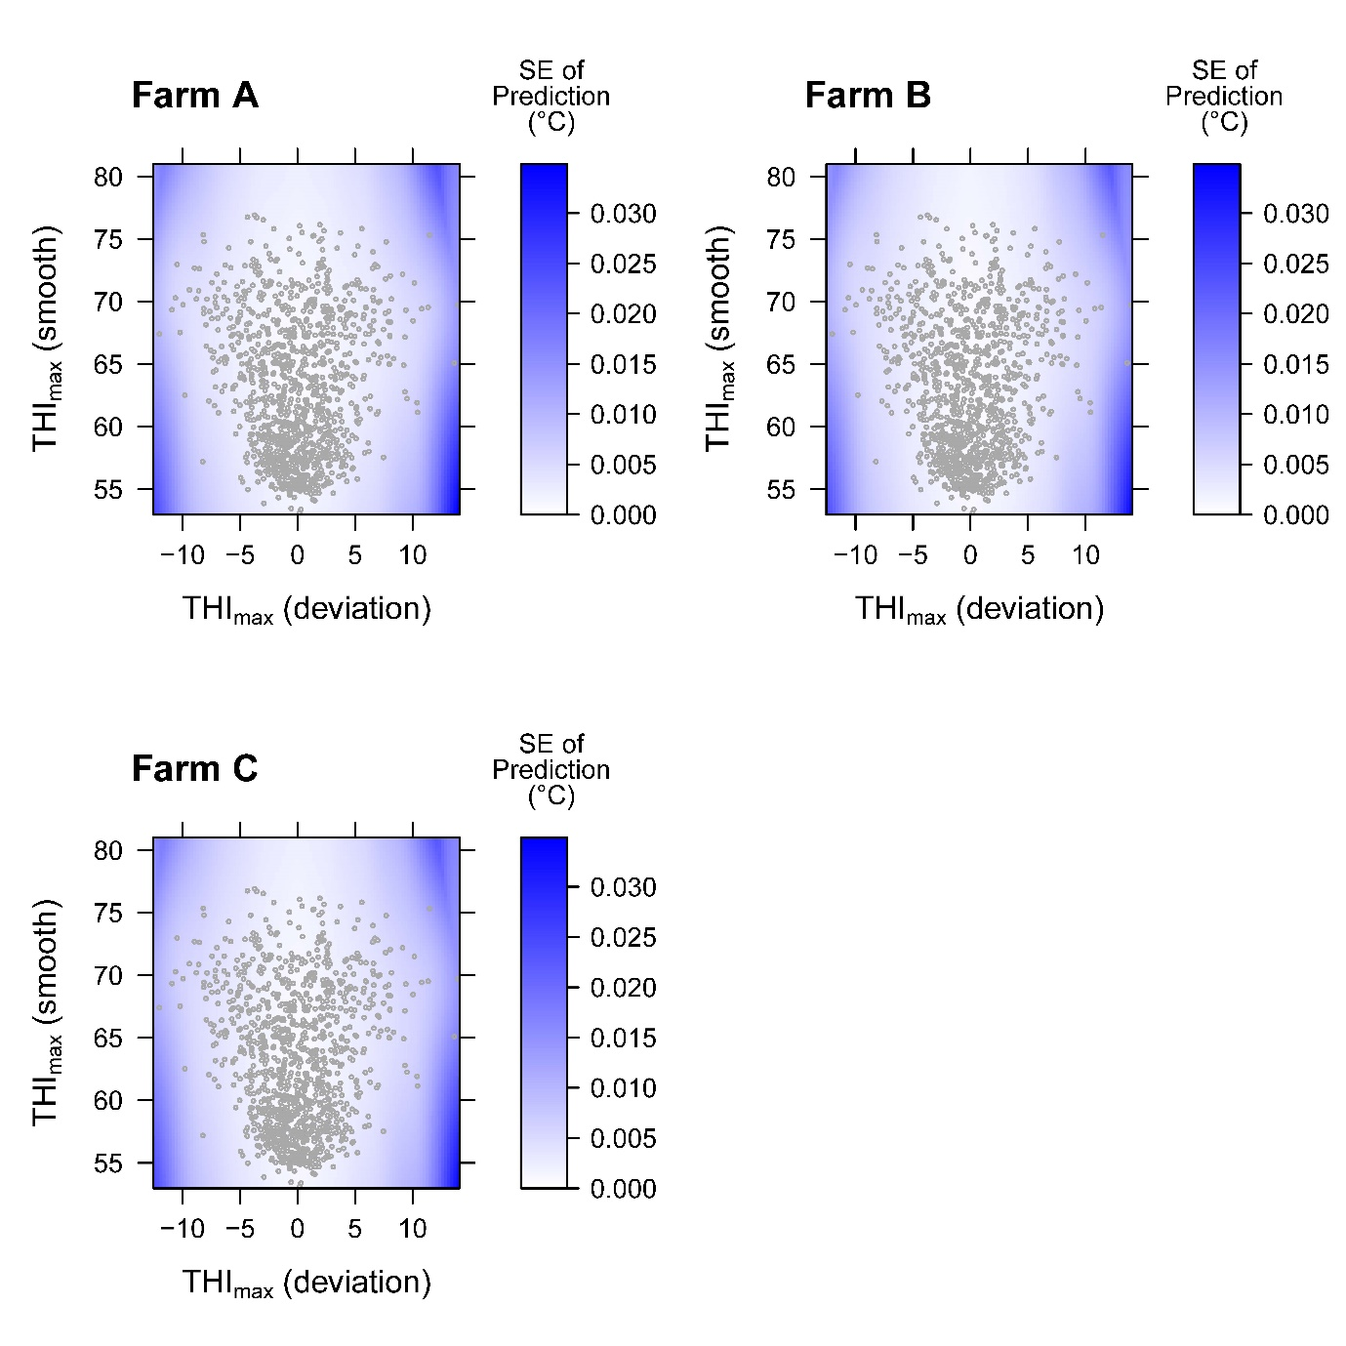
Supplementary Figure S2. Surface plot of standard error of predictions, overlayed with points showing observed value of THI_{max} (deviation) and THI_{max} (smooth). An individual surface plot is displayed per farm alongside a colour legend.
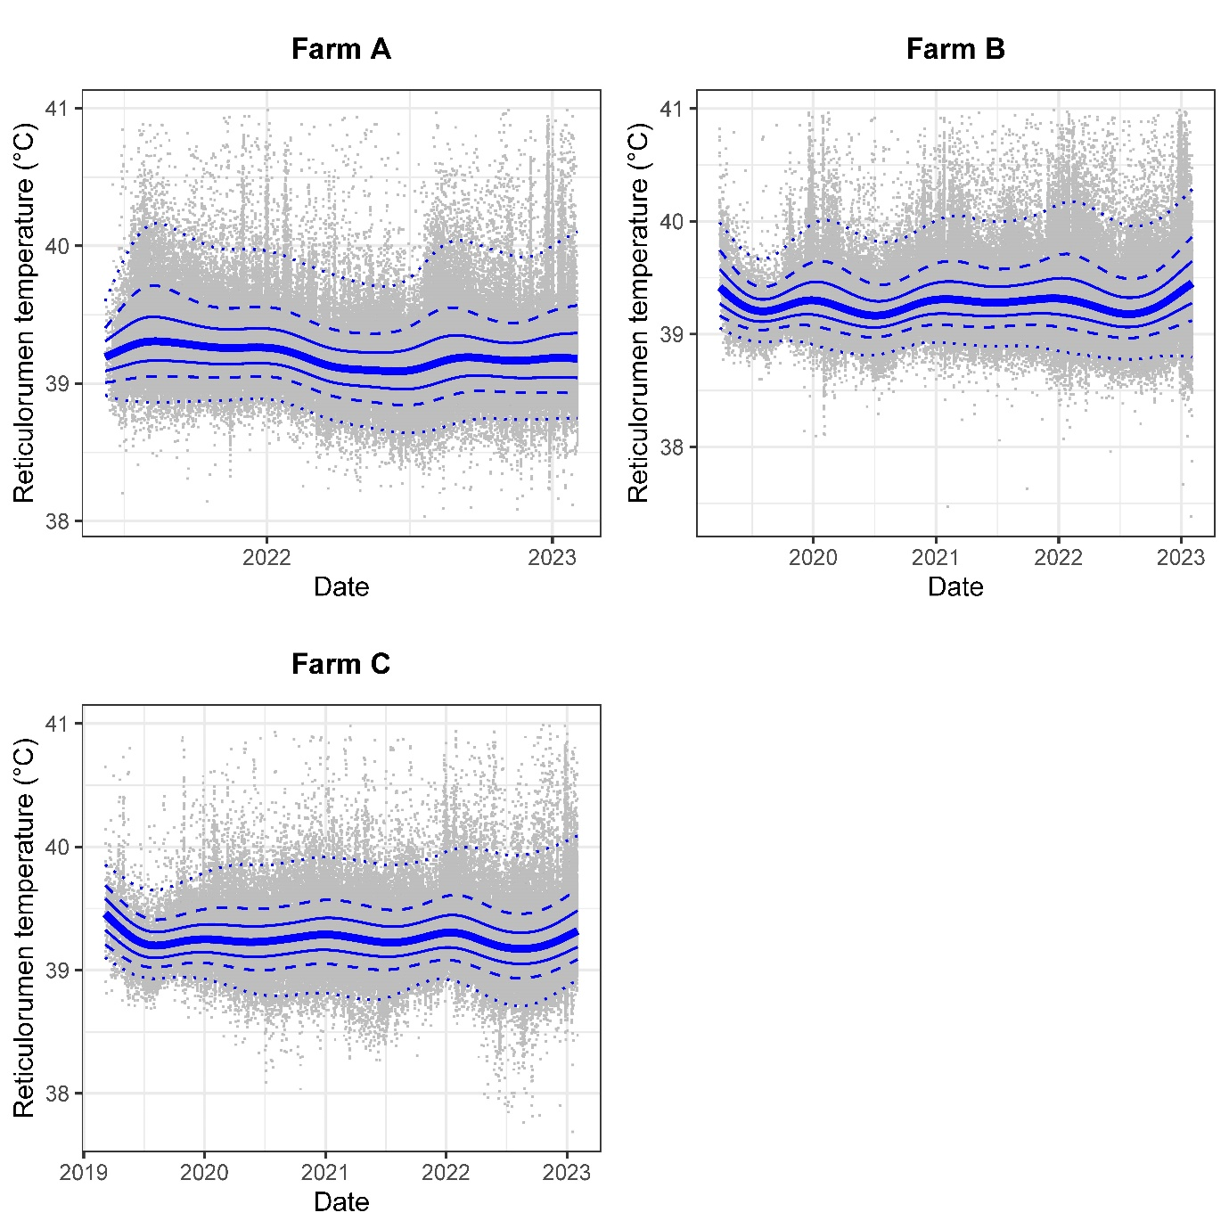
Supplementary Figure S3. Scatter plot of raw reticulorumen data for all animals over time, for each farm. The overlaid smoothed lines represent from bottom to top, the 1%, 10%, 25%, 50% (median), 75%, 90% and 99% quantiles.
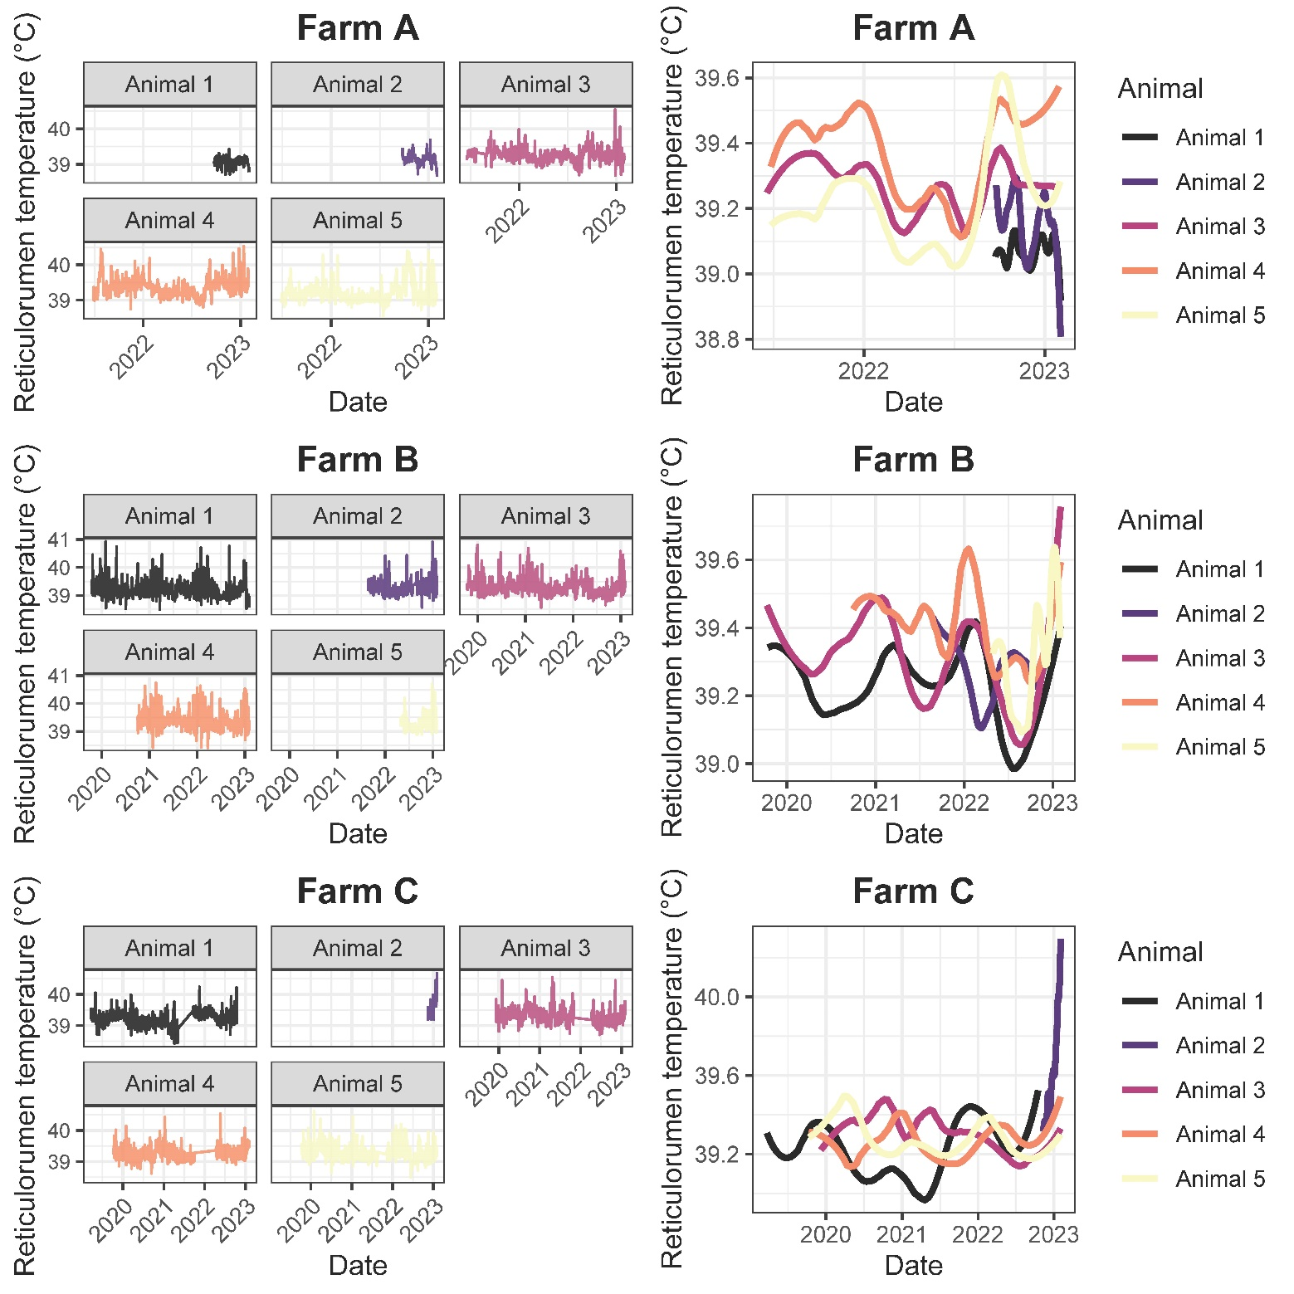
Supplementary Figure S4: Illustrative plot of a random sample of five animals from each farm showing raw reticulorumen data (LHS) and smoothed data (RHS) illustrating between-animal variation.
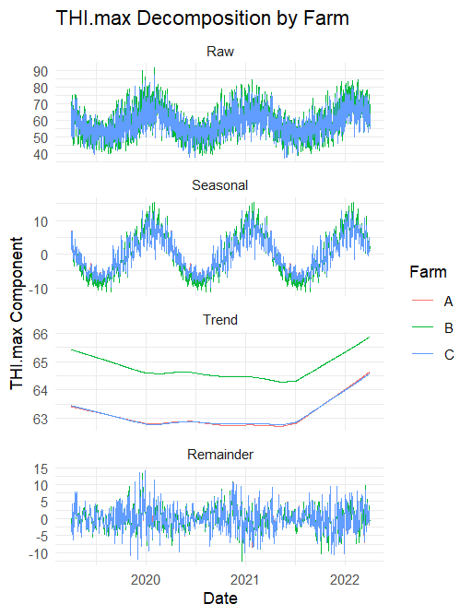
Supplementary Figure S5: Decomposition of raw temperature humidity index (THI) time-series data into deviations for 24-h cycle, trend, and residual deviations.

Supplementary Tables
Supplementary Table 1: Wald tests for fixed effects; response = reticulorumen temperature deviation (THI_{max} (deviation))
 | Num. DF | Den. DF | F-statistic | P-value
Farm | 2 | 303,988 | 3.12 | 0.0057
THI_{max_dev} | 1 | 2570 | 710.10 | < 0.0001
Farm $×$ THI_{max_dev} | 2 | 749 | 40.96 | < 0.0001

Supplementary Table 2: Estimated variance components for the association between THI_{max} (deviation) and reticulorumen temperature (˚C).
Source of variation | Variance estimate | Standard Error | z-ratio
s(THI _{max_dev}) | 2.60 × 10⁻³ | 1.59 × 10⁻³ | 1.63
ID | 2.19 × 10⁻¹⁰ | NA | NA
ID×THI _{max_dev} | 3.72 × 10⁻⁵ | 2.29 × 10⁻⁶ | 16.27
s(THI _{max_dev})×ID | 2.19 × 10⁻¹⁰ | NA | NA
Residual | 3.42 × 10⁻² | 8.77 × 10⁻⁵ | 389.85

Supplementary Table 3: Wald tests for fixed effects; response = reticulorumen temperature remainder (THI_{max} (smooth))
 | Num. DF | Den. DF | F-statistic | P-value
Farm | 2 | 304,752 | 36 | < 0.0001
THI_{max_smooth} | 1 | 52,188 | 1458 | < 0.0001
Farm $×$ THI_{max_smooth} | 2 | 304,753 | 164.8 | < 0.0001

Supplementary Table 4: Estimated variance components for the association between THI_{max} (smooth) and reticulorumen temperature (˚C).
Source of variation | Variance estimate | Standard Error | z-ratio
s(THI _{max_smooth}) | 7.06 × 10⁻³ | 4.12 × 10⁻³ | 1.72
ID | 3.62 × 10⁻⁹ | NA | NA
ID×THI _{max_smooth} | 1.45 × 10⁻¹¹ | NA | NA
s(THI _{max_smooth})×ID | 9.78 × 10⁻¹⁰ | NA | NA
Residual | 3.57 × 10⁻² | 9.15 × 10⁻⁵ | 390.35

