Supplementary Fig. S1. Subgroup analysis in individuals without preexisting cardiovascular diseases
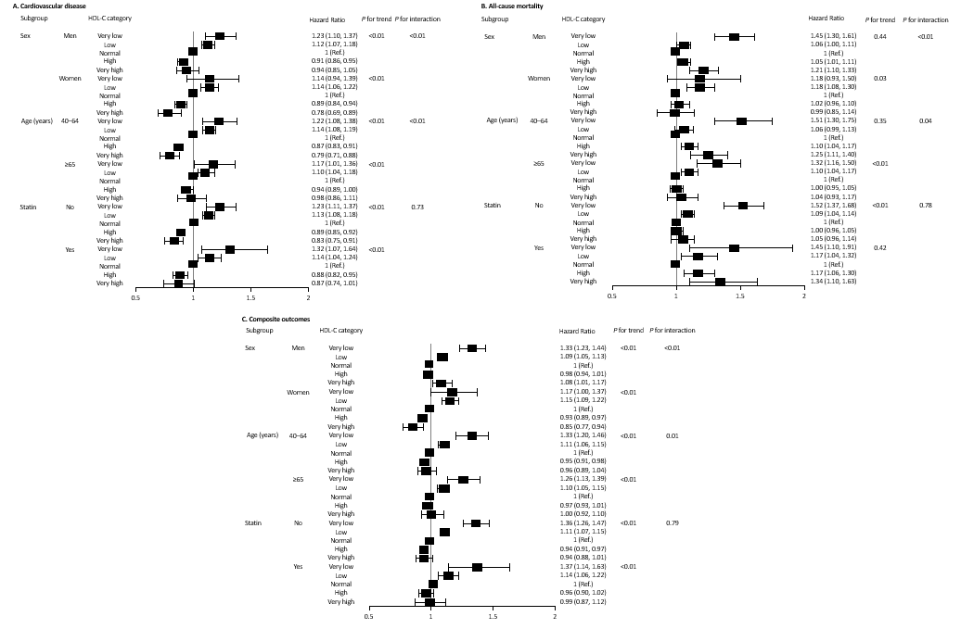
HDL-C, high-density lipoprotein cholesterol; IR, incidence rate; HR, hazard ratio; CI, confidence interval.
Values are presented as hazard ratio (95% confidential interval) using multivariable Cox proportional hazard regression analysis after adjusting for age, sex, smoking status, alcohol consumption, physical activity, income, body mass index, hypertension, diabetes mellitus, estimated glomerular filtration rate, low–density lipoprotein cholesterol, triglycerides, and statin.
Supplementary Fig. S2. Subgroup analysis in individuals with preexisting cardiovascular diseases
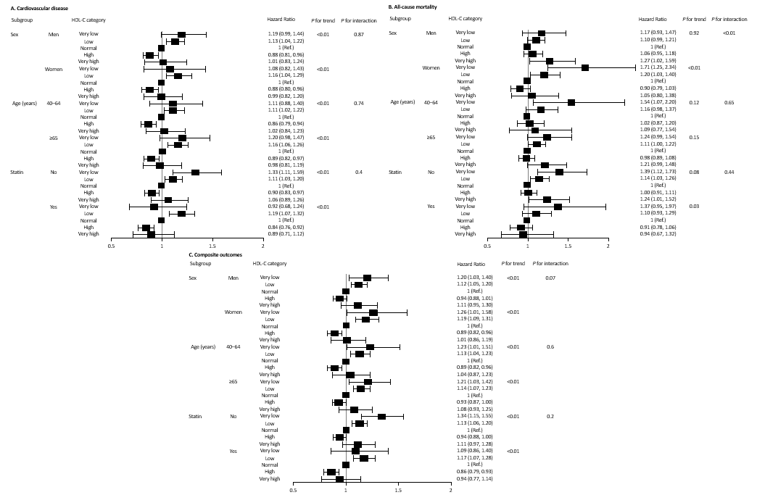
HDL-C, high-density lipoprotein cholesterol; IR, incidence rate; HR, hazard ratio; CI, confidence interval.
Values are presented as hazard ratio (95% confidential interval) using multivariable Cox proportional hazard regression analysis after adjusting for age, sex, smoking status, alcohol consumption, physical activity, income, body mass index, hypertension, diabetes mellitus, estimated glomerular filtration rate, low–density lipoprotein cholesterol, triglycerides, and statin.

