Design, Synthesis, and Insecticidal Potency of Novel 3-Methyl-Pyrazole Derivatives Against Culex pipiens Larvae
Hager R. Nofal¹, Ali Khalil Ali¹, Mahmoud F. Ismail¹, Mahmoud Kamal^{2,*}, Eslam M. Hosni², Eslam M. Abbass^{1,*}
¹ Chemistry Department, Faculty of Science, Ain Shams University, Cairo, 11566, Egypt.
² Entomology Department, Faculty of Science, Ain Shams University, Cairo, 11566, Egypt
* Corresponding Author:
Eslam M. Abbass
ORCID:https://orcid.org/0000-0002-3245-1653
Email: eslammorad@sci.asu.edu.eg

Table of Contents

Title | page
IR spectral data of the target compounds (1-20) | S3
Figure S1. IR spectrum of compound 1 | S3
Figure S2. IR spectrum of compound 2 | S4
Figure S3. IR spectrum of compound 3 | S5
Figure S4. IR spectrum of compound 4 | S6
Figure S5. IR spectrum of compound 5 | S7
Figure S6. IR spectrum of compound 6 | S8
Figure S7. IR spectrum of compound 7 | S9
Figure S8. IR spectrum of compound 8 | S10
Figure S9. IR spectrum of compound 9 | S11
Figure S10. IR spectrum of compound 10 | S12
Figure S11. IR spectrum of compound 11 | S13
Figure S12. IR spectrum of compound 12 | S14
Figure S13. IR spectrum of compound 13 | S15
Figure S14. IR spectrum of compound 14 | S16
Figure S15. IR spectrum of compound 15 | S17
Figure S16. IR spectrum of compound 16 | S18
Figure S17. IR spectrum of compound 17 | S19
Figure S18. IR spectrum of compound 18 | S20
Figure S19. IR spectrum of compound 19 | S21
¹H NMR spectral data of the target compounds | S22
Figure S21. ¹H NMR (500 MHz, DMSO-d₆) spectrum of compound 2 | S22
Figure S22. ¹H NMR (500 MHz, DMSO-d₆) spectrum of compound 4 | S23
Figure S23. ¹H NMR (500 MHz, DMSO-d₆) spectrum of compound 5 | S24
Figure S24. ¹H NMR (500 MHz, DMSO-d₆) spectrum of compound 6 | S25
Figure S25. ¹H NMR (500 MHz, DMSO-d₆) spectrum of compound 7 | S26
Figure S26. ¹H NMR (500 MHz, DMSO-d₆) spectrum of compound 8 | S27
Figure S27. ¹H NMR (500 MHz, DMSO-d₆) spectrum of compound 9 | S28
Figure S28. ¹H NMR (500 MHz, DMSO-d₆) spectrum of compound 10 | S29
Figure S29. ¹H NMR (500 MHz, DMSO-d₆) spectrum of compound 11 | S30
Figure S30. ¹H NMR (500 MHz, DMSO-d₆) spectrum of compound 14 | S31
Figure S31. ¹H NMR (500 MHz, DMSO-d₆) spectrum of compound 15 | S32
Figure S32. ¹H NMR (500 MHz, DMSO-d₆) spectrum of compound 16 | S33
Figure S33. ¹H NMR (500 MHz, DMSO-d₆) spectrum of compound 17 | S34
Figure S34. ¹H NMR (500 MHz, DMSO-d₆) spectrum of compound 18 | S35
Mass fragmentation of the target compounds | S36
Figure 35. Mass fragmentation of compound 4 | S36
Figure 36. Mass fragmentation of compound 5 | S37
Figure 37. Mass fragmentation of compound 6 | S38
Figure 38. Mass fragmentation of compound 7 | S39
Figure 39. Mass fragmentation of compound 8 | S40
Figure 40. Mass fragmentation of compound 9 | S41
Figure 41. Mass fragmentation of compound 10 | S42
Figure 42. Mass fragmentation of compound 11 | S43
Figure 43. Mass fragmentation of compound 14 | S44
Figure 44. Mass fragmentation of compound 15 | S45
Figure 45. Mass fragmentation of compound 16 | S46
Figure 46. Mass fragmentation of compound 17 | S47
Figure 47. Mass fragmentation of compound 18 | S48
Biological evaluation
Figure S47. Quality estimate parameters for modeled Acetylcholine Esterase (AChE) protein. | S49
Figure S48. Quality estimate parameters for modeled nicotinic acetylcholine receptor. | S50
Figure S49. AlphaFold Model of the Nicotinic Acetylcholine Receptor (nAChR) from Culex quinquefasciatus | S51
Table S1. 2D interaction profiles of the 19 synthesized compounds targeting acetylcholinesterase (AChE) in Culex pipiens, compared with the conventional AChE inhibitor chlorpyrifos | S52
Table S2. Molecular docking interaction profiles of 19 synthesized compounds with acetylcholinesterase (AChE) in Culex pipiens | S56
Table S3. 2D interaction profiles of the 19 synthesized compounds targeting the nicotinic acetylcholine receptor (nAChR) in Culex pipiens | S60
Table S4. Molecular docking interaction profiles of 19 synthesized compounds with the nicotinic acetylcholine receptor (nAChR) in Culex pipiens | S64
Ethical Approval | S66

IR spectral data of the target compounds (1-20)
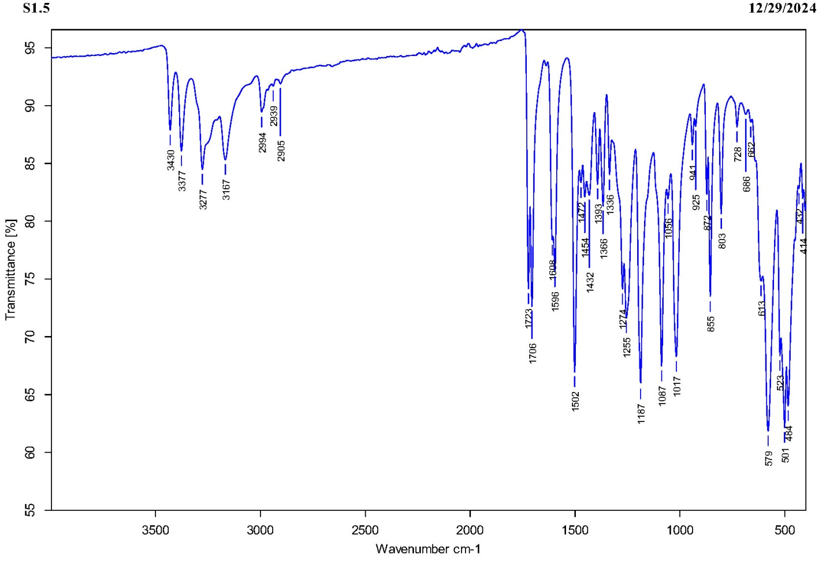
Figure S1. IR spectrum of compound 1.
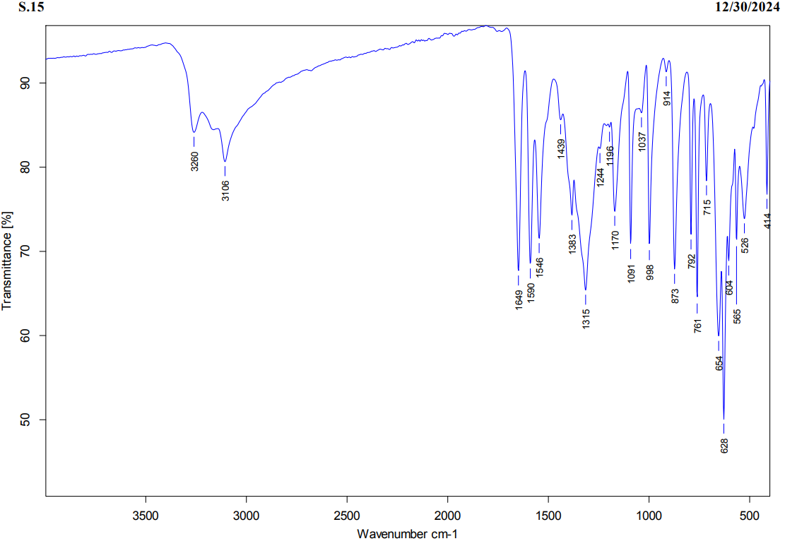
Figure S2. IR spectrum of compound 2
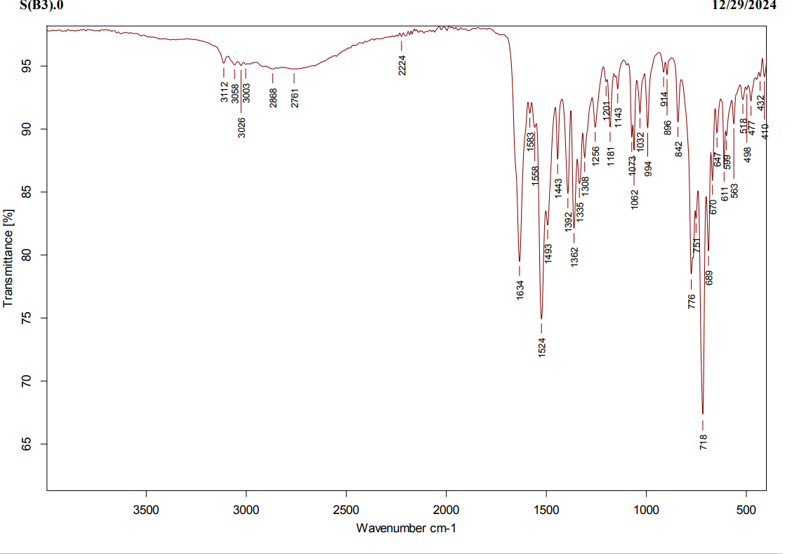
Figure S3. IR spectrum of compound 3
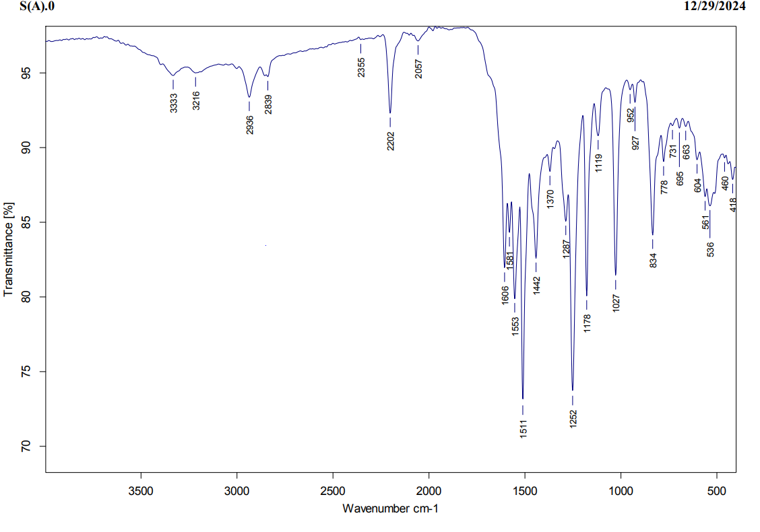
Figure S4. IR spectrum of compound 4

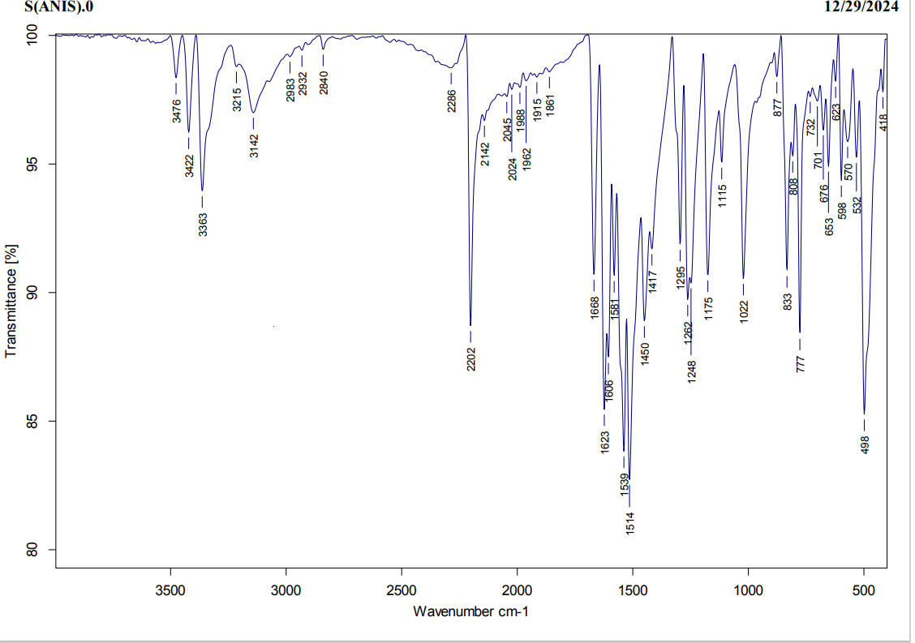
Figure S5. IR spectrum of compound 5

Figure S6. IR spectrum of compound 6

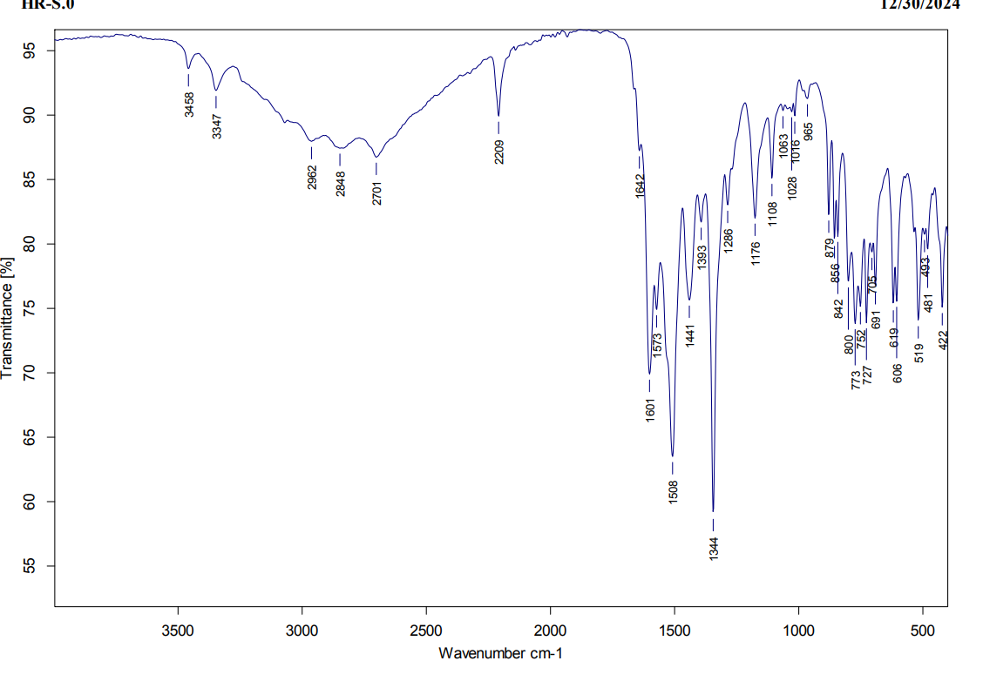
Figure S7. IR spectrum of compound 7
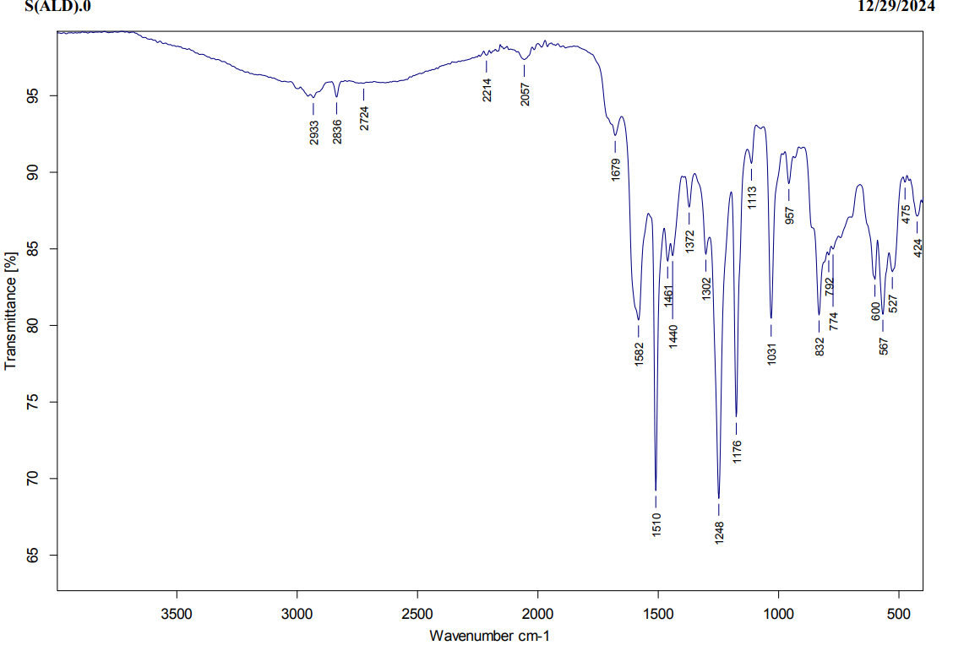
Figure S8. IR spectrum of compound 8
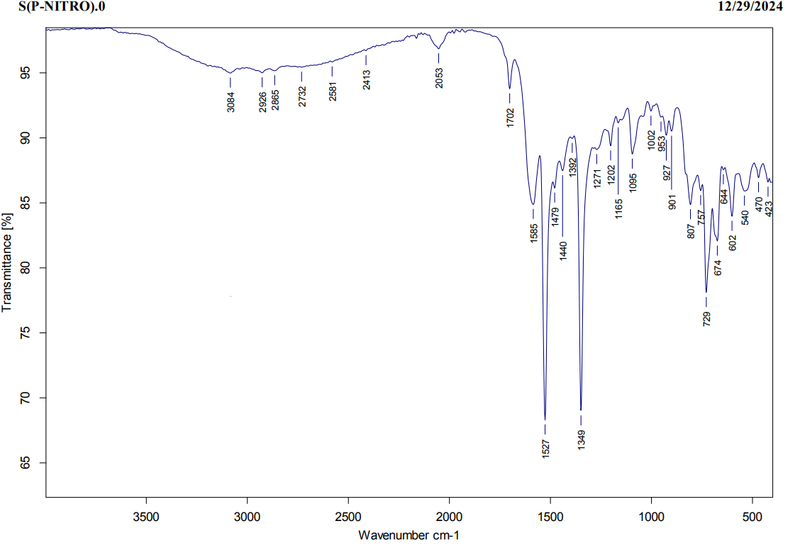
Figure S9. IR spectrum of compound 9

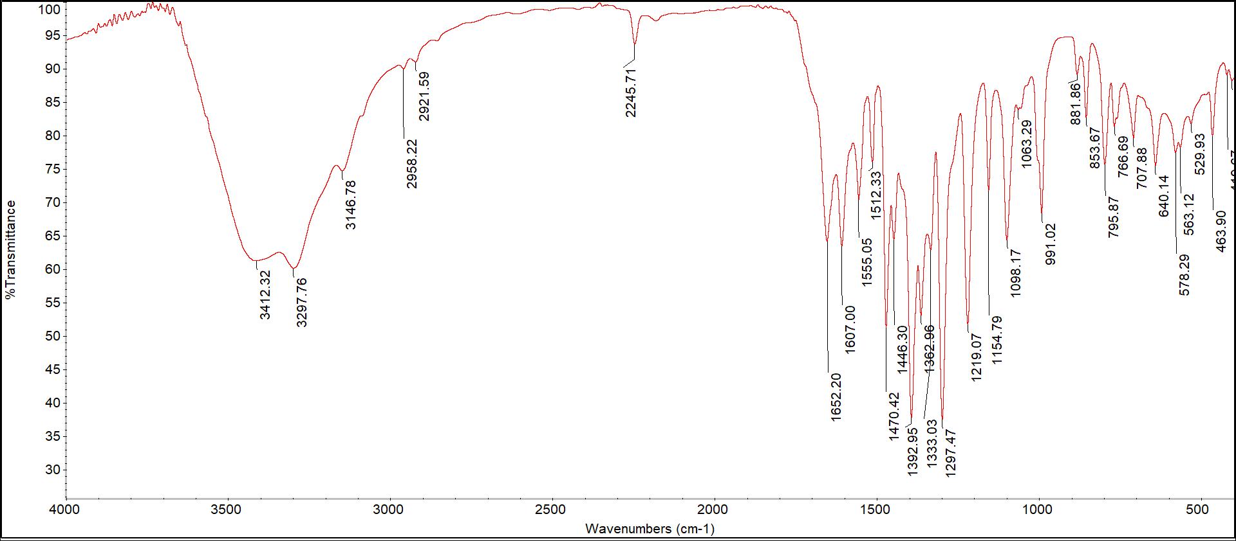
Figure S10. IR spectrum of compound 10

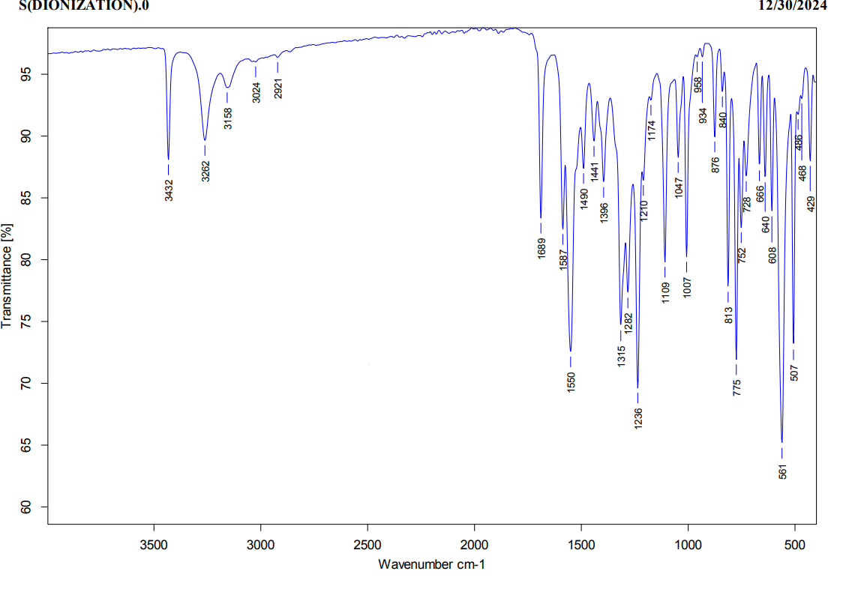
Figure S11. IR spectrum of compound 11

Figure S12. IR spectrum of compound 12

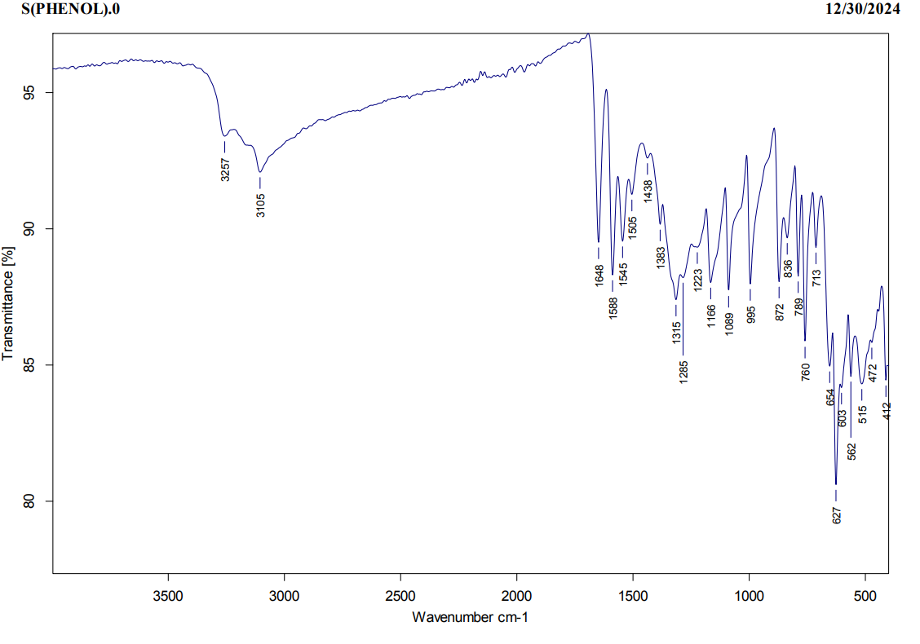
Figure S13. IR spectrum of compound 13
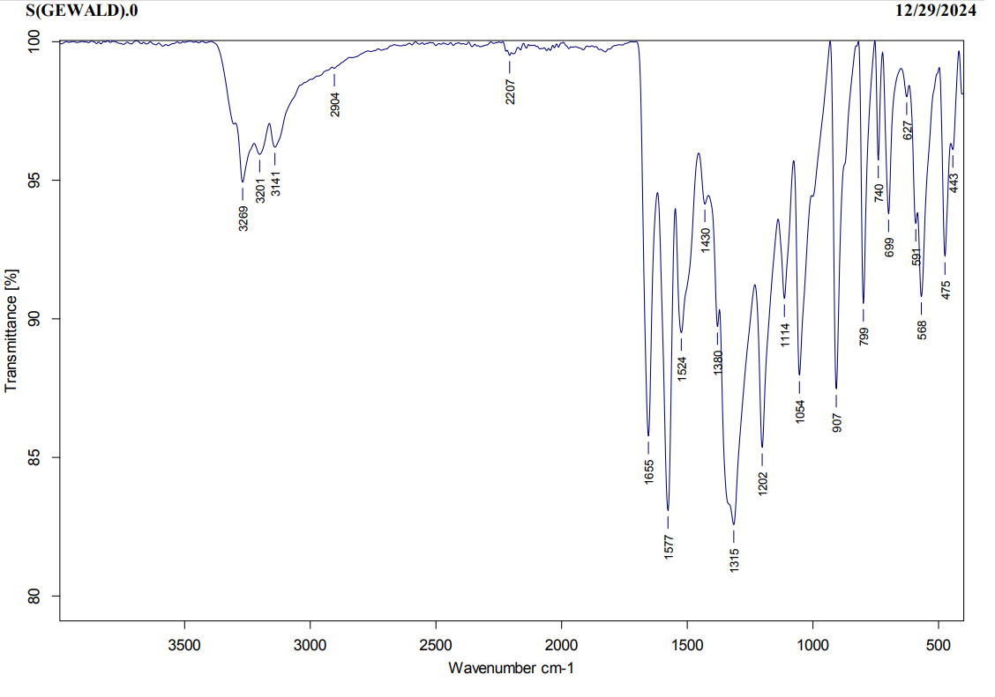
Figure S14. IR spectrum of compound 14

Figure S15. IR spectrum of compound 15

Figure S16. IR spectrum of compound 16

Figure S17. IR spectrum of compound 17

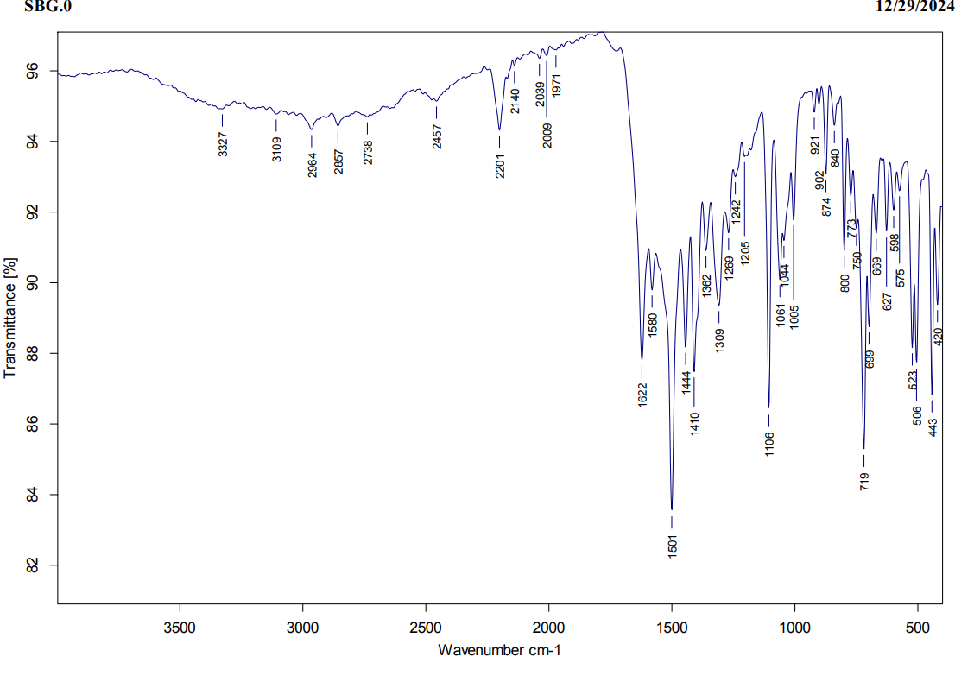
Figure S18. IR spectrum of compound 18

Figure S19. IR spectrum of compound 19

¹H NMR spectral data of the target compounds

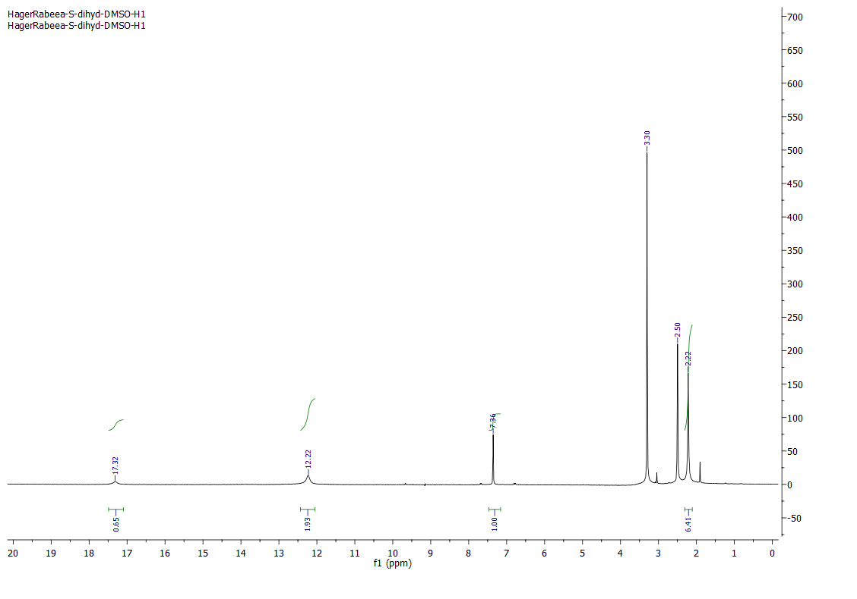
Figure S21. ¹H NMR (500 MHz, DMSO-d₆) spectrum of compound 2

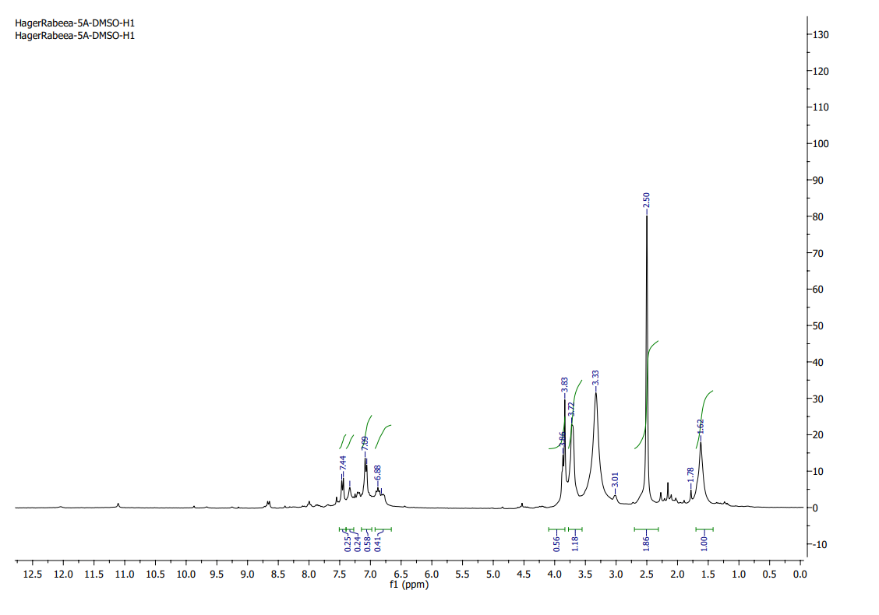
Figure S22. ¹H NMR (500 MHz, DMSO-d₆) spectrum of compound 4
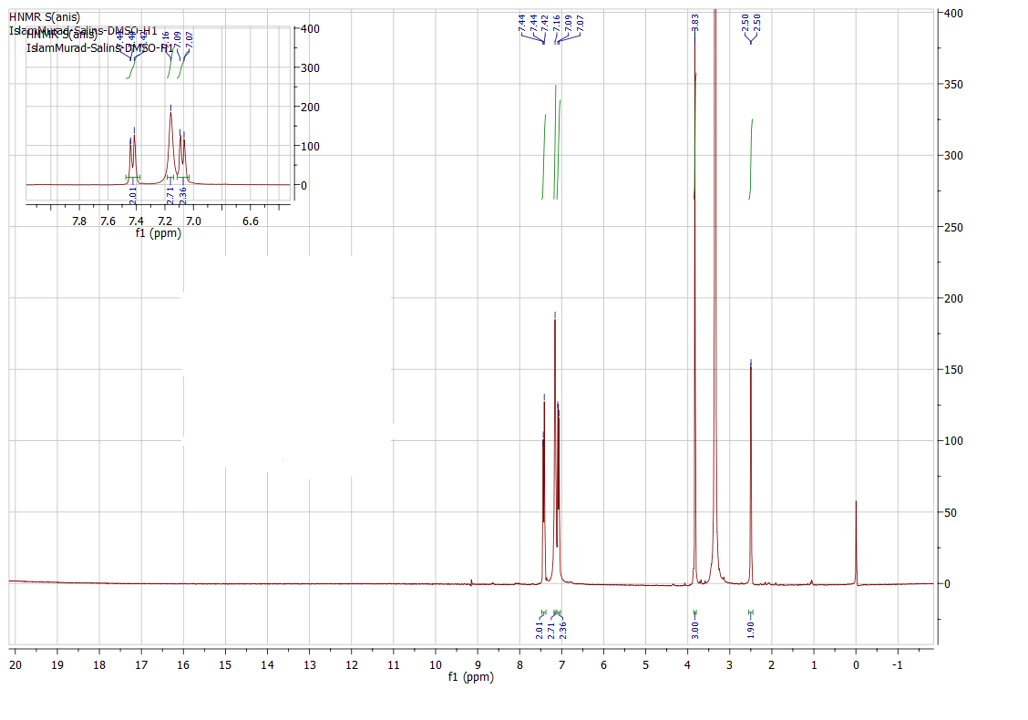
Figure S23. ¹H NMR (500 MHz, DMSO-d₆) spectrum of compound 5

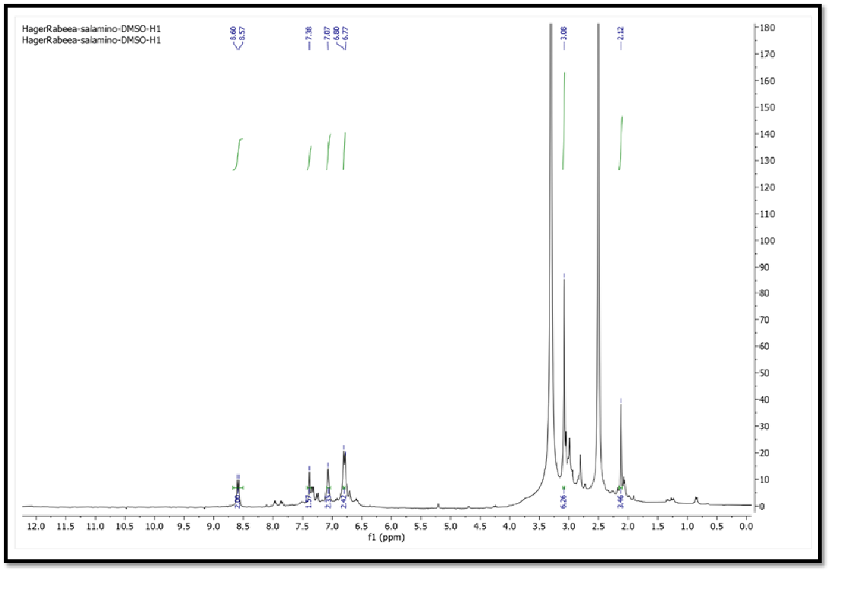
Figure S24. ¹H NMR (500 MHz, DMSO-d₆) spectrum of compound 6
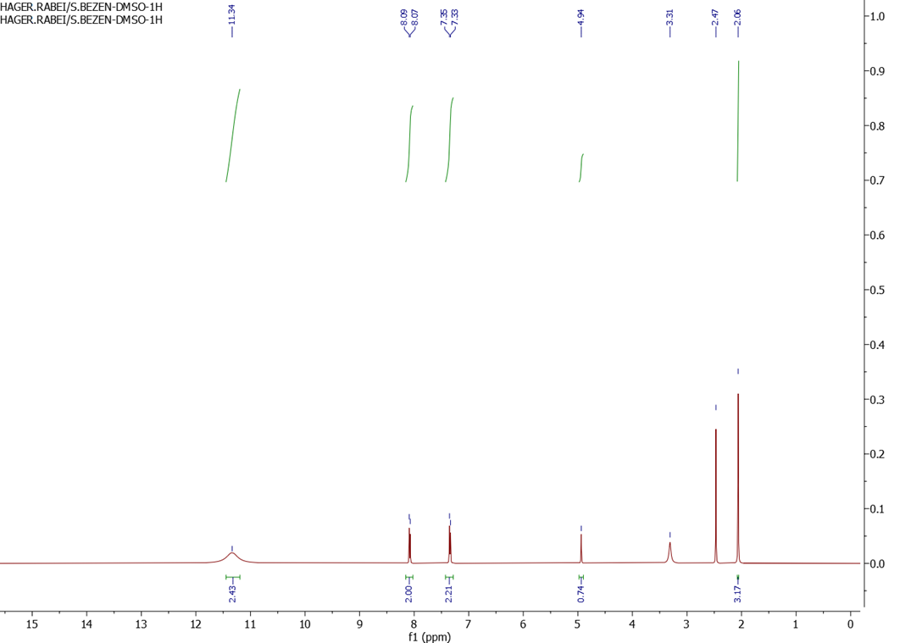
Figure S25. ¹H NMR (500 MHz, DMSO-d₆) spectrum of compound 7

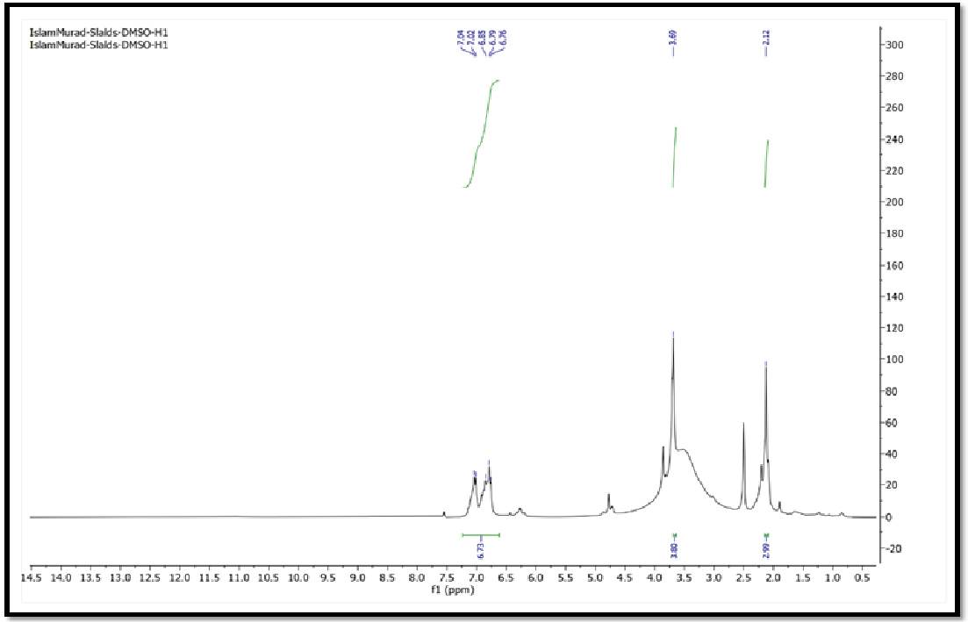
Figure S26. ¹H NMR (500 MHz, DMSO-d₆) spectrum of compound 8

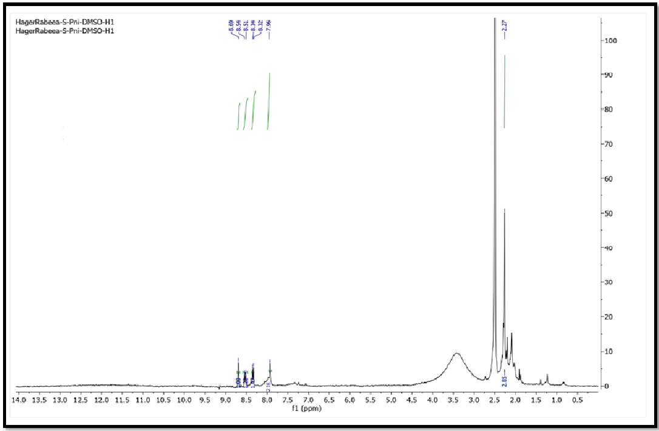
Figure S27. ¹H NMR (500 MHz, DMSO-d₆) spectrum of compound 9

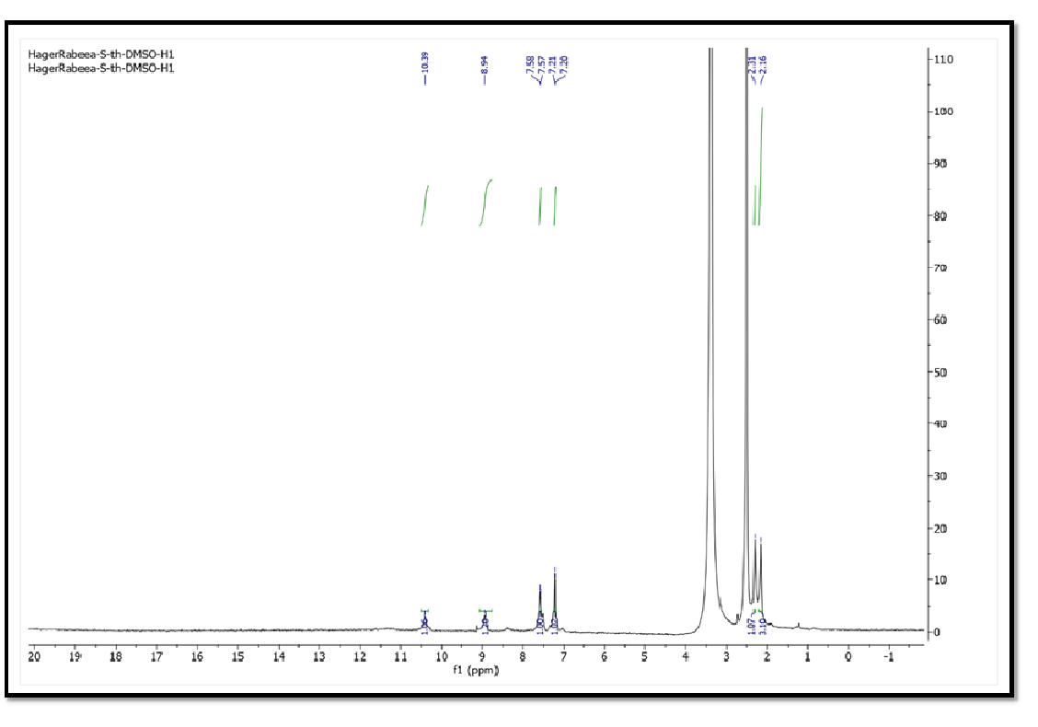
Figure S28. ¹H NMR (500 MHz, DMSO-d₆) spectrum of compound 10
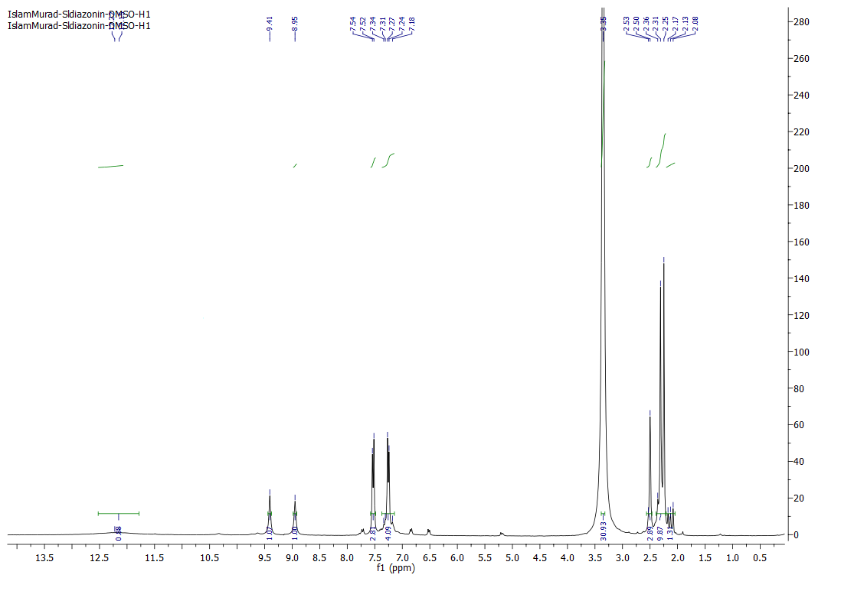
Figure S29. ¹H NMR (500 MHz, DMSO-d₆) spectrum of compound 11
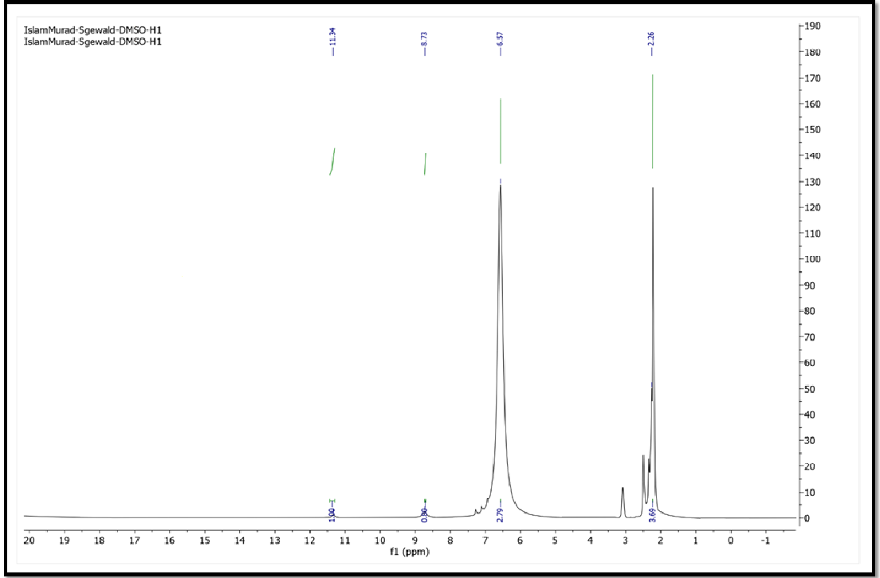
Figure S30. ¹H NMR (500 MHz, DMSO-d₆) spectrum of compound 14
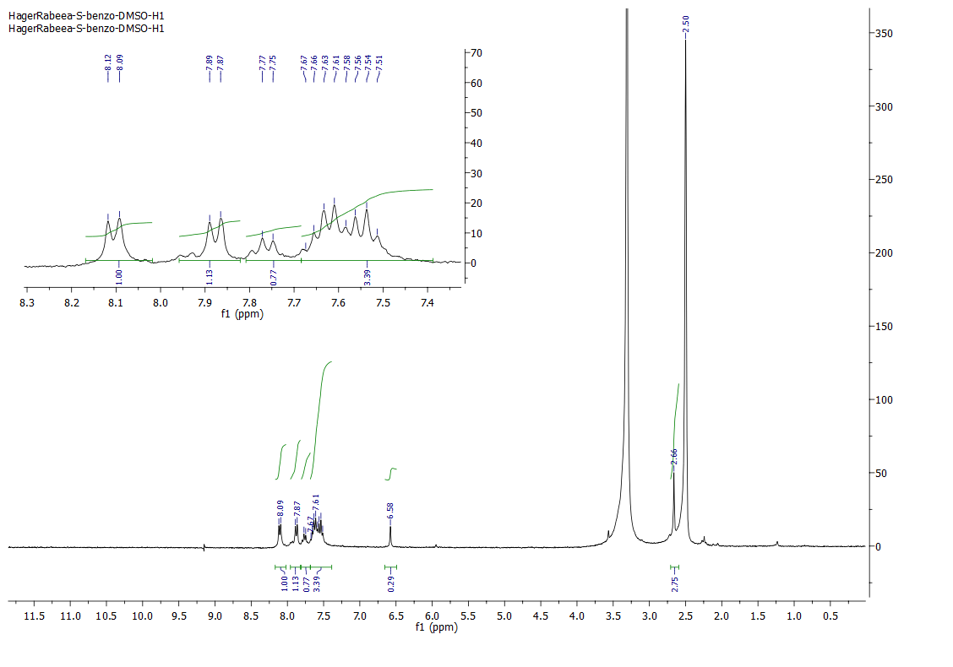
Figure S31. ¹H NMR (500 MHz, DMSO-d₆) spectrum of compound 15

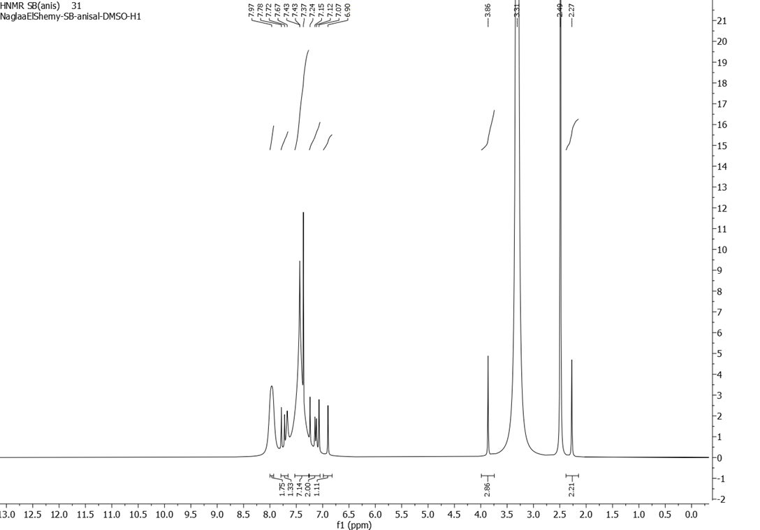
Figure S32. ¹H NMR (500 MHz, DMSO-d₆) spectrum of compound 16
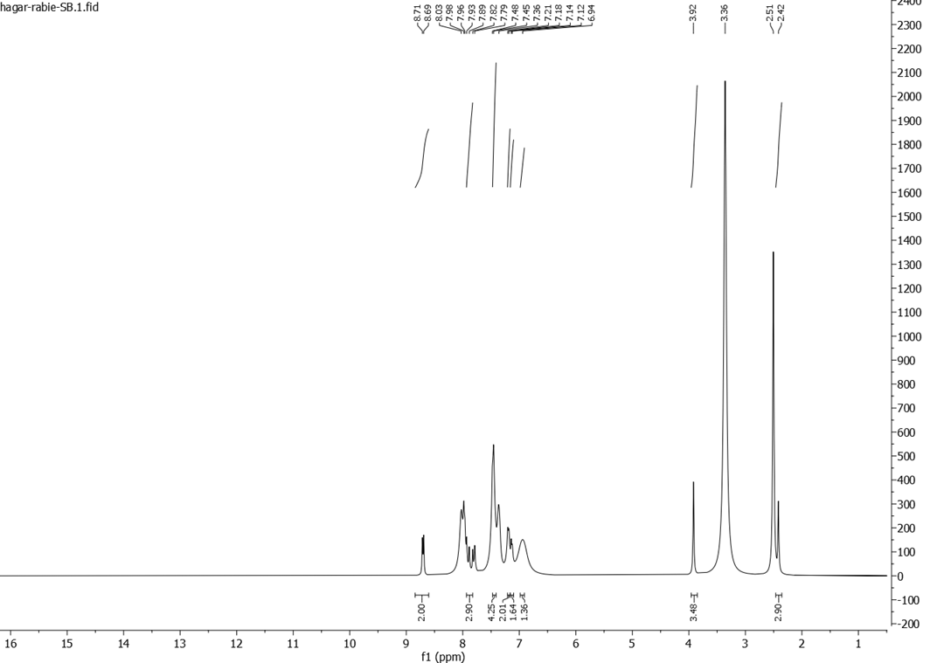
Figure S33. ¹H NMR (500 MHz, DMSO-d₆) spectrum of compound 17
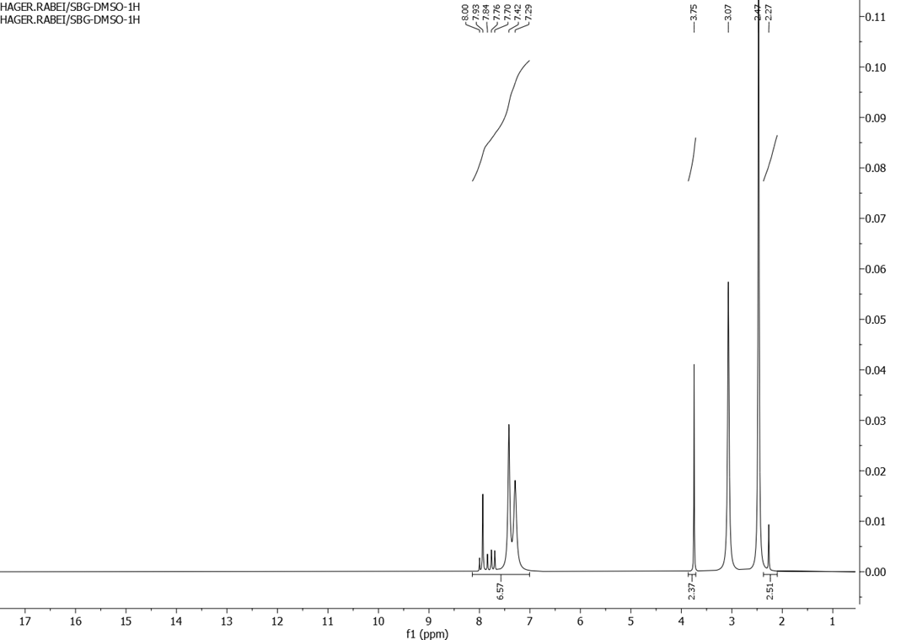
Figure S34. ¹H NMR (500 MHz, DMSO-d₆) spectrum of compound 18

Mass fragmentation of the target compounds
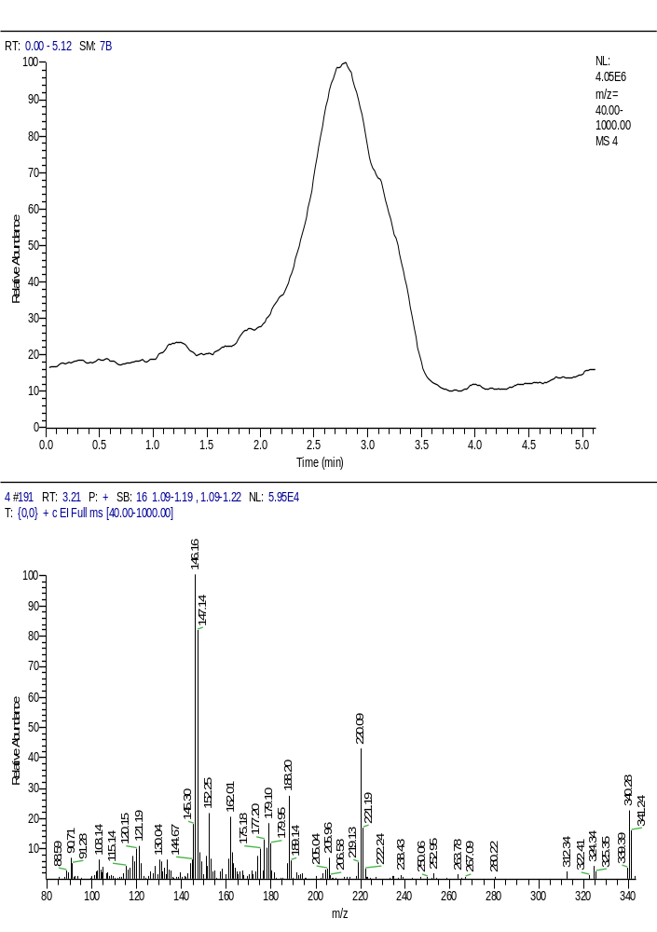
Figure S35. Mass fragmentation of compound 4

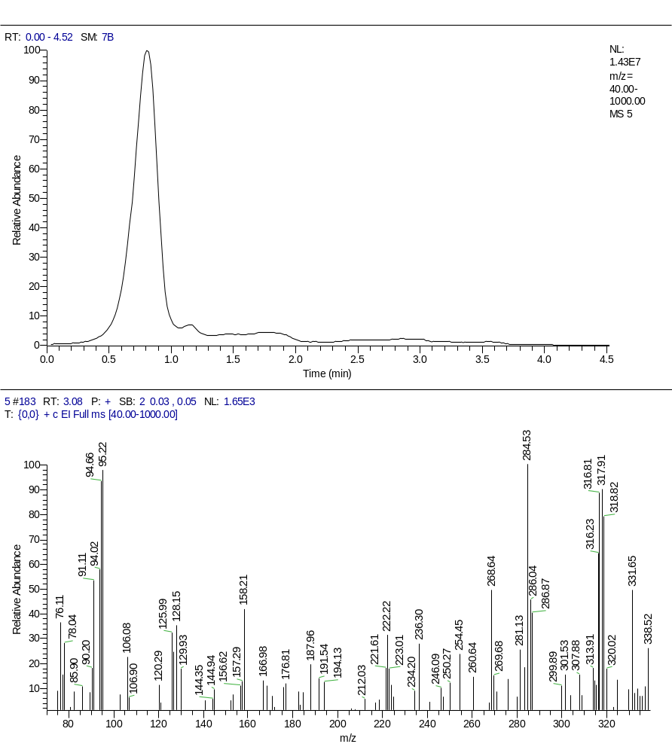
Figure S36. Mass fragmentation of compound 5

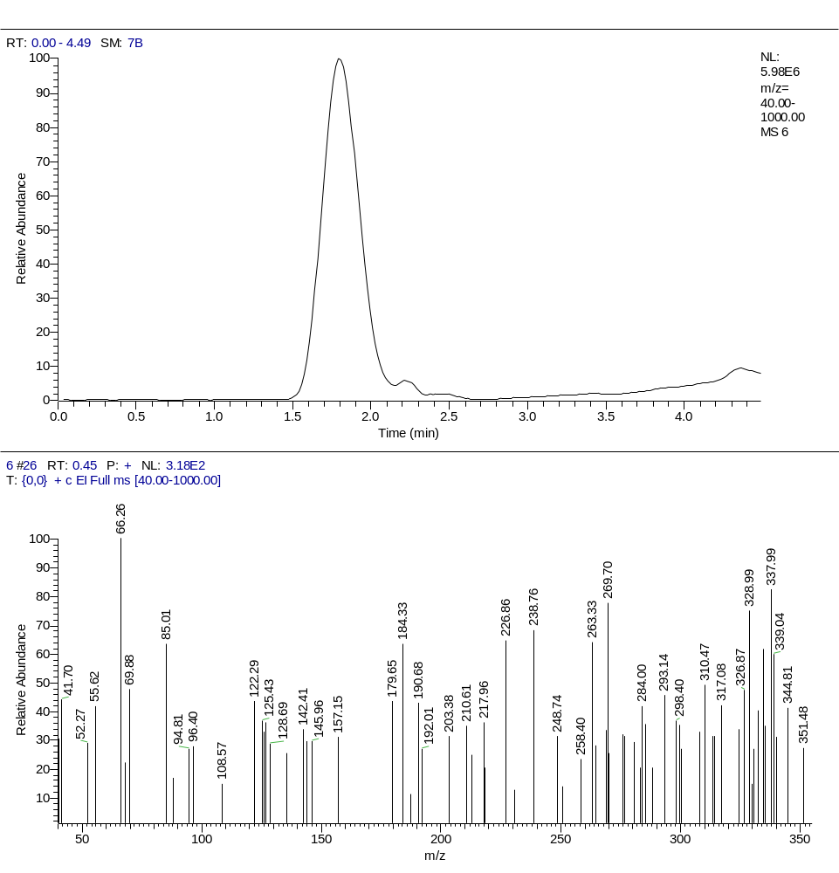
Figure S37. Mass fragmentation of compound 6

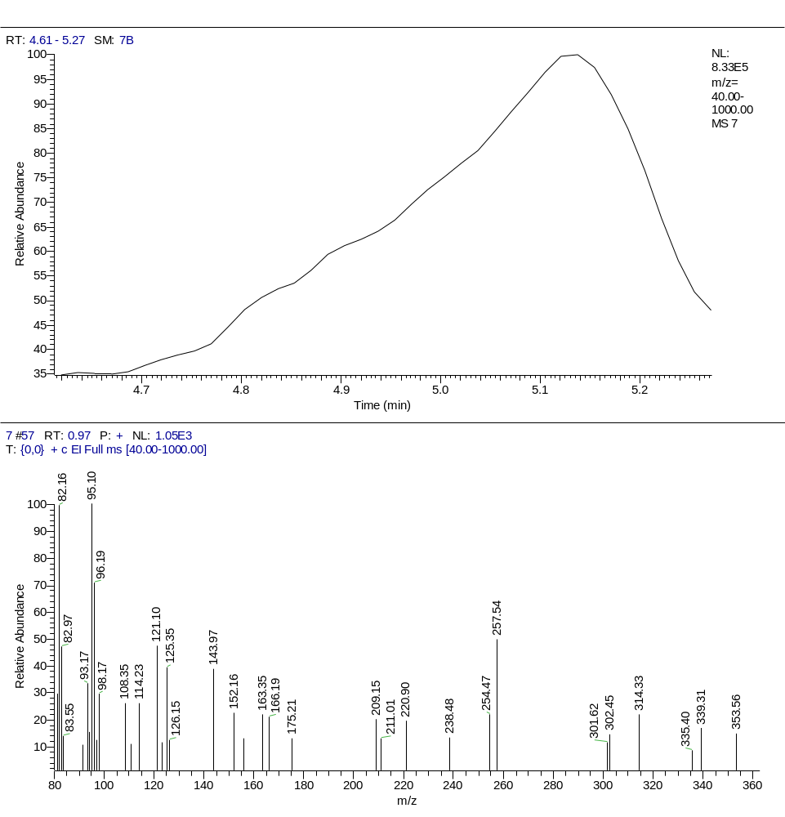
Figure S38. Mass fragmentation of compound 7

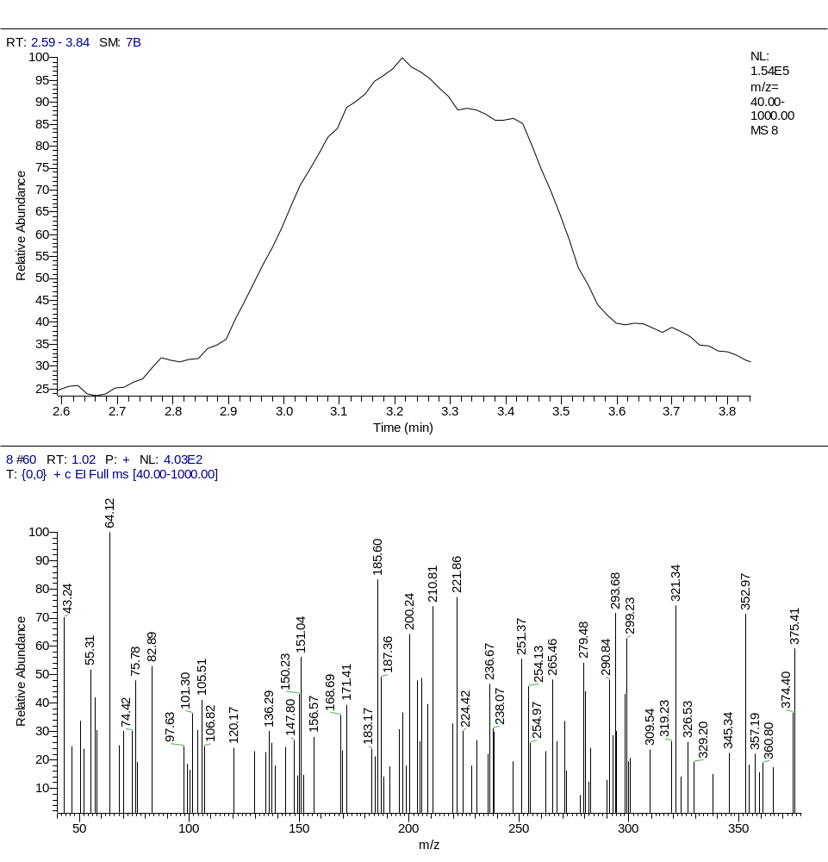
Figure S39. Mass fragmentation of compound 8

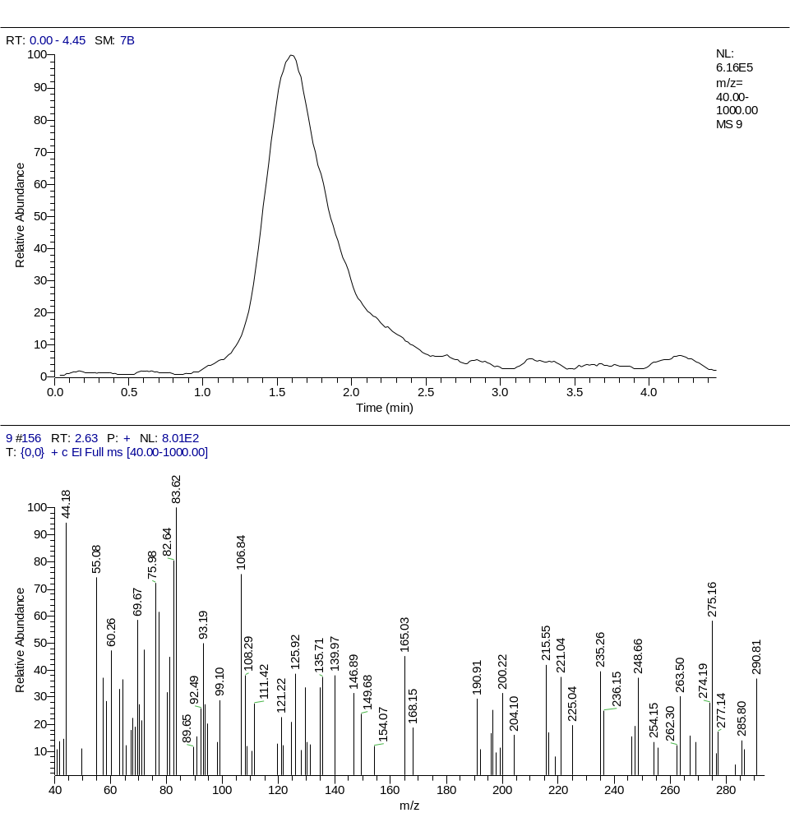
Figure S40. Mass fragmentation of compound 9

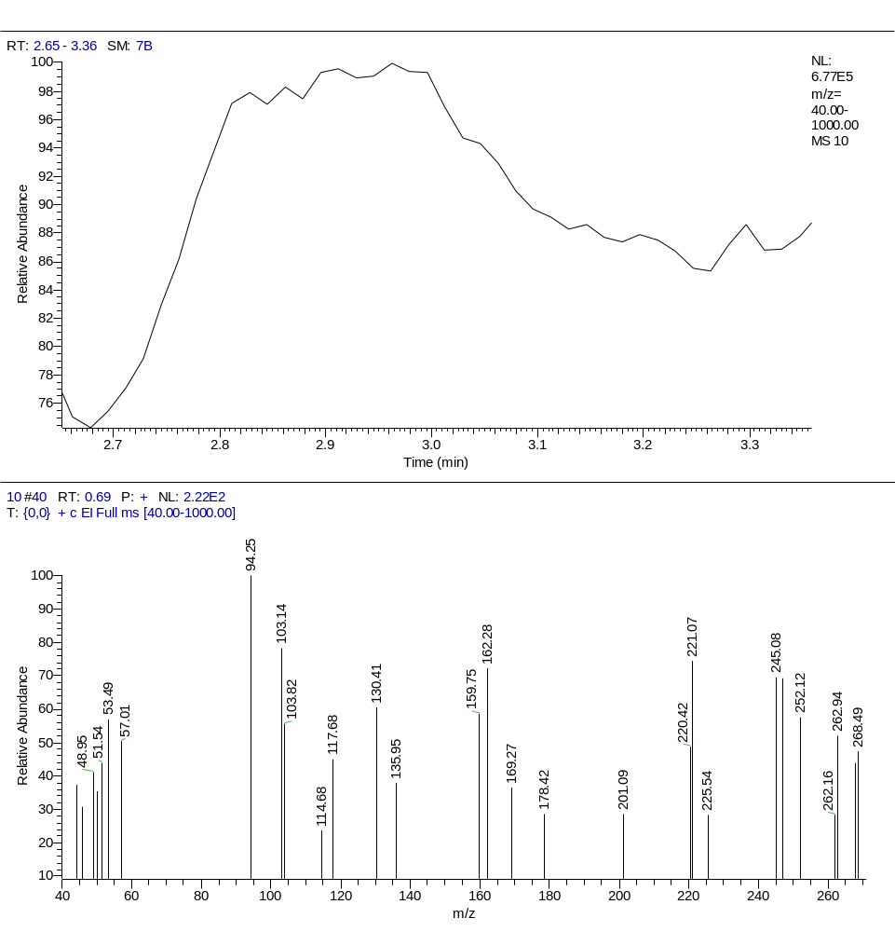
Figure S41. Mass fragmentation of compound 10

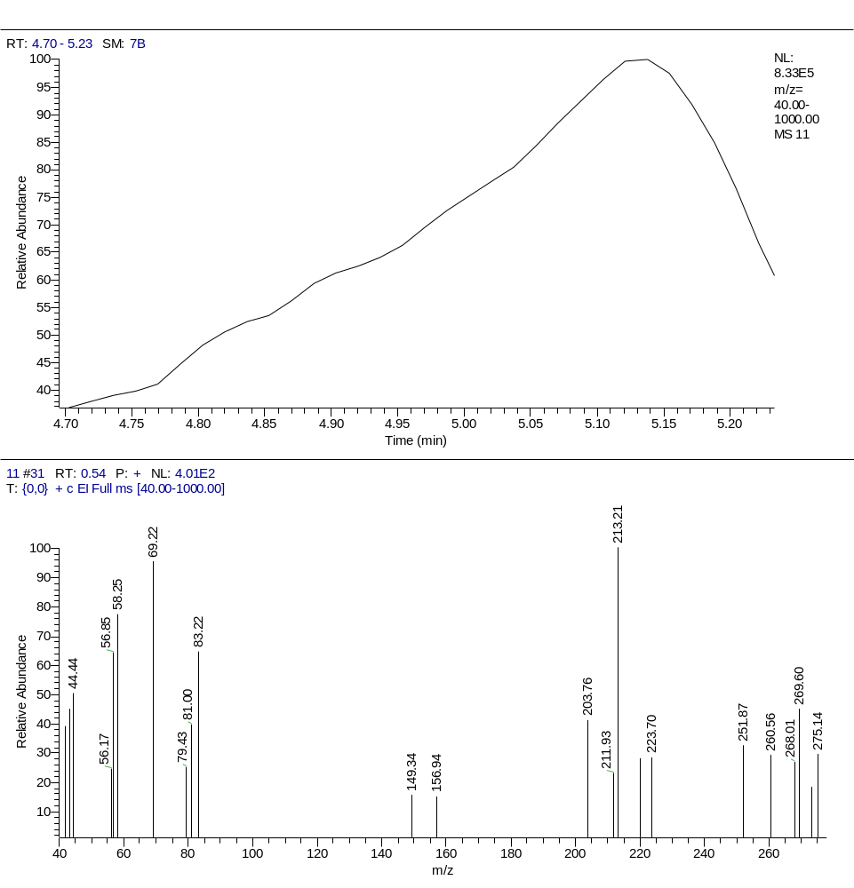
Figure S42. Mass fragmentation of compound 11

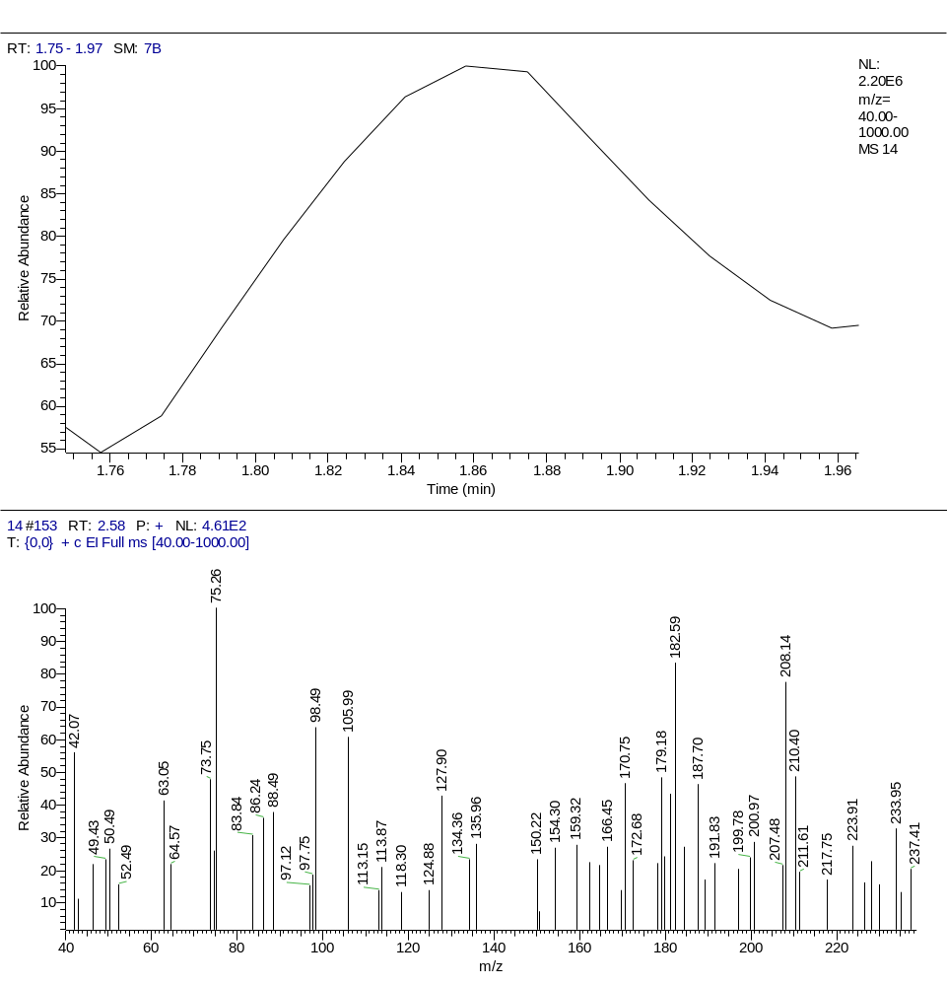
Figure S43. Mass fragmentation of compound 14

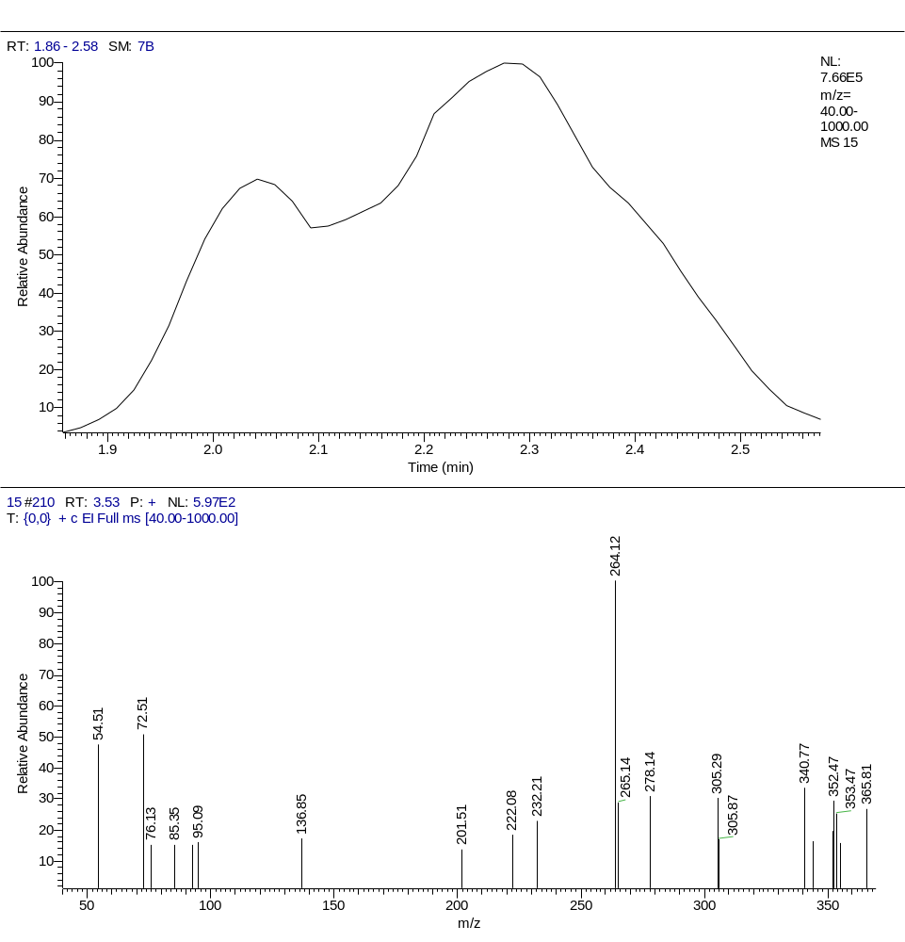
Figure S44. Mass fragmentation of compound 15

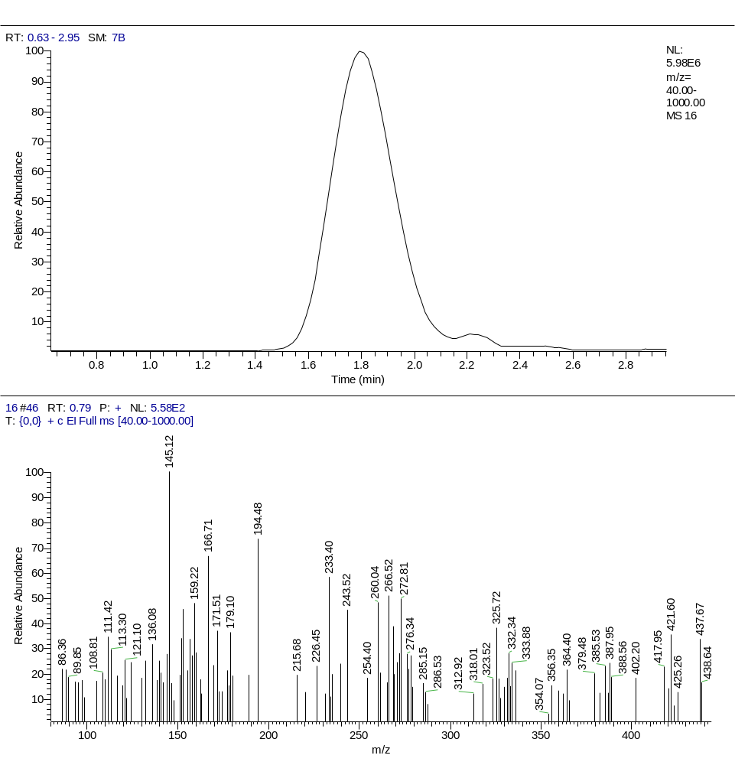
Figure S45. Mass fragmentation of compound 16

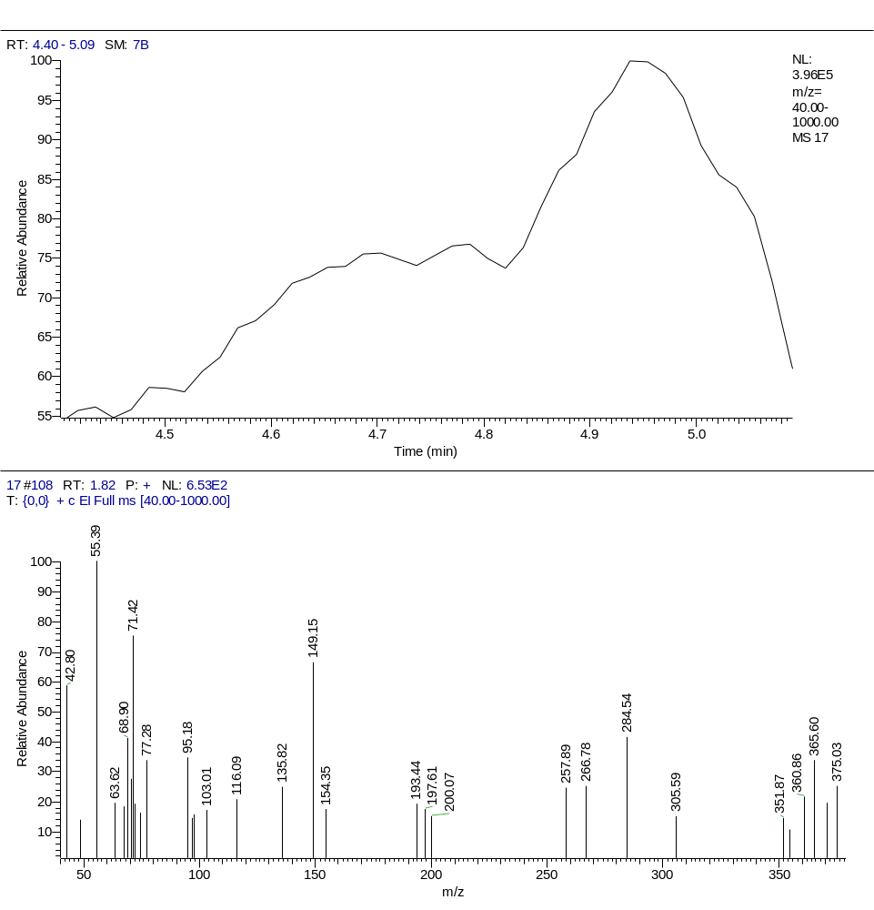
Figure S46. Mass fragmentation of compound 17

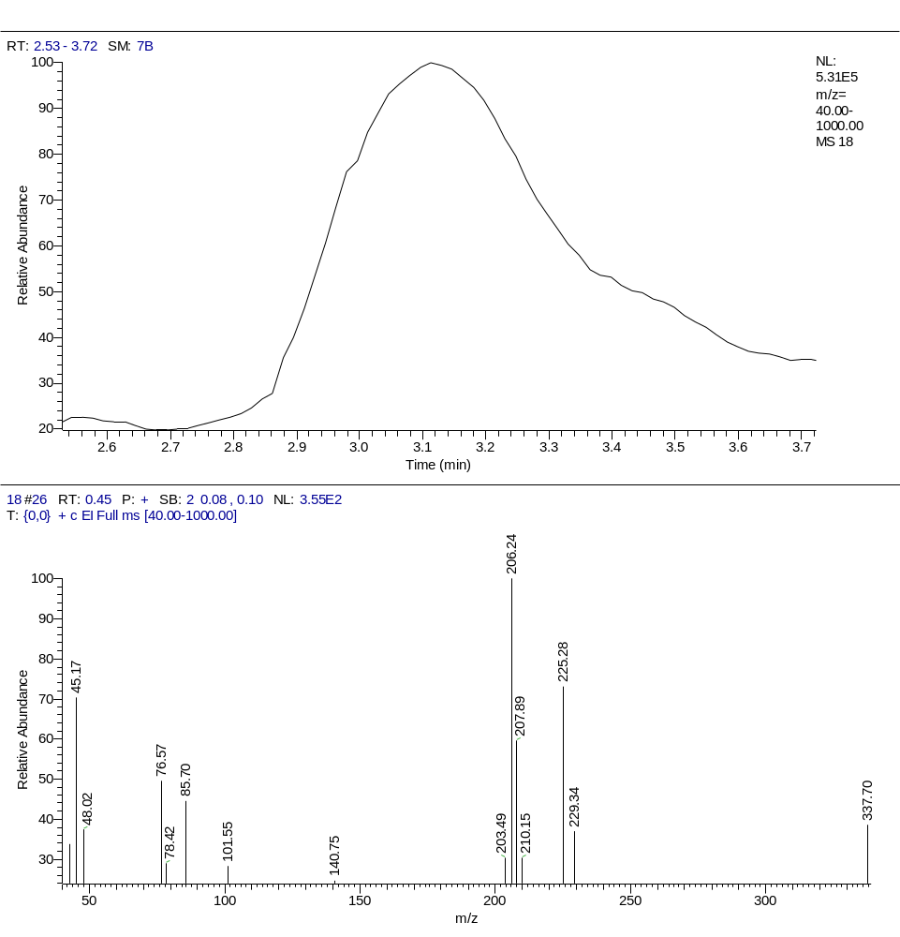
Figure S47. Mass fragmentation of compound 18

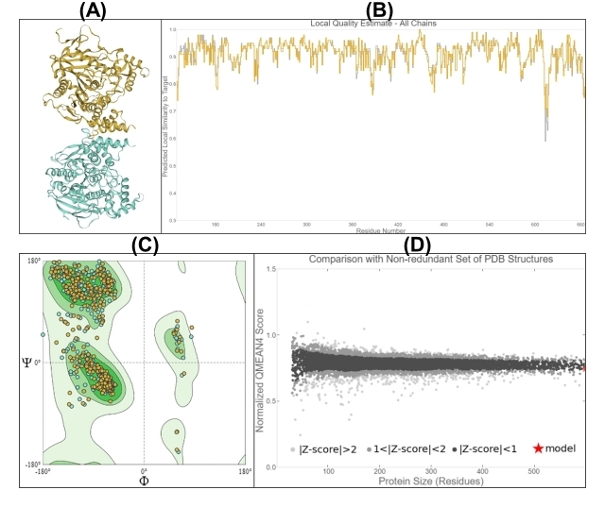
Figure S47. Quality estimate parameters for modeled Acetylcholine Esterase (AChE) protein. (A) Modelled AChE 3D Structure, (B) local model quality estimate, (C) Ramachandran plot, and (D) comparison with a non-redundant set of PDB structures. This figure was generated using SWISS-MODEL (online tool, URL: https://swissmodel.expasy.org).

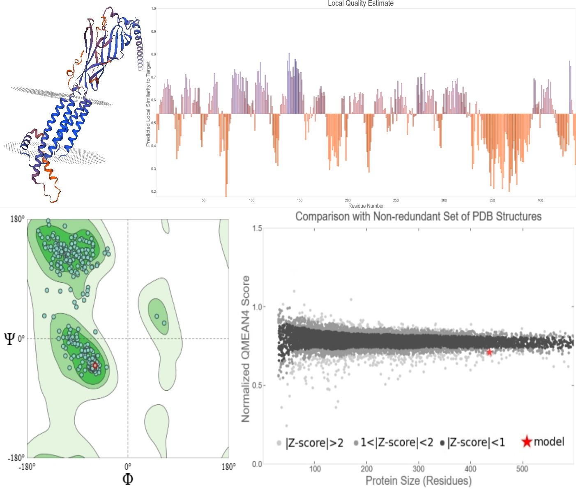
Figure S48. Quality estimate parameters for modeled nicotinic acetylcholine receptor. (A) Modelled nAChR 3D Structure, (B) local model quality estimate, (C) Ramachandran plot, and (D) comparison with a non-redundant set of PDB structures. This figure was generated using SWISS-MODEL (online tool, URL: https://swissmodel.expasy.org).

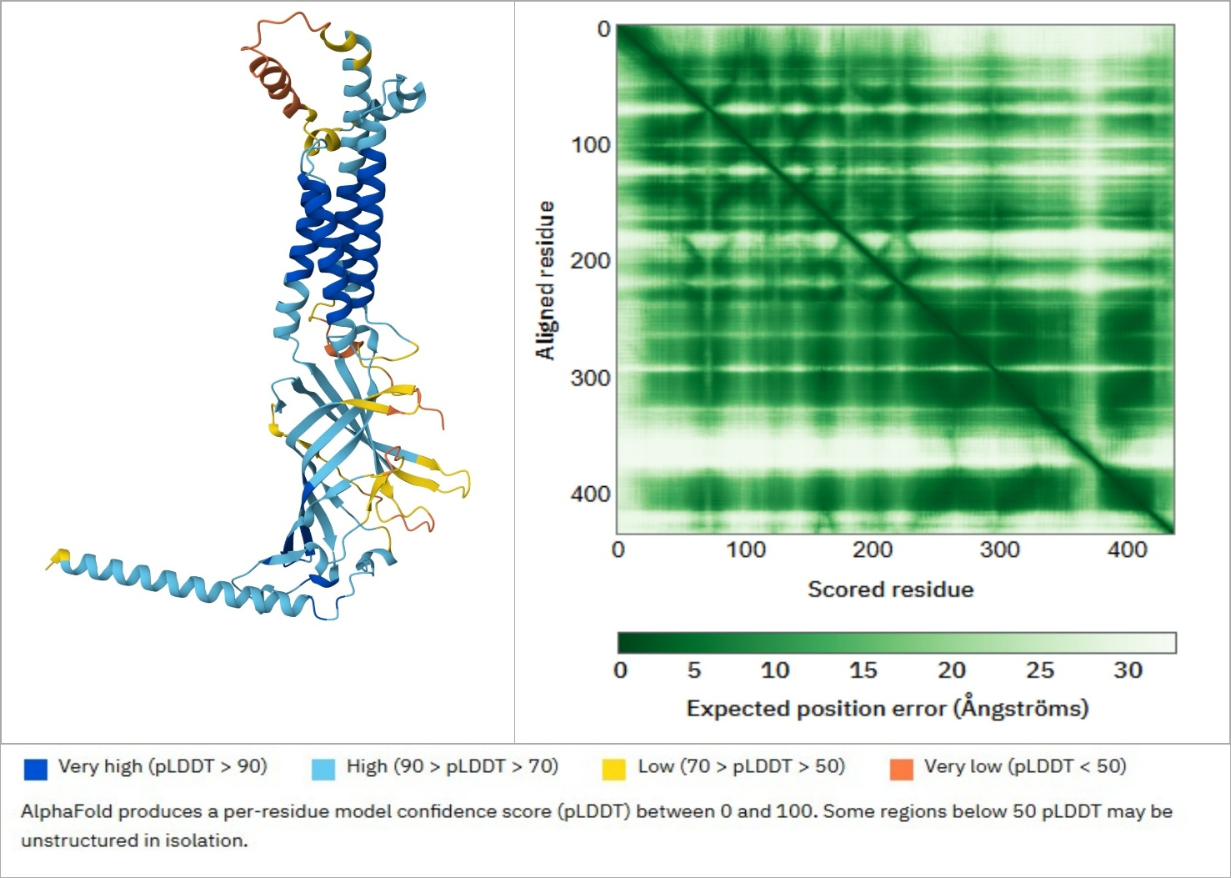
Figure S49. AlphaFold Model of the Nicotinic Acetylcholine Receptor (nAChR) from Culex quinquefasciatus. This figure presents the predicted three-dimensional structure and confidence metrics of the Culex quinquefasciatus nicotinic acetylcholine receptor (nAChR) obtained using AlphaFold. (Left Panel): The predicted structural model is color-coded based on per-residue confidence scores (pLDDT). Regions with very high confidence (pLDDT > 90) are shown in dark blue, high-confidence regions (70 < pLDDT < 90) in light blue, lower-confidence regions (50 < pLDDT < 70) in yellow, and regions with very low confidence (pLDDT < 50) in orange. Regions with lower confidence may be flexible or disordered in isolation. (Right Panel): The predicted alignment error (PAE) matrix indicates the expected positional error in Ångströms for each residue pair. The diagonal represents intra-domain confidence, while off-diagonal regions suggest inter-domain flexibility or uncertainty. Dark green indicates low expected error (higher confidence), whereas lighter shades denote higher uncertainty. This model provides structural insights into the Culex quinquefasciatus nAChR, which plays a critical role in neurotransmission and is a potential target for insecticides.

Table S1. 2D interaction profiles of the 19 synthesized compounds targeting acetylcholinesterase (AChE) in Culex pipiens, compared with the conventional AChE inhibitor chlorpyrifos
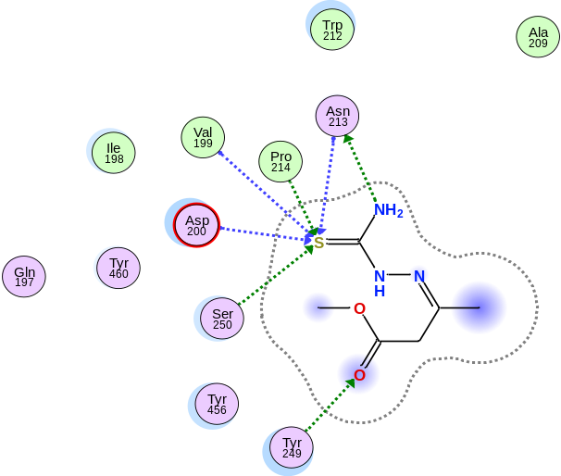  1 | 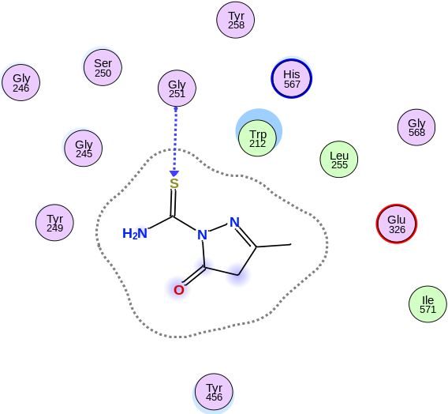  2
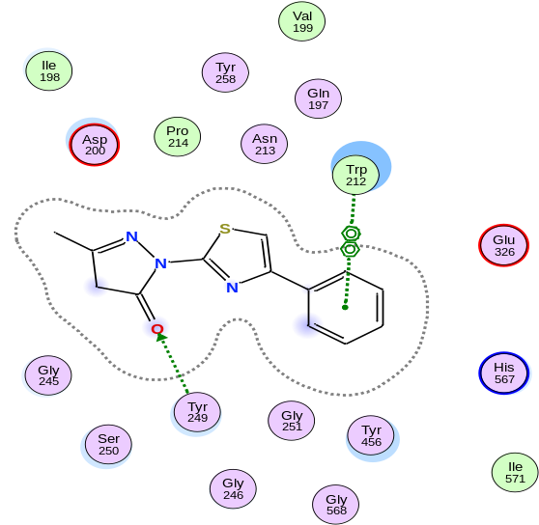  3 | 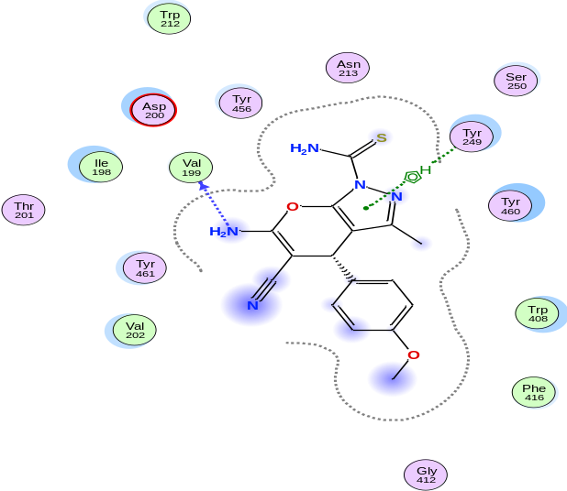  4
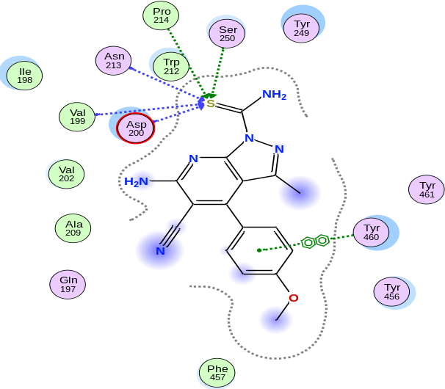  5 | 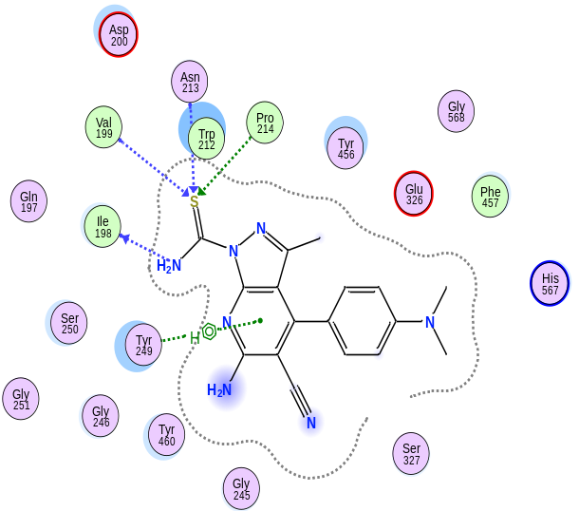  6
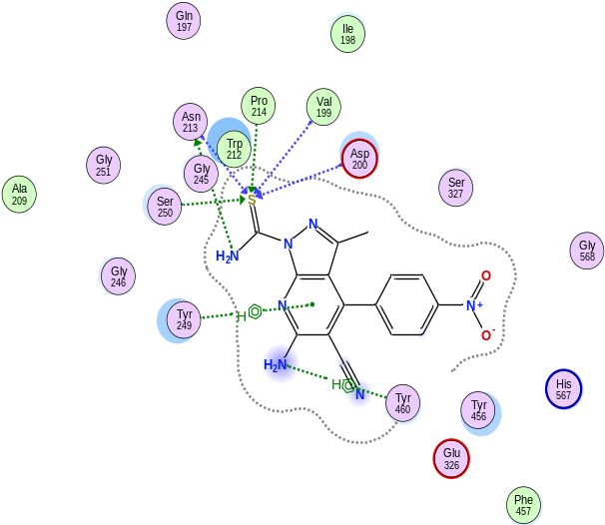  7 | 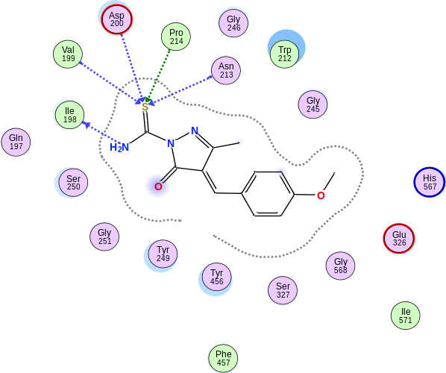  8
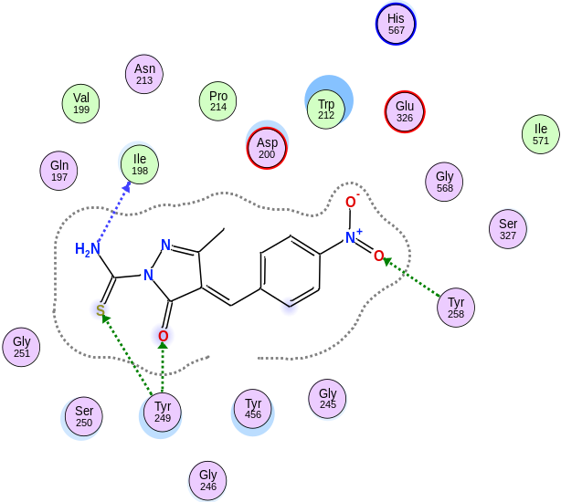  9 | 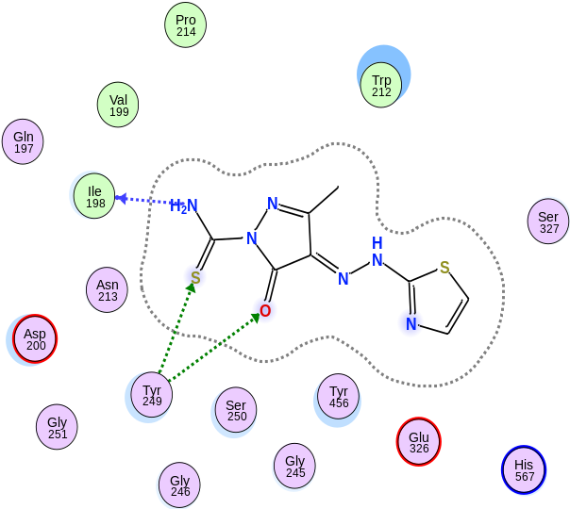  10
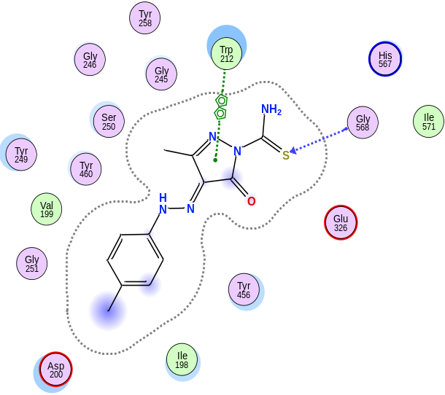  11 | 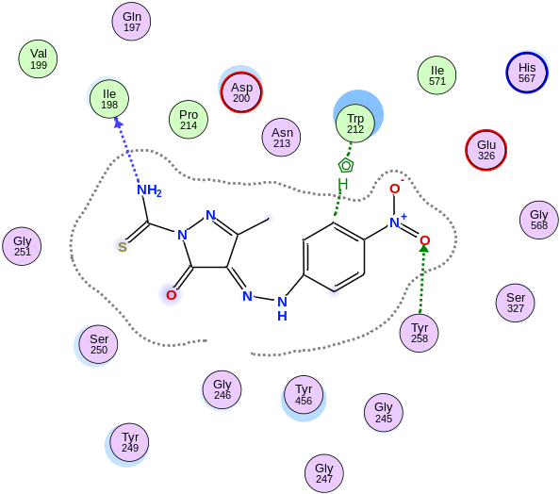  12
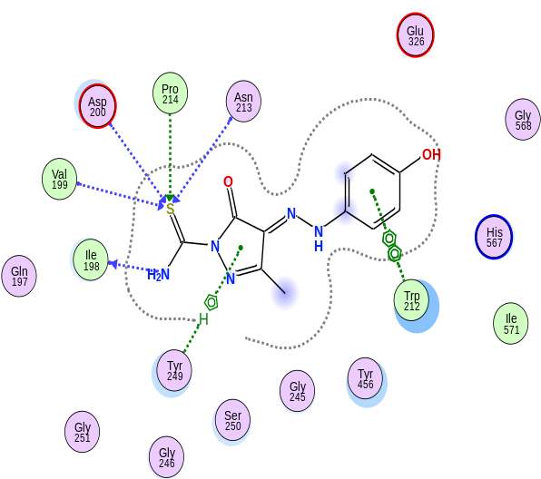  13 | 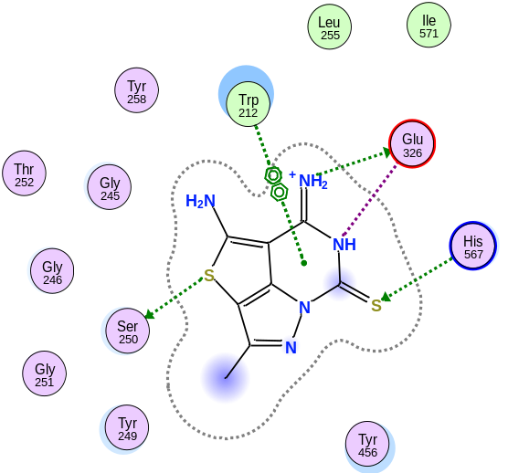  14
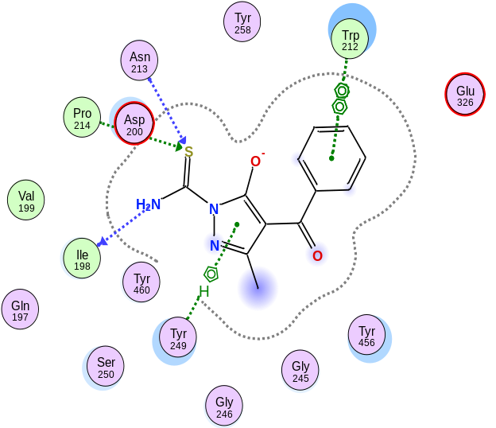  15 | 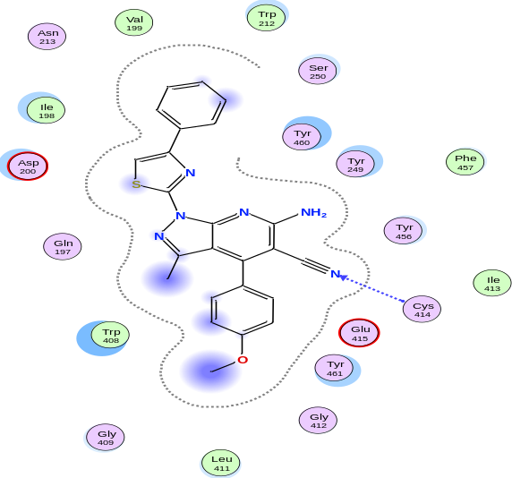  16
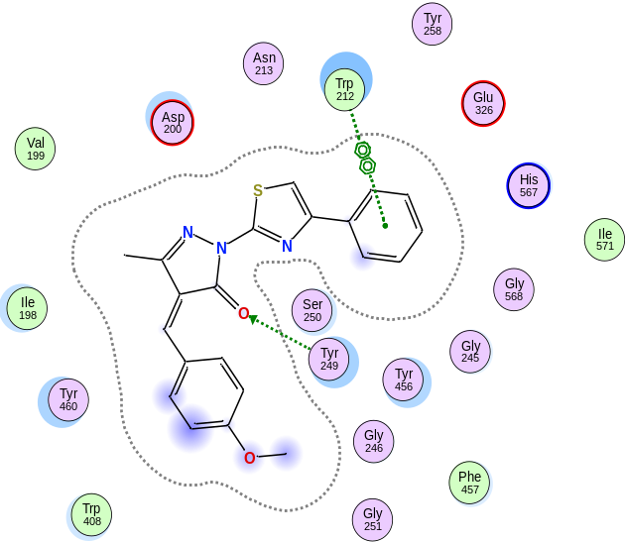  17 | 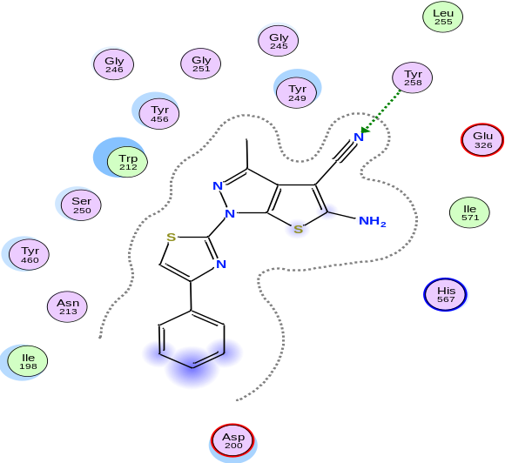  18
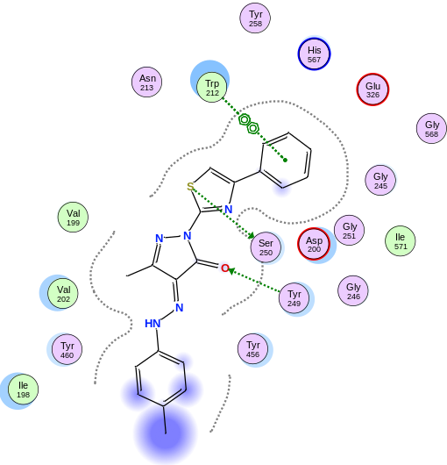  19 | 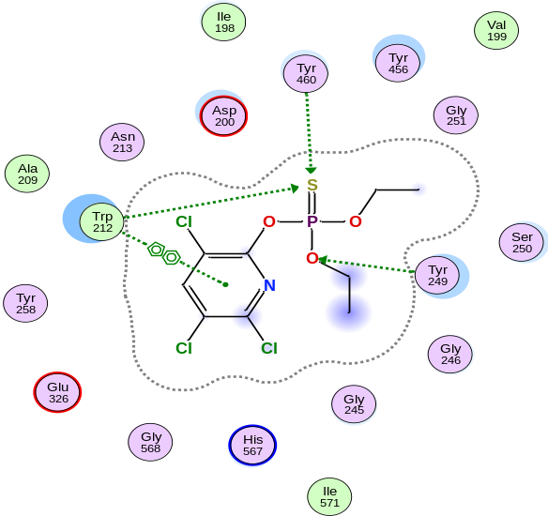  Chlorpyrifos

Table S2. Molecular docking interaction profiles of 19 synthesized compounds with acetylcholinesterase (AChE) in Culex pipiens, showing ligand–receptor interacting atoms, interacting residues, interaction types, hydrogen bond distances, and binding energies (E, kcal/mol). Data are compared with the conventional AChE inhibitor chlorpyrifos
Ligand | Ligand interacting atoms | Receptor  Interacting atoms | Receptor  Interacting  Residues | Interaction  Bond  Type | Distance | E (kcal/mol)
1 | N 21 | OD1 | ASN 213 (B) | H-donor | 3.04 | -0.8
1 | O 11 | OH | TYR 249 (B) | H-acceptor | 3 | -0.8
1 | S 20 | CA | VAL 199 (B) | H-acceptor | 4.43 | -0.9
1 | S 20 | N | ASP 200 (B) | H-acceptor | 4.16 | -2.5
1 | S 20 | CA | ASN 213 (B) | H-acceptor | 3.86 | -0.8
1 | S 20 | CD | PRO 214 (B) | H-acceptor | 3.85 | -0.5
1 | S 20 | CB | SER 250 (B) | H-acceptor | 3.68 | -0.9
2 | S 14 | CA | GLY 251 (B) | H-acceptor | 3.54 | -0.7
3 | O 12 | OH | TYR 249 (B) | H-acceptor | 2.9 | -1.5
3 | 6-ring | 5-ring | TRP 212 (B) | pi-pi | 4.34
3 | 6-ring | 6-ring | TRP 212 (B) | pi-pi | 4.01
4 | N 17 | O | VAL 199 (B) | H-donor | 2.88 | -0.9
4 | 5-ring | CE1 | TYR 249 (B) | pi-H | 3.77 | -0.8
5 | S 19 | CA | VAL 199 (B) | H-acceptor | 4.31 | -0.5
5 | S 19 | N | ASP 200 (B) | H-acceptor | 4.08 | -0.8
5 | S 19 | CA | ASN 213 (B) | H-acceptor | 4.16 | -1.2
5 | S 19 | CD | PRO 214 (B) | H-acceptor | 4.03 | -0.7
5 | S 19 | CB | SER 250 (B) | H-acceptor | 3.54 | -0.5
5 | 6-ring | 6-ring | TYR 460 (B) | pi-pi | 4.22
6 | N 20 | O | ILE 198 (B) | H-donor | 2.84 | -1.6
6 | S 19 | CA | VAL 199 (B) | H-acceptor | 4.2 | -0.9
6 | S 19 | CA | ASN 213 (B) | H-acceptor | 3.9 | -1
6 | S 19 | CD | PRO 214 (B) | H-acceptor | 3.45 | -1.1
6 | 6-ring | CE1 | TYR 249 (B) | pi-H | 3.91 | -0.9
7 | N 20 | OD1 | ASN 213 (B) | H-donor | 2.71 | -1.2
7 | S 19 | CA | VAL 199 (B) | H-acceptor | 4.2 | -0.9
7 | S 19 | N | ASP 200 (B) | H-acceptor | 4.1 | -1.7
7 | S 19 | CA | ASN 213 (B) | H-acceptor | 3.81 | -0.8
7 | S 19 | CD | PRO 214 (B) | H-acceptor | 3.57 | -0.6
7 | S 19 | CB | SER 250 (B) | H-acceptor | 3.8 | -0.7
7 | N 16 | 6-ring | TYR 460 (B) | H-pi | 4.54 | -0.6
7 | 6-ring | CE1 | TYR 249 (B) | pi-H | 3.9 | -0.7
8 | N 13 | O | ILE 198 (B) | H-donor | 3.1 | -0.8
8 | S 12 | CA | VAL 199 (B) | H-acceptor | 4.2 | -1
8 | S 12 | N | ASP 200 (B) | H-acceptor | 4.17 | -0.6
8 | S 12 | CA | ASN 213 (B) | H-acceptor | 3.9 | -1.1
8 | S 12 | CD | PRO 214 (B) | H-acceptor | 3.56 | -1.1
9 | N 13 | O | ILE 198 (B) | H-donor | 3.22 | -1.7
9 | O 10 | OH | TYR 249 (B) | H-acceptor | 3.06 | -1.3
9 | S 12 | CE1 | TYR 249 (B) | H-acceptor | 3.88 | -0.5
9 | O 30 | OH | TYR 258 (B) | H-acceptor | 3.23 | -0.7
10 | N 13 | O | ILE 198 (B) | H-donor | 3 | -3.1
10 | O 10 | OH | TYR 249 (B) | H-acceptor | 3.36 | -0.5
10 | S 12 | CE1 | TYR 249 (B) | H-acceptor | 3.96 | -0.5
11 | S 12 | CA | GLY 568 (B) | H-acceptor | 3.91 | -1.2
11 | 5-ring | 5-ring | TRP 212 (B) | pi-pi | 4.24
12 | N 13 | O | ILE 198 (B) | H-donor | 3.34 | -1.2
12 | O 31 | OH | TYR 258 (B) | H-acceptor | 3.15 | -1
12 | C 25 | 5-ring | TRP 212 (B) | H-pi | 3.61 | -0.6
13 | N 13 | O | ILE 198 (B) | H-donor | 2.87 | -1.3
13 | S 12 | CA | VAL 199 (B) | H-acceptor | 4.15 | -1
13 | S 12 | N | ASP 200 (B) | H-acceptor | 4.11 | -0.5
13 | S 12 | CA | ASN 213 (B) | H-acceptor | 3.98 | -1.1
13 | S 12 | CD | PRO 214 (B) | H-acceptor | 3.65 | -1.1
13 | 5-ring | CE1 | TYR 249 (B) | pi-H | 4.19 | -0.6
13 | 6-ring | 5-ring | TRP 212 (B) | pi-pi | 3.96
13 | 6-ring | 6-ring | TRP 212 (B) | pi-pi | 3.82
14 | S 3 | OG | SER 250 (B) | H-donor | 3.18 | -0.7
14 | N 21 | OE1 | GLU 326 (B) | H-donor | 3.11 | -2.8
14 | S 20 | CD2 | HIS 567 (B) | H-acceptor | 3.71 | -1.2
14 | N 18 | OE1 | GLU 326 (B) | Ionic | 3.91 | -0.7
14 | N 21 | OE1 | GLU 326 (B) | Ionic | 3.11 | -3.8
14 | 6-ring | 5-ring | TRP 212 (B) | pi-pi | 4.14
14 | 6-ring | 6-ring | TRP 212 (B) | pi-pi | 4.11
15 | N 13 | O | ILE 198 (B) | H-donor | 3.13 | -1.7
15 | S 12 | CA | ASN 213 (B) | H-acceptor | 3.75 | -1.4
15 | S 12 | CD | PRO 214 (B) | H-acceptor | 4.09 | -0.7
15 | 5-ring | CE1 | TYR 249 (B) | pi-H | 4.03 | -0.5
15 | 6-ring | 5-ring | TRP 212 (B) | pi-pi | 3.98
15 | 6-ring | 6-ring | TRP 212 (B) | pi-pi | 4.12
16 | N 50 | N | CYS 414 (B) | H-acceptor | 3.67 | -1.2
17 | O 16 | OH | TYR 249 (B) | H-acceptor | 2.88 | -0.8
17 | 6-ring | 5-ring | TRP 212 (B) | pi-pi | 4.31
17 | 6-ring | 6-ring | TRP 212 (B) | pi-pi | 3.93
18 | N 23 | OH | TYR 258 (B) | H-acceptor | 2.98 | -1.6
19 | S 11 | OG | SER 250 (B) | H-donor | 3.08 | -0.5
19 | O 16 | OH | TYR 249 (B) | H-acceptor | 2.98 | -0.7
19 | 6-ring | 5-ring | TRP 212 (B) | pi-pi | 4.33
19 | 6-ring | 6-ring | TRP 212 (B) | pi-pi | 3.95
Chlorpyrifos | S 4 | CB | TRP 212 (B) | H-acceptor | 3.52 | -0.8
Chlorpyrifos | S 4 | OH | TYR 460 (B) | H-acceptor | 4.27 | -0.8
Chlorpyrifos | O 6 | OH | TYR 249 (B) | H-acceptor | 3.02 | -0.6
Chlorpyrifos | 6-ring | 5-ring | TRP 212 (B) | pi-pi | 3.97

Table S3. 2D interaction profiles of the 19 synthesized compounds targeting the nicotinic acetylcholine receptor (nAChR) in Culex pipiens, compared with three conventional nAChR agonists (neonicotinoids): thiamethoxam, clothianidin, and imidacloprid
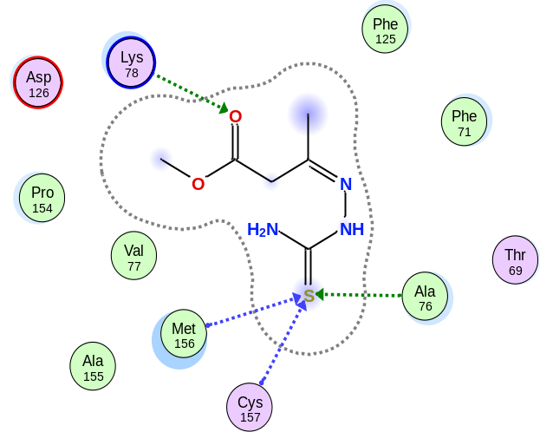  1 | 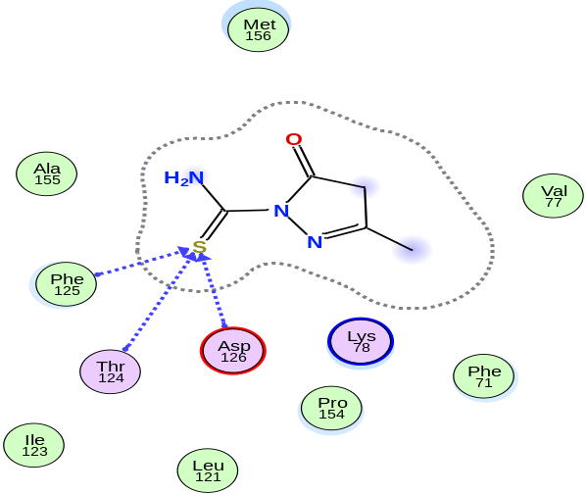  2
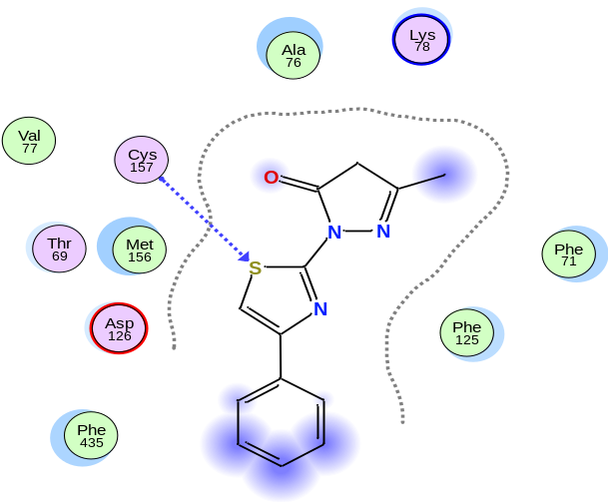  3 | 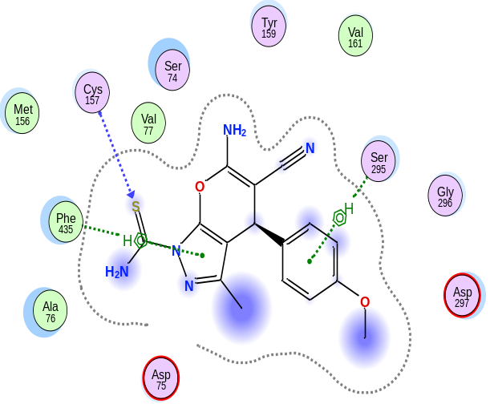  4
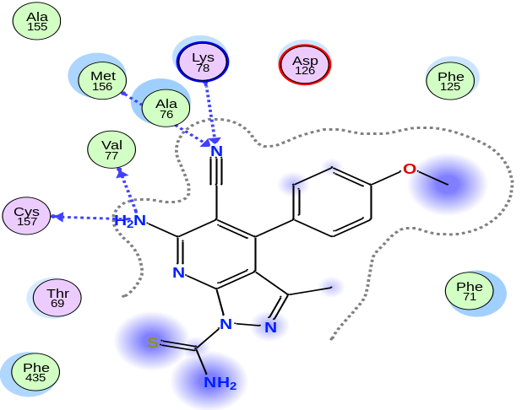  5 | 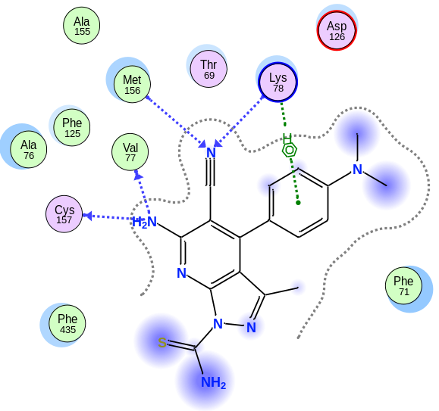  6
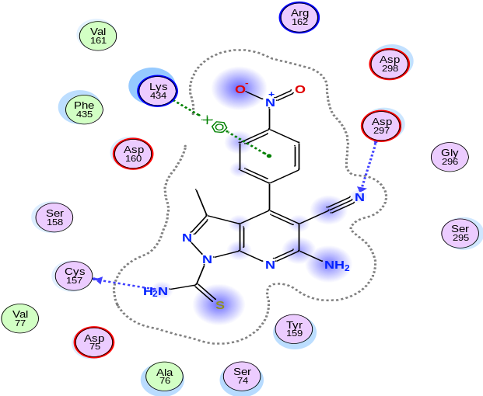  7 | 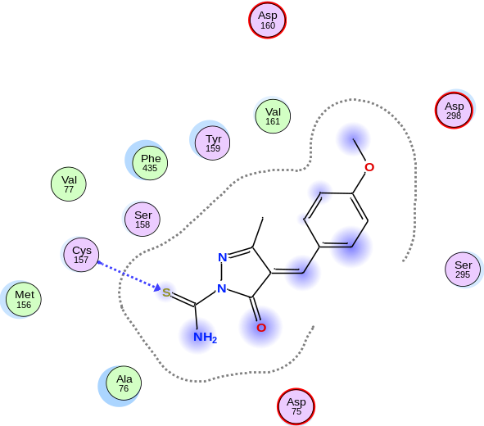  8
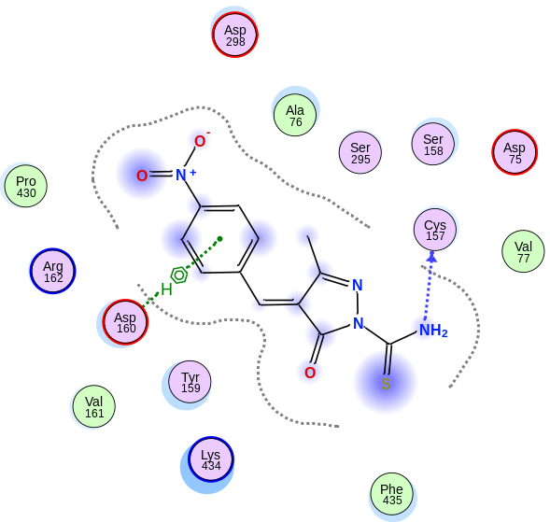  9 | 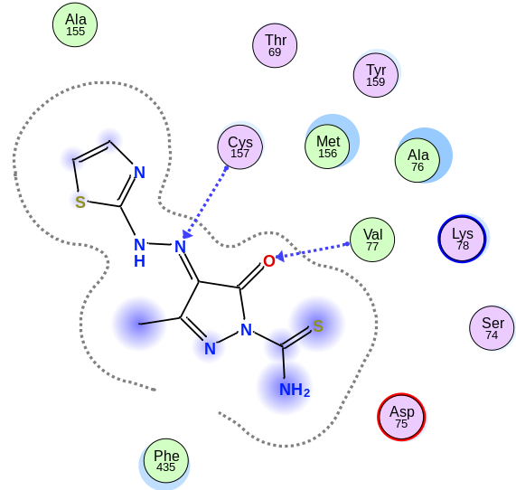  10
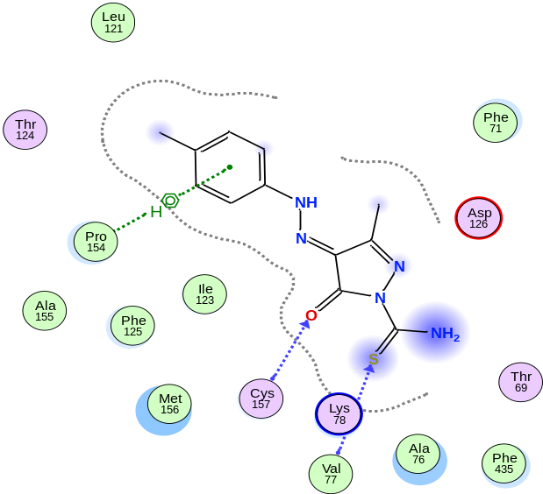  11 | 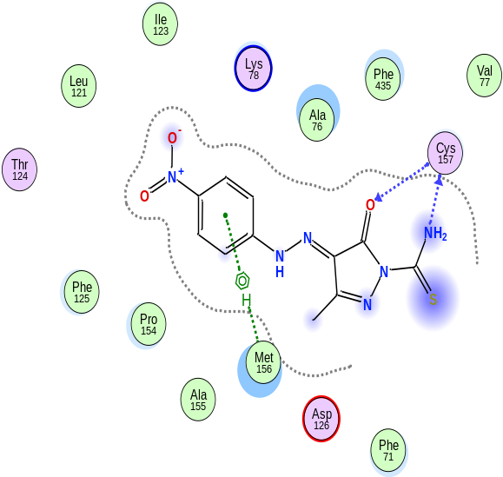  12
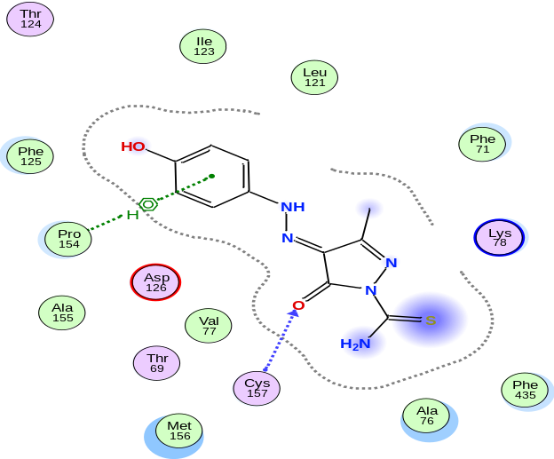  13 | 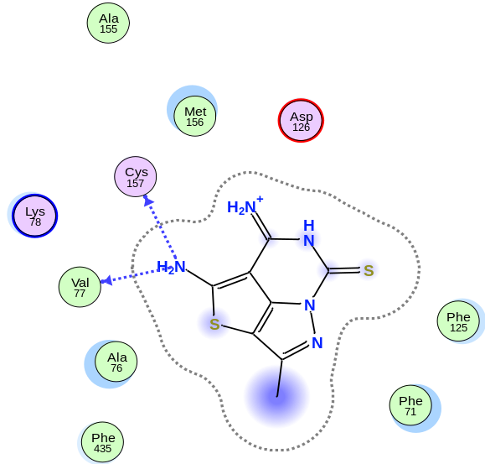  14
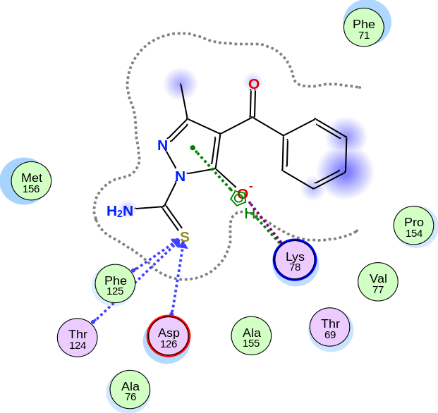  15 | 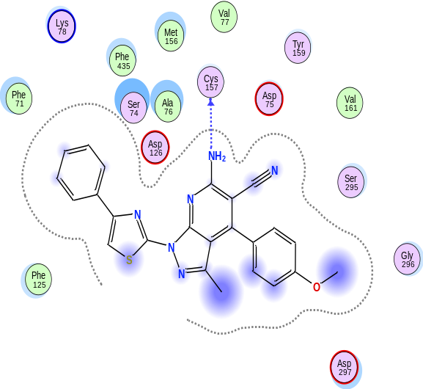  16
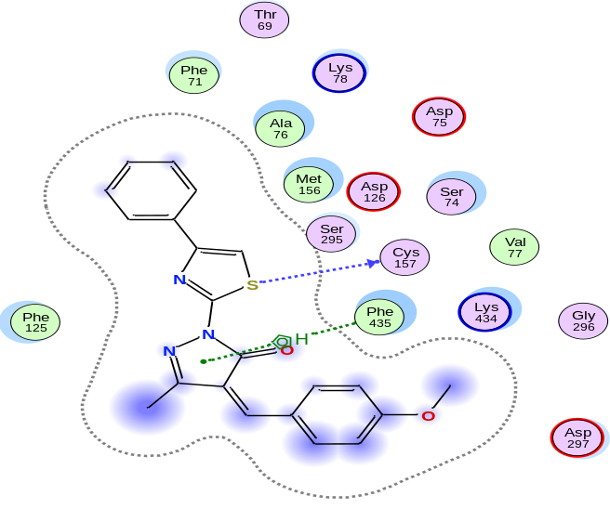  17 | 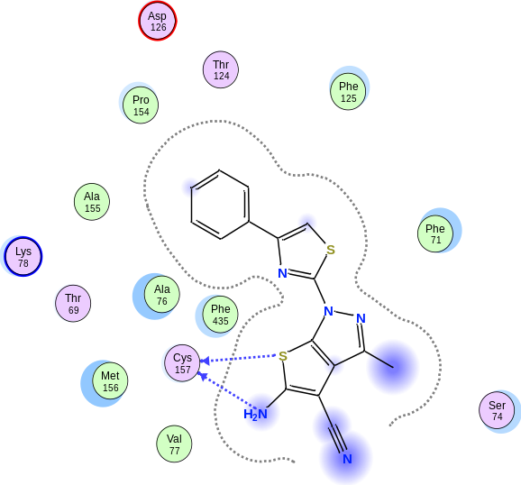  18
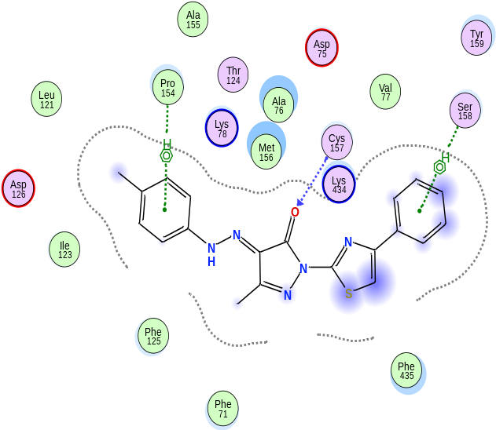  19 | 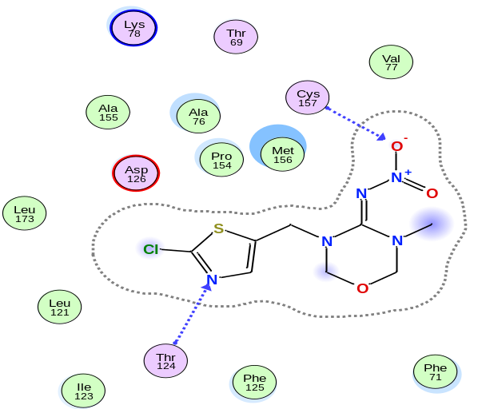  Thiamethoxam
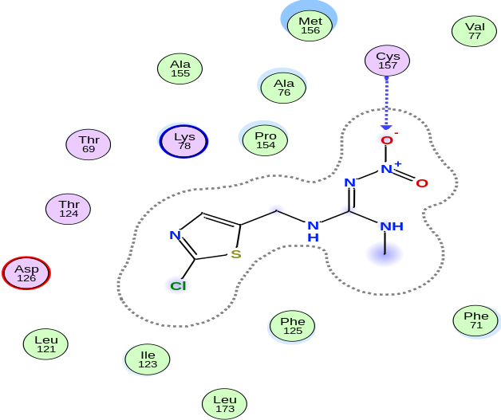  Clothianidin | 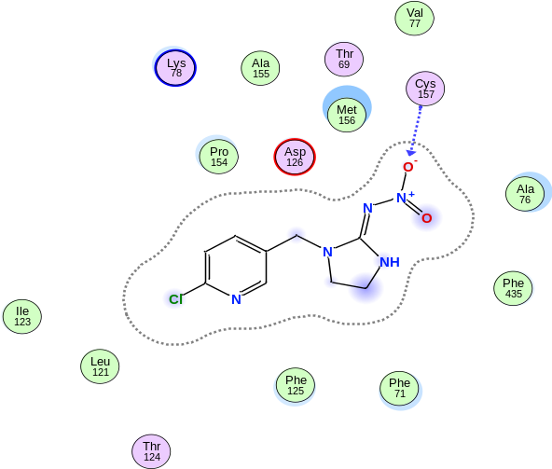  Imidacloprid

Table S4. Molecular docking interaction profiles of 19 synthesized compounds with the nicotinic acetylcholine receptor (nAChR) in Culex pipiens, showing ligand–receptor interacting atoms, interacting residues, interaction types, hydrogen bond distances, and binding energies (E, kcal/mol). Data are compared with three conventional nAChR agonists (neonicotinoids): thiamethoxam, clothianidin, and imidacloprid
Ligand | Ligand interacting atoms | Receptor  Interacting atoms | Receptor  Interacting  Residues | Interaction  Bond  Type | Distance | E (kcal/mol)
1 | O 11 | CE | LYS 78 (A) | H-acceptor | 3.32 | -0.7
1 | S 20 | CB | ALA 76 (A) | H-acceptor | 3.88 | -0.7
1 | S 20 | CA | MET 156 (A) | H-acceptor | 3.7 | -1.0
1 | S 20 | N | CYS 157 (A) | H-acceptor | 3.82 | -4.0
2 | S 14 | CA | THR 124 (A) | H-acceptor | 3.95 | -1.1
2 | S 14 | N | PHE 125 (A) | H-acceptor | 3.34 | -2.2
2 | S 14 | N | ASP 126 (A) | H-acceptor | 3.56 | -4.3
3 | S 14 | N | CYS 157 (A) | H-acceptor | 4.25 | -0.5
4 | S 20 | N | CYS 157 (A) | H-acceptor | 4.37 | -1.8
4 | 6-ring | CB | SER 295 (A) | pi-H | 4.32 | -0.5
4 | 5-ring | CE1 | PHE 435 (A) | pi-H | 3.85 | -0.5
5 | N 16 | O | VAL 77 (A) | H-donor | 2.92 | -2.5
5 | N 16 | O | CYS 157 (A) | H-donor | 2.92 | -2.5
5 | N 24 | CA | LYS 78 (A) | H-acceptor | 3.32 | -0.6
5 | N 24 | CA | MET 156 (A) | H-acceptor | 3.59 | -0.6
6 | N 16 | O | VAL 77 (A) | H-donor | 2.9 | -2.4
6 | N 16 | O | CYS 157 (A) | H-donor | 3.04 | -2.2
6 | N 24 | CA | LYS 78 (A) | H-acceptor | 3.36 | -0.6
6 | N 24 | CA | MET 156 (A) | H-acceptor | 3.61 | -0.6
6 | 6-ring | CD | LYS 78 (A) | pi-H | 4.68 | -0.5
7 | N 20 | O | CYS 157 (A) | H-donor | 3.17 | -3.3
7 | N 24 | N | ASP 297 (A) | H-acceptor | 3.4 | -1.3
7 | 6-ring | NZ | LYS 434 (A) | pi-cation | 4.6 | -0.9
8 | S 12 | N | CYS 157 (A) | H-acceptor | 3.65 | -3.6
9 | N 13 | O | CYS 157 (A) | H-donor | 2.96 | -3.0
9 | 6-ring | CA | ASP 160 (A) | pi-H | 4.52 | -0.5
10 | O 10 | N | VAL 77 (A) | H-acceptor | 2.94 | -2.2
10 | N 16 | N | CYS 157 (A) | H-acceptor | 3.36 | -0.6
11 | O 10 | N | CYS 157 (A) | H-acceptor | 3.25 | -2.3
11 | S 12 | N | VAL 77 (A) | H-acceptor | 4.43 | -0.8
11 | 6-ring | CB | PRO 154 (A) | pi-H | 3.91 | -0.6
12 | N 13 | O | CYS 157 (A) | H-donor | 3.13 | -3.2
12 | O 10 | N | CYS 157 (A) | H-acceptor | 2.99 | -2.8
12 | 6-ring | CE | MET 156 (A) | pi-H | 3.99 | -0.5
13 | O 10 | N | CYS 157 (A) | H-acceptor | 3.49 | -0.9
13 | 6-ring | CB | PRO 154 (A) | pi-H | 3.8 | -0.6
14 | N 13 | O | VAL 77 (A) | H-donor | 3.15 | -2.0
14 | N 13 | O | CYS 157 (A) | H-donor | 3.18 | -1.2
15 | S 12 | CA | THR 124 (A) | H-acceptor | 4.39 | -0.7
15 | S 12 | N | PHE 125 (A) | H-acceptor | 3.47 | -2.5
15 | S 12 | N | ASP 126 (A) | H-acceptor | 3.54 | -2.9
15 | O 10 | NZ | LYS 78 (A) | Ionic | 3.62 | -1.5
15 | 5-ring | CG | LYS 78 (A) | pi-H | 3.73 | -1.0
16 | N 20 | O | CYS 157 (A) | H-donor | 2.91 | -1.0
17 | S 11 | O | CYS 157 (A) | H-donor | 3.83 | -0.7
17 | 5-ring | CE1 | PHE 435 (A) | pi-H | 3.66 | -0.5
18 | S 18 | O | CYS 157 (A) | H-donor | 4.1 | -0.7
18 | N 20 | O | CYS 157 (A) | H-donor | 3.13 | -2.7
19 | O 16 | N | CYS 157 (A) | H-acceptor | 3.2 | -2.2
19 | 6-ring | CB | PRO 154 (A) | pi-H | 3.86 | -0.6
19 | 6-ring | CA | SER 158 (A) | pi-H | 4.15 | -0.9
Thiamethoxam | O4 | N | CYS 157 (A) | H-acceptor | 3.35 | -0.8
Thiamethoxam | N9 | CA | THR 124 (A) | H-acceptor | 3.61 | -0.5
Clothianidin | O3 | N | CYS 157 (A) | H-acceptor | 3.46 | -0.5
Imidacloprid | O2 | N | CYS 157 (A) | H-acceptor | 2.88 | -2.8

