Near Real-Time b -Value Analysis for Volcano Traffic Light Alert Systems and Eruption Forecasting

(Supporting information)

Thystere Matondo Bantidi ^{(1)(*)}, Kazuyoshi Z. Nanjo^{(2), (3), (4), (5)}, Takeo Ishibe^{(1), (4)}, Takeshi Nishimura⁽⁶⁾, Bogdan Enescu^{(4), (7), (8)}, Anscair Mukange Besa⁽⁹⁾

⁽¹⁾ Earthquake Research Center, Association for the Development of Earthquake Prediction, 1-5-18, Kanda-Sarugakucho, Chiyoda-ku, Tokyo, 101-0064, Japan

⁽²⁾ Global Center for Asian and Regional Research, Natural Disaster Research Section, University of Shizuoka, 3‑6‑1 Takajo, Aoi‑Ku, Shizuoka, 420‑0839, Japan.

⁽³⁾ Center for Integrated Research and Education of Natural Hazards, Shizuoka University, 836 Oya, Suruga‑Ku, Shizuoka, 422‑8529, Japan.

⁽⁴⁾ The Institute of Statistical Mathematics, 10‑3 Midori‑Cho, Tachikawa, Tokyo, 190‑8562, Japan.

⁽⁵⁾ Japan Agency for Marine‑Earth Science and Technology, Yokohama Institute for Earth Sciences, 3173‑25 Showa‑Machi, Kanazawa‑Ku, Yokohama, 236‑0001, Japan

⁽⁶⁾ Department of Geophysics, Graduate School of Science, Tohoku University, 6-3 Aramaki-aza Aoba, Aoba-ku, Sendai, 980-8578, Japan

⁽⁷⁾ Department of Geophysics, Graduate School of Science, Kyoto University, Kita-Shirakawa, Oiwake-cho, Sakyo-ku, Kyoto, 606-8502, Japan

⁽⁸⁾ National Institute for Earth Physics (NIEP), Magurele-Bucharest, Romania

⁽⁹⁾ Department of Physics, Faculty of Science, University of Kinshasa, 190, Kinshasa XI, Commune de Lemba, Kinshasa, Democratic Republic of the Congo

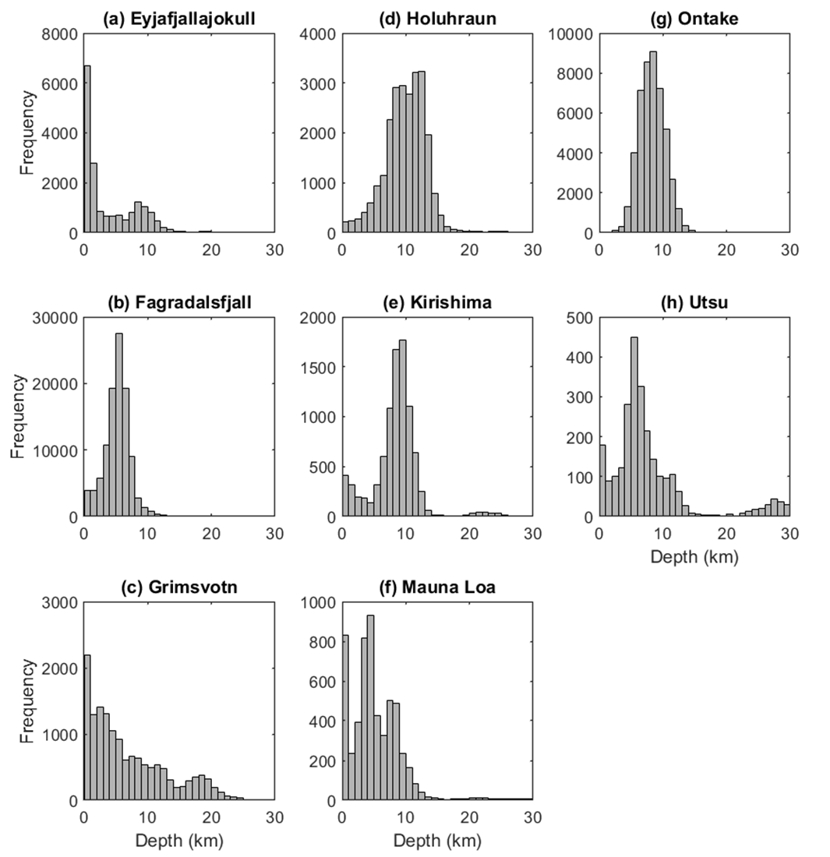
Supplementary Fig. 1 shows the histograms of earthquake depths for each volcano. (a) Eyjafjallajökull; (b) Fagradalsfjall; (c) Grímsvötn; (d) Holuhraun (Bárðarbunga); (e) Kirishima; (f) Mauna Loa (Kīlauea); (g) Ontake and (h) Usu. Clustered seismicity at two distinct depths (e.g., Eyjafjallajökull and Kirishima) likely reflects different processes within a complex magmatic plumbing system. However, we did not identify any systematic b-value patterns associated with this feature.

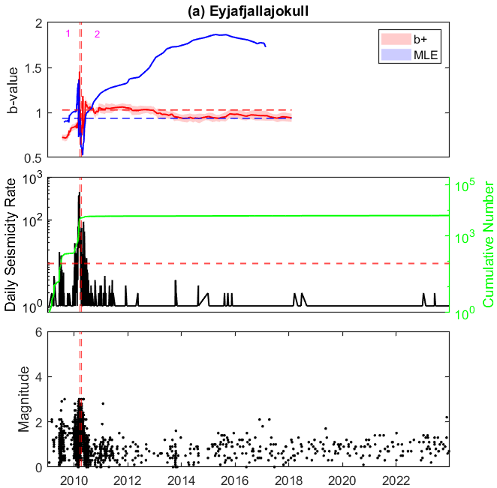 | 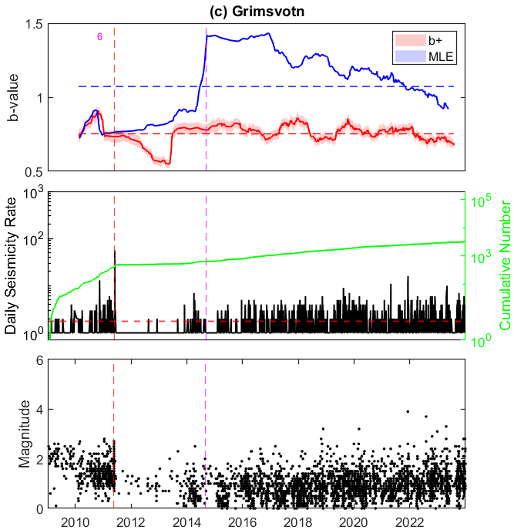
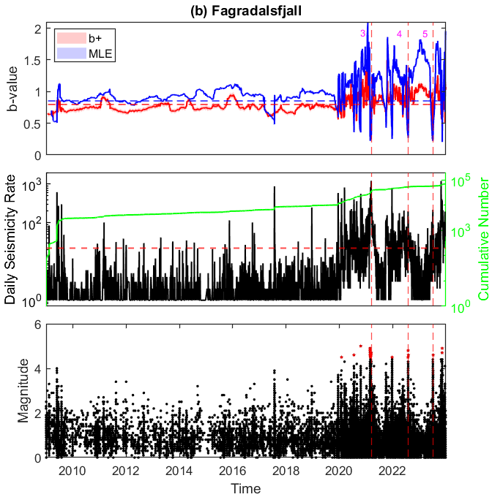 | 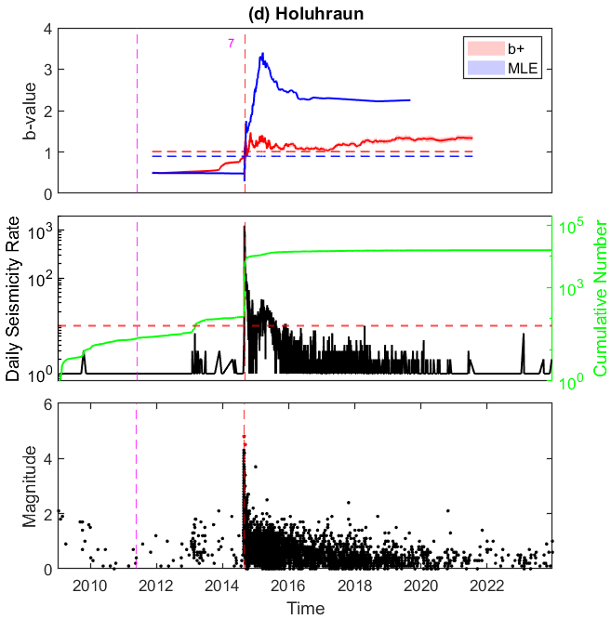
Supplementary Fig. 2. Comparison between transients’ variation of b-values using both using b -positive (b+) and the maximum likelihood (MLE) methods: (a) Eyjafjallajökull; (b) Fagradalsfjall; (c) Grímsvötn; (d) Holuhraun (Bárðarbunga). Red dashed vertical lines indicate the start of the eruption, and the magenta dashed vertical lines indicate the start of the eruption at the nearby volcano. The horizontal red and blue lines indicate the b_{th} (mean b-values). The shaded area represents a 95% standard deviation of the calculated b-values. The insert number labels eruptions (see Fig. S3). Figures appended below each plot show the daily seismicity rate-time and magnitude-time plots for each corresponding volcano, respectively. Dashed horizontal lines indicate the average daily seismicity rate. Green lines represent the cumulative numbers of events. Circles represent earthquakes. Red stars are events with magnitude M>=4.5.
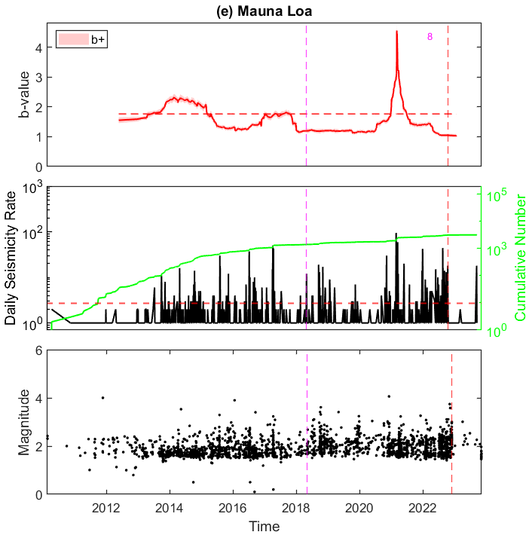 | 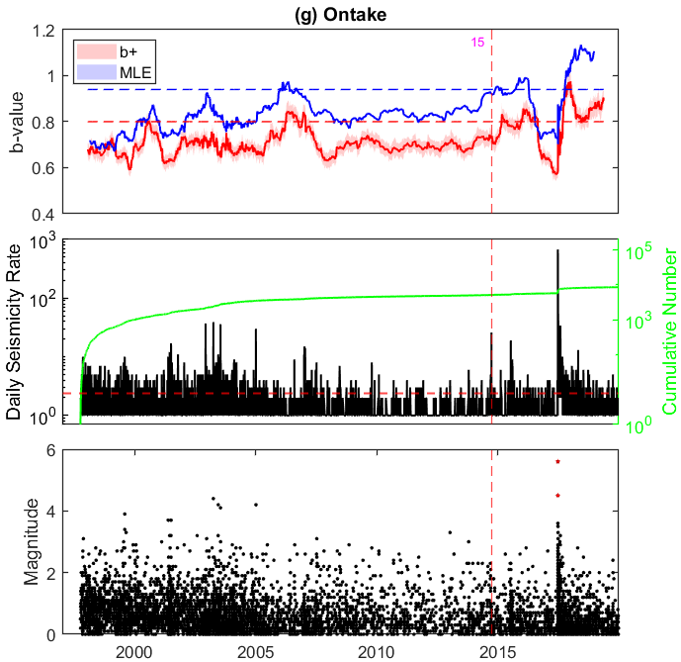
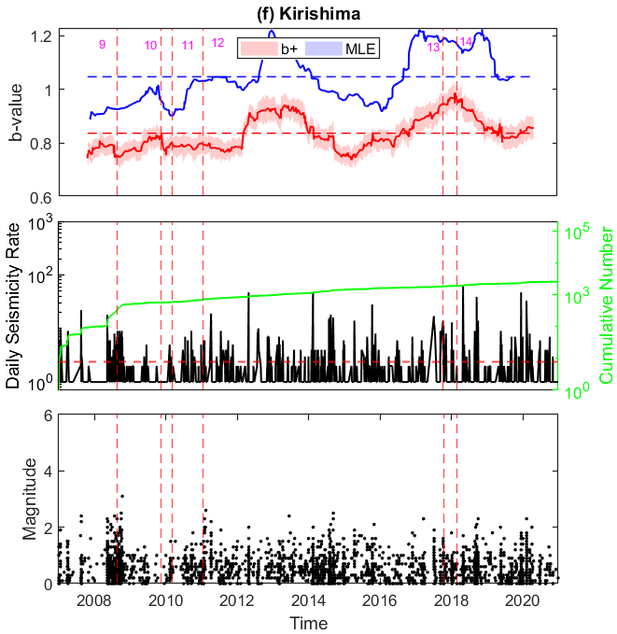 | 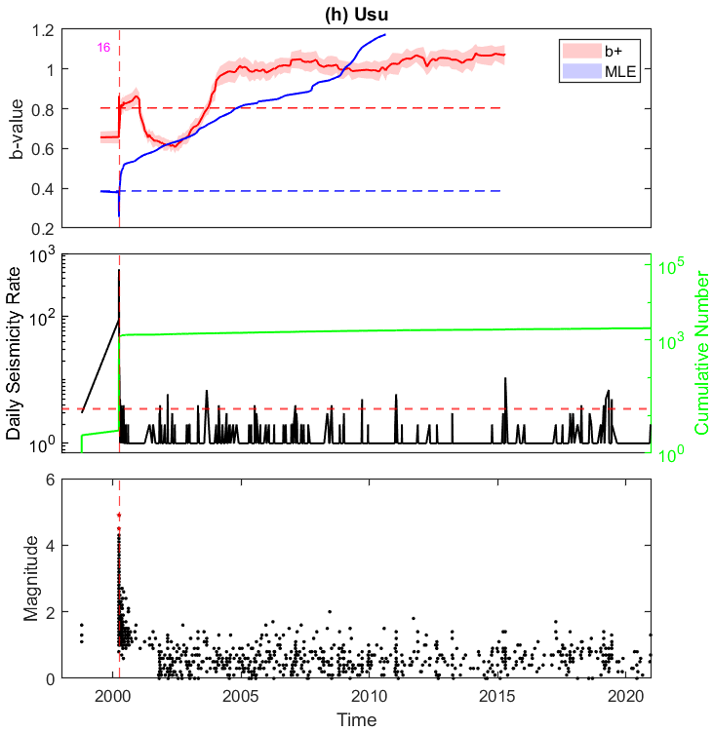
Supplementary Fig. 2 (Continued). (e) Mauna Loa (Kīlauea); (f) Kirishima; (g) Ontake and (h) Usu.

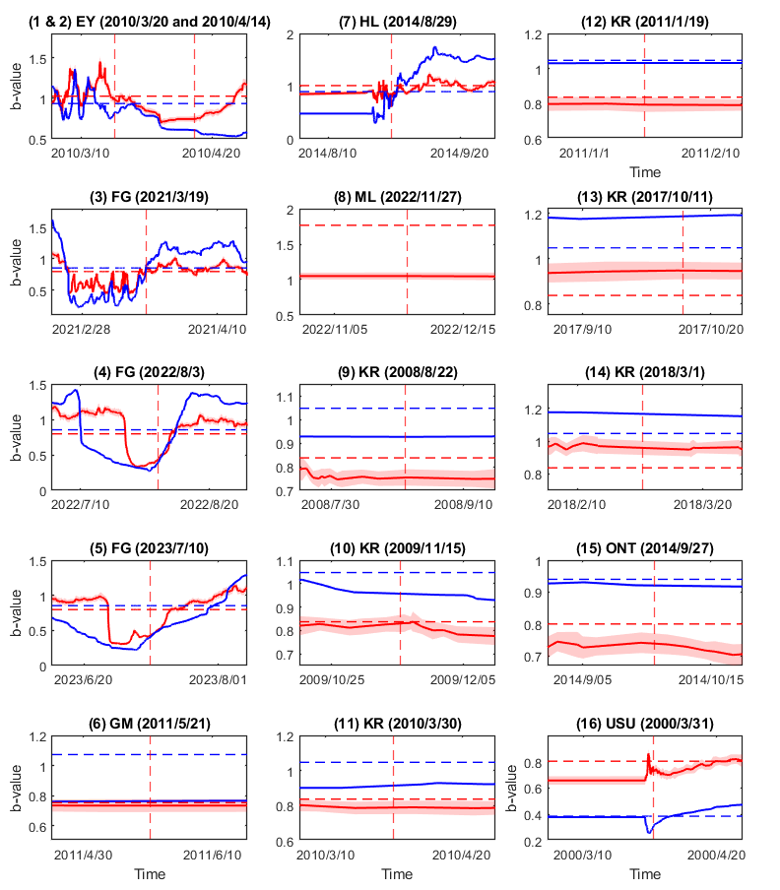
Supplementary Fig. 3. Zoomed view of b-value changes one month before and after each eruption (b+(red) and MLE (blue)). Numbers correspond to eruptions shown in Fig. S2. (1) and (2) for Eyjafjallajökull; (3 - 5) for Fagradalsfjall; (6) for Grímsvötn; (7) for Holuhraun (Bárðarbunga); (8) for Mauna Loa; (9 – 14) for Kirishima; (15) for Ontake; (16) for Usu.

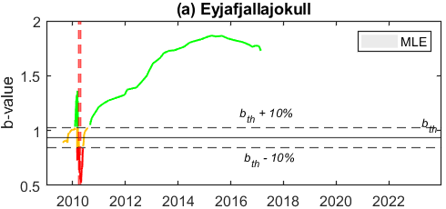 | 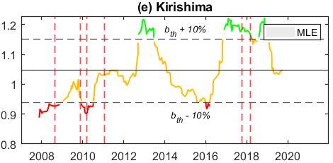
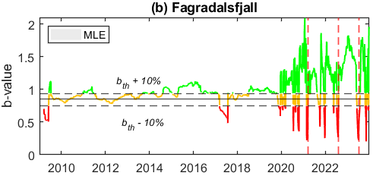 | 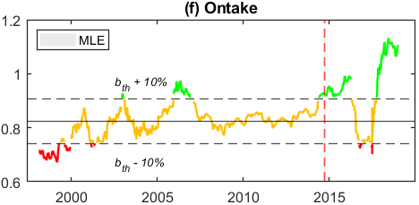
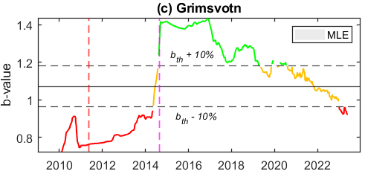 | 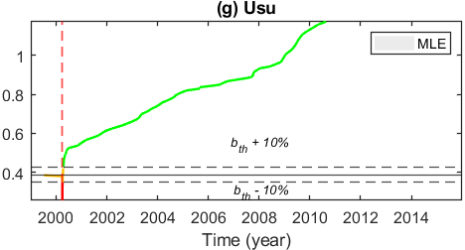
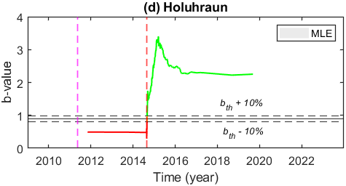 | 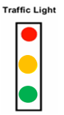
Supplementary Fig. 4. Time series of the Traffic Light Alert System (VTLAS) based on the b+ method (videos are available online in a GitHub repository; see Data and Code Availability statement). The continuous horizontal line represents the b_{th,}, whereas the horizontal dashed lines represent $±$ 10% increase (decrease) from the b_{th,}. The color indicates volcanic hazard levels: red for escalating danger (more than 10% decrease below the b_{th}), green for normal conditions (more than 10% above the b_{th}), and yellow for a cautious alert ($±$ 10% around the b_{th}). Vertical dashed lines represent eruption time. (a) Eyjafjallajökull; (b) Fagradalsfjall; (c) Grímsvötn; (d) Holuhraun (Bárðarbunga); (e) Kirishima; (f) Ontake and (g) Usu

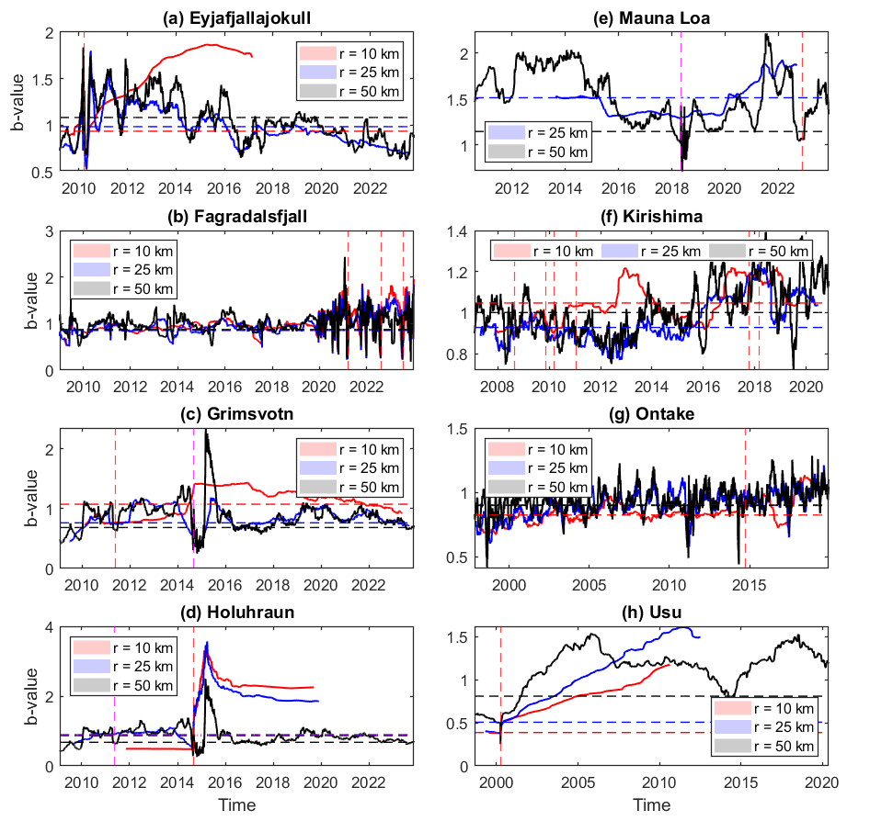
Supplementary Fig. 5. Comparison of transient b-value variations using earthquake catalogs within 10 km, 25 km, and 50 km radius around the volcano summit, based on the MLE method. (a) Eyjafjallajökull; (b) Fagradalsfjall; (c) Grímsvötn; (d) Holuhraun (Bárðarbunga); (e) Mauna Loa (Kīlauea); (f) Kirishima; (g) Ontake and (h) Usu. Red dashed vertical lines indicate the start of the eruption, and the magenta dashed vertical lines indicate the start of the eruption at the nearby volcano. The horizontal blue, red, and black lines indicate the background level of b-value (mean b-values in the time series) for 10 km, 25 km and 50 km, respectively. The shaded area represents a 95% standard deviation of the calculated b-values.
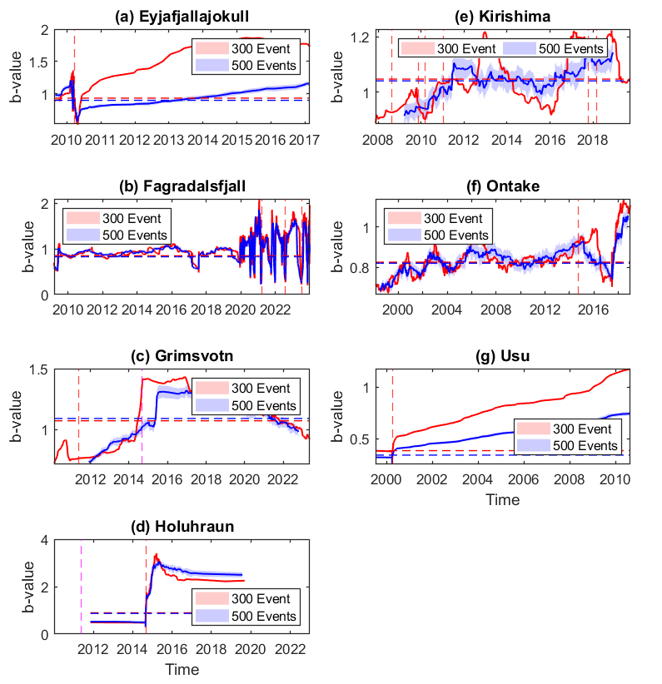
Supplementary Fig. 6. Comparison of transient b-value variations using two window sizes (300 and 500 events) with the MLE method. (a) Eyjafjallajökull; (b) Fagradalsfjall; (c) Grímsvötn; (d) Holuhraun (Bárðarbunga); (e) Kirishima; (f) Ontake and (g) Usu. Red dashed vertical lines indicate the start of the eruption, and the magenta dashed vertical lines indicate the start of the eruption at the nearby volcano (located within less than 50 km). The horizontal red and blue lines indicate the respective background level for b-value. The shaded area represents a 95% standard deviation of the calculated b-values.

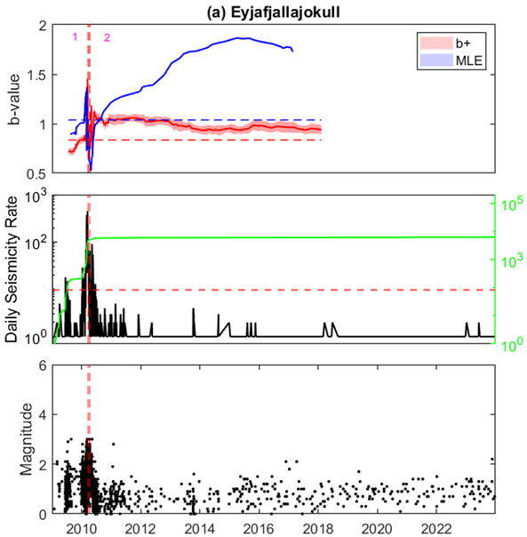 | 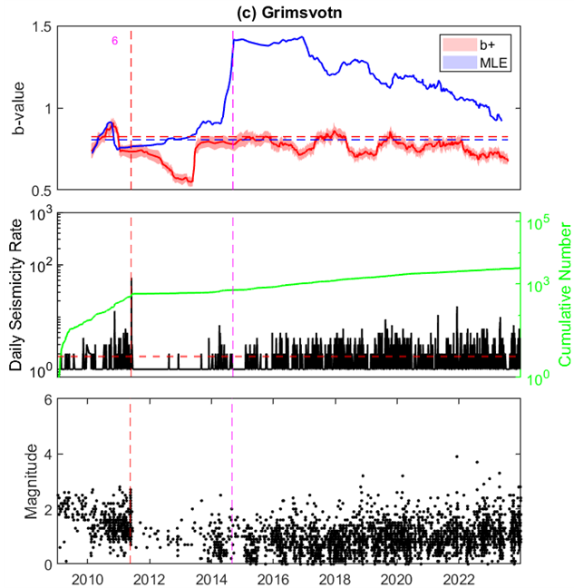
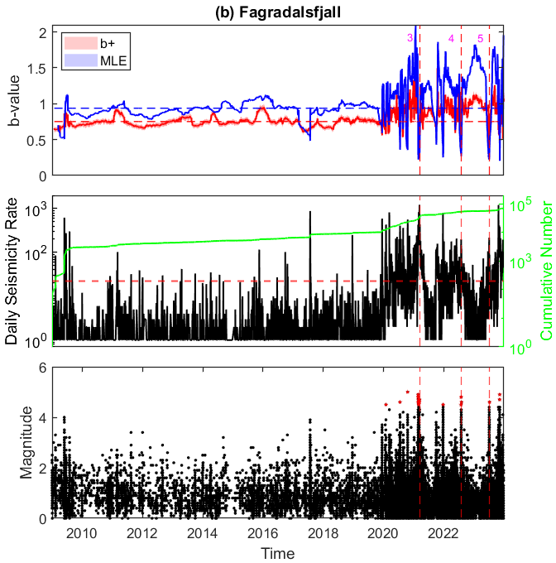 | 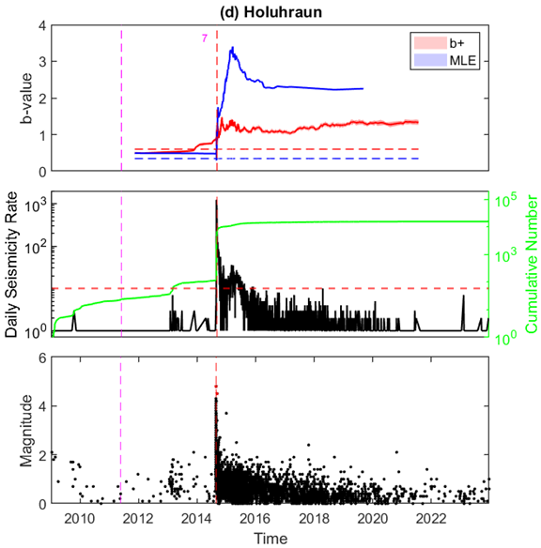
Fig. S7. Same as Fig. 2 using a different background b-value (here, a median of all the b-value estimates preceding the eruption).

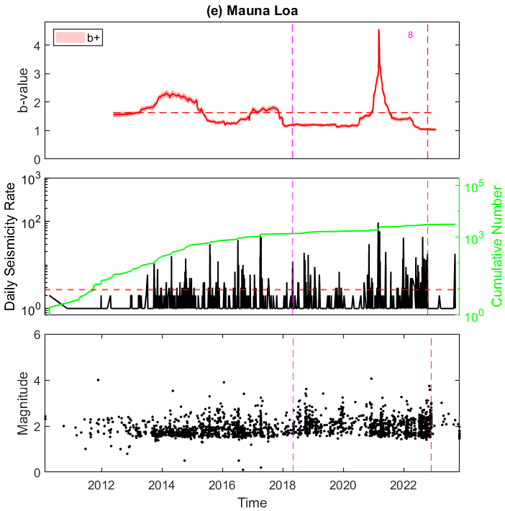 | 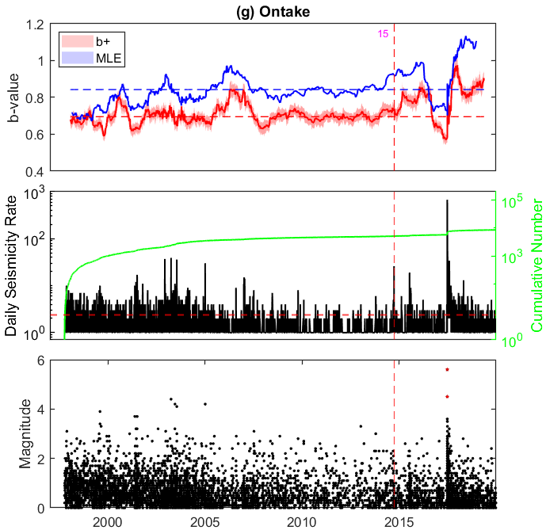
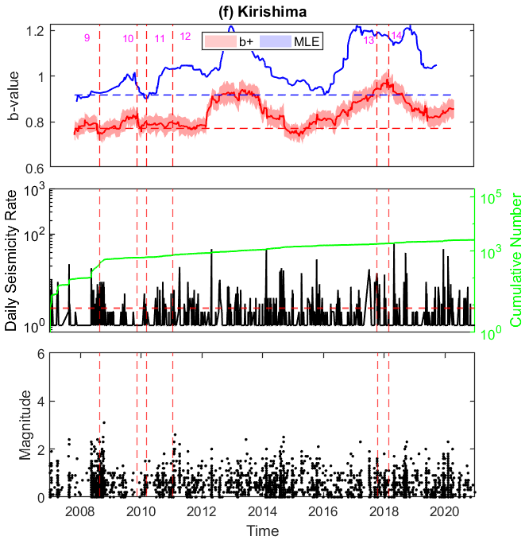 | 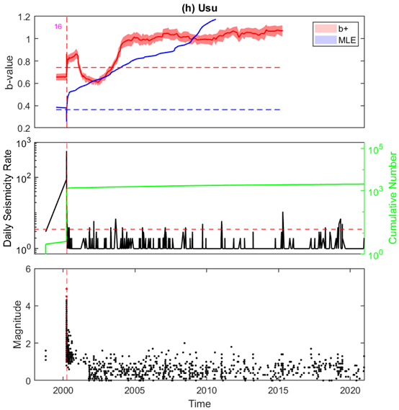
Fig. S7 (continued).

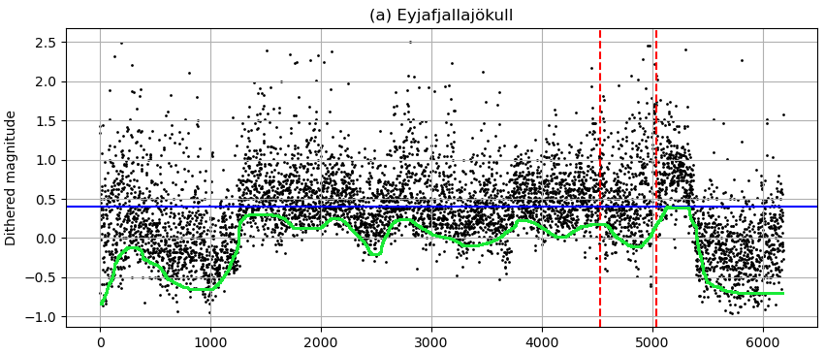 | 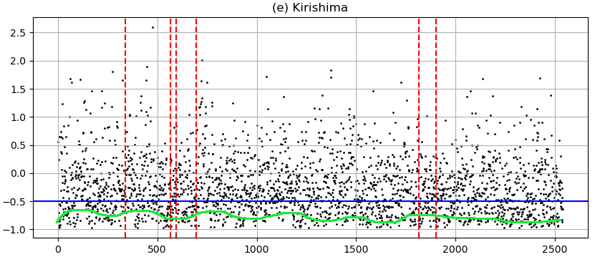
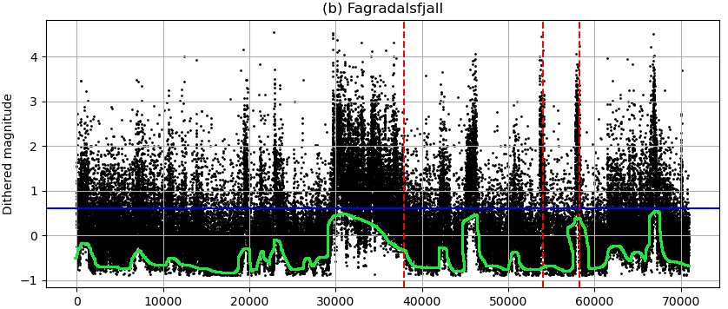 | 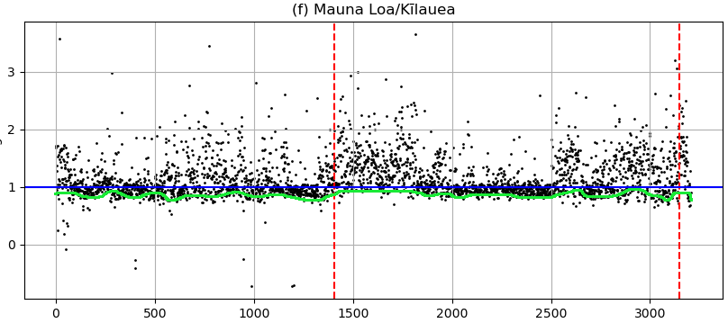
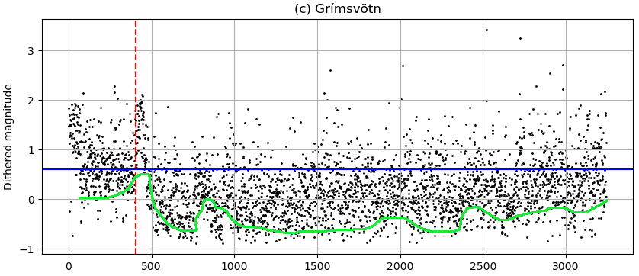 | 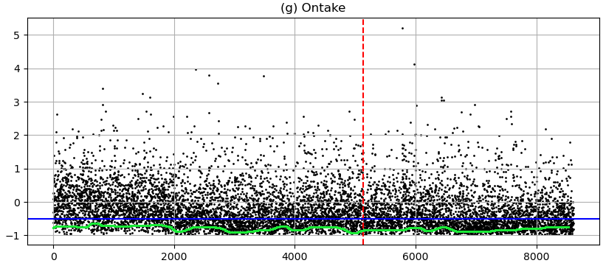
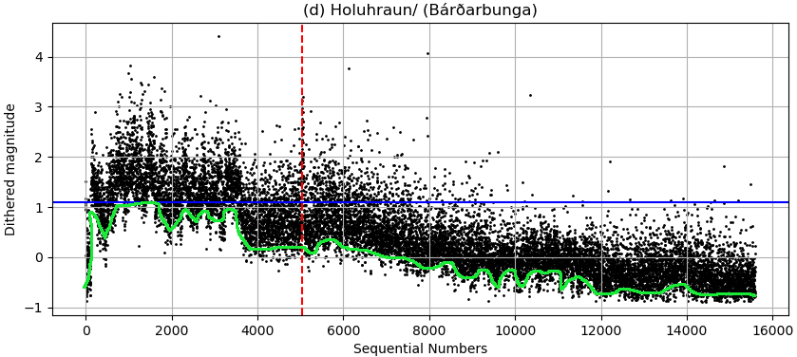 | 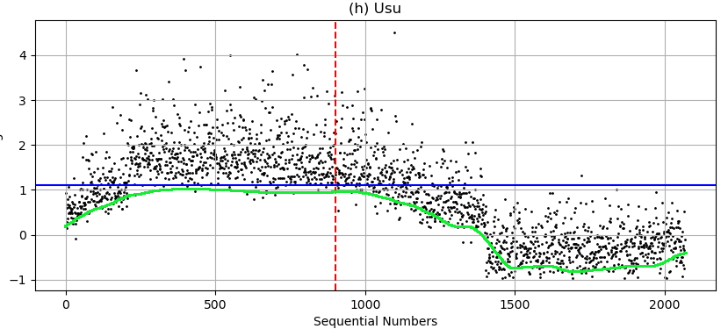

Supplementary Fig. 8. Plot of dithered magnitudes (using uniform Das magnitude scale, Mwg) versus sequential numbers of earthquakes. The timescale is equalized for observed events, and the magnitudes are dithered with random errors uniformly distributed in the range of [-0.05, 0.05]. Areas below the green lines indicate potential gaps in the catalog. The red dashed lines indicate the eruption time, and the magenta dashed lines indicate the eruption time at a nearby volcano. The blue continuous lines represent the completeness magnitude that would be assumed if a single value was used for the entire dataset. (a) Eyjafjallajökull; (b) Fagradalsfjall; (c) Grímsvötn; (d) Holuhraun (Bárðarbunga); (e) Kirishima; (f) Mauna Loa (Kīlauea); (g) Ontake and (h) Usu.

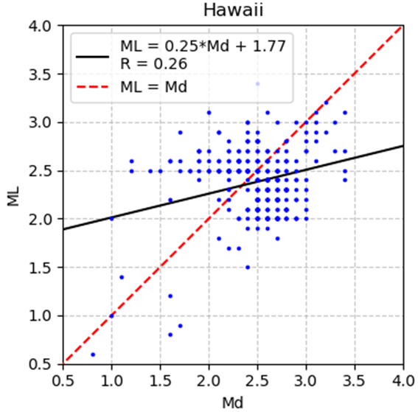
Supplementary Fig. 9. Difference in magnitude. The local magnitude (ML) is plotted as a function of the duration magnitude (Md) for earthquakes associated with the Mauna Loa volcano. The black solid line and red dashed line indicate the least-squares regression line and ML=Md, respectively. The equation and the correlation coefficient (R) for the least-squares regression line are shown.

