Supplements
Supplemental Table S1. Baseline characteristics across different lung disease groups
 | Control | COPD | ILD | Others | P-value
 | (N=61) | (N=52) | (N=59) | (N=53)
Age | 68.3 ± 11.2 | 74.6 ± 7.9 | 71.2 ± 10.8 | 67.5 ± 15.5 | 0.008
Female sex | 20 (32.8%) | 2 (3.8%) | 12 (20.3%) | 20 (37.7%) | <0.001
Height, cm | 162.2 ± 8.8 | 165.4 ± 6.5 | 163.2 ± 7.1 | 164.0 ± 8.7 | 0.183
Weight, kg | 66.1 ± 10.8 | 65.0 ± 10.5 | 64.8 ± 11.2 | 66.8 ± 12.4 | 0.745
BMI, kg/m² | 25.2 ± 3.7 | 23.8 ± 3.7 | 24.3 ± 3.7 | 24.8 ± 3.8 | 0.219
FVC, L | 3.18 ± 0.79 | 3.05 ± 0.81 | 2.98 ± 0.88 | 2.95 ± 0.67 | 0.421
FVC, % | 95.8 ± 13.2 | 88.2 ± 21.5 | 88.7 ± 20.3 | 89.1 ± 17.0 | 0.077
FEV₁, L | 2.28 ± 0.59 | 1.89 ± 0.36 | 2.25 ± 0.61 | 2.03 ± 0.60 | 0.002
FEV₁, % | 100.3 ± 17.8 | 83.0 ± 26.6 | 99.5 ± 22.0 | 88.3 ± 20.7 | <0.001
FEV₁/FVC, % | 72.3 ± 10.0 | 61.5 ± 12.0 | 76.3 ± 7.7 | 69.1 ± 13.9 | <0.001
DLCO, mL/mmHg/min | 15.2 ± 4.1 | 11.5 ± 4.6 | 11.5 ± 4.2 | 14.0 ± 4.6 | <0.001
DLCO, % | 88.0 ± 18.7 | 73.7 ± 23.8 | 71.6 ± 24.4 | 78.9 ± 19.7 | <0.001
DLCO/VA, mL/mmHg/min/L | 3.67 ± 0.81 | 2.90 ± 1.09 | 3.06 ± 0.78 | 3.54 ± 0.86 | <0.001
DLCO/VA, % | 98.9 ± 20.2 | 81.7 ± 29.0 | 84.1 ± 19.9 | 95.2 ± 20.4 | <0.001
Whole lung volume, cc | 4426 ± 1078 | 4742 ± 1016 | 3904 ± 1056 | 4253 ± 975 | <0.001
Mean lung density, HU | -829.0 ± 32.3 | -838.2 ± 39.8 | -802.0 ± 45.5 | -829.0 ± 37.1 | <0.001
Mean lung density heterogeneity | 157.0 ± 18.6 | 164.4 ± 22.8 | 189.0 ± 33.3 | 156.9 ± 22.3 | <0.001
LAA % | 3.7 ± 2.1 | 19.1 ± 12.1 | 12.9 ± 7.3 | 12.1 ± 8.8 | <0.001
HAA % | 5.23 ± 2.08 | 6.00 ± 2.96 | 8.52 ± 4.11 | 5.91 ± 3.43 | <0.001
PI15, HU | -936.2 ± 23.7 | -953.8 ± 32.4 | -938.7 ± 26.7 | -937.1 ± 27.7 | 0.003
D-slope | -6.92 ± 1.92 | -5.24 ± 1.46 | -5.54 ± 1.60 | -6.00 ± 1.72 | <0.001
AWTPi10, mm | 3.41 ± 0.71 | 3.48 ± 0.91 | 3.59 ± 0.72 | 3.58 ± 0.80 | 0.547
Lumen diameter, mm | 3.10 ± 0.38 | 3.22 ± 1.60 | 3.12 ± 0.46 | 3.05 ± 0.41 | 0.774
TBV | 224.5 ± 61.5 | 255.3 ± 77.6 | 237.9 ± 71.7 | 230.4 ± 77.3 | 0.133
BV5 | 107.0 ± 40.6 | 127.0 ± 51.9 | 116.7 ± 45.6 | 114.0 ± 51.6 | 0.167
BV5/TBV | 0.47 ± 0.08 | 0.49 ± 0.08 | 0.48 ± 0.08 | 0.48 ± 0.08 | 0.584

Abbreviations: FEV₁, forced expiratory volume in 1 second; FVC, forced vital capacity; DLCO, diffusing capacity for carbon monoxide; VA, alveolar volume; SD, standard deviation; LAA, low attenuation area; HAA, high attenuation area; PI15, percentile index 15; AWTPi10, airway wall thickness at perimeter of 10mm; TBV, total blood volume; BV5, blood volume in vessels with a cross-sectional area of ≤ 5 mm²

Supplemental Table S2. Final hyperparameter configurations for random forest models

Outcome | ntree | mtry
DLCO | 1000 | 5
DLCO% | 1500 | 8
DLCO/VA | 500 | 3
DLCO/VA% | 500 | 3

Abbreviations: DLCO, diffusing capacity for carbon monoxide; VA, alveolar volume; ntree, number of trees; mtry, number of variables randomly sampled at each split

Supplemental Table S3. Baseline characteristics of the external validation cohort
N=90 | Mean ± SD or %
Demographics
Age, years | 63.8 ± 10.8
Female sex | 29 (21.1%)
Height, cm | 165.2 ± 9.9
Weight, kg | 66.1 ± 12.6
Pulmonary function
FVC, L | 3.36 ± 0.98
FVC, % | 81.7 ± 16.2
FEV₁, L | 2.25 ± 0.86
FEV₁, % | 74.7 ± 20.5
FEV₁/FVC, % | 66.5 ± 12.8
DLCO, mL/mmHg/min | 15.6 ± 6.0
DLCO, % | 75.1 ± 20.5
DLCO/VA, mL/mmHg/min/L | 3.39 ± 0.88
DLCO/VA, % | 86.7 ± 21.0
CT findings
Whole lung volume, cc | 5160.9 ± 1084.4
Mean lung density, HU | -835.0 ± 36.7
Mean lung density heterogeneity, HU | 142.8 ± 15.6
LAA % | 11.0 ± 13.2
HAA % | 5.71 ± 1.75
PI15, HU | -929.7 ± 36.8
D-slope | -4.36 ± 0.79
AWTPi10, mm | 4.39 ± 0.94
Lumen diameter, mm | 3.18 ± 2.04
TBV | 277.2 ± 75.7
BV5 | 141.7 ± 48.3
BV5/TBV | 0.50 ± 0.06
Abbreviations: FEV₁, forced expiratory volume in 1 second; FVC, forced vital capacity; DLCO, diffusing capacity for carbon monoxide; VA, alveolar volume; MLD, mean lung density; SD, standard deviation; LAA, low attenuation area; HAA, high attenuation area; PI15, percentile index 15; AWTPi10, airway wall thickness at perimeter of 10 mm; TBV, total blood volume; BV5, blood volume in vessels with a cross-sectional area of ≤ 5 mm²

Supplemental Figure S1. Correlations between spirometric and diffusing capacity variables
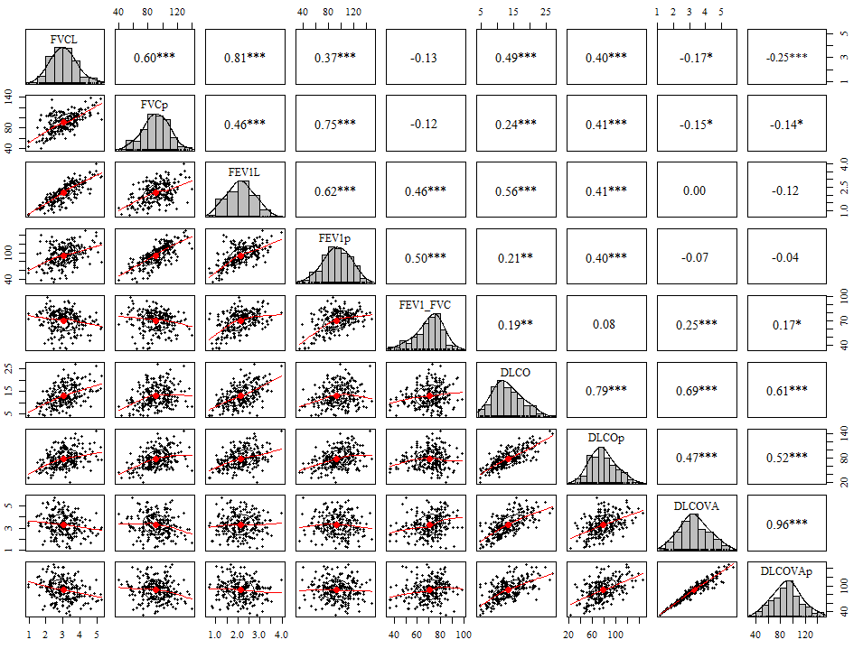
* Indicates statistical significance.
Abbreviations: FEV₁, forced expiratory volume in 1 second; FVC, forced vital capacity; DLCO, diffusing capacity for carbon monoxide; VA, alveolar volume

Supplemental Figure S2. Correlations between diffusing capacity parameters and quantitative CT-derived metrics
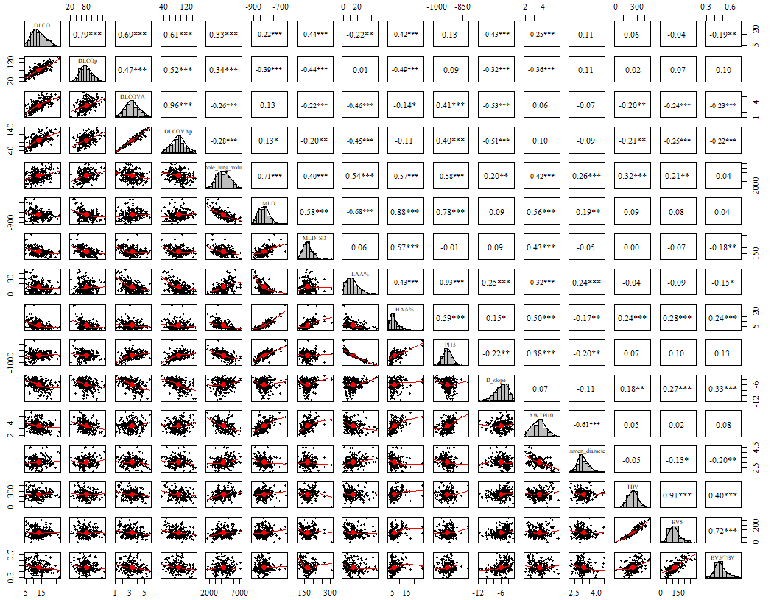

Supplemental Figure S3. Correlation networks of demographic variables, diffusing capacity, and quantitative CT metrics
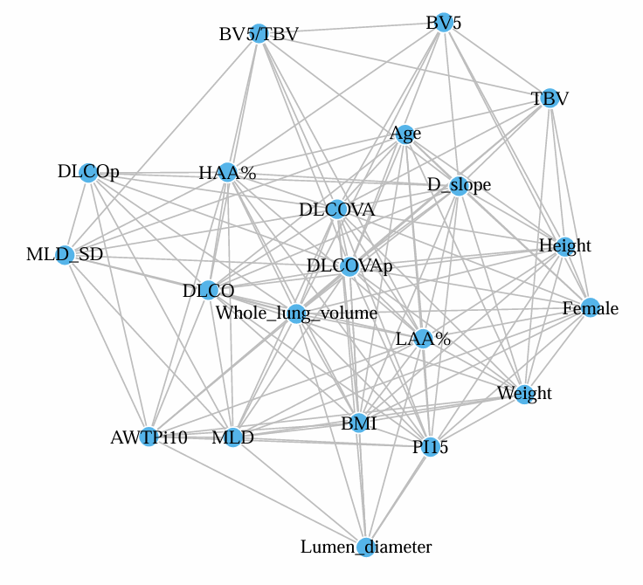
Abbreviations: DLCO, diffusing capacity for carbon monoxide; VA, alveolar volume; MLD, mean lung density; SD, standard deviation; LAA, low attenuation area; HAA, high attenuation area; PI15, percentile index 15; AWTPi10, airway wall thickness at perimeter of 10mm; TBV, total blood volume; BV5, blood volume in vessels with a cross-sectional area of ≤ 5 mm²
Supplemental Figure S4. Correlation networks stratified by disease group
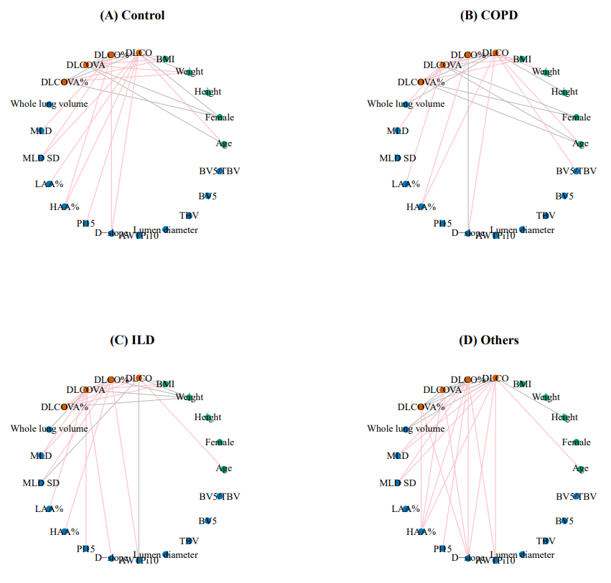
Supplemental Figure S5. Correlation between observed and predicted diffusing capacity values in the training and test sets
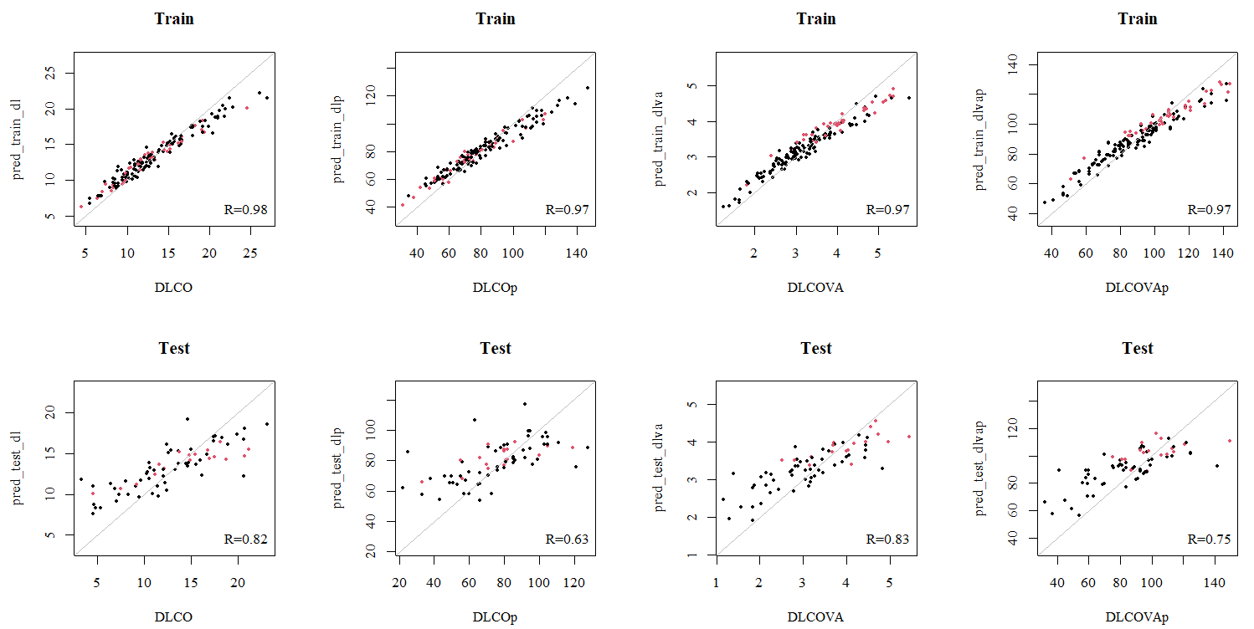

Abbreviations: DLCO, diffusing capacity for carbon monoxide; VA, alveolar volume
Supplemental Figure S6. Correlation between observed and predicted diffusing capacity values in the external validation dataset
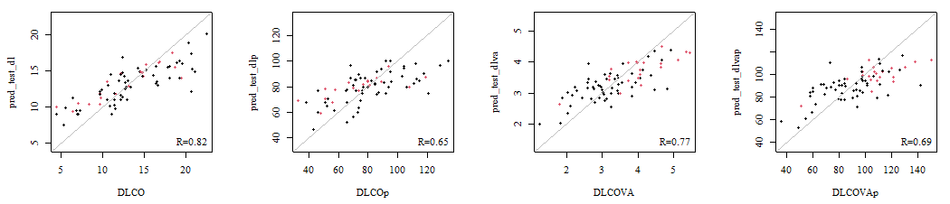

Abbreviations: DLCO, diffusing capacity for carbon monoxide; VA, alveolar volume

