Fig S1. Ion Identity/Feature-Based Molecular Network of three active fractions of LAB culture supernatant.
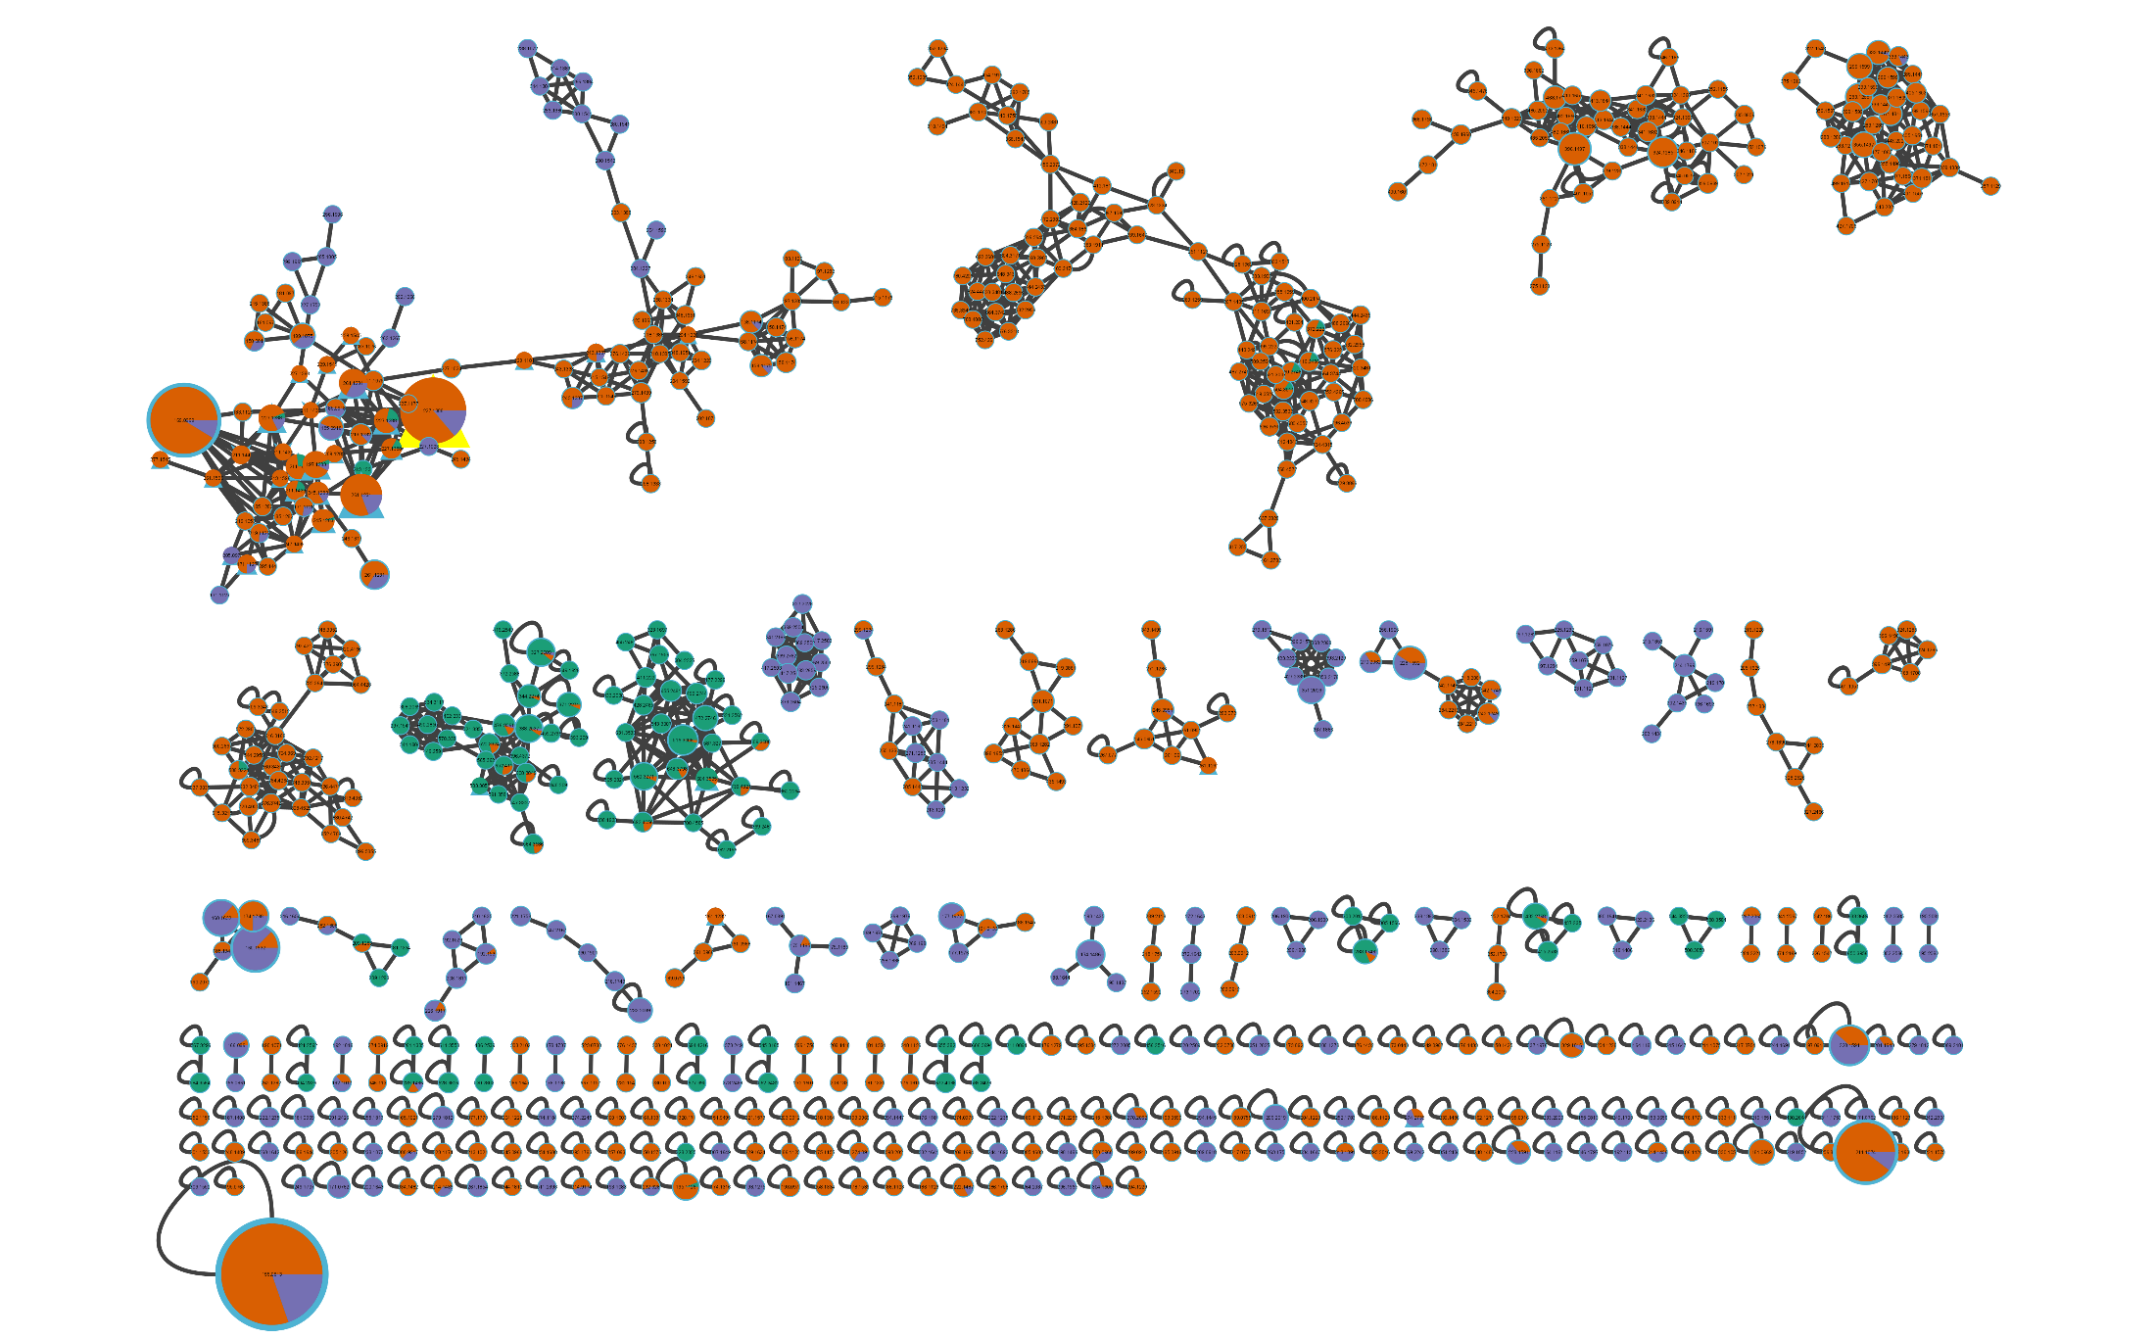

Fig S2. Corresponding MS/MS spectra (query vs. library spectrum), along with cosine scores, retention times, and a relative abundance of each of the potential active compounds across the active fractions.

A:
MS: 604.3535
RT=4.70 min
Cosine score: 0.76
Dereplication result: desmethylenylnocardamine
Query spectrum (up) vs. Library spectrum (down)
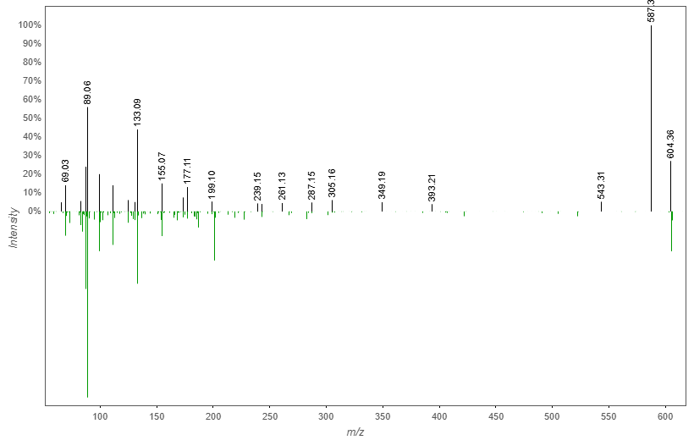

Relative abundance in each fraction
 | A35 | A57 | A45
Peak Area | 1.514599E7 | 0 | 1.6400302E6
% Relative abundance | 90.23% | 0 | 9.77%

B:
MS: 261.1231
RT=2.95 min
Cosine score: 0.81
Dereplication result: cyclo(tyrosyl-prolyl)
Query spectrum (up) vs. Library spectrum (down)
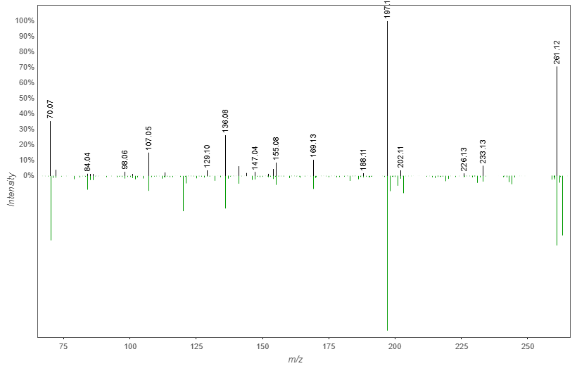

Relative abundance in each fraction
 | A35 | A57 | A45
Peak Area | 0 | 0 | 8.618151E5
% Relative abundance | 0% | 0% | 100%

C:
MS: 227.1388
RT=3.48 min
Cosine score: 0.89
Dereplication result: cyclo(L-Leu-L-4-hydroxy-Pro)
Query spectrum (up) vs. Library spectrum (down)
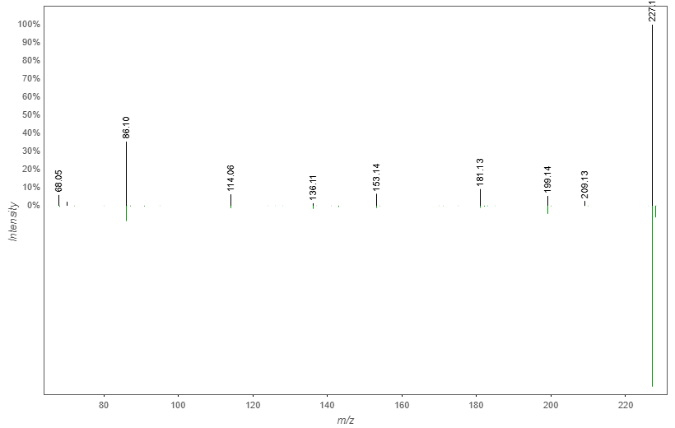

Relative abundance in each fraction
 | A35 | A57 | A45
Peak Area | 0 | 2.0830482E7 | 1.296534E8
% Relative abundance | 0% | 13.84% | 86.16%

