S.N. | Name of genotype | Cultivated species | Pedigree | Originating institute | Production condition | Features
1. | TAW 2021 | Triticum aestivum | PBW677mutant/TAW185 | BARC, Mumbai | TS & LS, IR | Terminal heat tolerant and high yielding mutant derivative
2. | TAW 2030 | Triticum aestivum | Electron Beam induced mutant of HD2967 | BARC, Mumbai | TS, IR | Terminal heat tolerant and high yielding mutant genotype
3. | TAW 1212 | Triticum aestivum | PBW677mutant/HD2967 mutant | BARC, Mumbai | TS, IR | High yielding mutant derivative
4. | TAW 1220 | Triticum aestivum | TAW100/TAW186 | BARC, Mumbai | TS, RF | Heat and drought tolerant and high yield
5. | DBW 187 | Triticum aestivum | NAC/TH/AC//3*PV N/3/MIRLO/BUC/4/ 2*PASTOR /5/KACHU/6/KACHU | ICAR-IIWBR, Karnal | TS, IR | Heat tolerant, high iron content and resistance to yellow and brown rusts, seed is amber coloured, hard, and medium-sized
6. | TAW 119 | Triticum aestivum | Gamma ray induced mutant of HD2967 | BARC, Mumbai | TS, IR | High yielding, terminal heat tolerant mutant genotype
7. | TAW 221 | Triticum aestivum | Electron beam induced PBW677 mutant | BARC, Mumbai | TS, IR | High yielding and rust resistant mutant
8. | TAW 226 | Triticum aestivum | Borlaug100mutant/PBW677 | BARC, Mumbai | TS & LS, IR | High yield, heat and drought tolerant, wide adaptable mutant derivative
9. | K 1317 | Triticum aestivum | K0307/K9162 | CSAUA & T, Kanpur | TS, RF | Resistance to brown rust and leaf blight diseases.
10. | HD 2967 | Triticum aestivum | ALD/COC//URES/HD2160M/HD2278 | IARI, New Delhi | LS, IR | Bold grain, double dwarf, dense ear density, medium late maturing, widely adapted, resistant against leaf blight and rust
11. | HD 2932 | Triticum aestivum | KAUZ/STAR//HD 2643 | IARI, New Delhi | TS & LS, IR | Bold grain, medium ear density, semi dwarf
12. | BW Local 1 | Triticum aestivum | Landraces | Collected from adjoining area of Chhatarpur, M.P. | - | -
13. | BW Local 2 | Triticum aestivum | Landraces | Collected from adjoining area of Hamirpur, U.P. | - | -

Table S1. Particulars of wheat genotypes used in the study

Table S2. Principal component analysis for different traits of wheat under control and heat stress conditions.
Principle components | Control condition |  |  | Heat stress condition
Principle components | Eigen value | Variability | Cumulative variability (%) | Eigen value | Variability | Cumulative variability (%)
PC1 | 7.19 | 25.68 | 25.68 | 9.40 | 33.58 | 33.58
PC2 | 4.79 | 17.10 | 42.78 | 3.76 | 13.44 | 47.02
PC3 | 3.45 | 12.31 | 55.09 | 3.19 | 11.40 | 58.42
PC4 | 2.81 | 10.04 | 65.13 | 2.56 | 9.13 | 67.55
PC5 | 2.53 | 9.05 | 74.18 | 2.44 | 8.73 | 76.28
PC6 | 2.09 | 7.47 | 81.65 | 1.91 | 6.80 | 83.08
PC7 | 1.51 | 5.38 | 87.03 | 1.62 | 5.78 | 88.86
PC8 | 1.18 | 4.20 | 91.24 | 1.05 | 3.76 | 92.62
PC9 | 0.96 | 3.41 | 94.65 | 0.88 | 3.13 | 95.75
PC10 | 0.69 | 2.46 | 97.11 | 0.55 | 1.95 | 97.70
PC11 | 0.58 | 2.08 | 99.19 | 0.45 | 1.59 | 99.29
PC12 | 0.23 | 0.81 | 100.00 | 0.20 | 0.71 | 100.00

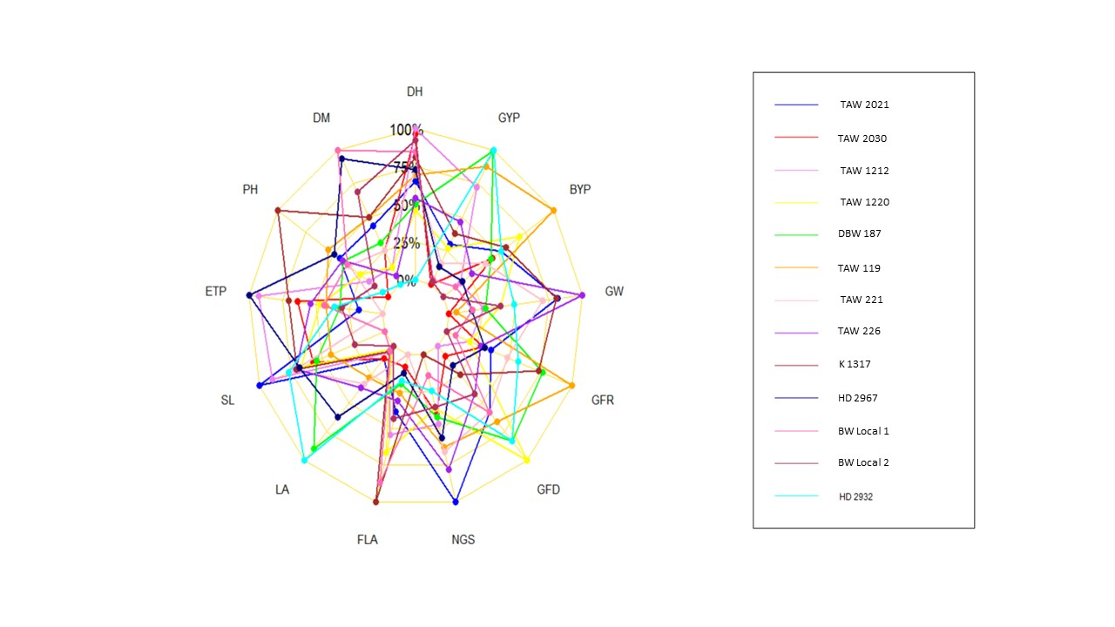

Figure S1. Radar plot showing reduction percentage of morphological traits of thirteen genotypes under heat stress condition.

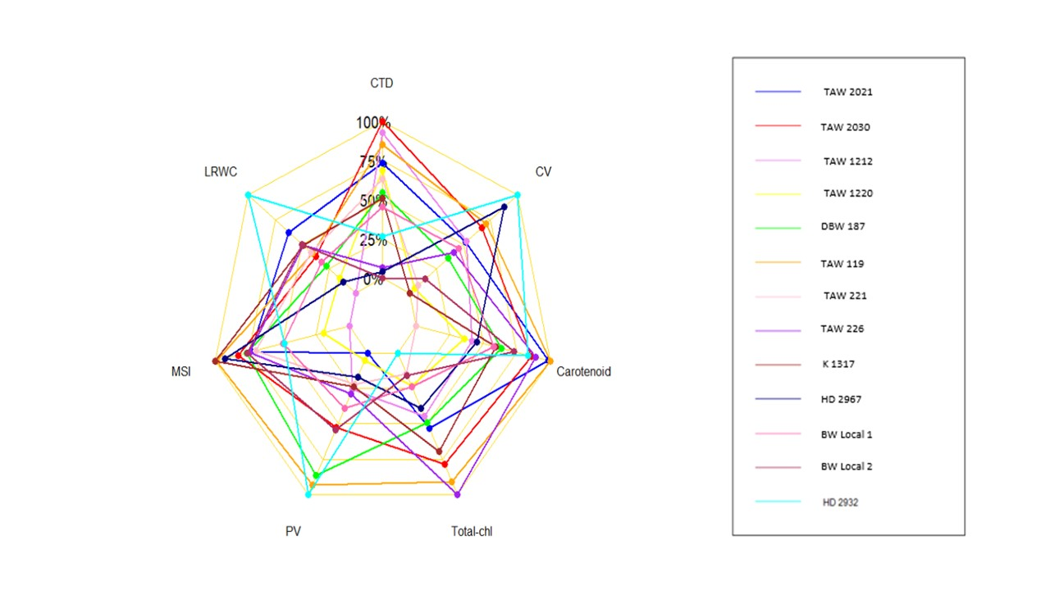

Figure S2. Radar plot showing proportionate change of physiological traits of thirteen genotypes under heat stress condition.

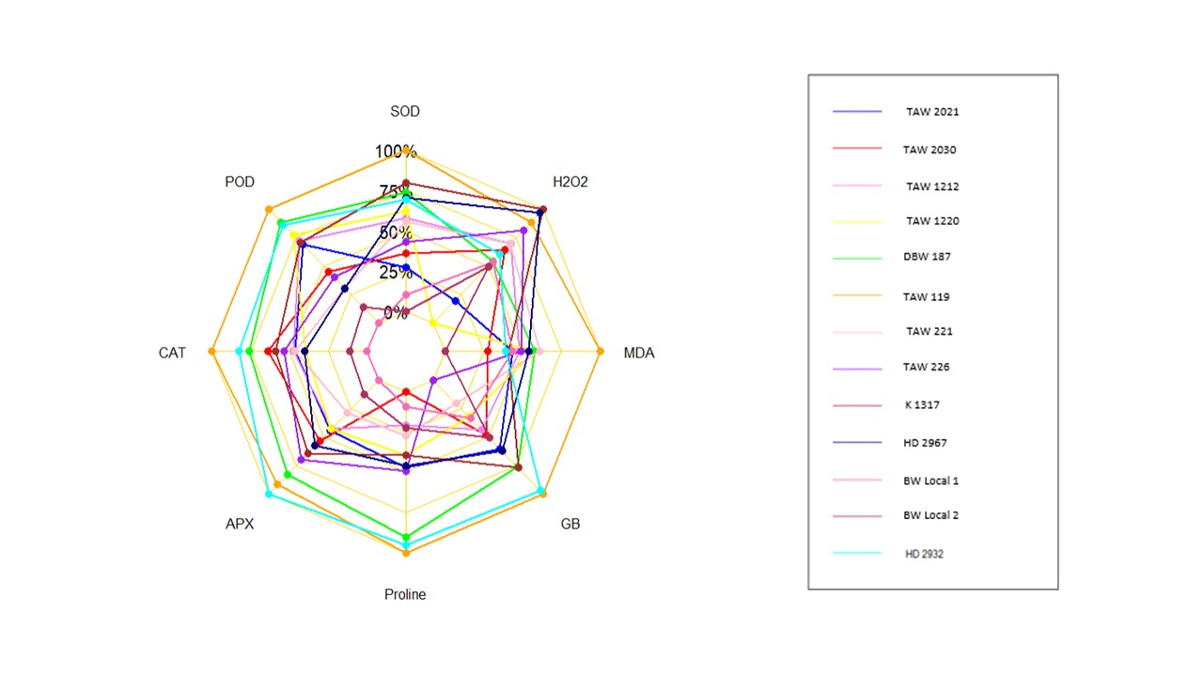 Figure S3. Radar plot showing proportionate change of biochemical traits of thirteen genotypes under heat stress condition.

