Nitric Oxide Dual-Enhanced Nanosystem Boosts Ferroptosis-Chemotherapy Synergy for Tumor Therapy
Xiaoyu Ding ^{a, #} , Jinjin Ren ^{c,} #, Dongyun Li ^{d e} , Huijuan Zhou ^{b}, Songchao Duan ^{b}, Xiaobao Gong ^{b}, and Hanchun Yao ^{b, *}
ªDepartment of Pharmacy, Zhoukou Central Hospital, Zhoukou 466000, China.
^{b} School of Pharmaceutical Science, Zhengzhou University, Zhengzhou 450001, China.
^{c} Nanjing Healthnice Pharmaceutical Technology Co., Ltd., Nanjing 210003, China.
^{d} Zhoukou Center for Disease Control and Prevention, Zhoukou 466000, China.
^{e} Specialized Hospital of Zhoukou Center for Disease Control and Prevention, Zhoukou 466000, China.
# co-first authors
* Corresponding Author, Email: yhchpaper@sina.com
Figure S1. DLS analysis results.
Figure S2. SEM image of AFe₃O₄ under different scales.

Figure S3. Release of NO in different concentration
Figure S4. Internalization amount of DOX, Arg-AFe₃O₄@DOX determined by flow cytometry in B16 cells.

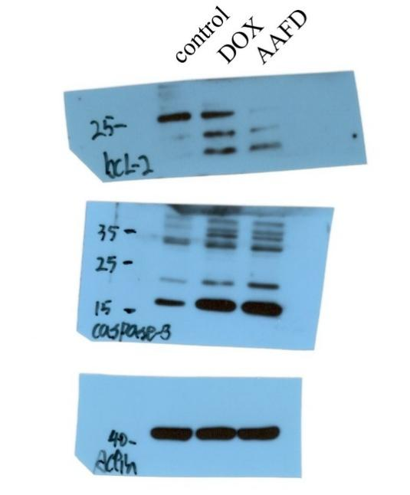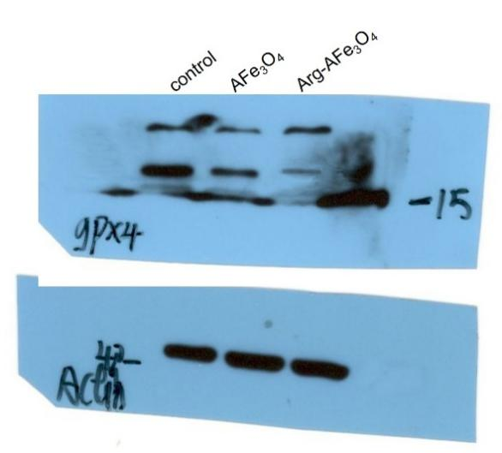
Figure S5. Full size blots of the immunoblot detection.

