SUPPLEMENTARY INFORMATION

Table S1. Number of Culex pipiens pools analyzed and prevalence, richness (S) and diversity (H’) of Plasmodium for each locality and year.

Locality name | Year | Nºpools | Prevalence | S | H’
Los Álamos | 2021 | 17 | 0.029 | 2 | 0.562
Los Álamos | 2022 | 28 | 0.013 | 4 | 1.386
Corrales | 2021 | 14 | 0.021 | 1 | 0.000
Corrales | 2022 | 31 | 0.017 | 3 | 1.040
Casa de los Ingleses | 2021 | 14 | 0.000 | 0 | -
Casa de los Ingleses | 2022 | 15 | 0.000 | 0 | -
Salinas del Astur | 2021 | 2 | 0.000 | 0 | -
Salinas del Astur | 2022 | 8 | 0.061 | 4 | 0.895
EDAR Moguer | 2021 | 13 | 0.096 | 2 | 0.693
EDAR Moguer | 2022 | 29 | 0.093 | 4 | 0.895
EDAR Huelva | 2021 | 24 | 0.000 | 0 | -
EDAR Huelva | 2022 | 89 | 0.013 | 4 | 0.895
Granja Escuela | 2021 | 15 | 0.031 | 1 | 0.000
Granja Escuela | 2022 | 12 | 0.101 | 2 | 0.693
Gibraleón | 2021 | 8 | 0.204 | 2 | 0.693
Gibraleón | 2022 | 7 | 0.281 | 3 | 1.040
Celestino Mutis | 2021 | 40 | 0.028 | 6 | 1.594
Celestino Mutis | 2022 | 74 | 0.023 | 8 | 1.620
Palacio de Doñana | 2021 | 7 | 0.333 | 0 | -
Palacio de Doñana | 2022 | 24 | 0.020 | 4 | 0.895
El Rocío | 2021 | 0 | 0.000 | 0 | -
El Rocío | 2022 | 0 | 0.000 | 0 | -
Palomares del Río | 2021 | 81 | 0.017 | 2 | 0.693
Palomares del Río | 2022 | 77 | 0.046 | 4 | 0.895
Dehesa de Abajo | 2021 | 59 | 0.018 | 1 | 0.000
Dehesa de Abajo | 2022 | 62 | 0.040 | 9 | 1.965
Cañada de los Pájaros | 2021 | 49 | 0.031 | 0 | -
Cañada de los Pájaros | 2022 | 47 | 0.020 | 4 | 0.895
Puebla del Río | 2021 | 125 | 0.001 | 1 | 0.000
Puebla del Río | 2022 | 143 | 0.003 | 5 | 1.468
Coría del Río | 2021 | 61 | 0.016 | 1 | 0.000
Coría del Río | 2022 | 54 | 0.024 | 2 | 0.562

Table S2. Number of Culex perexiguus pools analyzed and prevalence, richness (S) and diversity (H’) of Plasmodium for each locality and year.

Locality name | Year | Nºpools | Prevalence | S | H’
Los Álamos | 2021 | 2 | 0.000 | 0 | -
Los Álamos | 2022 | 3 | 0.000 | 0 | -
Corrales | 2021 | 1 | 0.000 | 0 | -
Corrales | 2022 | 6 | 0.000 | 0 | -
Casa de los Ingleses | 2021 | 0 | 0.000 | 0 | -
Casa de los Ingleses | 2022 | 0 | 0.000 | 0 | -
Salinas del Astur | 2021 | 2 | 0.000 | 0 | -
Salinas del Astur | 2022 | 0 | 0.000 | 0 | -
EDAR Moguer | 2021 | 2 | 0.000 | 0 | -
EDAR Moguer | 2022 | 2 | 0.000 | 0 | -
EDAR Huelva | 2021 | 1 | 0.000 | 0 | -
EDAR Huelva | 2022 | 9 | 0.007 | 1 | 0.000
Granja Escuela | 2021 | 5 | 0.112 | 1 | 0.000
Granja Escuela | 2022 | 4 | 0.126 | 1 | 0.000
Gibraleón | 2021 | 8 | 0.159 | 2 | 0.693
Gibraleón | 2022 | 5 | 0.269 | 2 | 0.693
Celestino Mutis | 2021 | 9 | 0.087 | 1 | 0.000
Celestino Mutis | 2022 | 6 | 0.414 | 1 | 0.000
Palacio de Doñana | 2021 | 9 | 0.016 | 1 | 0.000
Palacio de Doñana | 2022 | 17 | 0.000 | 0 | -
El Rocío | 2021 | 1 | 0.000 | 0 | -
El Rocío | 2022 | 2 | 0.000 | 0 | -
Palomares del Río | 2021 | 67 | 0.003 | 1 | 0.000
Palomares del Río | 2022 | 129 | 0.017 | 9 | 1.447
Dehesa de Abajo | 2021 | 199 | 0.010 | 9 | 1.822
Dehesa de Abajo | 2022 | 346 | 0.017 | 18 | 1.908
Cañada de los Pájaros | 2021 | 428 | 0.005 | 10 | 1.520
Cañada de los Pájaros | 2022 | 497 | 0.010 | 23 | 2.265
Puebla del Río | 2021 | 186 | 0.003 | 4 | 1.321
Puebla del Río | 2022 | 242 | 0.009 | 10 | 1.587
Coría del Río | 2021 | 75 | 0.003 | 1 | 0.000
Coría del Río | 2022 | 127 | 0.006 | 5 | 1.334

Table S3. GenBank accession codes for the lineages used in the phylogenetic analyses including those newly identified in this study. Novel lineages are highlighted in bold.

Lineage | Genus | Accession code | Reference
CB1 | Leucocytozoon | AY393804 | 1
COLPAL01 | Haemoproteus | KJ488710 | 2
STAL2 | Haemoproteus | EF607290 | 3
STRTUR01 | Haemoproteus | KJ488784 | 2
STRURA03 | Haemoproteus | KJ488826 | 2
TYTAL6 | Haemoproteus | KU528634 | 4
AFR106 | Plasmodium | KM056567 | 5
AFTRU5 | Plasmodium | DQ847263 | 6
BLUTI10 | Plasmodium | JQ434696 | 7
CIAE01 | Plasmodium | EF607288 | 3
COLL1 | Plasmodium | AY831747 | 8
CXBIT01 | Plasmodium | AB733351 | 9
CXPER01 | Plasmodium | HM179147 | 10
CXPER04 | Plasmodium | PQ798942 | This study
CXPER05 | Plasmodium | PQ798943 | This study
CXPER06 | Plasmodium | PQ798944 | This study
CXPER07 | Plasmodium | PQ798945 | This study
CXPIP23 | Plasmodium | JF411405 | 11
CXPIP33 | Plasmodium | LR990849 | NA
CXPIP35 | Plasmodium | PQ798937 | This study
CXPIP36 | Plasmodium | PQ798938 | This study
CXPIP37 | Plasmodium | PQ798939 | This study
CXPIP38 | Plasmodium | PQ798940 | This study
CXPIP39 | Plasmodium | PQ798941 | This study
DELURB4 | Plasmodium | EU154346 | 12
DELURB5 | Plasmodium | EU154347 | 12
DONANA02 | Plasmodium | JX458327 | 13
DONANA04 | Plasmodium | JX975223 | 13
GRW04 | Plasmodium | AF254975 | 14
GRW11 | Plasmodium | AY831748 | 8
LINN1 | Plasmodium | DQ847270 | 6
PADOM01 | Plasmodium | DQ058611 | 15
PADOM02 | Plasmodium | DQ058612 | 15
PAGRI02 | Plasmodium | JX196865 | NA
SGS1 | Plasmodium | AF495571 | 16
SGS2 | Plasmodium | JN661991 | 17
SYAT05 | Plasmodium | DQ847271 | 6
SYAT24 | Plasmodium | AY831749 | 8
TUMER06 | Plasmodium | KJ488827 | 2
TUPHI09 | Plasmodium | MT912308 | 18
YWT4 | Plasmodium | DQ368395 | 19

References
1. Hellgren, O., Waldenström, J., Bensch, S. A new PCR assay for simultaneous studies of Leucocytozoon, Plasmodium, and Haemoproteus from avian blood. J. Parasitol. 2004; 90: 797-802.
2. Drovetski, S. V., Aghayan, S. A., Mata, V. A., Lopes, R. J., Mode, N. A., Harvey, J. A., Voelker, G. Does the niche breadth or trade-off hypothesis explain the abundance–occupancy relationship in avian Haemosporidia?. Mol. Ecol. 2014; 23, 3322-3329.
3. Krone, O., Waldenström, J., Valkiūnas, G., Lessow, O., Müller, K., Iezhova, T. A., Fickel, J., Bensch, S. Haemosporidian blood parasites in European birds of prey and owls. J. Parasitol. 2008; 94, 709-715.
4. Salakij, C., Pornpanom, P., Lertwatcharasarakul, P., Kasorndorkbua, C., Salakij, J. Haemoproteus in barn and collared scops owls from Thailand. J. Vet. Sci. 2018; 19: 280-289.
5. Lutz, H. L., Hochachka, W. M., Engel, J. I., Bell, J. A., Tkach, V. V., Bates, J. M., Hackett, S.J., Weckstein, J. D. Parasite prevalence corresponds to host life history in a diverse assemblage of Afrotropical birds and haemosporidian parasites. PloS ONE. 2015; 10.
6. Hellgren, O., Waldenström, J., Pérez-Tris, J., Szöll, E., Si, Ö., Hasselquist, D., Krizanauskiene, A., Ottosson, U., Bensch, S. Detecting shifts of transmission areas in avian blood parasites—a phylogenetic approach. Mol. Ecol. 2007; 16: 1281-1290.
7. Ferrer, E. S., García-Navas, V., Sanz, J. J., Ortego, J. Molecular characterization of avian malaria parasites in three Mediterranean blue tit (Cyanistes caeruleus) populations. Parasitol. Res. 2012; 111: 2137-2142.
8. Pérez-Tris, J., Bensch, S. Dispersal increases local transmission of avian malarial parasites. Ecol. Lett. 2005; 8: 838-845.
9. Kim, K. S., Tsuda, Y. Avian Plasmodium lineages found in spot surveys of mosquitoes from 2007 to 2010 at Sakata wetland, Japan: do dominant lineages persist for multiple years?. Mol. Ecol. 2012; 21: 5374-5385.
10. Njabo, K. Y., Cornel, A. J., Bonneaud, C., Toffelmier, E., Sehgal, R. N. M., Valkiūnas, G., Russell, A.F., Smith, T. B. Nonspecific patterns of vector, host and avian malaria parasite associations in a central African rainforest. Mol. Ecol. 2011; 20: 1049-1061.
11. Inci, A., Yildirim, A., Njabo, K. Y., Duzlu, O., Biskin, Z., Ciloglu, A. Detection and molecular characterization of avian Plasmodium from mosquitoes in central Turkey. Vet. Parasitol. 2012; 188: 179-184.
12. Marzal, A., Bensch, S., Reviriego, M., Balbontin, J., De Lope, F. Effects of malaria double infection in birds: one plus one is not two. J. Evol. Biol. 2008; 21: 979-987.
13. Ferraguti, M., Martinez-de la Puente, J., Munoz, J., Roiz, D., Ruiz, S., Soriguer, R., Figuerola, J. Avian Plasmodium in Culex and Ochlerotatus mosquitoes from southern Spain: effects of season and host-feeding source on parasite dynamics. PloS ONE. 2013; 8: e66237.
14. Bensch, S., Stjernman, M., Hasselquist, D., Örjan, Ö., Hannson, B., Westerdahl, H., Pinheiro, R. T. Host specificity in avian blood parasites: a study of Plasmodium and Haemoproteus mitochondrial DNA amplified from birds. Proc. R. Soc. Lond. B Biol. Sci. 2000; 267: 1583-1589.
15. Bonneaud, C., Pérez-Tris, J., Federici, P., Chastel, O., Sorci, G. Major histocompatibility alleles associated with local resistance to malaria in a passerine. Evolution. 2006; 60: 383-389.
16. Waldenström, J., Bensch, S., Kiboi, S., Hasselquist, D., Ottosson, U. Cross-species infection of blood parasites between resident and migratory songbirds in Africa. Mol. Ecol. 2002; 11: 1545-1554.
17. Ishtiaq, F., Beadell, J. S., Warren, B. H., Fleischer, R. C. Diversity and distribution of avian haematozoan parasites in the western Indian Ocean region: a molecular survey. Parasitol. 2012; 139: 221-231.
18. Harl, J., Himmel, T., Valkiūnas, G., Ilgūnas, M., Bakonyi, T., Weissenböck, H. Geographic and host distribution of haemosporidian parasite lineages from birds of the family Turdidae. Malar. J. 2020; 19: 1-35.
19. Pérez-Tris, J., Hellgren, O., Križanauskienė, A., Waldenström, J., Secondi, J., Bonneaud, C., Fjeldså, J., Hasselquist, D., Bensch, S. Within-host speciation of malaria parasites. PLoS ONE. 2007; 2: e235.

Table S4. Localities sampled in this study. Number of BGs and CDCs per sampled site and periodicity of sampling are provided. In Casa de los Ingleses and Salinas del Astur BG’s were only used in 2021.

Locality name | Locality code | Coordinates | Nº BG | Nº CDC | Nº times sampled
Los Álamos | 0 | 37°16'43.3"N 6°54'36.8"W | 3 | 1 | Once per month
Corrales | 1 | 37°16'39.0"N 6°59'16.4"W | 3 | 1 | Once per month
Casa de los Ingleses | 2 | 37°10'59.1"N 6°58'19.7"W | 3 | 1 | Once per month
Salinas del Astur | 3 | 37°12'18.0"N 6°59'33.4"W | 3 | 1 | Once per month
EDAR Moguer | 4 | 37°16'10.8"N 6°51'39.1"W | 3 | 1 | Once per month
EDAR Huelva | 5 | 37°14'31.6"N 6°55'41.5"W | 3 | 1 | Once per month
Granja Escuela | 6 | 37°19'28.4"N 6°47'47.8"W | 3 | 0 | Once per month
Gibraleón | 7 | 37°22'54.8"N 6°59'14.5"W | 3 | 0 | Once per month
Celestino Mutis | 8 | 37°12'20.5"N 6°55'24.0"W | 3 | 1 | Once per month
Palacio de Doñana | 9 | 36°59'19.2"N 6°26'34.6"W | 3 | 1 | Once per month
El Rocío | 10 | 37°07'40.1"N 6°28'48.6"W | 3 | 0 | Once per month
Palomares del Río | 11 | 37°18'58.3"N 6°03'28.0"W | 3 | 0 | Once per week
Dehesa de Abajo | 12 | 37°13'01.7"N 6°11'08.0"W | 3 | 0 | Once per week
Cañada de los Pájaros | 13 | 37°14'17.9"N 6°07'45.6"W | 3 | 0 | Once per week
Puebla del Río | 14 | 37°16'14.9"N 6°03'51.8"W | 3 | 0 | Once per week
Coria del Río | 15 | 37°17'02.5"N 6°03'51.9"W | 3 | 0 | Once per week

Table S5. Description of the environmental variables used in the study. Source for each variable, spatial and temporal resolution, and units of measurement are reported for each variable.

Variables | Description | Source | Spatial resolution | Temporal resolution | Units
Maximum temperature (Tmax) | The highest temperature recorded in a given month | Terraclimate | ~ 4km | 2021-2022 | ºC
Minimum temperature (Tmin) | The lowest air temperature recorded in a given month | Terraclimate | ~ 4km | 2021-2022 | ºC
Mean temperature (Tmean) | The average air temperature in a given month | Terraclimate | ~ 4km | 2021-2022 | ºC
Precipitation | Total amount of precipitation in a given month | Terraclimate | ~ 4km | 2021-2022 | mm
Actual Evapotranspiration | Water loss measurement from the Earth’s surface | Terraclimate | ~ 4km | 2021-2022 | mm
Normalized Difference Vegetation Index (NDVI) | The monthly Green vegetation coverage index | MODIS  MOD13Q1  Version 6.1 | 250m | 2021-2022 | No units
Land Surface Temperature (LST) | Monthly average land surface temperature | MODIS  MOD11A2 Version 6.1 | 1km | 2021-2022 | ºC
Vapor pressure | Monthly average of vapor pressure (pressure exserted by vapor) | Terraclimate | ~ 4km | 2021-2022 | kpa
DEM-Digital Elevation Model | Topographic surface of the Earth | ASTER v2 | 30 m | 2022 | m
Land Uses (LND) | Proportion of land-use categories within buffers (see Appendix D) | SIPNA | Shapefile-Polygon | 2022 | %

Table S6. Land use categories considered, those considered more favorable for mosquito breeding are marked in bold.

Land code | Land use
1 | Mount
2 | River/Sea
3 | Saline
4 | Salt marshes
5 | Rice field
6 | Pine forest
7 | Industrial zone
8 | Lagoons
9 | Urban zone
10 | Greenhouses
11 | Mines

Table S7. Coordinates obtained in the Correspondence Analysis (CA) on the Plasmodium lineages detected in Culex pipiens and Culex perexiguus mosquitoes in each study locality and year.

Locality name | Year | Mosquito species | Coordinates  Dim 1 | Coordinates  Dim 2
Los Álamos | 2021 | Culex pipiens | 4.129 | 0.192
Los Álamos | 2022 | Culex pipiens | -0.247 | -0.0583
Corrales | 2022 | Culex pipiens | 4.129 | 0.192
Salinas Astur | 2022 | Culex pipiens | 4.129 | 0.192
EDAR Moguer | 2021 | Culex pipiens | -0.189 | -1.162
EDAR Moguer | 2022 | Culex pipiens | -0.189 | -1.162
EDAR Huelva | 2022 | Culex pipiens | 2.192 | -0.037
Granja Escuela | 2021 | Culex pipiens | -0.189 | -1.162
Granja Escuela | 2022 | Culex pipiens | -0.247 | -0.058
Granja Escuela | 2021 | Culex perexiguus | -0.189 | -1.162
Granja Escuela | 2022 | Culex perexiguus | 4.129 | 0.192
Gibraleón | 2021 | Culex pipiens | -0.189 | -1.162
Gibraleón | 2022 | Culex pipiens | -0.159 | 0.740
Gibraleón | 2021 | Culex perexiguus | -0.306 | 1.046
Gibraleón | 2022 | Culex perexiguus | -0.247 | -0.058
Celestino Mutis | 2021 | Culex pipiens | 0.307 | -0.165
Celestino Mutis | 2022 | Culex pipiens | 0.002 | -0.393
Celestino Mutis | 2022 | Culex perexiguus | -0.189 | -1.162
Palacio de Doñana | 2021 | Culex perexiguus | -0.306 | 1.046
Palomares del Río | 2021 | Culex pipiens | -0.247 | -0.058
Palomares del Río | 2022 | Culex pipiens | -0.220 | -0.725
Palomares del Río | 2021 | Culex perexiguus | -0.189 | -1.162
Palomares del Río | 2022 | Culex perexiguus | -0.159 | 0.387
Dehesa de Abajo | 2021 | Culex pipiens | -0.189 | -1.162
Dehesa de Abajo | 2022 | Culex pipiens | 0.219 | -0.299
Dehesa de Abajo | 2021 | Culex perexiguus | -0.232 | -0.399
Dehesa de Abajo | 2022 | Culex perexiguus | -0.146 | 0.046
Cañada de los Pájaros | 2022 | Culex pipiens | -0.271 | 0.102
Cañada de los Pájaros | 2021 | Culex perexiguus | -0.275 | 0.472
Cañada de los Pájaros | 2022 | Culex perexiguus | -0.147 | -0.174
Puebla del Río | 2021 | Culex pipiens | -0.189 | -1.162
Puebla del Río | 2022 | Culex pipiens | -0.211 | -0.134
Puebla del Río | 2021 | Culex perexiguus | -0.236 | -0.279
Puebla del Río | 2022 | Culex perexiguus | -0.101 | 0.252
Coría del Río | 2021 | Culex pipiens | -0.189 | -1.162
Coría del Río | 2022 | Culex pipiens | -0.189 | -1.162
Coría del Río | 2021 | Culex perexiguus | -0.306 | 1.046
Coría del Río | 2022 | Culex perexiguus | -0.287 | 0.450

Table S8. Abundance of Plasmodium lineages across sampling locations for Cx. pipiens. Values indicate the number of positive mosquito pools detected for each lineage at each location. Each row represents a distinct Plasmodium lineage, and each column corresponds to a sampling location. Letters correspond to the localities: (a) EDAR Huelva, (b) Granja Escuela, (c) Gibraleón, (d) Celestino Mutis, (e) Palacio de Doñana, (f) Palomares del Río, (g) Dehesa de Abajo, (h) Cañada de los Pájaros, (i) Puebla del Río, (j) Coria del Río.

 | a | b | c | d | e | f | g | h | i | j
AFR106 | 0 | 0 | 0 | 0 | 0 | 0 | 0 | 0 | 0 | 0
AFTRU5 | 2 | 0 | 1 | 0 | 0 | 0 | 1 | 1 | 1 | 0
BLUTI10 | 0 | 0 | 0 | 0 | 0 | 0 | 0 | 0 | 0 | 0
CIAE01 | 0 | 0 | 0 | 0 | 0 | 0 | 1 | 0 | 0 | 0
COLL1 | 0 | 0 | 0 | 0 | 0 | 0 | 0 | 0 | 0 | 0
CXBIT01 | 0 | 0 | 0 | 0 | 0 | 0 | 0 | 0 | 0 | 0
CXPER01 | 1 | 0 | 0 | 3 | 0 | 1 | 0 | 0 | 0 | 0
CXPER04 | 0 | 0 | 0 | 0 | 0 | 0 | 0 | 0 | 0 | 0
CXPER05 | 0 | 0 | 0 | 0 | 0 | 0 | 0 | 0 | 0 | 0
CXPER06 | 0 | 0 | 0 | 0 | 0 | 0 | 0 | 0 | 0 | 0
CXPER07 | 0 | 0 | 0 | 0 | 0 | 0 | 0 | 0 | 0 | 0
CXPIP23 | 0 | 0 | 0 | 1 | 0 | 0 | 1 | 1 | 0 | 0
CXPIP33 | 3 | 0 | 1 | 0 | 2 | 0 | 0 | 0 | 2 | 0
CXPIP35 | 0 | 0 | 0 | 0 | 0 | 0 | 0 | 1 | 0 | 0
CXPIP36 | 0 | 0 | 0 | 0 | 0 | 1 | 1 | 3 | 0 | 0
CXPIP37 | 0 | 0 | 0 | 1 | 0 | 0 | 0 | 0 | 0 | 0
CXPIP38 | 0 | 0 | 1 | 0 | 0 | 0 | 0 | 0 | 0 | 0
CXPIP39 | 0 | 0 | 0 | 1 | 0 | 0 | 0 | 0 | 0 | 0
DELURB4 | 4 | 0 | 0 | 0 | 0 | 0 | 0 | 0 | 0 | 0
DELURB5 | 0 | 0 | 0 | 2 | 0 | 0 | 0 | 0 | 0 | 0
DONANA02 | 0 | 0 | 0 | 0 | 0 | 0 | 0 | 0 | 0 | 0
DONANA04 | 0 | 0 | 0 | 0 | 0 | 0 | 1 | 0 | 0 | 0
GRW04 | 1 | 0 | 0 | 0 | 0 | 0 | 0 | 2 | 0 | 1
GRW11 | 1 | 0 | 0 | 0 | 0 | 0 | 0 | 0 | 0 | 0
LINN1 | 2 | 1 | 1 | 9 | 0 | 3 | 2 | 1 | 3 | 0
PADOM01 | 0 | 0 | 0 | 0 | 0 | 0 | 0 | 0 | 0 | 0
PADOM02 | 0 | 0 | 0 | 0 | 0 | 0 | 0 | 0 | 0 | 0
PAGRI02 | 0 | 0 | 0 | 0 | 0 | 0 | 0 | 0 | 0 | 0
SGS1 | 11 | 0 | 0 | 2 | 0 | 0 | 1 | 0 | 0 | 0
SGS2 | 0 | 0 | 0 | 0 | 0 | 0 | 0 | 0 | 0 | 0
SYAT05 | 5 | 3 | 1 | 16 | 0 | 11 | 7 | 1 | 6 | 4
SYAT24 | 0 | 0 | 0 | 2 | 0 | 0 | 1 | 0 | 0 | 0
TUMER06 | 0 | 0 | 0 | 0 | 0 | 0 | 0 | 0 | 0 | 0
TUPHI09 | 0 | 0 | 0 | 0 | 1 | 0 | 0 | 0 | 0 | 0
YWT4 | 0 | 0 | 0 | 1 | 0 | 0 | 0 | 0 | 1 | 0

Table S9. Abundance of Plasmodium lineages across sampling locations for Cx. perexiguus. Values indicate the number of positive mosquito pools detected for each lineage at each location. Each row represents a distinct Plasmodium lineage, and each column corresponds to a sampling location. Letters correspond to the localities: (a) EDAR Huelva, (b) Granja Escuela, (c) Gibraleón, (d) Celestino Mutis, (e) Palacio de Doñana, (f) Palomares del Río, (g) Dehesa de Abajo, (h) Cañada de los Pájaros, (i) Puebla del Río, (j) Coria del Río.

 | a | b | c | d | e | f | g | h | i | j
AFR106 | 0 | 0 | 0 | 0 | 0 | 0 | 1 | 0 | 0 | 0
AFTRU5 | 0 | 0 | 0 | 0 | 0 | 2 | 14 | 6 | 6 | 0
BLUTI10 | 0 | 0 | 0 | 0 | 0 | 0 | 1 | 1 | 0 | 0
CIAE01 | 0 | 0 | 0 | 0 | 0 | 0 | 0 | 0 | 0 | 0
COLL1 | 0 | 0 | 0 | 0 | 0 | 0 | 0 | 2 | 1 | 0
CXBIT01 | 0 | 0 | 0 | 0 | 0 | 0 | 1 | 0 | 0 | 0
CXPER01 | 0 | 0 | 0 | 1 | 0 | 1 | 0 | 7 | 2 | 2
CXPER04 | 0 | 0 | 0 | 0 | 0 | 0 | 0 | 1 | 0 | 0
CXPER05 | 0 | 0 | 0 | 0 | 0 | 0 | 1 | 0 | 0 | 0
CXPER06 | 0 | 0 | 0 | 0 | 0 | 0 | 0 | 2 | 0 | 0
CXPER07 | 0 | 0 | 0 | 0 | 0 | 0 | 0 | 1 | 0 | 0
CXPIP23 | 0 | 0 | 0 | 0 | 0 | 0 | 4 | 6 | 1 | 0
CXPIP33 | 0 | 0 | 0 | 0 | 0 | 0 | 1 | 0 | 0 | 0
CXPIP35 | 0 | 0 | 0 | 0 | 0 | 1 | 12 | 6 | 0 | 0
CXPIP36 | 0 | 0 | 0 | 0 | 0 | 3 | 12 | 1 | 5 | 2
CXPIP37 | 0 | 0 | 0 | 0 | 0 | 0 | 0 | 0 | 0 | 0
CXPIP38 | 0 | 0 | 0 | 0 | 0 | 0 | 1 | 3 | 1 | 0
CXPIP39 | 0 | 0 | 0 | 0 | 0 | 0 | 0 | 0 | 0 | 0
DELURB4 | 0 | 0 | 1 | 0 | 0 | 0 | 0 | 0 | 0 | 0
DELURB5 | 1 | 0 | 0 | 0 | 0 | 1 | 1 | 9 | 3 | 3
DONANA02 | 0 | 0 | 0 | 0 | 0 | 0 | 2 | 3 | 0 | 0
DONANA04 | 0 | 0 | 0 | 0 | 0 | 0 | 2 | 2 | 0 | 0
GRW04 | 0 | 0 | 0 | 0 | 0 | 0 | 2 | 11 | 1 | 0
GRW11 | 0 | 0 | 0 | 0 | 0 | 0 | 1 | 0 | 0 | 0
LINN1 | 0 | 0 | 2 | 0 | 1 | 25 | 47 | 61 | 32 | 14
PADOM01 | 0 | 0 | 0 | 0 | 0 | 0 | 0 | 1 | 0 | 0
PADOM02 | 0 | 0 | 0 | 0 | 0 | 0 | 0 | 1 | 0 | 0
PAGRI02 | 0 | 0 | 0 | 0 | 0 | 0 | 0 | 0 | 0 | 0
SGS1 | 0 | 1 | 0 | 0 | 0 | 1 | 2 | 2 | 2 | 0
SGS2 | 0 | 0 | 0 | 0 | 0 | 0 | 0 | 2 | 0 | 0
SYAT05 | 0 | 1 | 1 | 1 | 0 | 11 | 53 | 57 | 2 | 4
SYAT24 | 0 | 0 | 0 | 0 | 0 | 0 | 1 | 2 | 0 | 0
TUMER06 | 0 | 0 | 0 | 0 | 0 | 2 | 1 | 1 | 0 | 0
TUPHI09 | 0 | 0 | 0 | 0 | 0 | 0 | 0 | 0 | 0 | 0
YWT4 | 0 | 0 | 0 | 0 | 0 | 0 | 1 | 0 | 0 | 0

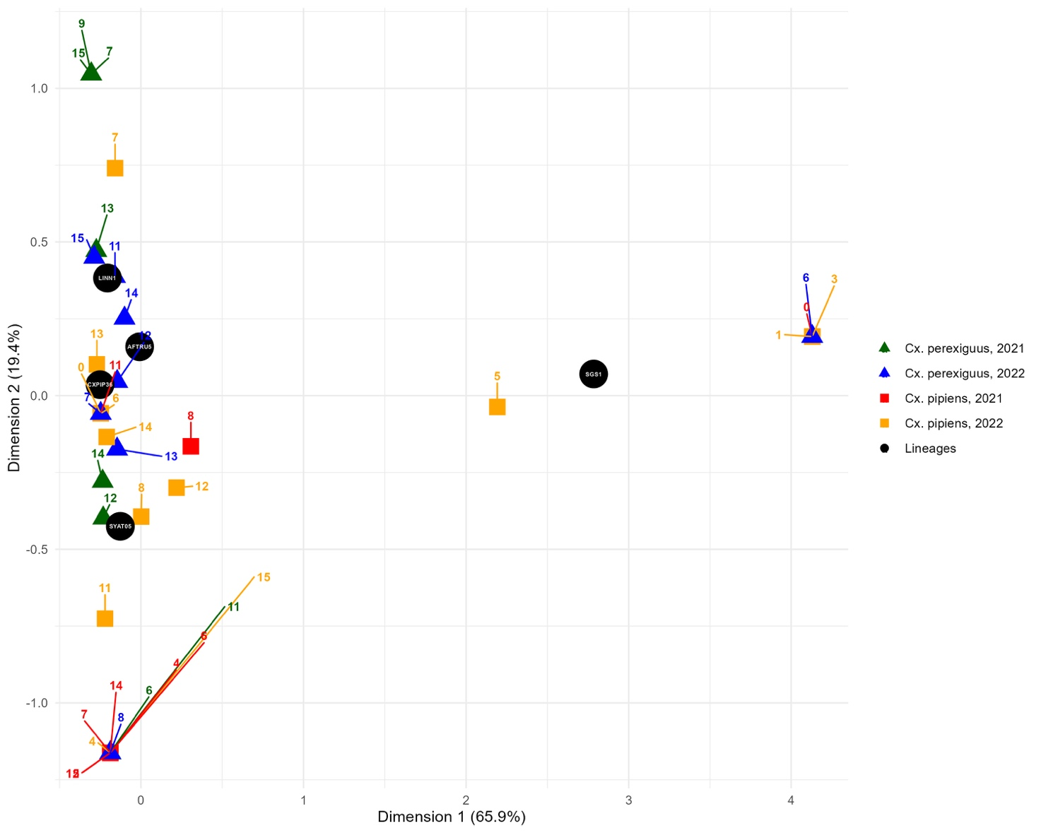

Figure S1. Correspondence analysis of the most abundant Plasmodium lineages found in Culex pipiens and Culex perexiguus. The plot highlights the distribution and relationship of different lineages across both vectors and years in the sampled localities. Numbers represent locality codes (see Table S4).

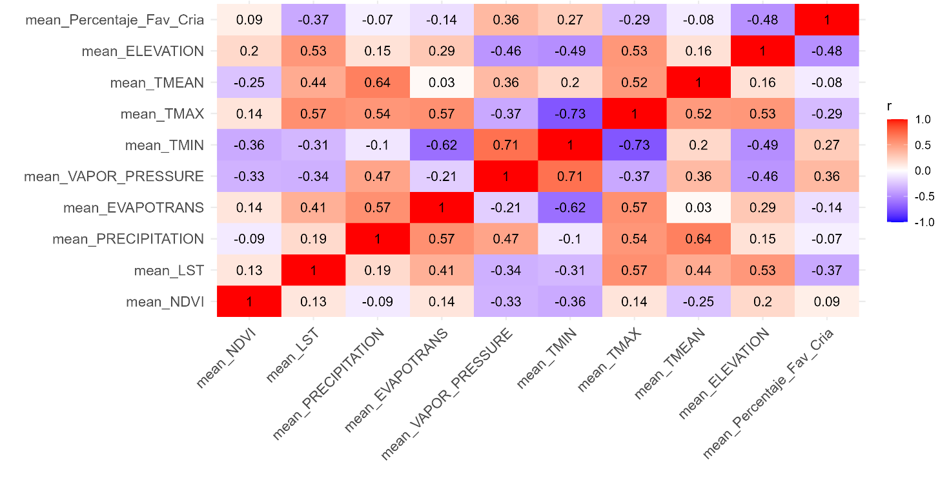
Figure S2. Heatmap showing pairwise correlations among environmental predictors used in the LMMs. Each cell displays the Pearson correlation coefficient (r) rounded to two decimal places. Blue indicates negative correlations, red indicates positive correlations, and white indicates near-zero correlations. Predictor abbreviations are defined as follows: mean_Percentage_Fav_Cria = annual mean percentage of land favorable for mosquito breeding; mean_ELEVATION = annual mean elevation; mean_TMEAN = annual mean mean temperature; mean_TMAX = annual mean maximum temperature; mean_TMIN = annual mean minimum temperature; mean_VAPOR_PRESSURE = annual mean vapor pressure; mean_EVAPOTRANS = annual mean evapotranspiration; mean_PRECIPITATION = annual mean precipitation; mean_LST = annual mean land surface temperature; and mean_NDVI = annual mean normalized difference vegetation index.

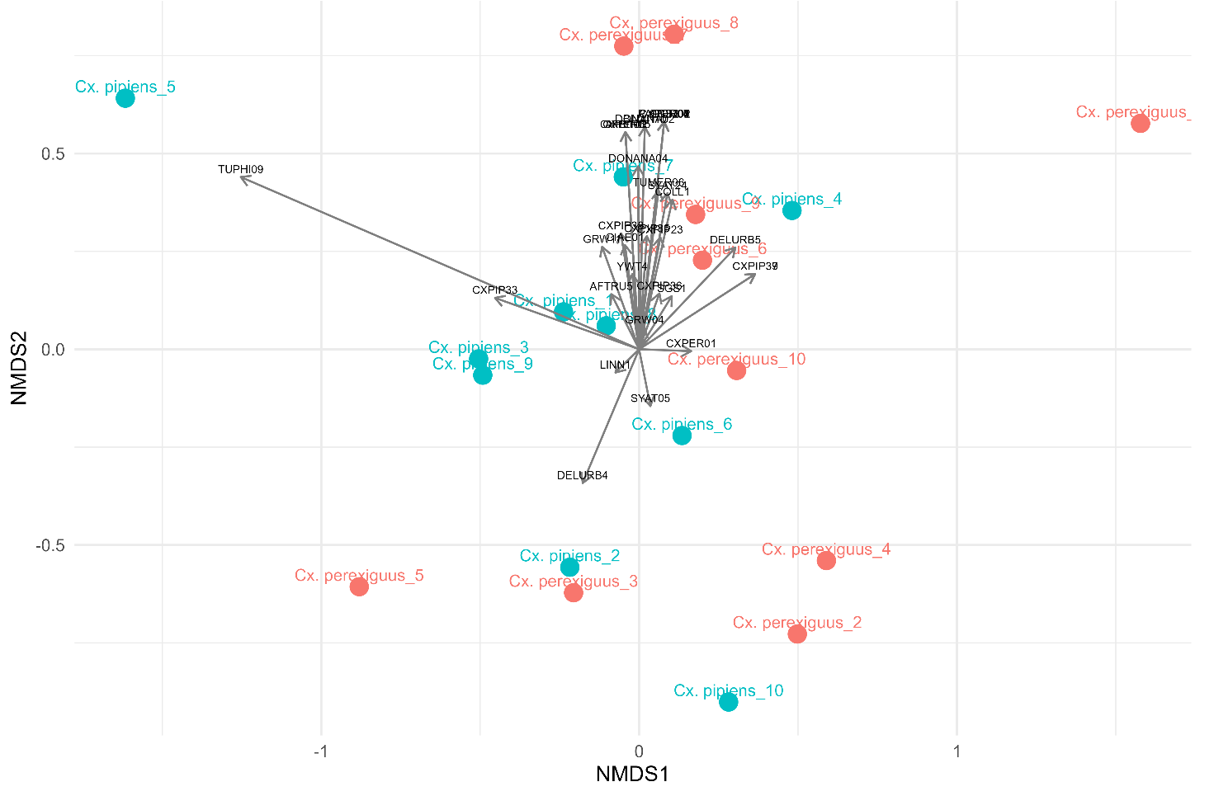

Figure S3. Non-metric multidimensional scaling (NMDS) plot based on Bray–Curtis dissimilarity, showing the ordination of Cx. pipiens (blue) and Cx. perexiguus (red) mosquito populations across different localities. Each point represents a population from a specific locality, labeled with its corresponding numbered code (see Table S4). Black arrows indicate Plasmodium lineages, with their orientation and length reflecting the strength and direction of their association with the mosquito populations.

