Supplementary Material

Contemplative practices serve as complementary mental health strategies in nationally representative samples from Australia and New Zealand

Karin Matko^{1*}, Cate Bailey^{1,2}, Julieta Galante¹, Jonathan N Davies¹, Nicholas T Van Dam¹

¹Contemplative Studies Centre, Melbourne School of Psychological Sciences, University of Melbourne
²Melbourne Health Economics, School of Population and Global Health, University of Melbourne
*Corresponding author: karin.matko@unimelb.edu.au

Section A

Figure A1. Participants’ main practice and their assigned survey practice
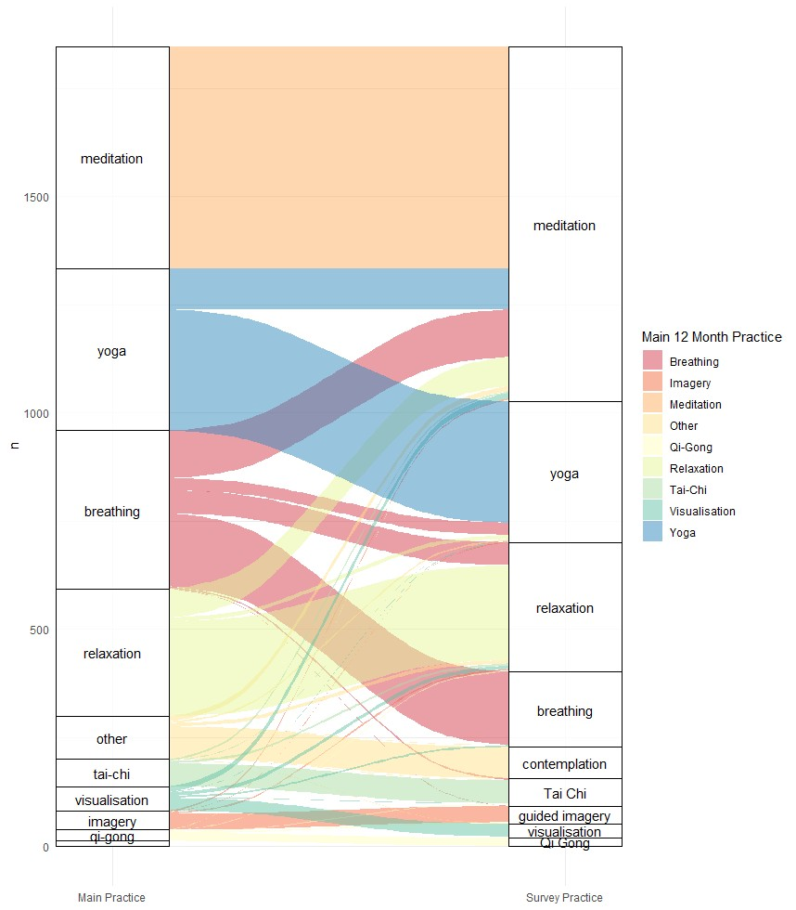

With respect to the four key practices identified earlier, only 63% of participants who responded to further meditation questions, actually reported meditation as their main practice. Likewise, only 75% of yoga practitioners responded to yoga questions, 74% of relaxation practitioners to relaxation questions, and 46% of breathing practitioners to breathing questions.

Table A2. Variables and their simplification for use in this study
Gender | Simplified to binary (male/female), “non-binary” or “prefer not so say” coded as NA
LGBTQIA+ | Binary (yes/no), “prefer not so say” coded as NA
Education | Table: Simplified to binary (degree below/ above university)  Regression: Original scale as orthogonal polynomials
Income | Recoded response options 1 and 2 in both AU (<$52,000) and NZ (<$30,000) as “low”, options 3 and 4 as “middle” (AU: $52,000−$156,000; NZ: $30,000−$70,000), options 5 and 6 as “high” income (AU: >$156,000; NZ: >$70,000) to merge and simplify country-specific brackets.  Table: Simplified to binary (high/ low or middle income)  Regression: Recoded scale as orthogonal polynomials
Occupation | Simplified to binary (working part- or full-time/ not working)
Chronic disease | Simplified to binary (yes/no)
Disability | Binary (yes/no), “prefer not so say” coded as NA
Caring for someone | Simplified to binary (yes/no)
Indigenous | Simplified to binary (yes/no) across both countries
Religion | Simplified to binary (any religion/ no religion)
Spiritual | Table: Simplified to binary (not at all/ more than slightly)  Regression: Original scale as orthogonal polynomials
Religious | Table: Simplified to binary (not at all/ more than slightly)  Regression: Original scale as orthogonal polynomials
Connected to higher power | Table: Simplified to binary (not at all/ more than slightly)
 | Regression: Original scale as orthogonal polynomials
Connected to all humanity | Table: Simplified to binary (not at all/ more than slightly)  Regression: Original scale as orthogonal polynomials
Connected to nature | Table: Simplified to binary (not at all/ more than slightly)  Regression: Original scale as orthogonal polynomials
No alcohol use | Simplified to binary (never/ more than yearly)
Non-smoker | Simplified to binary (never/ more than yearly)
No cannabis use | Simplified to binary (never/ more than yearly)
No psychedelics use | Simplified to binary (never/ more than yearly)

Section B – Prevalence and Correlations

Figure B1. Percentages of meditation, breathing, relaxation, and yoga being chosen as a lifetime, 12-month or main practice
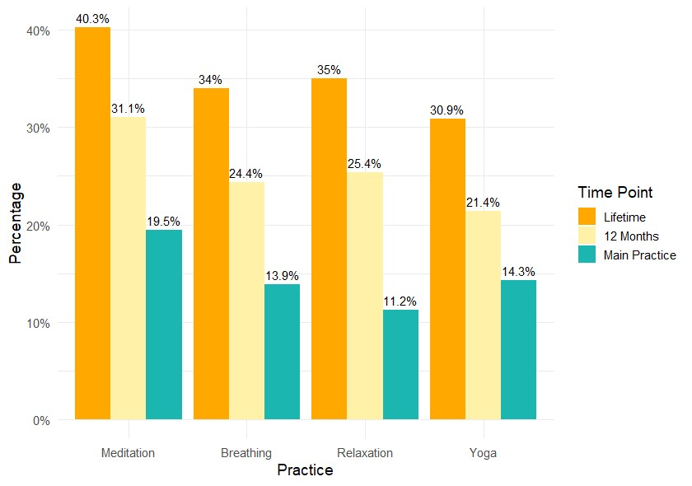
Note. Maximum frequency in each category was n = 2640. Selection of multiple responses was possible for lifetime and 12-month practice.

Of all participants who reported lifetime meditation practice, 77.1% reported having practiced meditation in the past 12 months and 48.2% selected it as their main practice. For yoga, 69.2% of lifetime practitioners had practiced in the past 12 months and 46.0% selected it as their main practice. For relaxation and breathing, percentage practice over the past 12 months and main practice were 72.5% and 31.9%, and 71.7% and 40.7% respectively.

Figure B2. Significant correlations larger than r = .20 among lifetime (A) and 12-month (B) contemplative practices
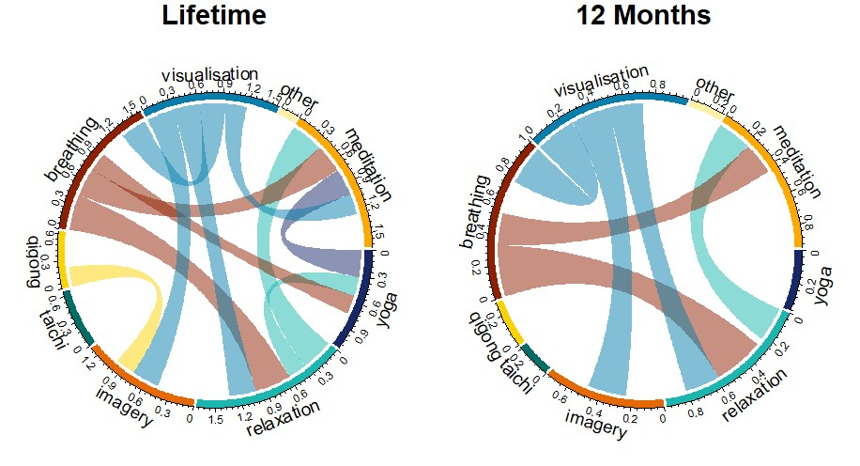
A

B

Note. Thickness of lines indicates the strength of the correlation.
Figure B2 shows correlations between all practices that tended to be selected simultaneously and were thus commonly practiced together. Examining only those practices that were correlated across both time windows, we observed the following. Meditation was associated with relaxation and breathing. Yoga showed no robust associations. Relaxation was associated with meditation, breathing, and visualisation. Imagery was associated with visualization. Breathing was associated with meditation and relaxation. Neither Tai Chi nor Qigong exhibited robust associations. Generally, there were fewer correlations at 12 months suggesting participants tended to combine more practices over lifetime than in the past 12 months.

Section C – Styles of Contemplative Practice

Table C1. Categories of other contemplative practices, number and total sample proportion of entries per category

 | n | % of total sample
Walking | 65 | 3.5
Prayer | 57 | 3.1
Gardening | 42 | 2.3
Sports, exercise | 33 | 1.8
Nature | 14 | 0.8
Music | 13 | 0.7
Reflection | 10 | 0.5
Journaling | 5 | 0.3
Hypnosis | 4 | 0.2
Book reading | 3 | 0.2
Sleep, dream | 3 | 0.2

What types of contemplative practice do participants report?
After participants were assigned a survey practice for the contemplative block, they were asked to describe what particular style they practiced. We followed a similar approach in analysing responses to this open-ended question as we did above with their reports on “other contemplative practices”. First, we analyzed all responses by meditators (n=820) and then all responses by participants practicing any other contemplative practice.

Meditators
We categorized 817 entries into 6 clusters and 46 categories. Table C2 summarises all clusters and categories and the number of entries per cluster/category.

Table C2. Clusters and categories of practice style and number of entries per category for meditation
Cluster | Category | n | n (total)
Tradition | yoga | 35 | 56
 | taoist | 6
 | buddhist | 5
 | zen | 4
 | christian | 3
 | transcendental | 3

Technique | breath | 122 | 348
 | mindfulness | 69
 | sitting in silence | 51
 | walking | 18
 | music | 13
 | sound | 12
 | sensory | 8
 | visualisation | 8
 | concentration | 7
 | mantra | 7
 | brahmavihara | 6
 | observing | 6
 | body scan | 5
 | body | 4
 | spiritual | 4
 | contemplation | 3
 | nidra | 3
 | dynamic | 2
Other contemplative | prayer | 19 | 36
 | sports, exercise | 8
 | hypnosis | 5
 | nature | 4
Aim | relax | 55 | 1 30
 | calm | 19
 | clear mind | 11
 | comfort | 9
 | reflection | 9
 | self | 7
 | sleep | 7
 | deep | 6
 | mind-wandering | 3
 | healing | 2
 | mood | 2
Mode | guided | 103 | 109
 | close eyes | 6
Unspecified | unspecified | 45 | 80
 | none | 20
 | dont know | 10
 | own style | 5
Other | other | 61 | 61
Asking participants to describe their style of practice can lead to quite varied responses. Only 7% of participants name a meditation tradition and 43% describe a specific meditation technique. Note that the top entries for these categories (yoga and breath) might reflect some participants for whom meditation was not their main practice. Of all other participants, 4% name a contemplative practice that is not considered a “classic” meditation technique, 13% describe a mode rather than a specific style of practice (e.g. guided), 16% name an aim or motivation for practicing (e.g. relaxing), 10% state an unspecific style (e.g. meditation), and 7% of entries could not be classified and fall in the “other” category.
In addition, the contemplative block included questions pertaining to the context of participants’ practice and the specific meditation techniques they were using. Both were multiple-choice questions that allowed participants to select all options that applied to them. Tables C3 and C4 provide an overview of the number and percentage of meditators who selected each option.

Table C3. Number and percentage of meditators who reported practicing different meditation techniques
Meditation Technique | Meditators  (N=820)
Meditation with movement (e.g., walking meditation) | 223 (27.2%)
Body-centred meditation (e.g., observing body, breath or energy) | 514 (62.7%)
Mindful observation (e.g., observing thoughts or emotions) | 500 (61.0%)
Contemplation (e.g., contemplating a question) | 210 (25.6%)
Visual concentration (e.g., visualisations or concentrating on an object) | 242 (29.5%)
Affect-centred meditation (e.g, lovingkindness or compassion) | 131 (16.0%)
Mantra meditation (e.g., repeating mantras, meditating with sound) | 121 (14.8%)
Something else | 19 (2.3%)

Table C3. Number and percentage of meditators who reported practicing in different meditation contexts
Meditation Context | Meditators  (N=820)
I work with a teacher or instructor | 77 (9.4%)
I listen to audio or video resources | 341 (41.6%)
I use a smartphone app | 239 (29.1%)
My practice is self-guided | 336 (41.0%)
I practice in a group | 111 (13.5%)
I practice alone | 397 (48.4%)
I don't practice anymore | 24 (2.9%)
Something else | 4 (0.5%)

The most commonly used meditation techniques were body-centered meditation and mindful observation, and the most common practice contexts were practicing alone, self-guided or listening to audio or video resources. Overall, participants practiced in a wide range of contexts and used various meditation techniques.

Other Contemplative Practices
Then, we analysed the responses of participants engaging in other contemplative practices. We categorized 1018 entries into 18 clusters and 42 categories. As breathing was a large category in this group, we further differentiated different styles of breathing in our coding system. Our coding system was general, i.e., not specific to each practice, which meant that different practices could receive the same code. Unfortunately, participant responses were too short and nonspecific to devise mutually exclusive categories. Hence, when we summarised how often each category appeared in each practice, we did not further distinguish between codes. In addition, when we looked at the number of entries in each practice, we found categories rather than clusters were more helpful in understanding the different styles in each practice. Hence, Table C5 summarises all categories and number of entries per category in each contemplative practice. To ease interpretation, we only report cells with more than 4 entries.

Table C5. Contemplative practices with categories of practice style and number of entries per category for contemplative practices other than meditation
Practice | Category | n
Breathing | breath other | 67
 | breath deep | 53
 | other | 14
 | breath slow | 10
 | breath box | 6
 | calm | 5
Relaxation | breath other | 55
 | other | 40
 | breath deep | 29
 | relax | 21
 | music | 20
 | sitting in silence | 13
 | walking | 12
 | none | 11
 | body | 9
 | mindfulness | 8
 | calm | 7
 | meditation | 7
 | sleep | 7
 | visualisation | 7
 | clear mind | 6
 | yoga yin | 6
 | prayer | 5
 | floating | 4
 | sports, exercise | 4
 | yoga other | 4
Yoga | yoga other | 75
 | other | 33
 | yoga flow | 24
 | yoga hatha | 23
 | yoga bikram | 20
 | sports, exercise | 18
 | don’t know | 17
 | relax | 17
 | stretching | 16
 | breath other | 14
 | unspecified | 12
 | yoga yin | 10
 | body | 7
 | beginner | 6
 | guided/video | 6
 | meditation | 6
 | none | 5
Guided imagery | none | 13
 | other | 8
Visualisation | other | 9
 | visualisation | 9
Tai Chi | other | 11
 | tai chi | 10
 | don't know | 9
 | calm | 7
 | none | 7
Qi Gong | qi gong | 7
 | other | 4
Other contempla-  tive practice | walking prayer | 23  14
 | gardening | 12
 | other | 9

Table C5 reveals that similar styles of practice can be found across various contemplative practices. For example, participants described breathing exercises as a style of breathing, relaxation and yoga. Often, participants did not know what their particular style was or wrote “none”. The “other” category reflects styles of practice that could not be categorized as they were either too specific or unspecific. Participants engaging in “other contemplative practices” often described walking, prayer or gardening as their style of practice.

Section D – Differences in Psychological Distress

Table D1. Pairwise t-tests for distress scores comparing practitioners of the four main contemplative practices and non-practitioners

Group1 None | Group2  Meditation | M1 5.12 | M2 8.65 | t | df | adjusted p |  | d
 |  |  |  | -11.58 | 1158.0 | 0.000 | **** | -0.65
None | Breathing | 5.12 | 8.68 | -9.81 | 696.4 | 0.000 | **** | -0.62
None | Relaxation | 5.12 | 7.32 | -5.57 | 514.3 | 0.000 | **** | -0.38
None | Yoga | 5.12 | 8.14 | -8.62 | 745.2 | 0.000 | **** | -0.54
Meditation | Breathing | 8.65 | 8.68 | -0.06 | 732.1 | 0.949 | ns | 0.00
Meditation | Relaxation | 8.65 | 7.32 | 3.27 | 557.9 | 0.002 | ** | 0.24
Meditation | Yoga | 8.65 | 8.14 | 1.38 | 772.2 | 0.209 | ns | 0.09
Breathing | Relaxation | 8.68 | 7.32 | 3.00 | 626.9 | 0.005 | ** | 0.24
Breathing | Yoga | 8.68 | 8.14 | 1.28 | 735.2 | 0.224 | ns | 0.09
Relaxation | Yoga | 7.32 | 8.14 | -1.87 | 618.2 | 0.089 | ns | -0.15
Note. Subsample sizes: nnone = 794, nmeditation = 512, nbreathing = 365, nrelaxation = 295, nyoga = 375.

Table D2. Full covariate model predicting psychological distress prior to reduction
 | 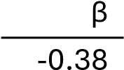 | p value | significance
Age |  | 0.000 | ***
Gender (woman) | 0.08 | 0.000 | ***
Income | -0.05 | 0.011 | *
Education | -0.06 | 0.001 | ***
Indigenous | -0.02 | 0.368 | ns
Disability | 0.07 | 0.000 | ***
Carer | 0.04 | 0.024 | *
LGBTQIA+ | 0.06 | 0.001 | ***
Working | -0.02 | 0.257 | ns
Physical Activity | 0.01 | 0.459 | ns
Chronic Disease | 0.12 | 0.000 | ***
No Alcohol Use | -0.02 | 0.229 | ns
Non-Smoker | -0.06 | 0.004 | **
No Cannabis Use | -0.06 | 0.007 | **
No Psychedelics Use | -0.15 | 0.000 | ***
Religion (yes) | -0.05 | 0.022 | *
Religiousness | 0.08 | 0.001 | **
Spirituality | 0.02 | 0.368 | ns
Connected to Higher Power | 0.06 | 0.021 | *
Connected to All Humanity | -0.07 | 0.000 | ***
Connected to Nature | -0.03 | 0.131 | ns
Note. *p<0.05; **p<0.01; ***p<0.001

Table D3. Regression estimates for past year meditation practice predicting psychological distress
0.041

Psychological Distress

(1)

(2)

(3)

(4)

Meditation 12
-
month

0.164
***

**
0.008

0.031

-
0.314
***

-
0.310
***

Age -0.363***
Gender (woman) |  | 0.078*** | 0.077*** | 0.077***
Income |  | -0.053*** | -0.051*** | -0.050***
Education |  | -0.067*** | -0.078*** | -0.078***
Disability |  | 0.070*** | 0.053*** | 0.054***
Carer |  | 0.037** | 0.023 | 0.024
LGBTQIA+ |  | 0.054*** | 0.036** | 0.040**
Chronic Disease |  | 0.118*** | 0.095*** | 0.095***
Non-Smoker |  | -0.054*** | -0.025 | -0.025
No Cannabis Use |  | -0.062*** | -0.056** | -0.058**
No Psychedelics Use |  | -0.150*** | -0.132*** | -0.133***
Religion (yes) |  | -0.045** | -0.043** | -0.044**
Religiousness |  | 0.083*** | 0.089*** | 0.091***
Connected to Higher Power |  | 0.055** | 0.037* | 0.034
Connected to All Humanity |  | -0.086*** | -0.072*** | -0.071***
Mental HC (unmet) |  |  | 0.163*** | 0.209***
Mental HC (yes) |  |  | 0.192*** | 0.194***
Meditation * Mental HC (unmet) |  |  |  | -0.073***
Meditation * Mental HC (yes) |  |  |  | -0.011
Observations | 2,640 | 2,598 | 2,598 | 2,598
R² | 0.027 | 0.329 | 0.37 | 0.372
Adjusted R² | 0.026 | 0.325 | 0.365 | 0.367
Note. HC = healthcare; *p<0.05; **p<0.01; ***p<0.001

D4 relaxation practice in the past 12 months predicting psychological distress across 4 models

Psychological Distress

(1)

(2)

(3)

(4)

Relaxation 12-month | 0.075*** | 0.019
Age |  | -0.368***
Gender (woman) |  | 0.078***
Income |  | -0.054**
Education |  | -0.063***
Disability |  | 0.069***
Carer |  | 0.036*
LGBTQIA+ |  | 0.057**
Chronic Disease |  | 0.118***
Non-Smoker |  | -0.055**
No Cannabis Use |  | -0.062**
No Psychedelics Use |  | -0.151***
Religion (yes) |  | -0.047*
Religiousness |  | 0.083***
Connected to Higher Power |  | 0.060**
Connected to All Humanity |  | -0.084***
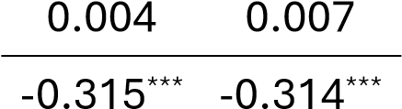
0.077*** 0.077***
-0.051** -0.050**
-0.077*** -0.077***
0.053** 0.052**
0.023 0.023
0.036* 0.037*
0.095*** 0.096***
-0.025 -0.026
-0.056* -0.055*
-0.132*** -0.133***
-0.043* -0.044*
0.089*** 0.092***
0.038 0.037
-0.071*** -0.072***
Mental HC (unmet) 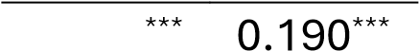0.163
Mental HC (yes) 0.193*** 0.181***

Relaxation * Mental HC (unmet)
Relaxation * Mental HC (yes)
-
0.049
*

0.021

2,598

Observations 2,640 2,598 2,598
R² 0.006 0.328 0.37 0.372
Adjusted R² 0.005 0.324 0.365 0.367

Note. HC = healthcare; *p<0.05; **p<0.01; ***p<0.001

D5 breathing practice in the past 12 months predicting psychological distress across 4 models
(2)

Psychological Distress

(1)

(3)

(4)

Breathing 12
-
month

0.110
***

***

0.051
**

0.042
*

-
0.310
***

-
0.310
***

0.073
Age -0.359***
Gender (woman) |  | 0.072*** |  | 0.072*** |  | 0.072***
Income |  | -0.054** |  | -0.051** |  | -0.051**
Education |  | -0.064*** |  | -0.077*** |  | -0.078***
Disability |  | 0.064*** |  | 0.049** |  | 0.049**
Carer |  | 0.040* |  | 0.025 |  | 0.026
LGBTQIA+ |  | 0.060*** |  | 0.039* |  | 0.039*
Chronic Disease |  | 0.116*** |  | 0.094*** |  | 0.093***
Non-Smoker |  | -0.055** |  | -0.025 |  | -0.026
No Cannabis Use |  | -0.059* |  | -0.053* |  | -0.053*
No Psychedelics Use |  | -0.160*** |  | -0.140*** |  | -0.140***
Religion (yes) |  | -0.046* |  | -0.042* |  | -0.042*
Religiousness |  | 0.089*** |  | 0.094*** |  | 0.095***
Connected to Higher Power |  | 0.050* |  | 0.03 |  | 0.029
Connected to All Humanity |  | -0.087*** |  | -0.074*** |  | -0.074***
Mental HC (unmet) |  |  |  | 0.161*** |  | 0.164***
Mental HC (yes) |  |  |  |  | 0.188*** |  | 0.176***
Breathing * Mental HC (unmet) |  |  |  |  |  |  | -0.006
Breathing * Mental HC (yes) |  |  |  |  |  |  | 0.024
Observations |  | 2,640 | 2,598 |  | 2,598 |  | 2,598
R² |  | 0.012 | 0.332 |  | 0.372 |  | 0.372
Adjusted R² |  | 0.012 | 0.328 |  | 0.368 |  | 0.368
Note. HC = healthcare; *p<0.05; **p<0.01; ***p<0.001

D6 yoga practice in the past 12 months predicting psychological distress across 4 models

Psychological Distress

(1)

(2)

(3)

(4)

Yoga 12-month | 0.092*** | -0.026
Age |  | -0.373***
Gender (woman) |  | 0.084***
Income |  | -0.053**
Education |  | -0.058***
Disability |  | 0.068***
Carer |  | 0.038*
LGBTQIA+ |  | 0.057**
Chronic Disease |  | 0.120***
Non-Smoker |  | -0.055**
No Cannabis Use |  | -0.065**
No Psychedelics Use |  | -0.149***
Religion (yes) |  | -0.047*
Religiousness |  | 0.080***
Connected to Higher Power |  | 0.064**
Connected to All Humanity |  | -0.081***
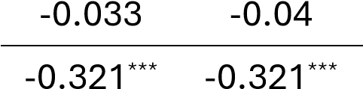
0.082*** 0.083***
-0.050** -0.050**
-0.072*** -0.072***
0.051** 0.052**
0.024 0.024
0.037* 0.036*
0.096*** 0.095***
-0.023 -0.024
-0.058** -0.058**
-0.131*** -0.131***
-0.043* -0.043*
0.087*** 0.088***
0.04 0.04
-0.068*** -0.069***
Mental HC (unmet) 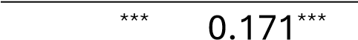0.165
Mental HC (yes) |  |  | 0.194*** | 0.185***
Yoga * Mental HC (unmet) |  |  |  | -0.011
Yoga * Mental HC (yes) |  |  |  | 0.021
Observations | 2,640 | 2,598 | 2,598 | 2,598
R² | 0.008 | 0.328 | 0.371 | 0.371
Adjusted R² | 0.008 | 0.324 | 0.366 | 0.366
Note. HC = healthcare; *p<0.05; **p<0.01; ***p<0.001

Section E – Full demographic descriptives by subsample

None Meditation Breathing Relaxation Yoga

(N=794) (N=512) (N=365) (N=295) (N=375)

Age group
18-29 | 91 (11.5%) | 124 (24.2%) | 112 (30.7%) | 46 (15.6%) | 126 (33.6%)
30-39 | 97 (12.2%) | 148 (28.9%) | 67 (18.4%) | 50 (16.9%) | 98 (26.1%)
40-49 | 94 (11.8%) | 96 (18.8%) | 57 (15.6%) | 60 (20.3%) | 72 (19.2%)
50-59 | 152 (19.1%) | 76 (14.8%) | 42 (11.5%) | 51 (17.3%) | 39 (10.4%)
60+ | 360 (45.3%) | 68 (13.3%) | 87 (23.8%) | 88 (29.8%) | 40 (10.7%)
Gender
Man | 462 (58.2%) | 259 (50.6%) | 137 (37.5%) | 122 (41.4%) | 128 (34.1%)
Woman | 330 (41.6%) | 252 (49.2%) | 225 (61.6%) | 173 (58.6%) | 246 (65.6%)
Non-binary | 2 (0.3%) | 1 (0.2%) | 3 (0.8%) | 0 (0%) | 1 (0.3%)
LGBTQIA+ status
No | 757 (95.3%) | 380 (74.2%) | 314 (86.0%) | 258 (87.5%) | 291 (77.6%)
Yes | 32 (4.0%) | 125 (24.4%) | 46 (12.6%) | 37 (12.5%) | 83 (22.1%)
Education
Less than Primary | 1 (0.1%) | 2 (0.4%) | 0 (0%) | 0 (0%) | 0 (0%)
Primary | 5 (0.6%) | 0 (0%) | 1 (0.3%) | 1 (0.3%) | 4 (1.1%)
Some Secondary | 114 (14.4%) | 16 (3.1%) | 27 (7.4%) | 24 (8.1%) | 12 (3.2%)
Secondary | 179 (22.5%) | 78 (15.2%) | 73 (20.0%) | 48 (16.3%) | 45 (12.0%)
Vocational or Similar | 209 (26.3%) | 86 (16.8%) | 82 (22.5%) | 71 (24.1%) | 59 (15.7%)
Some University but no degree | 63 (7.9%) | 70 (13.7%) | 37 (10.1%) | 36 (12.2%) | 58 (15.5%)
University - Bachelors Degree  Graduate or professional degree (MA, | 173 (21.8%) | 201 (39.3%) | 109 (29.9%) | 84 (28.5%) | 141 (37.6%)
MS, MBA, PhD, Law Degree, Medical Degree etc) | 50 (6.3%) | 59 (11.5%) | 36 (9.9%) | 31 (10.5%) | 56 (14.9%)
Employment status
Working full-time | 292 (36.8%) | 322 (62.9%) | 146 (40.0%) | 138 (46.8%) | 264 (70.4%)
Working part-time | 134 (16.9%) | 89 (17.4%) | 91 (24.9%) | 47 (15.9%) | 50 (13.3%)

Studying | 13 (1.6%) | 10 (2.0%) | 23 (6.3%) | 7 (2.4%) | 11 (2.9%)
Unemployed and looking for work | 43 (5.4%) | 18 (3.5%) | 18 (4.9%) | 16 (5.4%) | 12 (3.2%)
Unemployed and not looking for work | 35 (4.4%) | 12 (2.3%) | 20 (5.5%) | 12 (4.1%) | 7 (1.9%)
Retired | 250 (31.5%) | 48 (9.4%) | 58 (15.9%) | 66 (22.4%) | 26 (6.9%)
Other | 27 (3.4%) | 13 (2.5%) | 9 (2.5%) | 9 (3.1%) | 5 (1.3%)
Chronic health condition
No | 437 (55.0%) | 264 (51.6%) | 173 (47.4%) | 142 (48.1%) | 208 (55.5%)
Yes | 357 (45.0%) | 248 (48.4%) | 192 (52.6%) | 153 (51.9%) | 167 (44.5%)
Disability
No | 682 (85.9%) | 465 (90.8%) | 296 (81.1%) | 246 (83.4%) | 347 (92.5%)
Yes | 108 (13.6%) | 44 (8.6%) | 65 (17.8%) | 47 (15.9%) | 26 (6.9%)
Missing | 4 (0.5%) | 3 (0.6%) | 4 (1.1%) | 2 (0.7%) | 2 (0.5%)
Carer responsibilities
No | 577 (72.7%) | 244 (47.7%) | 225 (61.6%) | 157 (53.2%) | 168 (44.8%)
Yes | 217 (27.3%) | 268 (52.3%) | 140 (38.4%) | 138 (46.8%) | 207 (55.2%)
Indigenous status
No | 730 (91.9%) | 389 (76.0%) | 321 (87.9%) | 224 (75.9%) | 253 (67.5%)
Yes | 64 (8.1%) | 123 (24.0%) | 44 (12.1%) | 71 (24.1%) | 122 (32.5%)
Religion (current)
No religion  Christian (including Church of England, | 417 (52.5%) | 238 (46.5%) | 187 (51.2%) | 121 (41.0%) | 174 (46.4%)
Catholic, Protestant and all other Christian denominations) | 322 (40.6%) | 179 (35.0%) | 139 (38.1%) | 125 (42.4%) | 115 (30.7%)
Hindu | 3 (0.4%) | 29 (5.7%) | 4 (1.1%) | 6 (2.0%) | 23 (6.1%)
Jewish | 4 (0.5%) | 10 (2.0%) | 2 (0.5%) | 5 (1.7%) | 10 (2.7%)
Muslim | 16 (2.0%) | 18 (3.5%) | 3 (0.8%) | 6 (2.0%) | 17 (4.5%)
Buddhist | 7 (0.9%) | 18 (3.5%) | 9 (2.5%) | 12 (4.1%) | 9 (2.4%)
Sikh  Indigenous religions / spiritual prac- | 1 (0.1%) | 5 (1.0%) | 2 (0.5%) | 3 (1.0%) | 5 (1.3%)
tices (e.g., Australian Aboriginal, Māori spirituality, Polynesian spirituality, Hawaiian Religion, etc) | 7 (0.9%) | 5 (1.0%) | 6 (1.6%) | 8 (2.7%) | 13 (3.5%)

Other religion | 17 (2.1%) | 10 (2.0%) | 13 (3.6%) | 9 (3.1%) | 9 (2.4%)
Spiritual
Not at all | 374 (47.1%) | 50 (9.8%) | 61 (16.7%) | 51 (17.3%) | 71 (18.9%)
Slightly | 226 (28.5%) | 161 (31.4%) | 149 (40.8%) | 102 (34.6%) | 120 (32.0%)
Moderately | 107 (13.5%) | 215 (42.0%) | 109 (29.9%) | 85 (28.8%) | 132 (35.2%)
Very | 87 (11.0%) | 86 (16.8%) | 46 (12.6%) | 57 (19.3%) | 52 (13.9%)
Religious
Not at all | 451 (56.8%) | 146 (28.5%) | 167 (45.8%) | 108 (36.6%) | 141 (37.6%)
Slightly | 178 (22.4%) | 155 (30.3%) | 104 (28.5%) | 87 (29.5%) | 105 (28.0%)
Moderately | 104 (13.1%) | 153 (29.9%) | 64 (17.5%) | 66 (22.4%) | 100 (26.7%)
Very | 61 (7.7%) | 58 (11.3%) | 30 (8.2%) | 34 (11.5%) | 29 (7.7%)
Connected to higher power
Not at all | 433 (54.5%) | 71 (13.9%) | 119 (32.6%) | 77 (26.1%) | 97 (25.9%)
Slightly | 177 (22.3%) | 146 (28.5%) | 116 (31.8%) | 82 (27.8%) | 106 (28.3%)
Moderately | 96 (12.1%) | 198 (38.7%) | 83 (22.7%) | 88 (29.8%) | 114 (30.4%)
Very | 88 (11.1%) | 97 (18.9%) | 47 (12.9%) | 48 (16.3%) | 58 (15.5%)
Connection to nature
Not at all | 141 (17.8%) | 24 (4.7%) | 23 (6.3%) | 25 (8.5%) | 21 (5.6%)
Slightly | 309 (38.9%) | 158 (30.9%) | 116 (31.8%) | 89 (30.2%) | 123 (32.8%)
Moderately | 242 (30.5%) | 208 (40.6%) | 142 (38.9%) | 116 (39.3%) | 146 (38.9%)
Very | 102 (12.8%) | 122 (23.8%) | 84 (23.0%) | 65 (22.0%) | 85 (22.7%)
Connection to all humanity
Not at all | 196 (24.7%) | 41 (8.0%) | 61 (16.7%) | 36 (12.2%) | 42 (11.2%)
Slightly | 314 (39.5%) | 185 (36.1%) | 149 (40.8%) | 102 (34.6%) | 138 (36.8%)
Moderately | 217 (27.3%) | 213 (41.6%) | 117 (32.1%) | 108 (36.6%) | 140 (37.3%)
Very | 67 (8.4%) | 73 (14.3%) | 38 (10.4%) | 49 (16.6%) | 55 (14.7%)
Alcohol use (past year)
Never | 166 (20.9%) | 62 (12.1%) | 53 (14.5%) | 36 (12.2%) | 33 (8.8%)
Yearly | 76 (9.6%) | 52 (10.2%) | 43 (11.8%) | 33 (11.2%) | 40 (10.7%)
Monthly | 177 (22.3%) | 174 (34.0%) | 110 (30.1%) | 99 (33.6%) | 116 (30.9%)
weekly | 259 (32.6%) | 194 (37.9%) | 128 (35.1%) | 98 (33.2%) | 158 (42.1%)
Daily | 116 (14.6%) | 30 (5.9%) | 31 (8.5%) | 29 (9.8%) | 28 (7.5%)

Tobacco use (past year)
Never | 588 (74.1%) | 227 (44.3%) | 214 (58.6%) | 170 (57.6%) | 194 (51.7%)
Yearly | 11 (1.4%) | 44 (8.6%) | 19 (5.2%) | 20 (6.8%) | 22 (5.9%)
Monthly | 23 (2.9%) | 71 (13.9%) | 20 (5.5%) | 25 (8.5%) | 41 (10.9%)
weekly | 32 (4.0%) | 87 (17.0%) | 25 (6.8%) | 27 (9.2%) | 56 (14.9%)
Daily | 140 (17.6%) | 83 (16.2%) | 87 (23.8%) | 53 (18.0%) | 62 (16.5%)
Cannabis use (past year)
Never | 719 (90.6%) | 320 (62.5%) | 282 (77.3%) | 235 (79.7%) | 253 (67.5%)
Yearly | 25 (3.1%) | 52 (10.2%) | 28 (7.7%) | 17 (5.8%) | 43 (11.5%)
Monthly | 18 (2.3%) | 69 (13.5%) | 14 (3.8%) | 17 (5.8%) | 43 (11.5%)
weekly | 14 (1.8%) | 52 (10.2%) | 14 (3.8%) | 9 (3.1%) | 19 (5.1%)
Daily | 18 (2.3%) | 19 (3.7%) | 27 (7.4%) | 17 (5.8%) | 17 (4.5%)
Psychedelic use (past year)
Never | 748 (94.2%) | 369 (72.1%) | 337 (92.3%) | 260 (88.1%) | 291 (77.6%)
Yearly | 23 (2.9%) | 49 (9.6%) | 25 (6.8%) | 14 (4.7%) | 39 (10.4%)
Monthly | 14 (1.8%) | 57 (11.1%) | 3 (0.8%) | 11 (3.7%) | 22 (5.9%)
weekly | 8 (1.0%) | 34 (6.6%) | 0 (0%) | 9 (3.1%) | 20 (5.3%)
Daily | 1 (0.1%) | 3 (0.6%) | 0 (0%) | 1 (0.3%) | 3 (0.8%)
Household income (Australia)
$0 - $26,000 | 64 (10.9%) | 23 (5.2%) | 26 (10.3%) | 16 (6.9%) | 14 (4.4%)
$26,000 - $52,000 | 140 (23.9%) | 47 (10.6%) | 45 (17.9%) | 54 (23.4%) | 39 (12.3%)
$52,000 - $91,000 | 186 (31.8%) | 121 (27.2%) | 64 (25.4%) | 57 (24.7%) | 73 (23.1%)
$91,000 - $156,000 | 128 (21.9%) | 140 (31.5%) | 71 (28.2%) | 53 (22.9%) | 99 (31.3%)
$156,000 - $208,000 | 47 (8.0%) | 77 (17.3%) | 32 (12.7%) | 39 (16.9%) | 62 (19.6%)
$208,000+ | 20 (3.4%) | 37 (8.3%) | 14 (5.6%) | 12 (5.2%) | 29 (9.2%)
Ethnicity (Australia)
Australian | 206 (35.2%) | 98 (22.0%) | 73 (29.0%) | 62 (26.8%) | 84 (26.6%)
Australian Aboriginal or Torres Strait Islander | 22 (3.8%) | 14 (3.1%) | 5 (2.0%) | 7 (3.0%) | 13 (4.1%)
European (e.g., English, Irish, Scottish, Italian, German) | 266 (45.5%) | 230 (51.7%) | 129 (51.2%) | 109 (47.2%) | 126 (39.9%)
Asian (e.g., Chinese, Indian, Filipino) | 54 (9.2%) | 67 (15.1%) | 31 (12.3%) | 23 (10.0%) | 57 (18.0%)
Other | 37 (6.3%) | 36 (8.1%) | 14 (5.6%) | 30 (13.0%) | 36 (11.4%)
Remoteness (Australia)
Major Cities of Australia | 428 (73.2%) | 376 (84.5%) | 200 (79.4%) | 173 (74.9%) | 271 (85.8%)
Inner Regional Australia | 109 (18.6%) | 55 (12.4%) | 32 (12.7%) | 41 (17.7%) | 31 (9.8%)
Outer Regional Australia | 41 (7.0%) | 12 (2.7%) | 19 (7.5%) | 16 (6.9%) | 13 (4.1%)
Remote Australia | 6 (1.0%) | 2 (0.4%) | 1 (0.4%) | 0 (0%) | 1 (0.3%)
Very Remote Australia | 1 (0.2%) | 0 (0%) | 0 (0%) | 1 (0.4%) | 0 (0%)
Household income (New Zealand)
$0 - $20,000 | 7 (3.3%) | 1 (1.5%) | 10 (8.8%) | 4 (6.3%) | 2 (3.4%)
$20,000 - $30,000 | 22 (10.5%) | 10 (14.9%) | 13 (11.5%) | 4 (6.3%) | 0 (0%)
$30,000 - $50,000 | 36 (17.2%) | 10 (14.9%) | 20 (17.7%) | 12 (18.8%) | 1 (1.7%)
$50,000 - $70,000 | 36 (17.2%) | 4 (6.0%) | 14 (12.4%) | 13 (20.3%) | 7 (11.9%)
$70,000 - $100,000 | 35 (16.7%) | 13 (19.4%) | 20 (17.7%) | 8 (12.5%) | 14 (23.7%)
$100,000 - $150,000 | 44 (21.1%) | 15 (22.4%) | 21 (18.6%) | 9 (14.1%) | 19 (32.2%)
$150,000+ | 29 (13.9%) | 14 (20.9%) | 15 (13.3%) | 14 (21.9%) | 16 (27.1%)
Ethnicity (New Zealand)
European | 144 (68.9%) | 36 (53.7%) | 76 (67.3%) | 32 (50.0%) | 30 (50.8%)
Māori | 24 (11.5%) | 15 (22.4%) | 17 (15.0%) | 18 (28.1%) | 8 (13.6%)
Pacific peoples (e.g., Samoan, Cook Islands Māori, Tongan, Niuean) | 12 (5.7%) | 4 (6.0%) | 7 (6.2%) | 3 (4.7%) | 9 (15.3%)
Asian (e.g., Chinese, Indian) | 22 (10.5%) | 11 (16.4%) | 12 (10.6%) | 8 (12.5%) | 12 (20.3%)
Middle Eastern / Latin American / African | 5 (2.4%) | 1 (1.5%) | 0 (0%) | 0 (0%) | 0 (0%)
Other | 2 (1.0%) | 0 (0%) | 1 (0.9%) | 3 (4.7%) | 0 (0%)

