Electronic Supplementary Material
Hydrophobic deep eutectic solvent-based DLLME for simultaneous determination of triazole fungicides in grain and water samples
Fatemeh Sadat Fatemiª, Abolfath Shahsavaniª, Zolfaghar Aladaghlo^{b}, Ali Reza Fakhariª*
ªFaculty of Chemistry, Shahid Beheshti University, G. C., P.O. Box 198396-3113, Evin, Tehran, I.R. Iran.
^{b}Department of Soil Science, College of Agriculture and Natural Resources, University of Tehran, Karaj, 31587-77871, I.R. Iran.

Correspondence to Ali Reza Fakhari,
Tel & Fax: +98 (21) 22431683
E-mails: a-zavareh@sbu.ac.ir

Instrumental
Fourier transform infrared (FT-IR) spectra was acquired using an FT-IR spectrometer (Bruker instruments, model Aquinox 55, Darmstadt, Germany). The extraction solutions were sonicated using a WiseClean ultrasonic instrument from Witeg Labortechnik GmbH Company (Wertheim, Germany). Solution pH was measured using a Metrohm 827 pH lab pH meter (Metrohm, Switzerland). Centrifugation was carried out using Sigma 3-18 KS (Sigma Laborzentrifugen GmbH, Osterode am Harz, Germany). 701N 10 µL Hamilton syringe (UVISON, Wrotham, Kent, United Kingdom) was utilized to introduce sample solutions to GC-FID.

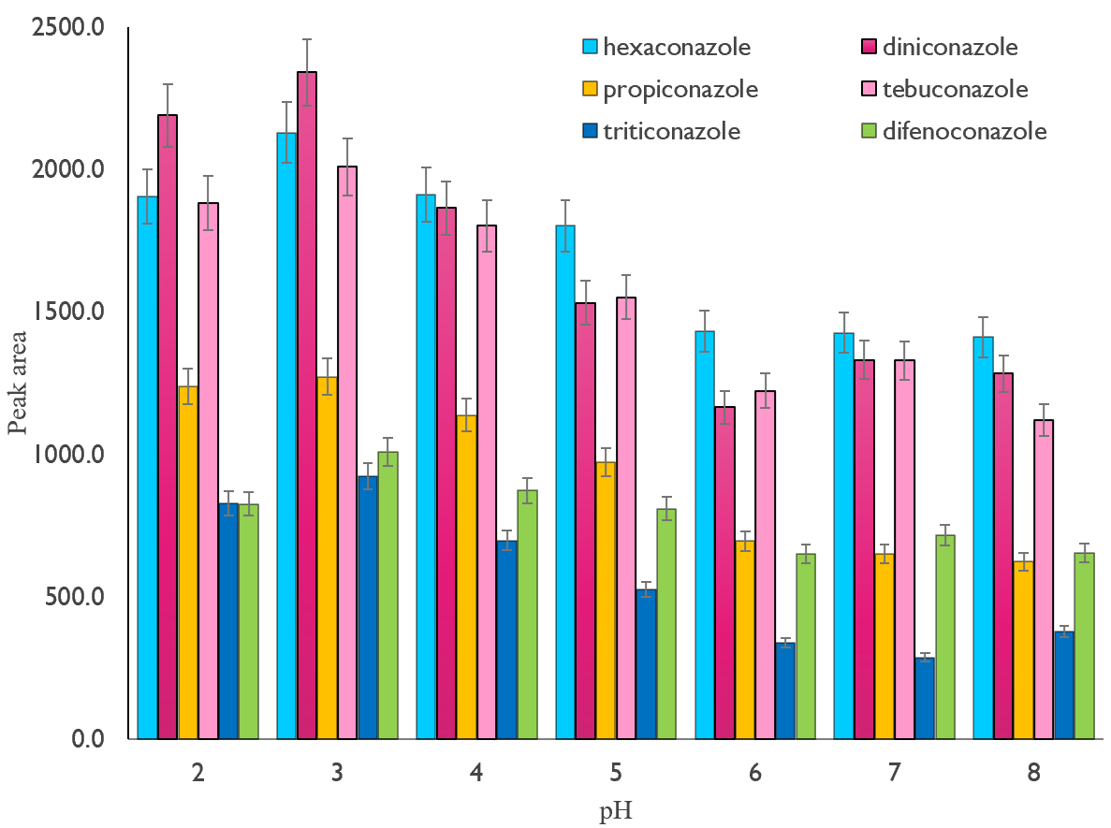
Fig. S1: The effect of pH (concentration of each TFs: 200 ng mL⁻¹, sample volume: 50 mL, extraction solvent amount: 34 μL, volume and type of the disperser solvent : 1000 μL methanol, centrifuge rate and time: 6000 rpm and 5.0 min)

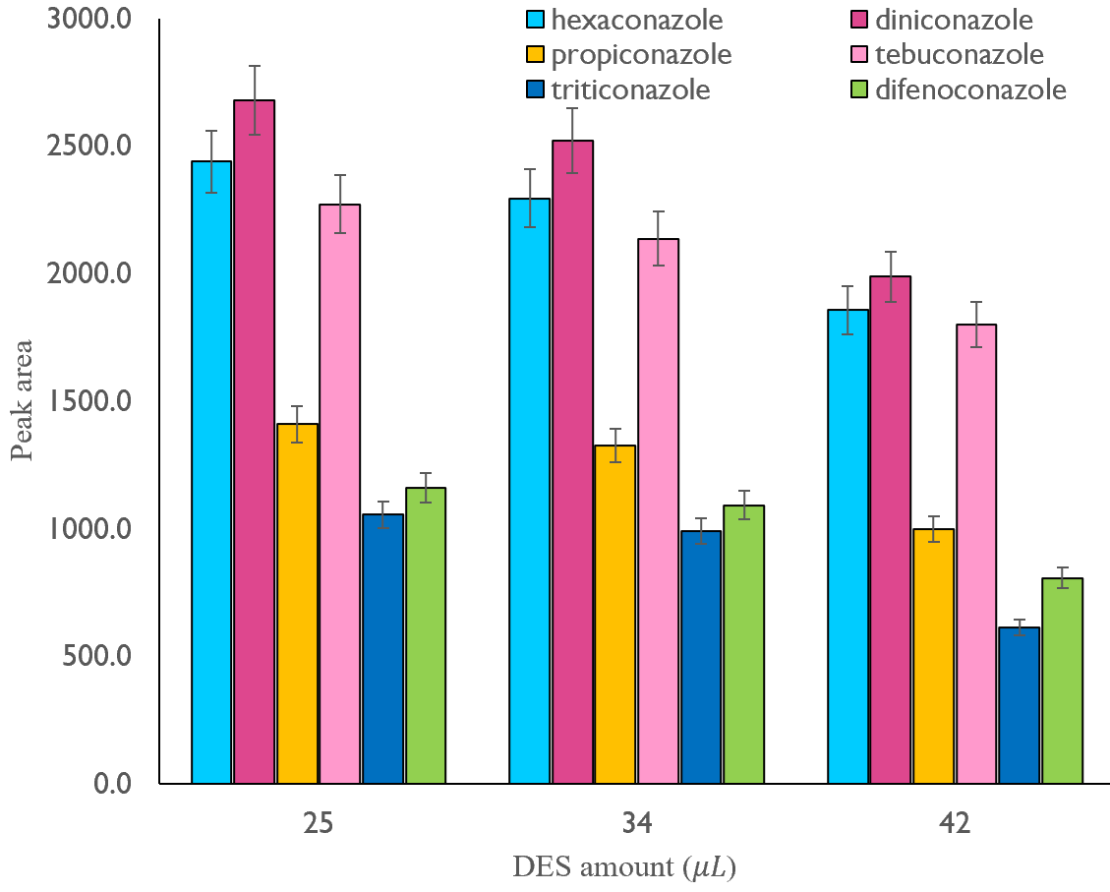
Fig. S2: The effect of extraction solvent amount (concentration of each TFs: 200 ng mL⁻¹, sample volume: 50 mL, pH: 3, volume and type of the disperser solvent : 1000 μL methanol, centrifuge rate and time: 6000 rpm and 5.0 min)
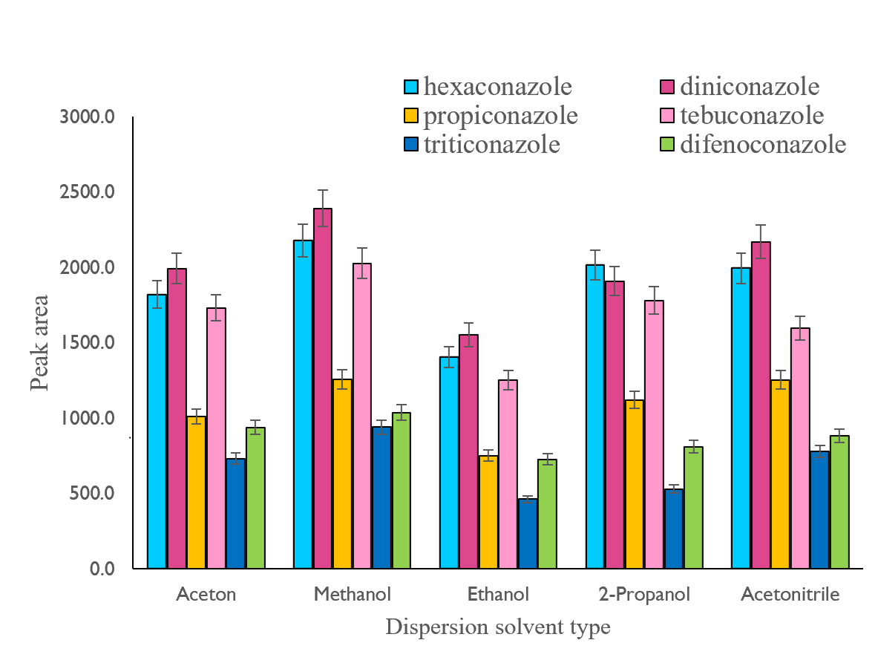
Fig. S3: The effect of dispersion solvent type (concentration of each TFs: 200 ng mL⁻¹, sample volume: 50 mL, pH: 3, extraction solvent amount: 25 μL, volume of the disperser solvent : 1000 μL methanol, centrifuge rate and time: 6000 rpm and 5.0 min)

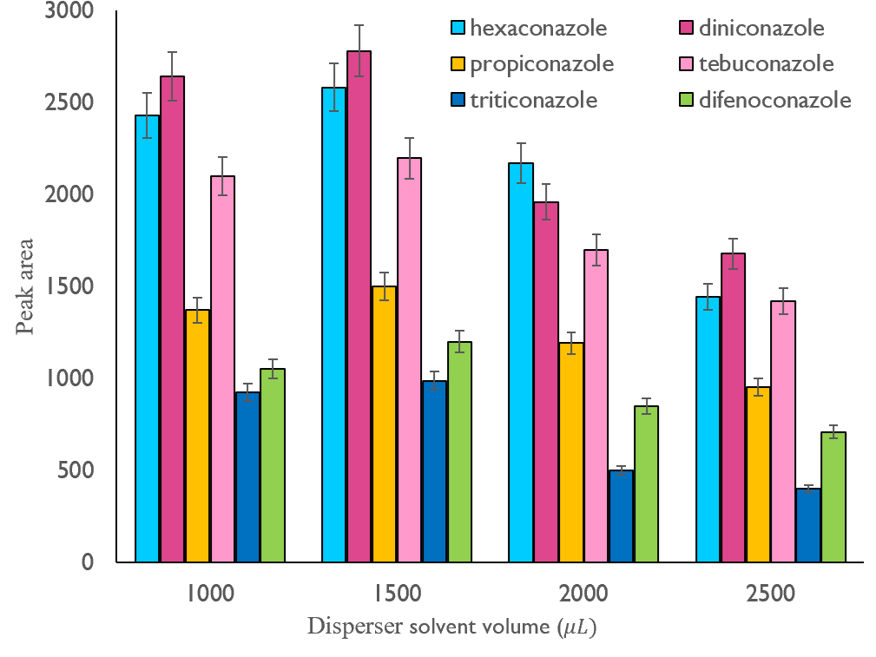
Fig. S4: The effect of disperser solvent volume (concentration of each TFs: 200 ng mL⁻¹, sample volume: 50 mL, pH: 3, extraction solvent amount: 25 μL, type of the disperser solvent : methanol, centrifuge rate and time: 6000 rpm and 5.0 min)

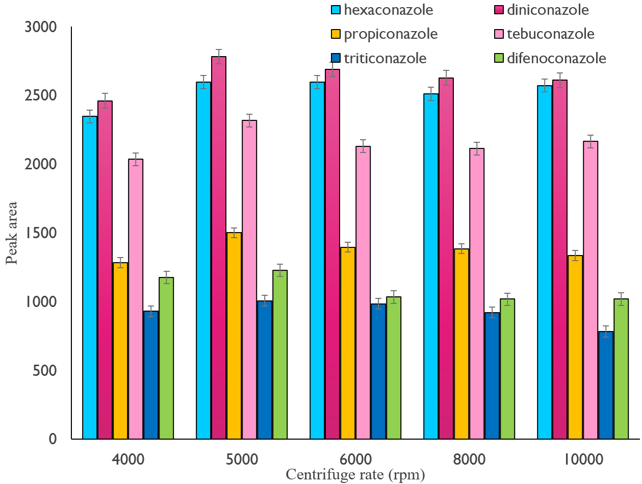
Fig. S5: The effect of centrifuge rate (concentration of each TFs: 200 ng mL⁻¹, sample volume: 50 mL, pH: 3, extraction solvent amount: 25 μL, volume and type of the disperser solvent : 1500 μL methanol, centrifuge time: 5.0 min)

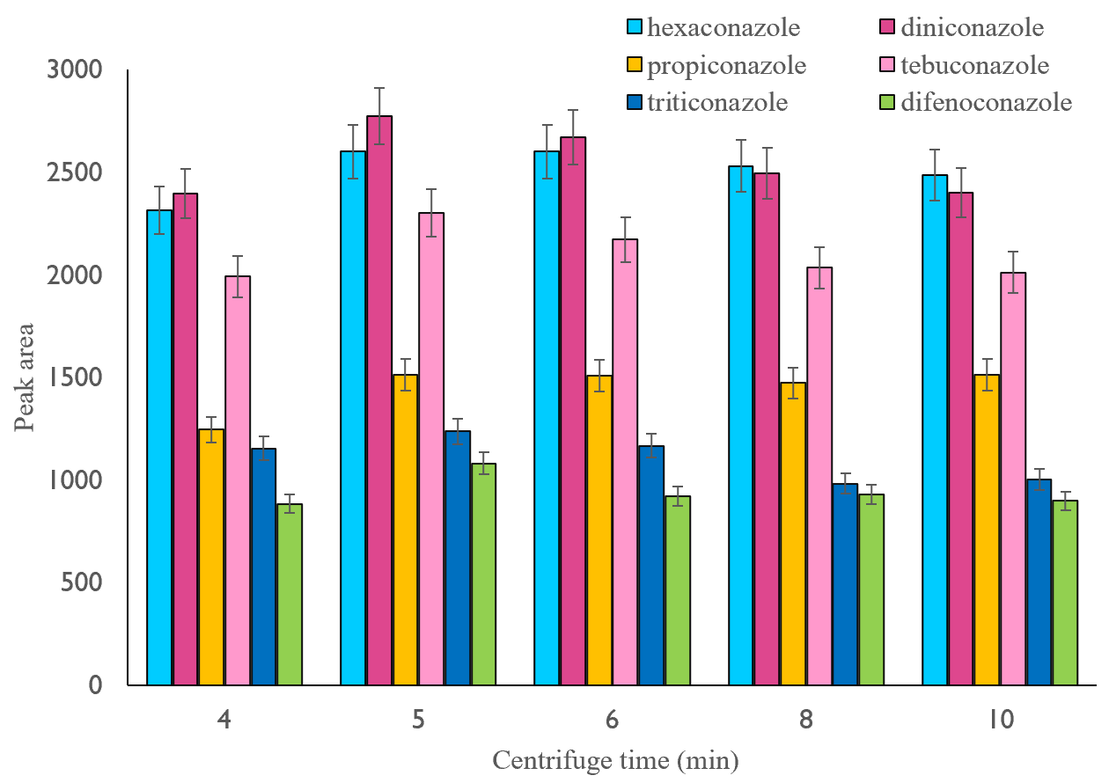

Fig. S6: The effect of centrifuge time (concentration of each TFs: 200 ng mL⁻¹, sample volume: 50 mL, pH: 3, extraction solvent amount: 25 μL, volume and type of the disperser solvent : 1500 μL methanol, centrifuge rate: 5000 rpm)

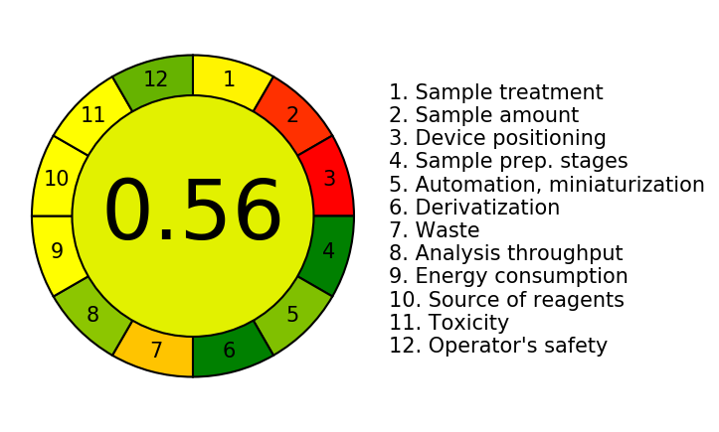
Fig. S7: AGREE greenness assessment of the proposed method

Table S1: Equations for direct and extraction calibration curves
( ª is expressed in mg L⁻¹ and, ^{b} is reported in ng mL⁻¹ )

Fungicide |  | Direct calibration curve equationª |  |  | Extraction calibration curve equation^{b}
Hexaconazole |  | y = 11.42x + 40.8 |  |  | y = 9.7823x + 112.69
Diniconazole |  | y = 10.607x + 407.93 |  |  | y = 10.69x + 101.18
Propiconazole |  | y = 8.7661x + 331.57 |  |  | y = 9.8581x + 66.236
Tebuconazole |  | y = 9.4231x + 355.15 |  |  | y = 9.5456x + 23.12
Triticonazole |  | y = 8.4813x + 257.75 |  |  | y = 5.0321x + 12.418
Difenoconazole |  | y = 3.7819x + 110.34 |  |  | y = 5.2233x + 23.762

