Supplementary Figure S0. 3D fit plots of the signals of differentially expressed peptides.
Supplementary Figure S1. Validation of proteome profiles of different individual differential peptides in Ting-Ting Gong studies.ROC analysis evaluated the diagnostic performance of differentially expressed peptides (red: up-regulated; blue: down-regulated).
Supplementary S2 General Information
This study was approved by the Ethics Committee of the Xianyang Hospital of Yan’an University (YDXY-KY-2023–006). A total of 188 patients with ovarian cancer and 208 healthy controls were enrolled. The median age (IQR) of the two groups was 49 (35, 60) years and 48 (37, 58) years, respectively. Mann-Whitney U test showed that there was no significant difference in age distribution between the two groups (U=1.865×10^{^4}, P=0.429, α=0.05; values with P＞0.05 were defined as lacking statistical significance).
Supplementary material - Methodological section
Standardized calibration process: The calibration operation in this study is divided into external calibration and confirmatory internal calibration. Among them, external calibration is conducted once a week and is completed using the fresh extract of Escherichia coli ATCC25922: ① Prepare the fresh extract of Escherichia coli ATCC25922 as the calibration sample; ② Load the calibration sample and collect the mass spectrometry spectrum; ③ The software automatically identifies the characteristic peaks; ④ The system calculates and optimizes the calibration parameters based on the characteristic peaks; ⑤ Save the calibration parameters to complete the calibration; ⑥ Select the quality control sample for automatic spectrum acquisition, verify the calibration effect, and only after verification is qualified can sample testing be carried out.
Internal quality control and batch control strategies: ① For each batch of samples, blank controls (pure matrix), positive quality control samples (known ovarian cancer serum samples), and negative quality control samples (healthy control serum samples) are set up for each test. These samples are tested on the same plate and in the same process as the test samples, and the detection deviations within the batch are monitored. ② Cross-batch quality control samples are inserted between adjacent batches to verify the consistency of the tests between batches. The relative deviation of the peak area of the quality control spectrum should be less than 5%. Otherwise, the instrument should be recalibrated and the samples of this batch should be re-tested. ③ After external calibration every week, three quality control samples are continuously tested. The retention time and peak intensity variation coefficient (CV) of the characteristic peaks of these samples should be less than 3% to ensure the stability of the instrument's detection. ④ All samples are randomly loaded. The testing personnel perform blind operations on the clinical grouping of the samples to minimize human and batch biases to the greatest extent.

Figure S2: Mass1548.67
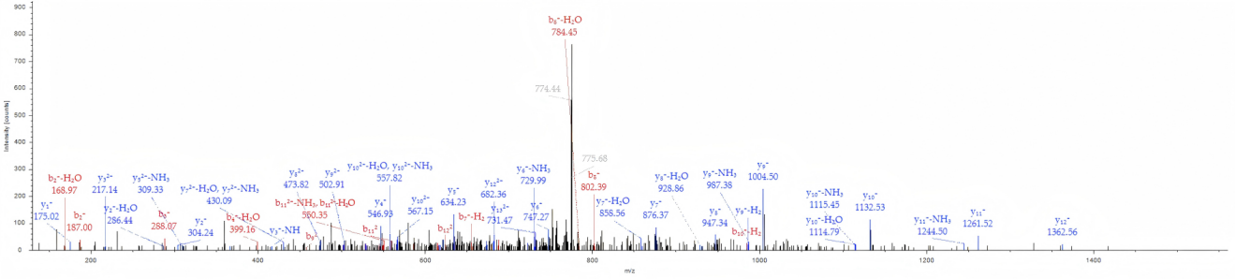
Figure S3: Mass1900.34
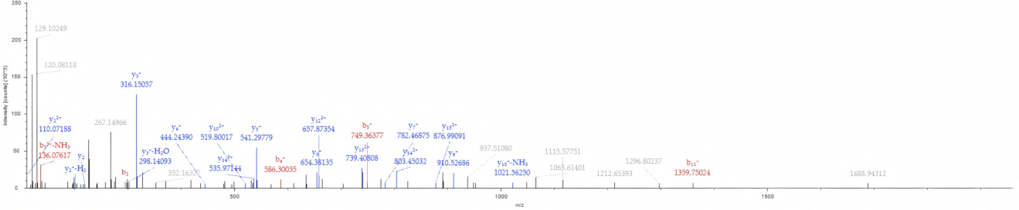
Figure S4: Mass1947.15
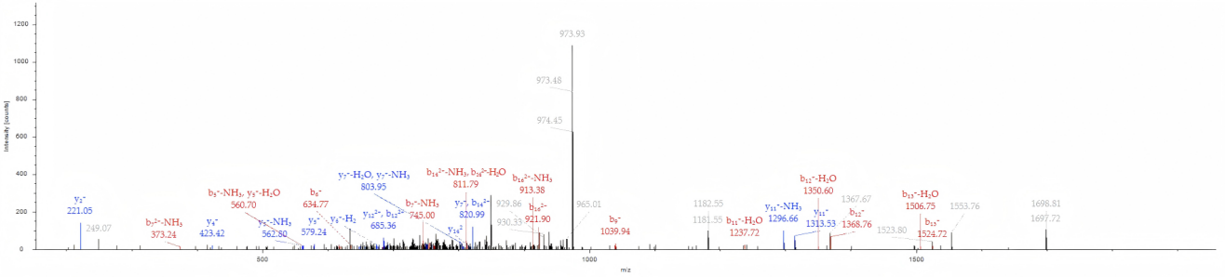
Figure S5: Mass2347.29
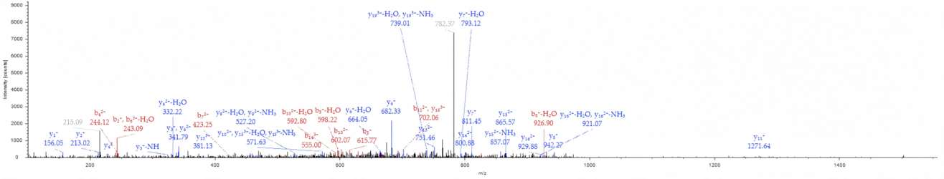
Figure S6: Mass2662.15
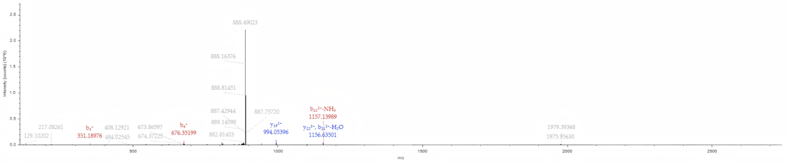
Figure S7: Mass2881.5
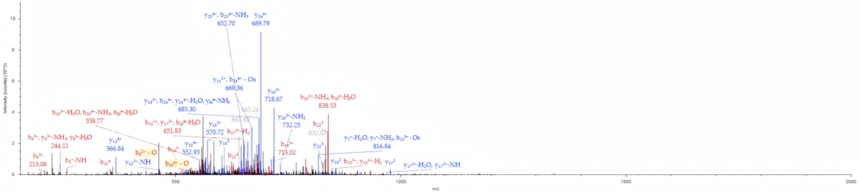
Figure S8: Mass2961.68
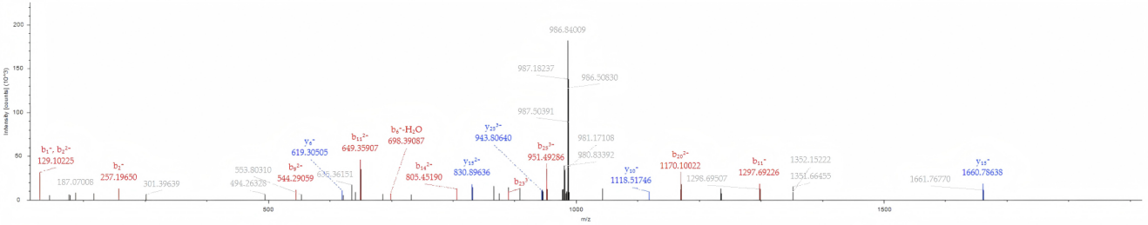
Figure S9: Mass4211.41
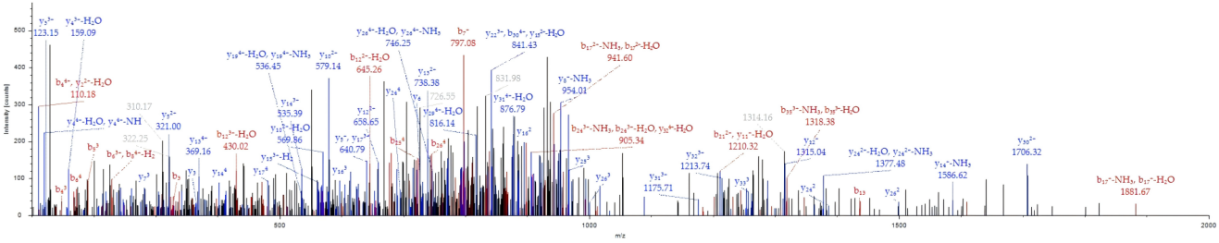
Supplementary Figure S2-9. MS/MS spectra for the 8 key peptides.
Supplementary Table1 Differential Peptide Segment Identification
Mass(Da) | Proteins | Modification sites | Amino acid sequences
94973 | P02671 | O-Glycosylation: Ser-338, Thr-525; Phosphorylation: Ser-22, Ser-609; N-Glycosylation: Asn-686 | 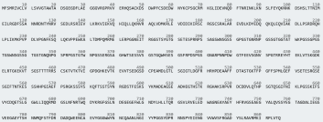
55928 | P02675 | Phosphorylation: S58, Y71, S138, Y172, S173, S174, Y182, T228, S237, Y255, S261, S262, Y266, Y269, T280, S289, Y299, Y315, T333, T338, Y356, Y368, S371, T396, Y408, S425, Y452, Y475; N-Glycosylation: N314, N394, N435; O-Glycosylation: S58, T108, T360; Acetylation: K208, K300, K313, K348, K471; S-Nitrosylation: C227, C231, C316; Methylation: N34 | 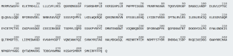
104752 | Q9HCR9 | PhosphoSitePlus: S117, S162, S163, S239, T252, S441, S771, S897, T900, S31 ,S34 | 