Supplementary Data
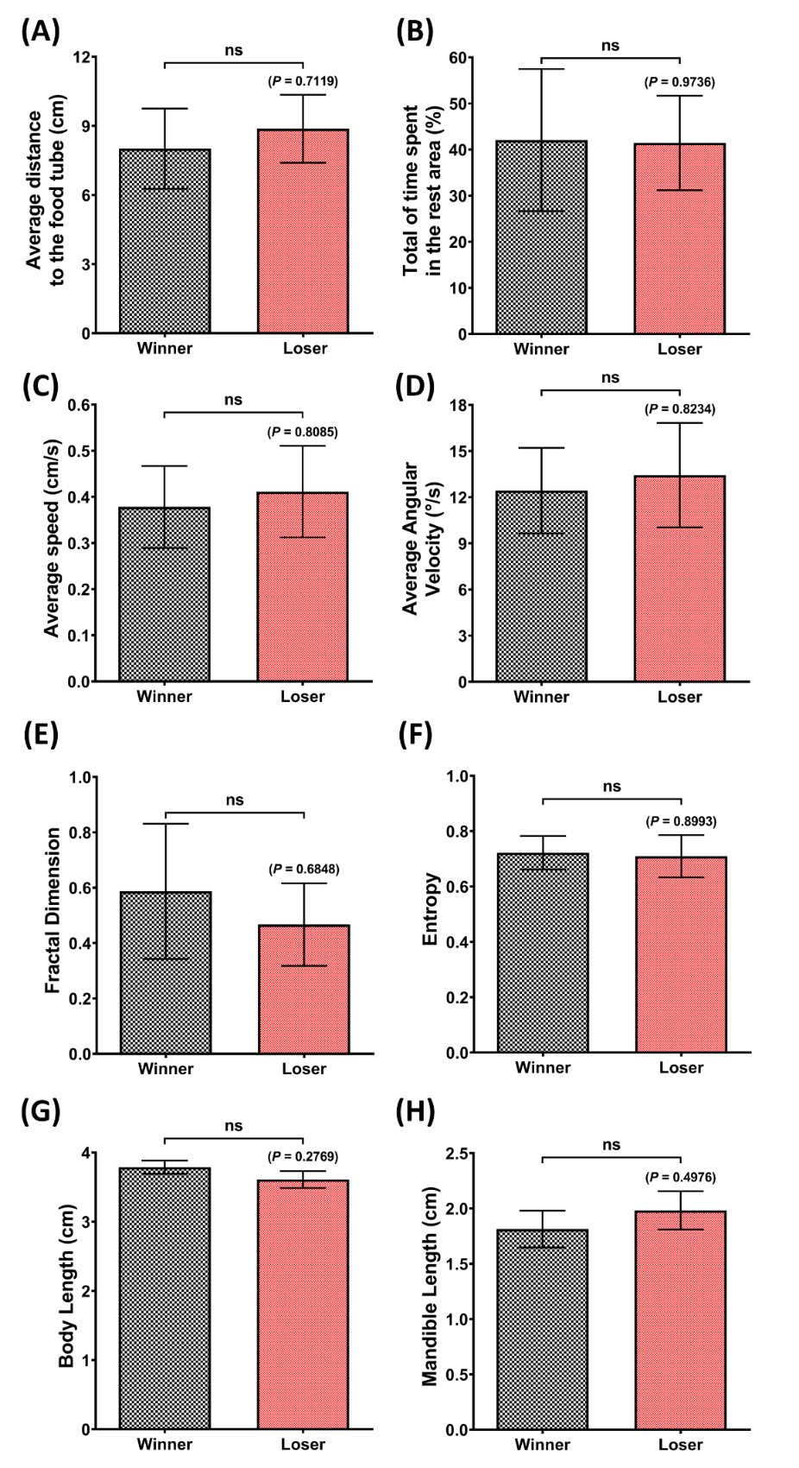
Supplementary Fig. 1. Calculated (A) average distance to the food tube, (B) total percentage of time in the rest area, (C) average speed, (D) average angular velocity, (E) fractal dimension, (F) entropy, (G) body length, and (H) mandible length of the winner and loser C. speciosus throughout the 60-minutes of contest test from all of the sample videos. The data are expressed as mean with SEM and were analyzed by an unpaired t-test (n = 6).
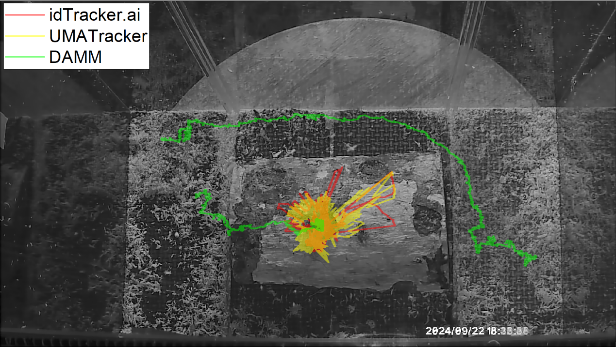
Supplementary Fig. 2. A representative figure for trajectories comparison between several animal movement tracking software, which were idTracker.ai, UMATracker, and DAMM, in tracking 30 minutes of two C. mniszechi.

