Supplementary Results
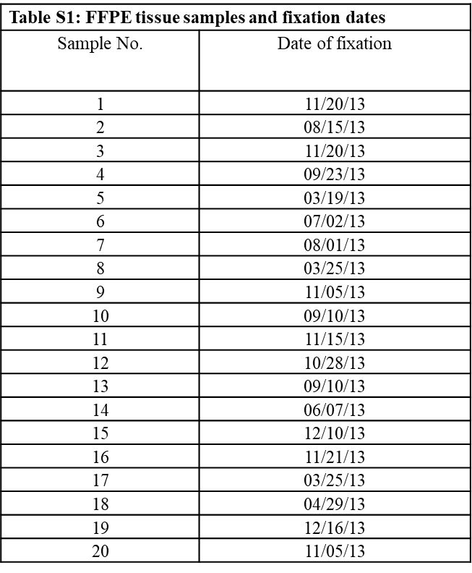
Supplementary Table S1: FFPE tissue samples and fixation dates. List of the tissue samples used in this study, including the sample number and the corresponding date of formalin fixation. This information provides context for sample age, which is relevant for assessing DNA integrity and suitability for downstream applications.
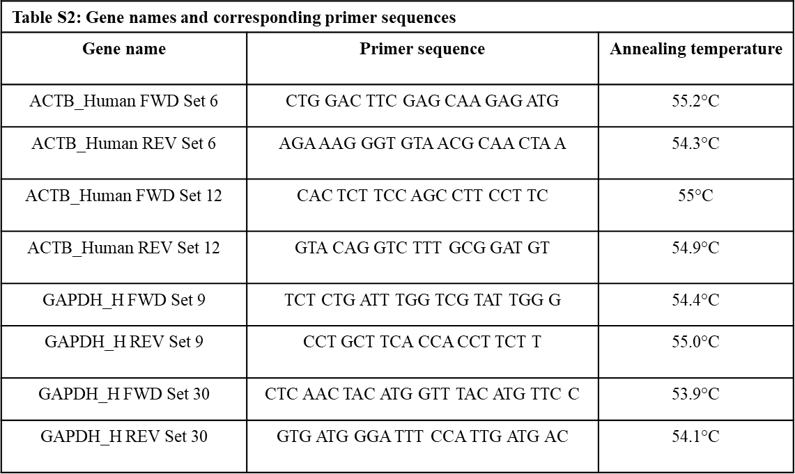
Supplementary Table S2. Gene names and corresponding primer sequences. This table lists the genes analyzed in this study along with the sequences of the forward and reverse primers used for PCR amplification.

