Antibiotic resistance profile of MDR bacteria used in the study
Isolate | Ofloxacin (5 µg) | Nitrofurantoin (300 µg) | Imipenem (10 µg) | Amikacin (30 µg) | Vancomycin (30 µg) | Tobramycin (10 µg) | Norfloxacin (10 µg) | Meropenem (10 µg) | Ceftazidime (30 µg) | Colistin (10 µg) | Ceftriaxone (30 µg)
E. coli | 0.0 ± 0.0 | 12 ± 0.9 | 0.0± 0.0 | 14 ±. 0.2 | 0 ± 0 | 0.0 ± 0.0 | 0.0 ± 0.0 | 23 ± 1.1 | 0.0 ± 0.0 | 18 ± 0.6 | 10 ± 0.3
K. pneumoniae | 0.0 ± 0.0 | 0.0± 0.0 | 0.0 ± 0.0 | 0.0 ± 0.0 | 0 ± 0 | 0.0 ± 0.0 | 0.0± 0.0 | 0.0 ± 0.0 | 15 ±1.3 | 0.0 ± 0.0 | 0.0 ± 0.0
S. typhi | 0.0 ± 0.0 | 0.0± 0.0 | 0.0 ± 0.0 | 0.0 ± 0.0 | 0 ± 0 | 0.0 ± 0.0 | 0.0± 0.0 | 20± 0.9 | 9± 0.4 | 0.0 ± 0.0 | 0.0 ± 0.0
P. mirabilis | 12 ± 0.5 | 0.0± 0.0 | 0.0 ± 0.0 | 12 ± 0.7 | 0 ± 0 | 0.0 ± 0.0 | 0.0± 0.0 | 21 ± 1.2 | 7± 0.9 | 16 ± 1.0 | 22 ± 0.8
S. aureus | 10 ± 0.2 | 0.0± 0.0 | 0.0 ± 0.0 | 0.0 ± 0.0 | 0 ± 0 | 0.0 ± 0.0 | 0.0± 0.0 | 18 ± 0.5 | 10± 0.4 | 0.0 ± 0.0 | 0.0 ± 0.0
Table 1. Inhibition zone diameters (in mm) for each bacterial isolate against the tested antibiotics. Values represent the mean diameter of the clear zone around antibiotic disks. Zones ≤ 14 mm were considered resistant, 15–19 mm intermediate, and ≥ 20 mm sensitive according to CLSI guidelines.

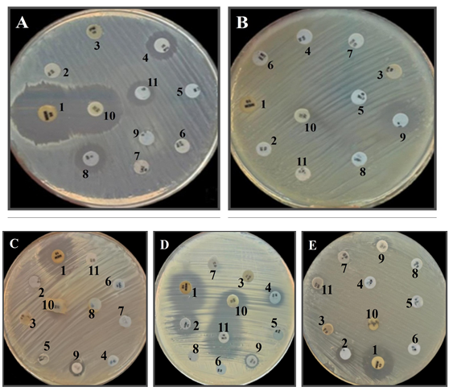
Figure 1. Antibiotic sensitivity test of E. coli (A), K. pneumoniae (B), S. typhi (C), P. mirabilis (D), and S. aureus (E). MEM (1), OFL (2), IPM (3), AK (4), VAN (5), TOB (6), NOR (7), NIT (8), CAZ (9), COL (10), and CRO (11).

Serial numbering system
A total of 20 clinical isolates were obtained from stool of patients suffering diarrhea. Each clinical isolate was given a code with two digits: CI-01 to CI-20 and designated as CI-01 to CI-20 for identification and analysis. Based on biochemical identification, isolate CI-11 was identified as Escherichia coli, CI-14 was identified as Salmonella typhi, CI-16 was identified as Proteus mirabilis, CI-17 was identified as Klebsiella pneumonia, and CI-20 was identified as Staphylococcus aureus.
Table 2. Serial numbering system of clinical isolates involved in the study.
Code | Clinical source | Biochemical identification
CI-11 | Stool | Escherichia coli
CI-14 | Stool | Salmonella typhi
CI-16 | Stool | Proteus mirabilis
CI-17 | Stool | Klebsiella pneumoniae
CI-20 | Stool | Staphylococcus aureus

Original gel picture

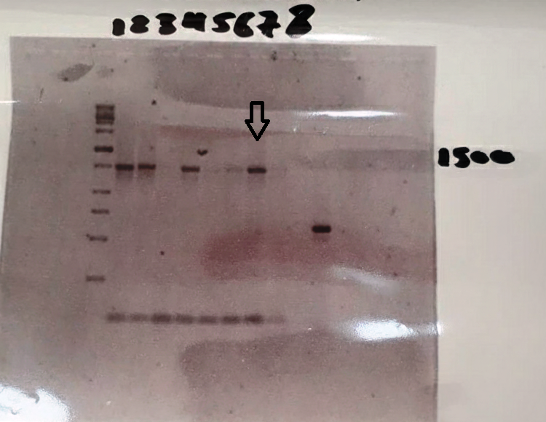
Figure 2. PCR-amplified 16S rRNA gene. Lane 1: Molecular weight marker (SiZer-1000 DNA marker); Lane 8: Amplified DNA fragment (~1500 bp) from a single colony of S. microflavus strain BA2.

