Supplementary materials

A water quantity-quality monitoring system to assess the impact of anthropogenic activities on urban rivers
Giulia Mazzarotto^{1*} and Paolo Salandin¹

- Technical details regarding the monitoring station set-up
Fig. S1. Shows in panel a the installation set-up with buoys (station A and B along the Sile River) and in panel b the instruments applied in the monitoring program. Each station is equipped with two non-contact radar sensors: one for water level (OTT RLS by Corr-Tek Idrometria Srl®) and another for surface velocity (SVR100 by Corr-Tek Idrometria Srl®), to obtain discharge evaluation. For convenience in installation and maintenance, multiparametric probes are typically installed near the riverbank even though here flow is prone to stagnation or recirculation²². Since no bridge pier was available in the monitoring positions defined, stations A and B were equipped with monitoring buoys (CB-40 by NexSens®) hosting quality sensors in the center of the river cross section, where discharge is also assessed.
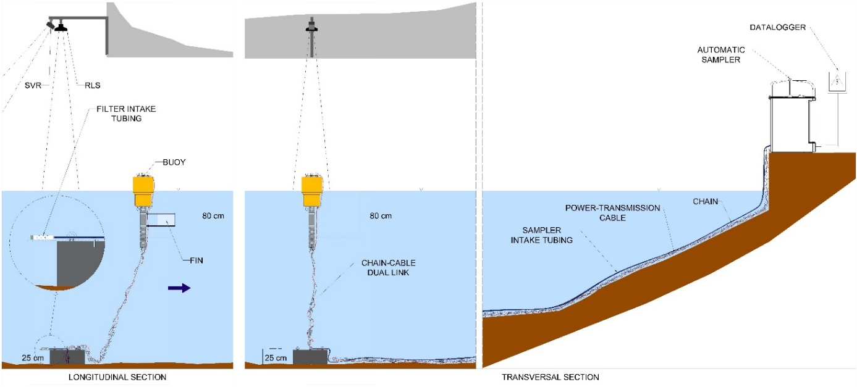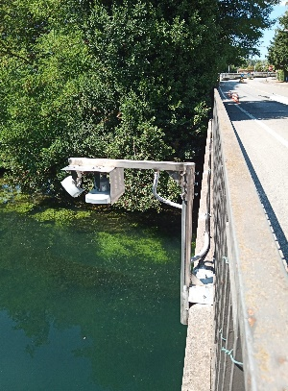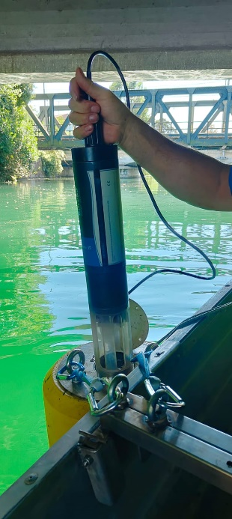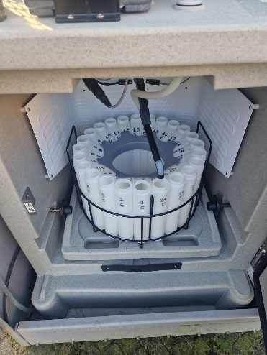
a)
b)
Fig. S1 Installation set-up: a) longitudinal and transversal section scheme of the water monitoring system developed in A and B with buoys; b) installed instruments, radar sensors - left, multiparametric probes - centre and automatic samplers - right.
This offers significant advantages (e.g. monitoring in the most active flow portion of the river cross-section) even though additional costs are required for installation and maintenance operations. The CB-40 buoy is a compact, rigid structure with an inner core of polyethylene foam and a 4-inch stainless steel pipe integrated into the structure, allowing for sensor placement. To secure the buoys in place, a custom anchoring system was designed (Fig. S1 panel a). This includes a cylindrical reinforced concrete body, measuring 0.6 m in diameter and 0.25 m in height, serving as an anchor connected to the buoy through a dual link of heavy steel chain and lightweight stainless-steel cable. This anchoring system was engineered to withstand hydrodynamic forces while accounting for the buoy's buoyancy and the weight of the chain and cables. The chain-cable dual link accommodates water surface elevation variability and limits horizontal buoy movement during low flows. To prevent cable twisting, a fin was added.
The intake for water sampling is placed on top of the anchor (about 25 cm above the bottom of the channel) again in the active portion of the river cross-section. The AS950 sampler is installed, together with the datalogger, on top of the riverbank where continuous electrical supply is provided. The tube connecting the sampler to the intake lays on the riverbed, weighted down by a steel chain. The probe power-transmission cable moves from the datalogger side by side to the chain reaching the anchor, and then from the anchor to the probe following the chain-cable dual link. A gallery of pictures of instruments adopted is shown in S1 panel b. For station E, due to favorable geometrical conditions (low bridge with pier), the probe was inserted in a 5-meter stainless-steel tube slotted at the bottom and anchored to the bridge deck where radar sensors for discharge monitoring are also installed.
The mobile samplers are identical to those installed in A, B and E, but since they lack a refrigerating system, no connection to the power grid is needed. This allows for easier installation with respect to the refrigerated ones, but samples must be readily transferred to the lab, and the sampling position is not always at the center of the channel cross-section, but its use is limited to channels of small width.

- y-v-Q correlation analysis
In Table S1 the correlation values between water level $y$ (m), velocity $v$ (ms¯¹) and discharge $Q$ (m³s¯¹) is reported. Although a strong correlation was observed between Q and y at stations A and B, it is evident that Q is primarily correlated with v. This is not unexpected, as both the Sile River and the Botteniga channel are water level-controlled rivers, meaning that variations in Q primarily result in changes in v.
Tab. S1 Correlation values between water level (y), velocity (v) and discharge (Q) recorded at stations A (left) B (middle) and E (right), using mean daily data.
 | Station A |  |  | Station B |  |  | Station E
 | y | v | Q | y | v | Q | y | v | Q
y | 1 |  |  | 1 |  |  | 1
v | 0.72 | 1 |  | 0.25 | 1 |  | -0.05 | 1
Q | 0.8 | 0.97 | 1 | 0.62 | 0.91 | 1 | 0.38 | 0.89 | 1
Anyway, differences in hydraulic regime between the two rivers are highlighted by the collected data in the Q-y plots, as detailed in Fig. S2. The operational behavior of the power plants (Fig. S2 panel b) influences the definition of the stage-discharge curve for the three monitoring stations. To exploit the maximum power production, the maximum stage upstream to the plant is kept constant for different discharge values, thus the Q-y curve is nearly a horizontal line. Whereas for station E along the Botteniga channel, the Q-y relationship is affected by the presence of a hydraulic control facility (Fig. S2 panel c) immediately downstream. This facility is characterized by several sluice gates that are opened and closed to manage water levels in downtown.
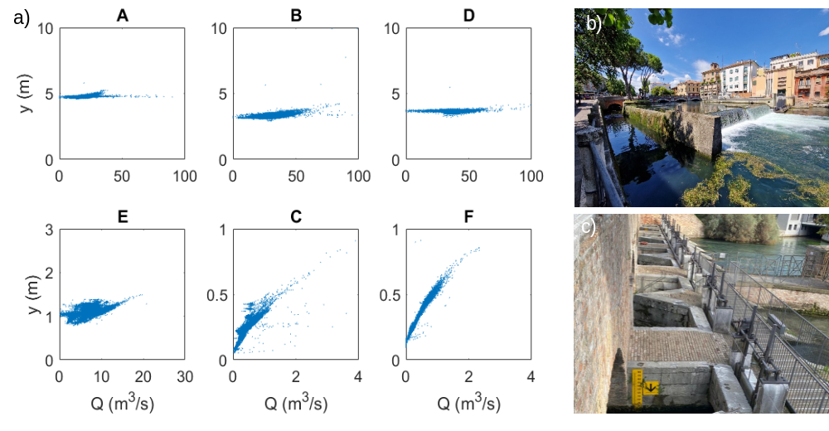
Fig. S2 Quantity data: a) Q-y curve for each station equipped with radar sensors; b) hydropower plant upstream between station A and B; c) hydraulic control facility downstream station E.

- Linear trendline slope
Slopes of linear interpolation of Q and T_{W} data reported in Fig. S3. The linear interpolation has been developed at each station (A, B and E) considering seasonal time window.
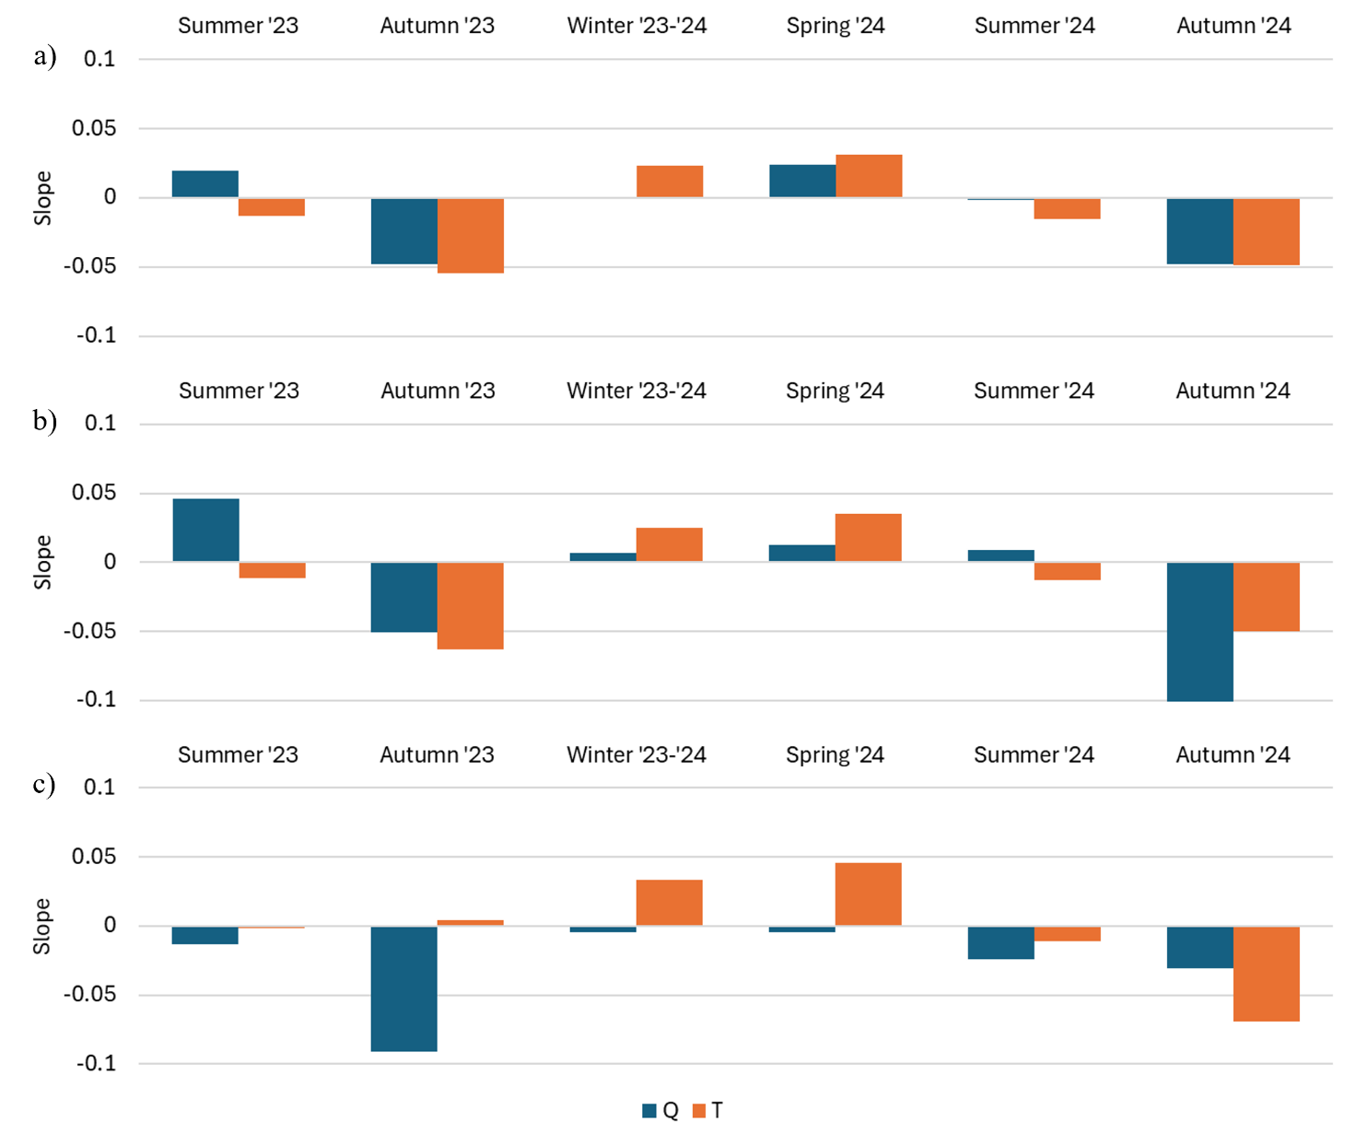
Fig. S3 Slopes of linear interpolation of Q and T_{W} seasonal data (Fig. 7 of the manuscript) at station A, B and E.

- Seasonal correlation values
In Fig. S4 correlation values between Q and T_{W} (panel a), Q and DO (panel b), Q and EC (panel c), DO and EC (panel d) for stations A, B and E are reported together with total rainfall $h$ (mm) and maximum hourly rainfall intensity $j_{max}$ (mm/s) for each month.
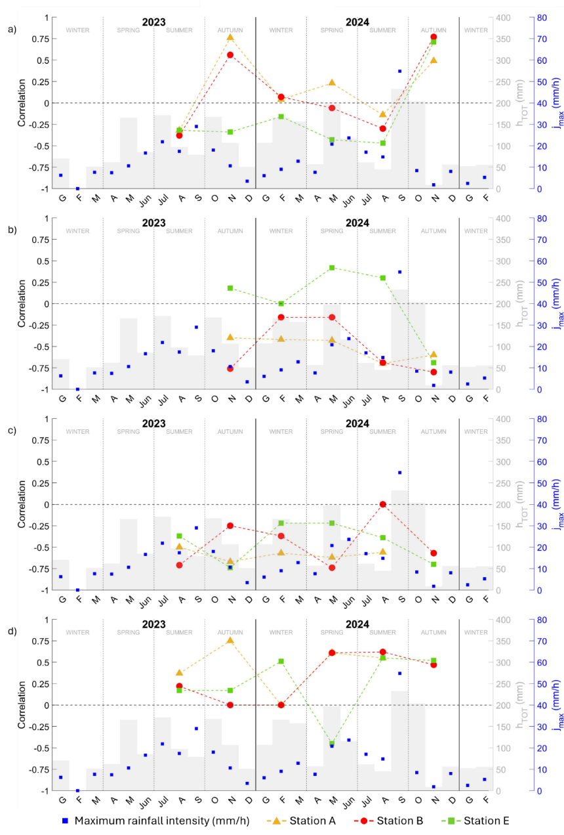
Fig. S4 Seasonal correlation values between Q and T_{W} (panel a), Q and DO (panel b), Q and EC (panel c), DO and EC (panel d) for stations A, B and E together with total rainfall h (mm) and maximum hourly rainfall intensity j_{max} (mm/s) for each month
- Correlation analysis with time delay
To investigate the effect of the time delay due to the movement of flow and contaminants in the subsurface, a correlation analysis (Fig. S5) has been repeated considering a shift of 6 (left), 12 (center) and 18 (right) hours between rainfall (h) and the other parameters (NO₃-N at B, NO₃-N at A, NO₃-N at E, Q at B,). This has been done considering all the available data (panel a) and the data collected during two single rainfall events (panel b and c), like in Fig. 12 of the manuscript.
The time delay at which the highest h-Q correlation values appear suggest the subsurface flow concentration time that is of the other of few hours. From panel b and c it is manifest a peak of h-Q correlation for 18 hours for the first event, and 6 hours for the second event. This difference in the hydrological response can be explained by a different spatial distribution of rainfall over the area as well as different initial conditions. Moreover, the highest h-Q correlation value reported in panel c of Fig. 12 of the manuscript, obtained with a time shift equal to 0, may result because of hydropower plant operation and/or relevant contributions from surface runoff.
When all data (from June to September) are considered in the analysis (panel a), a decreasing trend in correlation can be observed between the two parameters. During both rainfall events (panel b and c), the correlation of h with NO₃-N follows the same trend of the correlation between h and Q at B, being the nitrates mainly transported by subsurface flow that are feeding the river network. When all data is considered, correlation remains negligible for all time delays.
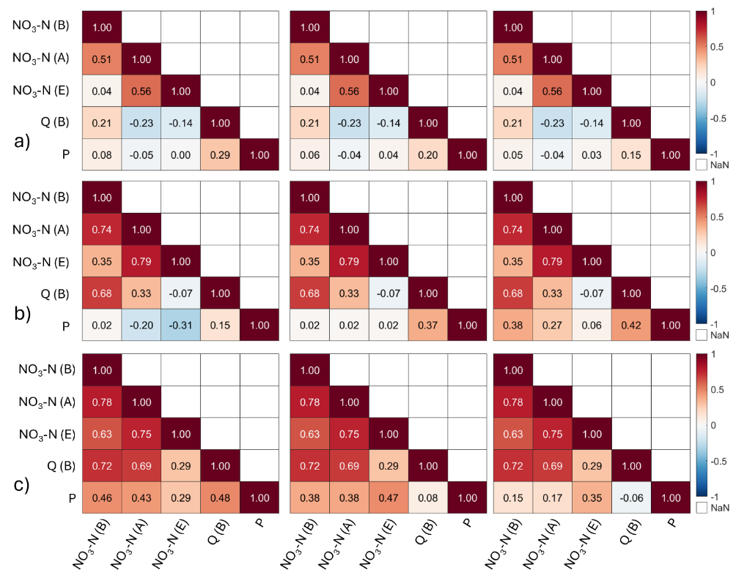
Fig. S5 Correlation analysis considering a time shift of 6 (panel a), 12 (panel b) and 18 (panel c) hours between h between h and the other parameters (NO₃-N at B, NO₃-N at A, NO₃-N at E, Q at B,).

- Multivariate Regression Analysis results
Results from the multivariate regression analysis are reported in Tab. S2. For each coefficient ($c_{i}$) of the linear model ($Y ≈ 1 + c_{1}x_{1} + c_{2}x_{2} + c_{3}x_{3}+ c_{4}x_{4}$) the following data is reported:
Estimate: coefficient estimates for each corresponding term in the model;
SE: standard error of the coefficients;
t_{stat}: t-statistic for each coefficient to test the null hypothesis that the corresponding coefficient is zero against the alternative that it is different from zero, given the other predictors in the model;
p_{value}: p-value for the t-statistic of the two-sided hypothesis test;
R-squared ($R^{2}$) and Adjusted R-squared (${R^{2}}_{adj}$): coefficient of determination and adjusted coefficient of determination.
Tab. S2 Multivariate Linear Regression analysis: estimated value, standard error, t-statistic and p-value for each coefficient.
 | Estimate | SE | t_{stat} | p_{value}
Intercept | -3.45 | 0.25 | -13.99 | 1.4E-42
$$c_{1}$$ | 1.11 | 0.03 | 36.82 | 1.7E-229
$$c_{2}$$ | -0.56 | 0.03 | -16.35 | 1.1E-56
$$c_{3}$$ | 0.09 | 0.005 | 19.64 | 5.9E-79
$$c_{4}$$ | -0.03 | 0.01 | -2.90 | 3.8E-03
$$Y ≈ 1 + c_{1}x_{1} + c_{2}x_{2} + c_{3}x_{3}+ c_{4}x_{4}$$
n° of observations: 2110
$R^{2}=0.425$; ${R^{2}}_{adj}=0.424$

- Contribution of each monitoring element in distinguishing between urban vs agricultural signatures
In Tab. S3 a summary of how each monitoring instrument is useful in distinguishing between urban and rural signatures.
Tab. S3 Summary table outlining the contribution of each monitoring element towards separating urban versus agricultural signatures
Instrument | Urban signature | Rural signature
Radar sensor | It is needed to obtain discharge data. Fundamental for the definition of pollutant loads in a river section, and thus to develop balances in the area.
Multiparametric probe | High frequency data can be obtained consistent with the temporal scale of urban processes. However, a limited set of macro-parameters can be monitored.  T_{w}, DO, EC and pH may be useful to recognize CSO presence. | It is potentially useful to define the temporal pattern connecting monthly samplings.  ISEs frequent malfunction limit the advantages of ammonium and nitrate monitoring. | Coupling between high frequency (sub-hourly) multiparametric probe monitoring and low-frequency (monthly) automatic sampling turned out to be the optimal match for the recognition of agricultural contributions.
Fixed/transportable sampler | Grab sampling with sub-hourly frequency allowed the recognition of urban discharges (E. Coli).  Can potentially monitor any parameter needed (e.g. pathogens, heavy metals, hydrocarbons) in the limits of economic constraints. Useful to check probe ISE data reliability. | Monthly composite sampling may be useful to follow seasonal variations of pollutants.  Can potentially recognize any parameters of interest (e.g. plant protection products and macronutrients) in the limits of economic constraints.
Fixed/transportable sampler | The transportable sampler does not always allow proper sampling position over the cross section, due to the cost of head losses with respect to suction head limits. It is effective to monitor small and easily accessible channels.

