Supplementary Tables and Figures

Supplementary Fig. S1. PCR Gel Electrophoresis of the amplified product of emeA, and efrB genes

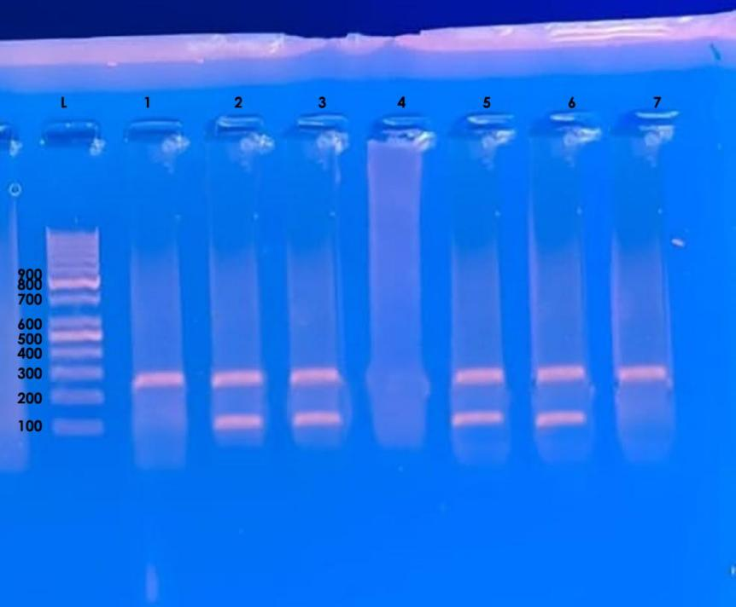

Lane L: DNA Molecular Size ladder (100−1000 bp). Lanes 2, 3,5, and 6: Positive for emeA with a band size of 128 bp. Lanes 1,4, and 7: Negative for emeA. Lanes 1-3, and 5- 7: Positive for efrB with a band size of 211 bp. Lane 4: Negative for efrB.

Supplementary Fig. S2. PCR Gel Electrophoresis of the amplified product of efrA gene.

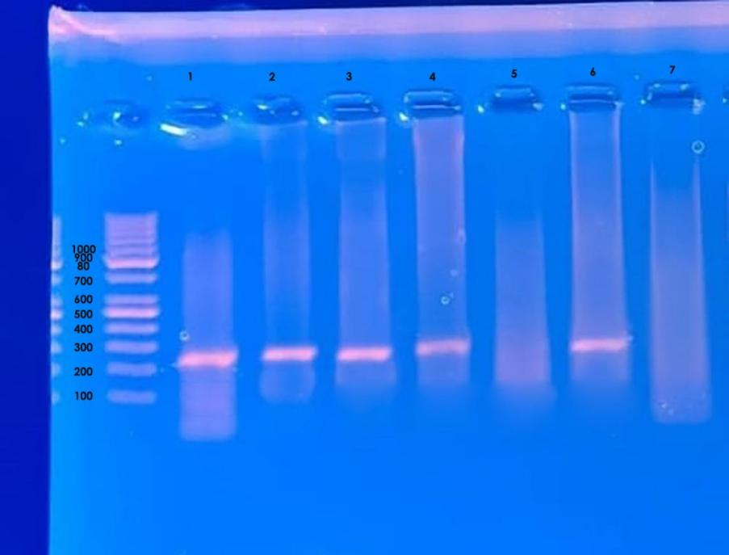

Lane L: DNA Molecular Size ladder (100−1000 bp). Lanes 1-4 and 6: Positive for efrA with a band size of 224 bp. Lanes 5 and 7: Negative for efrA.

Supplementary Table S1. Antimicrobial resistance profiles of the studied Enterococcus isolates identified by the Vitek-2 system (n = 120).
Antibiotic Group | Antimicrobial Agents | Enterococcus spp.  MIC Breakpoints (CLSI, 2025)
Antibiotic Group | Antimicrobial Agents | Sensitive | Intermediate | Resistant
Antibiotic Group | Antimicrobial Agents | N (%) | N (%) | N (%)
Penicillin | Ampicillin | 65 (54.2%) | 0 (0%) | 55(45.8%)
Aminoglycosides | Gentamycin high level | 68 (56.7%) | 0 (0%) | 52 (43.3%)
Aminoglycosides | Streptomycin high level | 55 (45.8%) | 0 (0%) | 65 (54.2%)
Macrolides | Erythromycin | 38 (31.7%) | 30 (25%) | 52 (43.3%)
Fluoroquinolones | Ciprofloxacin | 58 (48.3%) | 0 (0%) | 62 (51.7%)
Glycopeptides | Vancomycin | 93 (77.5%) | 0 (0%) | 27 (22.5%)
Oxazolidinones | Linezolid | 88 (87.5%) | 0 (0%) | 15 (12.5%)
Lipoglycopeptides | Teicoplanin | 100 (83.3%) | 1 (1%) | 19 (15.8%)
Tetracyclines | Tetracycline | 50 (41.7 %) | 0 (0%) | 70 (58.3%)
Glycycline | Tigecycline | 120 (100%) | 0 (0%) | 0 (0%)

Supplementary Table S2. Association between CHX and BCC MIC Levels and Susceptibility to ciprofloxacin, vancomycin, and gentamicin
- faecalis N=63 |  | CHX MIC50 (µg/mL) | CHX MIC90 (µg/mL) | BCC MIC50 (µg/mL) | BCC MIC90 (µg/mL)
CIP | R (n=24 ) | 8 | 8 | 8 | 16
CIP | S (n=39 ) | 4 | 8 | 4 | 8
VAN | R (n=9 ) | 8 | 8 | 8 | 32
VAN | S (n= 54) | 4 | 8 | 8 | 16
GEN | R (n= 22) | 8 | 8 | 8 | 16
GEN | S (n= 41) | 4 | 8 | 4 | 8
- faecium N=57 |  | CHX MIC50 (µg/mL) | CHX MIC90 (µg/mL) | BCC MIC50 (µg/mL) | BCC MIC90 (µg/mL)
CIP | R (n=38) | 8 | 8 | 4 | 16
CIP | S (n=19 ) | 4 | 8 | 2 | 8
VAN | R (n=18 ) | 8 | 16 | 8 | 16
VAN | S (n= 39) | 4 | 8 | 8 | 8
GEN | R (n= 30) | 4 | 8 | 4 | 16
GEN | S (n= 27) | 4 | 8 | 4 | 16

Supplementary Table S3. Biofilm-forming strength of E. faecalis and E. faecium isolated from different sources.

Biofilm strength | E. Faecalis (n=63) |  |  |  | E. Faecium (n=57)
Biofilm strength | Clinical (n=32) | Surfaces (n=16) | Healthy volunteers (n=15) | Total | Clinical (n=28) | Surfaces (n=17) | Healthy volunteers(n=12) | Total
Biofilm strength | N % | N % | N % | N % | N % | N % | N % | N %
No biofilm (I) | 1 3.125 | 6 37.5 | 11 73.3 | 18 28.6 | 7 25 | 8 47 | 7 58.3 | 22 38.6
Weak (II) | 2 6.25 | 0 0.00 | 0 0.00 | 2 3.2 | 1 3.6 | 0 0.00 | 0 0.00 | 1 1.8
Moderate (III) | 7 21.9 | 5 31.25 | 1 6.7 | 13 20.6 | 3 10.7 | 2 11.8 | 0 0.00 | 5 8.8
Strong (IV) | 22 68.75 | 5 31.25 | 3 20 | 30 47.6 | 17 60.7 | 7 41.2 | 5 41.7 | 29 50.8
Total biofilm producers (II, III,IV) | 31 96.9 | 10 62.5 | 4 26.7 | 45 71.4 | 21 75 | 9 53 | 5 41.7 | 35 61.4
p-value | P1 < 0.001∗ |  |  |  | P2 <0.001∗
P1: p value for comparing between the 3 sources of E.faecalis regarding biofilm-forming strength.
P2: p value for comparing between the 3 sources of E.faecium regarding biofilm-forming strength.
∗Statistically signifcant at p ≤ 0.05.

Supplementary Table S4. Frequency distribution of the Efflux-pump genes among E. faecalis and E. faecium isolates.

Variables |  | E. faecalis  (n=63) |  | E. faecium  (n=57) |  |  | Total  (n=120) |  | Test of significance |  | p*
 |  | No. | % | No. | % |  | No. | % |  |  | p*
efrAB
Present  Absent |  | 34  29 | 54  46 | 27  30 | 53  47 |  | 61  59 | 50.8  49.2 | 0.52 |  | 0.47
EmeA
Present  Absent |  | 25  38 | 39.7  60.3 | 16  41 | 28  72 |  | 41  79 | 34.2  65.8 | 1.7 |  | 0.18
Co-existence of efrAB+EmeA
Present  Absent | 17  46 |  | 27  73 | 10  47 |  | 17.5  82.5 | 27  93 | 22.5  77.5 |  | 1.52 | 0.216
P: p value for comparing between the E. faecalis and E. faecium isolates regarding efflux-pump genes carriage.
∗Statistically signifcant at p ≤ 0.05.

Supplementary Table S5. Association between Chlorhexidine digluconate and Benzalkonium chloride MICs with the presence of efflux-pump Genes

Biocide Associated Genes |  | Chlorhexidine digluconate MIC (μg/mL) |  |  |  |  |  |  |  |  |  |  |  |  |  |  |  |  |  |  |  |  |  |  |  |  |  |  |  |  | P
 |  | Total | 0.5 |  |  |  |  | 1 |  |  |  |  | 2 |  |  |  | 4 |  |  |  |  | 8 |  |  |  |  | 16
 |  | Total | NO |  | % |  | NO |  |  | % |  | NO |  |  | % | NO |  |  | % |  | NO |  |  | % |  | NO |  |  | %
efrAB  positive  negative |  | 61  59 | 0 (0.0)  1 1.7 |  |  |  |  | 1 1.6  4 6.8 |  |  |  |  | 7 11.7  11 18.6 |  |  |  | 20 32.8  20 33.9 |  |  |  |  | 32 52.5  23 40.4 |  |  |  |  | 1 1.6  0 (0.0) |  |  |  | 0.29
emeA  positive negative |  | 41  79 | 0 (0.0)  1 1.3 |  |  |  |  | 1 2.4  4 5.1 |  |  |  |  | 9 22  9 11.4 |  |  |  | 15 36.6  25 31.6 |  |  |  |  | 16 39  39 49.4 |  |  |  |  | 0 (0.0)  1 1.3 |  |  |  | 0.5
Biocide Resistance Genes | Total |  |  | Benzalkonium chloride MIC (μg/mL) |  |  |  |  |  |  |  |  |  |  |  |  |  |  |  |  |  |  |  |  |  |  |  |  |  | P
Biocide Resistance Genes |  |  |  | 2 |  |  |  |  | 4 |  |  |  |  | 8 |  |  |  |  |  | 16 |  |  |  |  | 32
Biocide Resistance Genes |  |  |  | NO |  | % |  |  | NO |  | % |  |  | NO |  |  |  | % |  | NO |  |  | % |  | NO |  |  | %
efrAB  positive  negative | 61  59 |  |  | 2 3.3  4 6.8 |  |  |  |  | 6 9.8  13 22 |  |  |  |  | 24 39.3  15 25.4 |  |  |  |  |  | 28 46  25 42.4 |  |  |  |  | 1 1.6  2 3.4 |  |  |  |  | 0.21
emeA  positive  negative | 41  79 |  |  | 1 2.4  5 6.3 |  |  |  |  | 5 12.2  14 17.7 |  |  |  |  | 15 36.6  24 30.4 |  |  |  |  |  | 17 41.5  36 45.6 |  |  |  |  | 2 4.9  1 1.3 |  |  |  |  | 0.52

P: p value for comparing between the variable CHX and BCC MICs values regarding acquisition of efflux-pump genes
∗Statistically signifcant at p ≤ 0.05.

