Scientific Reports: Supplementary Information

Micro-computed tomography indicates Eurotamandua, putative anteater from the Eocene of Messel, Germany, is related to pangolins, not xenarthrans

Kenneth D. Rose^{1*}, Renate Rabenstein², Jörg Habersetzer², Timothy J. Gaudin³

¹ Center for Functional Anatomy and Evolution, Johns Hopkins University, School of Medicine, Baltimore, Maryland 21205, USA; ORCiD 0000-0003-0326-9171; email: kdrose@jhmi.edu

² Senckenberg–Leibniz Institution for Biodiversity and Earth System Research, Senckenberg Research Institute and Natural History Museum Frankfurt/M., Senckenberganlage 25, Frankfurt am Main 60325, Germany; ORCiD 0000-0003-1421-6446; email: renate.rabenstein@senckenberg.de; ORCiD 0000-0002-1219-5808, email: jhaberse44@gmail.com

³Department of Biology, Geology & Environmental Science, University of Tennessee at Chattanooga, 615 McCallie Ave, Dept. 2653, Chattanooga, TN, 37403-2598, USA; ORCiD 0000-0003-0392-5001; email: Timothy-Gaudin@utc.edu

*Corresponding author

CONTENTS OF SUPPLEMENTARY FILE

S1. Comments on additional supposed vermilinguan characters in Eurotamandua
(according to Storch 1981, 2003 [1,2])

S2. Comparative Material
Specimens compared with the holotype of Eurotamandua joresi
Institutional abbreviations

S3. Phylogenetic Analysis
Modified characters from Gaudin et al. analysis [3]
New characters added for the present study (characters 396-448)
Distribution of apomorphies on the MPT illustrated in Figure 8

References cited in the Supplementary File

Supplementary Figures
Supplementary Fig. S1
Supplementary Fig. S2
Supplementary Fig. S3
Supplementary Fig. S4
Supplementary Fig. S5

S1. Comments on additional supposed vermilinguan characters of Eurotamandua [1,2,4]

Premaxilla very small, loosely attached and C-shaped—Also occurs in Eomanis and palaeanodonts (Metacheiromys). The premaxilla of Eurotamandua lacks an anteroposteriorly narrow ascending process typical of anteaters [3].

Maxilla has no orbital exposure—There is little or no maxillary exposure in the orbit of pangolins and Metacheiromys as well as vermilinguans [5,6]. Based on the CT-scan, however, the maxilla of Eurotamandua appears to extend into the orbit just inferior to the lacrimal, which is the primitive condition for placental mammals.

Lacrimal with well-developed facial extension, containing lacrimal foramen—The lacrimal is variable in Xenarthra: the facial part is larger than the orbital part in vermilinguans and cingulates [5,6], but the orbital part is larger in most sloths [6] as well as in Metacheiromys and Eurotamandua [7]. Reexamination suggests Eurotamandua has equal facial and orbital components, with the lacrimal foramen located on the orbital rim.

Jugal bone loosely attached—The jugal is loosely attached in most pilosans (=sloths + anteaters) [6]. Eurotamandua has a complete zygomatic arch and, aside from some postmortem deformation, its jugal does not appear to be loosely attached. Where known in palaeanodonts, the jugal is solidly attached.

Parietal has a large orbital (orbitotemporal) wing—Sutures are very difficult to discern, but the parietal appears to extend into the posterior wall of the orbitotemporal region. A large orbital wing is present in extant anteaters but not in the extinct Protamandua and Palaeomyrmidon [6]. Such an extension also occurs in most sloths and in Metacheiromys [6,8] but is absent from the primitive pholidotan Patriomanis [7].

Auditory bulla ossified—An ossified bulla is widespread among placentals, though its composition varies. It is present in most xenarthrans, as well as some palaeanodonts (e.g., Metacheiromys [9,10]), and some pholidotans. An ectotympanic bulla occurs in vermilinguans and in some pangolins (extant African clade).

Subarcuate fossa—A large subarcuate fossa was considered to be a feature shared by Eurotamandua and vermilinguans [2,4]. It is specific to Tamandua and Cyclopes, but not Myrmecophaga, and is not characteristic of other xenarthrans [5,11]). Nor is this fossa large in pangolins (where it is distinct but shallow) or in the palaeanodont Metacheiromys (smaller and shallower [10]). The subarcuate fossa is not only broad but also deep in Tamandua, and bulb-shaped, expanding below the rim of the fossa (TJG, unpublished observations). While the CT-scan reveals a large subarcuate fossa in Eurotamandua, its detailed structure is more ambiguous.

Atlas vertebra (C1) lacks ventral tubercle—The ventral surface of the atlas was not clarified in the CT-scan, so this character remains ambiguous. While vermilinguans are characterized by the absence of a ventral tubercle, the pholidotan Patriomanis also lacks this tubercle [7]. A very small ventral tubercle is present in Metacheiromys [9].

Ulna lacks projecting anconeal process—The CT-scan enabled 3-D examination of the anconeal process in the holotype, which confirms the morphology observed in the Geiseltal ulna: the process is much broader and more projecting in Eurotamandua than in Tamandua, more closely resembling the condition in palaeanodonts.

Tibia and fibula free—While the tibia and fibula are typically fused in adult cingulates and in some adult palaeanodonts [12,13], associated with digging habits, they are separate in vermilinguans and sloths. As this is the primitive state in placentals, the fact that the tibia and fibula are separate in Eurotamandua and vermilinguans does not provide support for their close relationship.

Absence of fabellae—Storch [1] identified a sesamoid bone at the proximolateral margin of the tibia in Eurotamandua, as in extant anteaters. This element, situated in the tendon of the popliteus muscle, has generally been identified as a cyamella or a fused cyamo-fabella [14-16], and it has also been reported in living and fossil sloths, as well as in many other mammals. Fabellae are sesamoids in the lateral and sometimes medial gastrocnemius tendons, typically situated just superior to the femoral condyles [14]. Although fabellae are known to occur in many orders of mammals [14], they are by no means ubiquitous. Xenarthra and Pholidota were not listed in reference 14 among orders in which fabellae are generally present. Fabellae are often associated with shallow articular facets above the condyles, whereas the cyamella is associated with an articular facet on the proximolateral tibia. However, the knee joints in the holotype skeleton are damaged, and based on the CT-scans, we are unable to confirm or reject the presence of fabellae in Eurotamandua.

S2. Comparative material:
Specimens compared with the holotype of Eurotamandua joresi
Eurotamandua: Eurotamandua joresi, Geiseltal (GMH XIV-4318-1956, right humerus; GMH XIV-3912-1956, right ulna; casts SMF 88/162 and SMF 88/161)

XENARTHRA
Dasypodidae: Dasypus novemcinctus (SMF 13439, SMF 13447, SMF 95287, USNM-M 49399, UTCM 926, UTCM 1520), Euphractus sexcinctus (SMF 1502)
Myrmecophagidae: Myrmecophaga tridactyla (SMF 43046), Tamandua tetradactyla (JHU X-2, JHU X-3, SMF 33554, USNM-M 361030, UTCM 901, UTCM 1577).

PHOLIDOTA:
Manidae: Manis pentadactyla (USNM-M 307385), Phataginus tricuspis (SMF 11451, SMF 92337), Smutsia gigantea (SMF 20447)
Eomanidae: Eomanis waldi (cast SMF 83/3, original in Royal Belgian Institute of Natural Sciences, Brussels)
Patriomanidae: Patriomanis americana (USNM 299960, 494439, 531556)
Pholidota, unassigned: Euromanis krebsi (cast SMF 94/1, original in private collection)

PALAEANODONTA:
Metacheiromys dasypus (AMNH 11718, holotype), Metacheiromys marshi (AMNH 131777, USNM 26132), Palaeanodon ignavus (USGS 21876, USGS 16471, USNM 491829), Tubulodon atopum (UM 93740, USNM 491828, USNM 538278) and cf. Tubulodon sp. (USNM 539571).

Institutional Abbreviations:
AMNH American Museum of Natural History, Department of Vertebrate Paleontology, New York, New York, USA
GMH Geiseltalmuseum; Zentralmagazin Naturwissenschaftliche Sammlungen (ZNS), Geiseltalsammlung, Martin-Luther-Universität Halle-Wittemberg, Germany
HLMD-Me Hessisches Landesmuseum Darmstadt, Germany, Messel Collection
JHU Johns Hopkins University School of Medicine, Center for Functional Anatomy and Evolution, Mammal collection
SMF Senckenberg Forschungsinsitut und Museum Frankfurt, Germany, Mammal collection
UM University of Michigan Museum of Paleontology, Ann Arbor, Michigan, USA
USGS U.S. Geological Survey (Denver), collection now housed in USNM Department of Paleobiology
USNM U.S. National Museum of Natural History, Department of Paleobiology, Smithsonian Institution, Washington, D.C., USA
USNM-M U.S. National Museum of Natural History, Division of Mammals, Smithsonian Institution, Washington, D.C., USA
UTCM University of Tennessee at Chattanooga Natural History Museum, Mammal Collection, Chattanooga, Tennessee, USA

S3. Phylogenetic Analysis

Modified characters from Gaudin et al. analysis [3].
Newly added character states are highlighted with boldface type. * denotes multistate characters; ** denotes multistate and ordered characters. Bolded state numbers indicate that the numbers have changed from ref [3].

*4. Shape of manual and pedal subungual process (=flexor tubercle) in ventral view: rounded triangular platform, perforated by subungual foramina (0); triangular platform but lacking perforations for subungual foramina, with grooves along either side of subungual process leading to subungual foramina instead (1); narrow subungual process, with grooves on either side leading to subungual foramina (2); triangular or ovate process, unconstricted by grooves, subungual foramina dorsal to subungual process (3); or subungual process absent (4).
*7. Distal condyles of manual and pedal proximal phalanges: with single, transversely elongate, cylindrical condyles (0); condyles divided into medial and lateral pulleys (1); or medial and lateral pulleys plus a median keel (2).
**8. Distal keel on metatarsals and metacarpals: present only as a moderate ridge on ventral half of articulation, distinct fossa on dorsal surface of metacarpal above the condyle absent (0); present only as a moderate ridge on ventral half of articulation, distinct fossa on dorsal surface of metacarpal above the condyle (1); ventral ridge on ventral half of articulation hypertrophied, distinct fossa on dorsal surface of metacarpal above the condyle still present (2); or keel extends along entire dorsoventral length of condyle, dorsal fossa above condyle absent (3).
*27. Shape of proximal articular surface of metatarsal III in proximal view: roughly dumbbell shape, expanded dorsally and ventrally and constricted in between (0); roughly triangular, narrowing ventrally (1); quadrangular, without constriction (2); or T-shaped (3).
*31. Shape of lateral flange of metatarsal V: elongated distally, straight or curved ventrally at distal end, separated from cuboid facet by groove (0); elongated distally, curved dorsally at distal end, separated from cuboid facet by groove (1); elongate dorsoventrally, separated from cuboid facet by pit enclosed by dorsal and ventral ridges (2); lateral flange a small tubercle (3); or lateral flange absent (4).
*50. Shape of navicular facet of lateral cuneiform: triangular or quadrangular (0); butterfly-shaped, expanded transversely on dorsal and ventral ends with concave medial and lateral margins (1); extended ventrally onto plantar tubercle (2); or L-shaped (3).
**53. Shape of plantar process of cuboid in plantar view: elongated transversely (0); round (1); or elongated proximodistally (2).
*54. Orientation of plantar process of cuboid in plantar view: tilts proximomedially (0); horizontal (1); tilts proximolaterally (2); or vertical (3).
**72. Deep groove for calcaneal-navicular “spring” ligament on ventral margin of astragalar head: absent (0); shallow groove present (1); or deep groove present (2).
*75. Orientation of long axis on astragalar ectal facet: proximodistal (0); proximomedial to distolateral (1); or proximolateral to distomedial (2).
*79. Shape of medial navicular facet on astragalar neck in medial view: narrow dorsally, extended proximally along ventral edge (0); depressed proximodistally along entire length (1); irregular shape, not markedly depressed (2); or tall proximodistally, triangular in outline (3).
*81. Shape of fibular facet of astragalus: oblique, irregularly triangular or teardrop-shaped, without strong vertical moiety distally (0); crescentic or boomerang-shaped, with concavity facing proximoplantarly or plantarly, or horseshoe-shaped, with concavity facing proximally (1); or rectangular (2).
*84. Tuber calcis (=tuber calcanei) shape: nearly cylindrical, dorsoventral depth ≥ transverse width (0); expanded transversely (1); expanded obliquely, greatest depth lies along dorsomedial to ventrolateral axis (2); expanded obliquely, greatest depth lies along dorsolateral to ventromedial axis (3); or compressed transversely (4).
**89. Position of sustentacular facet on calcaneus: situated directly medial to ectal and fibular facets (0); elongated distally, distal portion extends distal to ectal and fibular facets, reaching distal edge of sustentacular flange (1); situated well distal to ectal and fibular facets, but proximal to distal margin of calcaneus (2); or situated well distal to ectal and fibular facets, contacting distal margin of calcaneus (3).
**92. Shape of cuboid facet of calcaneus: narrow transversely, transverse width < dorsoventral depth (0); width ≈ depth (1); or elongated transversely, width > depth (2).
*104. Development of anterior distal and anterior lateral distal processes of tibia: anterior distal process elongated, narrow, anterior lateral distal process absent (0); anterior distal process present but shallow, wide, anterior lateral process absent or rudimentary (1); strongly reduced anterior distal process, anterior lateral distal process well developed (2); both processes absent (3); or both processes well developed though shallow, broad and triangular (4).
123. Shape of femoral shaft: slender, minimum width <11% of maximum length (0); or broadened transversely, minimum width >12% maximum length (1).
*132. Trochanteric fossa and intertrochanteric ridge: well developed (0); rudimentary or absent (1); trochanteric fossa large but intertrochanteric ridge rudimentary or absent (2); or trochanteric fossa absent but intertrochanteric ridge well developed (3).
*146. Gluteal fossa on ilium: large, with prominent lateral iliac crest, medial dorsal flange of ilium and caudal dorsal iliac spine (0); weak, iliac crest rounded but still well developed, small dorsal flange and free caudal dorsal iliac spine (1); poorly demarcated, iliac crest rounded, weak, dorsal flange absent, caudal dorsal iliac spine incorporated in sacroiliac junction (2); poorly demarcated, iliac crest rudimentary but small dorsal flange and caudal dorsal iliac spine present (3); or iliac crest very large and sharp, dorsal flange strong but low, no free caudal dorsal spine present (4).
**157. Number of thoracic vertebrae:11 (0); 12 (1); 13 (2); 14 (3); 15 (4); 16 (5); or 17 to 18 (6).
**160. Position of diaphragmatic vertebra: T7 or T8 (0); T9 (1); T10 (2); T11 and T12 (3); T12 (4); T12 and T13 (5); or T13 (6).
**168. Anteriormost thoracic vertebra in which the diapophysis is completely separated posteroventrally from the metapophysis: T7 (0); T10 (1); T11 (2); T12 (3); T13 (4); or T14 (5).
*172. Heights of neural spines in cervical vertebrae 3-7: C3>C4>C5<C6<C7 (0); C3≤C4≤C5<C6<C7 (1); or C3<C4<C5>C6>C7 (2).
*194. Cartilaginous extension of xiphisternum: short, length much less than ossified portion of xiphisternum, shovel shaped at distal end (0); elongated, length much greater than ossified portion of xiphisternum, shovel-shaped at distal end with central perforation (1); greatly elongated, extending posteriorly to pelvis, then curling dorsally toward vertebral column at its distal end (2); or short but not shovel-shaped distally (3).
**195. Number of true ribs: 6 (0); 7 (1); 8 (2); 9 (3); or 11 (4).
*217. Form of supinator crest: flared laterally at its distal end, with well-developed anterior concavity (0); extends nearly straight distally, with well-developed anterior concavity (1); or extends nearly straight distally, anterior concavity poorly marked or absent (2).
*263. Shape of proximal articulation on capitate: ovate or rectangular, without lateral indentation (0); roughly triangular, with slight lateral indentation (1); L-shaped, with abrupt, step-like lateral indentation between dorsal portion of facet and its palmar extension (2); dumbbell-shaped (3); or L-shaped, with step-like medial indentation between dorsal portion of facet and its palmar extension (4).
*277. Shape of metacarpal I in medial view: with elongated cylindrical shaft, may be slightly expanded proximally and distally (0); dumbbell-shaped, with broadly expanded proximal and distal ends joined by short shaft (1); expanded distally only, with shaft narrowing towards proximal end (2); or rectangular, proximodistal length > dorsoventral depth (3).
*283. Palmar extent of capitular facet on metacarpal III: palmar tuberosity well developed, little overlap of capitular facet on shaft (0); facet overlaps shaft proximally, palmar tuberosity weakly developed (1); or palmar tuberosity weakly developed but little overlap of capitular facet on shaft (2).
*284. Shape of capitular facet of metacarpal III in medial view: evenly convex (0); sigmoid, extended to form dorsal shelf (1); or concave (2).
*285. Dorsal surface of metacarpal III, proximal end: smoothly convex (0); with sharp midline crest terminating in prominent tubercle proximally (1); or with prominent distal tubercle, weak midline crest (2).
*290. Surface contour of proximal articulation of metacarpal IV: evenly convex transversely and dorsoventrally (0); mostly convex but with strong concave pit (1); concave transversely, convex dorsoventrally (2); or flat transversely, convex dorsoventrally (3).
*291. Shape of proximal articulation of metacarpal IV: rectangular, long axis oriented dorsoventrally (0); triangular with base facing dorsally (1); semicircular with flat edge facing dorsally (2); or rectangular, long axis oriented transversely (3).
*292. Contour of articular surface for metacarpal III on metacarpal IV: flat dorsoventrally (0); convex dorsoventrally (1); or concavo-convex (2).
*293. Contour of articular surface for metacarpal V on metacarpal IV: concave dorsoventrally (0); convex dorsoventrally (1); or flat (2).
*298. Relative lengths of manual proximal (PP) and intermediate (IP) phalanges: nearly equivalent, ratio of IP/PP length <1.2 on all digits (0); proximal phalanx shorter on digits II and III (1); proximal phalanges shortened on digits II-IV (2); proximal phalanx shorter on digit III (3); or all proximal phalanges shortened (4).
*300. Distal articulation of proximal phalanx on digit III: with paired distal condyles separate (0); with paired distal condyles joined at their dorsoventral midpoint by a transverse eminence (1); or with paired distal condyles and a median keel (2).
*306. Anterior border of nasal: with shallow notch (0); with deep notch forming elongated medial and lateral processes, with deep fossa on lateral process (1); deeply concave, with elongated lateral process but medial process rudimentary or absent (2); or evenly convex (3).
*309. Dorsal (facial) process of premaxilla in lateral view: C-shaped, broad anteroposteriorly with distinct anteroventral and anterodorsal processes (0); inclined posterodorsally (1); vertical, narrow anteroposteriorly (2); or elongate triangle with apex posterior (3).
**321. Ethmoidal foramen: within frontal (0); between frontal and orbitosphenoid (1); or within orbitosphenoid (2).
**333. Auditory tube orientation: anteromedial (0); medial (1); or posteromedial (2).
*355. Orientation (and size) of zygomatic process of squamosal: laterally directed (0); ventrally directed, elongated (1); ventrally directed, short (2); or anterolaterally directed, very short (3).
*386. Shape of zygomatic process of squamosal: elongated, uninflated, with blunt tip or elongated anterior sutural contact with jugal (0); short, inflated at base, and pointed at tip (1); very short, blunt tip, uninflated (2); or short, uninflated, with blunt tip and elongated anterior sutural contact with jugal (3).
*393. Teeth: normal mammalian dentition present (0); teeth present but reduced with large canine triangular in cross-section, but no incisors and only a few peg-like postcanine teeth (1); teeth absent (2); or teeth peg-like, without canine (3).

New characters added for the present study (characters 396-448).
* denotes multistate characters; ** denotes multistate and ordered characters.

**396. Shape of infraspinous fossa: narrows ventrally toward glenoid (0); slightly narrowed ventrally (1); or rectangular (2).
**397. Size of supraspinous fossa versus infraspinous fossa: supraspinous fossa > infraspinous fossa (0); supraspinous fossa = infraspinous fossa (1); or supraspinous fossa < infraspinous fossa (2).
398. Supinator crest and deltoid crest of humerus in lateral view: crests either not parallel, or do not overlap proximodistally, or both (0); or crests parallel and overlap proximodistally (1).
*399. Shape of distal end of deltopectoral platform: platform absent (0); platform terminates in v-shaped anterior projection (1); v-shaped anterior convergence of deltoid and pectoral crests, but not terminal, platform weak (2); or platform short, terminates in v-shaped, laterally directed projection (3).
**400. Lateral articular shelf of capitulum of humerus: absent (0); present, cylindrical (1); or present, flared at lateral end (2).
**401. Bicipital ridge of humerus (=crest of the lesser tubercle of Evans & Christensen 1979): rudimentary or absent (0); present, short (1); or present, elongated distally (2).
**402. Humeral head shape in posterior view: mediolaterally compressed (0); spherical (1); or transverse width > proximodistal length (2).
**403. Lesser tubercle of humerus, shape in medial view: elongated anterodistally (0); not distally elongated (1); or elongated posterodistally (2).
404. Depth of olecranon in medial view: uniform or tapered at proximal end (0); or flared dorsoventrally at proximal end (1).
405. Attachment surface for triceps at tip of olecranon: tip of olecranon narrow transversely (0); or tip broad transversely, forms broadest part of olecranon (1).
*406. Posterior border of ulna in lateral view: sinuous, convex proximally and concave distally (0); straight (1); or straight except for short proximal concavity at base of olecranon (2).
407. Radial facet relationship to lateral edge of ulnar shaft in anterior view: facet in line with lateral edge of shaft (0); or facet extends far lateral to lateral edge of shaft (1).
408. Attachment of m. brachialis to ulna: ulnar tuberosity present just distal to coronoid process (0); or pit present just distal to coronoid process (1).
*409. Development of styloid process of ulna: styloid process absent (0); styloid facet sessile, styloid process low, not well developed (1); or styloid facet borne on elongated neck, styloid process elongated (2).
**410. Indentation on medial surface of styloid process’s distal facet: absent (0); shallow (1); or deep (2).
*411. Orientation of distal facet on styloid process: faces dorsally, distally and somewhat medially (0); facet convex, faces distally, dorsally, and ventrally (1); or faces straight distally (2).
412. Orientation of radial head in anterior view: surface of head level, horizontal (0); or lateral margin elevated above remainder of surface (1).
413. Anterior capitular eminence of radius: absent (0); or present (1).
414. Scaphoid shape in proximal view: transverse width equal to or greater than dorsopalmar depth (0); or depth in dorsopalmar plane roughly twice transverse width (1).
415. Palmar tuberosity of scaphoid: single tuberosity (0); or double tuberosity separated by a vertical groove (1).
416. Prepollux: present (0); or absent (1).
*417. Shape of scaphoid dorsal surface in dorsal view: dorsal surface triangular, strongly tapered medially (0); dorsal surface only slightly tapered medially (1); quadrangular, i.e., uniform depth, deep proximodistally (2); or quadrangular, shallow proximodistally (3).
418. Dorsal and proximal articulations of scaphoid: radial facet confined to proximal surface, dorsal surface non-articular (0); or radial facet extends dorsally and distally to occupy most of dorsal surface (1).
**419. Size of trapezoid facet versus trapezium facet on distal scaphoid: trapezoid facet > trapezium facet (0); trapezoid facet = trapezium facet (1); or trapezoid facet < trapezium facet (2).
*420. Distal tubercle on distal articular surface of scaphoid: absent (0); present, on central portion of distal surface (1); or present, close to medial edge of distal surface (2).
**421. Transverse width versus proximodistal length of lunate in dorsal view: transverse width greater than proximodistal length (0); width equal to length (1); or length greater than width (2).
*422. Notched medial and lateral edges of lunate in proximal view: absent (0); with weak lateral notch only (1); with deep lateral notch (2); or with deep medial and lateral notches (3).
423. Shape of lunate palmar tuberosity: transverse width greater than proximodistal length (0); or tuber narrow and elongated distally, length greater than width (1).
424. Vascular foramen on distolateral corner of lunate dorsal surface: absent (0); or present (1).
*425. Capitate facet of lunate: facet absent (0); single uniform facet (1); or two facets, one shallow and dorsal, one palmar and deep (2).
*426. Hamate facet of lunate: facet absent (0); facet restricted to dorsal half of lunate lateral surface (1); or facet deep in dorsopalmar plane, covers most or all of lunate lateral surface (2).
*427. Shape of triquetrum dorsal surface in dorsal view: triangular, transverse width greater than proximodistal length (0); triangular, but length greater than width (1); square, width = length (2); or rectangular, width > length (3).
**428. Shape of triquetrum ulnar facet in proximal view: transverse width < dorsopalmar depth (0); transverse width = dorsopalmar depth (1); or transverse width < dorsopalmar depth (2).
429. Surface contour of triquetrum hamate facet: concave (0); or concavoconvex (1).
*430. Relative sizes of three lateral distal carpals (i.e., trapezoid, capitate, hamate): hamate distinctly larger than capitate, trapezoid (0); three bones are roughly equal in size (1); or capitate and hamate enlarged relative to trapezoid (2).
431. Rounded distal extension of the trapezoid dorsal surface: absent (0); or present (1).
*432. Surface contour of metacarpal II facet of trapezoid: concave (0); keeled, with central eminence flanked by medial and lateral concavities (1); with keel and lateral, but no medial concavity (2); concavoconvex, lacking central eminence and concavities (3); or flat (4).
*433. Surface contour of capitate proximal facet: convex surface, elongated in dorsopalmar plane (0); large palmar convexity with small concave dorsal portion (1); large palmar convexity with large concave dorsal portion (2); or simple convex knob compressed in dorsopalmar plane (3).
*434. Surface contour of metacarpal III facet of capitate: concave (0); weakly keeled (1); symmetrical keeled surface with central eminence flanked by concavities (2); or asymmetrical keeled surface with deep narrow medial concavity, broad shallow lateral concavity (3).
435. Curved distomedial extension of capitate dorsal surface: absent (0); or present (1).
**436. Surface contour of proximal triquetrum facet on hamate: convex (0); concavoconvex (1); or concave (2).
*437. Relative development of distal facets on hamate: no metacarpal III (= mc III) facet, mc IV facet > mc V facet (0); no mc III facet, mc IV = mc V (1); mc III facet > mc IV or mc V (2); mc III facet small, mc IV = mc V (3); or mc IV facet largest, > mc III or mc V (4).
438. Shaft of mc III in lateral/medial view: straight shaft (0); or shaft curved/bowed, concave ventrally (1).
*439. Extensor tubercles on metacarpals: absent (0); present on mc III only (1); present but weak, on midshaft of mc II and mc III (2); present on mc II and mc III, circular, proximal to midshaft (3); or present as v-shaped platform or proximodistally elongated crest on distal mc II-IV (4).
**440. Extensor fossa on distal mc III: fossa absent (0); fossa present but not visible in distal view (1); or fossa present, broadly visible in distal view (2).
**441. Keel on distal mc III: present ventrally, does not extend ventral to articular surface in distal view (0); present ventrally, extends ventral to articular surface in distal view (1); or elongated, extends above and below articular surface in distal view (2).
442. Surface features on either side of mc III distal keel: keel flanked by grooves (0); or keel flanked by pits (1).
*443. Shape of proximal mc III facet: trapezoidal, narrows toward palmar surface (0); trapezoidal, narrows toward lateral surface (1); or T-shaped (2).
444. Mc III with deep pit on palmar border of mc IV facet: absent (0); or present (1).
*445. Relative lengths and robusticity of metacarpals: all elongate and slender (0); all but mc III elongate and slender, mc III short and robust (1); metacarpals intermediate in length and robusticity (2); mc II and mc III intermediate in length and robusticity, mc I, mc IV and mc V reduced (3); all metacarpals except mc III intermediate in length and robusticity, mc III short and robust (4); or all metacarpals short and robust (5).
446. Relative shaft width of mc II and mc III: midshaft width of mc III <1.25 times that of mc II (0); or midshaft width of mc III >2.5 times mc II (1).
*447. Relative lengths and robusticity of manual proximal phalanges: all elongate and narrow (0); proximal phalanx II (= pp II) and pp IV elongate and narrow, pp III short and stout (1); all short and stout, but length > width at base (2); pp II and pp IV short and stout, pp III elongated (3); or all short and stout, length < width at base (4).
*448. Relative lengths of manual ungual phalanges: length uniform (0); ungual phalanx III (= up III) elongated (1); up II and III elongated (2); or up III and IV elongated (3).

Distribution of apomorphies on the MPT illustrated in Figure 8.
Characters shown in bold type are unambiguous synapomorphies; those in regular type are ambiguous synapomorphies.

Erinaceus + Nandinia: 34(1), 40(0), 45(0), 48(1), 57(3), 70(0), 79(2), 81(0), 95(1), 103(1), 145(1), 156(1), 176(2), 183(1), 184(0), 199(2), 201(2), 215(0), 230(2), 234(1), 235(2), 241(3), 247(0), 256(1), 257(2), 260(0), 270(1), 306(2), 307(0), 324(0), 373(1), 377(0), 394(0), 399(1), 402(2), 408(1), 431(1).
Node 1. Xenarthra + Pholidotamorpha: 5(1), 7(1), 15(1), 19(1), 42(2), 49(1), 62(1), 83(1), 98(1), 113(1), 123(1), 125(1), 152(1), 155(1), 165(1), 170(1), 189(1), 196(0), 216(1), 239(1), 240(1), 262(1), 291(1), 305(2), 340(1), 378(1), 384(1), 385(0), 393(2), 432(1), 434(1), 448(1).
Node 2. Xenarthra: 13(1), 16(1), 45(1), 47(1), 52(1), 53(1), 55(1), 62(2), 68(0), 74(2), 91(1), 95(1), 105(1), 108(1), 117(1), 124(2), 125(0), 130(0), 134(1), 158(2), 166(1), 175(1), 191(1), 206(2), 213(1), 217(1), 224(1), 257(1), 278(1), 288(1), 293(1), 329(1), 331(0), 347(1), 376(1), 390(1), 397(0), 426(2).
Node 3. Pholidotamorpha: 10(1), 12(1), 14(1), 19(0), 20(1), 37(1), 56(0), 77(0), 81(1), 85(0), 97(0), 100(4), 106(0), 154(0), 165(0), 180(1), 184(0), 212(1), 217(2), 221(1), 227(1), 231(1), 236(0), 240(2), 264(0), 274(1), 286(0), 314(1), 341(1), 391(1), 401(2), 402(0), 403(2), 411(0), 416(1), 444(1), 445(5), 447(3).
Node 4: 40(2), 96(0), 157(1).
Node 5. Eurotamandua + Palaeanodonta: 86(0), 105(1), 151(1), 202(1), 206(0), 207(1), 256(1), 269(1), 273(2), 274(2), 288(1), 299(0), 309(0), 377(0), 386(1), 397(0), 398(1), 399(1), 400(2), 408(1), 410(2), 415(1), 422(2), 424(1), 425(2), 430(1), 431(1), 433(2), 434(2), 435(1), 438(1), 439(3), 440(2), 441(0), 442(1), 443(2).
Node 6. Palaeanodonta: 2(1),48(1), 70(0), 71(0), 81(0), 84(3), 89(0), 95(1), 109(2), 111(1), 115(2), 116(0), 130(0), 146(2), 152(0), 155(0), 192(0), 208(0), 211(1), 216(0), 235(2), 241(0), 246(3), 280(0), 282(2), 290(2), 324(0), 331(0), 384(0), 393(1), 395(1).
Node 7. Pholidota: 11(1), 63(1), 116(3), 129(1), 150(1), 155(2), 160(2), 168(3), 178(2), 205(1), 218(1), 239(0), 246(1), 248(1), 262(2), 263(1), 267(1), 303(1), 313(1), 322(1), 358(1), 366(1), 370(1), 384(2), 392(1), 396(1).
Node 8. Manoidea: 1(1), 22(1), 33(2), 36(1), 65(1), 67(2), 80(1), 95(1), 99(0), 106(1), 117(1), 128(1), 166(1), 167(1), 186(0), 197(1), 198(1), 200(2), 206(0), 207(1), 213(1), 215(2), 216(2), 229(1), 244(1), 249(1), 287(0), 306(1), 320(1), 347(1), 354(1), 355(1), 361(1), 366(2), 371(1), 382(1), 383(1), 413(1), 414(0), 417(3), 419(2), 432(3).
Node 9. Patriomanidae (incl. Necromanis): 3(0), 25(2), 44(0), 54(1), 62(0), 66(0), 71(0), 74(0), 86(0), 107(0), 109(0), 163(0), 164(0), 207(0), 208(0), 221(0), 225(0), 241(0), 242(0), 247(0), 297(0), 406(2), 407(1), 418(1), 420(1), 422(1), 426 (2), 440(1).
Node 10. Manidae: 5(2), 6(1), 8(3), 9(1), 13(1), 21(1), 23(1), 24(1), 26(1), 27(1), 43(0), 49(2), 56(1), 59(1), 63(2), 69(1), 70(2), 77(3), 89(3), 90(1), 91(1), 102(2), 103(2), 110(1), 125(0), 128(3), 131(1), 132(1), 136(1), 137(1), 140(1), 141(1), 142(1), 144(1), 145(1), 146(2), 148(1), 153(1), 154(1), 156(1), 157(3), 160(3), 169(2), 171(1), 174(1), 202(1), 203(1), 204(1), 209(1), 222(1), 223(1), 226(1), 238(1), 244(2), 246(2), 248(2), 251(1), 252(1), 254(1), 257(1), 258(1), 260(2), 262(3), 264(1), 265(1), 266(1), 267(2), 270(1), 273(1), 275(1), 277(1), 282(1), 284(1), 289(1), 290(1), 293(1), 296(1), 298(4), 301(1), 302(1), 311(1), 317(2), 319(1), 328(1), 333(1), 334(1), 336(1), 337(1), 339(2), 342(1), 346(1), 352(1), 353(1), 356(1), 360(1), 361(2), 362(1), 363(1), 371(2), 372(1), 381(1), 387(1), 389(1), 406(1), 423(1), 427(3), 430(2), 435(1), 441(2), 446(1).
Tamandua tetradactyla: 103 unambiguous autapomorphies, 58 ambiguous autapomorphies.
Autapomorphies shared with Eurotamandua: 171(1), 215(2), 216(in part – Eurotamandua = 0/1, Tamandua = 0), 281(1), 317(in part – Eurotamandua = 0/1 [ambiguous autapomorphy], Tamandua = 1), 330(0, [ambiguous in Eurotamandua]), 412(1), 418(1).

References cited in the Supplementary Information:

[1] Storch, G. Eurotamandua joresi, ein Myrmecophagide aus dem Eozän der “Grube Messel” bei Darmstadt (Mammalia, Xenarthra). Senck. lethaea, 61, 247-289 (1981).

[2] Storch, G. Fossil Old World “edentates” (Mammalia). In: Morphological Studies in Fossil and Extant Xenarthra (Mammalia) (eds. Farina, R. A., Vizcaíno, S. F. & Storch, G.) Senck. biologica 83, 51-60 (2003).

[3] Gaudin, T. J., Emry, R. J. & Wible, J. R. The phylogeny of living and extinct pangolins (Mammalia, Pholidota) and associated taxa: a morphology based analysis. J. Mamm. Evol. 16, 235-305 (2009).

[4] Storch, G. & Habersetzer, J. Rückverlagerte Choanen und akzessorische Bulla tympanica bei rezenten Vermilingua und Eurotamandua aus dem Eozän von Messel (Mammalia: Xenarthra). Z. Saugetierkd. 56, 257-271 (1991).

[5] Gaudin, T. J. & Branham, D. G. The phylogeny of the Myrmecophagidae (Mammalia, Xenarthra, Vermilingua) and the relationship of Eurotamandua to the Vermilingua. J. Mamm. Evol. 5, 237-265 (1998).

[6] Gaudin, T. J. Phylogenetic relationships among sloths (Mammalia, Xenarthra, Tardigrada): the craniodental evidence. Zool. J. Linn. Soc. 140, 255-305 (2004).

[7] Gaudin, T. J., Emry, R. J. & Morris, J. Description of the skeletal anatomy of the North American pangolin Patriomanis americana (Mammalia, Pholidota) from the latest Eocene of Wyoming (USA). Sm. C. Paleob. 98, 1-102 (2016).

[8] Rose, K. D. & Emry, R. J. Relationships of Xenarthra, Pholidota, and fossil “edentates”: the morphological evidence. In: Mammal Phylogeny: Placentals (eds. Szalay, F. S., Novacek, M. J. & McKenna, M. C.) 81-102 (Springer, 1993).

[9] Simpson, G. G. Metacheiromys and the Edentata. B. Am. Mus. Nat. Hist. 59, 295-381 (1931).

[10] Gaudin, T. J., Wible, J. R., Rose, K. D., Emry, R. J. & Spaulding, M. Skeletal anatomy of the basicranium and auditory region in the metacheiromyid palaeanodont Metacheiromys (Mammalia, Pholidotamorpha) based on high-resolution CT scans. Fossil Imprint 75, 484-503 (2019).

[11] Gaudin, T. J. & McDonald, H. G. Morphology-based investigations of the phylogenetic relationships among extant and fossil xenarthrans. In: The Biology of the Xenarthra (eds. Vizcaíno, S. F & Loughry, W. J.) 24-36 (University Press of Florida, 2008).

[12] Rose, K. D. & Emry, R. J. Extraordinary fossorial adaptations in the Oligocene palaeanodonts Epoicotherium and Xenocranium (Mammalia). J. Morphol. 175, 33-56 (1983).
[13] Rose, K. D., Krishtalka, L. & Stucky, R. K. Revision of the Wind River faunas, early Eocene of central Wyoming. Part 11. Palaeanodonta (Mammalia). Ann. Carnegie Mus. 60 (1), 63-82 (1991).

[14] Lessertisseur, J. & Saban, R. Squelette appendiculaire In: Traité de Zoologie 16 (1) (ed. Grassé, P. P.) 709-1078 (Masson et Cie, Paris, 1967).

[15] Salas, R., Pujos, F. & de Muizon, C. Ossified meniscus and cyamo-fabella in some fossil sloths: a morpho-functional interpretation. Geobios 38, 389-394 (2005).

[16] da Silva, C. C. L. et al. Multimodal analysis of giant anteater (Myrmecophaga tridactyla) femorotibiopatellar joint anatomy: macroscopic, radiographic, and ultrasonographic findings. J. Morphol. 286(7):e70062 (2025).

Supplementary Figure S1. Closeup of right pelvis and pseudosacral vertebrae (dorsal view) of Eurotamandua joresi (holotype, HLMD-Me 17000) from the 3D model, showing superimposition of pseudosacral transverse processes on ischium. Abbreviations: sp p, spinous processes; tr p, transverse processes. Image prepared by R. Rabenstein and J. Habersetzer.

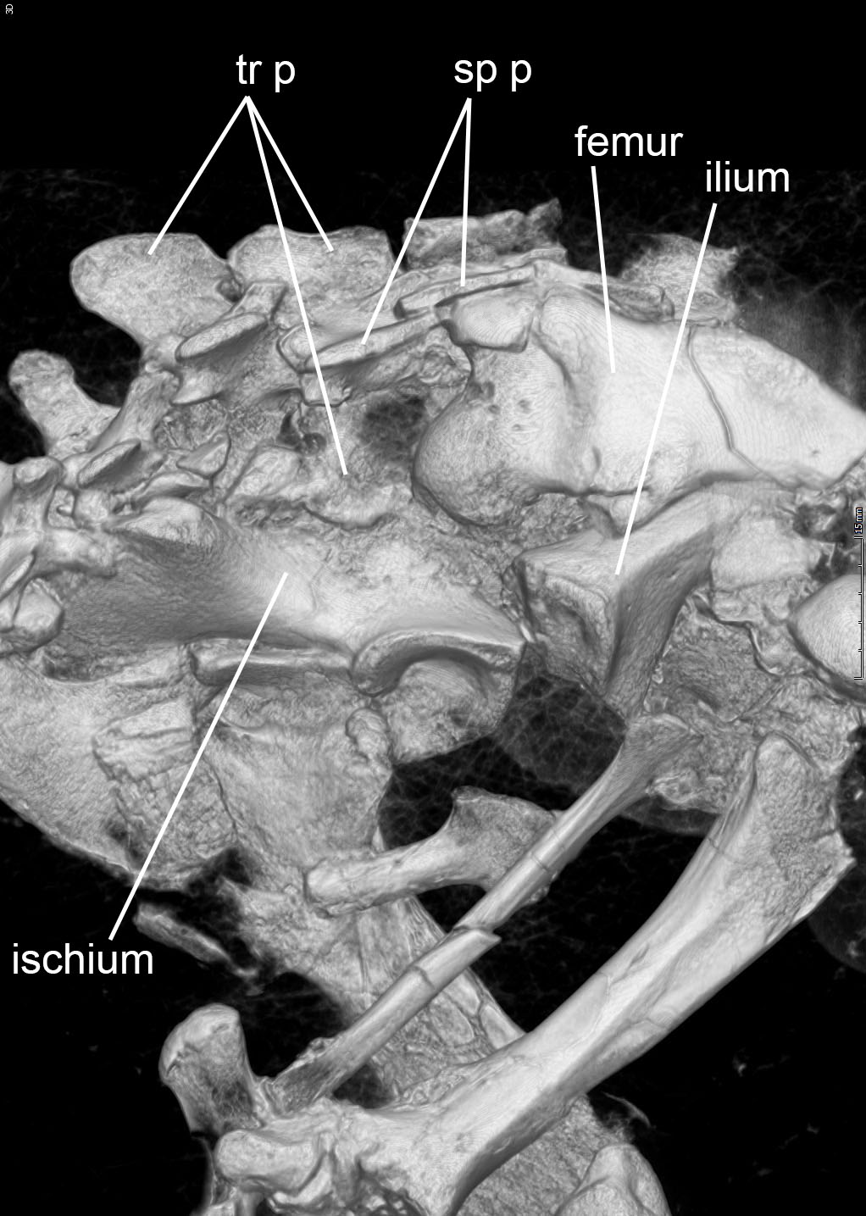
Supplementary Figure S2. Scapula of Eurotamandua joresi (holotype, HLMD-Me 17000) compared with those of Tamandua and Metacheiromys. a, Right scapula of Eurotamandua compressed against left scapula (approximate boundary indicated by dotted line); b, left scapula (reversed for comparison) of Metacheiromys marshi (USNM 26132); c, right scapula of Tamandua tetradactyla (UTCM 1577); d, left shoulder joint of Eurotamandua joresi, holotype, enlarged and rotated to show bifurcated acromion process extending over the glenohumeral joint. Abbreviations: acL, acromion of left scapula; isf, infraspinous fossa; psf, postscapular fossa; ss, secondary spine; ssf, supraspinous fossa. * is positioned on left humeral head in a and d.

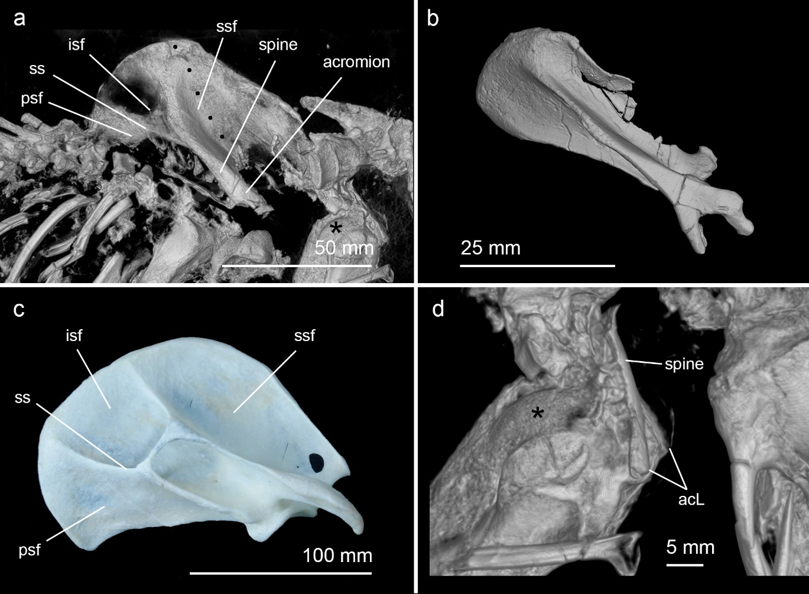
Supplementary Figure S3. Skull of Eurotamandua joresi (holotype, HLMD-Me 17000) showing auditory region cavities, including the bony labyrinth/inner ear, tympanic cavity, and epitympanic sinus (clearly dorsal and anterior to the tympanic cavity) in their preserved shape, position, and orientation. a, Right lateral view; b, dorsal view, showing cavities on the right side; c, left lateral view. The skull and the cavities in a–c are based on 3D reconstructions of micro-CT scan data. d, The auditory cavities in two conventional radiographic images, the upper one showing the cavities on the right side of the skull in dorsal view, the lower image in right lateral view.
Supplementary Fig. S4 – Dentary of Eurotamandua joresi (holotype, HLMD-Me 17000). a, Right dorsolateral view of skull, showing the very slender dentary with laterally curved symphyseal region; b, dorsomedial view of right dentary, showing a small mandibular prong (mp) anterolaterally (a pholidotan trait), and an incipient medial buttress (mb) posteromedially (a palaeanodont trait).

Supplementary Fig 5 – Right astragali in dorsal view. a, Eurotamandua joresi (holotype, HLMD-Me 17000); b, Tamandua tetradactyla (UTCM 901); c, Metacheiromys marshi (AMNH 131777, left astragalus reversed); d, Palaeanodon ignavus (USGS 16491, left astragalus reversed); Note convex head (navicular facet) in Eurotamandua and palaeanodonts, and concave head in Tamandua.

