Supporting Information
Fig. S1: Schematic diagram of guide RNA cloning strategy in pRGEB32
Fig. S2: Multiple sequence alignment of cloned PDS gene fragments (869 bp) from banana cv. Grand Naine with the reference sequence (Ma08_g16510). Three single nucleotide polymorphisms (SNPs) are highlighted in red boxes, indicating the presence of two distinct alleles. The CRISPR target region in the PDS gene is indicated by the blue box.
Table. S1: Comparison of the present study guide RNA with previously reported gRNAs for PDS gene editing in Banana: Sequences, features of Guide RNA, their editing efficiencies and percentage of albino plants
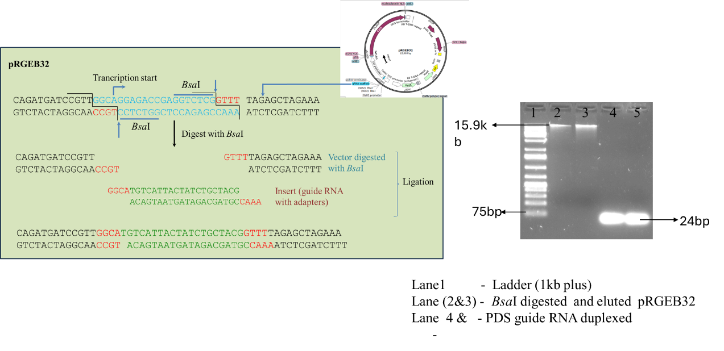

Figure. S1
Schematic diagram of PDS guide RNA cloning strategy in pRGEB32 CRISPR/Cas9 vector

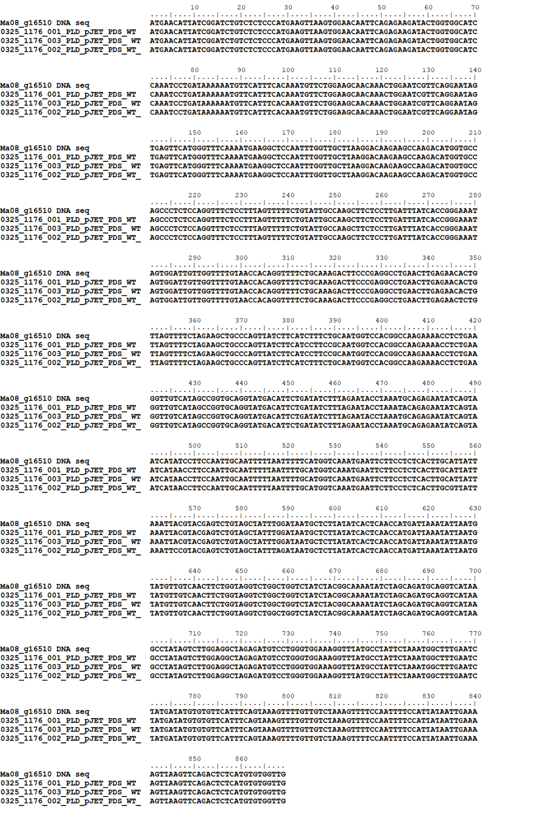

Figure S2. Multiple sequence alignment of cloned PDS gene fragments (869 bp) from banana cv. Grand Naine with the reference sequence (Ma08_g16510). Three single nucleotide polymorphisms (SNPs) are highlighted in red boxes, indicating the presence of two distinct alleles. The CRISPR target region in the PDS gene is indicated by the blue box.

Author’s Name | Guide RNA sequence | Location | Vector used in the present study | Guide RNA Promoter | Cas9  Promoter | GC % | Secondary structure | Total Editing Efficiency  % | Albino  %
Present study cv. Grand Naine | GAGGCTAGAGATGTCCTGGGTGG | Exon 3 | pRGEB32 | Rice SnoRNA U3 Promoter | Rice ubiquitin Promoter | 60% | 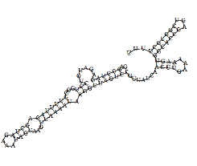 | 100% | 91.1%
Kaur et al. (2017) in cv. Rasthali | AATGATCGCTTGCAATGGAAGG | Exon5 | pRGEB31 | Rice SnoRNA U3 Promoter | Dual CaMV 35 promoter | 40% | 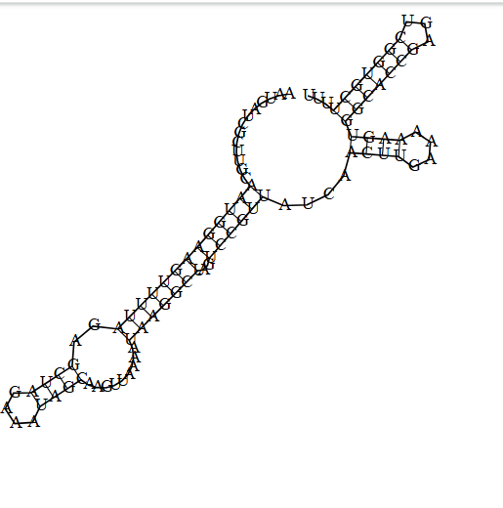 | 59% | -
Naim et al. (2018) in cv. cavendish ‘Williams’  (Double gRNA) | gRNA 1  GTCTCTCCCATGAAGTTAAGTGG  gRNA 2  AAGGACAAGAAGCCAAGACATGG | Exon1  Exon1 | pCAMBIA 1300  (pCas9-PDS) | Rice SnoRNA U3 Promoter | Dual CaMV 35 promoter  Maize polyubiquitin 1 | 45%  45% | 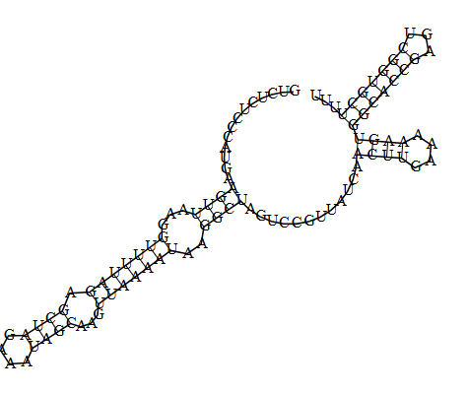  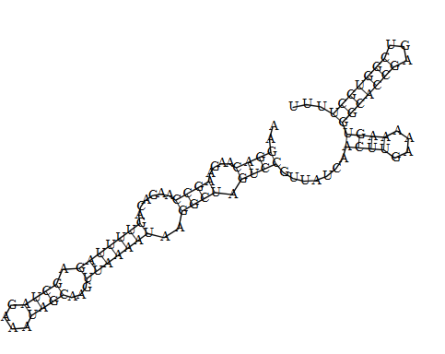 | 100% | 63%
Ntui et al. (2020) in cv.Gonja manjia and sukali ndiizi  (Double gRNA) | gRNA 1 GTATCAATGATCGCTTGCAATGG  gRNA 2  TTTTGCCAGCCATGCTTGGAGGG | Exon5  Exon6 | Gateway binary vector pMDC32 | rice Pol III promoter, OsU6 | double CaMV35S promoter | 40%  50% | 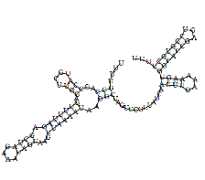  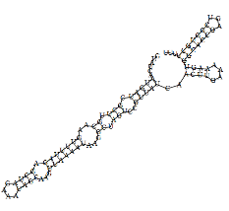 | 100% | 67.5%

Table S1: Comparison of the present study guide RNA with previously reported gRNAs for PDS gene editing in Banana: Sequences, features of Guide RNA, their editing efficiencies and percentage of albino plants

