Supplementary Materials

Integrative Multi-omics Analysis Identifies ATAD1 as a Potential Regulator of Metastasis in Pancreatic Cancer

Yi Zhang^{1,†}, Guangbo Kang^{2,†}, Haibin Yuan², Zelin Feng³, He Huang^{2,}*, Feng Gao^{1,4,}*

¹ Department of Physics, School of Science, Tianjin University, Tianjin 300072, China
² School of Synthetic Biology and Biomanufacturing, State Key Laboratory of Synthetic Biology, Tianjin Key Laboratory of Biological and Pharmaceutical Engineering, Tianjin University, Tianjin, 300350, China
³ Department of Gastroenterology and Hepatology, Tianjin Medical University General Hospital, Tianjin Medical University, Tianjin, 300052, China
⁴ Frontiers Science Center for Synthetic Biology and Key Laboratory of Systems Bioengineering (Ministry of Education), State Key Laboratory of Synthetic Biology, Tianjin University, Tianjin 300072, China
† These authors have contributed equally to this work
* Correspondence: He Huang (huang@tju.edu.cn); Feng Gao (fgao@tju.edu.cn)
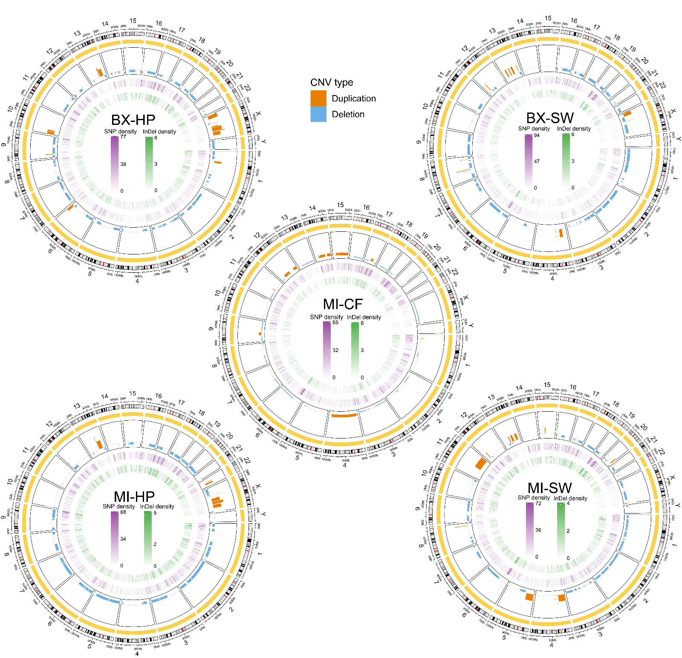

Figure S1. Genome-wide density of SNPs and InDels across primary- and metastasis-derived PDAC cell lines. The plots extend the analysis shown in Fig. 2B to all comparisons.
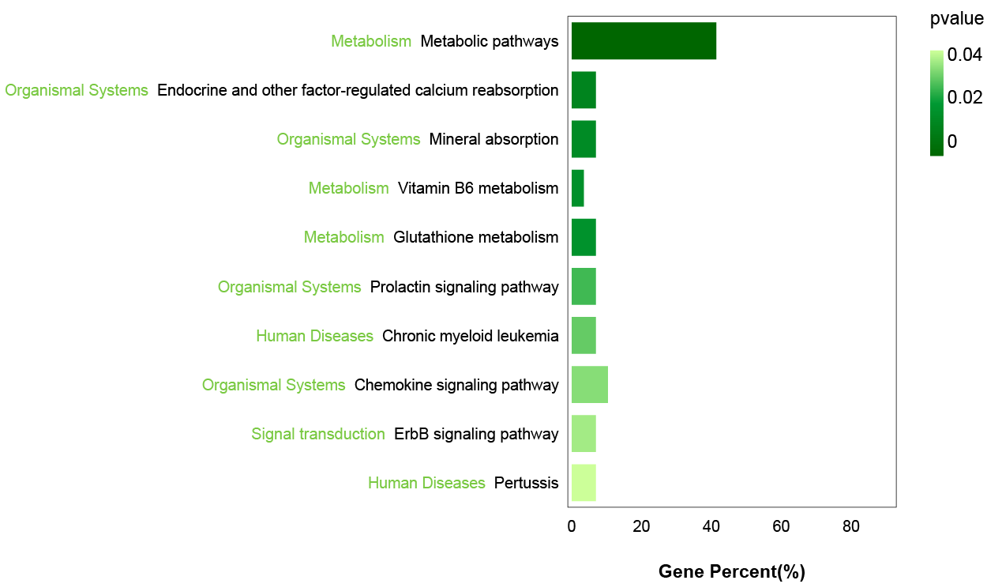

Figure S2. Pathway enrichment analysis of the 48 overlapped genes identified from integrated transcriptomic and proteomic data.
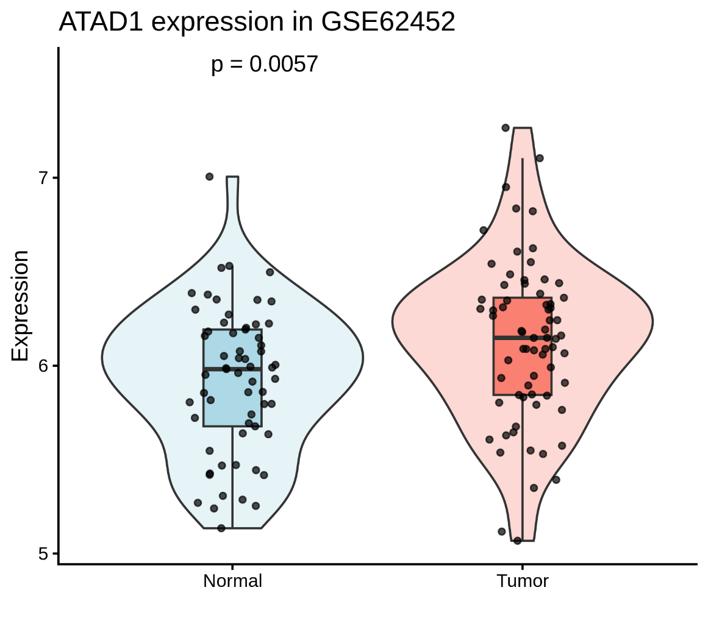
Figure S3. Validation of ATAD1 expression in the GSE62452 cohort. ATAD1 expression levels in tumor and normal pancreatic tissues are shown (Wilcoxon rank-sum test, p = 0.0057).
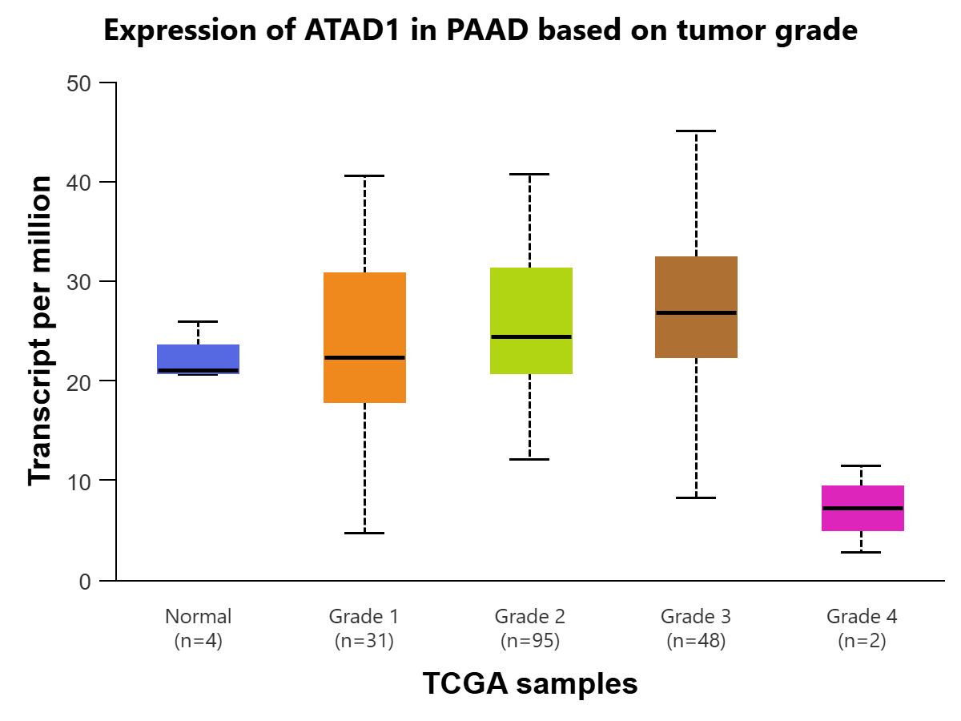
Figure S4. Expression of ATAD1 across tumor differentiation grades in the TCGA-PAAD cohort, showing a progressive increase from well- to poorly differentiated tumors.

ATAD1 BLVRA
CISD2 GLRX
GSTM3 LAP3
PNPO SEPHS2
STAT5B β-actin

Figure S5. The full uncropped Gels and Blots images in Figure 6A.

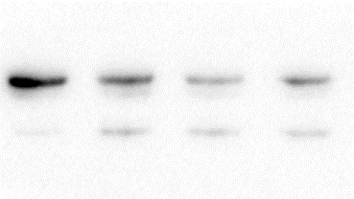
HPAF-II-ATAD1 CFPAC-1-ATAD1
HPAF-II-β-actin CFPAC-1-β-actin
Figure S6. The full uncropped Gels and Blots images in Figure 6C.

Table S1. Primer sequences used in qRT-PCR.

Name | Primer sequences (5'-3') | Name | Primer sequences (5'-3')
ATAD1-F | GCCATAAAGCTACAACCATCCA | RCN2-F | TGGACTCAGATGGCTTTCTCA
ATAD1-R | TCCCAGAGACTCATAAACTGAGC | RCN2-R | GACCTGAATCCTGGTTAGCTTTT
BLVRA-F | CTGATTGGCTTCGTGTCGAGA | RNASET2-F | TGGCCCGATAAAAGTGAAGGA
BLVRA-R | CATGGGGTATTCCACAAGGAC | RNASET2-R | AACGAGTGAATTACGTCAGGC
CISD2-F | GTGGCCCGTATCGTGAAGG | SEPHS2-F | CGGTGGTCAACCCTTGGATTA
CISD2-R | CTAGCGAACCCGGTAATGCTT | SEPHS2-R | GCTGTCCGGCATTATGAACTC
CFL2-F | AGAGGACCCCTACACATCTTTT | SHC1-F | CCCGCTCAGCTCTATCCTG
CFL2-R | CCAAGCCATTTACTTGCCACTC | SHC1-R | GGCAACATAGGCGACATACTC
CRAT-F | GTACCACAGTGACGGGACAC | SNX3-F | CCAAGCCGCAGAACCTGAAT
CRAT-R | CCGGTTCACCTTGTCTTTGAT | SNX3-R | GACCCTGATTTCGTAAGTGGTG
FAH-F | CCTACGGCGTCTTCTCGAC | STAT5B-F | GAGGTGCGGCATTATTTATCCC
FAH-R | CTGCAAGAACACTCTCGCCT | STAT5B-R | GCGGTCATACGTGTTCTGGAG
GLRX-F | CTCAAGAGTTTGTGAACTGCAA | UBE2N-F | CCCCGCAGGATCATCAAGG
GLRX-R | GGCTGTGATATCGACAAATTCC | UBE2N-R | CCCTCCCTCAAAGGGGGAA
GSTM3-F | TACCTCTTATGAGGAGAAACGGT | MTAP-F | CAGGCGAACATCTGGGCTTT
GSTM3-R | AGGAAAGTCCAGGTCTAGCTTG | MTAP-R | GGACTGAGGTCTCATAGTGGT
LAP3-F | CTGGAATCGACGAACAGGAAA | DNAJB6-F | CATGCCTCACCCGAGGATATT
LAP3-R | TCCATAGAGCTTTGCCGACAC | DNAJB6-R | CCTCCGCTACTTGCTTGAATTT
NUDT5-F | CAAGAACCAACGGAATCTTCTCA | CYHR1-F | CAGTGCAAGTACAAACGCATC
NUDT5-R | TGTTTCACCAGAACGATACACTC | CYHR1-R | CTCTGTGTAGCCAATCTTCTCG
PGLS-F | CAGACTGCCGATCCCAGAAAG | PTPA-F | TCTCAGGCATACGCTGACTAC
PGLS-R | CCCTTGGAATGCCTGTCTCA | PTPA-R | GGAGACTCTGTACTCGAAGGT
PNPO-F | AGGCTGTTCAGTGTCCTGAC | SORBS3-F | CCGCAGATGAGATCCCTAAGC
PNPO-R | AACATGCGAGCAGAGGGTTT | SORBS3-R | TGATGCGTCCCTCGTACCA
PRDX3-F | ACTGTGAAGTTGTCGCAGTCT | β-actin-F | TCATCACCATTGGCACTGAG
PRDX3-R | CACACCGTAGTCTCGGGAAA | β-actin-R | CACTGTGTTGGCGTACAGGT

Table S2. Sequences of siRNAs targeting ATAD1.

Name | siRNA sequences (5'-3') Sense | Antisense
ATAD1-714 | GGAGUGAUAUAGCAGGUUUTT | AAACCUGCUAUAUCACUCCTT
ATAD1-1128 | GCUGCCAGGUCAUAGUAAUTT | AUUACUAUGACCUGGCAGCTT
ATAD1-1866 | GGUGCUGGUUCCUAGACAUTT | AUGUCUAGGAACCAGCACCTT
GAPDH | UGACCUCAACUACAUGGUUTT | AACCAUGUAGUUGAGGUCATT
Negative control | UUCUCCGAACGUGUCACGUTT | ACGUGACACGUUCGGAGAATT

Table S3. Common ns-SNPs identified across all PDAC cell lines.

Chr | Start/End | Ref | Alt | Gene.refGene | Chr | Start/End | Ref | Alt | Gene.refGene
chr1 | 12827720 | T | G | PRAMEF11 | chr7 | 100960420 | C | A | MUC3A
chr1 | 13225068 | A | G | PRAMEF18;PRAMEF22 | chr7 | 100960528 | A | G | MUC3A
chr1 | 13225408 | T | A | PRAMEF18;PRAMEF22 | chr7 | 100960546 | C | T | MUC3A
chr1 | 13226028 | C | T | PRAMEF18;PRAMEF22 | chr7 | 100960582 | T | A | MUC3A
chr1 | 16758473 | G | C | MST1L | chr7 | 100960598 | G | C | MUC3A
chr1 | 16759007 | T | C | MST1L | chr7 | 100960609 | C | T | MUC3A
chr1 | 16759069 | A | G | MST1L | chr7 | 100960610 | A | G | MUC3A
chr1 | 16761087 | G | A | MST1L | chr7 | 100965345 | C | A | MUC3A
chr1 | 27382530 | C | T | CD164L2 | chr7 | 100965859 | A | G | MUC3A
chr1 | 27382554 | C | T | CD164L2 | chr7 | 100966916 | T | C | MUC3A
chr1 | 120449388 | G | A | NBPF8 | chr7 | 100969671 | G | A | MUC12
chr1 | 145873487 | G | A | ANKRD35 | chr7 | 100969680 | G | C | MUC12
chr1 | 146069569 | C | T | NBPF10 | chr7 | 100992310 | C | A | MUC12
chr1 | 149075770 | G | C | NBPF9 | chr7 | 102605864 | T | C | RASA4;RASA4B
chr1 | 150308112 | T | C | MRPS21 | chr7 | 102749386 | G | C | FAM185A
chr1 | 152215334 | G | A | HRNR | chr7 | 142865498 | G | T | EPHB6
chr1 | 171208951 | C | T | FMO2 | chr7 | 142912583 | T | C | TRPV5
chr1 | 219609937 | T | A | ZC3H11B | chr7 | 144318627 | C | G | OR2A1;OR2A42
chr1 | 247921162 | T | C | OR2T8 | chr7 | 152273771 | T | A | KMT2C
chr1 | 248441313 | A | T | OR2T7 | chr8 | 7450864 | T | C | SPAG11A;SPAG11B
chr1 | 248650751 | T | A | OR2T27 | chr9 | 39358957 | C | T | SPATA31A1
chr2 | 27101486 | C | T | CGREF1 | chr9 | 39360952 | G | A | SPATA31A1
chr2 | 95855549 | T | C | ANKRD36C | chr9 | 41996327 | A | T | CNTNAP3B
chr2 | 95938843 | A | G | ANKRD36C | chr9 | 65284049 | G | C | FOXD4L5
chr2 | 95938884 | A | T | ANKRD36C | chr10 | 45826456 | C | T | AGAP4
chr2 | 95945173 | T | G | ANKRD36C | chr10 | 46549538 | A | G | GPRIN2
chr2 | 95953986 | C | T | ANKRD36C | chr10 | 46549613 | A | G | GPRIN2
chr2 | 130074719 | T | A | POTEF | chr10 | 46550013 | T | C | GPRIN2
chr2 | 130120179 | T | C | POTEF | chr10 | 46550021 | C | T | GPRIN2
chr2 | 171976274 | T | C | HAT1 | chr10 | 46550040 | C | A | GPRIN2
chr3 | 75665147 | A | G | FRG2C | chr10 | 46550427 | T | C | GPRIN2
chr3 | 75665186 | T | G | FRG2C | chr10 | 46550466 | A | G | GPRIN2
chr3 | 75665637 | A | T | FRG2C | chr10 | 46550598 | C | T | GPRIN2
chr3 | 75665658 | C | T | FRG2C | chr10 | 46550618 | C | T | GPRIN2
chr3 | 75665668 | G | A | FRG2C | chr10 | 46550723 | C | T | GPRIN2
chr3 | 75665680 | G | A | FRG2C | chr10 | 46584599 | G | C | SYT15
chr3 | 75665689 | A | G | FRG2C | chr10 | 49945053 | G | C | TIMM23B
chr3 | 75665948 | T | A | FRG2C | chr10 | 94842866 | A | G | CYP2C19
chr3 | 75741293 | G | A | ZNF717 | chr11 | 1017746 | T | G | MUC6
chr3 | 75741362 | T | C | ZNF717 | chr11 | 1163940 | C | G | MUC5AC
chr3 | 195726080 | G | C | MUC20 | chr11 | 1187284 | T | A | MUC5AC
chr3 | 195726372 | C | T | MUC20 | chr11 | 1187845 | A | G | MUC5AC
chr3 | 195726386 | G | A | MUC20 | chr11 | 1188914 | G | A | MUC5AC
chr4 | 102901247 | G | A | SLC9B1 | chr11 | 1191524 | T | C | MUC5AC
chr5 | 23527130 | C | G | PRDM9 | chr11 | 1191527 | C | T | MUC5AC
chr5 | 132813992 | G | C | SOWAHA | chr11 | 1629890 | G | T | KRTAP5-5
chr5 | 141101254 | C | G | PCDHB3 | chr11 | 10508153 | T | C | MTRNR2L8
chr5 | 149981314 | T | C | SLC26A2 | chr11 | 10508192 | G | A | MTRNR2L8
chr5 | 176106582 | C | T | FAM153B | chr11 | 56700469 | G | T | OR9G1;OR9G9
chr5 | 179853379 | T | C | MRNIP | chr11 | 56700545 | G | A | OR9G1;OR9G9
chr6 | 150022075 | A | G | RAET1L | chr11 | 56700635 | C | T | OR9G1;OR9G9
chr6 | 153002459 | C | T | MTRF1L | chr11 | 56700722 | A | G | OR9G1;OR9G9
chr7 | 72728896 | C | T | TYW1B | chr11 | 56700892 | C | T | OR9G1;OR9G9
chr7 | 72728899 | A | C | TYW1B | chr11 | 56700940 | G | A | OR9G1;OR9G9
chr7 | 74797697 | G | C | GTF2IRD2 | chr11 | 56700973 | A | T | OR9G1;OR9G9
chr7 | 75501512 | G | C | SPDYE5 | chr11 | 56700976 | A | C | OR9G1;OR9G9
chr7 | 100951865 | T | C | MUC3A | chr11 | 56701223 | T | A | OR9G1;OR9G9
chr7 | 100951872 | A | T | MUC3A | chr11 | 56701228 | T | C | OR9G1;OR9G9
chr7 | 100951876 | C | A | MUC3A | chr11 | 56701244 | T | C | OR9G1;OR9G9
chr7 | 100951897 | G | A | MUC3A | chr11 | 99819697 | T | G | CNTN5
chr7 | 100951900 | A | C | MUC3A | chr11 | 124225179 | G | A | OR8G2P
chr7 | 100951907 | T | C | MUC3A | chr11 | 124225570 | C | T | OR8G2P
chr7 | 100951933 | G | T | MUC3A | chr11 | 124225572 | A | G | OR8G2P
chr7 | 100951943 | G | A | MUC3A | chr11 | 130910330 | C | A | SNX19
chr7 | 100951952 | T | A | MUC3A | chr12 | 11031043 | A | G | TAS2R31
chr7 | 100952057 | A | G | MUC3A | chr12 | 11031077 | C | T | TAS2R31
chr7 | 100952063 | C | T | MUC3A | chr12 | 11031098 | C | A | TAS2R31
chr7 | 100952147 | C | T | MUC3A | chr12 | 11031123 | A | C | TAS2R31
chr7 | 100952233 | G | A | MUC3A | chr12 | 11186063 | T | C | TAS2R42
chr7 | 100952254 | T | C | MUC3A | chr12 | 11186144 | C | T | TAS2R42
chr7 | 100952295 | T | G | MUC3A | chr13 | 24321421 | A | G | C1QTNF9
chr7 | 100952302 | T | C | MUC3A | chr13 | 110457271 | G | C | COL4A2-AS2
chr7 | 100952339 | C | T | MUC3A | chr14 | 18601712 | G | T | OR11H12
chr7 | 100952498 | C | T | MUC3A | chr14 | 19434064 | T | C | POTEG
chr7 | 100952788 | A | C | MUC3A | chr14 | 19827675 | T | C | OR4N2
chr7 | 100952930 | T | C | MUC3A | chr14 | 21523492 | G | C | SALL2
chr7 | 100952931 | G | C | MUC3A | chr14 | 21634161 | T | G | OR10G2
chr7 | 100953001 | T | C | MUC3A | chr14 | 21634283 | G | C | OR10G2
chr7 | 100955225 | T | A | MUC3A | chr14 | 21634589 | A | C | OR10G2
chr7 | 100957691 | A | G | MUC3A | chr14 | 31483548 | G | A | GPR33
chr7 | 100957702 | C | T | MUC3A | chr14 | 70457784 | C | G | ADAM21
chr7 | 100957726 | A | G | MUC3A | chr15 | 23440436 | T | C | GOLGA6L2
chr7 | 100957778 | C | A | MUC3A | chr15 | 23440500 | C | T | GOLGA6L2
chr7 | 100957844 | A | G | MUC3A | chr15 | 23440581 | C | G | GOLGA6L2
chr7 | 100957857 | G | C | MUC3A | chr15 | 23440748 | C | T | GOLGA6L2
chr7 | 100957964 | T | C | MUC3A | chr15 | 23440872 | G | C | GOLGA6L2
chr7 | 100957982 | T | C | MUC3A | chr15 | 23440884 | T | C | GOLGA6L2
chr7 | 100958000 | T | C | MUC3A | chr15 | 30407956 | A | G | GOLGA8R
chr7 | 100958035 | C | A | MUC3A | chr16 | 28606164 | C | T | SULT1A1
chr7 | 100958051 | T | C | MUC3A | chr17 | 21298879 | C | A | MAP2K3
chr7 | 100958128 | T | A | MUC3A | chr17 | 21298925 | G | C | MAP2K3
chr7 | 100958135 | T | C | MUC3A | chr17 | 21415470 | G | A | KCNJ12
chr7 | 100958136 | G | C | MUC3A | chr17 | 21415555 | G | A | KCNJ12
chr7 | 100958186 | A | C | MUC3A | chr17 | 21416474 | G | A | KCNJ12
chr7 | 100958188 | G | C | MUC3A | chr17 | 21703362 | G | C | KCNJ18
chr7 | 100958191 | A | T | MUC3A | chr17 | 21703417 | C | T | KCNJ18
chr7 | 100958207 | A | G | MUC3A | chr17 | 41226760 | C | T | KRTAP9-2
chr7 | 100958354 | A | T | MUC3A | chr19 | 501719 | T | C | MADCAM1
chr7 | 100958371 | A | C | MUC3A | chr19 | 501738 | C | A | MADCAM1
chr7 | 100958393 | A | T | MUC3A | chr19 | 501786 | C | A | MADCAM1
chr7 | 100958396 | T | C | MUC3A | chr19 | 8888842 | A | G | MUC16
chr7 | 100958398 | A | T | MUC3A | chr19 | 39886243 | C | G | FCGBP
chr7 | 100958447 | G | C | MUC3A | chr19 | 39886257 | C | T | FCGBP
chr7 | 100958491 | G | A | MUC3A | chr19 | 39886279 | T | G | FCGBP
chr7 | 100958510 | C | G | MUC3A | chr19 | 39886282 | G | T | FCGBP
chr7 | 100958584 | G | A | MUC3A | chr19 | 39886422 | A | T | FCGBP
chr7 | 100958585 | A | G | MUC3A | chr19 | 39906242 | T | C | FCGBP
chr7 | 100958618 | G | C | MUC3A | chr19 | 54074853 | T | C | TARM1
chr7 | 100958626 | C | A | MUC3A | chr19 | 54158305 | T | C | LENG1
chr7 | 100958648 | C | T | MUC3A | chr19 | 54219161 | A | C | LILRB3
chr7 | 100958657 | T | C | MUC3A | chr19 | 54252055 | G | C | LILRB5
chr7 | 100958671 | A | G | MUC3A | chr19 | 54360987 | A | G | LAIR1
chr7 | 100958708 | C | T | MUC3A | chr19 | 54361004 | T | A | LAIR1
chr7 | 100958740 | G | A | MUC3A | chr19 | 54361091 | G | C | LAIR1
chr7 | 100958744 | A | C | MUC3A | chr19 | 54574782 | C | T | LILRA2
chr7 | 100958759 | C | T | MUC3A | chr19 | 54667913 | G | A | LILRB4
chr7 | 100958789 | A | G | MUC3A | chr19 | 54735264 | A | C | KIR3DL3
chr7 | 100958831 | A | C | MUC3A | chr19 | 54906696 | C | A | NCR1
chr7 | 100958845 | A | C | MUC3A | chr21 | 10602146 | A | C | TPTE
chr7 | 100958906 | G | C | MUC3A | chr21 | 44574611 | T | G | KRTAP10-4
chr7 | 100959436 | A | G | MUC3A | chr21 | 44579776 | G | C | KRTAP10-5
chr7 | 100959437 | T | C | MUC3A | chr21 | 44579876 | G | C | KRTAP10-5
chr7 | 100959449 | T | G | MUC3A | chr21 | 44580031 | C | A | KRTAP10-5
chr7 | 100959517 | A | G | MUC3A | chrX | 8170130 | T | C | VCX2
chr7 | 100959533 | C | T | MUC3A | chrX | 8170141 | A | G | VCX2
chr7 | 100959563 | C | T | MUC3A | chrX | 48991032 | A | G | GRIPAP1
chr7 | 100959590 | C | T | MUC3A | chrX | 49304890 | C | T | GAGE10
chr7 | 100959644 | C | A | MUC3A | chrX | 49304903 | G | T | GAGE10
chr7 | 100959649 | G | A | MUC3A | chrX | 55146104 | G | A | FAM104B
chr7 | 100959664 | G | T | MUC3A | chrX | 55146212 | C | T | FAM104B
chr7 | 100959713 | C | T | MUC3A | chrX | 55146254 | T | C | FAM104B
chr7 | 100959889 | T | G | MUC3A | chrX | 55146275 | T | G | FAM104B
chr7 | 100959965 | G | C | MUC3A | chrX | 141003560 | C | G | SPANXB1
chr7 | 100959988 | G | T | MUC3A | chrX | 141698335 | A | G | SPANXD
chr7 | 100960006 | T | C | MUC3A | chrX | 141698344 | G | A | SPANXD
chr7 | 100960229 | C | G | MUC3A | chrX | 141698355 | A | T | SPANXD
chr7 | 100960242 | C | G | MUC3A | chrX | 141906066 | C | G | MAGEC1
chr7 | 100960255 | A | G | MUC3A | chrX | 141906078 | T | C | MAGEC1
chr7 | 100960261 | T | C | MUC3A | chrX | 154465991 | G | C | PLXNA3
chr7 | 100960283 | T | C | MUC3A | chrX | 154653251 | C | G | CTAG2
chr7 | 100960306 | T | A | MUC3A
chr7 | 100960307 | C | T | MUC3A
chr7 | 100960406 | G | A | MUC3A

Table S4. Common frameshift insertions/deletions (fs-InDels) identified across all PDAC cell lines.

Chr | Start/End | Ref | Alt | Gene.refGene | ExonicFunc.refGene
chr1 | 156384556 | - | C | RHBG | frameshift insertion
chr4 | 154323250 | TTTG | - | DCHS2 | frameshift deletion
chr14 | 20198016 | - | A | OR11G2 | frameshift insertion

Table S5. CNV similarity between primary- and metastasis-derived PDAC cell lines.

Chromosome | BX-CF vs MI-CF | BX-HP vs MI-HP | BX-SW vs MI-SW
1 | 0.1500 | 0.5700 | -0.0820
2 | 0.9758* | 0.2600 | 0.5379
3 | 0.4795 | -0.0964 | 0.0566
4 | 0.1895 | 0.9686* | 0.7469*
5 | -0.1382 | 0.2352 | 0.6482
6 | 0.9956* | 0.2948 | 0.1738
7 | 0.2769 | -0.1407 | 0.6682
8 | -0.2254 | 0.0458 | 0.3801
9 | 0.0906 | 0.0063 | -0.1418
10 | 0.0819 | 0.0141 | 0.7623*
11 | 0.3682 | 0.0245 | 0.6578
12 | 0.9060* | 0.1400 | 0.7113*
13 | 0.9792* | 0.9303* | 0.1162
14 | 0.2663 | 0.2339 | -0.3072
15 | 0.1175 | 0.7680* | 0.6152
16 | 0.8217* | 0.5883 | 0.4510
17 | 0.8026* | 0.9495* | 0.7819*
18 | 0.3646 | 0.5754 | 0.9798*
19 | -0.3828 | 0.0032 | -0.8727
20 | 0.0995 | 0.5711 | 0.4391
21 | 0.0911 | 0.0173 | 0.5140
22 | 0.2642 | 0.4722 | 0.2929
X | 0.0447 | 0.1871 | 0.4283
'*' represents r > 0.70 and p < 0.001.
Table S6. Mutant genes identified in this study and their reported association with cancer.

Mutant Gene | Full Name | Chromosome | Relationship with cancer | Ref.
TMEM236 | Transmembrane Protein 236 | 10p12.33 | The expression level of TMEM236 in colorectal cancer is significantly down-regulated, and it has the opportunity to be used as a new biomarker for the diagnosis of colorectal cancer. | [1]
OR10G2 | Olfactory Receptor Family 10 Subfamily G Member 2 | 14q11.2 | - | -
CD177 | CD177 Molecule | 19q13.31 | CD177 is a representative of neutrophils. Sachs et al. demonstrated that CD177 is involved in the adhesion of neutrophils to endothelial cells and their transendothelial migration by cationic-dependent interaction with the heterophilic domains of PECAM-1 (CD31). Dalerba et al. used CD177 to predict the clinical prognosis of colorectal cancer. Kaplan-Meier survival curve analysis showed that CD177-positive patients had a better prognosis. | [2, 3]
NPY4R | Neuropeptide Y Receptor Y4 | 10q11.22 | The NPY4R-specific agonist BA-129 is able to inhibit the proliferation of pancreatic cancer cells in vitro. Abnormal methylation of the NPY4R promoter is also positively correlated with recurrence of patients with head and neck squamous cell carcinoma. | [4]
PRAMEF10 | PRAME Family Member 10 | 1p36.21 | - | -
TP53 | Tumor Protein P53 | 17p13.1 | TP53 is a tumor suppressor gene and one of the most common mutant genes in pancreatic cancer. | [5]
RGPD3 | RANBP2 Like And GRIP Domain Containing 3 | 2q12.2 | - | -
TTN | Titin | 2q31.2 | KRAS, TP53, CDKN2A, SMAD4 and TTN remained the most commonly mutant genes in pancreatic cancer. | [6]
ZNF717 | Zinc Finger Protein 717 | 3p12.3 | - | -
DST | Dystonin | 6p12.1 | DST is a cytoplasmic protein that promotes cell spreading and cell-substratum adhesion, and is abnormally expressed in a variety of cancers. Jain et al. demonstrated that DST is a candidate tumor suppressor in breast cancer. | [7]
PLEC | Plectin | 8q24.3 | PLEC1 is the first biomarker to differentiate primary and metastatic PDAC through imaging. | [8]
PTCHD3 | Patched Domain Containing 3 | 10p12.1 | PTCHD3 is a part of Hedgehog signaling pathway and a tumor suppressor of colorectal cancer. | [9]

References

- Maurya NS, Kushwaha S, Chawade A, et al. Transcriptome profiling by combined machine learning and statistical R analysis identifies TMEM236 as a potential novel diagnostic biomarker for colorectal cancer. Sci Rep, 2021, 11(1): 14304. doi: 10.1038/s41598-021-92692-0.
- Moritz E, Norcia AM, Cardone JD, et al. Human neutrophil alloantigens systems. An Acad Bras Cienc, 2009, 81(3): 559-569. doi: 10.1590/s0001-37652009000300019.
- Dalerba P, Kalisky T, Sahoo D, et al. Single-cell dissection of transcriptional heterogeneity in human colon tumors. Nat Biotechnol, 2011, 29(12): 1120-1127. doi: 10.1038/nbt.2038.
- Misawa K, Imai A, Mochizuki D, et al. Genes encoding neuropeptide receptors are epigenetic markers in patients with head and neck cancer: a site-specific analysis. Oncotarget, 2017, 8(44): 76318-76328. doi: 10.18632/oncotarget.19356.
- Wild CP, Weiderpass E, Stewart BW, editors (2020). World Cancer Report: Cancer Research for Cancer Prevention. Lyon, France: International Agency for Research on Cancer. Available from: http://publications.iarc.fr/586. Licence: CC BY-NC-ND 3.0 IGO.
- Wang ZZ, Zou WB, Wang F, et al. Identification of the immune cell infiltration landscape in pancreatic cancer to assist immunotherapy. Future Oncol, 2021. doi: 10.2217/fon-2021-0495.
- Jain PB, Guerreiro PS, Canato S, et al. The spectraplakin Dystonin antagonizes YAP activity and suppresses tumourigenesis. Sci Rep, 2019, 9: 19843. doi: 10.1038/s41598-019-56296-z.
- Bausch D, Thomas S, Mino-Kenudson M, et al. Plectin-1 as a novel biomarker for pancreatic cancer. Clin Cancer Res, 2011, 17(2): 302-309. doi: 10.1158/1078-0432.CCR-10-0999.
- Smith CG, Naven M, Harris R, et al. Exome resequencing identifies potential tumor-suppressor genes that predispose to colorectal cancer. Hum Mutat, 2013, 34(7):1026-1034. doi: 10.1002/humu.22333.

Supplementary Methods

1. Protein Extraction and Digestion
Samples were lysed in buffer (1% sodium deoxycholate, 8 M urea, 1x Protease Inhibitor Cocktail (Roche Ltd. Basel, Switzerland)), mixed by vortexing, sonicated for 2 min, and kept at 4 °C for 30 min with vortexing every 10 min. The mixture was then centrifuged at 12,000 g and 4 °C for 20 min, and the supernatant protein concentration was determined using the Bicinchoninic acid (BCA) Protein Assay Kit. BCA standard concentrations were 0, 0.2, 0.4, 0.8, 1.2, 1.6 and 2 mg/mL; 150 µL BCA working reagent was added to each. After SDS-PAGE glue configured, electrophoresis and Coomassie brilliant blue staining were performed. 100 μg protein was taken from each sample and adjusted to 100 μL constant volume with 8 M urea. Then, 2 μL 0.5 M Tris (2-carboxyethyl) phosphine (TCEP) was added and reacted at 37 ℃ for 1 h and alkylated with 4 μL 1 M iodoacetamide (IAM) at room temperature in the dark. According to the ratio of 1:5, cold acetone was added to precipitate overnight at -20 ℃. The settings of high-speed centrifugation: 12000 g, 20 min, 4 ℃. Samples were then resolubilized in 100 μL 100 mM TEAB and trypsin (Promega, Madison, WI) was added, followed by overnight digestion. Peptides were desalted with C18 Zip Tip, and quantified by Pierce TM Quantitative Colorimetric Peptide Assay (23275) and lyophilized by SpeedVac.

2. High PH Reverse Phase Separation
The peptide mixture was redissolved in buffer A (20 mM ammonium formate, pH 10.0, adjusted with ammonium hydroxide) and fractionated on Ultimate 3000 system (ThermoFisher Scientific, MA, USA) connected to a reverse-phase column (XBridge C18 column, 4.6mm x 250 mm, 5μm, (Waters Corporation, MA, USA)). High-pH separation was performed with a linear gradient of 5% - 45% B (80% ACN with 20 mM ammonium formate, pH 10.0, adjusted with ammonium hydroxide) in 40 min. The column was equilibrated for 15 min. The flow rate was maintained at 1 mL/min and the column temperature was maintained at 30 ℃. Ten fractions were collected. The fractions were dried in a vacuum concentrator.

3. Data-dependent Acquisition (DDA): nano-HPLC-MS/MS Analysis
The desalted lyophilized peptides were redissolved in solvent A (0.1% formic acid in water) and analyzed by LC-MS/MS with an online nanojet ion source. The complete system is an Orbitrap Fusion Lumos mass spectrometer (Thermo Fisher Scientific, MA, USA) in tandem with an EASY-nLC 1200 system. The mass spectrometer was operated under data-dependent acquisition mode, automatically switching between MS and MS/MS mode. MS parameters: (1) MS: Scan range (m/z) 350–1500; Resolution 120,000; AGC target 400,000; Maximum injection time 50 ms; Dynamic exclusion duration 30 s; (2) HCD-MS/MS: Resolution 15,000; AGC target 50,000; Maximum injection time 35 ms; Collision energy 32.

4. Data-independent Acquisition (DIA): nano-HPLC-MS/MS Analysis
Each sample was suspended by adding 30 μL solvent A (0.1% formic acid in water) and 10 x iRT peptide, then separated by nano-LC and analyzed by online nanospray LC-MS/MS on an Orbitrap Fusion Lumos coupled to EASY-nLC 1200 system. 3 μL peptide sample was loaded onto the analytical column (Acclaim PepMap C18, 75 μm x 25 cm) and separated in a 120 min gradient: 5%- 35% B (0.1% formic acid in ACN). The column flow rate was controlled at 200 nL/min, 40 °C and the electrospray voltage was 2 kV. MS spectrometry: (1) MS: Scan range (m/z) 350–1500; Resolution 120,000; AGC target 4,000,000; Maximum injection time 50 ms; (2) HCD-MS/MS: Resolution 30,000; AGC target 1,000,000; Collision energy 32; Energy increase 5%. (3) 60 variable windows overlapping by 1 m/z.

5. Data Analysis
Both DDA and DIA data were processed by Spectronaut X (Biognosys AG, Switzerland). The false positive rate (FDR) was set to 1%. The database was built for trypsin digestion using Uniprot, and decoy database was generated using a mutated strategy. The automatic calibration was performed by Spectronaut, and all selected precursors passing the filters were used to calculate the expression level. Fixed modification: Carbamidomethyl (C), variable modification: methionine oxidation (M).

