Supplementary File
Microbial Zonation and Functional Specialization Across the Gut Compartments of White grub (Maladera insanabilis) Larvae
Anil^{1,2}, Kurubarahalli Bhoothanna Ramesh^{1,3}, M. N. Rudra Gouda¹, Sabtharishi Subramanian ^{#1}
# Corresponding author: entosubra@yahoo.co.in
Anil ^{1,2}
¹Division of Entomology, ICAR-Indian Agricultural Research Institute, New Delhi, 110 012
India
²Central Horticultural Experiment Station, ICAR-CIAH, Godhra-Vadodara Highway, Vejalpur, Panchmahals, Gujarat, 389 340, India
Email: anildp444@gmail.com
Orcid Id: 0009-0009-2296-1711

Kurubarahalli Bhoothanna Ramesh ^{1,3}
¹Division of Entomology, ICAR-Indian Agricultural Research Institute, New Delhi, 110 012
India
²Department of Entomology, ICAR-Indian Institute of Vegetable Research, Regional Research Station, Sargatia, Uttar Pradesh, 274 406 India
Email: rameshjayaveera29@gmail.com
Orcid Id: 0009-0002-2761-8639

M. N. Rudra Gouda^{1,4}
¹Division of Entomology, Indian Agricultural Research Institute, New Delhi-110012, India
⁴Central Silk Board, Bangalore, Karnataka, 560068, India
e-mail: rudragoudamn@gmail.com
Orcid Id: 0000-0002-1644-4226

Sabtharishi Subramanian ^{#1}
¹Division of Entomology, Indian Agricultural Research Institute, New Delhi- 110012, India
e-mail: entosubra@yahoo.co.in
Phone: 8076595366
Orcid Id: 0000-0001-8337-9666

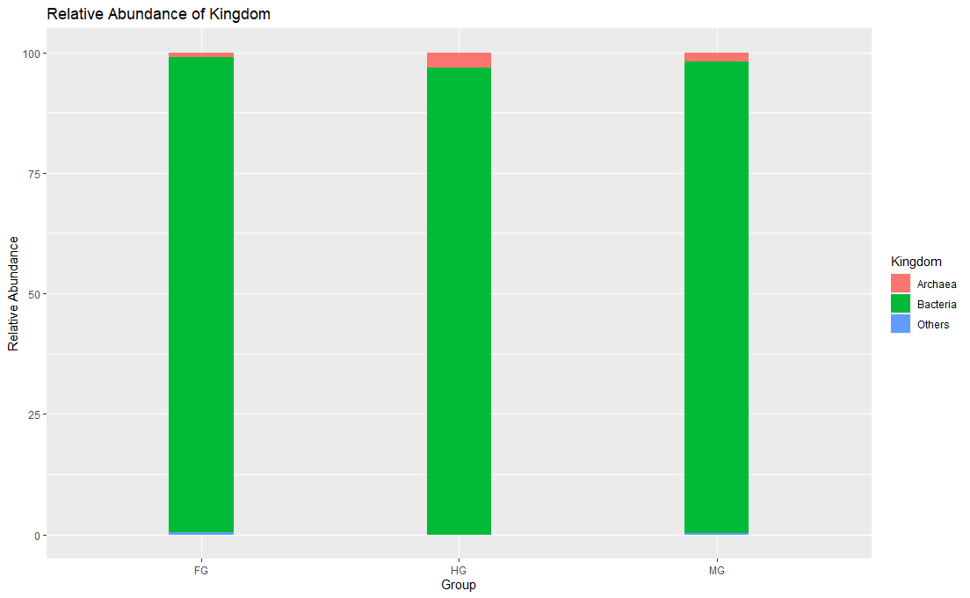

Fig. S1. Histogram of relative abundance of the kingdom in the gut compartments of M. insanabilis at kingdom level. Letters FG; Foregut MG; Midgut and HG; Hindgut.

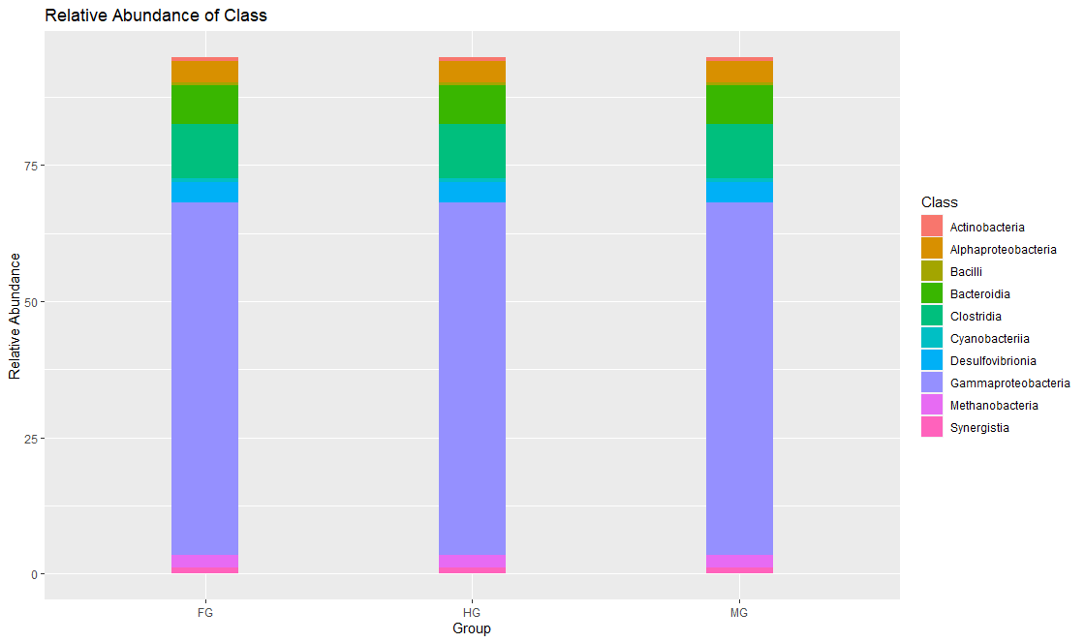

Fig. S2. Histogram of relative abundance of 10 major bacterial groups in the gut compartments of M. insanabilis at the class level. Letters FG; Foregut MG; Midgut and HG; Hindgut.

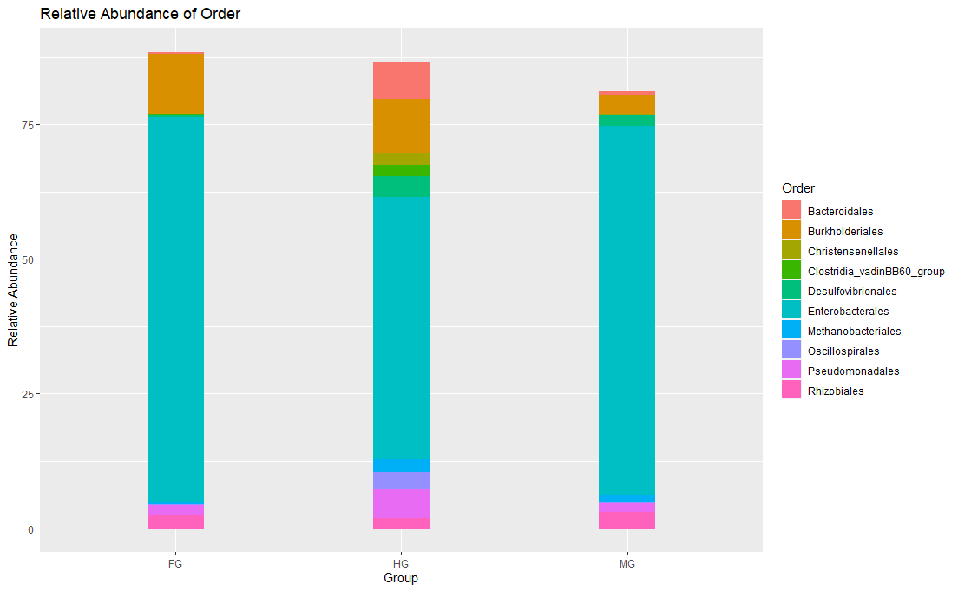

Fig. S3. Histogram of relative abundance of 10 major bacterial groups in the gut compartments of M. insanabilis at the order level. Letters FG; Foregut MG; Midgut and HG; Hindgut.

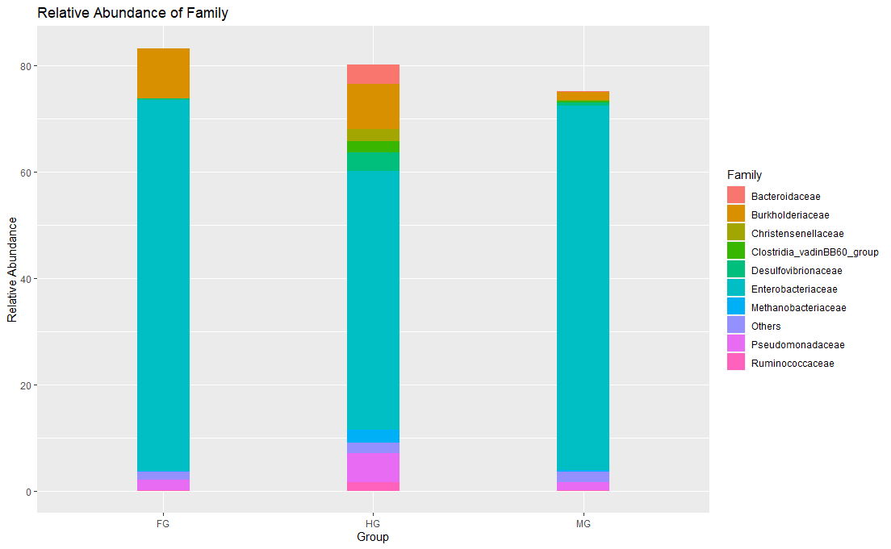

Fig. S4. Histogram of relative abundance of 10 major bacterial groups in the gut compartments of M. insanabilis at family level. Letters FG; Foregut MG; Midgut and HG; Hindgut.

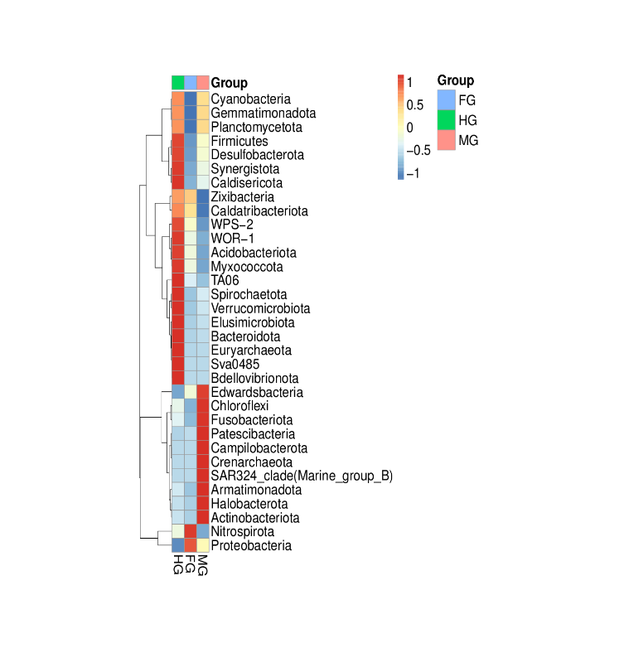
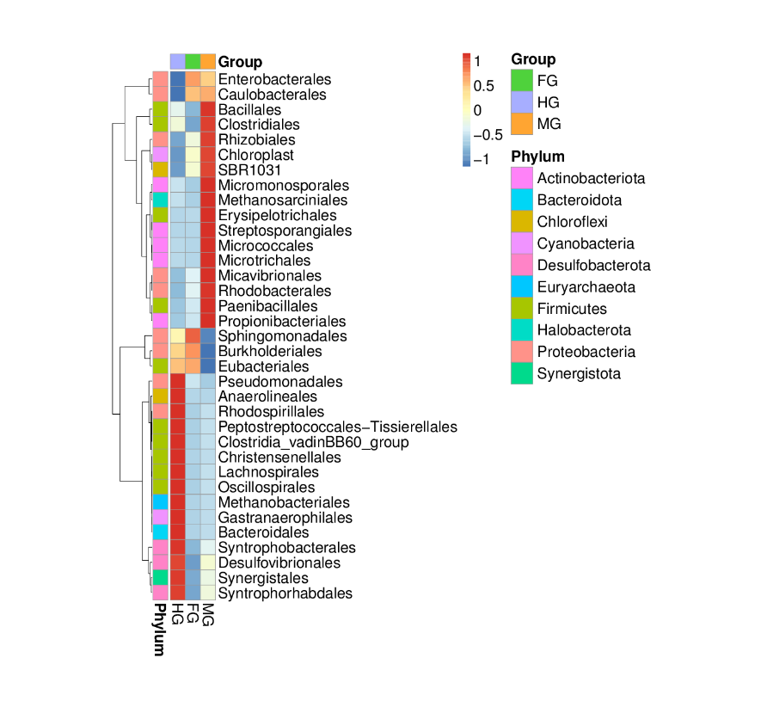
Fig. S5 & S6. Heat map of the top 35 most abundant bacterial phylum and order in the gut of M. insanabilis. Rows are bacterial (S5) phylum and (S6) order. Columns are the average abundance of phylum and order of the gut in the gut compartments within each group. Colors indicate a higher (red) and lower (blue) abundance of bacterial phylum and order in each gut compartment, identified by the Z-score. M. insanabilis gut includes Foregut (FG), Midgut (MG) and Hindgut (HG).

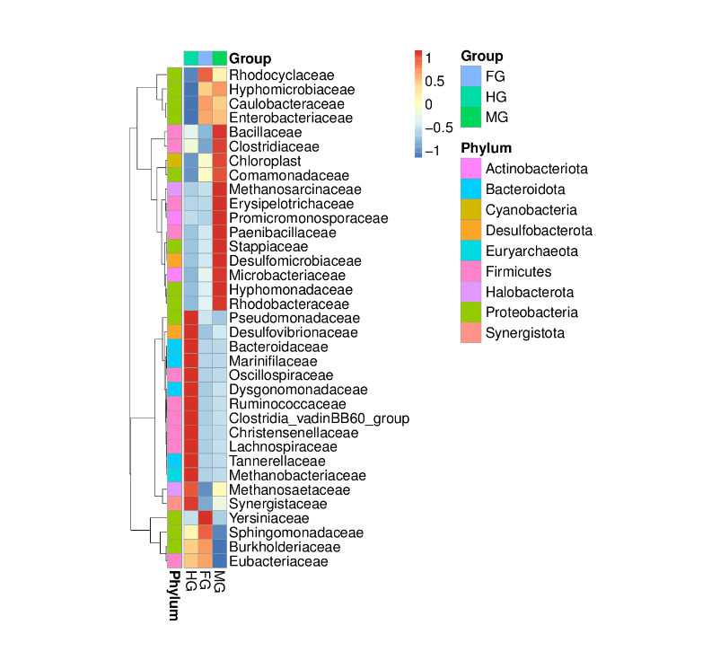
Fig. S7. Heat map of the top 35 most abundant bacterial family in the gut of M. insanabilis. Rows are bacterial family. Columns are the average abundance of gut bacterial family in the gut compartments within each group. Colors indicate a higher (red) and lower (blue) abundance of bacterial family in each gut compartment, identified by the Z-score. M. insanabilis gut includes Foregut (FG), Midgut (MG) and Hindgut (HG).

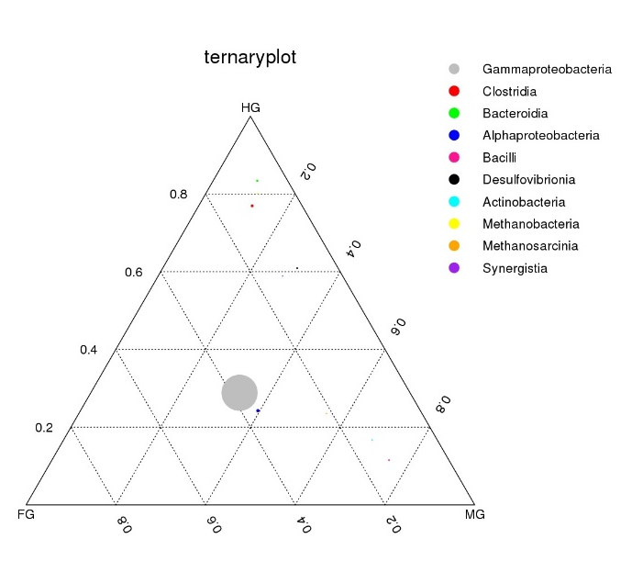
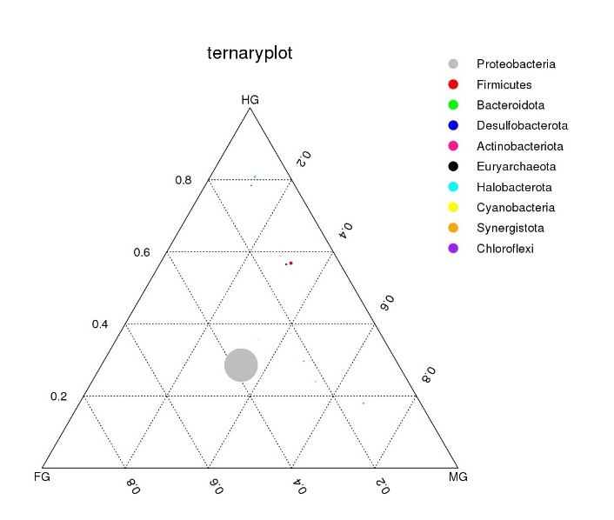

Fig. S8 & S9. Ternary plot representing the relative abundance of the gut bacterial phylum and class of all ASVs (> 5%) in the foregut, midgut and hindgut respectively. ASVs are represented by circles. Each circle's size corresponds to its proportional abundance. Its position with each compartment denotes its relative abundance. Grey in the foregut, red in the hindgut and green in the midgut are three examples of ASVs that are much more abundant in the foregut, midgut and hindgut respectively.

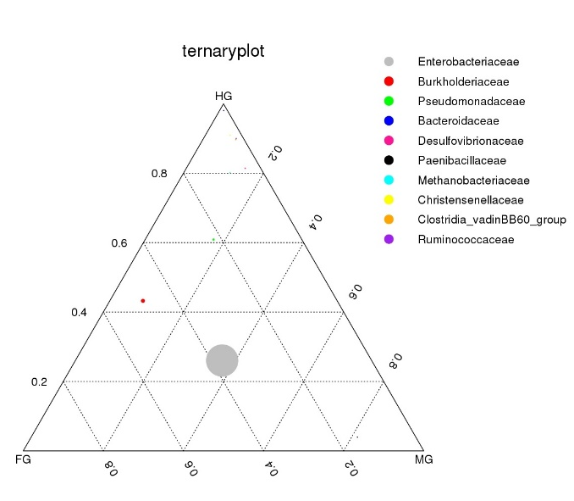
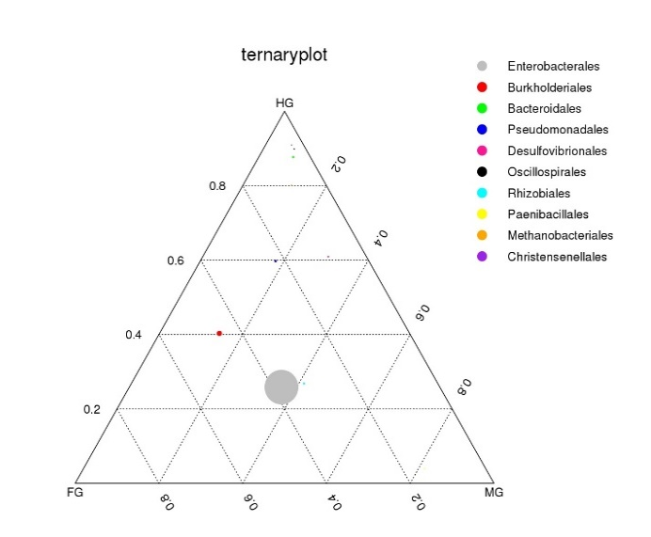

Fig. S10 & S11. Ternary plot representing the relative abundance of the gut bacterial family and order of all ASVs (> 5%) in the foregut, midgut and hindgut respectively. ASVs are represented by circles. Each circle's size corresponds to its proportional abundance. Its position with each compartment denotes its relative abundance. Grey in the foregut, red in the hindgut and green in the midgut are three examples of ASVs that are much more abundant in the foregut, midgut and hindgut respectively.

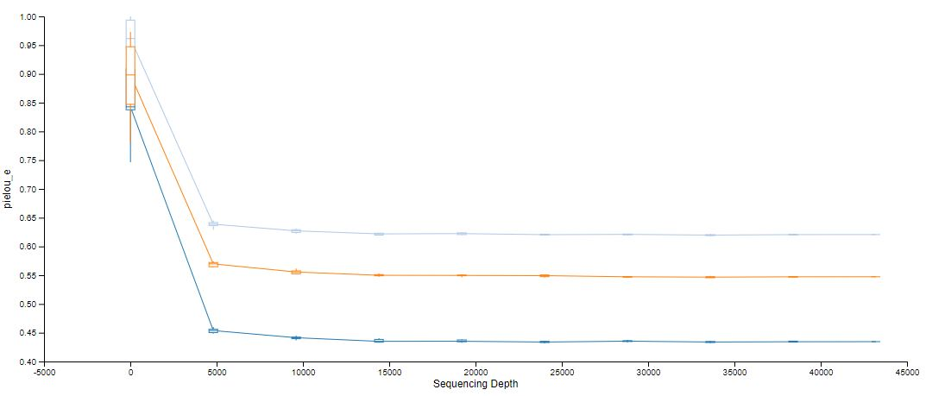
Fig. S12. Pielou_e index, representing bacterial communities in the different gut compartments of M. insanabilis. Dark Blue = FG; Orange = Midgut; Light Blue = Hindgut.

Table S1. List of selected nitrogen cycling primers and reference genes designed for expression analysis
Gene | Forward primer | Reverse primer | Annealing Tm ˚C
AMX | CCGGATGGAAATATCCTCTTCTC | ATATGCACCATCCCAGTTATCC | 54.5
NifH | TCACCCGGATGATGAAGAAATC | TAATAACACCACGACCAGCAC | 54.7
nirS | CGGTCAAGCACAAGGATCA | GACTTCGGATGGGTCTTGATG | 55.2
nirK | TCGCAAGCCAACAGAGATAC | ACCATGTTTCCTGATCGAGTTC | 54.9
HZO | TAAAGACCTTGCACCTGACC | CTCACCCTTCTTACCACCATAC | 54.7
Reference/Housekeeping gene
RPL13a | GAAAGAGGCAAGCAAGCATT | CCAACCGACTTCGTGAGACA | 52-62
TUBb | TATGGGCACATTACTCATCTCAA | AGGGTGGCGTTGTATGGTTC | 52-62

Table S2. Colonization of aerobic and anaerobic gut bacteria in different gut compartments of M. insanabilis larvae collected from Ghaziabad, Uttar Pradesh, India
Gut compartments | Culture condition: Aerobic |  |  |  |  | Culture condition: Anaerobic
Gut compartments | Nutrient  agar | Bacillus cereus agar | Pseudomonas Isolation agar | Tryptone soya agar | Nitrate  agar | Thioglycolate medium
Gut compartments | Colony Forming Unit CFU ml⁻¹ (×10⁶) (Mean ± Std. Error)
Foregut | 1.080± 0.025^{c} | 1.240±  0.105^{c} | 1.247±  0.038^{c} | 1.303± 0.171^{b} | 3.070± 0.116ª | 2.493±  0.191^{b}
Midgut | 2.333± 0.140^{c} | 1.897±  0.044^{b} | 1.227±  0.058^{c} | 2.520±  0.231^{b} | 4.143± 0.367ª | 3.427±  0.236ª
Hindgut | 1.603± 0.087^{b} | 1.410±  0.142^{b} | 3.467±  0.173ª | 1.733± 0.127^{b} | 3.257± 0.039ª | 3.500±  0.031ª
P value | 0.0059 | 0.0008 | 0.0074 | 0.0010 | 0.0060 | 0.310
C.D. | 0.386 | 0.659 | 0.518 | 0.548 | 0.784 | 0.353
SE(m) | 0.124 | 0.211 | 0.166 | 0.179 | 0.258 | 0.120
SE(d) | 0.175 | 0.299 | 0.235 | 0.241 | 0.213 | 0.180
C.V. | 12.345 | 13.958 | 11.701 | 14.460 | 12.257 | 11.176
C.D: Critical Difference, SE(m): Standard error of the mean, SE(d): Standard error of difference (with three replicates) CV: Coefficient of variation. Means followed by the same letter in each column were not significantly different (P <0.05) by post hoc Duncan’s test for individual group comparisons after One-way analysis of variance (ANOVA).

Table S3. Culturable aerobic gut bacteria isolated from the gut of Maladera insanabilis
Strain ID | The closest relative from the gene bank | Gene Bank Accession NO | Percent similarity (%) | Phylum | Family
WGM-1 | Bacillus pumilus | OP107274 | 99.93 | Firmicutes | Bacillaceae
WGNM-2 | Bacillus paramycoides | OM346735 | 100 | Firmicutes | Bacillaceae
WGNM-3 | Brucella cicero | OM346736 | 100 | Pseudomonadota | Brucellacece
WGNM-6 | Brucella sp. | OM346737 | 100 | Pseudomonadota | Brucellacece
WGM-8 | Brevibacillus laterosporus | OM346727 | 100 | Bacillota | Paenobacillaceae
WGM-9 | Bacillus licheniformis | OM346728 | 100 | Firmicutes | Bacillaceae
WGM-11 | Bacillus aerophilus | OM346729 | 100 | Firmicutes | Bacillaceae
WGNM-11 | Priestia megaterium | OM346738 | 100 | Firmicutes | Bacillaceae
WGM-12 | Brucella intermedia | OM346730 | 100 | Pseudomonadota | Brucellacece
WGNM-12 | Bacillus cereus | OM346739 | 100 | Bacillota | Bacillaceae
WGM-13 | Brucella anthropi | OP107275 | 94 | Pseudomonadota | Brucellacece
WGM-15 | Brevibacillus brevis | OM346731 | 100 | Bacillota | Paenobacillaceae
WGM-16 | Serratia marcescens | OM346726 | 100 | Pseudomonadota | Yersiniaceae
WGM-17 | Lysinibacillus sphaericus | OM346733 | 100 | Bacillota | Bacillaceae
WGM-18 | Bacillus subtilis | OP107276 | 99 | Bacillota | Bacillaceae
WGM-20 | Bacillus velezensis | OM346725 | 100 | Bacillota | Bacillaceae

Table S4. Anaerobic gut bacteria isolated from the gut of Maladera insanabilis
Strain ID | The closest relative from the gene bank | Gene bank Accession NO | Percent similarity (%) | Phylum | Family
WG-AN-MG1 | Bacillus tequilensis | OP076963 | 98 | Bacillota | Bacillaceae
WG-AN-FG3 | Bacillus subtilis | OP076964 | 100 | Bacillota | Bacillaceae
WG-AN-HG4 | Bacillus licheniformis | OP076965 | 99 | Bacillota | Bacillaceae
WG-AN-MG5 | Burkholderia cepacia | OP076966 | 97 | Pseudomonadota | Burkholderiaceae
WG-AN-MG6 | Bacillus cereus | OP076967 | 99 | Bacillota | Bacillaceae
WG-AN-MG7 | Staphylococcus hominis | OP076968 | 99 | Bacillota | Staphylococcaceae
WG-AN-HG8 | Bacillus sp. | OP076969 | 99 | Bacillota | Bacillaceae
WG-AN-HG9 | Burkholderia contaminans | OP076970 | 99 | Pseudomonadota | Burkholderiaceae
WG: White grub; AN: Anaerobic; FG: Foregut; MG: Midgut; HG: Hindgut.

Table S5. Statistical results of data processing of V3-V4 metagenomic analysis of three
distinct gut compartments
S No | Sample Name | Raw PE | Combined | Qualified | Nochime | Avg length | Q20 | Q30 | GC %
1 | Foregut | 1,21,050 | 92,504 | 90,668 | 69,992 | 426 | 96.31 | 89.17 | 55.34
2 | Midgut | 1,36,796 | 1,03,975 | 1,02,045 | 81,061 | 425 | 96.26 | 89.12 | 55.55
3 | Hindgut | 1,20,008 | 89,762 | 88,093 | 61,439 | 423 | 96.17 | 88.91 | 54.61
Note: “PE” denotes Paired End; ‘GC” denotes Guanine and Cytosine
Table S6. Bacterial alpha diversity indices for three gut compartments
Samples | Chao1 | Observed OTUs | Shannon | Simpson | Goods Coverage | Dominance | pielou_e
Foregut | 376 | 376 | 3.717 | 0.774 | 1 | 0.226 | 0.434
Midgut | 471.2 | 471 | 4.86 | 0.871 | 1 | 0.129 | 0.547
Hindgut | 514 | 514 | 5.589 | 0.913 | 1 | 0.087 | 0.621

Table S7. Nitrate reductase activity of culturable anaerobic gut bacteria from M. insanabilis from Ghaziabad, UP, India
Sl. No | Bacterial strain | Nitrate reductase activity  (nmol min⁻¹ ml⁻¹)
1 | Bacillus tequilensis | 33.211±1.096^{c}
2 | Bacillus subtilis | 41.444±2.350^{b}
3 | Bacillus licheniformis | 37.456±0.645^{b}
4 | Burkholderia cepacia | 37.978±2.536^{b}
5 | Bacillus cereus | 28.422±0.481^{d}
6 | Staphylococcus hominis | 16.489±0.339e
7 | Bacillus sp | 25.711±1.157^{d}
8 | Burkholderia contaminans | 47.967±0.852ª
P value (0.05) |  | 0.001
C.D. |  | 4.274
SE(m) |  | 1.413
SE(d) |  | 1.999
C.V. |  | 7.290

Table S8. Nitrite reductase activity of culturable anaerobic gut bacteria from M. insanabilis from Ghaziabad, UP, India
Sl. No | Bacterial strain | Nitrate reductase activity  (nmol min⁻¹ ml⁻¹)
1 | Bacillus tequilensis | 8.414±0.620d
2 | Bacillus subtilis | 30.550±1.312b
3 | Bacillus licheniformis | 26.435±1.654bc
4 | Burkholderia cepacia | 44.646±3.831a
5 | Bacillus cereus | 40.471±0.461a
6 | Staphylococcus hominis | 25.211±1.799bc
7 | Bacillus sp | 9.899±1.602d
8 | Burkholderia contaminans | 23.179±3.474c
P value (0.05) |  | 0.0001
C.D. |  | 6.556
SE(m) |  | 2.168
SE(d) |  | 3.066
C.V. |  | 14.387

Table S9. The relative expression level of the HZO gene in different gut compartments of M. insanabilis larvae
Sl. No | Treatment details | Relative expression of HZO gene
Sl. No | Treatment details | Foregut | Midgut | Hindgut
1 | Naturally Infested Soil | 0.846±0.53^{f} | 1.08±0.52^{f} | 2.22±0.52e
2 | Farmyard Manure | 2.34±0.51e | 3.17±0.50^{d} | 7.78±0.46^{b}
3 | Vermicompost | 2.97±0.51^{d} | 4.97±0.48^{c} | 10.23±0.46ª
 | p (< 0.05) |  | 0.0001
 | SE(m) |  | 0.156
 | SE(d) |  | 0.221
 | CV |  | 6.846

A two-way ANOVA of the HZO gene in M. insanabilis (Mean ± Standard error, N = 9, Tukey’s test: p < 0.05).

Table S10. The relative expression level of the AMX gene in different gut compartments of M. insanabilis larvae
Sl. No | Treatment details | Relative expression of AMX gene
Sl. No | Treatment details | Foregut | Midgut | Hindgut
1 | Naturally Infested Soil | 1.13±0.748^{f} | 1.693±0.73^{ef} | 1.903±0.72e
2 | Farmyard Manure | 1.57±0.74^{ef} | 2.69±0.706^{d} | 7.15±0.65^{b}
3 | Vermicompost | 1.99±0.73^{ef} | 4.5±0.685^{c} | 8.851±0.74ª
 | p (< 0.05) |  | 0.001
 | SE(m) |  | 0.221
 | SE(d) |  | 0.311
 | CV |  | 11.0015
A two-way ANOVA of the AMX gene in M. insanabilis (Mean ± Standard error, N = 9, Tukey’s test: p < 0.05).

Table S11. The relative expression level of the nifH gene in different gut compartments of M. insanabilis larvae
Sl. No | Treatment details | Relative expression of nifH gene
Sl. No | Treatment details | Foregut | Midgut | Hindgut
1 | Naturally Infested Soil | 0.62±1.29^{f} | 1.31±1.264^{ef} | 2.06±1.24d^{e}
2 | Farmyard Manure | 1.30±1.27^{ef} | 3.64±1.18^{c} | 9.96±1.13ª
3 | Vermicompost | 1.09±1.28^{ef} | 2.69±1.22^{cd} | 7.24±1.13^{b}
 | p (< 0.05) |  | 0.0001
 | SE(m) |  | 0.381
 | SE(d) |  | 0.539
 | CV |  | 12.84
A two-way ANOVA of the nifH gene in M. insanabilis (Mean ± Standard error, N = 9, Tukey’s test: p < 0.05).

Table S12. The relative expression level of the nirS gene in different gut compartments of M. insanabilis larvae from Ghaziabad, UP, India
Sl. No | Treatment details | Relative expression of nirS gene
Sl. No | Treatment details | Foregut | Midgut | Hindgut
1 | Naturally Infested Soil | 0.32±0.52^{g} | 1.91±0.513e | 2.94±0.49^{c}
2 | Farmyard Manure | 1.06±0.51^{f} | 2.46±0.49^{d} | 5.43±0.45^{b}
3 | Vermicompost | 2.14±0.50d^{e} | 3.37±0.47^{c} | 6.91±0.45ª
 | p (< 0.05) |  | 0.001
 | SE(m) |  | 0.153
 | SE(d) |  | 0.216
 | CV |  | 8.972
A two-way ANOVA of the nirS gene in M. insanabilis (Mean ± Standard error, N = 9, Tukey’s test: p < 0.05).

Table S13. The relative expression level of the nirK gene in different gut compartments of M. insanabilis larvae
Sl. No | Treatment details | Relative expression of nirK gene
Sl. No | Treatment details | Foregut | Midgut | Hindgut
1 | Naturally Infested Soil | 1.180±0.795^{f} | 3.567±0.765^{d} | 2.0300±0.776e
2 | Farmyard Manure | 1.693±0.790^{ef} | 3.89±0.750^{d} | 5.486±0.728^{b}
3 | Vermicompost | 1.957±0.784e | 4.786±0.728^{c} | 7.51±0.69ª
 | p (< 0.05) |  | 0.0001
 | SE(m) |  | 0.234
 | SE(d) |  | 0.331
 | CV |  | 11.348
A two-way ANOVA of the nirK gene in M. insanabilis (Mean ± Standard error, N = 9, Tukey’s test: p < 0.05).

