Spatial memory performance is associated with region-specific coordination of hippocampo–cortical sleep oscillations

Mauricio Caneo, Nelson Espinosa, Alejandro Aguilera, Guillermo Lazcano, Ariel Lara-Vasquez, Pablo Fuentealba

Supplementary Figures

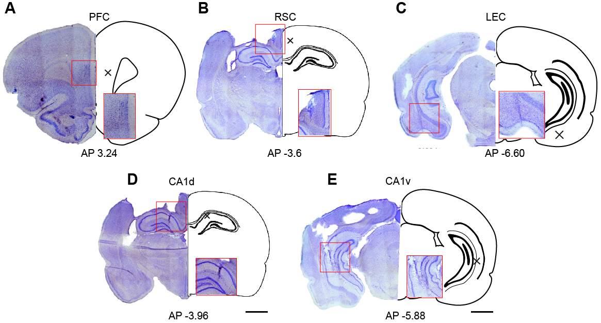
Figure S1. Histological verification of electrode placement. Representative Nissl-stained coronal brain sections illustrating the locations of recording electrodes in the prefrontal cortex (PFC; A), retrosplenial cortex (RSC; B), lateral entorhinal cortex (LEC; C), dorsal CA1 of the hippocampus (CA1d; D), and ventral CA1 of the hippocampus (CA1v; E). For each panel, the left image shows the histological section, and the right schematic depicts the corresponding atlas level. Red rectangles indicate the regions of interest and the approximate locations of electrode tracks or recording sites. Black crosses mark the estimated center of the recording area within each target structure. Anteroposterior (AP) coordinates relative to bregma are indicated below each panel. Scalebars, 2 mm.

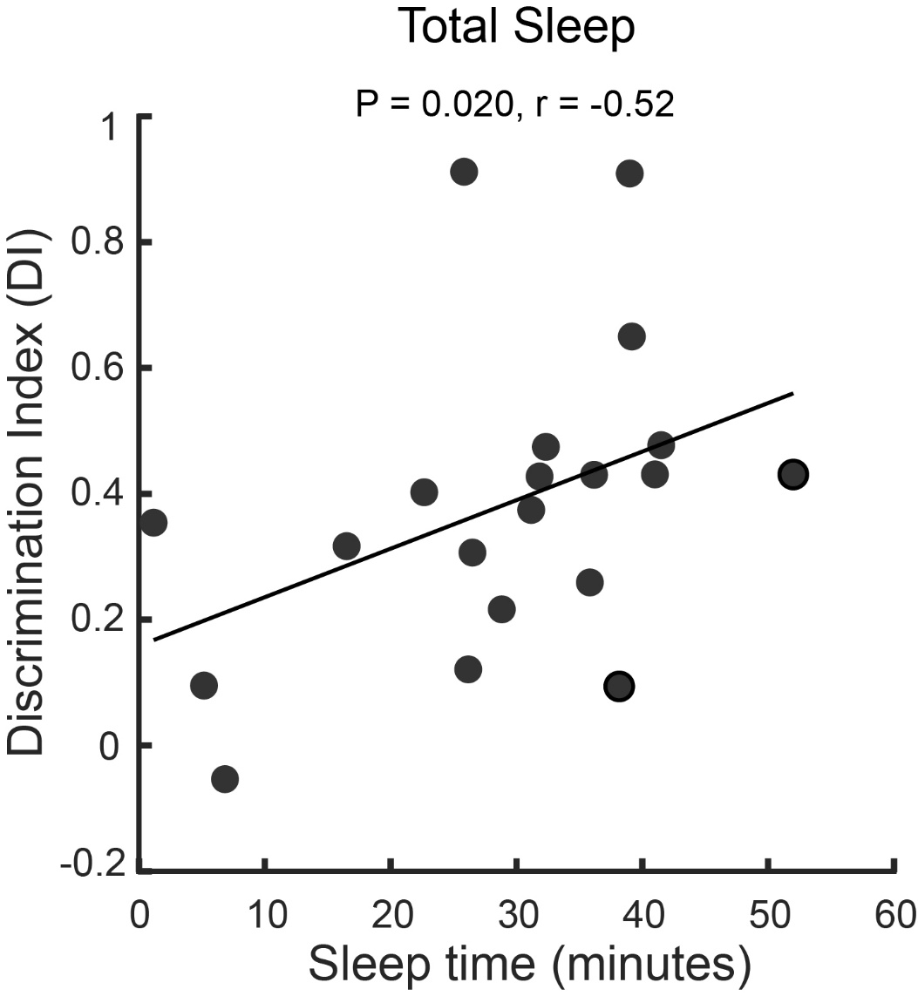
Figure S2. Relationship between total sleep duration and spatial memory performance. Scatter plot showing the association between total sleep time during the post-sample retention period and spatial memory performance, quantified by the discrimination index (DI) in the object–place recognition task. Each data point represents a single experimental session. The solid line indicates the linear regression fit, illustrating a positive relationship whereby longer total sleep duration is associated with higher discrimination indices, consistent with improved spatial memory performance (r= 0.52, P = 0.02, n = 10 rats, 20 sessions).

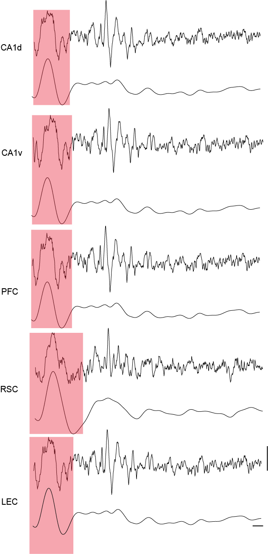
Figure S3. Representative example of hippocampal–cortical slow oscillations during nREM sleep. Example local field potential (LFP) traces recorded simultaneously from dorsal CA1 (CA1d), ventral CA1 (CA1v), prefrontal cortex (PFC), retrosplenial cortex (RSC), and lateral entorhinal cortex (LEC) during non–rapid eye movement (nREM) sleep. Red shaded regions indicate cortical slow oscillation (SO) events, illustrating the temporal alignment of large-amplitude low-frequency activity across hippocampal and cortical regions. For each channel, the raw LFP trace is shown above, with the corresponding low-frequency (0.1–4 Hz) SO component displayed below. This example highlights the widespread yet region-specific expression of slow oscillations across the hippocampo–cortical network during nREM sleep. Scale bars indicate 100 ms (horizontal) and 500 µV (vertical).

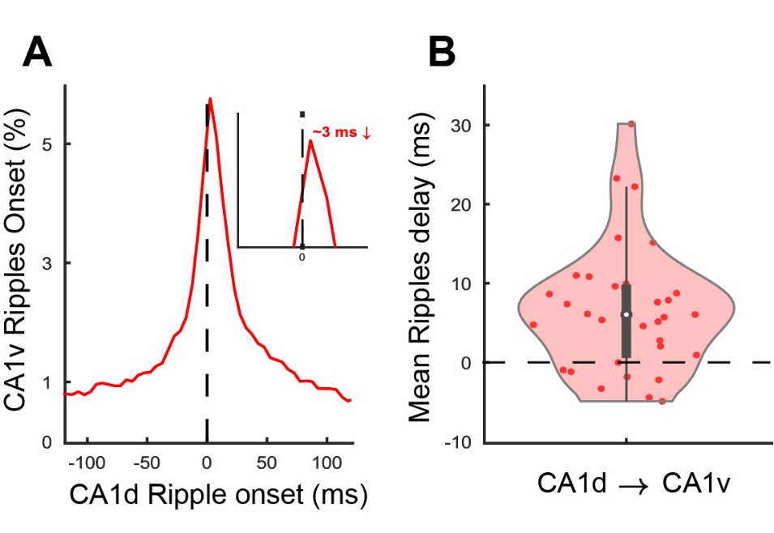
Figure S4. Temporal coordination of ripples across the hippocampal dorso-ventral axis. A, Distribution of CA1v ripple onsets aligned to CA1d ripple onset (t = 0 ms, dashed line). The histogram shows the probability of ventral ripple occurrence relative to dorsal events, revealing a sharp peak at short positive delays. Inset illustrates the peak histogram delay, indicating a dorsal-to-ventral temporal offset of approximately ~3 ms. B, Distribution of session-wise mean delays between CA1d and CA1v ripple onsets. The violin plot shows the distribution of mean delays across sessions, with individual sessions overlaid as points. Positive values indicate that CA1v ripples occur after CA1d ripples. The distribution is centered above zero, consistent with a predominant dorsal-to-ventral propagation of ripple activity.

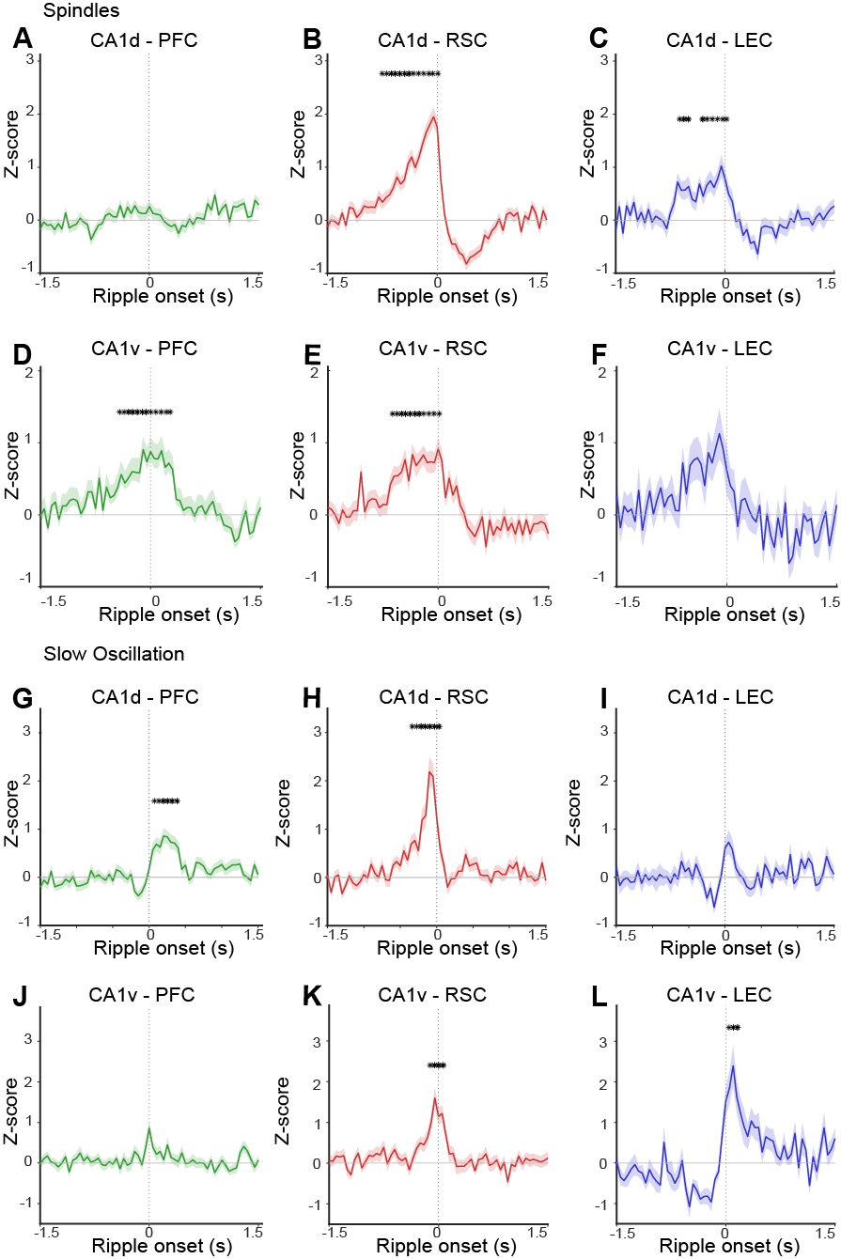
Figure S5. Ripple-aligned cortical spindle and slow-oscillation probability across hippocampal–cortical pathways. Average z-scored probability of cortical spindle (A–F) and slow-oscillation (SO; G–L) events aligned to hippocampal ripple onset (time 0) detected in dorsal CA1 (CA1d; A–C, G–I) or ventral CA1 (CA1v; D–F, J–L). Traces show mean ± s.e.m. across sessions for each hippocampal–cortical pair: prefrontal cortex (PFC, green), retrosplenial cortex (RSC, red), and lateral entorhinal cortex (LEC, blue). Vertical dashed lines indicate ripple onset. Asterisks denote time windows in which spindle or SO probability differed significantly from baseline (cluster-based or windowed statistical tests, P < 0.05). The panels illustrate pronounced region- and pole-specific modulation of cortical oscillations around hippocampal ripples, with strong pre- and peri-ripple increases in RSC and LEC relative to PFC, and distinct profiles for CA1d- versus CA1v-aligned events.

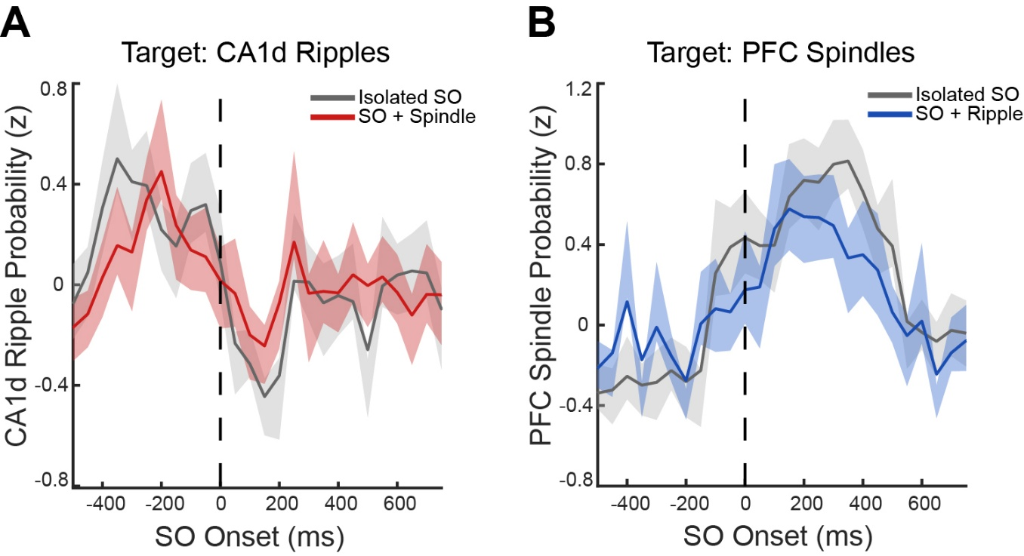
Figure S6. Influence of coupled oscillations on ripple and spindle occurrence. A, CA1d ripple probability aligned to SO onset (t = 0 ms, dashed line), comparing isolated SO events (gray) and SO events coupled with spindles (red). Traces represent mean z-scored ripple probability, with shaded areas indicating ± SEM across sessions. B, Prefrontal cortex (PFC) spindle probability aligned to SO onset, comparing isolated SO events (gray) and SO events coupled with hippocampal ripples (blue). Traces represent mean z-scored spindle probability, with shaded areas indicating ± SEM. These analyses assess whether temporally coupled SO events (SO–spindle or SO–ripple) differentially modulate hippocampal and cortical event probability compared to isolated SOs.

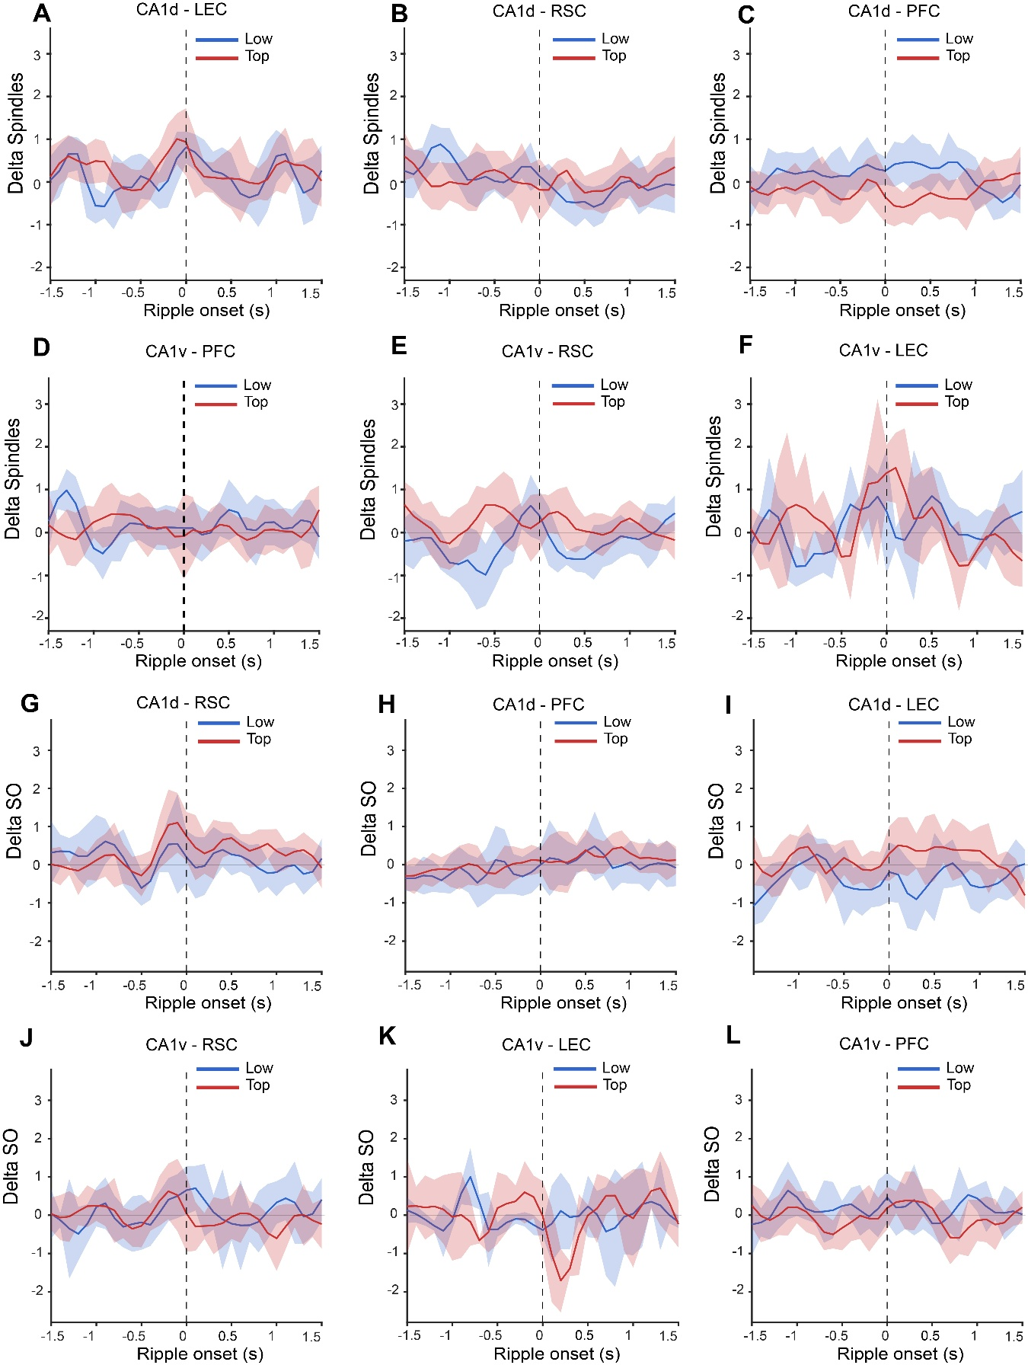
Figure S7. Performance-dependent modulation of ripple-triggered spindle and slow oscillation (SO) coupling across hippocampo–cortical circuits. (A–F) Ripple onset–triggered spindle coupling (Δ sleep: task – baseline) comparing low- (blue) and top-performing (red) sessions using ripples detected in CA1d (A–C) and CA1v (D–F) as temporal reference. Traces represent mean baseline-corrected (Δ sleep) z-scored spindle probability for the indicated region pairs: CA1d–LEC (A), CA1d–RSC (B), CA1d–PFC (C), CA1v–PFC (D), CA1v–RSC (E), and CA1v–LEC (F). Shaded areas indicate ± SEM across sessions. (G–L) Ripple onset–triggered SO coupling (Δ sleep: task – baseline) comparing low- and top-performing sessions using ripples detected in CA1d (G–I) and CA1v (J–L) as temporal reference. Traces represent mean baseline-corrected (Δ sleep) z-scored SO probability for CA1d–RSC (G), CA1d–PFC (H), CA1d–LEC (I), CA1v–RSC (J), CA1v–LEC (K), and CA1v–PFC (L). All traces are aligned to ripple onset (t = 0 s, dashed line). These data illustrate the temporal profiles underlying the performance-dependent differences quantified in the main figures.

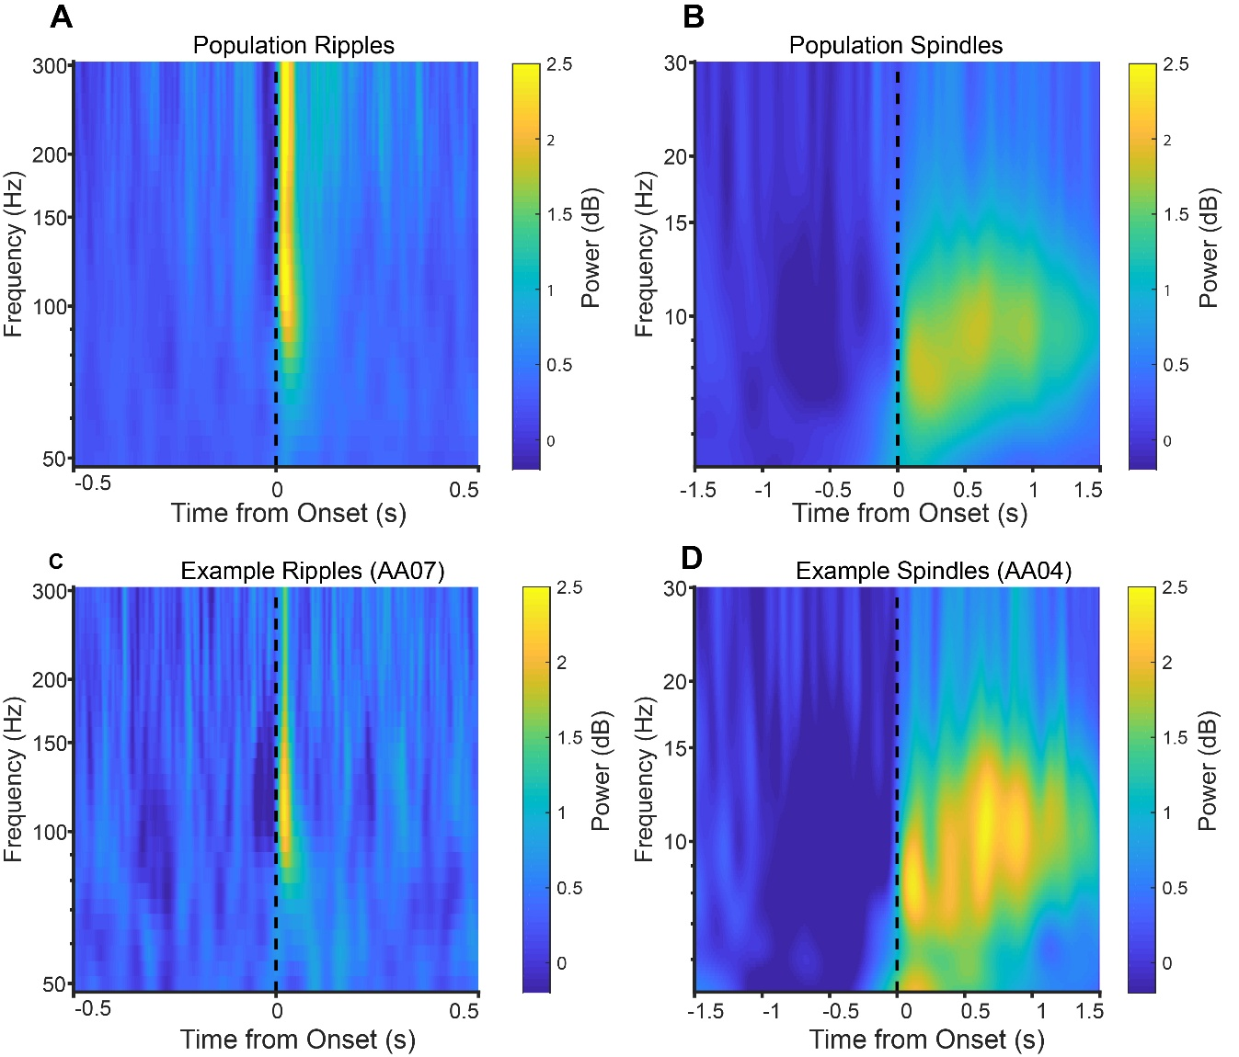
Figure S8. Peri-event spectrograms illustrating ripple and spindle detections. (A–B) Population-averaged (n = 10 animals) spectrograms aligned to ripple onset (A) and spindle onset (B). (A) Ripple events show a transient increase in high-frequency power (100–250 Hz) tightly time-locked to event onset (t = 0 s, dashed line). (B) Spindle events exhibit a sustained increase in power within the spindle frequency range (7–15 Hz) following onset. (C–D) Representative single-session examples of ripple (C; animal AA07) and spindle (D; animal AA04) spectrograms. These examples illustrate the consistency of event-related spectral signatures at the single-session level. Color scale represents power in decibels (dB). Spectrograms are aligned to event onset (t = 0 s, dashed line).

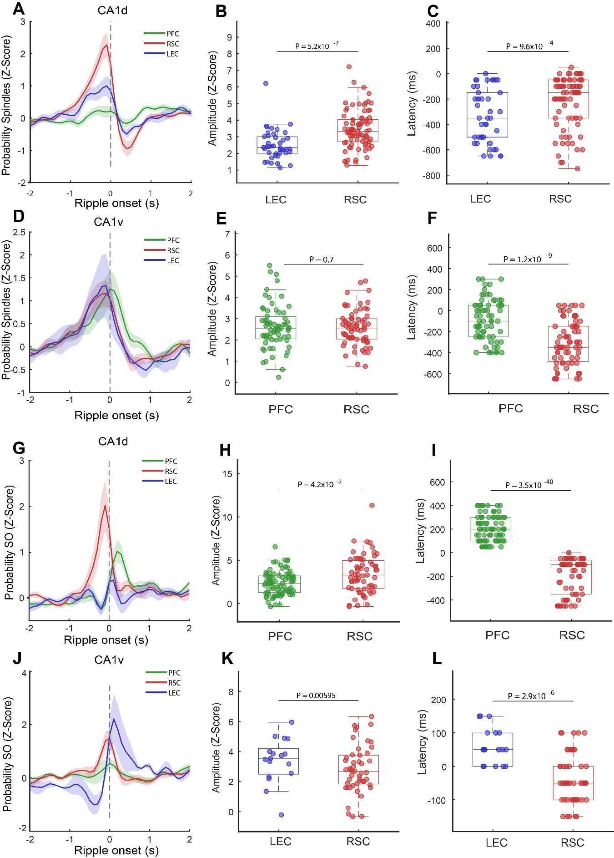
Figure S9. Z-scored ripple onset–triggered spindle and slow oscillation (SO) coupling across hippocampo–cortical circuits (replication analysis with ripple onset threshold at 1.5 SD). (A–D) Ripple onset–triggered spindle coupling (z-scored) using ripples detected in CA1d (A) and CA1v (D) as temporal reference. Traces represent mean z-scored spindle probability for prefrontal cortex (PFC, green), retrosplenial cortex (RSC, red), and lateral entorhinal cortex (LEC, blue), aligned to ripple onset (t = 0 s, dashed line). Shaded areas indicate ± SEM across sessions. (B–C, E–F) Quantification of spindle coupling. Peak amplitude (B, E) and latency (C, F) are shown for the indicated region pairs. For CA1d-triggered events, RSC exhibits higher peak amplitude than LEC (B) and shorter latency relative to ripple onset (C). For CA1v-triggered events, no difference in peak amplitude is observed between PFC and RSC (E), whereas latency differs between regions (F). (G–J) Ripple onset–triggered SO coupling (z-scored) using ripples detected in CA1d (G) and CA1v (J) as temporal reference. Traces represent mean z-scored SO probability for PFC (green), RSC (red), and LEC (blue), aligned to ripple onset. Shaded areas indicate ± SEM across sessions. (H–I, K–L) Quantification of SO coupling. For CA1d-triggered events, RSC shows higher peak amplitude than PFC (H) and shorter latency (I). For CA1v-triggered events, LEC shows higher peak amplitude than RSC (K), whereas RSC exhibits shorter latency (L). Statistical comparisons were performed using linear mixed-effects models (LMM). Points represent individual sessions, and box plots indicate median and interquartile range. Colors correspond to cortical regions as indicated.

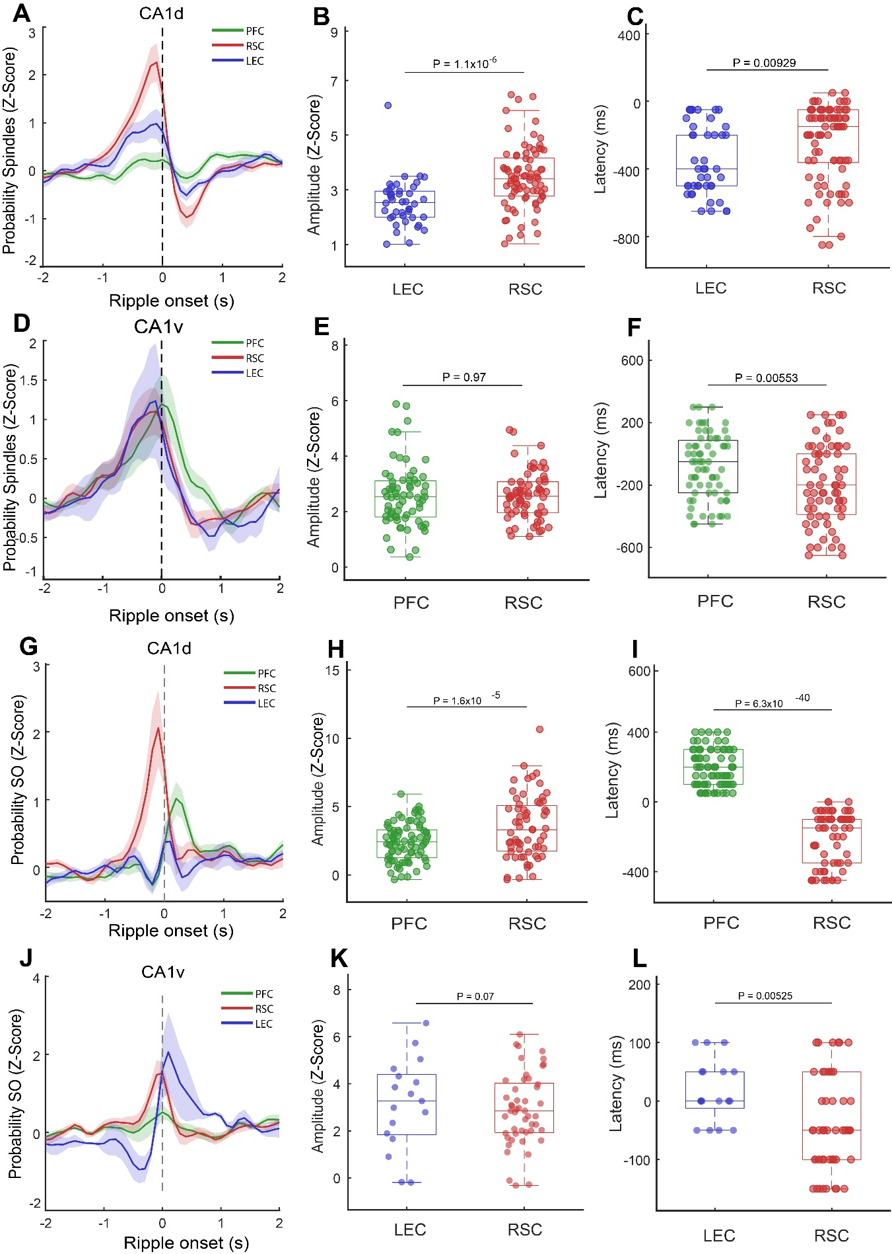
Figure S10. Z-scored ripple onset–triggered spindle and slow oscillation (SO) coupling across hippocampo–cortical circuits (replication analysis with ripple onset threshold at 2 SD). (A–D) Ripple onset–triggered spindle coupling (z-scored) using ripples detected in CA1d (A) and CA1v (D) as temporal reference. Traces represent mean z-scored spindle probability for prefrontal cortex (PFC, green), retrosplenial cortex (RSC, red), and lateral entorhinal cortex (LEC, blue), aligned to ripple onset (t = 0 s, dashed line). Shaded areas indicate ± SEM across sessions. (B–C, E–F) Quantification of spindle coupling. Peak amplitude (B, E) and latency (C, F) are shown for the indicated region pairs. For CA1d-triggered events, RSC exhibits higher peak amplitude than LEC (B) and shorter latency relative to ripple onset (C). For CA1v-triggered events, no difference in peak amplitude is observed between PFC and RSC (E), whereas latency differs between regions (F). (G–J) Ripple onset–triggered SO coupling (z-scored) using ripples detected in CA1d (G) and CA1v (J) as temporal reference. Traces represent mean z-scored SO probability for PFC (green), RSC (red), and LEC (blue), aligned to ripple onset. Shaded areas indicate ± SEM across sessions. (H–I, K–L) Quantification of SO coupling. For CA1d-triggered events, RSC shows higher peak amplitude than PFC (H) and shorter latency (I). For CA1v-triggered events, no difference in peak amplitude is observed between LEC and RSC (K), whereas latency differs between regions (L). Statistical comparisons were performed using linear mixed-effects models (LMM). Points represent individual sessions, and box plots indicate median and interquartile range. Colors correspond to cortical regions as indicated.

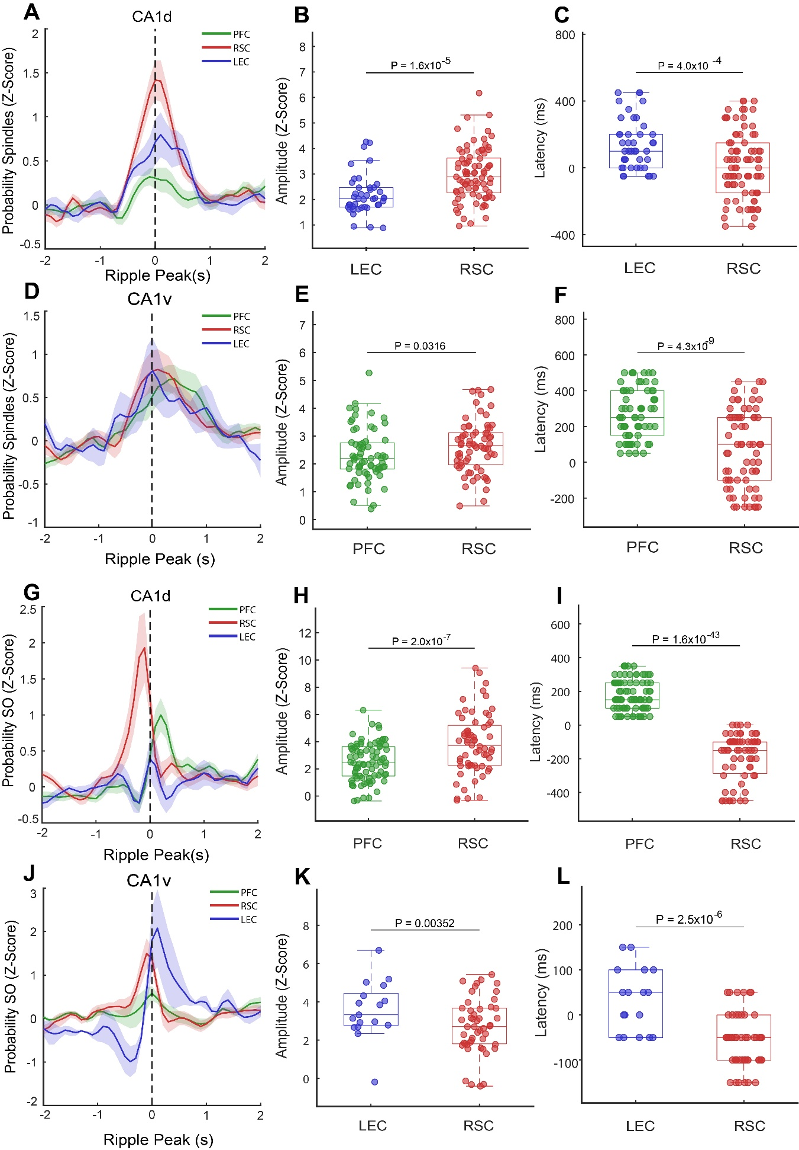
Figure S11. Z-scored ripple peak–triggered spindle and slow oscillation (SO) coupling across hippocampo–cortical circuits. (A–D) Ripple peak–triggered spindle coupling (z-scored) using ripples detected in CA1d (A) and CA1v (D) as temporal reference. Traces represent mean z-scored spindle probability for prefrontal cortex (PFC, green), retrosplenial cortex (RSC, red), and lateral entorhinal cortex (LEC, blue), aligned to ripple peak (t = 0 s, dashed line). Shaded areas indicate ± SEM across sessions. (B–C, E–F) Quantification of spindle coupling. Peak amplitude (B, E) and latency (C, F) are shown for the indicated region pairs. For CA1d-triggered events, RSC exhibits higher peak amplitude than LEC (B) and shorter latency relative to ripple peak (C). For CA1v-triggered events, RSC shows higher peak amplitude than PFC (E) and shorter latency (F). (G–J) Ripple peak–triggered SO coupling (z-scored) using ripples detected in CA1d (G) and CA1v (J) as temporal reference. Traces represent mean z-scored SO probability for PFC (green), RSC (red), and LEC (blue), aligned to ripple peak. Shaded areas indicate ± SEM across sessions. (H–I, K–L) Quantification of SO coupling. For CA1d-triggered events, RSC shows higher peak amplitude than PFC (H) and shorter latency (I). For CA1v-triggered events, LEC shows higher peak amplitude than RSC (K), whereas RSC exhibits shorter latency (L). Statistical comparisons were performed using linear mixed-effects models (LMM). Points represent individual sessions, and box plots indicate median and interquartile range. Colors correspond to cortical regions as indicated.

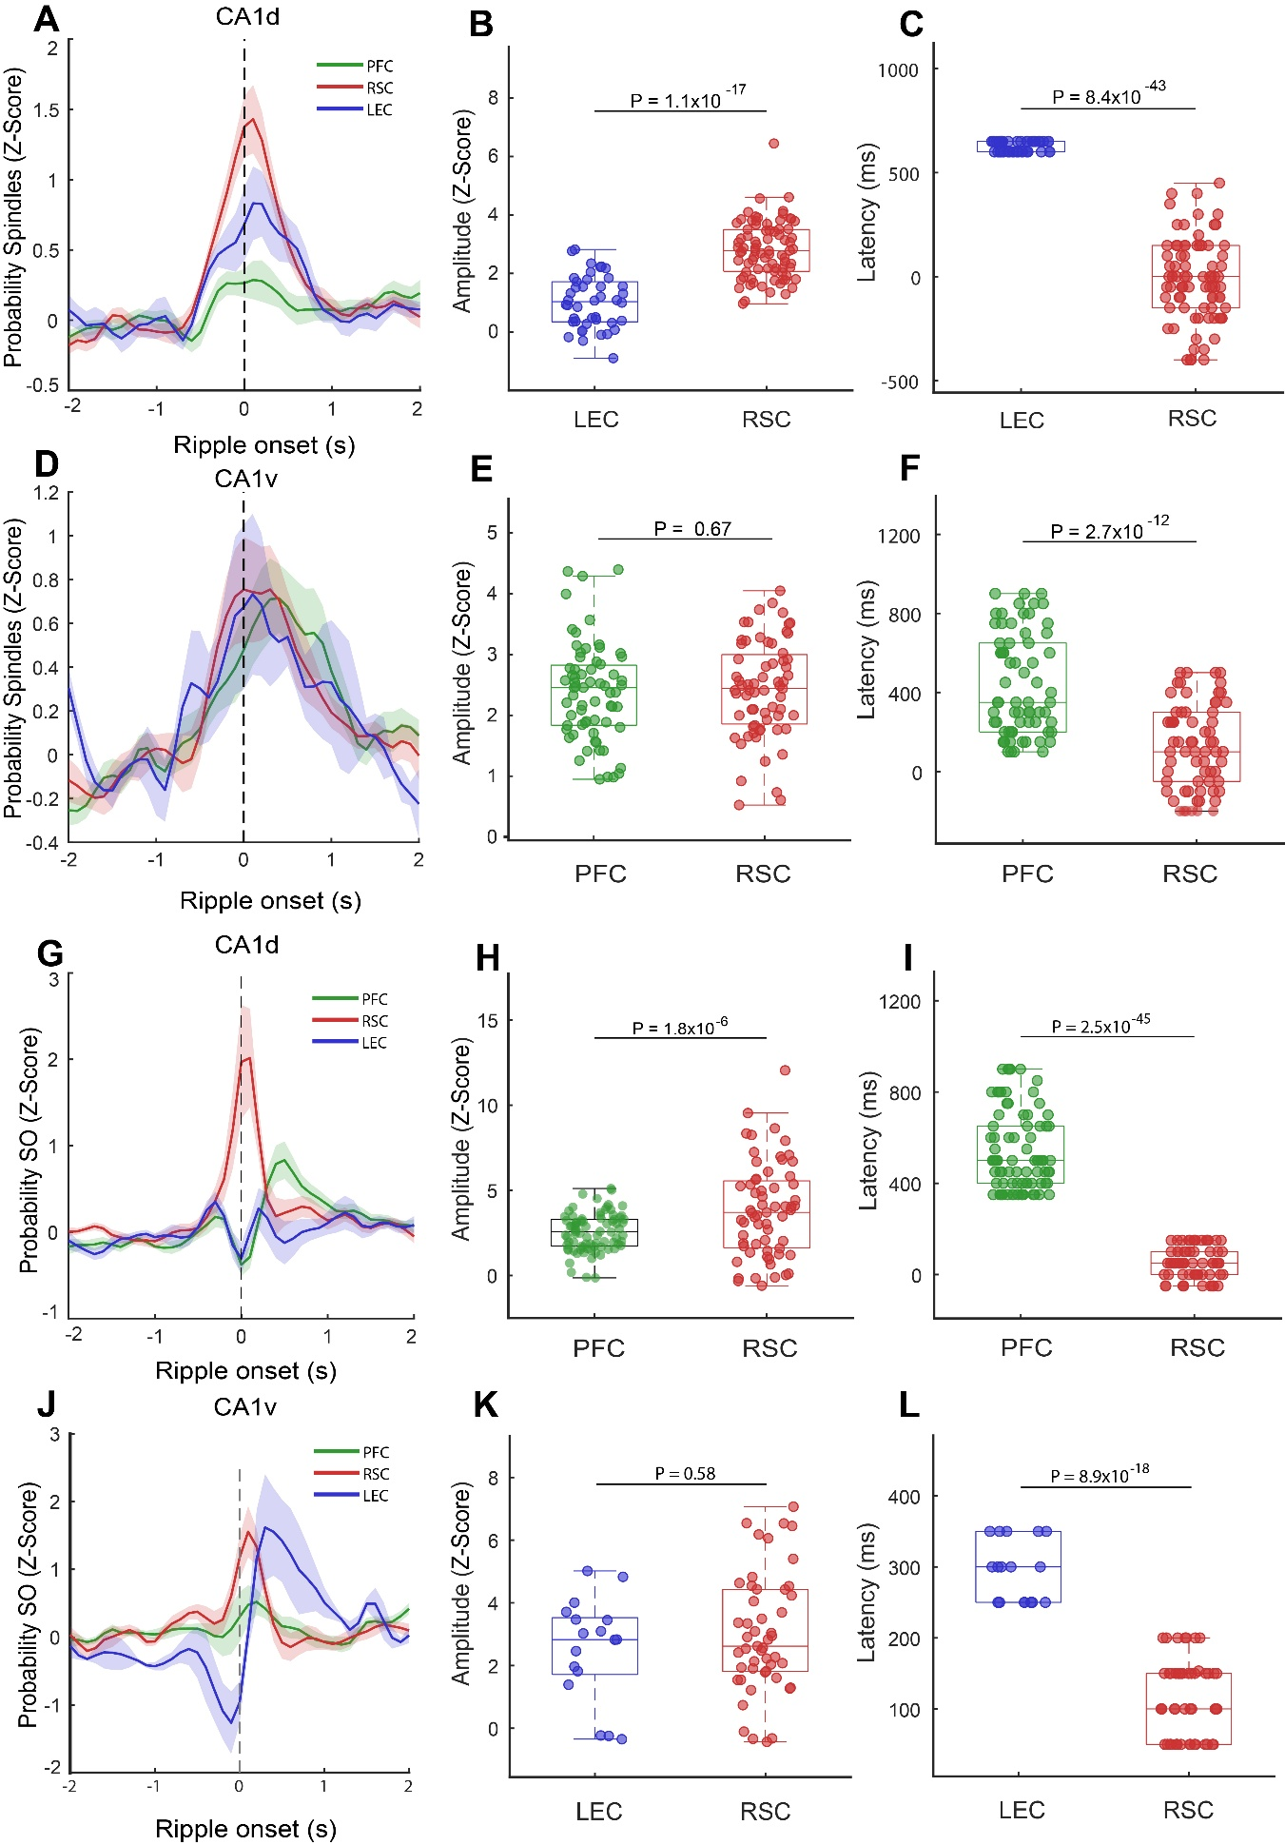
Figure S12. Z-scored ripple-triggered spindle and slow oscillation (SO) coupling across hippocampo–cortical circuits. (A–D) Ripple-triggered spindle coupling (z-scored) using ripples detected in CA1d (A) and CA1v (D) as temporal reference and spindles peaks. Traces represent mean z-scored spindle probability for prefrontal cortex (PFC, green), retrosplenial cortex (RSC, red), and lateral entorhinal cortex (LEC, blue), aligned to ripple onset (t = 0 s, dashed line). Shaded areas indicate ± SEM across sessions. (B–C, E–F) Quantification of spindle coupling. Peak amplitude (B, E) and latency (C, F) are shown for the indicated region pairs. For CA1d-triggered events, RSC exhibits higher peak amplitude than LEC (B) and shorter latency relative to ripple onset (C). For CA1v-triggered events, no difference in peak amplitude is observed between PFC and RSC (E), whereas latency differs between regions (F). (G–J) Ripple-triggered SO coupling (z-scored) using ripples detected in CA1d (G) and CA1v (J) as temporal reference and SOs peaks. Traces represent mean z-scored SO probability for PFC (green), RSC (red), and LEC (blue), aligned to ripple onset. Shaded areas indicate ± SEM across sessions. (H–I, K–L) Quantification of SO coupling. For CA1d-triggered events, RSC shows higher peak amplitude than PFC (H) and shorter latency (I). For CA1v-triggered events, no difference in peak amplitude is observed between LEC and RSC (K), whereas latency differs between regions (L). Statistical comparisons were performed using linear mixed-effects models (LMM). Points represent individual sessions, and box plots indicate median and interquartile range. Colors correspond to cortical regions as indicated.

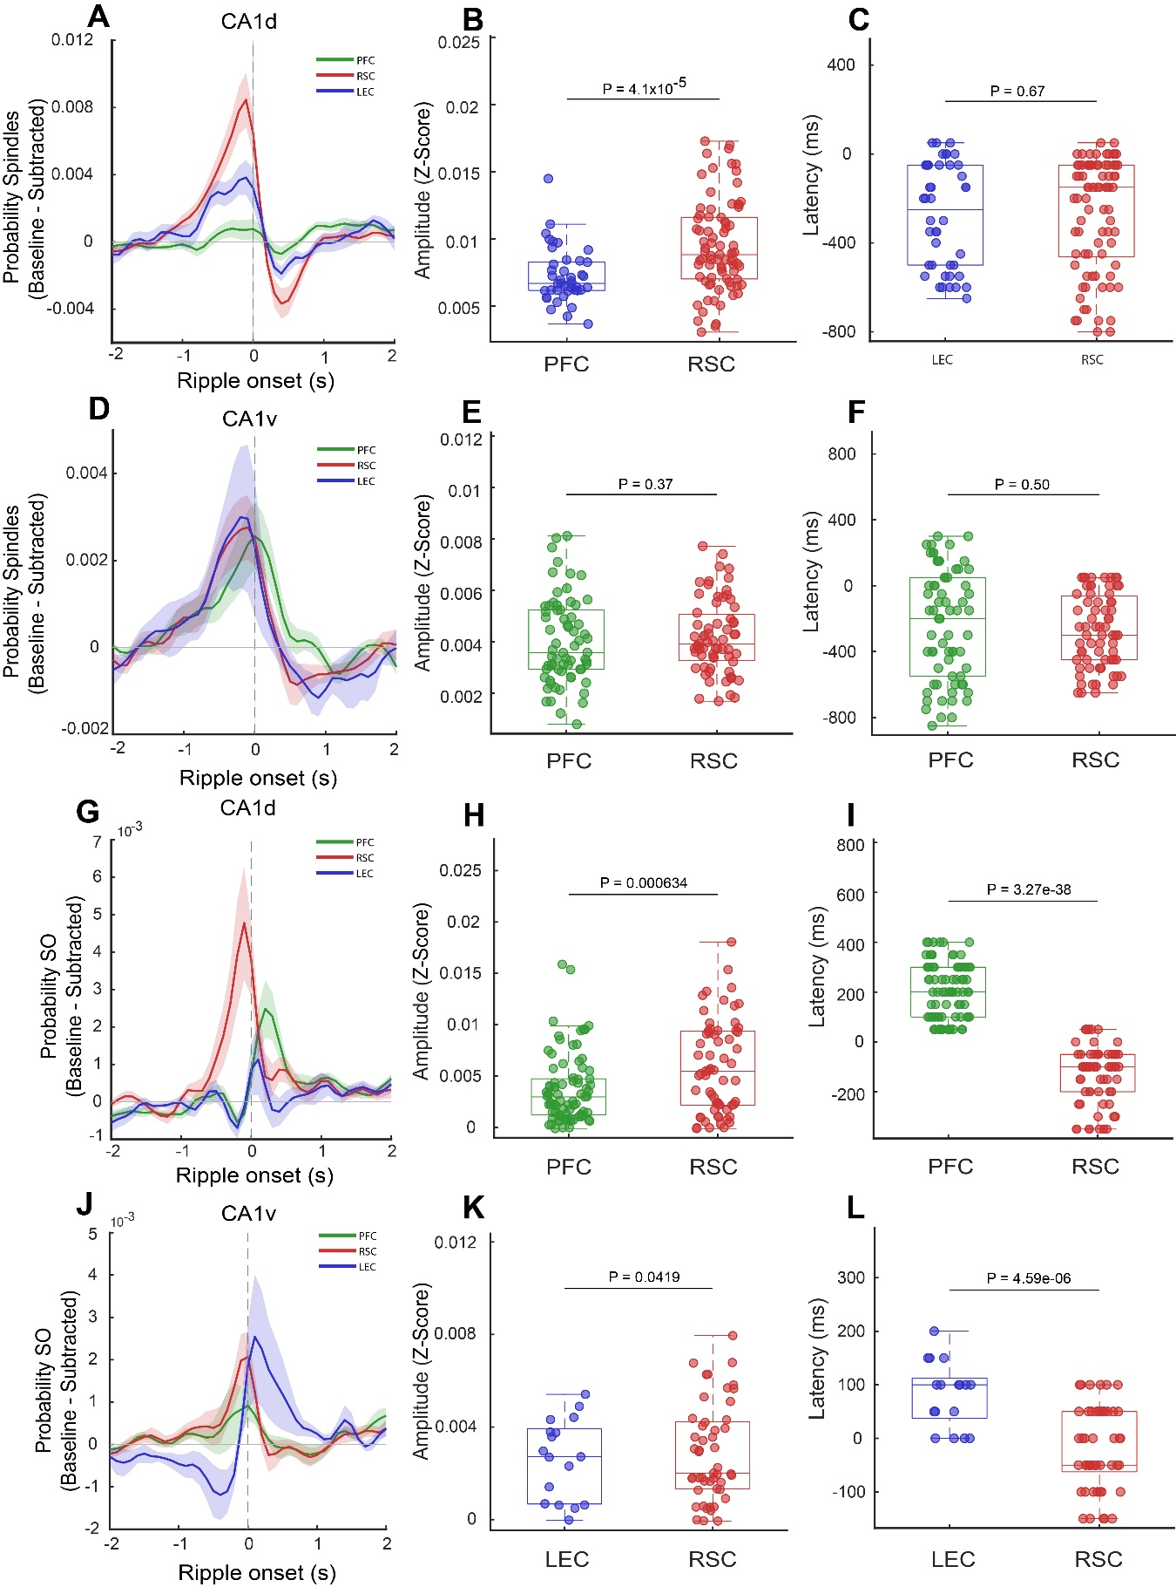
Figure S13. Baseline-subtracted ripple-triggered spindle and slow oscillation (SO) coupling across hippocampo–cortical circuits. (A–D) Baseline-subtracted ripple-triggered spindle probability using ripples detected in CA1d (A) and CA1v (D) as temporal reference. Traces show mean spindle probability relative to baseline for prefrontal cortex (PFC, green), retrosplenial cortex (RSC, red), and lateral entorhinal cortex (LEC, blue), aligned to ripple onset (t = 0 s, dashed line). Shaded areas indicate ± SEM across sessions. (B–C, E–F) Quantification of spindle coupling. Peak amplitude (B, E) and latency (C, F) of ripple-triggered spindle probability are shown for the indicated region pairs. For CA1d-triggered events, RSC exhibits higher peak amplitude than PFC (B), while latency does not differ between RSC and LEC (C). For CA1v-triggered events, neither amplitude (E) nor latency (F) differs between PFC and RSC. (G–J) Baseline-subtracted ripple-triggered SO probability using ripples detected in CA1d (G) and CA1v (J) as temporal reference. Traces show mean SO probability relative to baseline for PFC (green), RSC (red), and LEC (blue), aligned to ripple onset. Shaded areas indicate ± SEM across sessions. (H–I, K–L) Quantification of SO coupling. For CA1d-triggered events, RSC shows higher peak amplitude than PFC (H), and shorter latency relative to ripple onset (I). For CA1v-triggered events, RSC exhibits higher peak amplitude than LEC (K) and shorter latency (L). Statistical comparisons were performed using linear mixed-effects models (LMM). Points represent individual sessions, and box plots indicate median and interquartile range. Colors correspond to cortical regions as indicated.

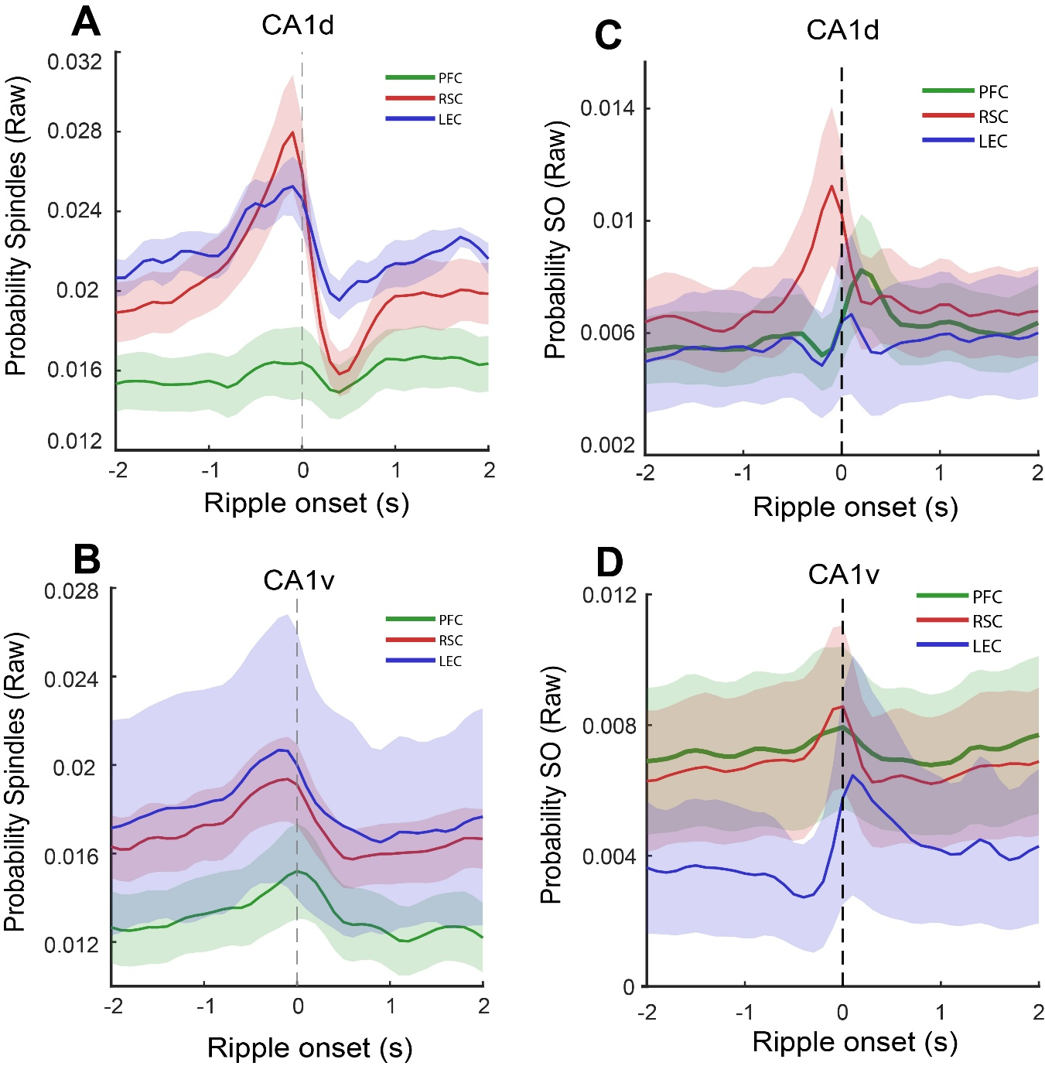
Figure S14. Raw probability of ripple-triggered spindle and slow oscillation (SO) events across hippocampo–cortical circuits. (A–B) Ripple-triggered spindle probability using ripples detected in CA1d (A) and CA1v (B) as temporal reference. (C–D) Ripple-triggered SO probability using ripples detected in CA1d (C) and CA1v (D) as temporal reference. Traces represent the mean event probability (raw, unnormalized) across sessions for prefrontal cortex (PFC, green), retrosplenial cortex (RSC, red), and lateral entorhinal cortex (LEC, blue), aligned to ripple onset (t = 0 s, dashed line). Shaded areas indicate ± SEM across sessions. These raw probability traces illustrate the baseline temporal structure of ripple–cortical coupling prior to normalization, highlighting region- and oscillation-specific differences in event probability and temporal dynamics. No statistical comparison was performed given the different baselines.

