Examining the Immunomodulatory Role of Nanoparticles on Mast Cell Activation
Jessica Perez Pineda¹ and Lisa A. DeLouise^{1,2}

¹Department of Biomedical Engineering, University of Rochester, Rochester, NY
²Department of Dermatology, University of Rochester Medical Center, Rochester, NY

Supplemental Information

Created in Biorender

Nanoparticle | Surface charge  (mV) | Size (TEM) | Hydrodynamic Size | PDI
SiO₂ (20 nm) 10 µg/mL | -26.6 ± 3.89 | 21.42 ± 2.37 | 31.8 ± 1.67 | 0.217
mTiO₂ (<100 nm) 1 µg/mL | -9.1 ± 2.26 | 56.02 ± 17.3 | 530.7 ± 45.5 | 0.296
Table S1 Nanoparticle characterization via DLS (pH=6.5) and TEM
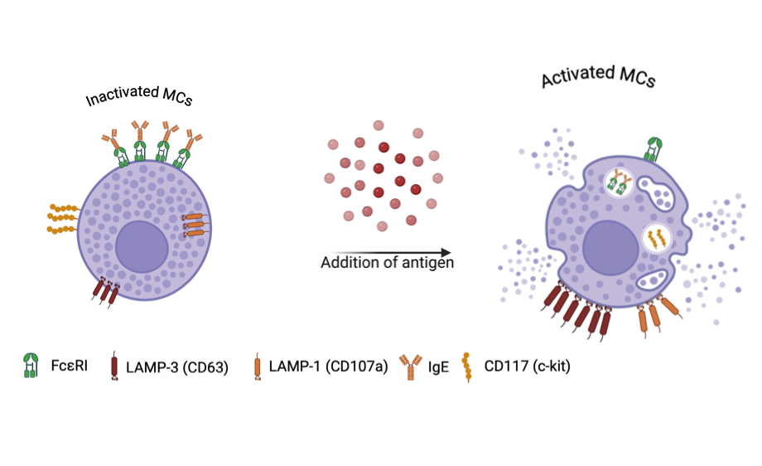
Fig. S1 Mast Cells Surface Marker expression. Before activation (left) and after being exposed to antigen (right). This image was created in BioRender. Perez, J. (2025) https://BioRender.com/ospqk4j

Fig. S2 TEM of SiO₂ NPs. Scale bar 100 nm

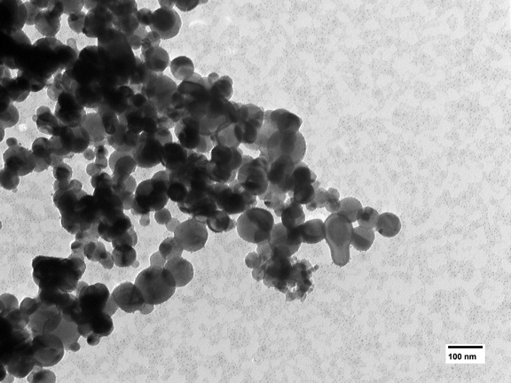
Fig. S3 TEM of mTiO₂ NPs. Scale bar 100 nm
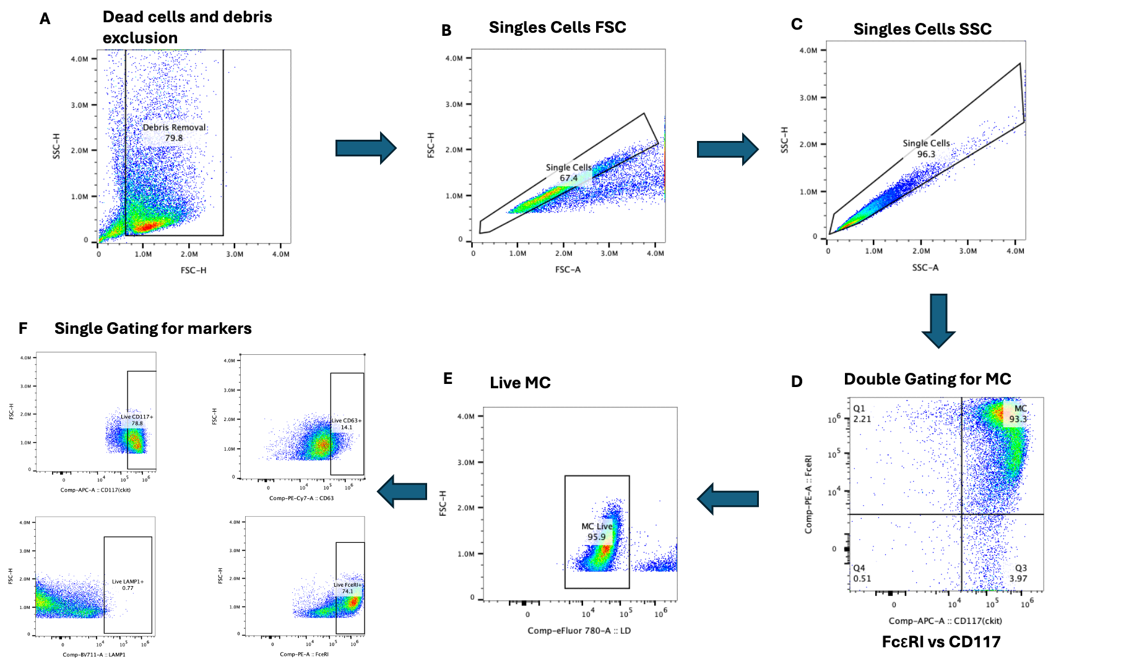
Fig. S4 BMMC Gating strategy performed through FlowJo. A) Cell population excluding the debris was selected. B-C) Single cells were gated through FSC and SSC. D) Cells were gated under FcεRI+CD117+ (Q2) which are defined as the BMMC. E) Fixable Viability Dye eFluor™780 was used to stain dead cells, then live cell population was separated. F) After live cells were separated, cells were gated for the evaluation of each marker

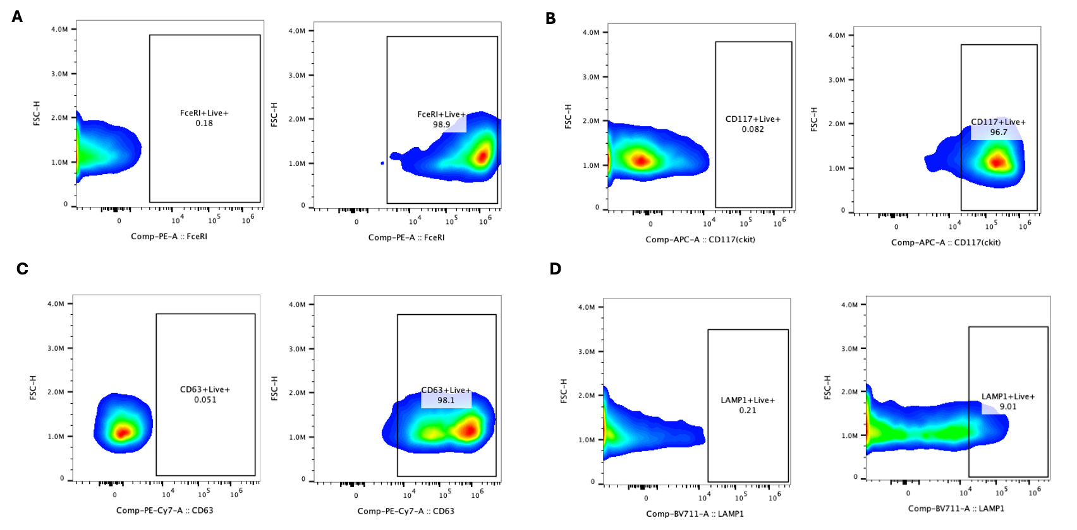
Fig. S5 FMO Controls Gating. Positive identification of each marker was done using single staining and compared to non-stained cells to identify the positive population. Comparison between non-stained cells (left) and single-stained cells (right) for each marker. A) FcεRI, B) CD117, C) CD63, D) LAMP-1.
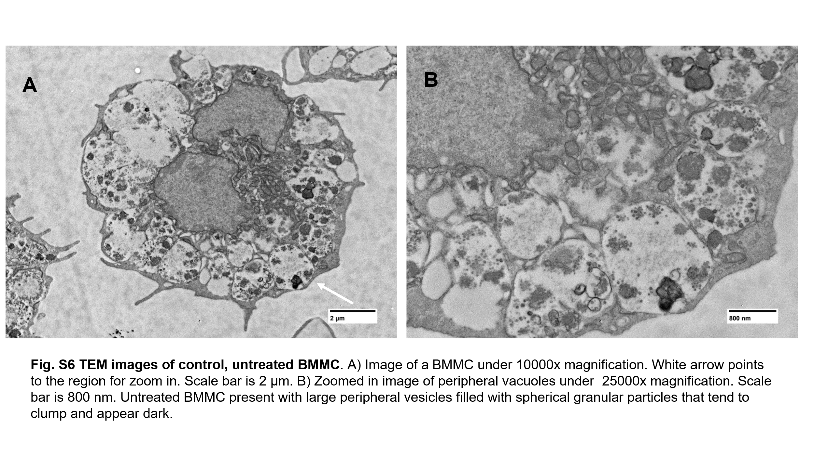

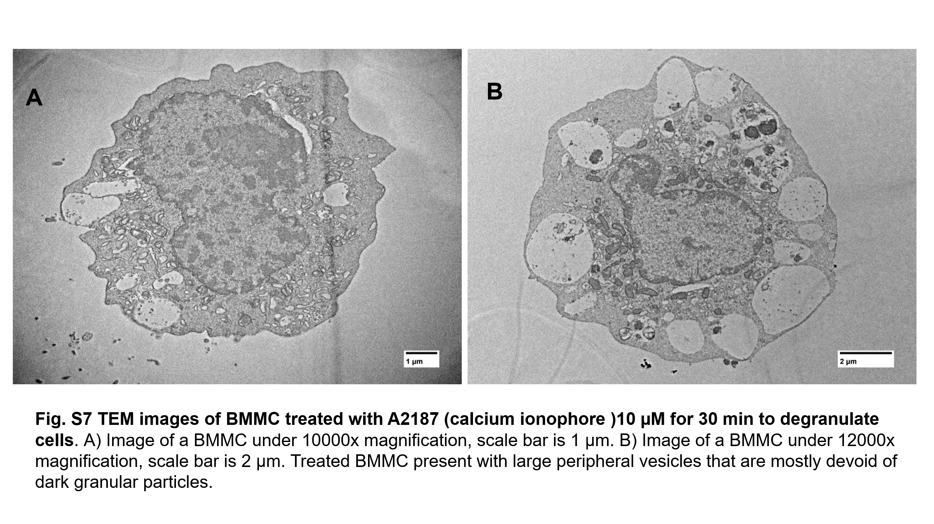
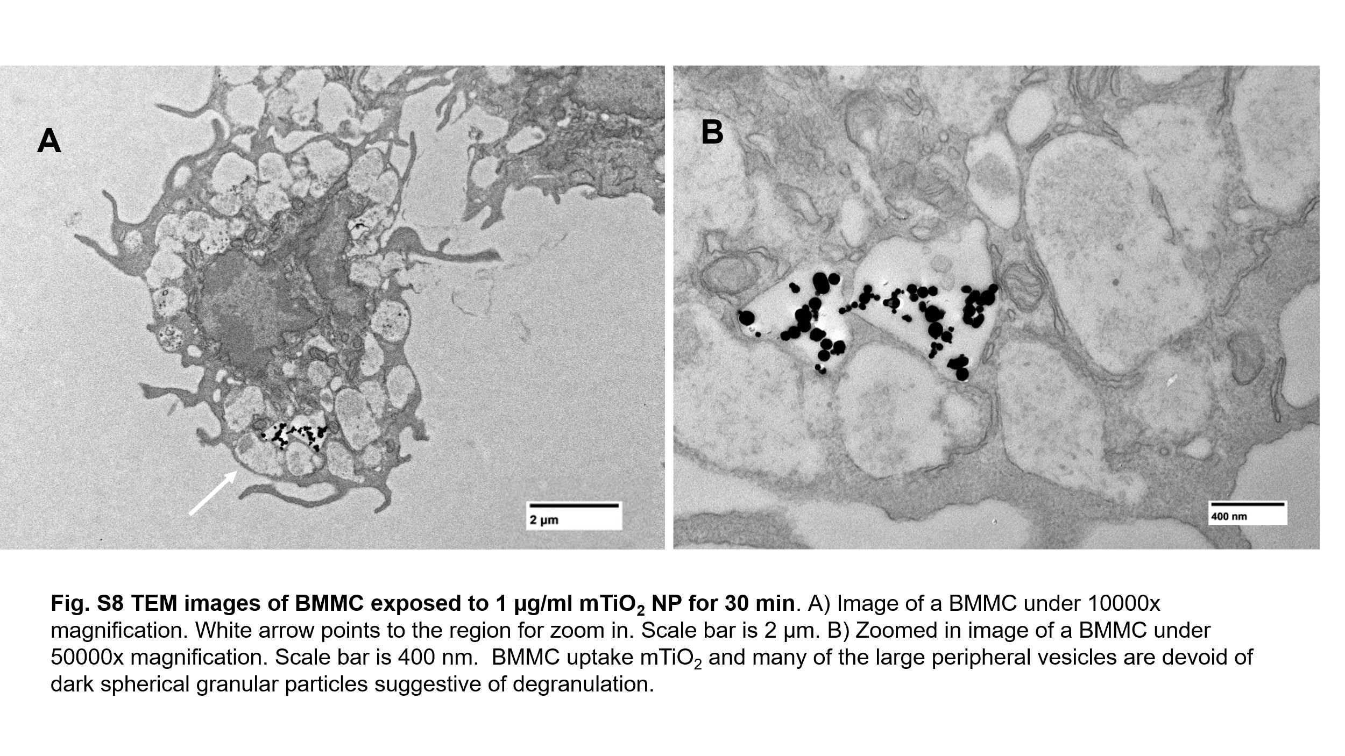
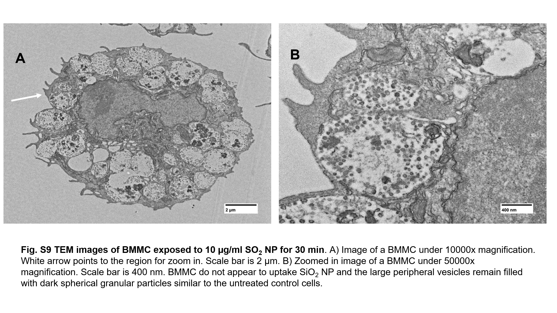

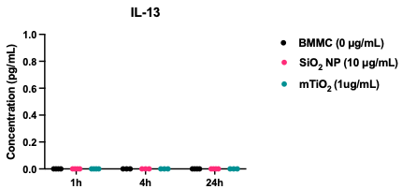
Fig. S10 Release of proinflammatory cytokine IL-13 as a function of time after NP exposure.

