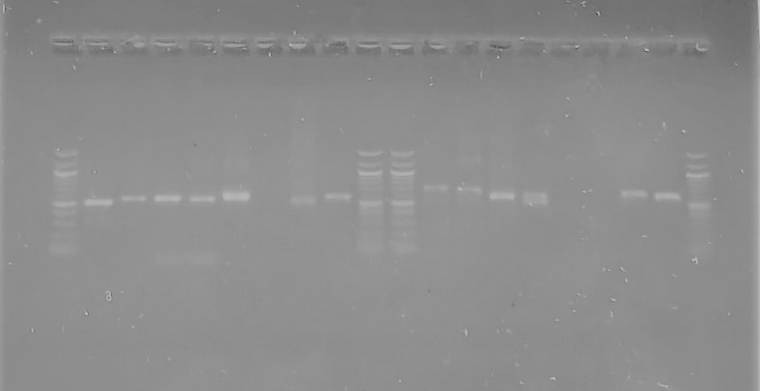
Figure 3 : PCR/electrophoresis product profile of P. falciparum DNA

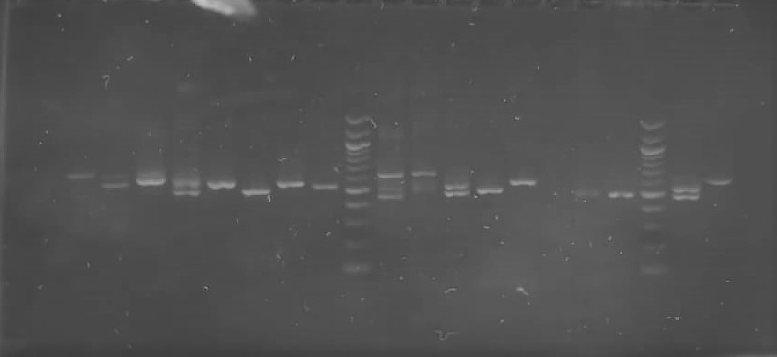

Figure 6: Electropherogram of the amplification products of the msp2 gene

