Repeat 2
Repeat 1
(A) Western blot of MSI2
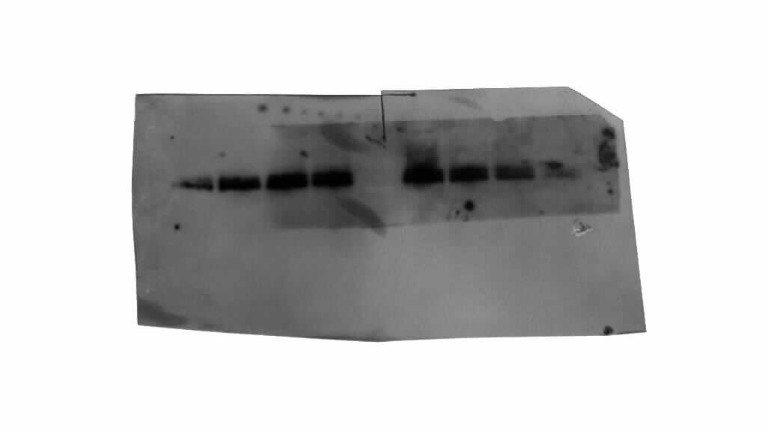
Repeat 1
Repeat 2

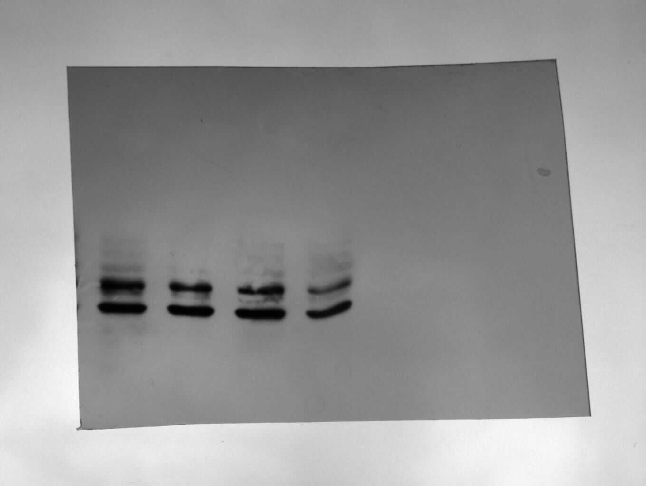
Repeat 3
(B) Western blot of GAPDH

(B) Western blot of GAPDH
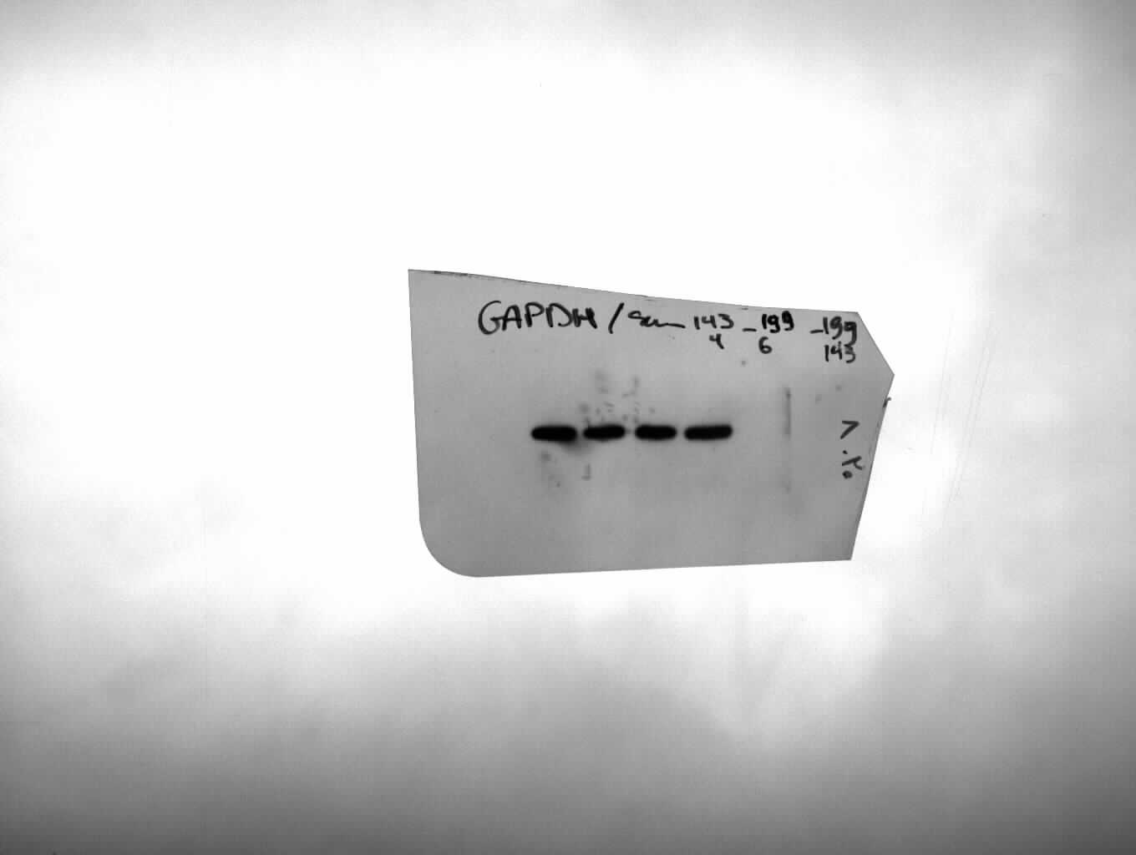
Repeat 1
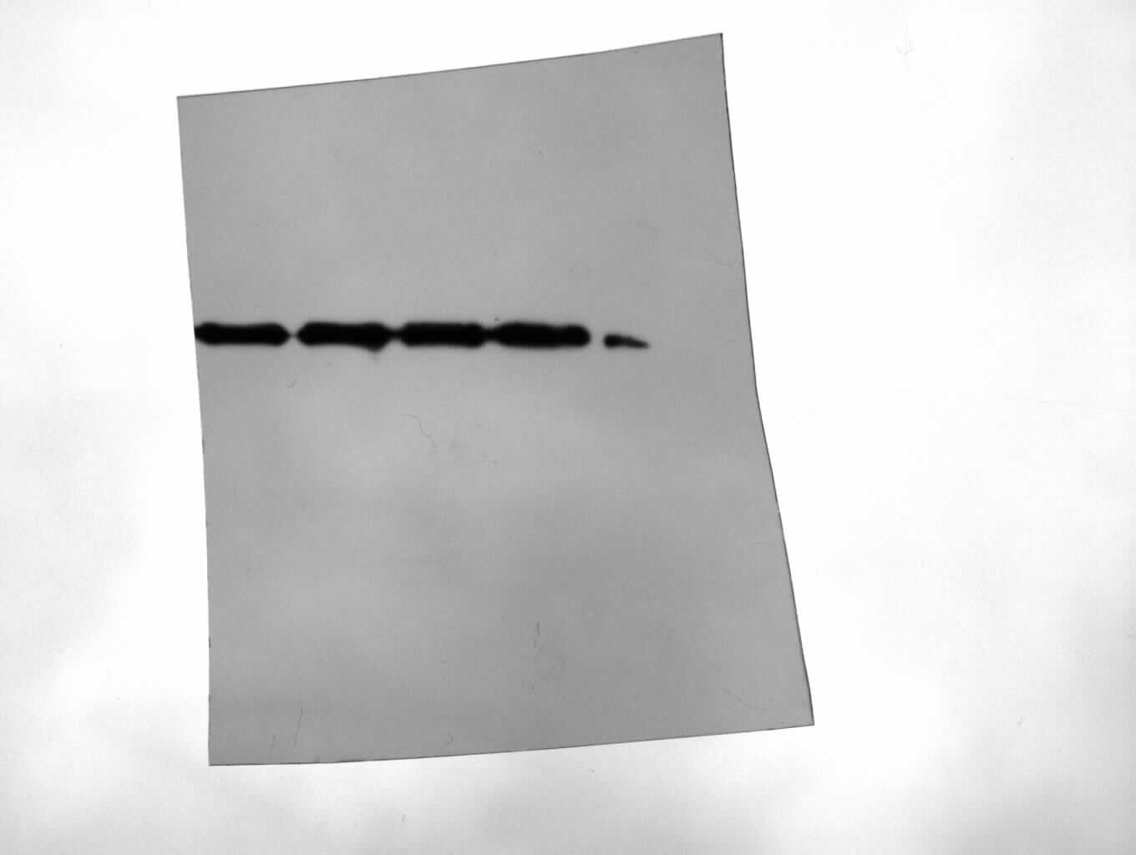
Repeat 2

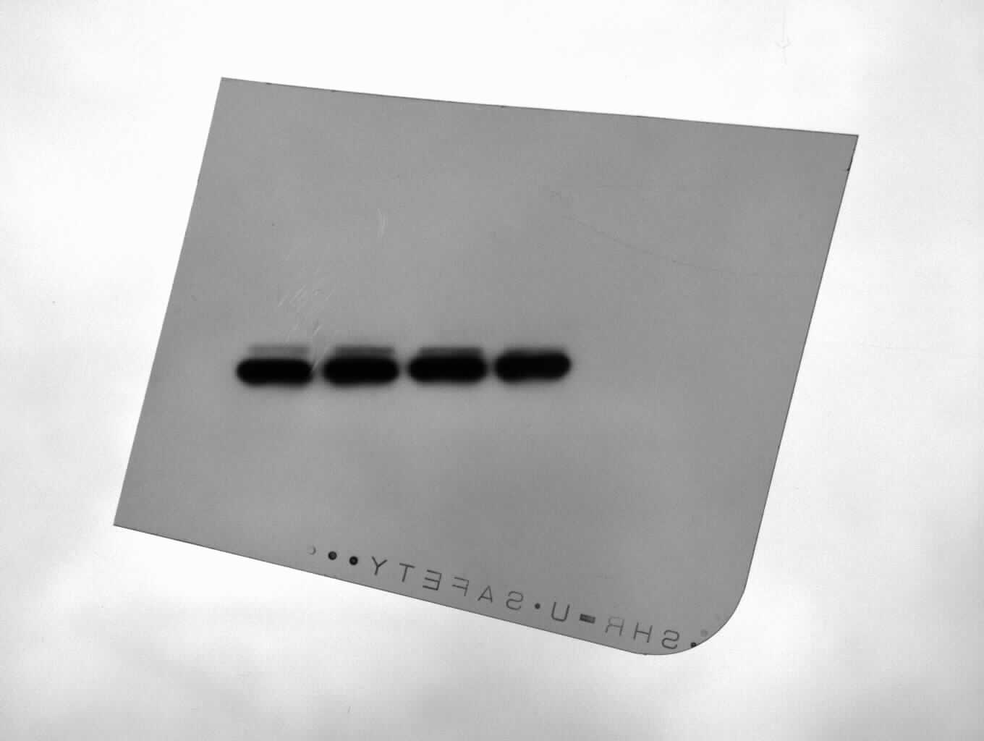
Repeat 3
Fig. 1S: The protein expression levels of MSI2 and GAPDH were evaluated following the overexpression of miR-143-3p or miR-199a-3p in K562 cells. Three Western blot images show the relative expression levels of MSI2 (A) compared to GAPDH (B) as a reference in K562 stable clones.

