Supplementary Materials
Occupational Heat Risk Perceptions and Behavioral Adaptation Strategies Among Construction and Welding Workers in Bangladesh
Ashiqur Rahman Tamim, Muhammad Mainuddin Patwary, Mondira Bardhan, Md Ismay Azam Badhon, Md Shahinur Rahman, Imran Chowdhury Sakib, Afif Iftikhar, Md Pervez Kabir, Md Najmus Sayadat Pitol, Chameli Saha, Matthew H.E.M. Browning

Table S1. Differences in self-reported physical illness during hot weather across workers in Bangladesh.
Variable | Response | Total | Construction | Welding | P value
Excessive sweating | Never | 4 (1.3%) | 4 (2.6%) | 0 (0%) | 0.011*
 | Rarely | 2 (0.6%) | 2 (1.3%) | 0 (0%)
 | Sometimes | 18 (5.6%) | 11 (7.1%) | 7 (6.0%)
 | Often | 85 (26.6%) | 58 (37.7%) | 27 (23.3%)
 | Always | 161 (50.3%) | 79 (51.3%) | 82 (70.7%)
Frequently thirsty | Never | 4 (1.3%) | 4 (2.6%) | 0 (0%) | 0.013
 | Rarely | 4 (1.3%) | 3 (1.9%) | 1 (0.9%)
 | Sometimes | 37 (11.6%) | 29 (18.8%) | 8 (6.9%)
 | Often | 88 (27.5%) | 48 (31.2%) | 40 (34.5%)
 | Always | 137 (42.8%) | 70 (45.5%) | 67 (57.8%)
Muscle cramps | Never | 17 (5.3%) | 9 (6.1%) | 8 (7.0%) | 0.009**
 | Rarely | 37 (11.6%) | 25 (17.0%) | 12 (10.4%)
 | Sometimes | 84 (26.3%) | 57 (38.8%) | 27 (23.5%)
 | Often | 72 (22.5%) | 35 (23.8%) | 37 (32.2%)
 | Always | 52 (16.3%) | 21 (14.3%) | 31 (27.0%)
Tiredness or weakness | Never | 5 (1.6%) | 5 (3.3%) | 0 (0%) | 0.317
 | Rarely | 11 (3.4%) | 6 (3.9%) | 5 (4.3%)
 | Sometimes | 57 (17.8%) | 35 (23.0%) | 22 (19.1%)
 | Often | 116 (36.3%) | 64 (42.1%) | 52 (45.2%)
 | Always | 78 (24.4%) | 42 (27.6%) | 36 (31.3%)
Headache | Never | 24 (7.5%) | 15 (9.9%) | 9 (7.9%) | 0.225
 | Rarely | 18 (5.6%) | 10 (6.6%) | 8 (7.0%)
 | Sometimes | 78 (24.4%) | 52 (34.4%) | 26 (22.8%)
 | Often | 97 (30.3%) | 48 (31.8%) | 49 (43.0%)
 | Always | 48 (15.0%) | 26 (17.2%) | 22 (19.3%)
Dizziness | Never | 51 (15.9%) | 25 (16.8%) | 26 (22.6%) | 0.530
 | Rarely | 65 (20.3%) | 38 (25.5%) | 27 (23.5%)
 | Sometimes | 73 (22.8%) | 45 (30.2%) | 28 (24.3%)
 | Often | 53 (16.6%) | 27 (18.1%) | 26 (22.6%)
 | Always | 22 (6.9%) | 14 (9.4%) | 8 (7.0%)
Nausea or vomiting | Never | 126 (39.4%) | 61 (40.1%) | 65 (57.0%) | 0.018*
 | Rarely | 47 (14.7%) | 25 (16.4%) | 22 (19.3%)
 | Sometimes | 54 (16.9%) | 38 (25.0%) | 16 (14.0%)
 | Often | 25 (7.8%) | 17 (11.2%) | 8 (7.0%)
 | Always | 14 (4.4%) | 11 (7.2%) | 3 (2.6%)
Fainting | Never | 214 (66.9%) | 107 (70.9%) | 107 (93.0%) | <0.001***
 | Rarely | 18 (5.6%) | 14 (9.3%) | 4 (3.5%)
 | Sometimes | 10 (3.1%) | 10 (6.6%) | 0 (0%)
 | Often | 14 (4.4%) | 12 (7.9%) | 2 (1.7%)
 | Always | 10 (3.1%) | 8 (5.3%) | 2 (1.7%)
*p<0.05; **p<0.01; ***p<0.001;

Table S2. Differences in self-reported mental health symptoms during hot weather across workers in Bangladesh (n = 320).
Variables | Total  (n=320) | Construction (n=185) | Welding  (n=135) | P value
Emotional irritability | 32 (10.0%) | 104 (56.2%) | 100 (74.1%) | 0.263
Difficulty to control temper | 204 (63.7%) | 105 (56.8%) | 109 (80.7%) | 0.263
Low mood | 214 (66.9%) | 70 (37.8%) | 59 (43.7%) | 0.263
Decline of memory | 129 (40.3%) | 41 (22.2%) | 32 (23.7%) | 0.263
Insomnia | 73 (22.8%) | 98 (53.0%) | 55 (40.7%) | 0.263
Trouble on concentration things | 153 (47.8%) | 46 (24.9%) | 40 (29.6%) | 0.263
Little interest on things | 86 (26.9%) | 57 (30.8%) | 38 (28.1%) | 0.263
Poor appetite | 95 (29.7%) | 47 (25.4%) | 48 (35.6%) | 0.263
multiple responses allow more than one answer; totals may exceed n.
Table S3. Differences in behavioral adaptation between workers at their workplaces during hot weather (n =320).
Practices | Response | Total (n=320) | Construction (n=185) | Welding (n=135) | P value
Drink cool water before feeling thirsty |  |  |  |  | 0.097
 | Never do it | 18 (5.6%) | 13 (7.0%) | 5 (3.7%)
 | Decreases a lot | 2 (0.6%) | 2 (1.1%) | 0 (0.0%)
 | Decreases | 7 (2.2%) | 6 (3.2%) | 1 (0.7%)
 | No change | 37 (11.6%) | 27 (14.6%) | 10 (7.4%)
 | Increases | 111 (34.7%) | 68 (36.8%) | 43 (31.9%)
 | Increases a lot | 145 (45.3%) | 69 (37.3%) | 76 (56.3%)
Take regular breaks in cooler/shaded areas |  |  |  |  | 0.004**
 | Never do it | 30 (9.4%) | 20 (10.8%) | 10 (7.4%)
 | Decreases a lot | 7 (2.2%) | 5 (2.7%) | 2 (1.5%)
 | Decreases | 10 (3.1%) | 5 (2.7%) | 5 (3.7%)
 | No change | 53 (16.6%) | 30 (16.2%) | 23 (17.0%)
 | Increases | 127 (39.7%) | 72 (38.9%) | 55 (40.7%)
 | Increases a lot | 93 (29.1%) | 53 (28.6%) | 40 (29.6%)
Wear loose and light-colored clothing |  |  |  |  | 0.412
 | Never do it | 44 (13.8%) | 19 (10.3%) | 25 (18.5%)
 | Decreases a lot | 10 (3.1%) | 4 (2.2%) | 6 (4.4%)
 | Decreases | 3 (0.9%) | 1 (0.5%) | 2 (1.5%)
 | No change | 77 (24.1%) | 44 (23.8%) | 33 (24.4%)
 | Increases | 108 (33.8%) | 71 (38.4%) | 37 (27.4%)
 | Increases a lot | 78 (24.4%) | 46 (24.9%) | 32 (23.7%)
Plan work in cooler hours |  |  |  |  | 0.004**
 | Never do it | 100 (31.3%) | 75 (40.5%) | 25 (18.5%)
 | Decreases a lot | 10 (3.1%) | 7 (3.8%) | 3 (2.2%)
 | Decreases | 9 (2.8%) | 7 (3.8%) | 2 (1.5%)
 | No change | 35 (10.9%) | 28 (15.1%) | 7 (5.2%)
 | Increases | 101 (31.6%) | 45 (24.3%) | 56 (41.5%)
 | Increases a lot | 65 (20.3%) | 23 (12.4%) | 42 (31.1%)
Use cooling systems (fans) |  |  |  |  | 0.116
 | Never do it | 94 (29.4%) | 79 (42.7%) | 15 (11.1%)
 | Decreases a lot | 5 (1.6%) | 4 (2.2%) | 1 (0.7%)
 | Decreases | 9 (2.8%) | 3 (1.6%) | 6 (4.4%)
 | No change | 50 (15.6%) | 30 (16.2%) | 20 (14.8%)
 | Increases | 81 (25.3%) | 44 (23.8%) | 37 (27.4%)
 | Increases a lot | 81 (25.3%) | 25 (13.5%) | 56 (41.5%)
Use personal protective equipment (PPE) |  |  |  |  | <0.001***
 | Never do it | 195 (60.9%) | 99 (53.5%) | 96 (71.1%)
 | Decreases a lot | 21 (6.6%) | 7 (3.8%) | 14 (10.4%)
 | Decreases | 10 (3.1%) | 8 (4.3%) | 2 (1.5%)
 | No change | 28 (8.8%) | 22 (11.9%) | 6 (4.4%)
 | Increases | 37 (11.6%) | 24 (13.0%) | 13 (9.6%)
 | Increases a lot | 29 (9.1%) | 25 (13.5%) | 4 (3.0%)
Follow weather forecast |  |  |  |  | 0.087
 | Never do it | 123 (38.4%) | 78 (42.2%) | 45 (33.3%)
 | Decreases a lot | 3 (0.9%) | 3 (1.6%) | 0 (0.0%)
 | Decreases | 2 (0.6%) | 1 (0.5%) | 1 (0.7%)
 | No change | 56 (17.5%) | 34 (18.4%) | 22 (16.3%)
 | Increases | 80 (25.0%) | 44 (23.8%) | 36 (26.7%)
 | Increases a lot | 56 (17.5%) | 25 (13.5%) | 31 (23.0%)
Slow down work rate |  |  |  |  | 0.236
 | Never do it | 66 (20.6%) | 39 (21.1%) | 27 (20.0%)
 | Decreases a lot | 12 (3.8%) | 8 (4.3%) | 4 (3.0%)
 | Decreases | 14 (4.4%) | 7 (3.8%) | 7 (5.2%)
 | No change | 55 (17.2%) | 39 (21.1%) | 16 (11.9%)
 | Increases | 136 (42.5%) | 74 (40.0%) | 62 (45.9%)
 | Increases a lot | 37 (11.6%) | 18 (9.7%) | 19 (14.1%)
Participate in heat safety training |  |  |  |  | <0.001***
 | Never do it | 219 (68.4%) | 109 (58.9%) | 110 (81.5%)
 | Decreases a lot | 11 (3.4%) | 6 (3.2%) | 5 (3.7%)
 | Decreases | 4 (1.3%) | 3 (1.6%) | 1 (0.7%)
 | No change | 26 (8.1%) | 22 (11.9%) | 4 (3.0%)
 | Increases | 35 (10.9%) | 27 (14.6%) | 8 (5.9%)
 | Increases a lot | 25 (7.8%) | 18 (9.7%) | 7 (5.2%)
*p<0.05; **p<0.01; ***p<0.001;

Table S4. Factors affecting the behavioral adaptation by workers at different levels of significance (n = 317).

 |  | Drink cool water before feeling thirsty
Predictors | Categories | Decrease | Increase
Daily work hours | >8h |  | 6.41 (1.45–28.35)*
Heat illness concern | Slightly concerned |  | 31.85 (1.28–793.83)*
Heat illness symptoms | Excessive sweating |  | 6.35 (1.67–24.14)*
 | Muscle cramp |  | 0.17 (0.05–0.53)*
 | Tiredness or weakness |  | 3.19 (1.22–8.35)*
Mental health symptoms | Insomnia |  | 8.67 (1.30–57.77)*
 |  | Take regular break in cooler/shaded areas
Predictors | Categories | Decrease | Increase
Income | >20000 BDT | 0.03 (0.00–0.77)*
Sector | Construction worker | 9.17 (1.29–64.96)* | 9.49 (2.45–36.74)**
Workplace environment | Mainly outdoor |  | 0.21 (0.06–0.69)**
Injury experienced | Hitting objects |  | 3.49 (1.04–11.77)*
 |  | Wear loose and light-colored clothing
Predictors | Categories | Decrease | Increase
Sector | Construction worker |  | 4.26 (1.14–15.90)*
Outdoor time spent | >5h | 0.01 (0.00–0.56)*
Workplace environment | Completely indoor |  | 0.08 (0.01–0.69)*
 | Mainly indoor |  | 0.05 (0.01–0.26)*
Concern about heat | Yes |  | 0.11 (0.02–0.74) *
Heat illness concern | Very concerned |  | 0.06 (0.01–0.34) **
Heat illness symptoms | Muscle cramp |  | 2.42 (1.20–4.87)*
 | Tiredness or weakness |  | 0.47 (0.23–0.95)*
 | Fainting |  | 2.64 (1.07–6.51)*
 |  | Plan work early morning/evening or in shade
Predictors | Categories | Decrease | Increase
Age | >30 years | 0.07 (0.01–0.81)*
Sector | Construction worker | 34.81 (2.22–46.80)*
Injury experienced | Burn |  | 6.55 (1.17–36.74)*
Heat-related training | Yes |  | 6.50 (1.00–42.21)*
Mental health symptoms | Little interest in things |  | 9.90 (1.60–61.29)*
 |  | Use cooling systems (fans, etc.)
Predictors | Categories | Decrease | Increase
Sector | Construction worker |  | 2.84 (1.12–7.22)*
Work experience | 5–9 years |  | 3.19 (1.13–8.99)*
 | >9 years |  | 6.97 (1.97–24.68)**
Heat illness concern | Slightly concerned |  | 7.14 (1.05–48.47)*
 | Injury-related factors
Injury experienced | Being hit by moving objects |  | 7.90 (1.81–34.56)**
Mental health symptoms | Decline of memory |  | 11.72 (2.04–67.38)**
 |  | Follow weather forecast
Predictors | Categories | Decrease | Increase
Work experience | >9 years |  | 3.81 (1.01–14.37)*
Daily work hours | >8h |  | 9.76 (1.39–68.59)*
Heat illness concern | Very concerned |  | 5.21 (1.20–22.61)*
Heat illness symptoms | Muscle cramp |  | 1.95 (1.09–3.47)*
 |  | Slow down work rate
Predictors | Categories | Decrease | Increase
Sector | Construction worker | 14.20 (2.03–99.21)**
Work experience | >9 years | 6.96 (1.31–9.45)*
Heat illness concern | Moderately concerned |  | 0.20 (0.04–0.93)*
 | Extremely concerned |  | 6.73 (1.12–40.49)*
Mental health symptoms | Decline of memory |  | 4.28 (1.01–18.14)*
 |  | Participate in heat safety training
Predictors | Categories | Decrease | Increase
Education | College or higher | 0.08 (0.01–0.94)* | 0.22 (0.05–0.93)*
Note: *p<0.05; **p<0.01; Results reported as Odds Ratio (OR) with 95% confidence interval;

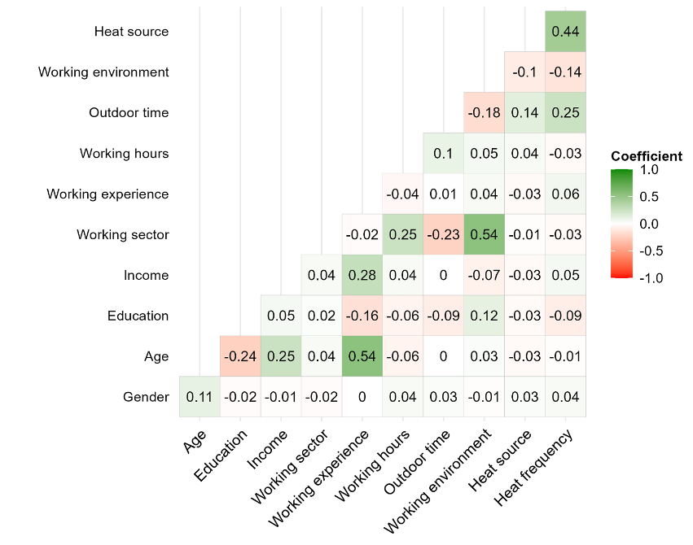 | 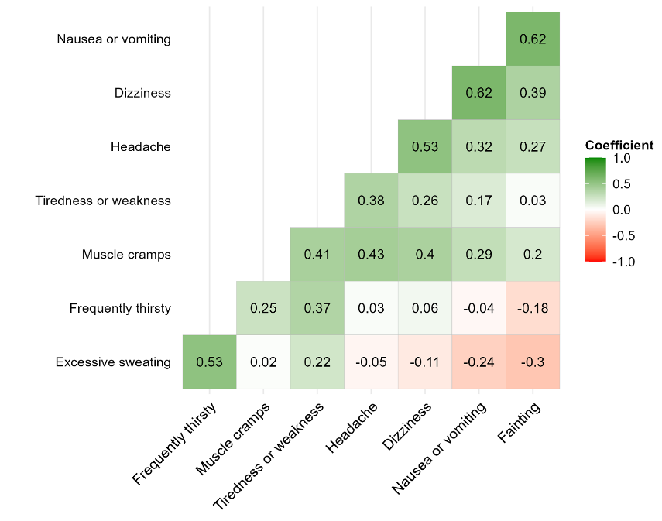
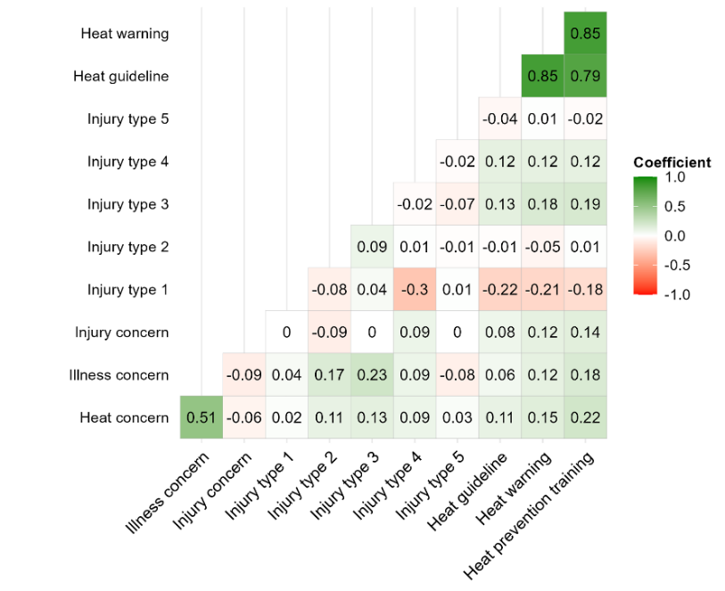 | 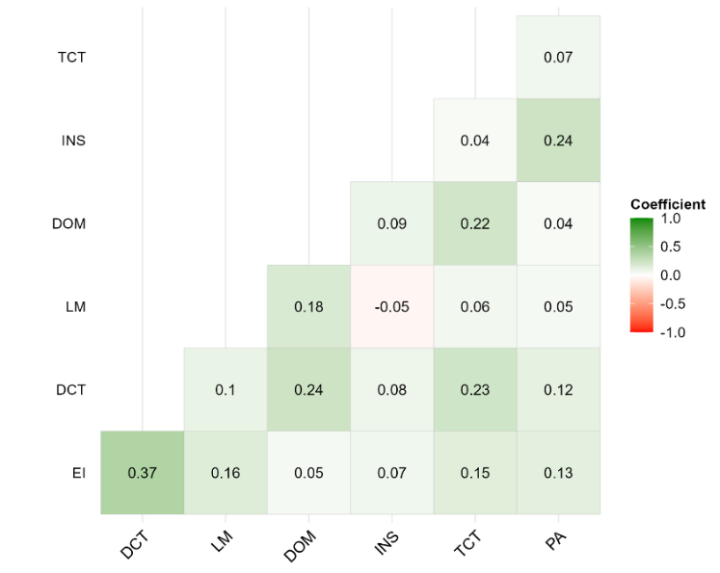

Figure S1. Correlations among independent variables including demographic & working variables (top-left), self-reported heat-related physical illness (top-right), occupational risk perceptions (bottom-left) and self-reported mental health symptoms (bottom-right).

Questionnaire

First of all, we ask a few very general screening questions. The answers help us to target specific questions for you.

Part 1: Screening
- What is your current working place (city)?
○ Dhaka ○ Khulna ○ Barishal
- What is your age group?
○ 18-30 ○ 31-40 ○ 41-50 ○ 51-60 ○60+
Part 2. Climate change risk perceptions
- Are you aware of climate change?
Yes No
- In your opinion, what are the signs of climate change?
Increase in temperature and hot weather
Irregular rainfall pattern
Increased frequency of cyclones and storms
Frequent floods
Prolonged drought
Rising sea level
Lower water level
Saline water
Don’t know
- Do you think climate change could affect the frequency or severity of heat-related stress in your workplace?
Yes No
- What environmental factors influencing the heat exposure in your workplace?
Hot air around the workplace
High humidity in the workplace
Air flow around the workplace
Exposure to direct sunlight or other sources of radiant heat
Others (please specify)
- What are the work-related factors influencing the heat exposure in your workplace?
Type of physical workload
Duration of working hours
Type of protective clothing
Access to cooling systems (e.g., air conditions & fans)
Duration of break/rest hours
Access to shade
Access to drinking water
Type of clothing
Don’t know
- How concerned are you about the potential impacts of climate change on occupational heat stress risks in your workplace?
Not at all concerned all
Slightly concerned
Moderately concerned
Highly concerned
Extremely concerned

Part 3. Occupational heat risk perceptions
- Are you concerned about the heat exposure at your workplace?
○ Yes ○ No
- Have you ever experienced heat illness at your work?
○ Yes ○ No
- If ‘Yes’ in Q10, what types of illness you have experienced to what extent?

 | Never | Rarely | Sometimes | Often | Always
Heavy sweating | ○ | ○ | ○ | ○ | ○
Thirsty | ○ | ○ | ○ | ○ | ○
Cough | ○ | ○ | ○ | ○ | ○
Muscle cramps | ○ | ○ | ○ | ○ | ○
Tiredness or weakness | ○ | ○ | ○ | ○ | ○
Headache | ○ | ○ | ○ | ○ | ○
Dizziness | ○ | ○ | ○ | ○ | ○
Cold, clammy skin | ○ | ○ | ○ | ○ | ○
Nausea or vomiting | ○ | ○ | ○ | ○ | ○
Feeling hot | ○ | ○ | ○ | ○ | ○
Fainting | ○ | ○ | ○ | ○ | ○

- What types of psychological illnesses symptoms you have suffered due to heat stress?
○ None ○ Emotional irritability ○ Difficulty to control temper ○ Low mood ○ Decline of memory ○ Insomnia ○ Trouble on concentration things ○ Little interest on things ○ Poor appetite ○ Others (please specify)
- How concerned are you about the heat illness risk at your work?
Not at all concerned all
Slightly concerned
Moderately concerned
Highly concerned
Extremely concerned
- Have you ever injured yourself at work during hot weather?
○ Yes ○ No ○ Don’t know
- If ‘Yes’ in Q14, what type of injuries you have had?
Falls, trips and slips
Hitting objects
Being hit by moving objects
Burn
Loss of grip and controls due to sweaty hands
Others (please specify)
- Are there any guidelines in your workplace for working during hot weather?
○ Yes ○ No ○ Don’t know
- Have you ever received information or warnings from your authorities or health organizations about staying safe during heatwaves?
○ Yes ○ No ○ Don’t know
- Have you received training on the prevention of heat-related injuries carried out in your work?
○ Yes ○ No ○ Don’t know

Part 4. Heat adaptation strategies of outdoor workers to occupational heat exposure
What are the personal behaviors in what extent you adapted to avoid or deal with heat?
1 = Never do it during hot weather; 2 = Decreases a lot during hot weather; 3 = Decreases during hot weather; 4 = No change during hot weather; 5 = Increases during hot weather
6 = Increases a lot during hot weather
- Follow weather forecast
○ 1 ○ 2 ○ 3 ○ 4 ○ 5 ○ 6
- Frequently drink lots of cool water before feeling thirsty
○ 1 ○ 2 ○ 3 ○ 4 ○ 5 ○ 6
- Wear loose and light-colored clothing while working in hot weather conditions
○ 1 ○ 2 ○ 3 ○ 4 ○ 5 ○ 6
- Take regular breaks away from hot conditions in a cooler or shaded area
○ 1 ○ 2 ○ 3 ○ 4 ○ 5 ○ 6
- Plan and carry out heavy routine outdoor work during the early morning or evening hours or in shaded areas during hot weather
○ 1 ○ 2 ○ 3 ○ 4 ○ 5 ○ 6
- Participate in training programs on working safely in the heat
○ 1 ○ 2 ○ 3 ○ 4 ○ 5 ○ 6
- Slow down work rate to meet hot weather conditions
○ 1 ○ 2 ○ 3 ○ 4 ○ 5 ○ 6
- Use personal protective equipment (e.g., sunglasses, gloves) during hot weather conditions
○ 1 ○ 2 ○ 3 ○ 4 ○ 5 ○ 6
- Use cooling systems like electric fans during hot weather conditions in the workplace
○ 1 ○ 2 ○ 3 ○ 4 ○ 5 ○ 6
Part 5. Demographic information and work characteristics
- What is your gender?
○ Male ○ Female ○ Prefer not to say
- What is your highest education level?
○ No formal education ○ Primary ○ Secondary ○ College ○ Undergraduate or higher
- Which sectors you are working now?
○ Construction site ○ Welding Industry
- What is your regular monthly income (BDT)? (open ended)
- How many years are you working in this current job?
○ <5 ○ 5-9 ○ 10+
- What is your daily working hours? (open ended)
- How much time you spent in outdoors during hot weather (hours in a day)?
○ Below 1h ○ 1-3h ○ 3-5h ○ 5-9h ○ >9h
- How is your workplace environment?
○ Completely outdoor ○ Mainly outdoor ○ Completely indoor ○ Mainly indoor ○ Others (specify)
- Do you work closely any type of heat source (e.g., under sun, fire, welding heat, oven)?
○ No ○ Yes
- If ‘Yes’ what is the frequency of your work around heat source?
○ Never ○ Rarely ○Sometimes ○ Often ○ Always

