Supplementary Information

Direct and Capacitive Electrical Stimulation Shapes Neural Progenitor Cell Survival and Orientation on Conductive Scaffolds

Kelly W. McConnell**, Kamila J. Thompson**, Michael Spaid, Michael Paukshto, Haixia Dai, Zeba Firadous Shaik, Grace Jiang, Haya Bakdounes, Sepideh Kiani Shabestari, Paul M. George*
*Corresponding author: Paul M. George, pgeorge1@stanford.edu

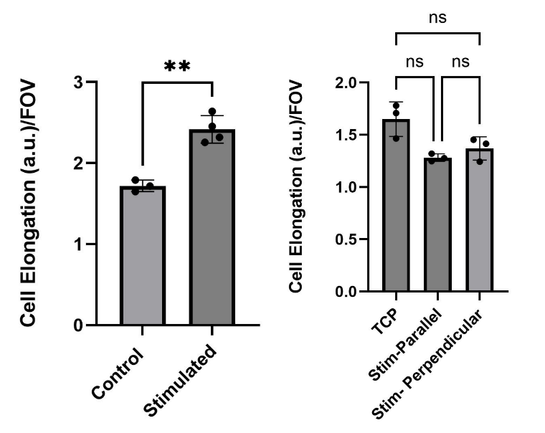
Figure S1: Cell Elongation Calculation for Live/Dead Data. (a) Fraction of cells elongated on the direct stimulation device. Analyzed using unpaired t-test, ***p<0.01, N=3. (b) Fraction of cells elongated on the capacitively coupled device. Analyzed using one-way ANOVA and Tukey’s multiple comparisons test, N=3.
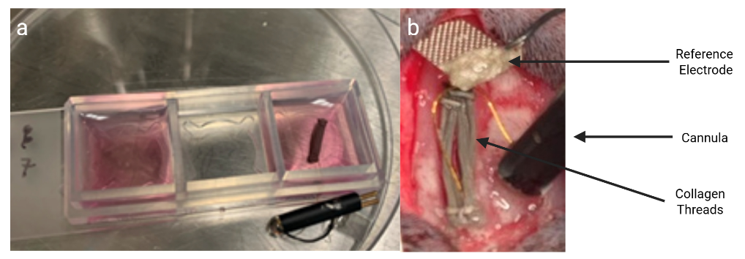
Figure S2: In Vivo Biocompatibility Testing. (a) NPCs cultured on direct stimulation collagen threads 24 hours prior to implantation. (b) Direct stimulation system consisting of the collagen threads with cultured NPCs, reference electrode, and cannula to connect the two and allow for stimulation after surgery.

