Supplementary Material

Table S1. Context, wellbeing, and relational background
Domain / construct | Instrument or questionnaire block | Items (n) | Response format | Scoring / derived indicators | Source / notes
Sociodemographic background | Study questionnaire, Block 0 | 5 core items + age/sex variables | Categorical and ordinal items | Sex/gender self-report, age, perceived family economic situation/social class, living arrangement, and siblings. Used to describe the sample and profile differences. | Ad hoc sociodemographic block in questionnaire; sample described in manuscript.
General wellbeing and life satisfaction | Study questionnaire, Block 0 | 1 happiness item + 6 satisfaction items | Happiness: 1-10; satisfaction items: 1-10 | Items analysed independently (e.g., family, studies, friends, leisure, economic situation, future prospects). These variables appear in descriptive profiling and Table 4 of the manuscript. | Ad hoc wellbeing block in questionnaire.
Perceived relational quality | Study questionnaire, Block 1: positive relationships | 7 items | Relationship items: 1-5; image items: 1-5 | Items analysed independently: family, teachers, friends, classmates, schoolmates, image according to friends, image according to family. Used in cluster characterisation and Table 4. | Ad hoc relational context block in questionnaire.

Table S2. Core mental health and victimisation measures
Domain / construct | Instrument or questionnaire block | Items (n) | Response format | Scoring / derived indicators | Source / notes
General loneliness | RULS-6 short form (as named in questionnaire/manuscript) | 6 | 1 = never to 4 = always | Items averaged to obtain a general loneliness score (SOLEDAD). Item-level indicators were also available in the analytical dataset and several were included in the cluster model. | RULS-6 named in questionnaire/manuscript; computation specified in questionnaire.
Social loneliness | ESTE social loneliness subscale | 7 | 1 = never to 5 = always | Items reverse-scored and averaged to obtain social loneliness (SOLEDAD_SOCIAL). Inverted item variables and composite score were available in the analytical dataset. | Cardona Jiménez et al. (2010), as cited in questionnaire; adolescent use cited in questionnaire (Cano et al., 2023).
Family loneliness | Family loneliness block | 4 | 1 = never to 5 = always | Items reverse-scored and averaged to obtain family loneliness (SOLEDAD_FAMILIAR). Inverted item variables and composite score were available in the analytical dataset. | Questionnaire block with explicit recoding instructions.
Suicidal ideation / suicidality | Paykel Suicide Scale | 5 | Dichotomous yes/no | Sum score from 0 to 5. The analytical dataset included both the full score and a partial ideation score (e.g., 3-item ideation indicator), while item-level suicidal ideation indicators were also available. | Fonseca-Pedrero et al. (2018), as cited in questionnaire.
Depressive symptoms | DASS-21 depression subscale | 7 | 0 = not at all to 3 = most of the time | Seven depression items averaged to obtain the depression score used in the analytical dataset (DEPRESION/DEPRESIÓN). Item-level indicators were also available. | Fonseca-Pedrero et al. (2010), as cited in questionnaire.
Bullying victimisation | Study questionnaire, Block 1: relational bullying victimisation | 6 | 1 = never to 5 = always | Item means available for each bullying indicator; the analytical dataset also included a bullying composite (BULLYING). Used both at item level and as a descriptive composite. | Ad hoc victimisation block in questionnaire.
Cyberbullying victimisation | Study questionnaire, Block 1: cyberbullying victimisation | 12 | 1 = never to 5 = always | Item means available for each cyberbullying indicator; the analytical dataset also included a cyberbullying composite (CYBERBULLYING). Used both at item level and as a descriptive composite. | Ad hoc victimisation block in questionnaire.

Table S3. Digital use, socio-emotional functioning, and social skills
Domain / construct | Instrument or questionnaire block | Items (n) | Response format | Scoring / derived indicators | Source / notes
Problematic internet/mobile use | CERM - Cuestionario de Experiencias Relacionadas con el Móvil | 10 | 1 = almost never to 5 = always | Items averaged to obtain the problematic internet/mobile use score (PIU). The manuscript refers to this construct as problematic internet use. | Instrument name and computation reported in questionnaire.
Appearance concern in social media | Social media appearance concern block | 3 | 1 = totally disagree to 5 = totally agree | Three items averaged to obtain concern about appearance in social networks (APARIENCIA / concern about appearance). Used in Table 4 and discussion. | Questionnaire block on social media appearance.
Online socio-emotional competences | E-socioemotional competences block | 25 (5 subscales x 5 items) | 0 = never to 10 = always | Subscales: e-emotional awareness, e-regulation, e-impulsivity self-control, e-emotional autonomy, and e-social competence. The analytical dataset included derived composites such as ECONCIENCIA, EREGULACION, EAUTOCONTROL, EAUTONOMIA, and ECSOCIAL. | Cebollero et al. (2020), as named in questionnaire.
Offline emotional regulation | Offline emotional regulation block | 10 | 1 = totally disagree to 7 = totally agree | Items averaged to obtain REGULACION_EMOCIONAL. Individual regulation items were also available in the analytical dataset and some entered the cluster solution. | Questionnaire block with explicit scoring instructions.
Social goals | Social goals block: avoidance and popularity | 8 (4 + 4) | 1 = not at all true to 5 = completely true | Two composite indicators were derived: social goals-avoidance and social goals-popularity (MS_EVITACION and MS_POPULARIDAD). | Questionnaire block with explicit scoring instructions.
Social self-esteem | Social self-esteem block | 6 | 1 = not at all true to 5 = completely true | Items with reverse coding where required; used to obtain AUTOESTIMA_SOCIAL / social self-esteem. Item-level variables were also available. | Questionnaire block with explicit reverse-scoring instructions.
Social skills | Social skills block | 12 | 1 = totally false to 5 = totally true | The questionnaire generated derived composites for communication/social skills, assertiveness, and conflict resolution, reflected in the analytical dataset (HABILIDADES_COMYSOC, ASERTIVIDAD, RES_CONFLICTOS). | Questionnaire block with specified derived indicators.

Note. These tables summarise the principal measures used to construct and characterise the cluster solution. When a formal source reference was explicitly available in the questionnaire, it is reported here. For ad hoc questionnaire blocks or derived composites without a full reference in the available materials, the instrument/block is labelled as such. The manuscript states that all indicators were standardised to Z scores prior to cluster estimation.
Abbreviations. PIU = problematic internet use; RULS-6 = six-item Revised UCLA Loneliness Scale short form; DASS-21 = Depression Anxiety and Stress Scales-21; CERM = Cuestionario de Experiencias Relacionadas con el Móvil.

This supplementary figure presents the within-cluster sum of squares (WSS) for K-means solutions from k = 2 to k = 6. The curve shows a visible inflection at k = 4, supporting the choice of the four-cluster solution on both statistical and interpretative grounds.
Figure S1. Elbow plot for cluster solutions from k = 2 to k = 6.
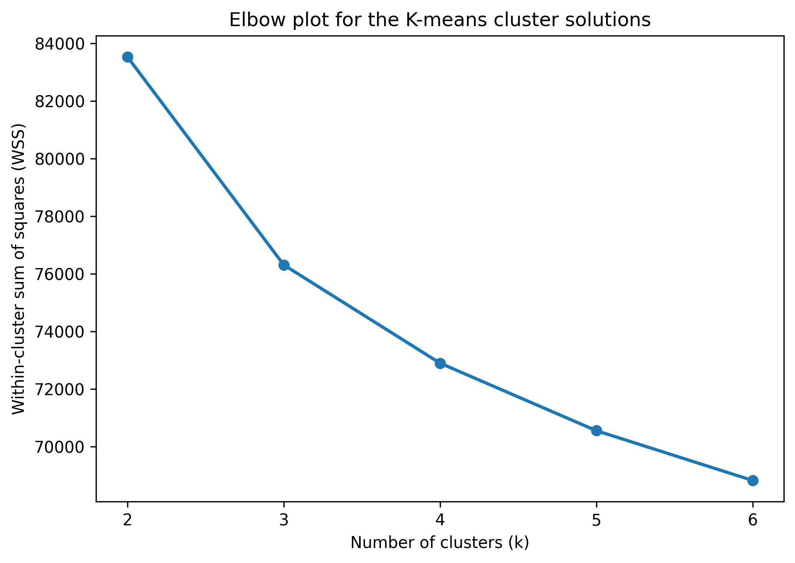
Note. The figure presents the within-cluster sum of squares (WSS) across candidate cluster solutions. The visible inflection at k = 4 supports the choice of the four-cluster solution.

