Substance | Activity* | R | p value
As  (1 week) | All activities | -0.165 | 0.19
As  (1 week) | Enclosed building fires | -0.03 | 0.81
As  (1 week) | Open field fires | 0.039 | 0.76
As  (1 week) | Vehicle fires | 0.099 | 0.43
As  (1 week) | Fire suppression drills | 0.197 | 0.12
Pb  (1 month) | All activities | 0.172 | 0.17
Pb  (1 month) | Enclosed building fires | 0.127 | 0.31
Pb  (1 month) | Open field fires | 0.163 | 0.19
Pb  (1 month) | Vehicle fires | 0.007 | 0.96
Pb  (1 month) | Fire suppression drills | 0.057 | 0.65
Hg  (3 months) | All activities | -0.015 | 0.91
Hg  (3 months) | Enclosed building fires | 0.071 | 0.57
Hg  (3 months) | Open field fires | -0.082 | 0.52
Hg  (3 months) | Vehicle fires | -0.143 | 0.26
Hg  (3 months) | Fire suppression drills | 0.041 | 0.74
COHb  (3 months) | All activities | 0.092 | 0.42
COHb  (3 months) | Enclosed building fires | 0.136 | 0.23
COHb  (3 months) | Open field fires | 0.13 | 0.25
COHb  (3 months) | Vehicle fires | 0.156 | 0.17
COHb  (3 months) | Fire suppression drills | -0.131 | 0.24
Cd  (2 years) | All activities | -0.135 | 0.26
Cd  (2 years) | Enclosed building fires | -0.05 | 0.68
Cd  (2 years) | Open field fires | -0.09 | 0.45
Cd  (2 years) | Vehicle fires | -0.077 | 0.52
Cd  (2 years) | Fire suppression drills | -0.03 | 0.8

Supplemental Table 1: correlations of metals and carboxyhemoglobin with firefighting activities
*Activities performed during the relevant period for substance elimination from the body. The relevant period for each substance is indicated in parentheses by the substance.

Supplemental Table 2: Metal concentrations by role group
 | Command-level  N = 13¹ | Mid-level  N = 42¹ | Firefighters/Others  N = 33¹ | p-value¹
Cr | 0.36 (0.19-0.51) | 0.21 (0.13-0.42) | 0.23 (0.13-0.50) | 0.7
Ni | 0.36 (0.19-0.60) | 0.23 (0.13-0.56) | 0.23 (0.15-1.00) | 0.9
As | 10 (5-19) | 9 (5-16) | 9 (5-18) | 0.8
Pb | 0.19 (0.18-0.31) | 0.22 (0.13-0.33) | 0.15 (0.10-0.28) | 0.3
Hg | 0.27 (0.20-0.45) | 0.35 (0.22-0.55) | 0.29 (0.25-0.47) | 0.6
Cd | 0.28 (0.16-0.57) | 0.24 (0.19-0.39) | 0.18 (0.11-0.25) | 0.008
COHb | 1.80 (1.70-2.20) | 1.95 (1.80-3.30) | 2.10 (1.80-3.60) | 0.5

Values presented as Median (Q1-Q3)
²Kruskal-Wallis rank sum test

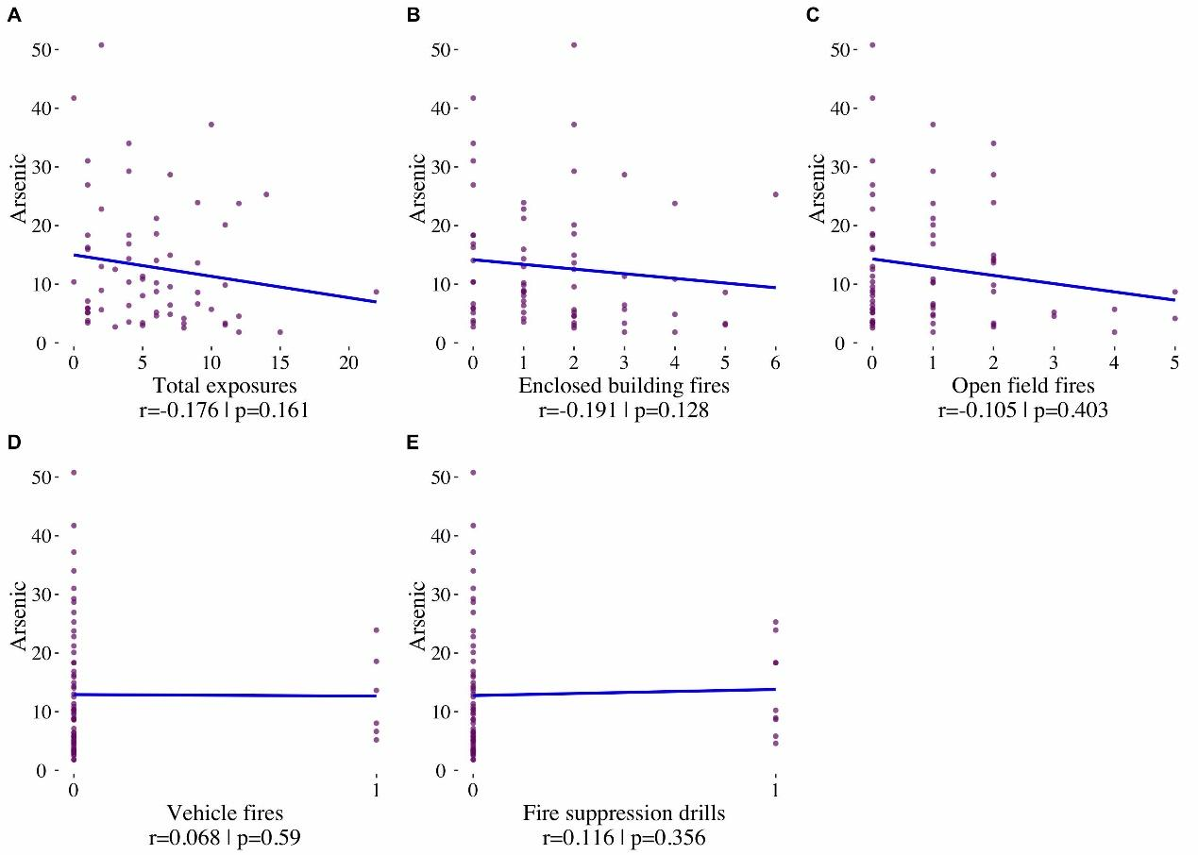
Supplemental Figure 1: Correlations between As levels and the number of total fire exposures (A), enclosed building fires (B), open field fires (C), vehicle fires (D) and fire suppression drills (E) during one week preceding recruitment to the study.

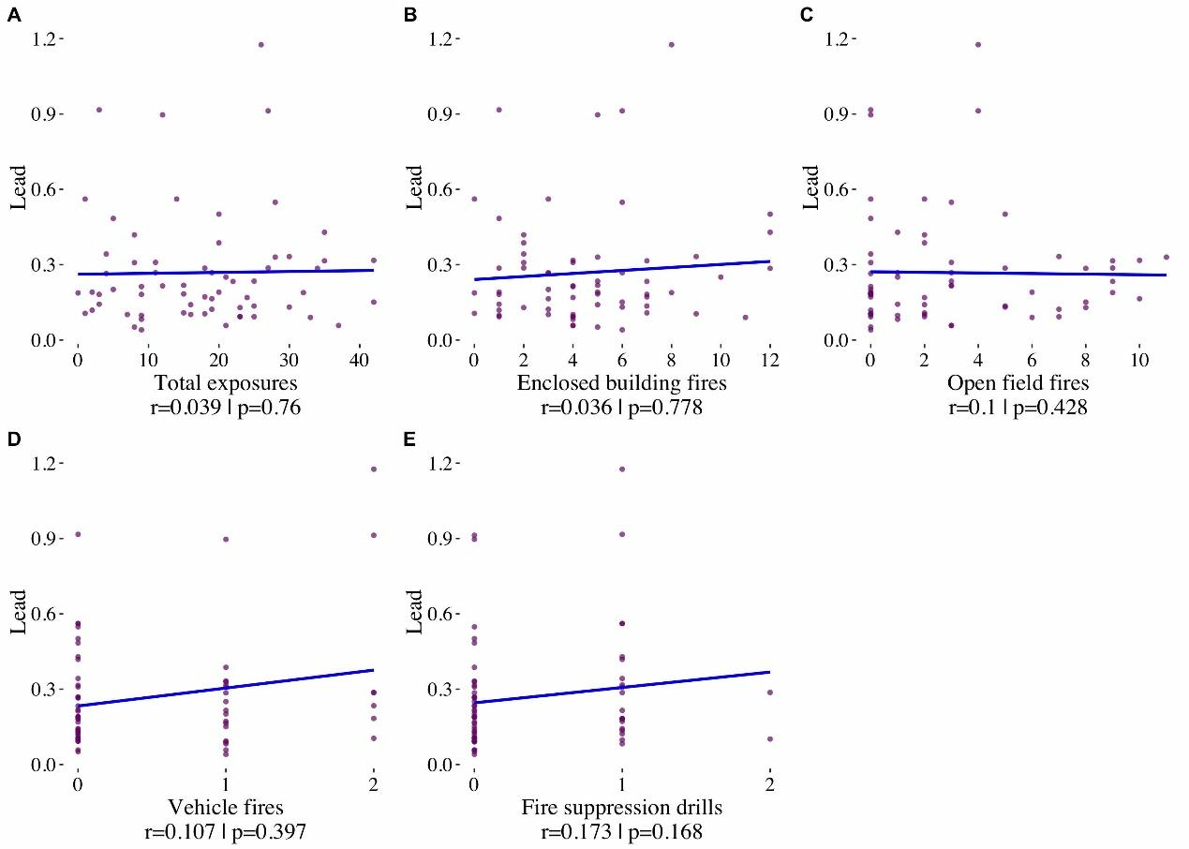
Supplemental Figure 2: Correlations between Pb levels and the number of total fire exposures (A), enclosed building fires (B), open field fires (C), vehicle fires (D) and fire suppression drills (E) during one month preceding recruitment to the study.

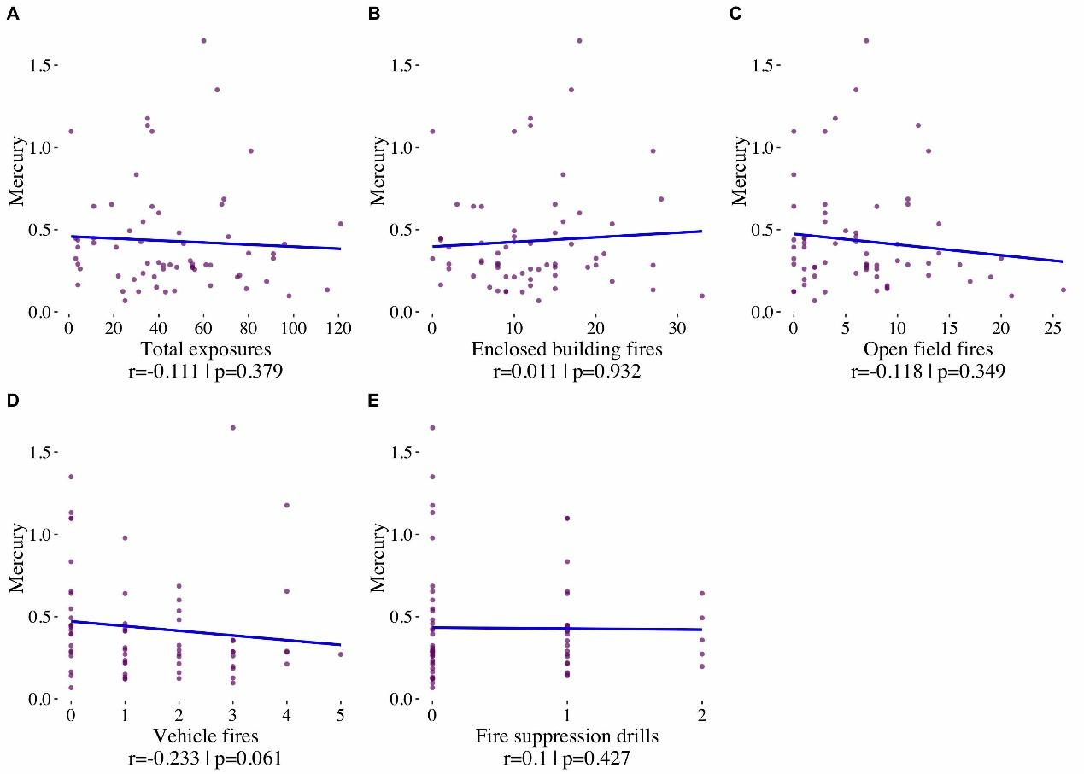
Supplemental Figure 3: Correlations between Hg levels and the number of total fire exposures (A), enclosed building fires (B), open field fires (C), vehicle fires (D) and fire suppression drills (E) during 3 months preceding recruitment to the study.

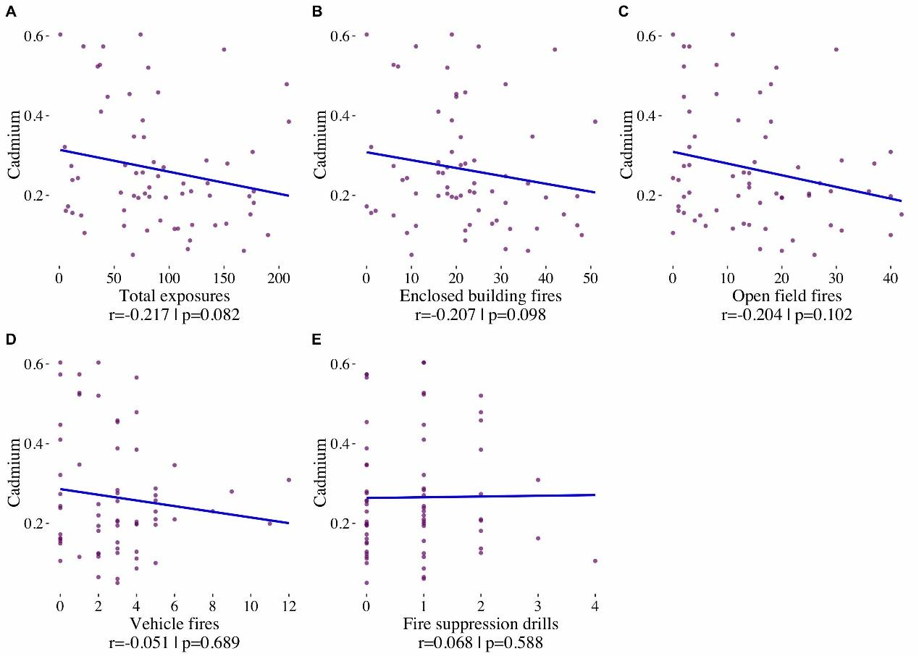
Supplemental Figure 4: Correlations between Cd levels and the number of total fire exposures (A), enclosed building fires (B), open field fires (C), vehicle fires (D) and fire suppression drills (E) during 2 years preceding recruitment to the study.

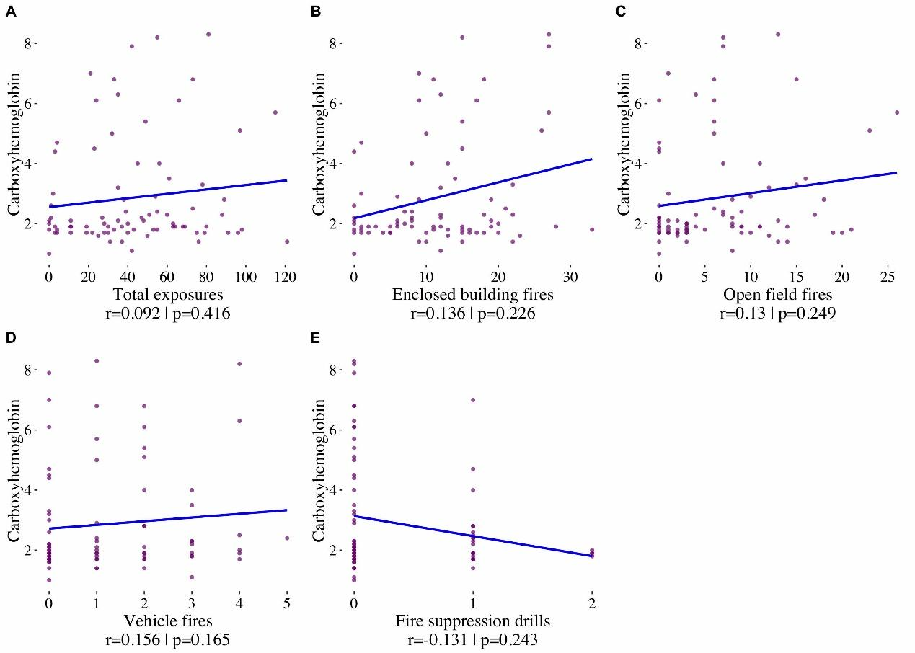
Supplemental Figure 5: Correlations between COHb levels and the number of total fire exposures (A), enclosed building fires (B), open field fires (C), vehicle fires (D) and fire suppression drills (E) during 3 months preceding recruitment to the study.

