Supplementary data

¹H-NMR Spectra
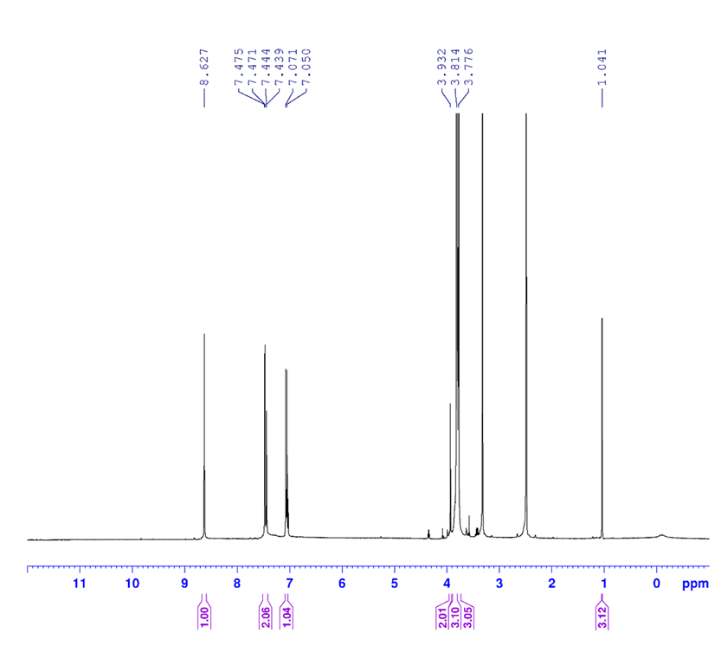
Figure 1S. (E)-3-(((E)-3,4-dimethoxybenzylidene)amino)-2-(methylimino)thiazolidin-4-one (7a)

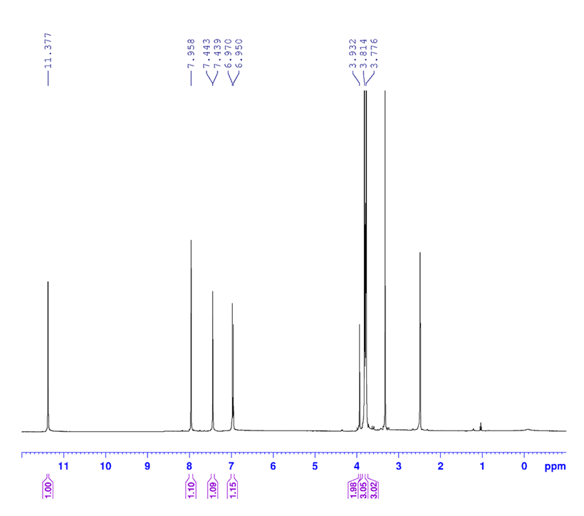
Figure 2S. N-((E)-3-(((E)-3,4-dimethoxybenzylidene)amino)-4-oxothiazolidin-2-ylidene)nitramide (7b)

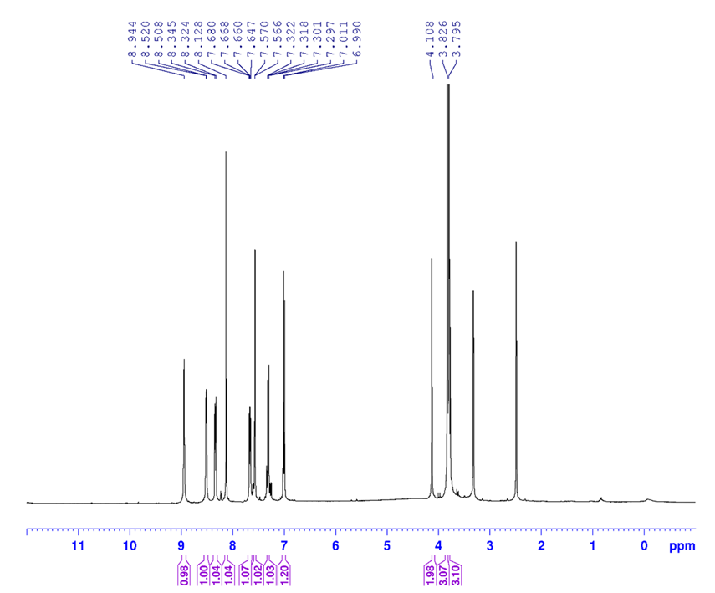
Figure 3S. (E)-3-(((E)-3,4-dimethoxybenzylidene)amino)-2-(pyridin-2-ylimino)thiazolidin-4-one (7c)

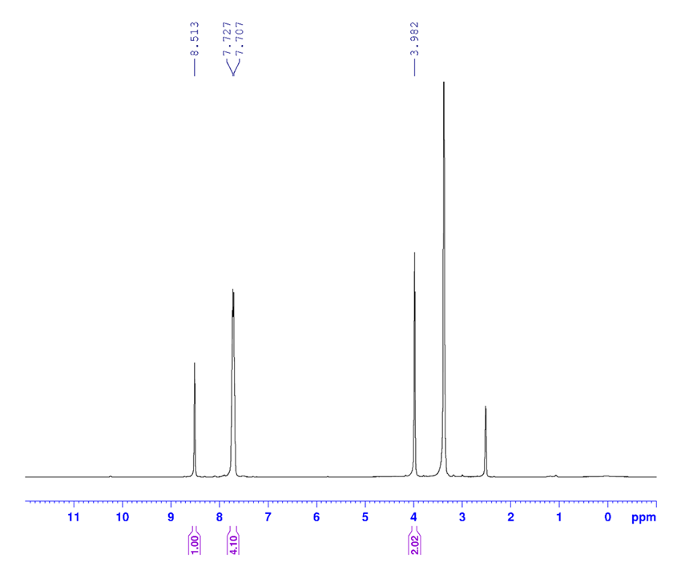
Figure 4S. N-((E)-3-(((E)-4-bromobenzylidene)amino)-4-oxothiazolidin-2-ylidene)nitramide (7d)

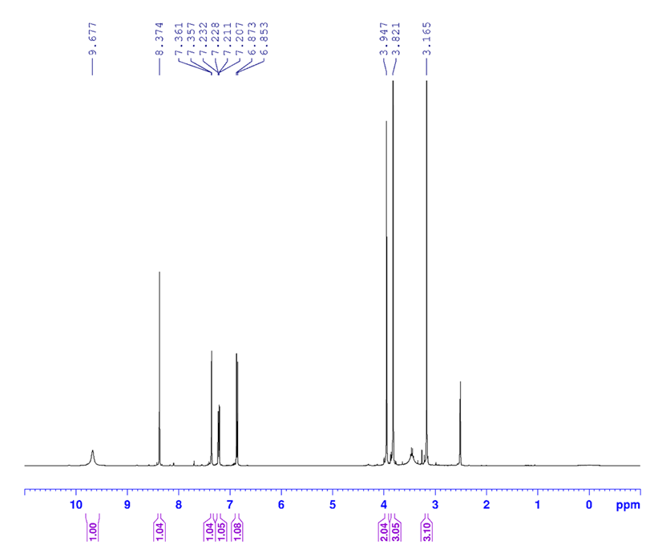
Figure 5S. (E)-3-(((E)-4-hydroxy-3-methoxybenzylidene)amino)-2-(methylimino)thiazolidin-4-one (7e)

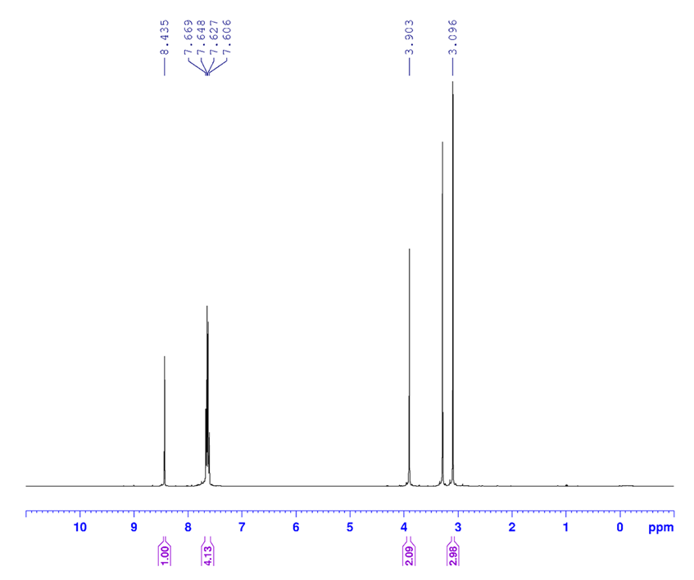
Figure 6S. (E)-3-(((E)-4-bromobenzylidene)amino)-2-(methylimino)thiazolidin-4-one (7f)

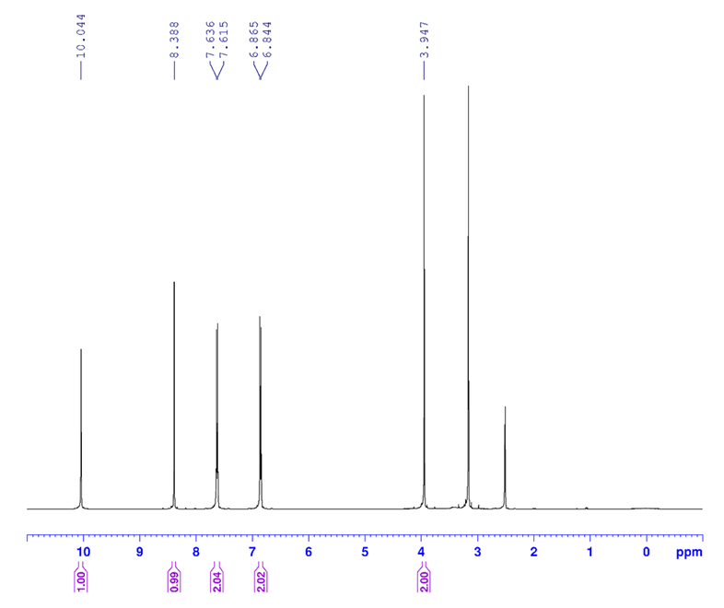
Figure 7S. N-((E)-3-(((E)-4-hydroxybenzylidene)amino)-4-oxothiazolidin-2-ylidene)nitramide (7g)

¹³C-NMR Spectra
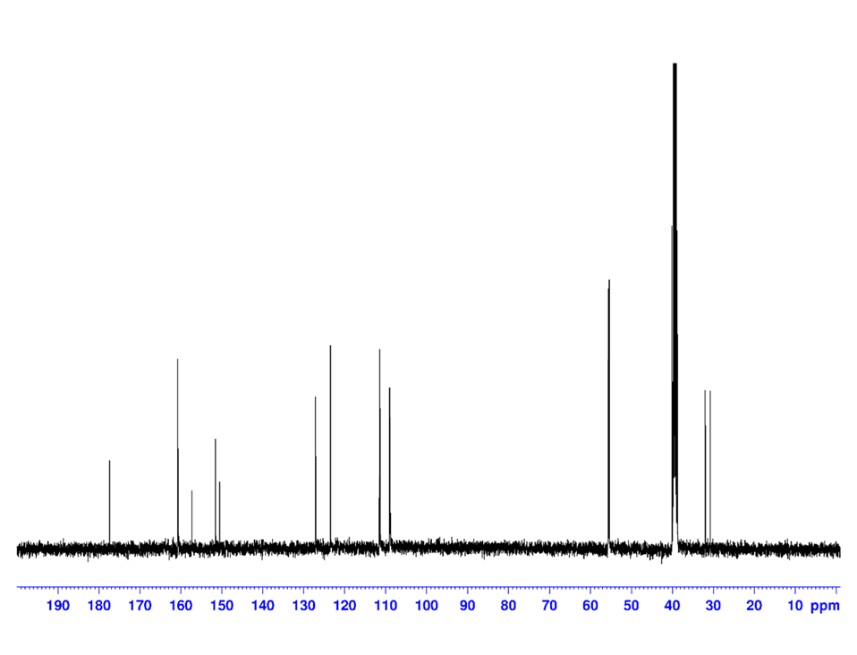
Figure 8S. (E)-3-(((E)-3,4-dimethoxybenzylidene)amino)-2-(methylimino)thiazolidin-4-one (7a)

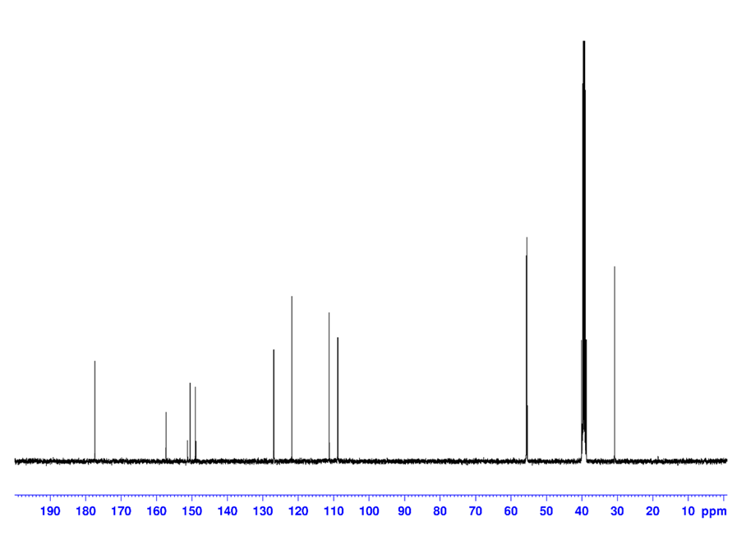
Figure 9S. N-((E)-3-(((E)-3,4-dimethoxybenzylidene)amino)-4-oxothiazolidin-2-ylidene)nitramide (7b)

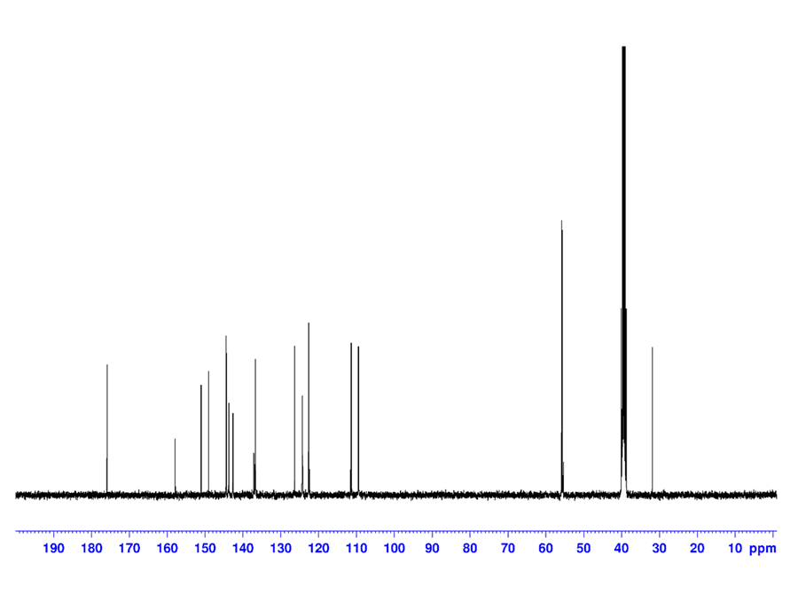
Figure 10S. (E)-3-(((E)-3,4-dimethoxybenzylidene)amino)-2-(pyridin-2-ylimino)thiazolidin-4-one (7c)

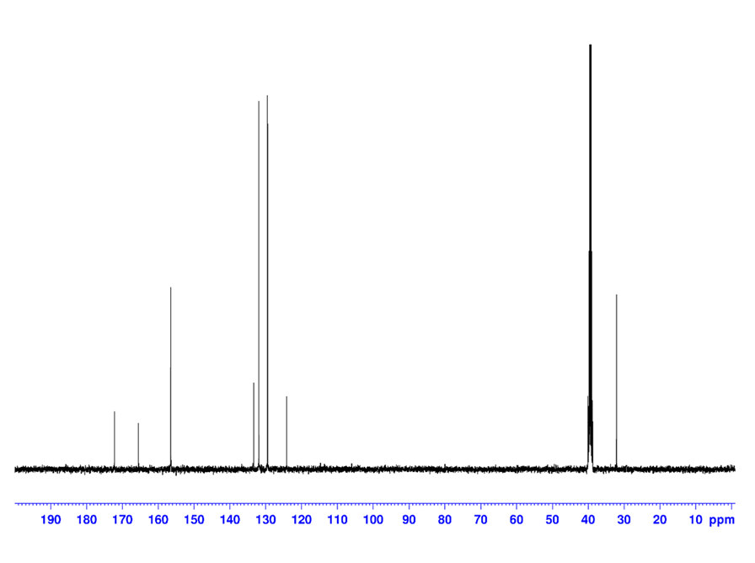
Figure 11S. N-((E)-3-(((E)-4-bromobenzylidene)amino)-4-oxothiazolidin-2-ylidene)nitramide (7d)

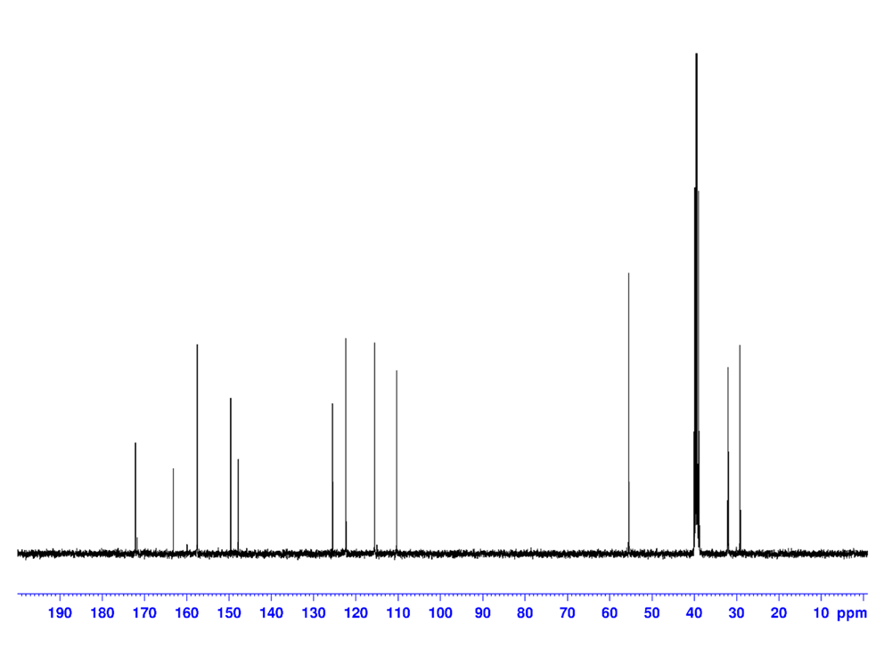
Figure 12S. (E)-3-(((E)-4-hydroxy-3-methoxybenzylidene)amino)-2-(methylimino)thiazolidin-4-one (7e)

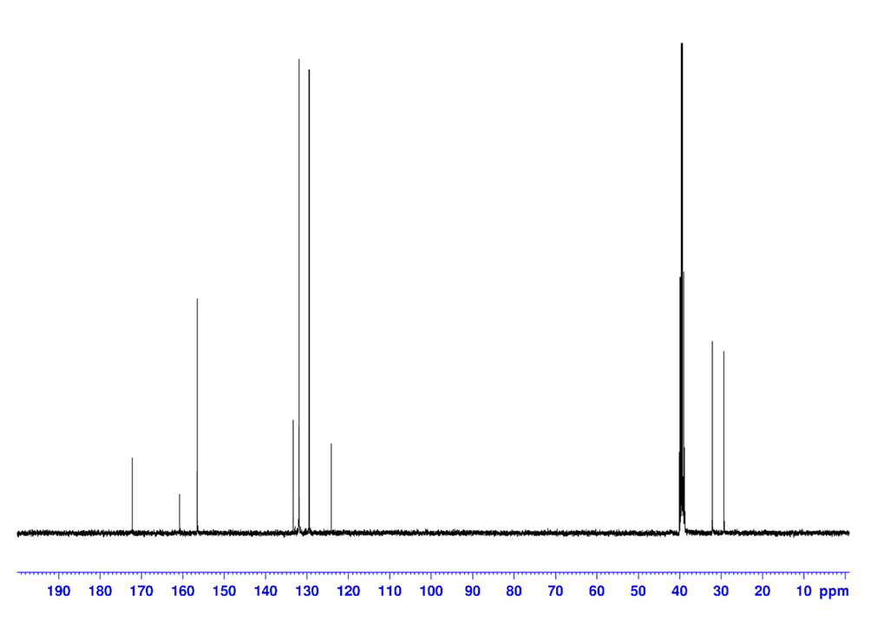
Figure 13S. (E)-3-(((E)-4-bromobenzylidene)amino)-2-(methylimino)thiazolidin-4-one (7f)

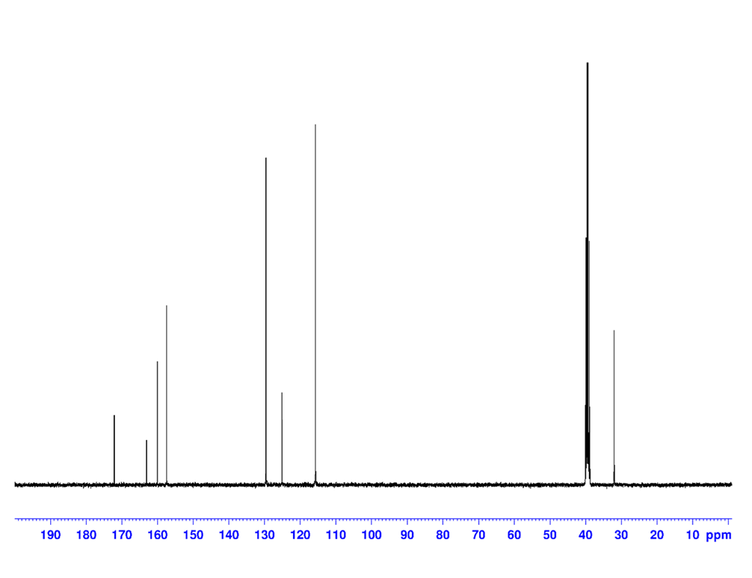
Figure 14S. N-((E)-3-(((E)-4-hydroxybenzylidene)amino)-4-oxothiazolidin-2-ylidene)nitramide (7g)

FT-IR Spectra
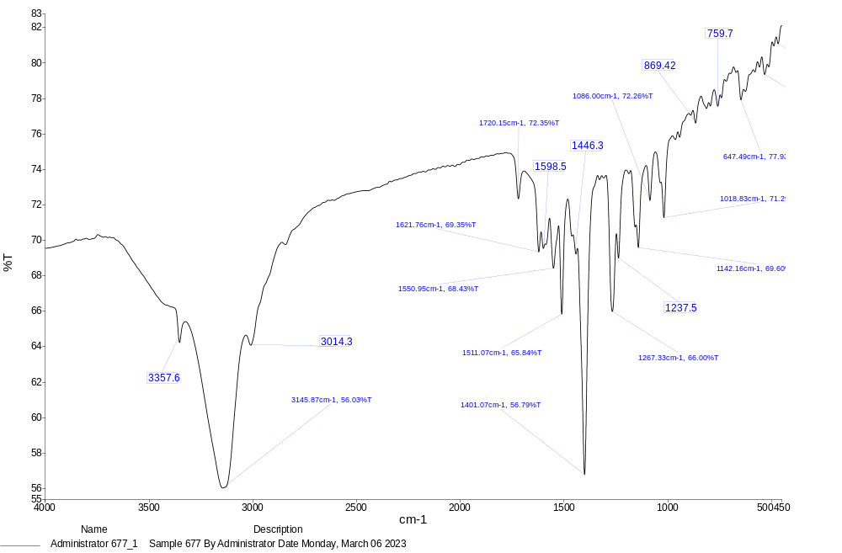
Figure 15S. (E)-3-(((E)-3,4-dimethoxybenzylidene)amino)-2-(methylimino)thiazolidin-4-one (7a)

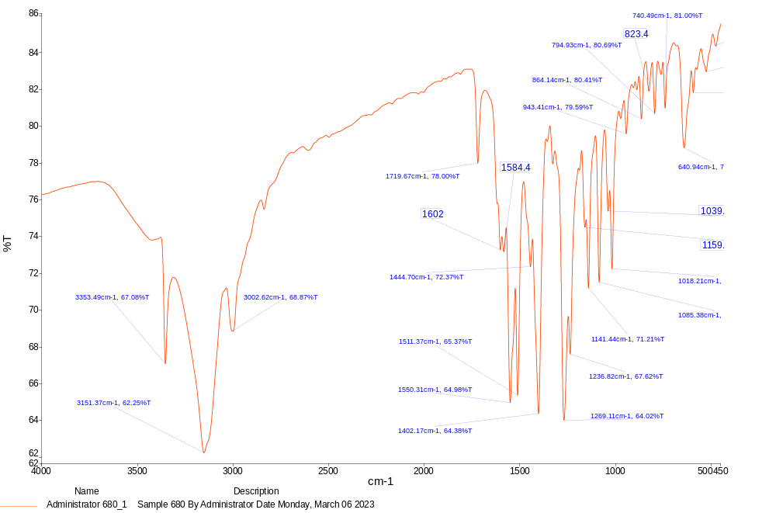
Figure 16S. N-((E)-3-(((E)-3,4-dimethoxybenzylidene)amino)-4-oxothiazolidin-2-ylidene)nitramide (7b)

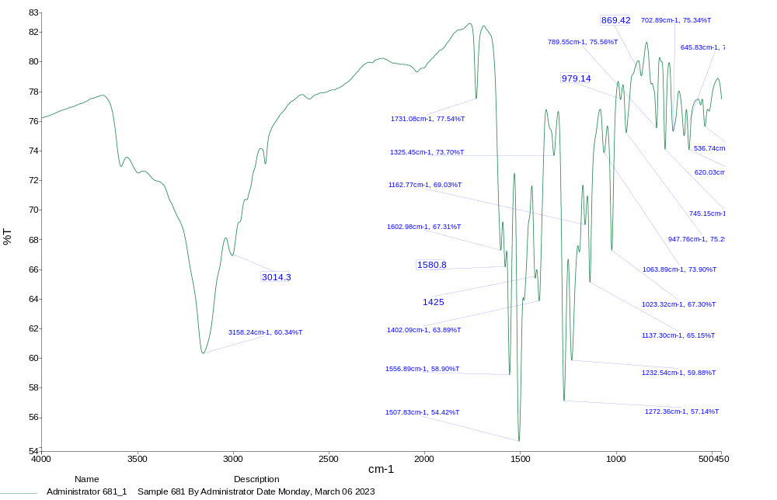
Figure 17S. (E)-3-(((E)-3,4-dimethoxybenzylidene)amino)-2-(pyridin-2-ylimino)thiazolidin-4-one (7c)

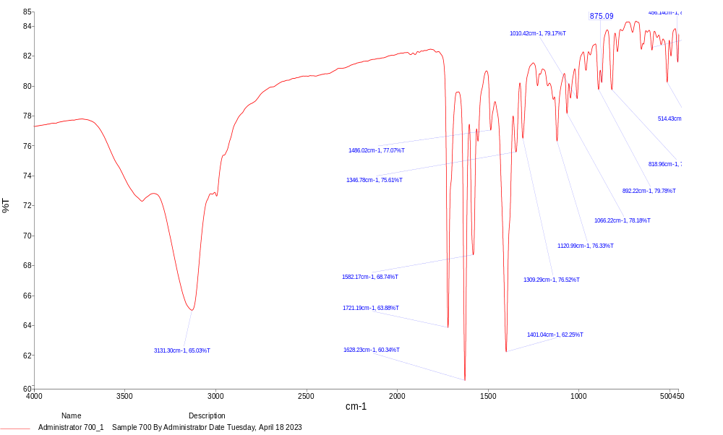
Figure 18S. N-((E)-3-(((E)-4-bromobenzylidene)amino)-4-oxothiazolidin-2-ylidene)nitramide (7d)

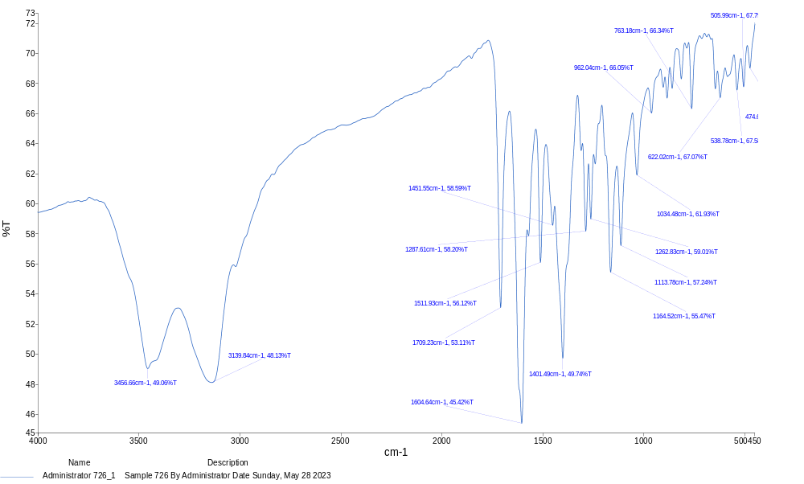
Figure 19S. (E)-3-(((E)-4-hydroxy-3-methoxybenzylidene)amino)-2-(methylimino)thiazolidin-4-one (7e)

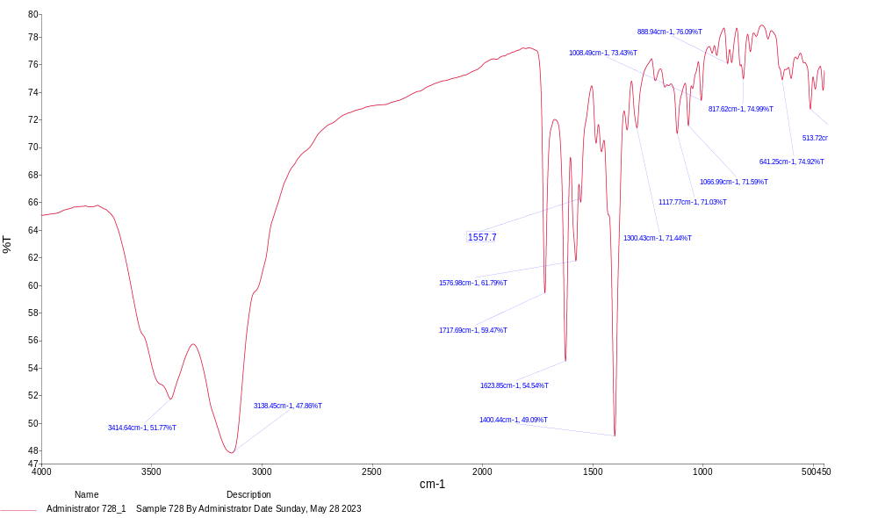
Figure 20S. (E)-3-(((E)-4-bromobenzylidene)amino)-2-(methylimino)thiazolidin-4-one (7f)

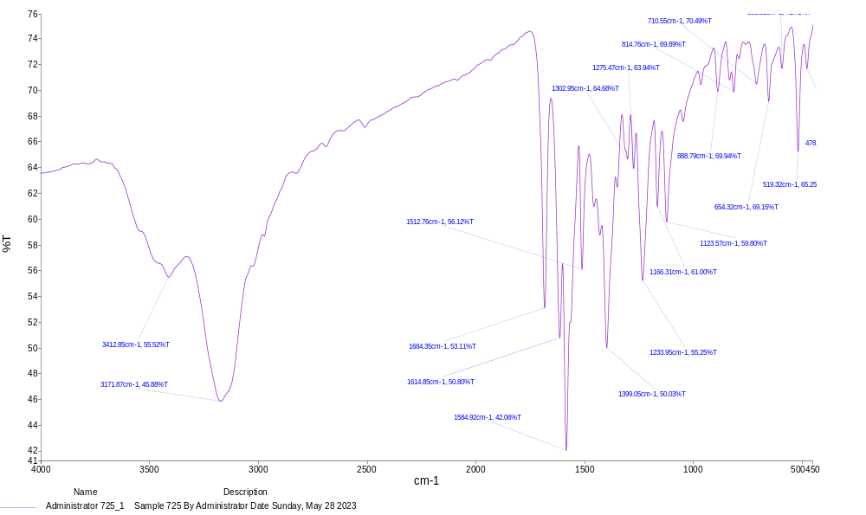
Figure 21S. N-((E)-3-(((E)-4-hydroxybenzylidene)amino)-4-oxothiazolidin-2-ylidene)nitramide (7g)

