Supplement

Associations of the Uric Acid–to–High-Density Lipoprotein Cholesterol Ratio With Hypertension: Evidence From the China Health and Retirement Longitudinal Study

Chaoyang Liang, Lan Gao

Table S1. Baseline Characteristics of Participants Included in and Excluded from the Analysis.
Variables | Participants excluded | Participants in the analysis
Age | 58.34 (10.84) | 59.58 (9.43)
Sex
Men | 4160 (49.2%) | 4318 (46.7%)
Women | 4291 (50.8%) | 4937 (53.3%)
Antihypertensives
No | 6887 (81.5%) | 7470 (80.7%)
Yes | 1566 (18.5%) | 1785 (19.3%)
Glucose-lowering medications
No | 8101 (95.8%) | 8920 (96.4%)
Yes | 352 (4.2%) | 335 (3.6%)
Lipid_lowering drugs
No | 8062 (95.4%) | 8755 (94.6%)
Yes | 391 (4.6%) | 500 (5.4%)
DM
No | 7757 (91.8%) | 7864 (85.0%)
Yes | 696 (8.2%) | 1391 (15.0%)
Hypertension
No | 5697 (67.4%) | 5411 (58.5%)
Yes | 2756 (32.6%) | 3844 (41.5%)
CVD
No | 7298 (86.3%) | 7996 (86.4%)
Yes | 1155 (13.7%) | 1233 (13.3%)
Missing | 0 (0.0%) | 26 (0.3%)
CKD
No | 8019 (94.9%) | 8636 (93.3%)
Yes | 434 (5.1%) | 546 (5.9%)
Missing | 0 (0.0%) | 73 (0.8%)
Educational levels
High-School or Below | 8163 (96.6%) | 9153 (98.9%)
College degree or higher | 274 (3.2%) | 102 (1.1%)
Unknown | 16 (0.2%) | 0 (0.0%)
Smoking status
Never | 5017 (59.4%) | 5611 (60.6%)
Ever | 3297 (39.0%) | 3634 (39.3%)
Missing | 135 (1.6%) | 10 (0.1%)
Drinking status
Never | 5226 (61.8%) | 5638 (60.9%)
Ever | 3222 (38.1%) | 3601 (38.9%)
Missing | 5 (0.1%) | 16 (0.2%)
CKD, chronic kidney disease. CVD, cardiovascular disease. DM,diabetes mellitus

Table S2. Associations Between UHR and Hypertension odds Across Five Multiple Imputation Datasets and Pooled Estimates
 | Data set 1 | Data set 2 | Data set 3 | Data set 4 | Data set 5 | Pooled results
 | OR (95% CI) | OR (95% CI) | OR (95% CI) | OR (95% CI) | OR (95% CI) | OR (95% CI)
Per 1-SD increase | 1.22 (1.16, 1.28) | 1.22 (1.16, 1.28) | 1.22 (1.16, 1.28) | 1.22 (1.16, 1.28) | 1.22 (1.16, 1.28) | 1.22 (1.16, 1.28)
Low (< 8.65) | Ref | Ref | Ref | Ref | Ref
High (≥ 8.65) | 1.47 (1.34, 1.61) | 1.47 (1.34, 1.61) | 1.47 (1.34, 1.61) | 1.47 (1.34, 1.61) | 1.47 (1.34, 1.61) | 1.47 (1.34, 1.61)
Values are odds ratios (ORs) with 95% confidence intervals (CIs) from logistic regression models. Results were combined from five multiple imputation datasets using Rubin’s rules.
Models were adjusted for age, sex , smoking status, drinking status, physical activity, body mass index, cardiovascular disease, chronic kidney disease,and diabetes.

Table S3. Associations Between UHR and the Odds of Hypertension After Additional Covariate Adjustment
Exposure | Case | Proportion (%) | OR (95% CI) | P-value
UHR
Per 1-SD increase | 3844 | 41.53 | 1.11 (1.05, 1.18) | 0.025
Low versus high
Low (< 8.65) | 1640 | 35.3 | Ref.
High (≥ 8.65) | 2204 | 47.8 | 1.28 (1.15, 1.43) | <0.001
The Model was adjusted for age, sex , smoking status, drinking status, physical activity, body mass index, cardiovascular disease, chronic kidney disease, diabetes, C-reactive protein, antihypertensive, lipid-lowering durgs, glucose-lowering medications, and hyperlipidemia.

Table S4. Associations of the UHR with the odds of hypertension, evaluated using multivariate logistic regression.
Exposure | Case | Proportion (%) | OR (95% CI) | P-value
UHR
Per 1-SD increase | 3844 | 41.53 | 1.23 (1.15, 1.31) | <0.001
Low versus high
Low (< 8.65) | 1640 | 35.3 | Ref.
High (≥ 8.65) | 2204 | 47.8 | 1.50 (1.32, 1.71) | <0.001
Model was adjusted for age, sex, smoking status, drinking status, physical activity, body mass index, cardiovascular disease, chronic kidney disease, diabetes, and systolic blood pressure.

Table S5. E-values for the Association Between UHR and Hypertension Risk.
Hypertension | OR (95% CI) | P value | E-value
UHR | 1.21 (1.15, 1.28) | <0.001 | 1.56
Per 1-SD increase
Low (< 8.65) | Ref.
High (≥ 8.65) | 1.46 (1.33, 1.61) | <0.001 | 1.99
Values are odds ratios (ORs) with 95% confidence intervals (CIs) from multivariable logistic regression models.
E-values represent the minimum strength of association that an unmeasured confounder would need to have with both the exposure and the outcome to fully explain away the observed association.
Models were adjusted for age, sex , smoking status, drinking status, physical activity, body mass index, cardiovascular disease, chronic kidney disease, and diabetes.

Table S6. Sensitivity Analysis of the Associations of UHR With Hypertension Odds Defined by Self-Report and Antihypertensive Medication Use.
 |  |  | Model 1 |  | Model 2 |  | Model 3
Exposure | Case | Proportion (%) | OR (95% CI) | P-value | OR (95% CI) | P-value | OR (95% CI) | P-value
UHR
Per 1-SD increase | 2493 | 26.94 | 1.46 (1.38, 1.53) | <0.001 | 1.35 (1.28, 1.42) | <0.001 | 1.10 (1.02, 1.19) | 0.011
Low versus high
Low (< 8.65) | 971 | 20.9 | Ref. |  | Ref. |  | Ref.
High (≥ 8.65) | 1522 | 33 | 2.01 (1.83, 1.22) | <0.001 | 1.75 (1.58, 1.94) | <0.001 | 1.25 (1.05, 1.49) | 0.01
Model 1 was adjusted for age and sex.
Model 2 was adjusted for age, sex , smoking status, drinking status, physical activity.
Model 3 was adjusted for age, sex , smoking status, drinking status, physical activity, body mass index, cardiovascular disease, chronic kidney disease, and diabetes.

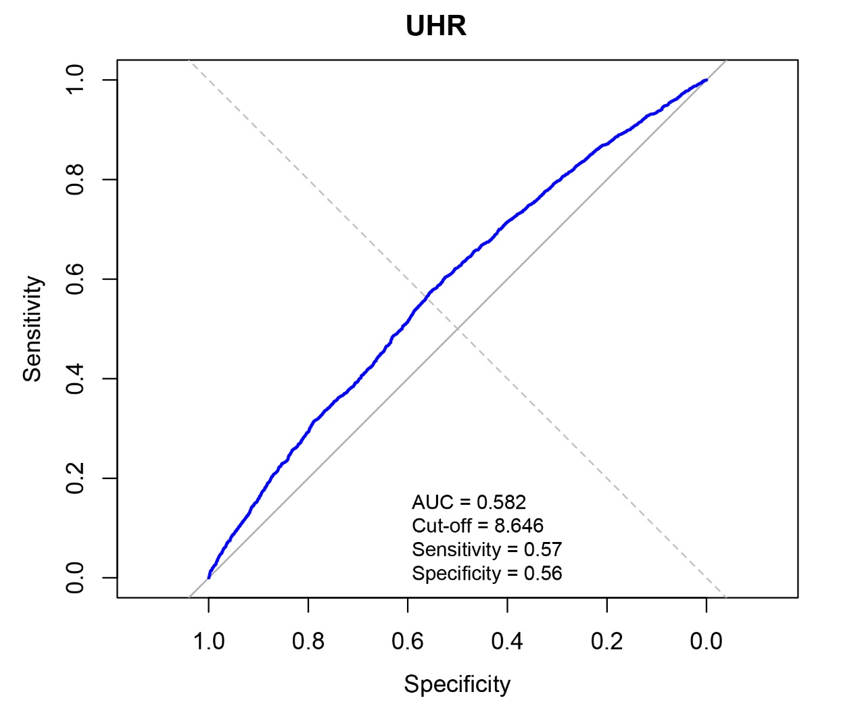
Figure S1. Receiver Operating Characteristic Curve of the Uric Acid–to–HDL Cholesterol Ratio (UHR) for Hypertension odds

The optimal cutoff value of UHR for identifying hypertension was 8.65, yielding an area under the curve (AUC) of 0.582, with a sensitivity of 0.57 and specificity of 0.56.

