Supplementary Figure 1- Original blots for gel image

- anti-IFN alpha2b/beta
(pSTAT1)
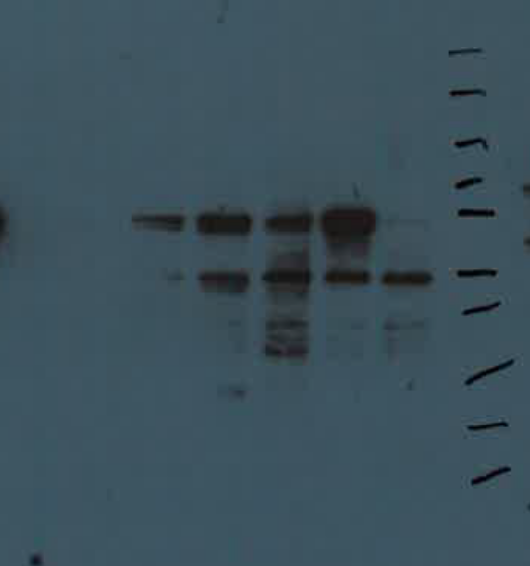
75kDa
(STAT1)
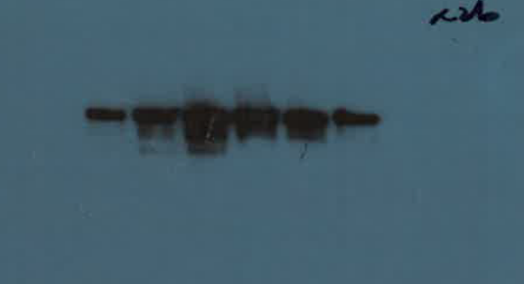
75kDa
(GAPDH)
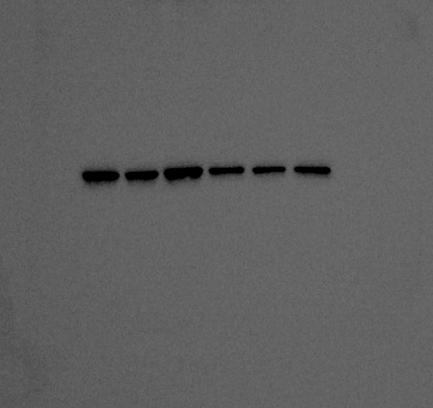
37kDa

- anti-IFN omega
(pSTAT1)
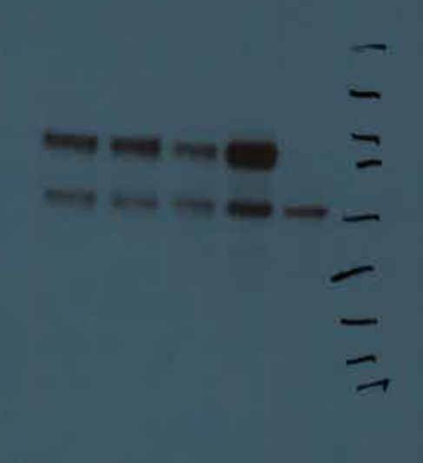
75kDa
(STAT1)
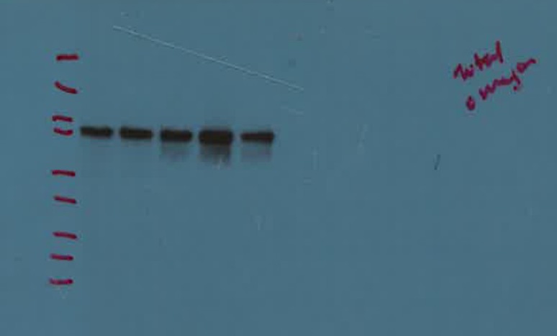
75kDa
(GAPDH) 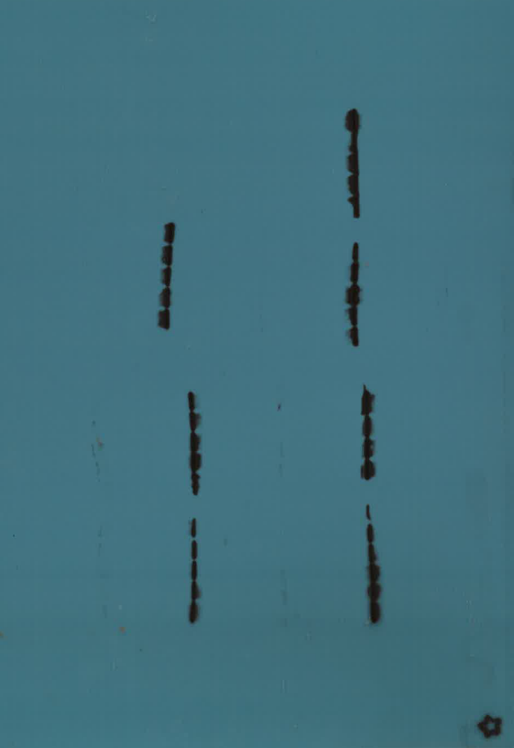
37kDa

- anti-IFNAR
(pSTAT1)
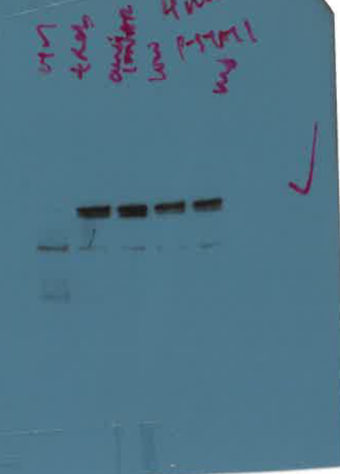
75kDa

(STAT1)
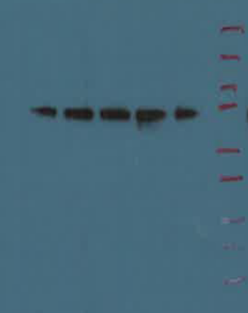
75kDa
(GAPDH) 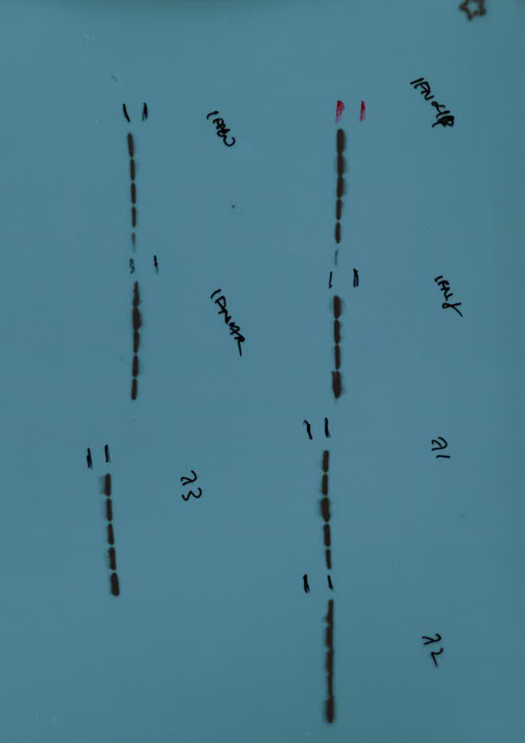
37kDa

- anti-IFN gamma
(pSTAT1)
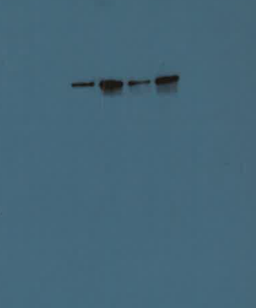
75kDa
(STAT1)
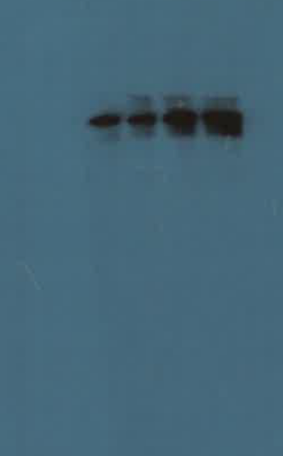
75kDa
(GAPDH)
37kDa

- anti-IFN lambda 1

(pSTAT1)

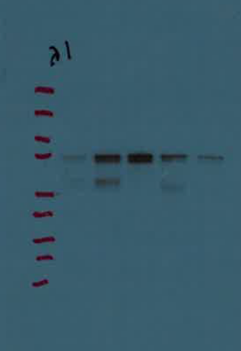
75kDa

(STAT1)
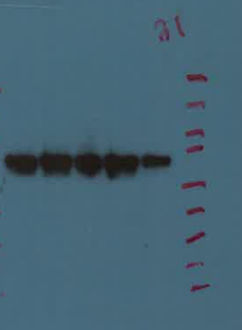
75kDa
(GAPDH)
37kDa

- anti-IFN lambda 2
(pSTAT1)
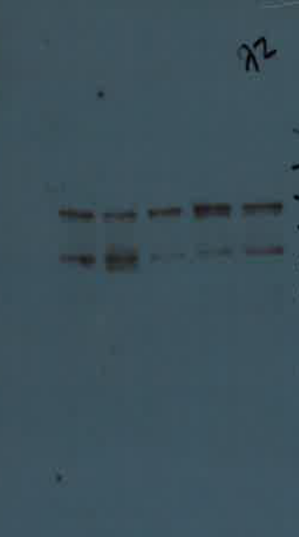
75kDa
(STAT1)
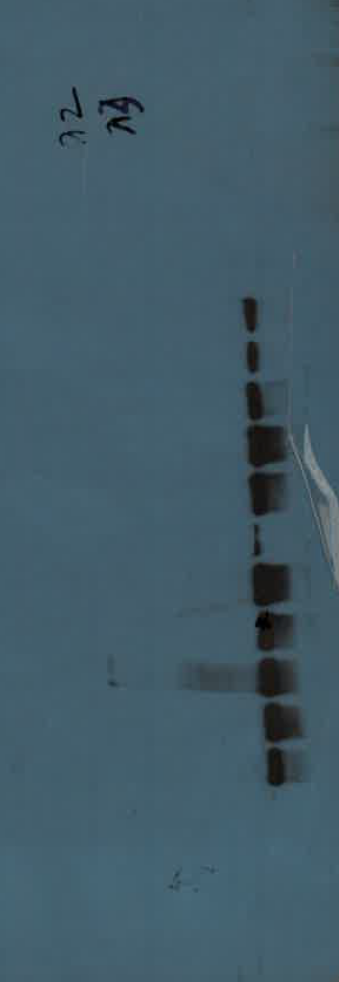
75kDa

(GAPDH)
37kDa
- anti-IFN lambda 3
(pSTAT1)
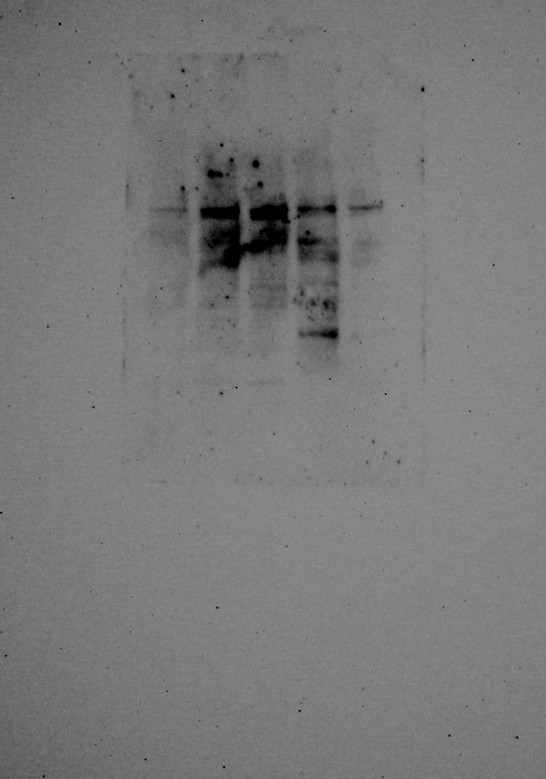
75kDa
(STAT1)
75kDa
(GAPDH)
37kDa

