Supplementary information for the manuscript:
Tumor implantation site dictates the immune landscape of syngeneic mouse models of head and neck cancer

Antigen | Clone | Fluorochrome | Dilution | Vendor | Catalogue no.
Live dead |  | Fixable blue | 1:2500 | Thermo Scientific | L34961
CD3e | 145-2C11 | BV421 | 1:200 | BioLegend | 100341
CD11b | M1/70 | BV510 | 1:1000 | BD Horizon | 562950
TIM3 | 5D12/TIM-3 | BV605 | 1:200 | BD Optibuild | 747624
CD4 | GK1.5 | BV650 | 1:400 | BioLegend | 100469
CD8α | 53-6.7 | BV711 | 1:400 | BioLegend | 100747
CD45.2 | 104 | FITC | 1:200 | BioLegend | 109805
PD-1 | J43 | PE | 1:100 | Thermo Fisher Scientific | 12-9985-82
FoxP3 | FKJ-16s | PerCP-eF710 | 1:100 | Thermo Fisher Scientific | 46-5773-82
IFNγ | XMG1.2 | PE-Cy7 | 1:100 | BioLegend | 505826
Dump channel markers (lineage)
CD19 | 1D3 | APC-Cy7 | 1:400 | BD Bioscience | 557655
Ly6G | 1A8 | APC-Cy7 | 1:400 | BioLegend | 127624
NK1.1 | PK136 | APC-Cy7 | 1:400 | BioLegend | 108724
SiglecF | E50-2440 | APC-Cy7 | 1:200 | BD Bioscience | 565527
Supplementary table 1 |List of TIL antibodies. Antibodies used to identify the main population of tumor-infiltrating lymphocytes (TIL panel).

Antigen | Clone | Fluorochrome | Dilution | Vendor | Catalogue no.
Live dead |  | Fixable blue | 1:2500 | Thermo Scientific | L34961
CD163 | TNKUPJ | eF450 | 1:400 | Thermo Fisher Scientific | 48-1631-82
CD11b | M1/70 | BV510 | 1:1000 | BD Horizon | 562950
CD103 | 2E7 | BV605 | 1:200 | BioLegend | 121433
CD8α | 53-6.7 | BV650 | 1:1000 | BioLegend | 100741
Ly6G | 1A8 | BV711 | 1:400 | BD Horizon | 563979
F4/80 | BM8 | BV785 | 1:400 | BioLegend | 123141
Ly6C | AL-21 | FITC | 1:1000 | BD Pharmingen | 561085
CD45.2 | 30-F11 | PerCP-Cy5.5 | 1:400 | BioLegend | 103132
CD169 | SER-4 | PE | 1:400 | Thermo Fisher Scientific | 12-5755-82
PD-L1 | 10F.9G2 | PE-Dazzle94 | 1:200 | BioLegend | 124324
CD11c | N418 | PE-Cy7 | 1:200 | BioLegend | 117318
MHC-II | M5/114.15.2 | AF700 | 1:400 | Thermo Fisher Scientific | 56-5321-82
Dump channel markers (lineage)
CD3 | 145-2c11 | APC-Cy7 | 1:200 | BioLegend | 100330
CD19 | 1D3 | APC-Cy7 | 1:400 | BD Bioscience | 557655
NK1.1 | PK136 | APC-Cy7 | 1:200 | BioLegend | 108724
SiglecF | E50-2440 | APC-Cy7 | 1:200 | BD Bioscience | 565527
Supplementary table 2 | List of TAM antibodies. Antibodies used to identify the main population of tumor-infiltrating myeloid cells populations (TAM panel).

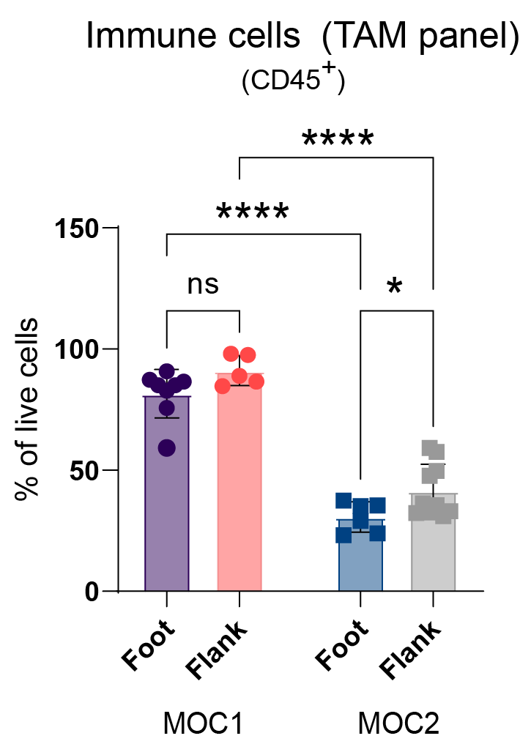
Supplementary figure 1 | Percentage of CD45⁺ cells identified with the TAM panel. Bars represent mean values and error bars indicate the standard deviation. Statistical significance between the four groups were determined using two-way ANOVA. The significance level was set to p < 0.05.

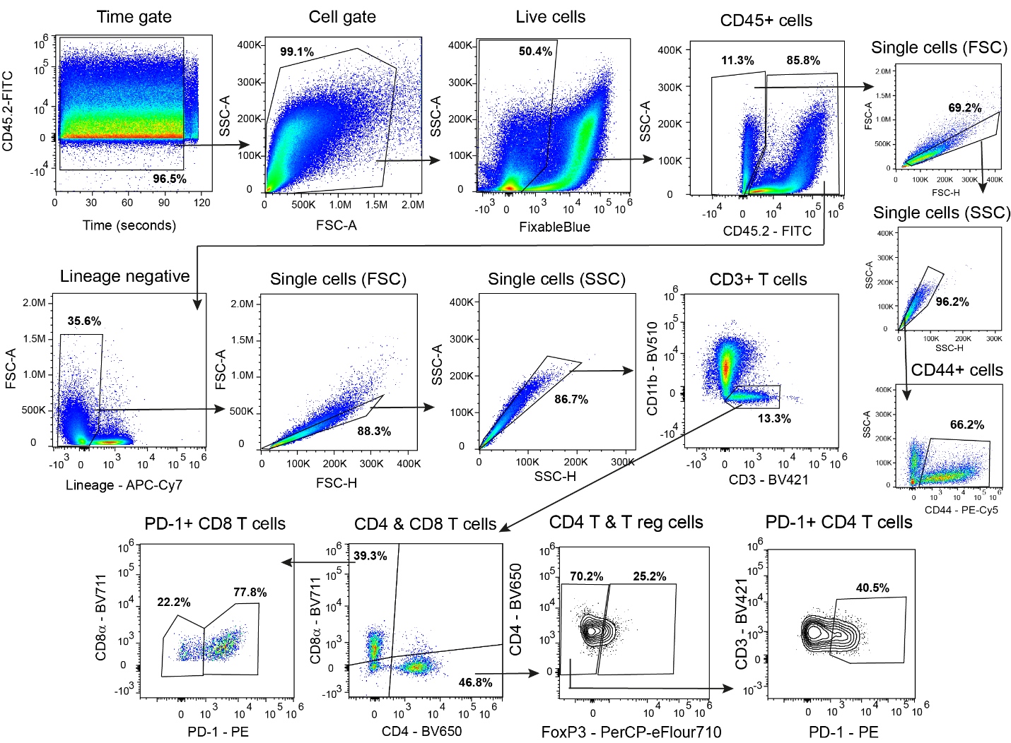
Supplementary figure 2 | TIL gating strategy. Example of the gating strategy for identifying the major T cell populations of the tumor. The exemplified sample is a MOC1 foot tumor. The indicated percentages are of the parent population.

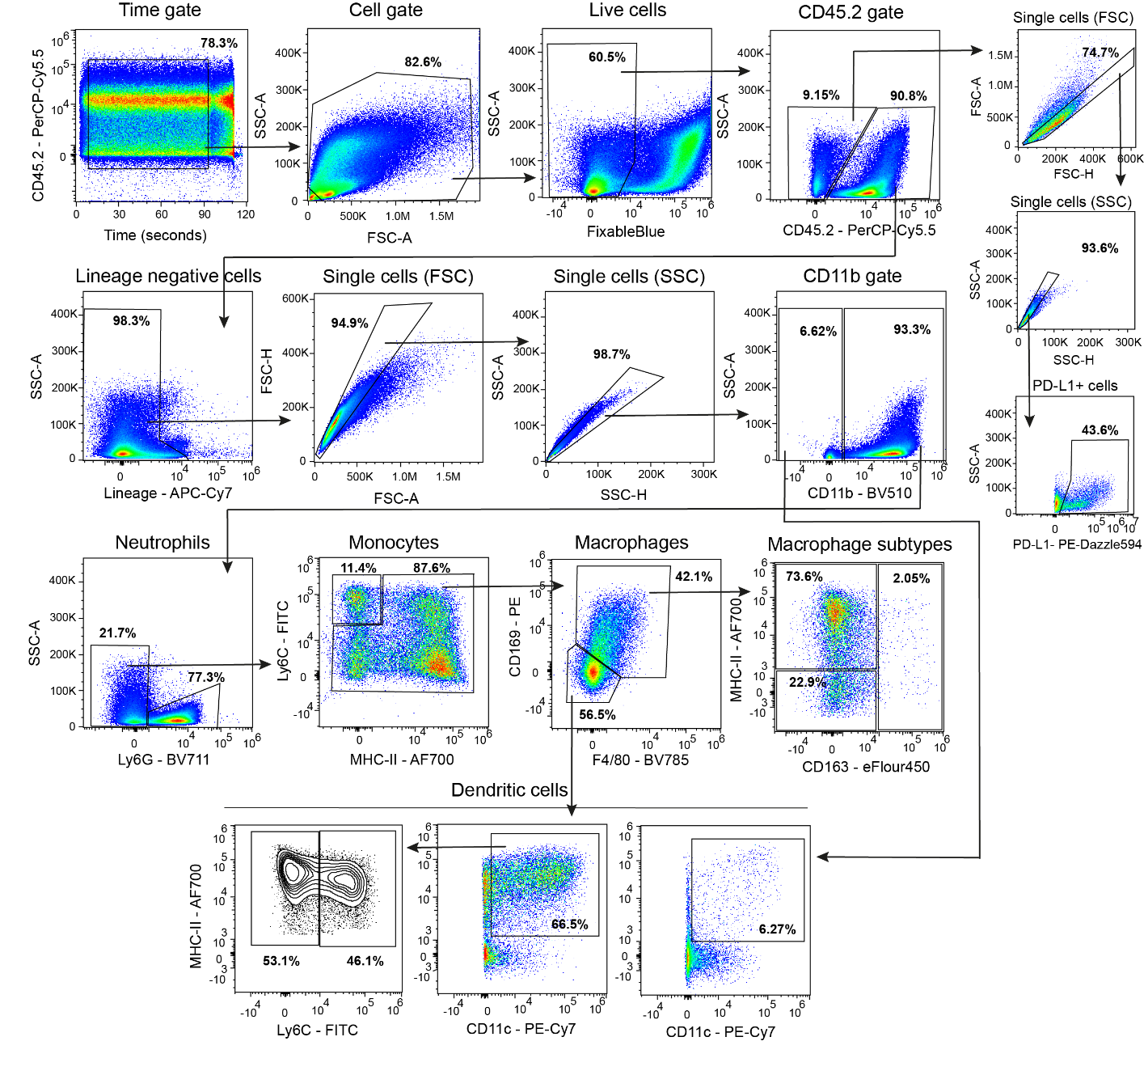
Supplementary figure 3 | TAM gating strategy. The gating strategy for identifying the major myeloid cells populations of the tumor. The exemplified sample is a MOC1 foot tumor. The indicated percentages are of the parent population.

