Additional file 1
To control for potential confounding effects of demographic characteristics, we incorporated four demographic control variables (gender, occupation, work experience, and number of night shifts) into the structural equation model, with direct paths predicting turnover intention. These variables were selected based on prior studies demonstrating their significant association with turnover intention among medical workers [1-3].
The results confirmed that all main paths, direct effects, and mediating effects remained robust and statistically significant after controlling for these demographic factors, with no substantive changes in direction or magnitude. Specifically, the path coefficients of PM→PH (β=0.511, p<0.001), PM→SM (β=0.692, p<0.001), PH→TI (β=-0.502, p<0.001), SM→TI (β=0.088, p<0.05), and PM→TI (β=-0.114, p<0.05) were highly consistent with the original model. The R²of turnover intention increased from 0.335 to 0.378, demonstrating that the core findings of this study are stable and not substantially affected by demographic characteristics.
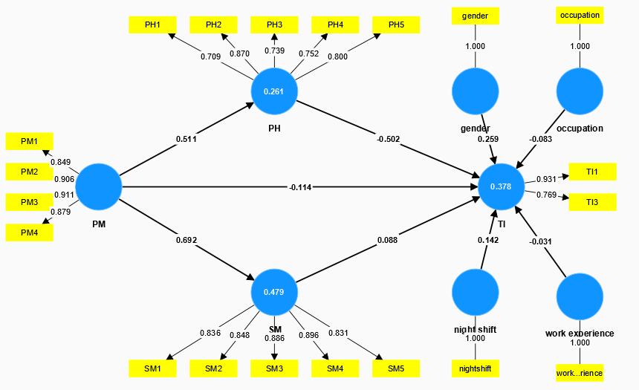
Figure 1 Results of the structural equation model with demographic control variables.
Note: TI: Turnover Intention; PM: The Presence of Meaning in Life; SM: The Search for Meaning in Life; PH: Professional Happiness.

References:
de Vries, N. et al. The Race to Retain Healthcare Workers: A Systematic Review On Factors that Impact Retention of Nurses and Physicians in Hospitals. INQUIRY-J HEALTH CAR. 60, (2023).
Wu, J. et al. Factors Affecting Intention to Leave Among Icu Healthcare Professionals in China: Insights From a Cross-Sectional Survey and Xgboost Analysis. RISK MANAG HEALTHC P. 16, 2543-2553 (2023).
Xu, K. et al. Turnover Intention Among Healthcare Workers in Shenzhen, China: The Mediating Effect of Job Satisfaction and Work Engagement. BMC HEALTH SERV RES. 24, 1413 (2024).

