Supplementary material for:

How barbule orientation drives iridescent coloration in Coeligena hummingbirds

- Optical modelling of reflectance
Reflectance spectra were simulated using a modified Transfer Matrix Method (TMM), in which the multilayer system was modeled as N optically thin, laterally infinite layers separated by parallel interfaces, with light propagating through layers characterized by generally complex refractive indices that incorporate both real and imaginary components [2,3,9]. The parameters used in the model include: d_{j} (thicknesses of layer j), n_{j} (complex refractive index of layer j), $θ_{j}$ (angle of incidence in layer j), k (wavenumber in vacuum), κ (absorption coefficient of the medium), n_{jR} (real part of the refractive index), n_{jI} (imaginary part of the refractive index), and λ (wavelength of light).
The refractive index is a complex value,
$n_{j}=n_{jR}-in_{jI}, j=1,2,…,N$, | (1)
The imaginary part of the refractive index is associated with the absorption coefficient of the medium. Let C_{m}, C_{a} and C_{k} denote the concentration of melanin, air, and keratin within the melanosome, respectively. Since these components sum to unity, the melanin concentration is given by: $C_{m}=1-C_{a}-C_{k}$. For the sake of clarity in the analysis, melanin concentration was categorized into three levels: low (0.05-0.40), medium (0.41-0.70), and high: (0.71-1.0)
$ĸ_{j}=2kn_{jI}=2(2π/λ)n_{jI}$, or $n_{jI}=ĸ_{j}(λ/4π)$. | (2)
The account for the wavelength dependence of the refractive index. We used the Cauchy equation:
$n_{j}=A+B/λ^{2}$ | (3)
Where the subscripts k and m refer to keratin and melanin, respectively. The Cauchy coefficients used in our model were: A_{k} = 1.532, B_{k} = 5890 nm⁻², A_{m} = 1.648 and B_{m} = 23.700 nm⁻².
We considered only the spectral absorption of melanin ($ĸ$_{m}) to be significant. The imaginary part of its refractive index ($ĸ_{m}$) was modeled as: $ĸ_{m}=C_{m}a_{m}\exp\left(-\frac{λ}{b_{m}}\right)$, with a_{m} = 0.56 and b_{m} = 270 nm [3]. Keratin absorption ($ĸ$_{k}) was assumed to be negligible.
To simulate the recursive light interaction through multiple interfaces, we employed the characteristic matrix formalism (M):
$$M=\left(\begin{matrix}M_{11} & M_{12} \\ M_{21} & M_{22}\end{matrix}\right)=D_{0}^{-1}\left\lfloor \prod_{j-1}^{N}{Q_{j}}\right\rfloor D_{n}$$ | (4)
The matrix M is composed of the coefficients M₁₁, M₁₂, M₂₁, and M₂₂, and represents  the global characteristic matrix of the multilayer system. The matrices $D_{o}$ and $D_{n}$  correspond to the first and last layers, respectively. The output matrix is defined by:  $$D_{n}=\left(\begin{matrix}p_{n} & p_{n} \\ q_{n} & {-q}_{n}\end{matrix}\right), n= 1,2,…, N+1$$  Each layer j is described by the matrix $Q_{j}$:  $$Q_{j}=\left(\begin{matrix}a_{j} & {ib}_{j}p_{j}/q_{j} \\ {ib}_{j}q_{j}/p_{j} & a_{j}\end{matrix}\right), j=1,2,…, N$$  Where:  $a_{j}=cosΦ_{j}$,${ b}_{j}=sinΦ_{j}$,${ Φ}_{j}=kn_{j}d_{j}cosθ_{j}$ | (5)  (6)
For TE-polarized waves (transverse-electric mode) we used: $p_{j}=1$, $q_{j}=n_{j}cosθ_{j}$
yielding:
$Q_{j}=\left(\begin{matrix}cosΦ_{j} & isinΦ_{j}1/n_{j}cosθ_{j} \\ isinΦ_{j}n_{j}cosθ_{j}/1 & cosΦ_{j}\end{matrix}\right), j=1,2,…, N$ | (7)
For TM-polarized waves (transverse-magnetic mode), $p_{j}=cosθ_{j}$, $q_{j}=n_{j}$
resulting in:
$Q_{j}=\left(\begin{matrix}cosΦ_{j} & isinΦ_{j}cosθ_{j}/n_{j} \\ isinΦ_{j}n_{j}/cosθ_{j} & cosΦ_{j}\end{matrix}\right), j=1,2,…, N$ | (8)
The simulated reflectance of the multilayer system is defined as the ratio of the reflected to the incident light intensity:
$$R_{sim}={\left|\frac{M_{21}}{M_{11}}\right|}^{2}$$ | (9)

Filling fraction parameterization
To account for the composite nature of melanosomes, an effective refractive index ($n_{eff}$) was computed as a volume-weighted average of the keratin, melanin, and air contributions, expressed as:
$$n_{eff}=f_{k}n_{k}+f_{m}\left(n_{m}-ik_{m}\right)+f_{a}n_{a}$$ | (10)
Where $f_{k}$, $f_{m}$ and $f_{a}$represent the volume fractions of keratin, melanin, and air, respectively
Based on thickness ratios measured from transmission electron micrographs of the species analyzed in this study (figure 2) and from previously published datasets (figure 3), three filling-fraction configurations were defined: Type I ($f_{k}=0.05$, $f_{m}=0.40$, $f_{a}=0.55$), Type II ($f_{k}=0.05$, $f_{m}=0.30$, $f_{a}=0.65$), and Type III ($f_{k}=0.025$, $f_{m}=0.025$, $f_{a}=0.95$); the configuration assigned to each species is reported in Tables 1 and 2.
RGB coordinates
Reflectance spectra measured between 360 and 830 nm were converted to standard color coordinates using CIE colorimetric procedures. Spectra were interpolated to 1-nm resolution and used to compute tristimulus values (XYZ) following CIE 1931 and 1964 recommendations, using standard illuminant D65 and the 10° standard observer ISO/CIE 11664-Parts 1, 2 and 3 (https://www.iso.org/standard/74165.html). XYZ values were converted to sRGB coordinates using the IEC 61966-2-1:1999 standard.

- ANATOBIRD simulator: implementation and modelling framework

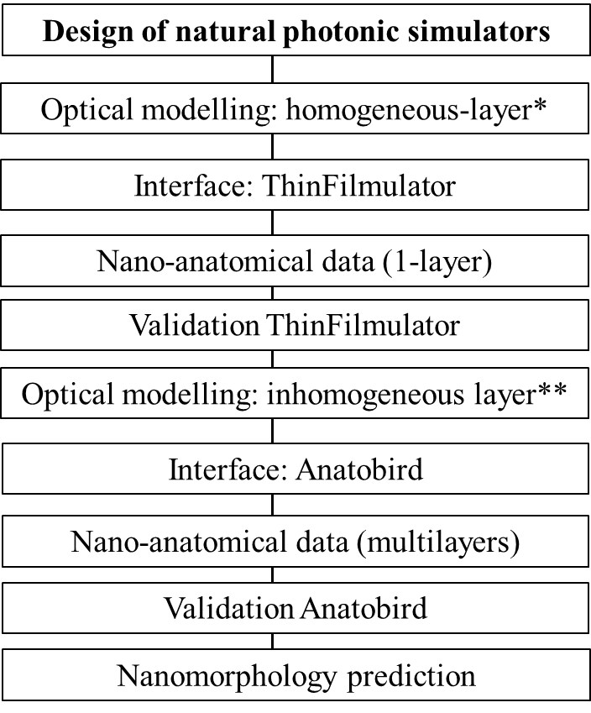
Figure S1. Workflow used in generating the natural photonic simulators.
We used the equations (Stavenga, 2014) (eqs. 1-9)* and a modification of this method proposed by Giraldo et al (2018) (eq. 10)**, respectively.

Optical framework.
Reflectance spectra were simulated using ANATOBIRD, a graphical user interface developed in MATLAB R2020 that implements a modified transfer-matrix method (TMM; Eqs. 1–10). The framework was previously evaluated across a broad comparative dataset including 86 bird species (hummingbirds and ducks), enabling simulation of reflectance spectra and corresponding RGB color coordinates arising from regular and inhomogeneous nanomorphological traits. In the present study, results are reported for four species based on our own experimental measurements (figure 1) and for 15 iridescent feather patches derived from literature-reported values (figure 2, Tables 1 and 2). ANATOBIRD operates on multilayer optical systems and was preceded by a validation stage, ThinFilmulator (equations. 1–9; steps 1–4), which models homogeneous single-layer systems, followed by multilayer simulations (steps 5–9) that incorporate nanostructural inhomogeneity by accounting for variability in melanosome and air-interstice organization (figure S1). The interface allows specification of physical parameters (incidence angle and refractive indices of keratin, melanin, and air) and biological traits (layer thicknesses) required to compute reflectance spectra and simulated RGB colors, with nano-anatomical thickness schemes shown in figure S2.
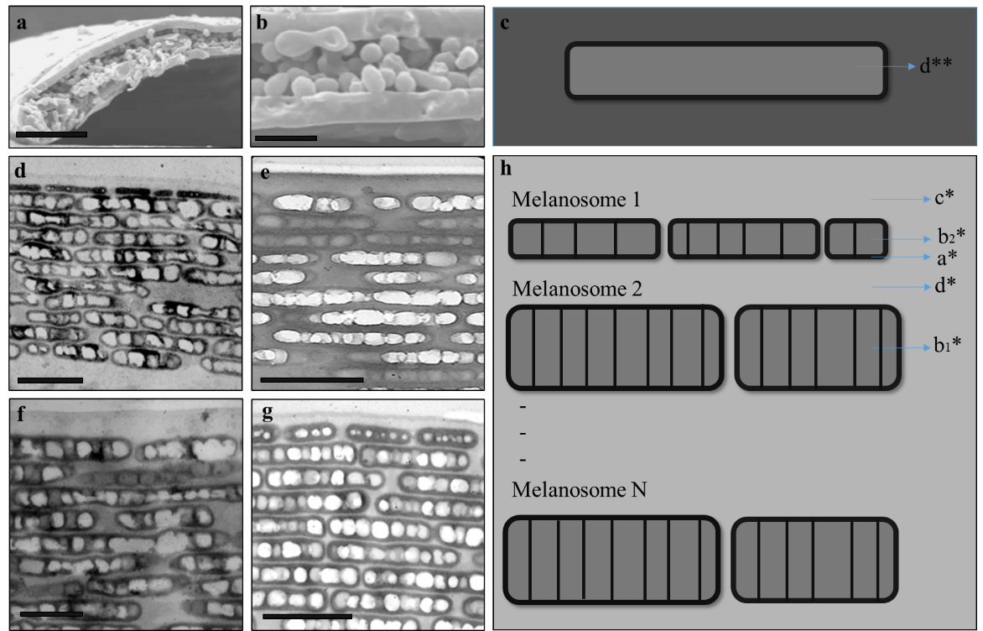
Figure S2. Nano-anatomical data.
a-c. Thickness for 1-layer. The SEM images of barbules correspond to domestic pigeons (Yin et al., 2006, figure 2a,b) (a-b). Barbule Scheme where d** is layer thickness (c). d-h. Thickness for multilayers. The TEM images of melanosomes in gorget of hummingbirds: Coeligena wilsoni (d), Coeligena prunellei (e), Coeligena lutetiae (f), and Coeligena iris (g). Based on the anatomy, we used the following parameters for each melanosome scheme, a*: thickness internal air layer of top melanosomes, b₂*: thickness internal air layer of top melanosomes, b₁*: thickness internal air layer of other melanosomes, c*: thickness keratin cortex, d*: thickness keratin layer in between melanosomes, and N: number of melanosome layers. Scale bar: a: 5 µm, b: 1 µm, d-g: 500 nm.

Nano-anatomical data and optical simulations.
Nanomorphological parameters (nm) and corresponding reflectance spectra were compiled from published studies; when numerical data were unavailable, reflectance spectra were digitized from reported plots and nanostructural thicknesses were extracted from SEM/TEM images using ImageJ. Single-layer systems were characterized by a single thickness parameter (d⁎⁎; figure S2a,b), whereas multilayer systems, including melanosomes in hummingbirds and ducks, were described using multiple thickness parameters (a⁎, b₂⁎, b₁⁎, c⁎, and d⁎; figure S2d–g), each averaged from 15 measurements along the melanosomes. These data were used as inputs for ThinFilmulator and ANATOBIRD, MATLAB-based graphical user interfaces that simulate reflectance spectra and corresponding RGB color coordinates for single-layer and multilayer biological photonic structures, respectively. Simulations incorporated refractive indices, material volume fractions, incidence angle, number of layers, and absorption properties, and were directly compared with experimental reflectance spectra (see Methods: Reflectance calculations).

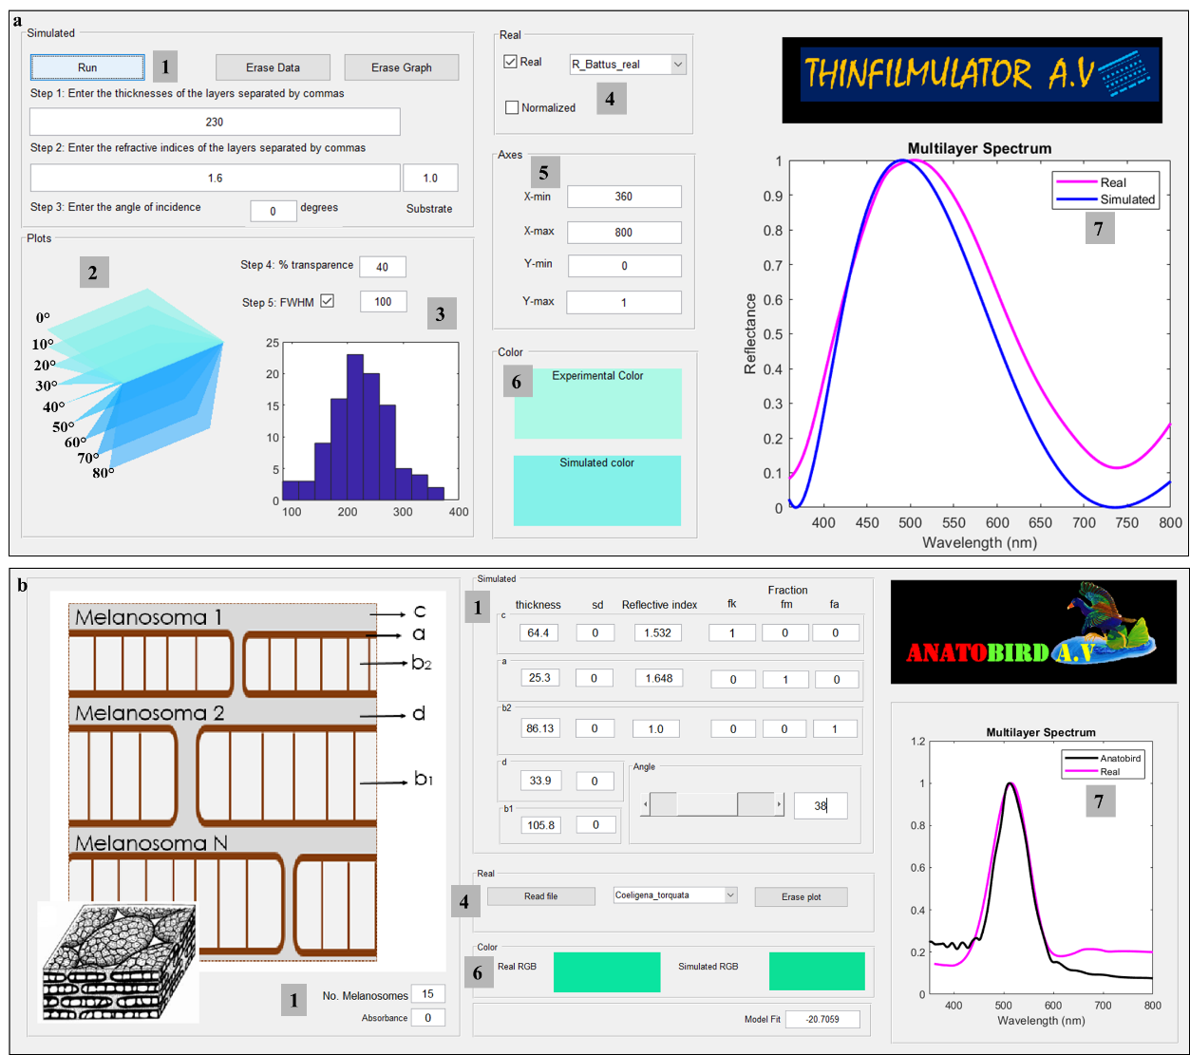
Figure S3. The interface of the simulators ThinFilmulator (GUI) and Anatobird (GUI).
a. ThinFilmulator has 6 sections. [1] input parameters, [2] 3D-plot with color depending angle, [3] FWHM: full width at half maximum, deviations in thickness, [4] load experimental data, [5] axes adjustment, [6], RGB coordinate display, and [7] experimental and simulated reflectance graphics. b. Anatobird has 4 sections [1], [4], [6], and [7]

- Manual fitting procedure for barbule inclination estimation
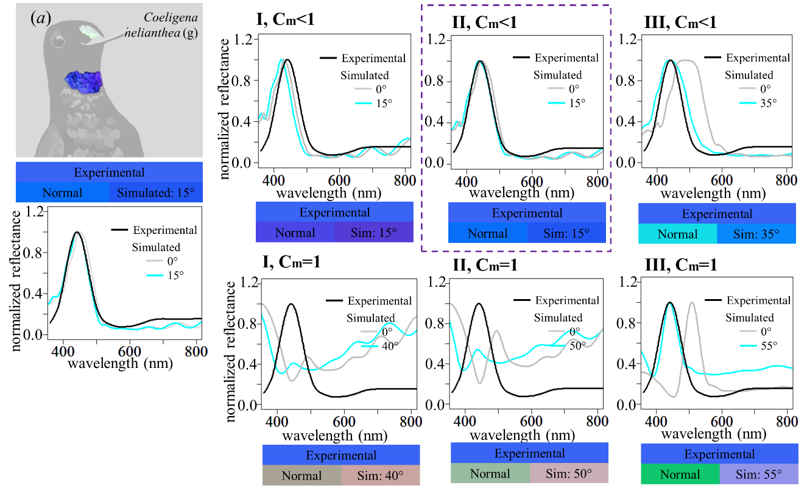
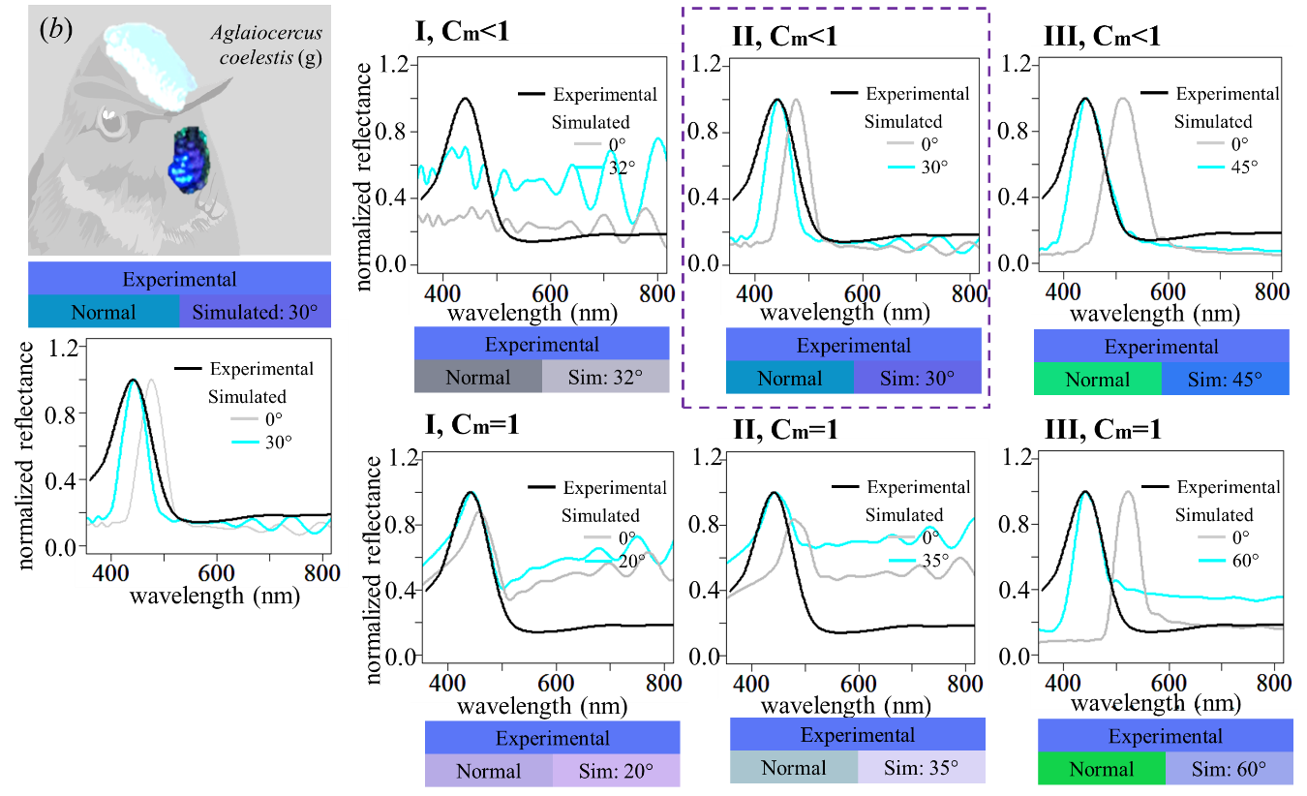
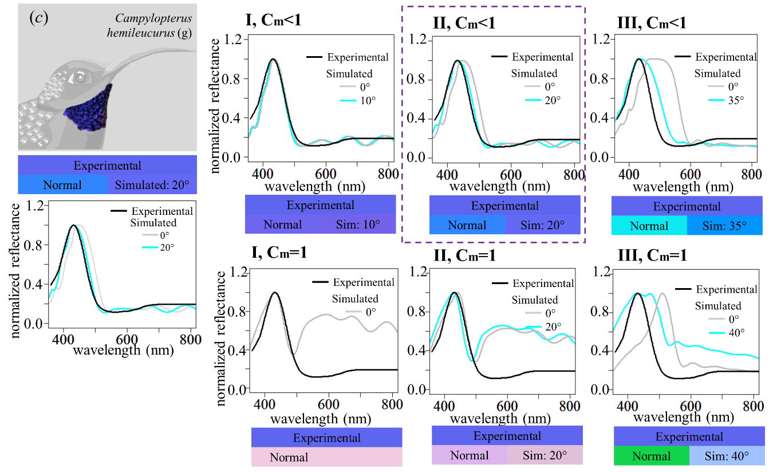
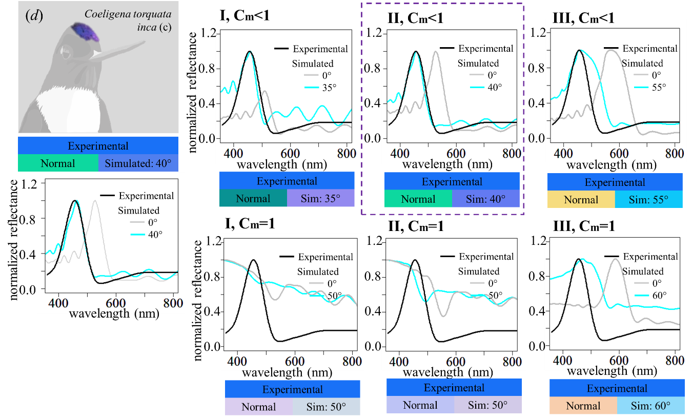
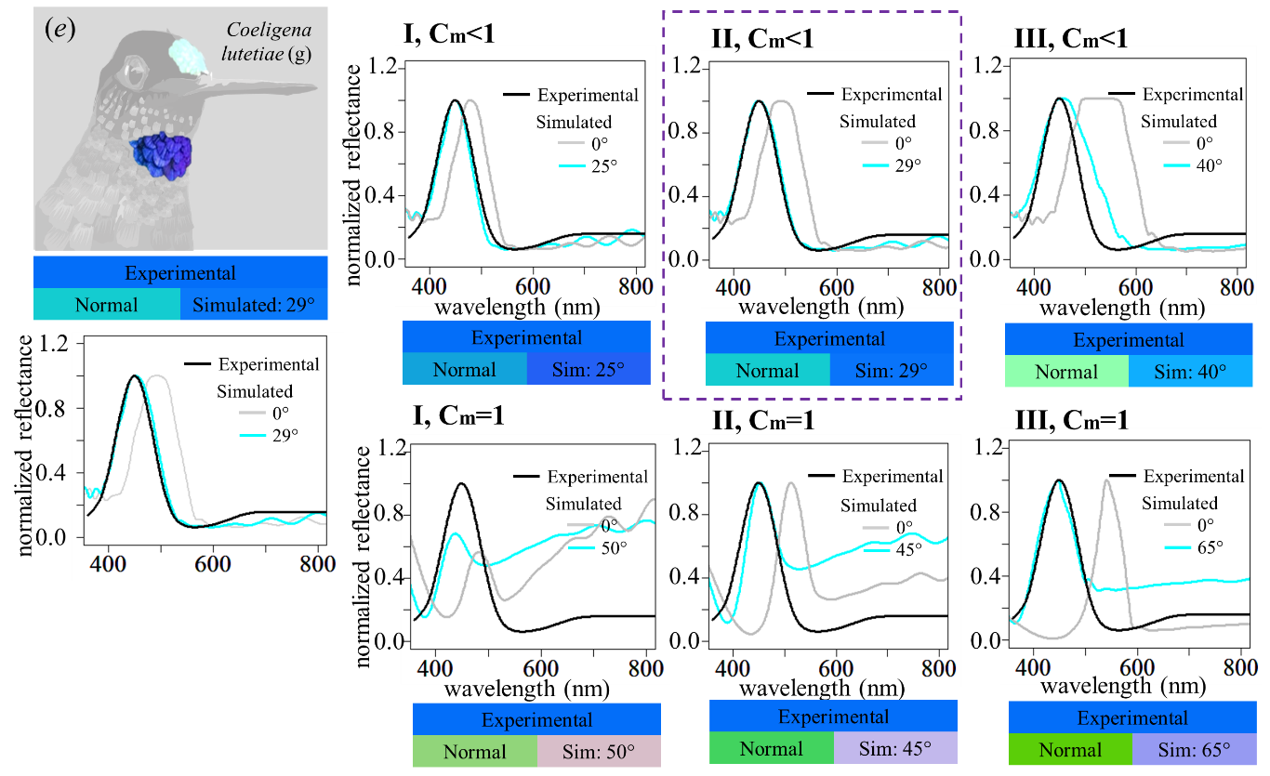
Figure S4. Model fitting of reflectance spectra using ANATOBIRD. Experimental and calculated reflectance spectra of (a) Coeligena helianthea, (b) Aglaiocercus coelestis, (c) Campylopterus hemileucurus, (d) Coeligena torquata inca, (e) Coeligena lutetiae. Each simulation was based on one of three structural types (I, II, III), determined by the volumetric occupancy of melanosomes observed in TEM images. Fill-fraction values (f) correspond to structural types as follows: Type I (f_{k}: 0.05, f_{m}: 0.40, f_{a}:0.55), Type II (f_{k}: 0.05, f_{m}: 0.30, f_{a}:0.65), and Type III (f_{k}:0.025, f_{m}: 0.025, f_{a}:0.95). Melanin concentration (Cm) was also considered, where Cm=1 indicates highly condense melanin and Cm<1 reflects a more diffuse distribution. A least-squares fitting procedure was applied to quantify the agreement between each simulated reflectance spectrum and its corresponding experimental measurement (black vs cyan). The angle of incidence associated with the lowest residual error was reported as the most likely measurement angle. To guide the selection of appropriate fill-fraction values, four criteria were applied: (1) values previously reported by Giraldo et al, (2018), which correspond to Type I structures; (2) visual color matching based on RGB coordinate similarity; (3) relative melanin content, inferred from the air-to-melanin layer ratio; and (4) alignment of the spectral peak at normal incidence-spectra with leftward-shifted peaks were excluded from analysis.

