Supplementary Figures
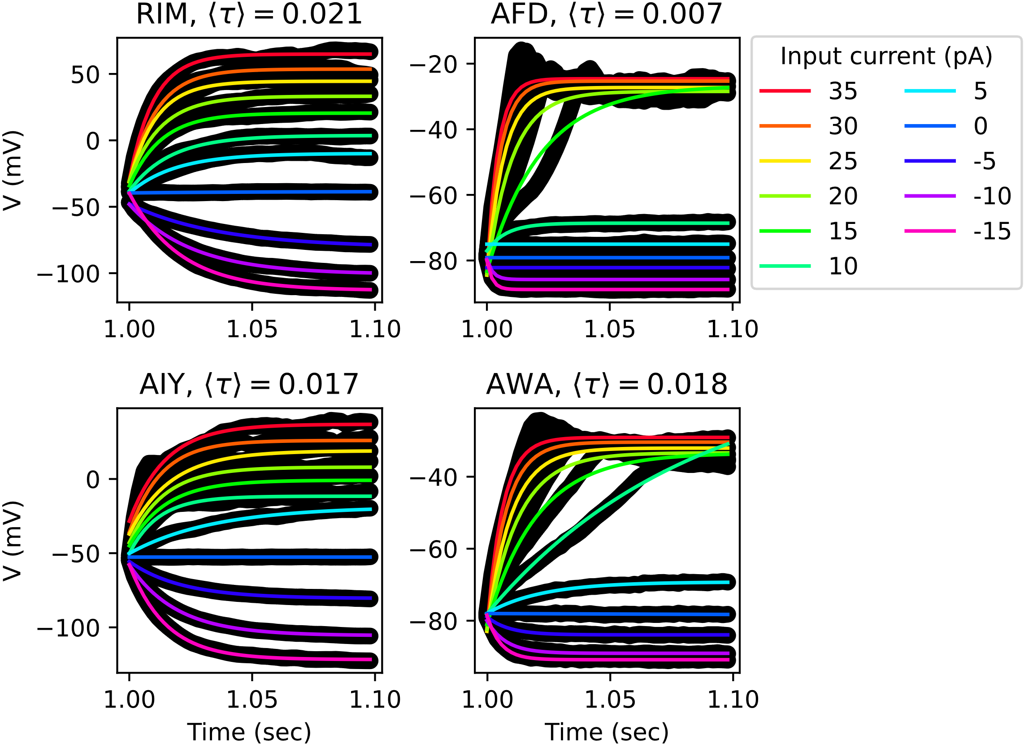
Figure S1. Fitting of the neuron membrane potential response to input current using an exponential function. Exponential function fitting (thin colored line) to the neuron membrane potential (thick black line) over time, which was measured in previous experiments[1]. The time constant of the membrane potential response to input current was determined through exponential function fitting to its time course.

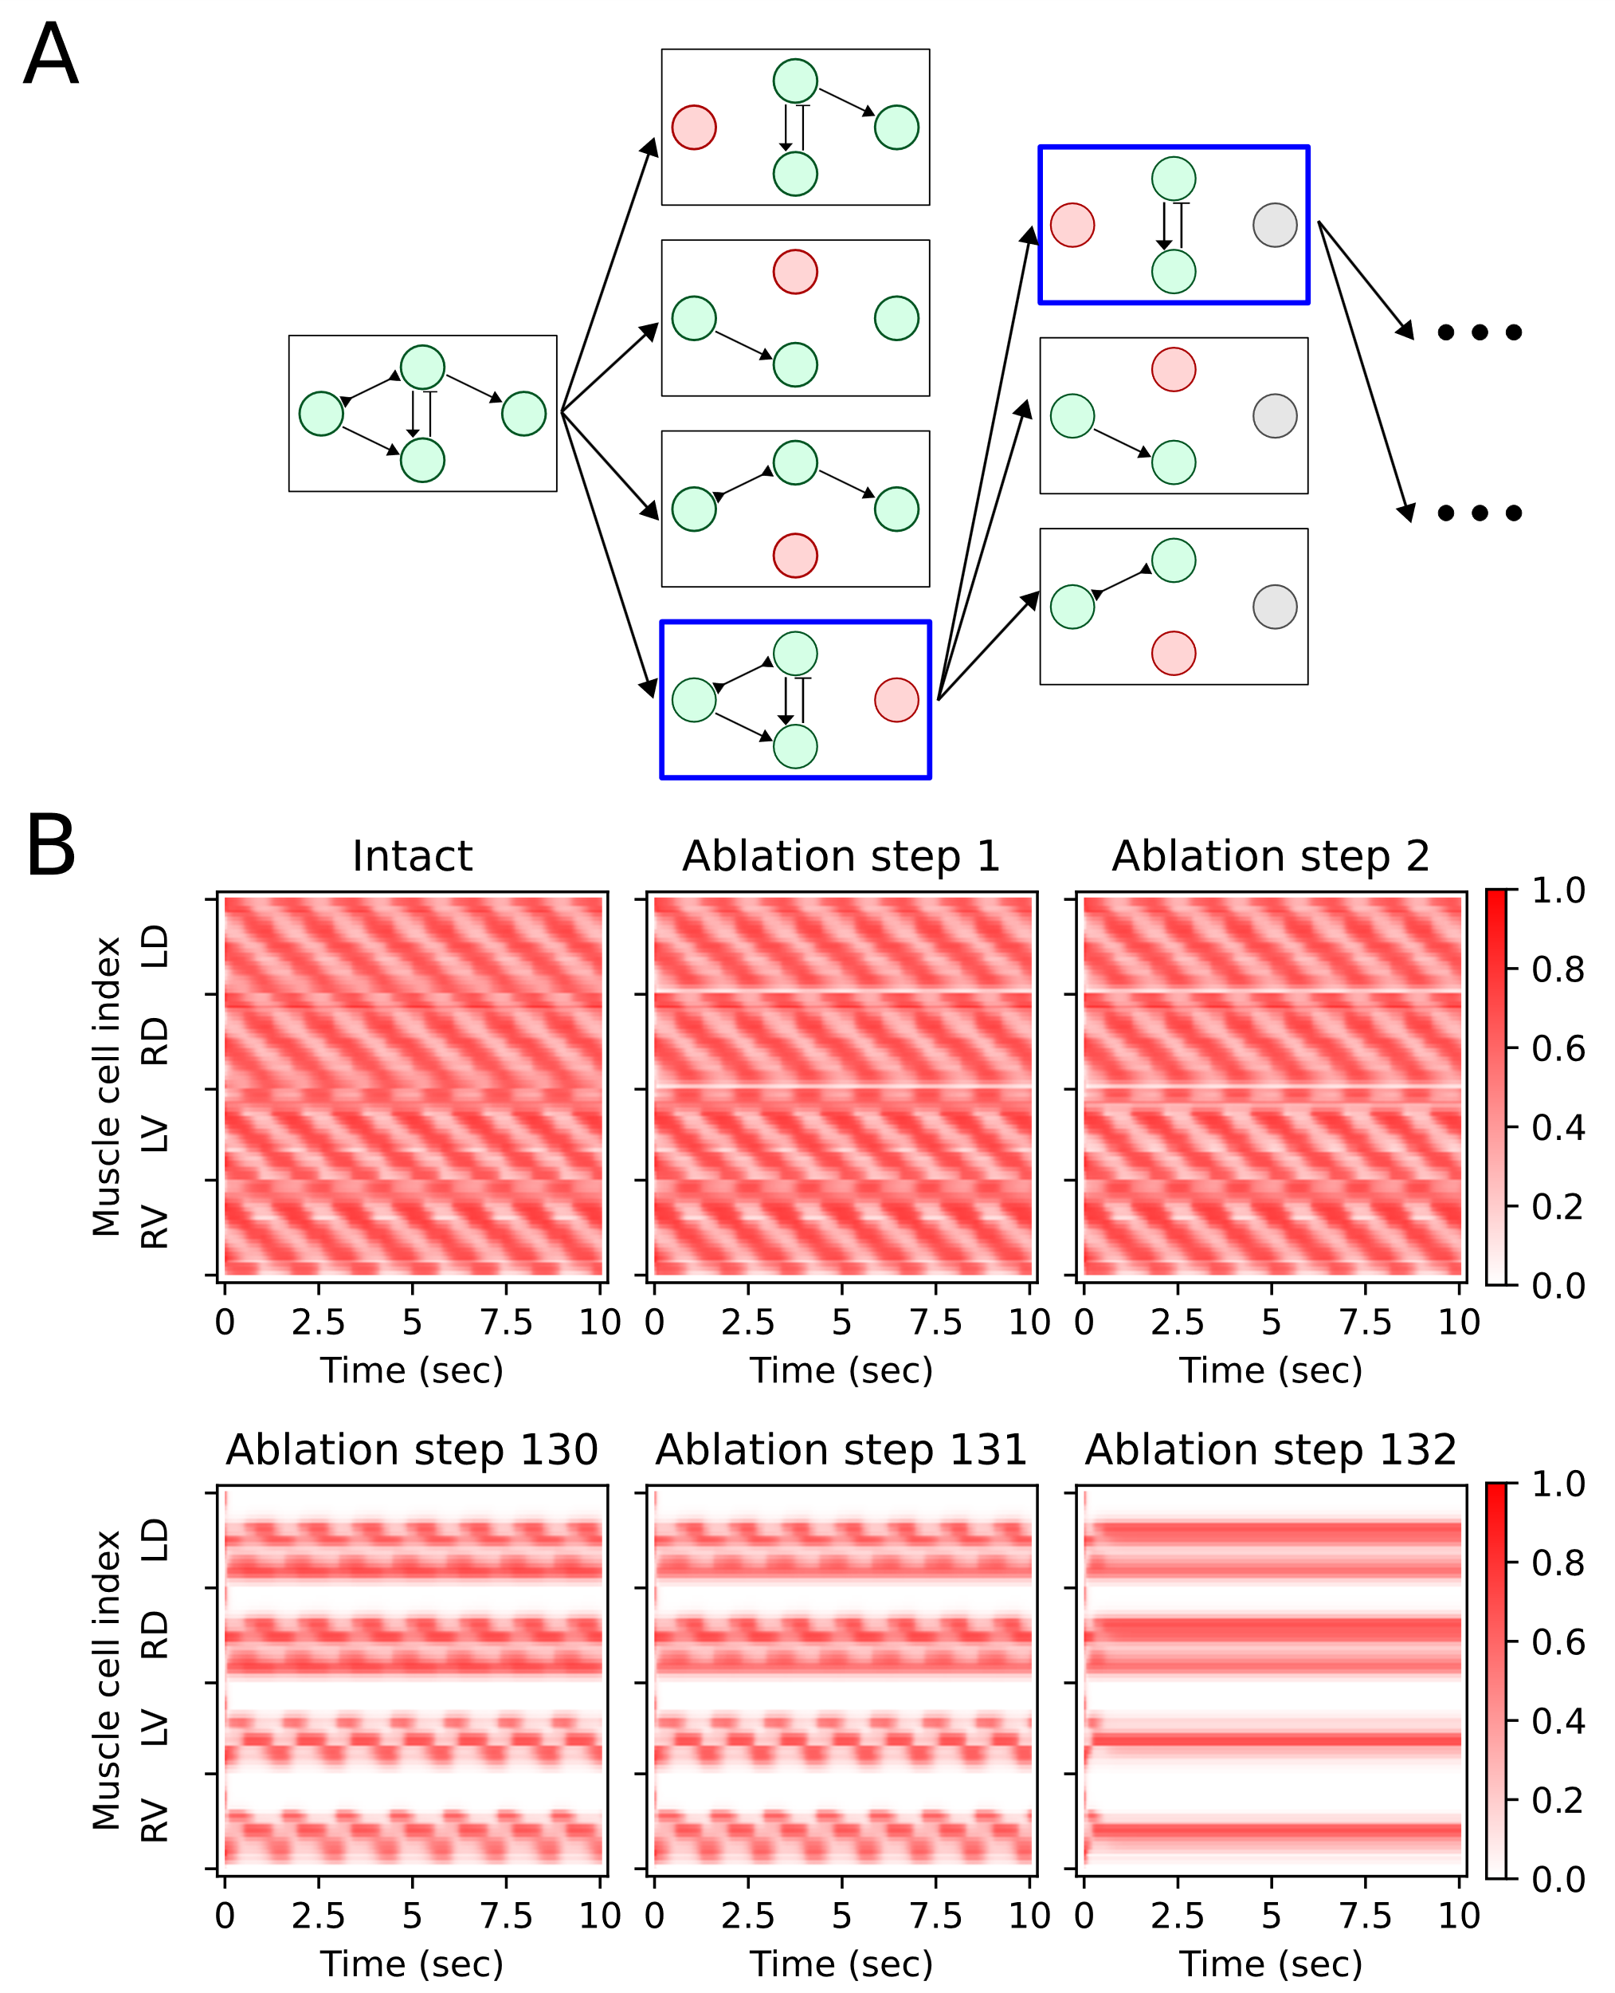
Figure S2. Stepwise neuron elimination (A) Conceptual diagram illustrates the stepwise neuron elimination methodology used to identify the type I necessary neuron group maintaining the oscillatory activity patterns of body-wall muscle cells. Each box in the diagram represents a different network configuration. Each column of boxes corresponds to a specific step in the stepwise neuron elimination process. Each circle symbolizes a neuron: green for active neurons, red for neurons eliminated in the current step, and gray for those eliminated in previous steps. Arrows featuring a standard triangle head denote excitatory chemical synapses. Arrows with a vertical line at the head signify inhibitory chemical synapses, while those with both a reverse triangle head and tail indicate gap junctions. Within each column, the blue box denotes the network configuration chosen as the base network for the subsequent step. Arrows connecting the boxes illustrate the computational sequence in the stepwise neuron elimination process, with the arrow tail indicating the prior state and the arrowhead pointing to the subsequent state. (B) Example muscle membrane potential during stepwise neuron elimination. This example illustrates the changes in muscle membrane potential during the stepwise neuron elimination process. The abbreviations are defined as follows: LD for Left Dorsal, RD for Right Dorsal, LV for Left Ventral, and RV for Right Ventral. In this example, oscillation persists in ablation step 131. However, oscillation ceases upon the ablation of one additional neuron, advancing to ablation step 132. This means 31 active neurons in ablation step 131, out of 162 motor neurons, are identified as the type I necessary neurons.

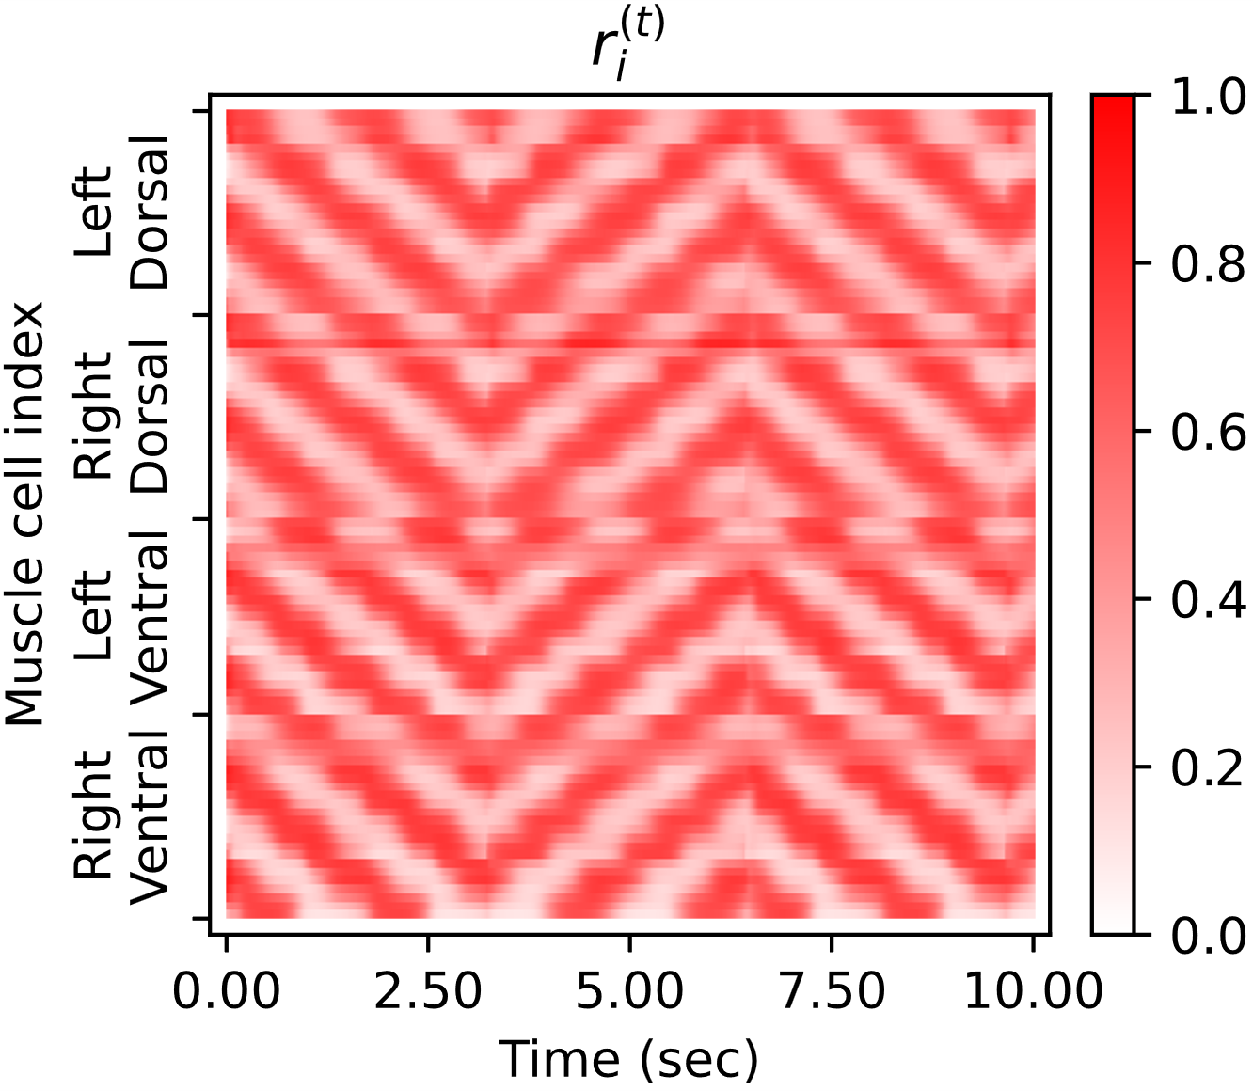
Figure S3. Degree of muscle contraction. Degree of muscle contraction ($r_{i}^{\left(t\right)}$) from the representative machine-learning trajectory.

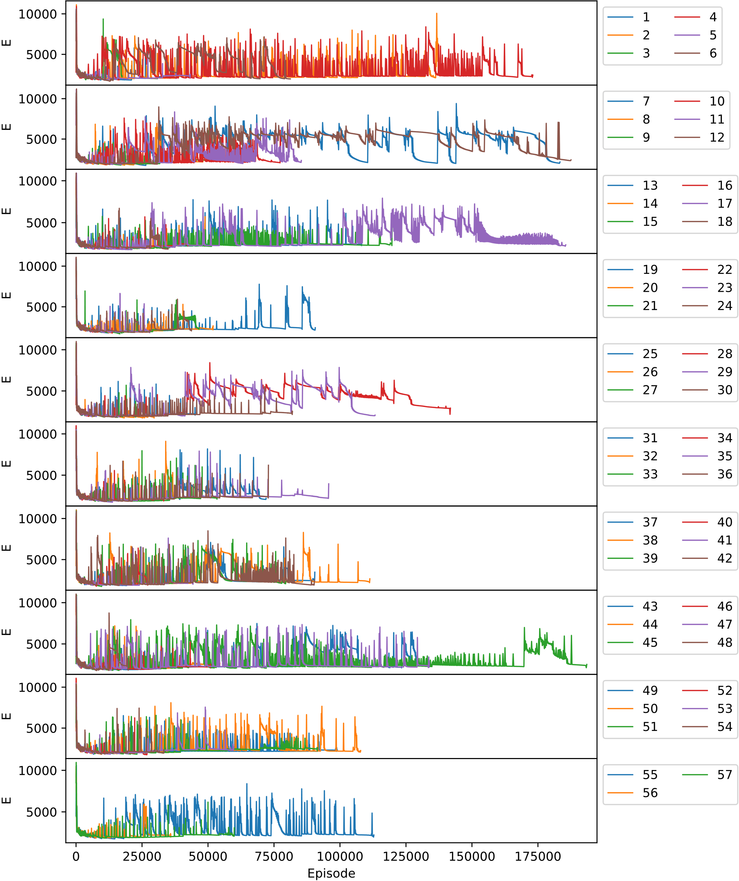
Figure S4. Error minimization of Converged Machine Learning trajectories. Evolution of the total error (E) over optimization episodes for the 57 trajectories that met the convergence criterion, out of 300 machine-learning trajectories in total. Each line represents one converged trajectory. Optimization was run for up to 200,000 episodes; trajectories that did not converge within this budget are not shown.

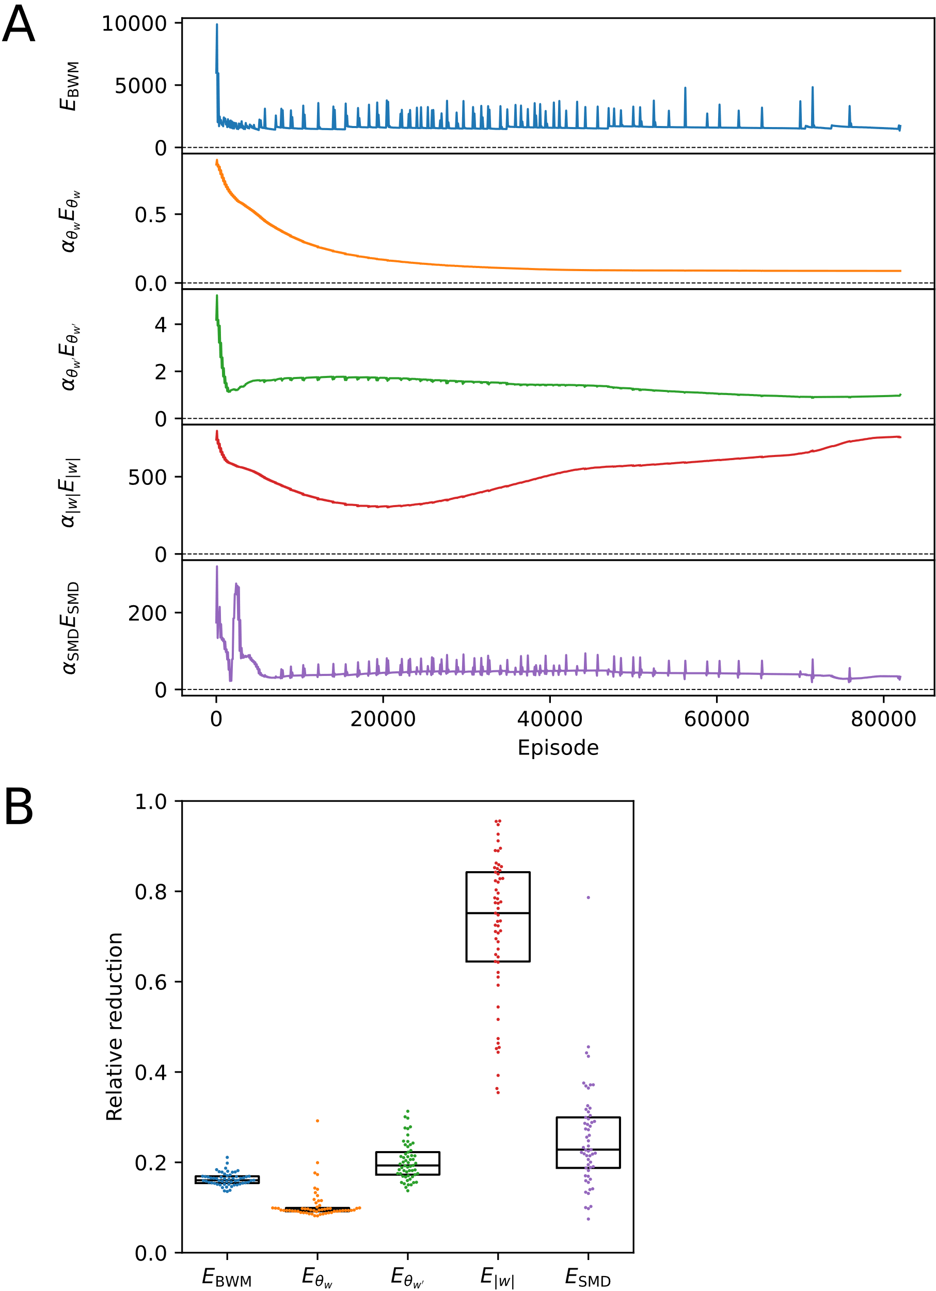
Figure S5. Reduction of error terms during optimization. (A) Evolution of the error terms ($E_{BWM}$, $E_{θ_{w}}$, $E_{θ_{w'}}$, $E_{\left|w\right|}$, and $E_{SMD}$) over optimization episodes for a representative machine-learning trajectory. (B) Distribution of relative reduction of each error term across the 57 converged machine-learning trajectories, defined as the value of each error term at the final episode divided by its value at the initial episode. Each point represents a machine-learning trajectory. Box plots indicate median and interquartile range (Q1–Q3).
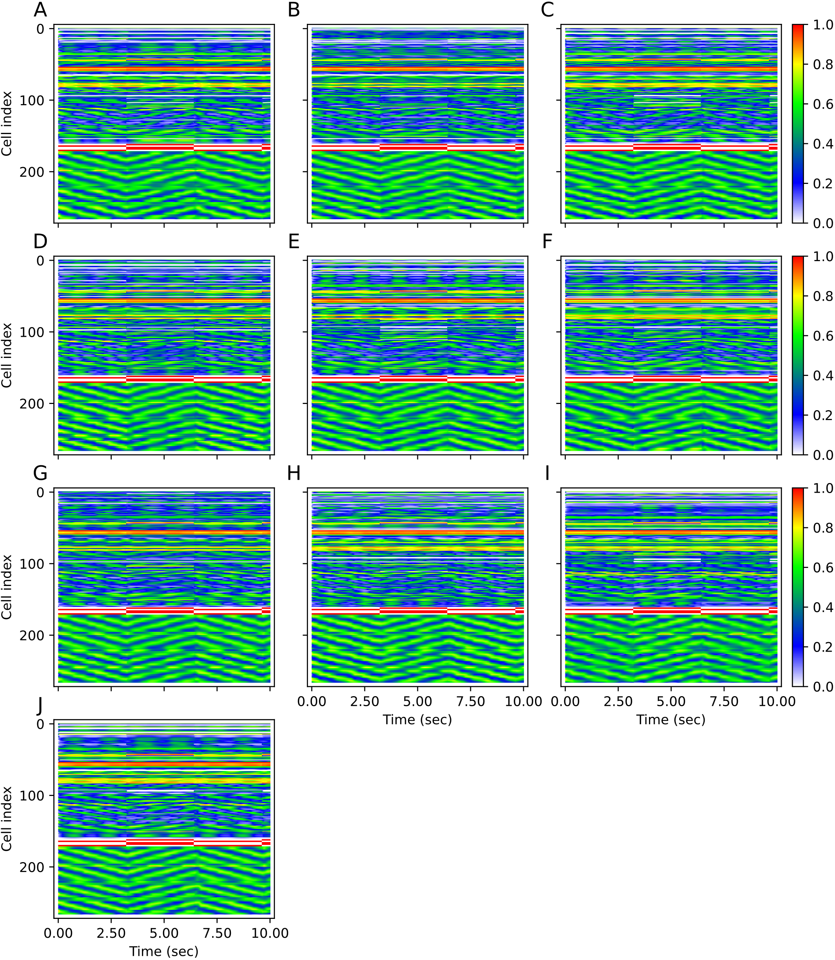Figure S6. Whole-network membrane potential dynamics for the ten most promising optimized weight sets. Heat maps show normalized membrane potentials for all cells in the CANN model (162 motor neurons, and 10 command interneurons, 95 body-wall muscle cells; (n=267)). Simulation was performed under alternation between forward- and backward-locomotion commands every 3.2 s over a total duration of 10 s. Color indicates membrane potential. Panels correspond to the ten trajectories identified as most promising based on reproducing the trp-1,2 and SMD(D/V) ablation phenotypes. The trajectory IDs are (A) 17-02, (B) 38-00, (C) 55-02, (D) 56-01, (E) 58-02, (F) 66-02, (G) 70-01, (H) 72-01, (I) 72-02, (J) 84-00 in parameter sets data [2].

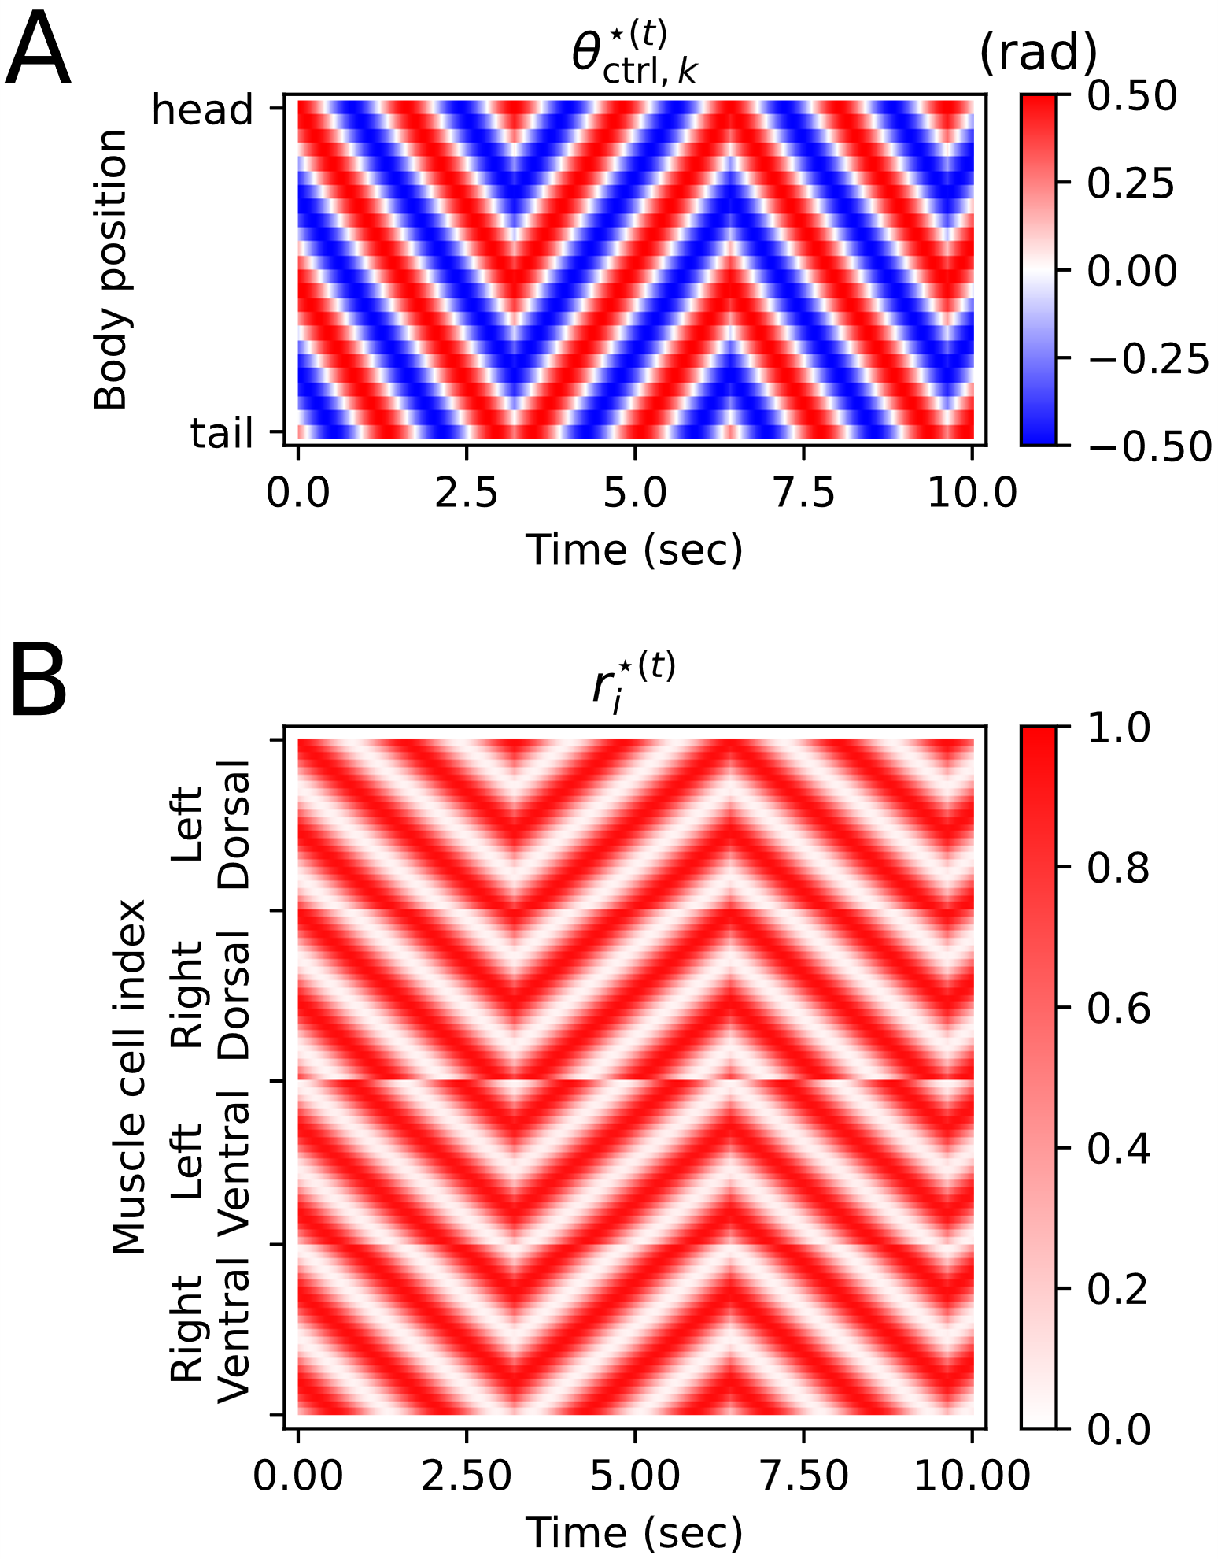
Figure S7. Calculation of target degree of muscle contraction (A) Target body control angle ($θ_{\text{ctrl},k}^{⋆\left(t\right)}$) (B) Target degree of muscle contraction ($r_{i}^{⋆\left(t\right)}$) for a synaptic weight update process.

Supplementary Information References
1. Liu, Q., Kidd, P. B., Dobosiewicz, M. & Bargmann, C. I. C. elegans AWA Olfactory Neurons Fire Calcium-Mediated All-or-None Action Potentials. Cell 175, 57-70.e17 (2018).
2. Chung, T. & Kim, S. C. elegans Artificial Neural Network Model Parameter Set. Zenodo https://doi.org/10.5281/zenodo.18626935 (2026).

