Supplementary Information
A global survey of Systems Biology-based predictions of gene-rare disease associations to enhance new diagnoses
Yolanda Benítez1,2,3, Graciela Uría-Regojo1, Pablo Mínguez1,2,3#
1. Department of Genetics and Genomics, Instituto de Investigación Sanitaria-Fundación Jiménez Díaz University Hospital, Universidad Autónoma de Madrid (IIS-FJD, UAM), Madrid, Spain.
2. Bioinformatics Unit, Instituto de Investigación Sanitaria-Fundación Jiménez Díaz University Hospital, Universidad Autónoma de Madrid (IIS-FJD, UAM), Madrid, Spain.
3. Center for Biomedical Network Research on Rare Diseases (CIBERER), Instituto de Salud Carlos III, Madrid, Spain.
# Corresponding author: Pablo Mínguez, E-mail: pablo.minguez@iis-fjd.es

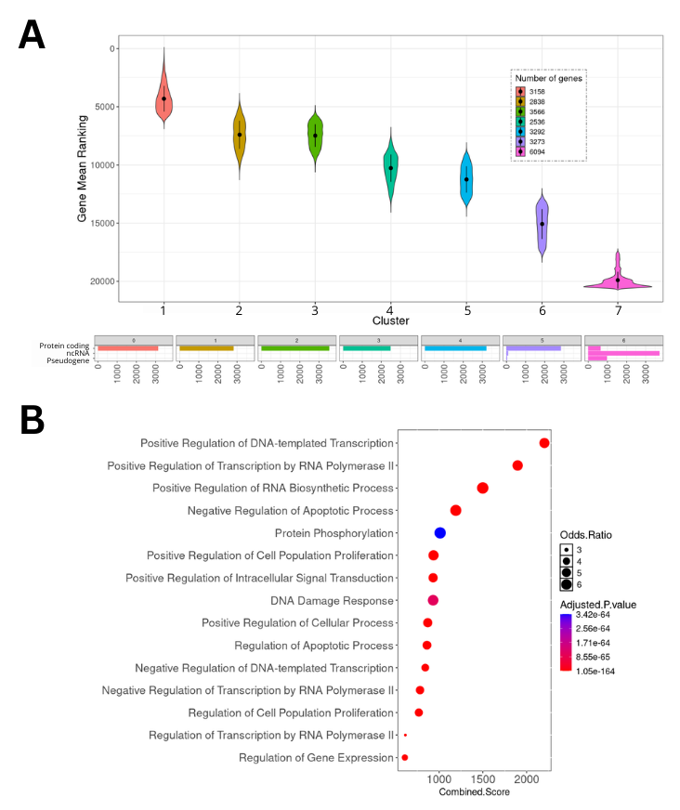

Supplementary Figure 1. Genes and functions systematically associated and not associated with rare diseases with K=7. (A) Boxplots with the distribution of the mean ranking values of the genes, grouped by identified clusters. Includes the composition of each cluster by loci type. (B) Gene ontology enrichment analysis genes in cluster 1 (most linked to diseases). No function was significantly enriched in cluster 7 (less linked to diseases).

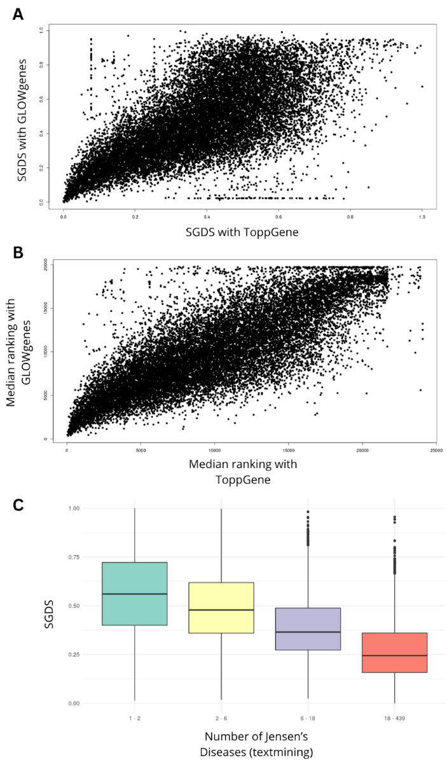

Supplementary Figure 2. Benchmarking of the SGDS against two other prioritization methods. (A) Correlation between the SGDS calculated using GLOWgenes and ToppGene (r=0.66). (B) Correlation between the median gene ranking calculated using GLOWgenes and ToppGene (r=0.8). (C) Box plot showing the relationship between SGDS and the number of associated diseases predicted by Jensen’s Diseases.

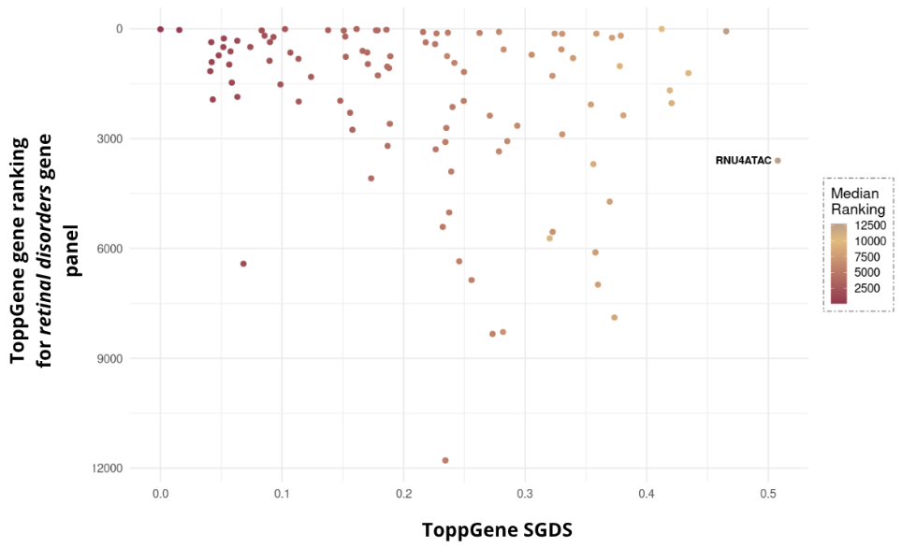

Supplementary Figure 3. Retrospective evaluation of SGDS calculated with ToppGene (ToppGene-SGDS) on successive PanelApp releases. Points correspond to the genes that have been associated with retinal disorders from the first version of the PanelApp panel up to version 4.82. In the y-axis the genes are ranked as their predicted association to the disease by ToppGenes. In the x-axis the genes are ranked as their SGDS. Point color corresponds to their median position in the rankings representing the predictions of association to >200 rare diseases. Gene names are labeled for those with a ToppGene-SGDS > 0.5.

