S1 Document: Comparative performance analysis of machine learning methods, decision curve analysis for MACE prediction, and performance comparison of ML models on the validation set.

Text S1. Comparative performance analysis of machine learning methods
A comparative evaluation of machine learning algorithms for predicting MACE was conducted. The most commonly used classification methods were considered, including logistic regression, k-nearest neighbors (KNN), Random Forest, LightGBM, XGBoost, and CatBoost. The dataset was split into training (70%) and validation (30%) subsets using stratified random sampling to preserve the distribution of the target outcome. Ten input features selected during the preliminary feature selection stage (Section 3.3) were used for model development. For logistic regression, KNN, and Random Forest, missing values were imputed using median values, whereas gradient boosting–based models handled missing data using their native mechanisms. For models sensitive to feature scaling, standardization was applied to achieve zero mean and unit variance. Hyperparameters for all models were optimized using Bayesian optimization implemented in the Optuna framework. The resulting performance metrics are summarized in Table S1.
Table S1. Comparison of the prediction performance of different models
 | Logistic Regression | KNN | Random Forest | LightGBM | XGBoost | CatBoost
 | Training set
Accuracy | 0.65 | 1.00 | 0.75 | 0.85 | 0.82 | 0.94
Precision | 0.69 | 1.00 | 0.85 | 0.87 | 0.88 | 0.97
Recall | 0.31 | 1.00 | 0.49 | 0.77 | 0.68 | 0.89
Specificity | 0.89 | 1.00 | 0.94 | 0.91 | 0.93 | 0.98
ROC-AUC | 0.71 | 1.00 | 0.85 | 0.92 | 0.89 | 0.99
F1-Score | 0.43 | 1.00 | 0.62 | 0.81 | 0.76 | 0.93
 | Validation Set
Accuracy | 0.64 | 0.67 | 0.66 | 0.66 | 0.66 | 0.67
Precision | 0.68 | 0.67 | 0.73 | 0.64 | 0.66 | 0.66
Recall | 0.29 | 0.45 | 0.34 | 0.48 | 0.44 | 0.46
Specificity | 0.89 | 0.83 | 0.90 | 0.80 | 0.83 | 0.82
ROC-AUC | 0.69 | 0.70 | 0.70 | 0.70 | 0.69 | 0.72
F1-Score | 0.41 | 0.53 | 0.46 | 0.55 | 0.52 | 0.54

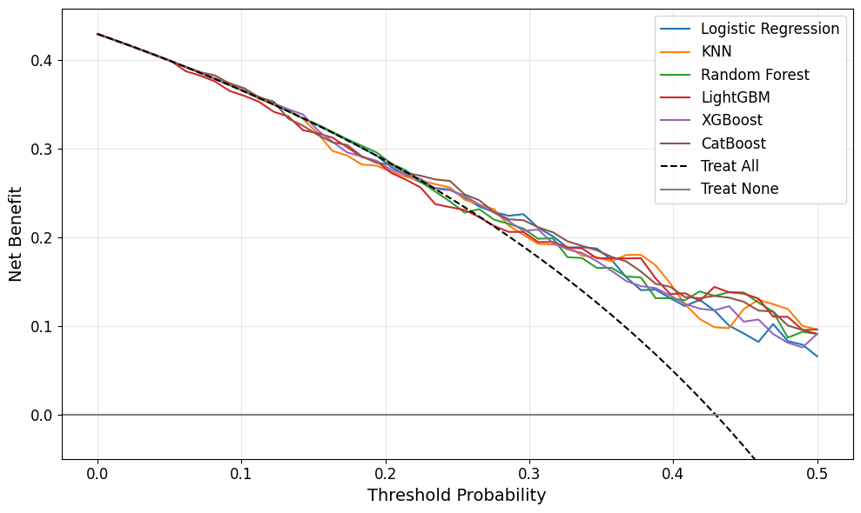
Figure S1. Decision Curve Analysis for MACE prediction on the validation set.

Figure S1 presents the decision curve analysis (DCA) of the machine learning models on the validation cohort, illustrating their clinical utility in terms of net benefit across a range of threshold probabilities for predicting MACE. The reference strategies of “treat all” and “treat none” are shown for comparison.
Across the entire range of evaluated threshold probabilities, all machine learning models demonstrated a positive net benefit and consistently outperformed the “treat none” strategy, indicating potential clinical usefulness of MACE risk prediction. At low threshold probabilities (up to approximately 0.15), differences between models were minimal, and the decision curves were closely aligned with each other and with the “treat all” strategy, reflecting the predominance of sensitivity over specificity in this range.
Within the intermediate threshold probability range (approximately 0.15–0.35), logistic regression, Random Forest, and CatBoost exhibited the highest and most stable net benefit. These models consistently outperformed both the “treat all” strategy and alternative algorithms, suggesting a more balanced trade-off between false-positive and false-negative decisions. LightGBM and XGBoost showed comparable but slightly less stable net benefit, particularly at higher threshold probabilities.
At higher threshold probabilities (>0.35), a general decline in net benefit was observed for all models, likely due to an increasing number of missed MACE events. Although the advantage over the “treat all” strategy diminished in this range, most models maintained a positive net benefit up to threshold probabilities of approximately 0.45–0.50. The KNN model exhibited more pronounced fluctuations in the decision curve, indicating lower robustness of clinical decision-making with respect to threshold variation.
Overall, the DCA results demonstrate that the application of machine learning models for MACE prediction provides clinical benefit across a broad range of threshold probabilities, with the greatest utility observed in the intermediate-risk range.
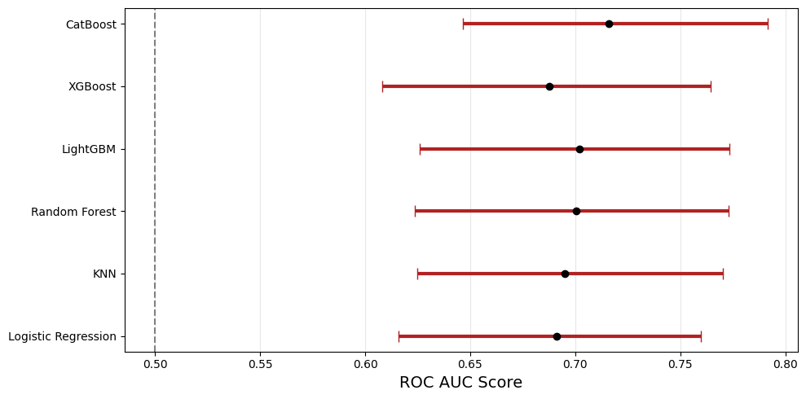
Figure S2. Comparison of machine learning model performance on the validation set. Central markers indicate ROC-AUC values, and horizontal lines represent 95% confidence intervals.

Figure S2 shows a comparison of the discriminative performance of the models on the validation set using the ROC-AUC metric, with confidence intervals estimated via bootstrapping (n = 1000). The vertical dashed line indicates the performance of a random classifier (ROC-AUC = 0.5).
All evaluated models achieved ROC-AUC values significantly exceeding random classification, confirming their discriminative ability for predicting MACE. CatBoost achieved the highest median ROC-AUC, indicating superior performance in distinguishing between patients at high and low risk of events. Random Forest and LightGBM demonstrated comparable performance, slightly below that of CatBoost, while maintaining consistently high discriminative capacity.
Logistic regression and XGBoost yielded moderate ROC-AUC values within a similar range, with logistic regression demonstrating competitive performance despite its simpler model structure. The KNN model showed comparable median ROC-AUC values but with somewhat wider confidence intervals, suggesting lower stability of performance estimates.
The substantial overlap of bootstrap-derived confidence intervals across models indicates the absence of pronounced statistically significant differences in ROC-AUC. Taken together, these results confirm that ensemble-based methods provide the highest discriminative performance. Based on this comparative analysis, CatBoost was selected as the most appropriate method and was used for subsequent analyses.

