Supplementary Material

Supplementary Figure 1. Flow chart of MonDAFIS trial and this subanalysis’ patient population.

Supplementary Figure 2. Overview of incremental relative detection rate of 72-hour monitoring in comparison to 24 hours for selected ECG findings. Abbreviations: AF – atrial fibrillation, VT – ventricular tachycardia, SVT – supraventricular tachycardia, PVC – premature ventricular complex, PAC – premature atrial complex.
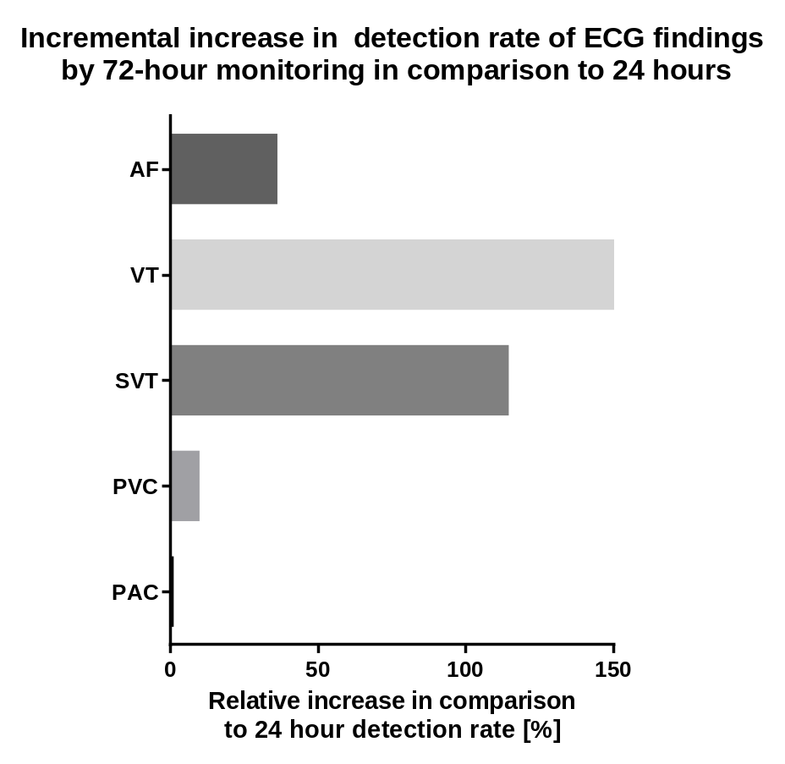

Supplementary Figure 3. Overview of age-specific detection rates [%] of selected Holter ECG findings upon 24 hours of recording. Statistical significance as calculated by chi square test is displayed with ns ≙ p>0.05; * ≙ p≤0.05; ** ≙ p≤0.01; *** ≙ p≤0.001; **** ≙ p≤0.0001. Abbreviations: PAC – Premature atrial complexes, SVcouplet – Supraventricular ectopic couplets, SVrun – Supraventricular ectopic run, SVT – supraventricular tachycardia, AF – atrial fibrillation, PVC – Premature ventricular complex, Vcouplet – Ventricular ectopic couplet, Vbigeminy – Ventricular bigeminy, nsVT – non-sustained ventricular tachycardia

Supplementary Figure 4. Overview of sex-specific detection rates [%] of selected Holter ECG findings upon 24 hours of recording. Statistical significance as calculated by chi square test is displayed with ns ≙ p>0.05; * ≙ p≤0.05; ** ≙ p≤0.01 ; *** ≙ p≤0.001; **** ≙ p≤0.0001. Abbreviations: PAC – Premature atrial complexes, SVcouplet – Supraventricular ectopic couplets, SVrun – Supraventricular ectopic run, SVT – supraventricular tachycardia, AF – atrial fibrillation, PVC – Premature ventricular complex, Vcouplet – Ventricular ectopic couplet, Vbigeminy – Ventricular bigeminy, nsVT – non-sustained ventricular tachycardia

Supplementary Figure 5. Overview of TIA- and stroke-specific detection rates [%] of selected Holter ECG findings upon 24 hours of recording. Statistical significance as calculated by chi square test is displayed with ns ≙ p>0.05; * ≙ p≤0.05; ** ≙ p≤0.01 ; *** ≙ p≤0.001; **** ≙ p≤0.0001. Abbreviations: PAC – Premature atrial complexes, SVcouplet – Supraventricular ectopic couplets, SVrun – Supraventricular ectopic run, SVT – supraventricular tachycardia, AF – atrial fibrillation, PVC – Premature ventricular complex, Vcouplet – Ventricular ectopic couplet, Vbigeminy – Ventricular bigeminy, nsVT – non-sustained ventricular tachycardia

Supplementary Table 1. Overview of baseline characteristics of the subpopulation of the MonDAFIS trial with available 24 hour ECG recording categorized by age groups. Provided are total number and percentage or median and 25th; 75th percentile and p-values as per chi square test.
 | 24 hours
Age (years) | Total | <50 years | 50-75 years | >75 years | p-value
 | N = 1,665 | N = 175  (10.5%) | N = 1,026  (61.6%) | N = 464  (27.9%)
Women, n (%) | 672 (40.4) | 71 (40.6) | 368 (35.9) | 233 (50.2) | < 0.0001
NIHSS on admission 0, n (%) | 177 (10.7) | 34 (19.7) | 107 (10.5) | 36 (7.8) | 0.0007
NIHSS on admission 1-4, n (%) | 1118 (67.5) | 109 (63.0) | 686 (67.3) | 323 (69.6) | 0.0007
NIHSS on admission >4, n (%) | 361 (21.8) | 30 (17.3) | 226 (22.2) | 105 (22.6) | 0.0007
mRS on admission >2, n (%) | 610 (36.7) | 38 (22.0) | 367 (35.8) | 205 (44.3) | < 0.0001
TIA, n (%) | 488 (29.4) | 68 (39.3) | 298 (29.1) | 122 (26.3) | 0.0076
Endovascular thrombectomy, n (%) | 39 (2.4) | 5 (2.9) | 20 (2.0) | 14 (3.0) | 0.4026
Intravenous thrombolysis, n (%) | 361 (21.7) | 38 (22.0) | 238 (23.2) | 85 (18.3) | 0.3330
Heart failure, n (%) | 48 (2.9) | 1 (0.6) | 36 (3.5) | 11 (2.4) | 0.0739
COPD, n (%) | 77 (4.7) | 2 (1.2) | 55 (5.4) | 20 (4.4) | 0.0456
Arterial hypertension, n (%) | 1282 (77.6) | 66 (38.4) | 818 (80.1) | 398 (86.7) | < 0.0001
Diabetes mellitus, n (%) | 441 (26.7) | 17 (9.9) | 284 (27,8) | 140 (30.5) | < 0.0001
Hyperlipidemia, n (%) | 877 (53.1) | 65 (37.8) | 561 (54.9) | 251 (54.7) | < 0.0001
Renal impairment, n (%) | 128 (7.7) | 1 (0.6) | 56 (5.5) | 71 (15.5) | < 0.0001
Vascular disease, n (%) | 237 (14.4) | 3 (1.7) | 144 (14.1) | 90 (19.7) | < 0.0001
Prior cardiovascular event, n (%) | 405 (24.5) | 15 (8.7) | 247 (24.2) | 143 (31.3) | < 0.0001
Smoking, n (%) | 826 (49.9) | 110 (63.6) | 586 (57.4) | 130 (28.2) | < 0.0001
BMI >30kg/m², n (%) | 412 (25.0) | 54 (31.2) | 270 (26.6) | 88 (19.2) | 0.0014

Supplementary Table 2. Overview of baseline characteristics of the subpopulation of the MonDAFIS trial used for 24 hour ECG analysis categorized by sex. Provided are total number and percentage or median (25th; 75th percentile) and p-value as calculated by chi square test.
 | Total | Men | Women | p-value
 | N = 1,665 | N = 993 (59.6%) | N = 672 (40.4%)
Age, years | 67 (57; 76) | 66 (56; 75) | 70 (59; 78)
Age <50 years, n (%) | 175 (10.5) | 104 (10.5) | 71 (10.6) | < 0.0001
Age 50 – 75 years, n (%) | 1,026 (61.6) | 658 (66.3) | 368 (54.8) | < 0.0001
Age >75 years, n (%) | 464 (27.9) | 231 (23.3) | 233 (34.7) | < 0.0001
NIHSS on admission 0, n (%) | 177 (10.7) | 89 (9.0) | 88 (13.2) | 0.0234
NIHSS on admission 1-4, n (%) | 1,118 (67.5) | 677 (68.5) | 441 (66.1) | 0.0234
NIHSS on admission >4, n (%) | 361 (21.8) | 223 (22.5) | 138 (20.7) | 0.0234
mRS on admission >2, n (%) | 610 (36.7) | 362 (36.5) | 248 (37.1) | 0.8518
TIA, n (%) | 488 (29.4) | 274 (27.6) | 214 (31.9) | 0.0615
Endovascular thrombectomy, n (%) | 39 (2.4) | 20 (2.0) | 19 (2.9) | 0.2817
Intravenous thrombolysis, n (%) | 361 (21.7) | 215 (21.7) | 146 (21.8) | 0.9711
Heart failure, n (%) | 48 (2.9) | 32 (3.2) | 16 (2.4) | 0.3140
COPD, n (%) | 77 (4.7) | 40 (4.0) | 37 (5.6) | 0.1589
Arterial hypertension, n (%) | 1,282 (77.6) | 774 (78.3) | 508 (76.5) | 0.2635
Diabetes mellitus, n (%) | 441 (26.7) | 311 (31.4) | 130 (19.5) | < 0.0001
Hyperlipidemia, n (%) | 877 (53.1) | 531 (53.7) | 346 (52.0) | 0.4258
Renal impairment, n (%) | 128 (7.7) | 76 (7.7) | 52 (7.8) | 0.9494
Vascular disease, n (%) | 237 (14.4) | 181 (18.3) | 56 (8.3) | < 0.0001
Prior cardiovascular event, n (%) | 405 (24.5) | 273 (27.7) | 132 (19.9) | 0.0002
Smoking, n (%) | 826 (49.9) | 582 (58.8) | 244 (36.6) | < 0.0001
BMI >30kg/m², n (%) | 412 (25.0) | 254 (25.8) | 158 (23.9) | 0.3376

Supplementary Table 3. Overview of baseline characteristics of the subpopulation of the MonDAFIS trial in the 24 hour ECG analysis by stroke and TIA. Provided are total number with percentage and p-value as calculated by chi square test.
 | Total | TIA | Stroke | p-value
 | N = 1,661 | N = 488 (29.4%) | N = 1,173 (70.6%)
Women, n (%) | 670 (40.3) | 214 (43.9) | 456 (38.9) | 0.0596
Age <50, n (%) | 173 (10.4) | 68 (13.9) | 105 (9.0) | 0.0058
Age 50 – 75, n (%) | 1,025 (61.7) | 298 (61.1) | 727 (62.0) | 0.0058
Age >75, n (%) | 463 (27.9) | 122 (25.0) | 341 (29.1) | 0.0058
NIHSS 0, n (%) | 177 (10.7) | 114 (23.5) | 63 (5.4) | < 0.0001
NIHSS 1-4, n (%) | 1,116 (67.5) | 306 (63.0) | 810 (69.4) | < 0.0001
NIHSS >4, n (%) | 360 (21.8) | 66 (13.6) | 294 (25.2) | < 0.0001
mRS >2, n (%) | 608 (36.7) | 105 (21.5) | 503 (43) | < 0.0001
Endovascular Thrombectomy, n (%) | 39 (2.4) | 9 (1.9) | 30 (2.6) | 0.2565
Intravenous thrombolysis, n (%) | 361 (21.8) | 102 (20.9) | 259 (22.1) | 0.5958
Heart Failure, n (%) | 48 (2.9) | 15 (3.1) | 33 (2.8) | 0.7729
COPD, n (%) | 77 (4.7) | 16 (3.3) | 61 (5.2) | 0.0898
Arterial Hypertension, n (%) | 1,281 (77.6) | 336 (69.4) | 945 (81.0) | < 0.0001
Diabetes mellitus, n (%) | 440 (26.6) | 105 (21.6) | 335 (28.7) | 0.0030
Hyperlipidemia, n (%) | 876 (53.1) | 230 (47.4) | 646 (55.4) | 0.0031
Renal impairment, n (%) | 128 (7.8) | 30 (6.2) | 98 (8.4) | 0.1245
Vascular disease, n (%) | 237 (14.4) | 59 (12.2) | 178 (15.3) | 0.1016
Prior cardiovascular event, n (%) | 405 (24.6) | 107 (22.1) | 298 (25.6) | 0.1326
Smoking, n (%) | 824 (49.9) | 222 (45.7) | 602 (51.6) | 0.0304
BMI >30kg/m², n (%) | 412 (25.1) | 108 (22.4) | 304 (26.2) | 0.1037

Supplementary Table 4. Overview of further ECG abnormalities within the first 24 hours categorized by age groups. Provided are number (%) and median (25th; 75th percentile) and p-value as calculated by chi square test.
ECG finding (24 hours) | Total  N=1,665 | <50 years  N=175 | 50-75 years  N=1,026 | >75 years  N=464 | p-value
Premature atrial complexes | 1,633 (98.1%) | 163 (93.1%) | 1,012 (98.6%) | 458 (98.7%) | 0.0003
Supraventricular ectopic couplets | 1,135 (68.2%) | 72 (41.1%) | 679 (66.2%) | 384 (82.8) | < 0.0001
Supraventricular ectopic run | 915 (55.0%) | 47 (26.9%) | 537 (52.3%) | 331 (71.3%) | < 0.0001
Supraventricular tachycardia (SVT) | 68 (4.1%) | 4 (2.3%) | 39 (3.8%) | 25 (5.4%) | 0.1598
Atrial fibrillation (AF) | 36 (2.2%) | 0 (0.0%) | 16 (1.6%) | 20 (4.3%) | 0.0004
Premature ventricular complex (PVC) | 1,428 (85.8%) | 116 (66.3%) | 885 (86.3%) | 427 (92.0%) | < 0.0001
Ventricular ectopic couplet | 466 (28.0%) | 20 (11.4%) | 275 (26.8%) | 171 (36.9%) | < 0.0001
Ventricular bigeminy | 233 (14.0%) | 8 (4.6%) | 129 (12.6%) | 96 (20.7%) | < 0.0001
Ventricular trigeminy | 241 (14.5%) | 10 (5.7%) | 135 (13.2%) | 96 (20.7%) | < 0.0001
R-on-T phenomenon | 84 (5.0%) | 1 (0.6%) | 45 (4.4%) | 38 (8.2%) | 0.0001
Ventricular run/accelerated idioventricular rhythm | 97 (5.8%) | 3 (1.7%) | 58 (5.7%) | 36 (7.8%) | 0.0135
Ventricular ectopic triplet | 152 (9.1%) | 1 (0.6%) | 94 (9.2%) | 57 (12.3%) | < 0.0001
Ventricular tachycardia | 28 (1.7%) | 2 (1.1%) | 18 (1.8%) | 8 (1.7%) | 0.8310
Tachycardia | 245 (14.7%) | 55 (31.4%) | 128 (12.5%) | 62 (13.4) | < 0.0001
Bradycardia | 336 (20.2%) | 46 (26.3%) | 206 (20.1%) | 84 (18.1%) | 0.0707
Pause | 33 (2.0%) | 3 (1.7%) | 17 (1.7%) | 13 (2.8%) | 0.3283
Supraventricular escape | 430 (25.8%) | 46 (26.3%) | 245 (23.9%) | 139 (30.0%) | 0.0454
Ventricular escape | 118 (7.1%) | 6 (3.4%) | 56 (5.5%) | 56 (12.1%) | < 0.0001

Supplementary Table 5. Overview of further ECG abnormalities within the first 24 hours categorized by sex. Provided are absolute number (%).
ECG finding (24 hours) | Total  N=1,665 | Male  N = 993 (59.6%) | Female  N = 672 (40.4%) | p-value
Premature atrial complex | 1,633 (98.1%) | 977 (98.4%) | 656 (97.6%) | 0.2617
Supraventricular ectopic couplets | 1,135 (68.2%) | 653 (65.8%) | 482 (71.7%) | 0.0103
Supraventricular ectopic run | 915 (55.0%) | 520 (52.4%) | 395 (58.8%) | 0.0099
Supraventricular tachycardia (SVT) | 68 (4.1%) | 34 (3.4%) | 34 (5.1%) | 0.0981
Atrial fibrillation (AF) | 36 (2.2%) | 17 (1.7%) | 19 (2.8%) | 0.1247
Premature ventricular complex (PVC) | 1,428 (85.8%) | 868 (87.4%) | 560 (83.3%) | 0.0194
Ventricular ectopic couplet | 466 (28.0%) | 312 (31.4%) | 154 (22.9%) | 0.0001
Ventricular bigeminy | 233 (14.0%) | 158 (15.9%) | 75 (11.2%) | 0.0061
Ventricular trigeminy | 241 (14.5%) | 164 (16.5%) | 77 (11.5%) | 0.0040
R-on-T phenomenon | 84 (5.0%) | 56 (5.6%) | 28 (4.2%) | 0.4211
Ventricular run/accelerated idioventricular rhythm (AIVR) | 97 (5.8%) | 64 (6.4%) | 33 (4.9%) | 0.1897
Ventricular ectopic triplet | 152 (9.1%) | 97 (9.8%) | 55 (8.2%) | 0.2709
Ventricular tachycardia (VT) | 28 (1.7%) | 22 (2.2%) | 6 (0.9%) | 0.0395
Tachycardia | 245 (14.7%) | 119 (12.0%) | 126 (18.8%) | 0.0001
Bradycardia | 336 (20.2%) | 221 (22.3%) | 115 (17.1%) | 0.0103
Pause | 33 (2.0%) | 25 (2.5%) | 8 (1.2%) | 0.0566
Supraventricular escape (SVEsc) | 430 (25.8%) | 267 (26.9%) | 163 (24.3%) | 0.2286
Ventricular escape (VEsc) | 118 (7.1%) | 72 (7.3%) | 46 (6.8%) | 0.7517

Supplementary Table 6. Overview of further ECG abnormalities within the first 24 hours divided in stroke and TIA cases. Provided are absolute number (%).
ECG finding (24 hours) | Total  N=1,661 (4 missing) | TIA  N = 488 (29.4%) | Stroke  N = 1,173 (70.6%) | p-value
Premature atrial complex | 1,629 (98.1%) | 477 (97.7%) | 1,152 (98.2%) | 0.5310
Supraventricular ectopic couplets | 1,132 (68.2%) | 331 (67.8%) | 801 (68.2%) | 0.8550
Supraventricular ectopic run | 914 (55.0%) | 254 (52.0%) | 660 (56.3%) | 0.1156
Supraventricular tachycardia (SVT) | 68 (4.1%) | 24 (4.9%) | 44 (3.8%) | 0.2743
Atrial fibrillation (AF) | 36 (2.2%) | 10 (2.0%) | 26 (2.2%) | 0.8310
Premature ventricular complex (PVC) | 1,426 (85.9%) | 419 (85.9%) | 1,007 (85.8%) | 0.9947
Ventricular ectopic couplet | 465 (28.0%) | 124 (25.4%) | 341 (29.1%) | 0.1301
Ventricular bigeminy | 233 (14.0%) | 71 (14.5%) | 162 (13.8%) | 0.6930
Ventricular trigeminy | 241 (14.5%) | 62 (12.7%) | 179 (15.3%) | 0.1780
R-on-T phenomenon | 84 (5.1%) | 23 (4.7%) | 61 (5.2%) | 0.6798
Ventricular run/accelerated idioventricular rhythm (AIVR) | 97 (5.8%) | 22 (4.5%) | 75 (6.4%) | 0.1355
Ventricular ectopic triplet | 152 (9.2%) | 40 (8.2%) | 112 (9.5%) | 0.3842
Ventricular tachycardia (VT) | 28 (1.7%) | 7 (1.4%) | 21 (1.8%) | 0.6078
Tachycardia | 244 (14.7%) | 74 (15.2%) | 170 (14.5%) | 0.7249
Bradycardia | 335 (20.2%) | 129 (26.4%) | 206 (17.6%) | < 0.0001
Pause | 33 (2.0%) | 7 (1.4%) | 26 (2.2%) | 0.2981
Supraventricular escape (SVEsc) | 429 (25.8%) | 140 (28.7%) | 289 (24.6%) | 0.0858
Ventricular escape (VEsc) | 118 (7.1%) | 40 (8.2%) | 78 (6.6%) | 0.2636

Supplementary Table 7. Overview of ECG findings investigated and their clinical relevance based on the literature.
ECG finding | Clinical Relevance
Supraventricular ectopic beats (SVE) | Ubiquitous even in absence of cardiac disease²⁹; higher frequency associated with AF, stroke and mortality^{12,30-32}
Supraventricular ectopic couplet | See Supraventricular ectopic beats (SVE)
Supraventricular ectopic run | See Supraventricular ectopic beats (SVE)
Premature ventricular complex (PVC) | High prevalence in general population; association with cardiovascular disease (e.g. coronary artery disease and myocardial infarction) and mortality³³⁻³⁶
Ventricular ectopic couplet | See Premature ventricular complex (PVC)
Ventricular ectopic triplet | See Premature ventricular complex (PVC)
Ventricular tachycardia (VT) | Potentially life-threatening arrhythmia when sustained; incidental detection of non-sustained VT in the absence of underlying cardiac disease of unknown relevance^{35,37-39}
Tachycardia | Spectrum of causes with varying clinical significance; association of elevated resting heart rate with mortality ^{15,40,41}
Bradycardia | Spectrum of causes with varying clinical significance; sinus bradycardia usually without adverse prognostic significance⁴²⁻⁴⁴
Pause | Spectrum of causes with varying clinical significance (e.g. sinus pause, atrioventricular block)^{43,44}
Supraventricular escape | Indicator of atrial, especially sinus node dysfunction⁴⁵
Ventricular escape (VEsc) | Indicator of atrial or AV node dysfunction
R-on-T phenomenon | PVC initiation in the “vulnerable period” potentially leading to malignant ventricular arrhythmias⁴⁶
Supraventricular tachycardia (SVT) | Spectrum of causes with varying clinical significance (e.g. atrial and AV nodal disorders)
Ventricular run/accelerated idioventricular rhythm | See Premature ventricular complex (PVC)
Ventricular bigeminy | See Premature ventricular complex (PVC)
Ventricular trigeminy | See Premature ventricular complex (PVC)
Atrial fibrillation (AF) | Association with increased morbidity and mortality, e.g. through increased risk of stroke and heart failure⁵

Supplementary Table 8. Overview ECG findings with respective definition used for core laboratory classification
Abnormal ECG finding | Definition
Premature atrial complex | isolated premature ectopic supraventricular beats
Supraventricular ectopic couplets | two consecutive supraventricular ectopic beats
Supraventricular ectopic run | three or more consecutive supraventricular ectopic beats
Supraventricular tachycardia | >180 bpm, <30 s
Atrial fibrillation | Atrial fibrillation ≥30 s
Premature ventricular complex | isolated ventricular ectopic beats
Ventricular ectopic couplet | two consecutive ventricular ectopic beats
Ventricular bigeminy | repetitive patterns in which every second beat was ventricular
Ventricular trigeminy | repetitive patterns in which every third beat was ventricular
R-on-T phenomenon | premature ventricular complex superimposed on the T wave of the preceding beat
Ventricular run/accelerated idioventricular rhythm (AIVR) | ≥3 consecutive ventricular beats usually with gradual onset
Ventricular ectopic triplet | three consecutive supraventricular ectopic beats
Non-sustained ventricular tachycardia | 4–30 beats
Sustained ventricular tachycardia | >30 beats
Supraventricular escape (SVEsc) | delayed subsidiary supraventricular beat occurring after a pause
Ventricular escape (VEsc) | delayed subsidiary ventricular beat occurring after a pause
Pause | ≥5 s
Bradycardia | <60 bpm
Tachycardia | ≥100 bpm

