SUPPLEMENTARY MATERIAL
Risk factors of osteoporosis in post-gastrectomy gastric cancer patients:
a systematic review and meta-analysis

Supplementary Table
Supplementary Table 1 - Search strategy
Supplementary Table 2 - Quality assessment of included studies by Newcastle-Ottawa Scale
Supplementary Table 3 - Risk factors of osteoporosis in post-gastrectomy GC patients, stratified by HR and OR
Supplementary Table 4 - Egger's test of risk factors of osteoporosis in post-gastrectomy GC patients

Supplementary Fig
Supplementary Fig 1 - Forest plot of pooled results

Table 1. The detailed search strategy for all four databases incl. search terms used for the systematic literature searches.
Database | Search Term | Result
PubMed | #1: (Stomach Neoplasms) OR (Gastric Neoplasms) OR (Gastric Cancer) OR (Stomach Cancer) OR (Stomach Tumor) OR (Gastric Tumor) OR (Gastric Malignancy) OR (Stomach Malignancy) OR (Gastric Adenocarcinoma) | 206,605
PubMed | #2: (Gastrectomy) OR (Bariatric Surgery) OR (Endoscopic Mucosal Resection) OR (Jejunoileal Bypass) OR (Gastric Bypass) OR (Biliopancreatic Diversion) OR (Endoscopic Treatment) | 502,069
PubMed | #3: (Osteoporosis) OR (Fracture) OR (Vitamin D) OR (Bone Density) OR (Bone Remodeling) OR (Age Related Bone Loss) OR (Broken Bone) OR (Bone Metabolism) OR (Bone Turnover) | 933,412
PubMed | #4: #1 AND #2 AND #3 | 243
EMBASE | #1: 'stomach neoplasms' OR 'gastric neoplasms' OR 'gastric cancer' OR 'stomach cancer' OR 'stomach tumor' OR 'gastric tumor' OR 'gastric malignancy' OR 'stomach malignancy' OR 'gastric adenocarcinoma' | 234,684
EMBASE | #2: 'gastrectomy' OR 'bariatric surgery' OR 'endoscopic mucosal resection' OR 'jejunoileal bypass' OR 'gastric bypass' OR 'biliopancreatic diversion' OR 'endoscopic treatment' | 177,835
EMBASE | #3: 'osteoporosis' OR 'fracture' OR 'vitamin d' OR 'bone density' OR 'bone remodeling' OR 'age related bone loss' OR 'broken bone' OR 'bone metabolism' OR 'bone turnover' | 874,510
EMBASE | #4: #1 AND #2 AND #3 | 225
Cochrane Library | #1: Stomach Neoplasms OR Gastric Neoplasms OR Gastric Cancer OR Stomach Cancer OR Stomach Tumor OR Gastric Tumor OR Gastric Malignancy OR Stomach Malignancy OR Gastric Adenocarcinoma in All Text | 14,324
Cochrane Library | #2: Gastrectomy OR Bariatric Surgery OR Endoscopic Mucosal Resection OR Jejunoileal Bypass OR Gastric Bypass OR Biliopancreatic Diversion OR Endoscopic Treatment in All Text | 23,588
Cochrane Library | #3: Osteoporosis OR Fracture OR Vitamin D OR Bone Density OR Bone Remodeling OR Age Related Bone Loss OR Broken Bone OR Bone Metabolism OR Bone Turnover in All Text | 64,837
Cochrane Library | #4: #1 AND #2 AND #3 | 125
Web of Science | #1: TS=((Stomach Neoplasms) OR (Gastric Neoplasms) OR (Gastric Cancer) OR (Stomach Cancer) OR (Stomach Tumor) OR (Gastric Tumor) OR (Gastric Malignancy) OR (Stomach Malignancy) OR (Gastric Adenocarcinoma)) | 377,803
Web of Science | #2: TS=((Gastrectomy) OR (Bariatric Surgery) OR (Endoscopic Mucosal Resection) OR (Jejunoileal Bypass) OR (Gastric Bypass) OR (Biliopancreatic Diversion) OR (Endoscopic Treatment)) | 280,265
Web of Science | #3: TS=((Osteoporosis) OR (Fracture) OR (Vitamin D) OR (Bone Density) OR (Bone Remodeling) OR (Age Related Bone Loss) OR (Broken Bone) OR (Bone Metabolism) OR (Bone Turnover)) | 2,832,903
Web of Science | #4: #1 AND #2 AND #3 | 562
Time | 21 July 2025

Table 2. Methodological quality of cohort studies included in the meta-analysis*
Source | Selection |  |  |  | Comparability | Outcome |  |  | Total score/Quality
Source | Representativeness of the exposed cohort | Selection of the unexposed  cohort | Ascertainment  of exposure | Outcome of interest not present at start of study | Control for  important factor or additional factor† | Assessment of outcome | Follow-up  long enough for outcomes  to occur ‡ | Adequacy of  follow-up  of cohorts § | Total score/Quality
An S, 2024 | ⚝ | ⚝ | ⚝ | ⚝ | ⚝⚝ | ⚝ | ⚝ | - | 8/High
Kawabata R, 2023 | ⚝ | ⚝ | ⚝ | ⚝ | ⚝⚝ | ⚝ | - | - | 7/High
Oh H, 2023 | ⚝ | ⚝ | ⚝ | ⚝ | ⚝⚝ | ⚝ | ⚝ | - | 8/High
Zhu Y, 2023 | ⚝ | ⚝ | ⚝ | ⚝ | ⚝ | ⚝ | ⚝ | - | 7/High
Yun I, 2022 | ⚝ | ⚝ | ⚝ | ⚝ | ⚝ | ⚝ | ⚝ | - | 7/High
Park KB, 2021 | ⚝ | ⚝ | ⚝ | ⚝ | ⚝ | ⚝ | ⚝ | - | 7/High
Seo HS, 2021 | ⚝ | ⚝ | ⚝ | ⚝ | ⚝⚝ | ⚝ | - | - | 7/High
Seo GH, 2018 | ⚝ | ⚝ | ⚝ | ⚝ | ⚝ | ⚝ | ⚝ | - | 7/High
Yoo SH, 2018 | ⚝ | ⚝ | ⚝ | ⚝ | ⚝ | ⚝ | ⚝ | - | 7/High
Oh HJ, 2016 | ⚝ | ⚝ | ⚝ | ⚝ | ⚝⚝ | ⚝ | ⚝ | - | 8/High
Lim JS, 2007 | ⚝ | ⚝ | ⚝ | ⚝ | ⚝⚝ | ⚝ | - | - | 7/High
* A study could be awarded a maximum of one star for each item except for the item Control for important factor or additional factor.
† A maximum of 2 stars could be awarded for this item. Studies that controlled for family history of colorectal cancer (most important), age, sex, body mass index, smoking and comorbidities received two stars.
‡ A cohort study with a follow-up time >5 y was assigned one star.
§ A cohort study with a follow-up rate >90% was assigned one star.
Table 3. Risk factors of osteoporosis in post-gastrectomy GC patients, stratified by HR and OR
Risk factor | Effect Measure | No. of  studies | Pooled Estimate (95% CI) | I² | P
Sociodemographic factor
Sex-F | HR | 3 | 1.97 (1.53, 2.53) | 94.9% | <0.001
Sex-F | OR | 3 | 2.56 (0.61, 10.81) | 99.0% | 0.201
Sex-M | HR | 2 | 0.71 (0.15, 3.36) | 99.2% | 0.670
Sex-M | OR | 1 | NA | NA | NA
Age | HR | 3 | 1.06 (1.03, 1.09) | 95.9% | <0.001
Age | OR | 1 | NA | NA | NA
Urban residence | HR | 2 | 0.87 (0.78, 0.97) | 59.4% | 0.013
Medical aid beneficiary | HR | 1 | NA | NA | NA
Medical aid beneficiary | OR | 2 | 1.07 (0.85, 1.35) | 0.0% | 0.558
Income-L | HR | 1 | NA | NA | NA
Income-L | OR | 2 | 1.11 (0.97, 1.26) | 53.5% | 0.125
Income-M | HR | 2 | 0.98 (0.89, 1.08) | 0.0% | 0.632
Income-M | OR | 2 | 1.04 (0.96, 1.13) | 0.0% | 0.353
Behavioral risk factor
Body weight change | HR | 1 | NA | NA | NA
Body weight change | OR | 2 | 2.14 (0.93, 4.91) | 50.3%
Smoking | HR | 1 | NA | NA | NA
Smoking | OR | 2 | 1.05 (0.15, 7.34) | 88.9%
Drinking | HR | 1 | NA | NA | NA
Drinking | OR | 2 | 1.35 (0.77, 2.37) | 45.6% | 0.301
Clinical factor
Diabetes mellitus | HR | 2 | 1.16 (1.11, 1.22) | 0.0% | <0.001
Diabetes mellitus | OR | 3 | 1.08 (0.86, 1.36) | 41.9% | 0.517
Total gastrectomy | HR | 3 | 1.50 (0.75, 2.99) | 99.2% | 0.255
Total gastrectomy | OR | 2 | 1.26 (0.59, 2.69) | 64.4% | 0.546
Subtotal gastrectomy | HR | 3 | 1.52 (0.79, 2.92) | 96.1% | 0.205
Subtotal gastrectomy | OR | 1 | NA | NA | NA
Chemotherapy | HR | 2 | 1.02 (0.92, 1.12) | 58.0% | 0.754
Chemotherapy | OR | 1 | NA | NA | NA
Abbreviations: GC, gastric cancer; HR, Hazard Ratio; OR, Odds Ratios; Sex-F, Sex-Female; Sex-M, Sex-Male; Income-L, Income-Low; Income-M, Income-Medium; BMI, body mass index; No, number; CI, confidence interval.

Table 4. Egger's test of risk factors of osteoporosis in post-gastrectomy GC patients.
Risk factor | No. of studies | P
Sociodemographic factor
Sex-F | 6 | 0.888
Sex-M | 3 | 0.210
Age | 4 | 0.942
Medical aid beneficiary | 3 | 0.587
Income-L | 3 | 0.497
Income-M | 4 | 0.656
Income-H | 3 | NA
Urban residence | 2 | NA
Behavioral risk factor
Body weight change | 3 | 0.208
Smoking | 3 | 0.733
Drinking | 3 | 0.289
BMI | 2 | NA
Clinical factor
ALP | 2 | NA
Anemia | 2 | NA
CCI | 2 | NA
Diabetes mellitus | 5 | 0.772
Total gastrectomy | 5 | 0.683
Subtotal gastrectomy | 3 | 0.126
ESD/EMR | 2 | NA
Radiotherapy | 2 | NA
Hypertension | 3 | 0.207
Chemotherapy | 3 | 0.368
Abbreviations: GC, gastric cancer; Sex-F, Sex-Female; Sex-M, Sex-Male; Income-L, Income-Low; Income-M, Income-Medium; Income-H, Income-High; BMI, body mass index; ALP, alkaline phosphatase; CCI, Charlson comorbidity index; ESD/EMR, endoscopic submucosal dissection/endoscopic mucosal resection; No, Number.
Fig 1. Forest plot of pooled results.
A Age; B ALP; C Anemia; D BMI; E Body weight change; F CCI; G Chemotherapy; H Diabetes mellitus; I Drinking; J ESD/EMR; K Female; L Income-M; M Income-H; N Income-L; O Male; P Q Medical aid beneficiary; R Radiotherapy; S Smoking; T Subtotal gastrectomy; U Total gastrectomy; V Urban residence.
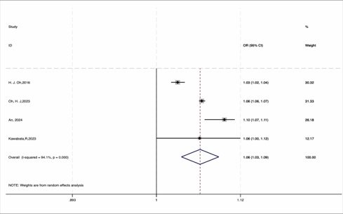 | 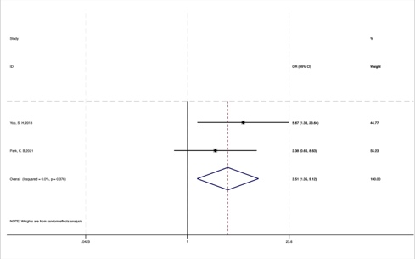  C  B  A | 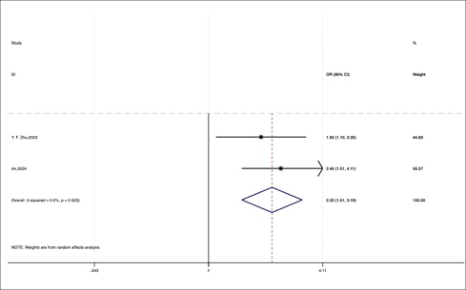
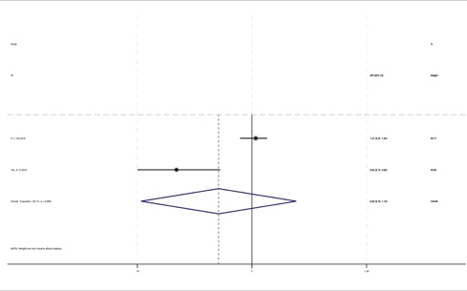  D  E  F | 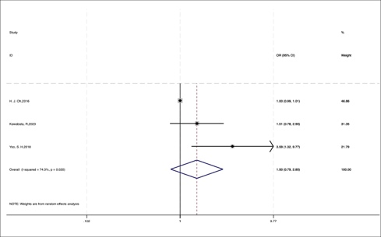  I  H  G | 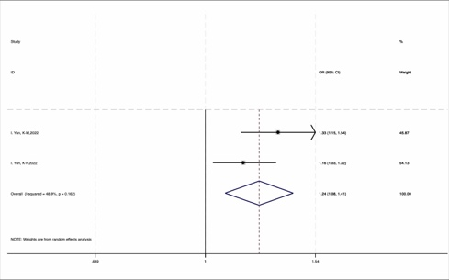
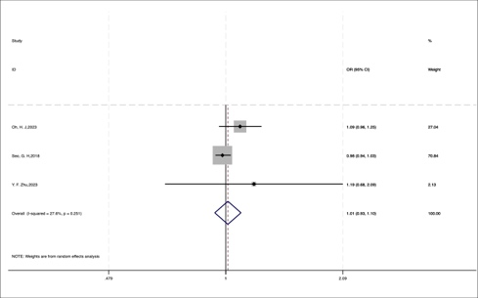 | 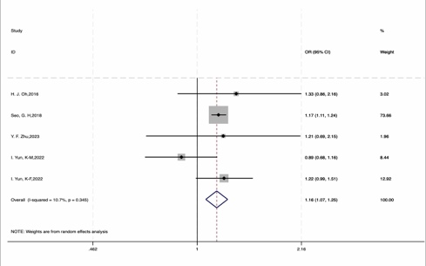 | 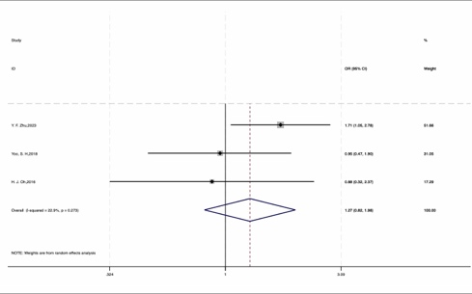
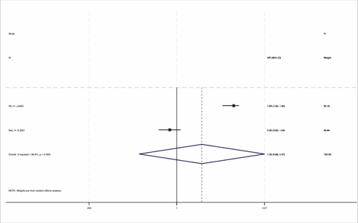 | 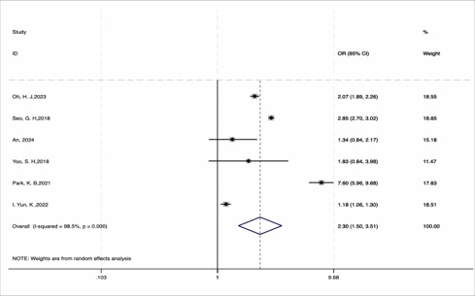 | 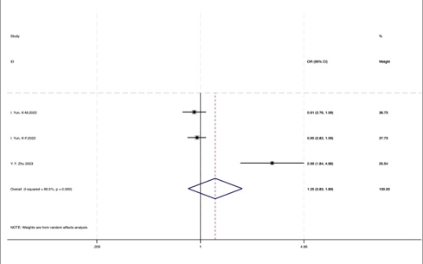
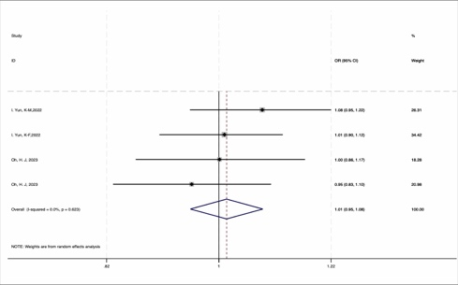 | 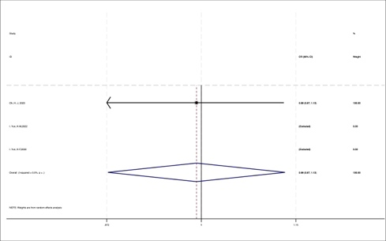 | 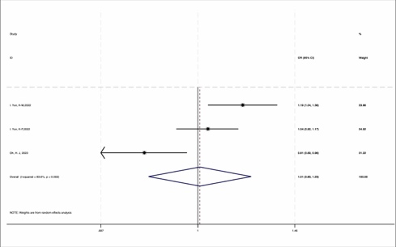
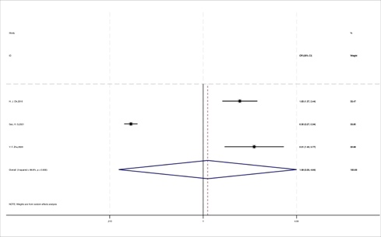 | 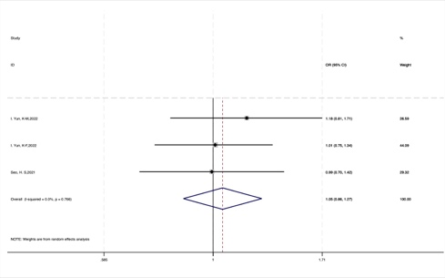  M  N  O  P  Q  R  L  K  J | 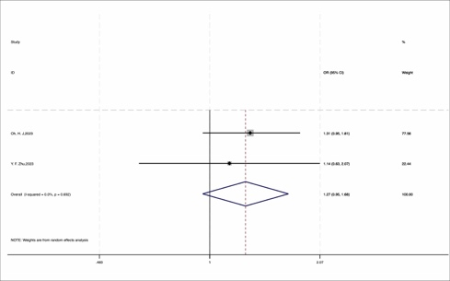
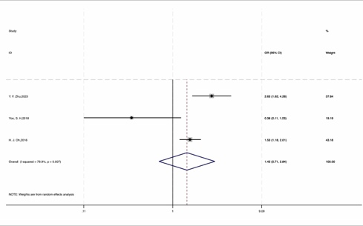 | 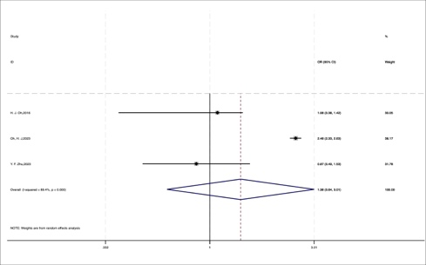 | 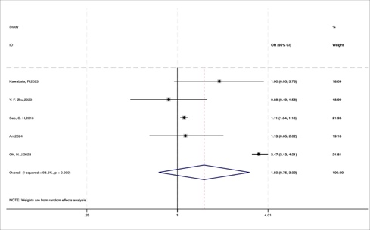
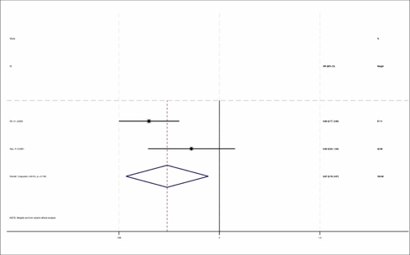
V
S
T
U

