Supplementary Information
Drought influence on carbon assimilation and water use efficiency in Mediterranean ecosystems
This supplementary material provides additional figures and tables supporting analyses of drought-driven shifts in carbon–water coupling across Mediterranean ecosystems from 2000 to 2020. Data include spatial patterns, correlation statistics, growing season definitions, and drought event distributions during drought events for Gross Primary Productivity (GPP), Normalized Difference Vegetation Index (NDVI), Crop Water Stress Index (CWSI), Actual Evapotranspiration (ET), and Water Use Efficiency (WUE) across 11 IGBP vegetation classes: Evergreen Needleleaf Forest (ENF), Evergreen Broadleaf Forest (EBF), Deciduous Broadleaf Forest (DBF), Mixed Forest (MF), Closed Shrublands (CS), Open Shrublands (OS), Woody Savannas (WS), Savannas (SAV), Grasslands (GRA), Croplands (CRP), and Cropland/Natural Vegetation Mosaic (CNM). All figures and tables are cited in the main text and presented in their original order.
Supplementary methods
1. CWSI Calculation
The temperature differences is:
$$∆T= T_{c}- T_{a}$$
where $T_{c}$is MODIS LST and $T_{a}$is ERA5-Land air temperature. NDVI-based stress baselines were established per pixel and time step: $∆T_{min}$ was the 5th percentile of $∆T$ for high NDVI (>95th percentile, well-watered conditions), and $∆T_{max}$ was the 95th percentile for low NDVI (<5th percentile, stressed conditions)¹.
CWSI was computed as:
$$CWSI= \frac{∆T- ∆T_{min}, }{∆T_{max}- ∆T_{min}}$$
following the methodology of Jackson et al^{2,3}, adapted for regional-scale analysis.
2. Ecosystem-specific growing season masks
To restrict analyses to periods of active vegetation growth, vegetation-type-specific growing seasons were defined using NDVI climatology. Monthly NDVI climatology (2000–2020) was computed by averaging NDVI values for each month across the study period, grouped by IGBP classes. For each class $\left(c\right)$, the climatology was calculated as:
$${NDVI}_{clim}\left(m,c\right)= \frac{1}{N_{y}}\sum_{y=2000}^{2020}{NDVI(m,y,c)}$$
where $\left(m\right)$ is the month, $\left(c\right)$ is the IGBP class, and $N_{y}$ is the number of valid years. A threshold for growing season was defined as:
$$Treshold\left(c\right)= {NDVI}_{min}\left(c\right)+0.30 ∙({NDVI}_{max}\left(c\right)- {NDVI}_{min}\left(c\right))$$
Months with ${NDVI}_{clim}\left(m, c\right)$ $>$ $Treshold\left(c\right)$were classified as growing season months for each class ($c$)⁴. The 30% relative threshold (minimum NDVI + 30% × NDVI amplitude) was selected following established remote sensing phenology conventions, as it is robust across diverse ecosystem types and insensitive to absolute NDVI magnitudes that vary substantially among the 11 Mediterranean vegetation classes⁵. This approach yielded ecosystem-specific growing season definitions, applied to mask all variables to ensure that analyses reflect periods of active vegetation functioning. NDVI climatology plots and the corresponding growing season thresholds for each of the 11 ecosystem types are provided in Figures S4–S15
3. Lagged and cumulative correlation analyses
Lagged and cumulative correlation methods are detailed in the main text. Briefly, lagged correlations between 1-month SPEI or CWSI and ecosystem indicators (GPP, NDVI, ET, WUE) were computed to determine the response time of vegetation to drought stress. Cumulative correlations were calculated over 1–12 month accumulation periods to capture prolonged drought effects. Maximum lagged correlations (|R_max|), maximum cumulative correlations (|R_max_cum|), and associated lag/cumulative durations were mapped for each variable and vegetation type (Figures S1–S4).
4. Software and data processing
All spatial and temporal analyses were performed using Python (v3.9) with packages including numpy, pandas, xarray, and matplotlib. GIS operations were conducted with rasterio and geopandas. All gridded datasets were projected to a common 0.05° × 0.05° resolution for consistency. CMCC supercomputing cloud resources were used for computationally intensive correlation and trend analyses.
Supplementary Figures

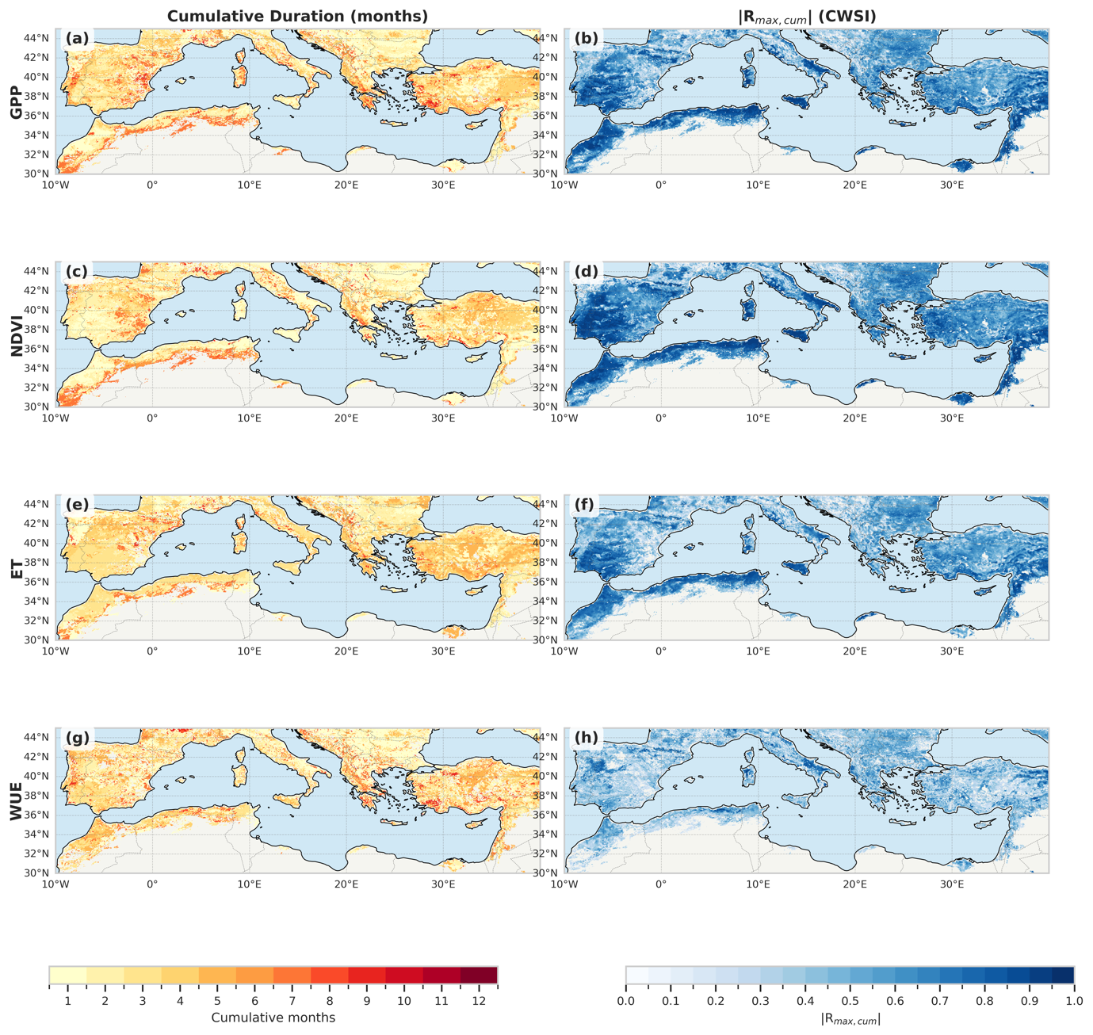

Figure S1: Spatial patterns of cumulative duration (months) and maximum cumulative correlation (|R_max_cum|) between CWSI and GPP, NDVI, ET, and WUE across Mediterranean ecosystems during 2000–2020. Maps highlight the cumulative time scales and correlation strengths, emphasizing CWSI’s sensitivity to drought stress.

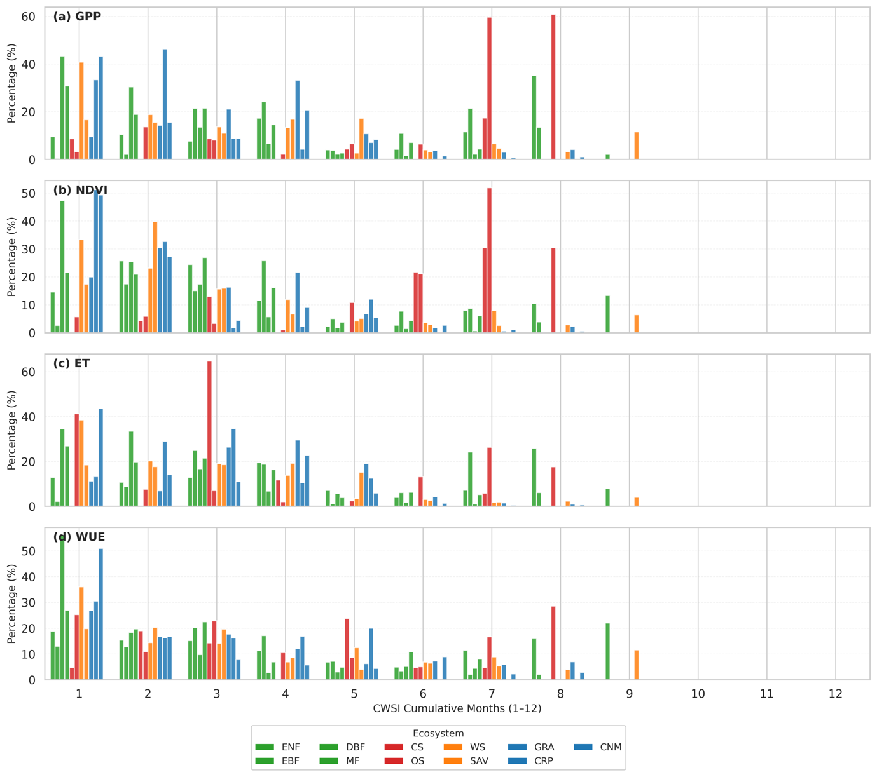
Figure S2: Distribution of cumulative durations (months) at which maximum cumulative correlation (|R_max_cum|) occurs between CWSI (1–12 month scales) and GPP, NDVI, ET, and WUE across Mediterranean ecosystems. Bars indicate the percentage of |R_max_cum| within each vegetation type (ENF, EBF, DBF, MF, CS, OS, WS, SAV, GRA, CRP, CNM) exhibiting peak cumulative correlation at a given duration.
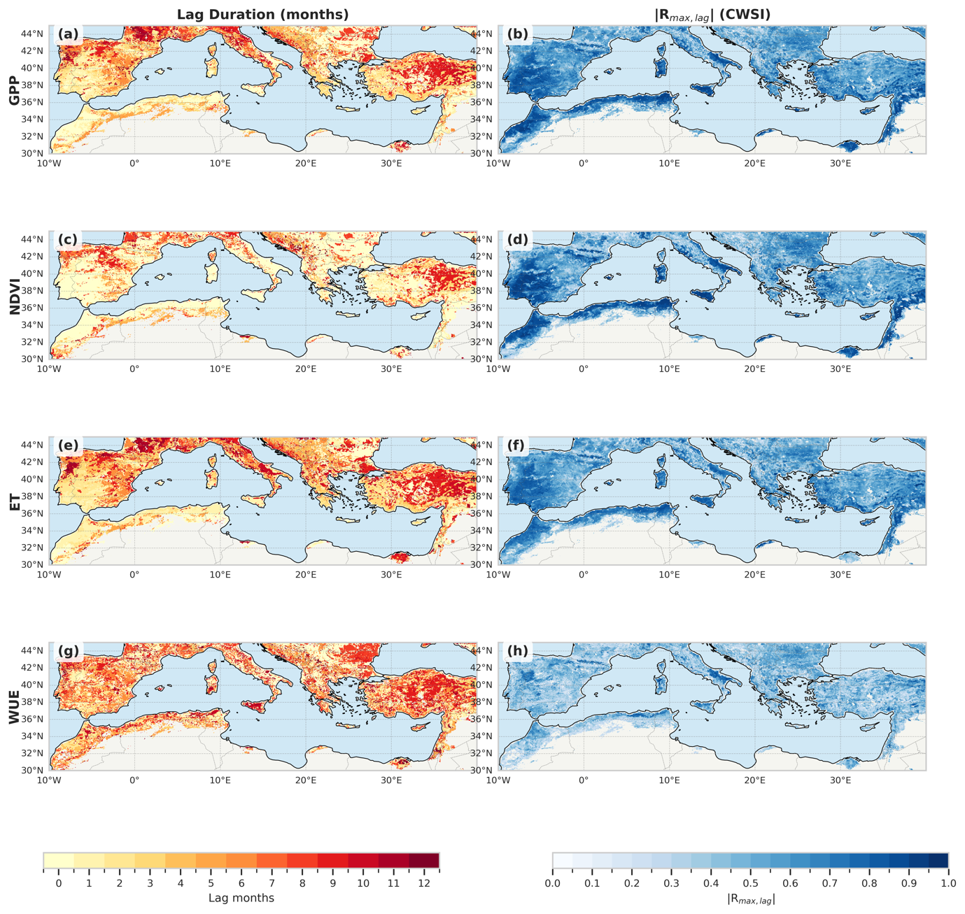
Figure S3. Spatial patterns of lag durations and maximum correlation (|R_max|) between CWSI and GPP, NDVI, ET, and WUE across Mediterranean ecosystems during 2000–2020. Maps show the spatial distribution of lag times and correlation strengths.
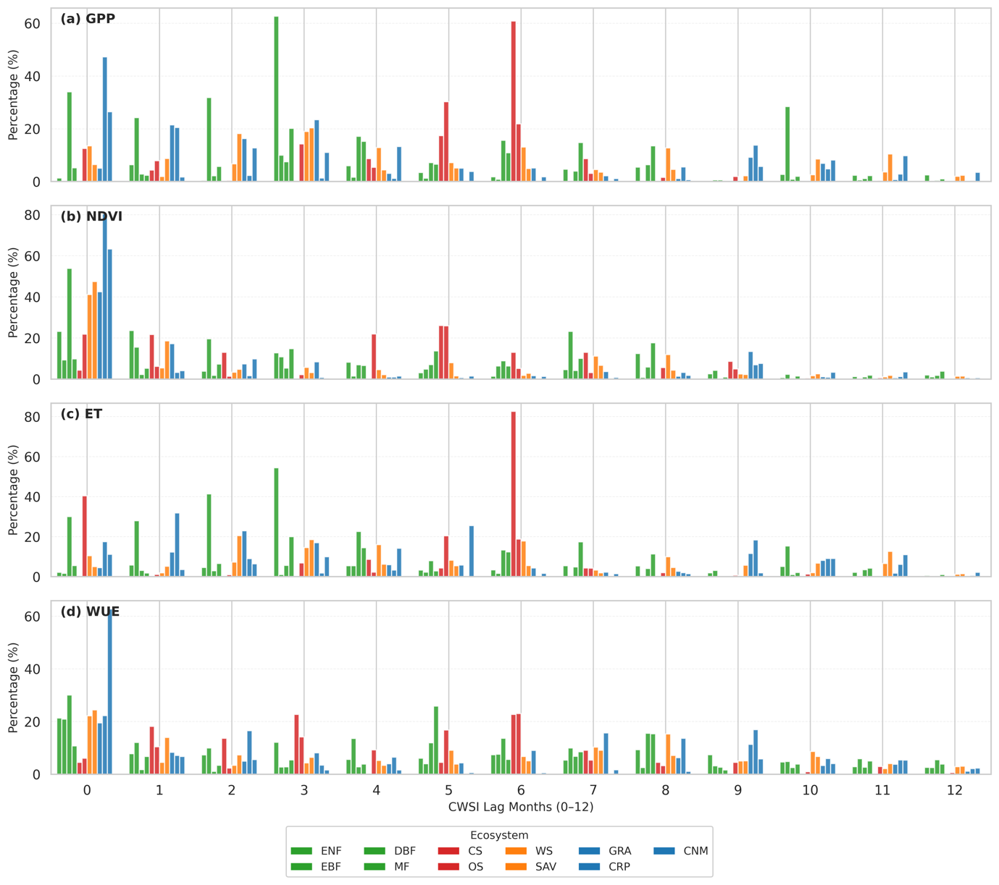
Figure S4. Distribution of lag times (in months) at which maximum correlation (|R_max|) occurs between CWSI and GPP, NDVI, ET, and WUE across Mediterranean ecosystems. Bars indicate the percentage of |R_max| within each vegetation type (ENF, EBF, DBF, MF, CS, OS, WS, SAV, GRA, CRP, CNM) exhibiting peak correlation at a given lag.
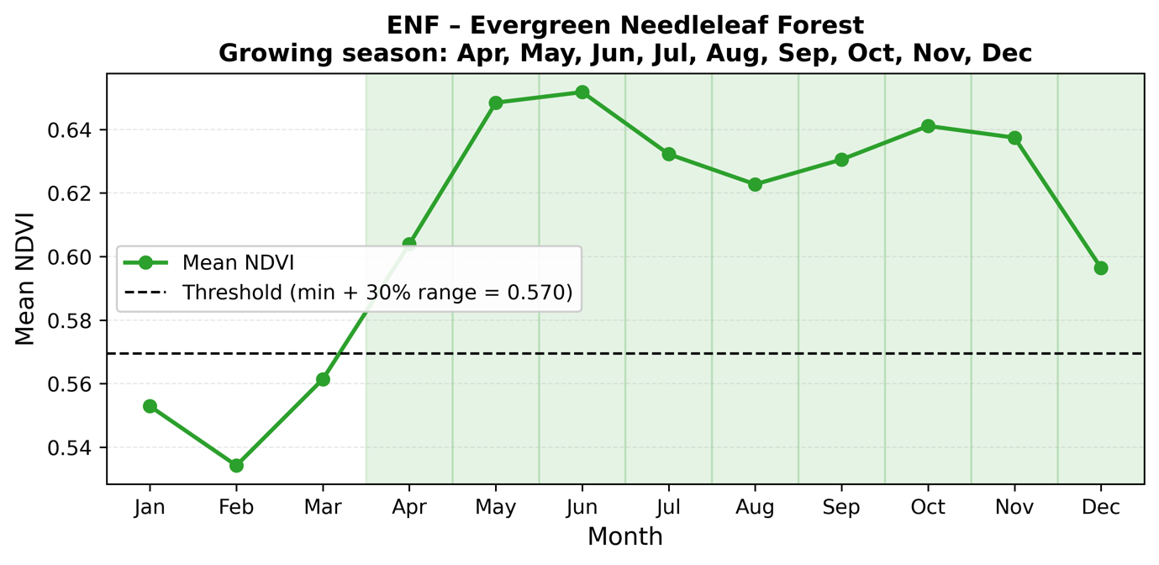
Figure S5: NDVI climatology for Evergreen Needleleaf Forest (ENF) (2000–2020). Mean monthly NDVI values across the Mediterranean region, derived from 2000–2020 satellite data. The red dashed line indicates the growing season threshold (minimum NDVI + 30% of NDVI range), identifying April–December as the growing season.

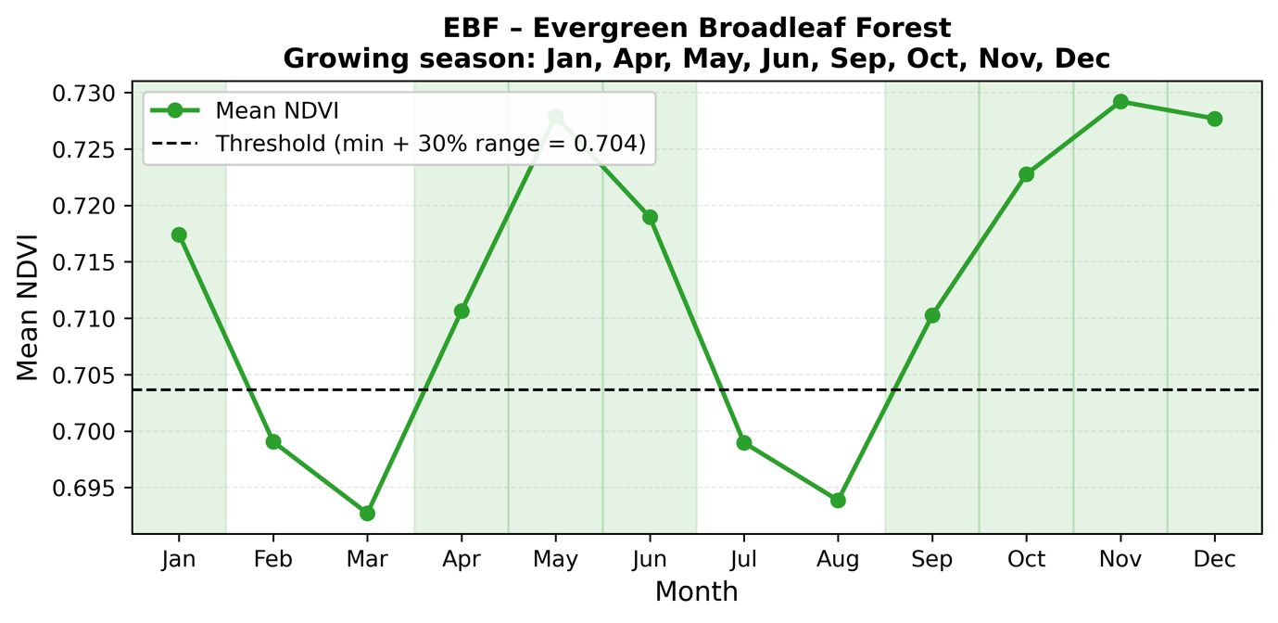
Figure S6: NDVI Climatology for Evergreen Broadleaf Forest (2000–2020)
Monthly NDVI climatology for Evergreen Broadleaf Forest, based on 2000–2020 data. The threshold (red dashed line) defines January, April–June, and September–December as the growing season, reflecting periods of peak photosynthetic activity.

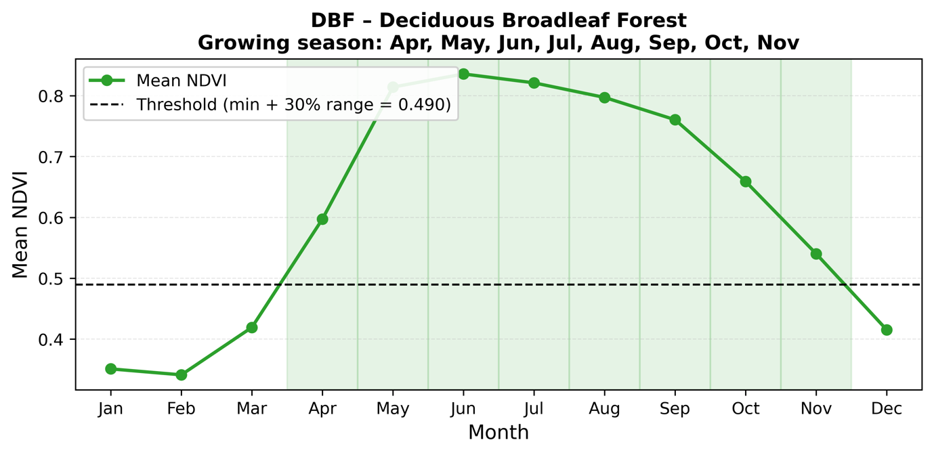
Figure S7: NDVI Climatology for Deciduous Broadleaf Forest (2000–2020)
Mean NDVI timeseries for Deciduous Broadleaf Forest over 2000–2020. The growing season, marked by the threshold (red dashed line), spans April–November, capturing the seasonal cycle of leaf development and senescence.

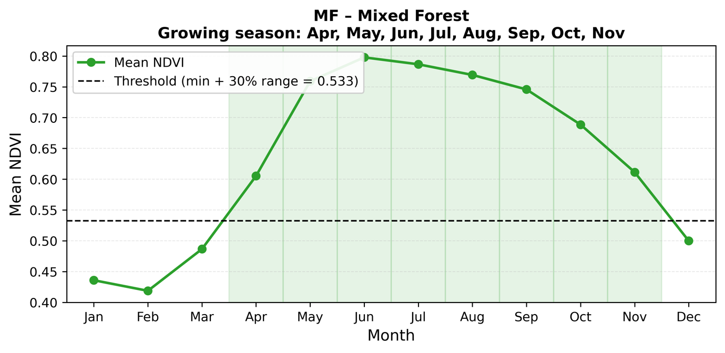
Figure S8: NDVI Climatology for Mixed Forest (2000–2020)
NDVI climatology for Mixed Forest in the Mediterranean, averaged over 2000–2020. The growing season (April–November) is indicated by the threshold (red dashed line), reflecting combined evergreen and deciduous phenology.

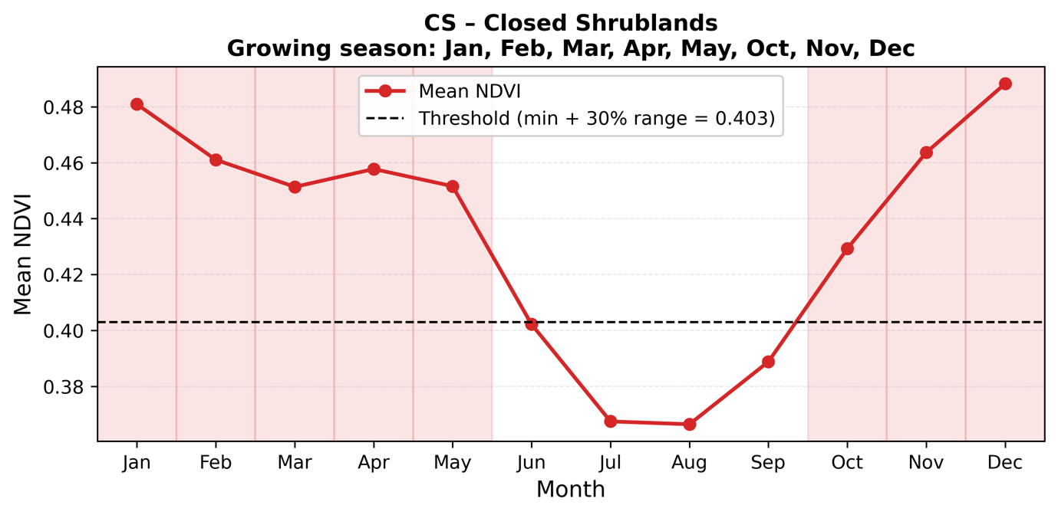

Figure S9: NDVI Climatology for Closed Shrublands (2000–2020)
Monthly mean NDVI for Closed Shrublands from 2000–2020. The threshold (red dashed line) identifies January–May and October–December as the growing season, highlighting periods of active vegetation growth.

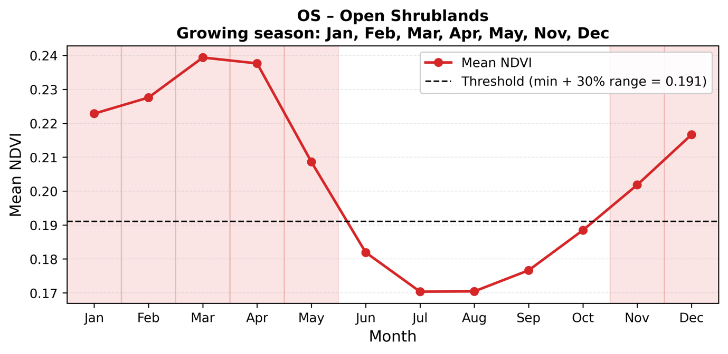

Figure S10: NDVI Climatology for Open Shrublands (2000–2020)
NDVI timeseries for Open Shrublands, averaged over 2000–2020. The growing season, defined by the threshold (red dashed line), includes January–May, November, and December, reflecting sparse vegetation dynamics.

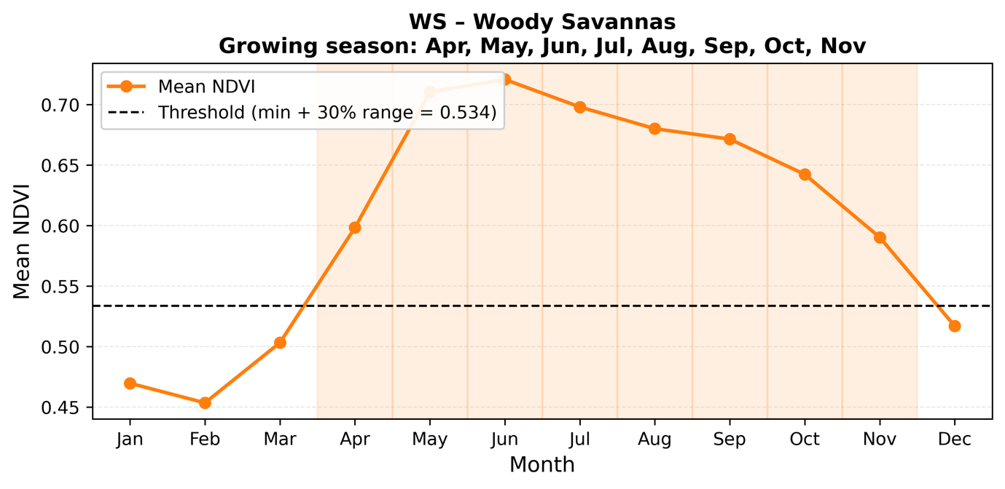
Figure S11: NDVI Climatology for Woody Savannas (2000–2020)
Mean monthly NDVI for Woody Savannas across 2000–2020. The threshold (red dashed line) marks April–November as the growing season, indicating periods of enhanced photosynthetic activity.

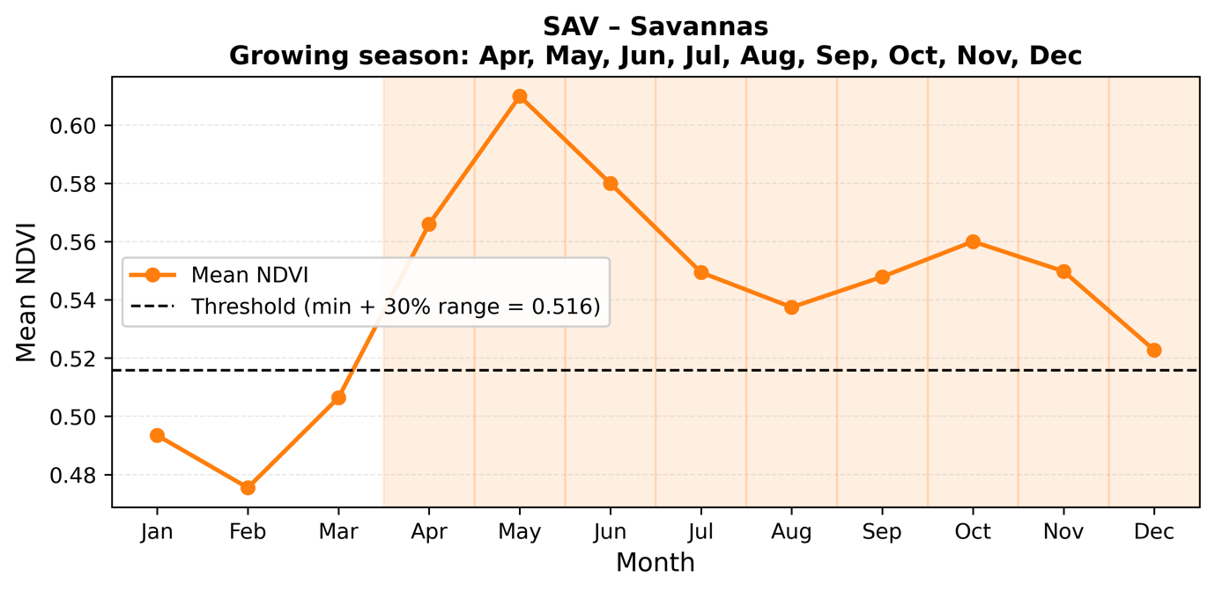
Figure S12: NDVI Climatology for Savannas (2000–2020)
NDVI climatology for Savannas, derived from 2000–2020 data. The growing season (April–December) is shown by the threshold (red dashed line), capturing the seasonal productivity of grass and tree mixtures.

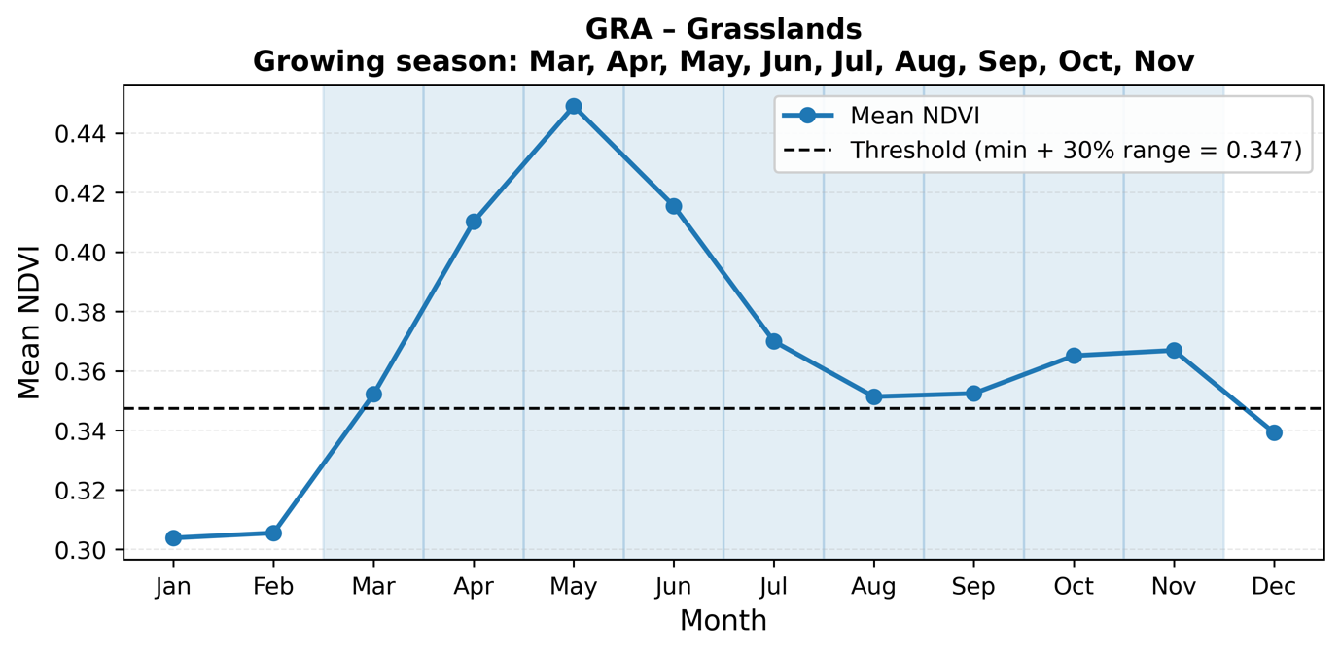
Figure S13: NDVI Climatology for Grasslands (2000–2020)
Monthly NDVI averages for Grasslands over 2000–2020. The threshold (red dashed line) defines March–November as the growing season, reflecting peak grass growth in the Mediterranean region.

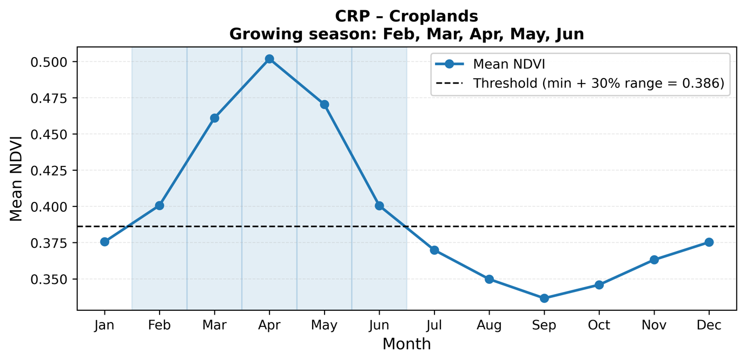

Figure S14: NDVI Climatology for Croplands (2000–2020)
NDVI timeseries for Croplands, averaged over 2000–2020. The growing season, indicated by the threshold (red dashed line), spans February–June, aligning with agricultural cycles in the Mediterranean.

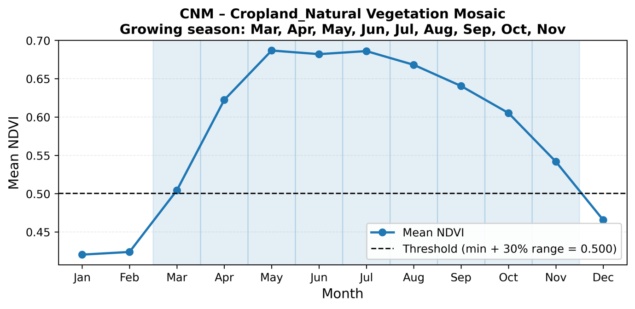

Figure S15: NDVI Climatology for Cropland/Natural Vegetation Mosaic (2000–2020)
Mean NDVI climatology for Cropland/Natural Vegetation Mosaic from 2000–2020. The threshold (red dashed line) identifies March–November as the growing season, reflecting mixed agricultural and natural vegetation phenology.

Supplementary Tables
Table S1: Lagged Correlation Statistics with SPEI by Ecosystem
This table summarizes the lagged correlation statistics between GPP, NDVI, CWSI, ET, and SPEI-1 month for each ecosystem type in the Mediterranean region.
Ecosystem | Variable | Significant Pixels (%) | Min |R_Lag_max| | Max |R_Lag_max| | Mean |R_Lag_max| | Median |R_Lag_max| | Mean lag_max | Positive R_Lag_max (%) | Negative R_Lag_max (%)
ENF | GPP | 43.2 | 0.149 | 0.43 | 0.255 | 0.252 | 5 | 65.4 | 34.6
ENF | NDVI | 72.2 | 0.149 | 0.571 | 0.278 | 0.261 | 2.2 | 86.1 | 13.9
ENF | CWSI | 63 | 0.149 | 0.471 | 0.254 | 0.237 | 2.9 | 21.1 | 78.9
ENF | ET | 47.1 | 0.149 | 0.79 | 0.275 | 0.255 | 4.7 | 65.1 | 34.9
ENF | WUE | 72.9 | 0.148 | 0.647 | 0.242 | 0.228 | 3.4 | 23.3 | 76.7
EBF | GPP | 92.1 | 0.149 | 0.396 | 0.242 | 0.238 | 6.5 | 75.7 | 24.3
EBF | NDVI | 87.7 | 0.143 | 0.502 | 0.265 | 0.245 | 3.9 | 76.2 | 23.8
EBF | CWSI | 47.2 | 0.147 | 0.379 | 0.23 | 0.223 | 3.9 | 40.9 | 59.1
EBF | ET | 94 | 0.16 | 0.777 | 0.289 | 0.258 | 5.9 | 70.5 | 29.5
EBF | WUE | 87.7 | 0.143 | 0.61 | 0.278 | 0.264 | 2.3 | 7.9 | 92.1
DBF | GPP | 27.4 | 0.158 | 0.421 | 0.244 | 0.243 | 7 | 87.3 | 12.7
DBF | NDVI | 31.7 | 0.157 | 0.389 | 0.246 | 0.246 | 6.4 | 81.3 | 18.7
DBF | CWSI | 53.6 | 0.157 | 0.495 | 0.242 | 0.237 | 4.6 | 23.4 | 76.6
DBF | ET | 39.3 | 0.157 | 0.602 | 0.253 | 0.246 | 4.6 | 62.7 | 37.3
DBF | WUE | 78.3 | 0.157 | 0.582 | 0.24 | 0.235 | 3.2 | 52 | 48
MF | GPP | 44.3 | 0.157 | 0.456 | 0.26 | 0.263 | 6.6 | 83.3 | 16.7
MF | NDVI | 51.3 | 0.158 | 0.534 | 0.243 | 0.236 | 3.8 | 65.6 | 34.4
MF | CWSI | 71 | 0.157 | 0.552 | 0.248 | 0.243 | 4.5 | 20.7 | 79.3
MF | ET | 47 | 0.159 | 0.681 | 0.291 | 0.289 | 5.9 | 87.4 | 12.6
MF | WUE | 67.6 | 0.158 | 0.536 | 0.249 | 0.242 | 4 | 45.4 | 54.6
CS | GPP | 95.8 | 0.232 | 0.439 | 0.294 | 0.281 | 8.4 | 47.8 | 52.2
CS | NDVI | 95.8 | 0.192 | 0.399 | 0.283 | 0.278 | 2.8 | 78.3 | 21.7
CS | CWSI | 91.7 | 0.192 | 0.377 | 0.292 | 0.289 | 1.9 | 9.1 | 90.9
CS | ET | 95.8 | 0.217 | 0.402 | 0.298 | 0.299 | 7.2 | 78.3 | 21.7
CS | WUE | 83.3 | 0.16 | 0.332 | 0.258 | 0.263 | 4.7 | 60 | 40
OS | GPP | 46.8 | 0.158 | 0.458 | 0.258 | 0.255 | 5.5 | 83.7 | 16.3
OS | NDVI | 69 | 0.158 | 0.503 | 0.307 | 0.303 | 3.5 | 96.1 | 3.9
OS | CWSI | 55.6 | 0.158 | 0.499 | 0.269 | 0.266 | 2.4 | 15.3 | 84.7
OS | ET | 61 | 0.158 | 0.681 | 0.348 | 0.322 | 2.7 | 88.3 | 11.7
OS | WUE | 61.9 | 0.158 | 0.569 | 0.3 | 0.287 | 1.3 | 19.5 | 80.5
WS | GPP | 54.6 | 0.157 | 0.519 | 0.307 | 0.304 | 6.1 | 86.7 | 13.3
WS | NDVI | 65.1 | 0.157 | 0.607 | 0.296 | 0.285 | 3.9 | 84.1 | 15.9
WS | CWSI | 74.9 | 0.157 | 0.587 | 0.282 | 0.273 | 3.2 | 18.3 | 81.7
WS | ET | 60.1 | 0.159 | 0.718 | 0.325 | 0.323 | 3.7 | 57.2 | 42.8
WS | WUE | 77 | 0.157 | 0.595 | 0.264 | 0.254 | 3.5 | 64.3 | 35.7
SAV | GPP | 48.8 | 0.141 | 0.479 | 0.263 | 0.258 | 5.4 | 63.2 | 36.8
SAV | NDVI | 74.8 | 0.141 | 0.588 | 0.301 | 0.267 | 2 | 90.7 | 9.3
SAV | CWSI | 75.8 | 0.141 | 0.542 | 0.284 | 0.272 | 1.4 | 8 | 92
SAV | ET | 55 | 0.141 | 0.77 | 0.268 | 0.262 | 4.3 | 52.3 | 47.7
SAV | WUE | 70.1 | 0.141 | 0.593 | 0.238 | 0.221 | 2.6 | 40.4 | 59.6
GRA | GPP | 58.5 | 0.148 | 0.553 | 0.326 | 0.34 | 4.9 | 77.1 | 22.9
GRA | NDVI | 76.8 | 0.148 | 0.605 | 0.33 | 0.312 | 3 | 84 | 16
GRA | CWSI | 85.9 | 0.148 | 0.612 | 0.328 | 0.316 | 1 | 6.1 | 93.9
GRA | ET | 59.2 | 0.148 | 0.71 | 0.318 | 0.341 | 4.7 | 70.7 | 29.3
GRA | WUE | 75.5 | 0.148 | 0.575 | 0.253 | 0.239 | 3 | 35.7 | 64.3
CRP | GPP | 74.5 | 0.18 | 0.705 | 0.38 | 0.385 | 3 | 81.4 | 18.6
CRP | NDVI | 84.1 | 0.18 | 0.677 | 0.384 | 0.392 | 3.3 | 81.2 | 18.8
CRP | CWSI | 85.9 | 0.18 | 0.647 | 0.378 | 0.376 | 1.4 | 5.9 | 94.1
CRP | ET | 82.6 | 0.18 | 0.718 | 0.36 | 0.362 | 2.1 | 84.2 | 15.8
CRP | WUE | 71.9 | 0.18 | 0.621 | 0.312 | 0.309 | 3.5 | 26.7 | 73.3
CNM | GPP | 41.6 | 0.149 | 0.469 | 0.227 | 0.222 | 6.6 | 60.3 | 39.7
CNM | NDVI | 61.7 | 0.148 | 0.501 | 0.251 | 0.238 | 2.4 | 88.9 | 11.1
CNM | CWSI | 94 | 0.155 | 0.445 | 0.295 | 0.295 | 1.8 | 16.4 | 83.6
CNM | ET | 51.3 | 0.148 | 0.706 | 0.262 | 0.264 | 1.2 | 5.8 | 94.2
CNM | WUE | 75.5 | 0.148 | 0.471 | 0.246 | 0.233 | 2.6 | 75.7 | 24.3

Table S2: Cumulative Correlation Statistics with SPEI
This table presents the cumulative correlation statistics between GPP, NDVI, CWSI, ET, and SPEI for the each vegetation types.
Ecosystem | Variable | Significant Pixels (%) | Min |R_max_cum| | Max |R_max_cum| | Mean |R_max_cum| | Median |R_max_cum| | Mean cum_months | Positive R_max_cum (%) | Negative R_max_cum (%)
ENF | GPP | 51.9 | 0.145 | 0.43 | 0.222 | 0.209 | 4.3 | 43.9 | 56.1
ENF | NDVI | 80.7 | 0.145 | 0.593 | 0.302 | 0.295 | 5.6 | 93.2 | 6.8
ENF | CWSI | 74 | 0.145 | 0.524 | 0.274 | 0.26 | 3.9 | 0.3 | 99.7
ENF | ET | 58.3 | 0.145 | 0.78 | 0.258 | 0.232 | 4.8 | 65.2 | 34.8
ENF | WUE | 68.8 | 0.145 | 0.63 | 0.262 | 0.248 | 5.3 | 22.4 | 77.6
EBF | GPP | 92.2 | 0.137 | 0.37 | 0.216 | 0.218 | 2.2 | 8.1 | 91.9
EBF | NDVI | 78.5 | 0.138 | 0.5 | 0.296 | 0.297 | 4.1 | 76.6 | 23.4
EBF | CWSI | 34.1 | 0.137 | 0.488 | 0.261 | 0.249 | 2.1 | 0 | 100
EBF | ET | 89.4 | 0.138 | 0.796 | 0.263 | 0.229 | 4.8 | 59.1 | 40.9
EBF | WUE | 86.1 | 0.138 | 0.619 | 0.301 | 0.295 | 3.3 | 2 | 98
DBF | GPP | 33.6 | 0.153 | 0.386 | 0.182 | 0.173 | 2.3 | 2.5 | 97.5
DBF | NDVI | 28.8 | 0.153 | 0.385 | 0.206 | 0.19 | 4.3 | 40.8 | 59.2
DBF | CWSI | 53.7 | 0.153 | 0.613 | 0.239 | 0.222 | 5.4 | 3.6 | 96.4
DBF | ET | 49.4 | 0.153 | 0.601 | 0.222 | 0.207 | 3.5 | 29.3 | 70.7
DBF | WUE | 64.1 | 0.153 | 0.57 | 0.229 | 0.205 | 3.5 | 41.7 | 58.3
MF | GPP | 43.7 | 0.154 | 0.379 | 0.207 | 0.202 | 1.4 | 2.3 | 97.7
MF | NDVI | 45.4 | 0.153 | 0.565 | 0.228 | 0.208 | 3.4 | 48.1 | 51.9
MF | CWSI | 66.2 | 0.154 | 0.531 | 0.243 | 0.238 | 4.5 | 2.3 | 97.7
MF | ET | 48.4 | 0.154 | 0.671 | 0.244 | 0.234 | 2.1 | 16.3 | 83.7
MF | WUE | 53.9 | 0.153 | 0.552 | 0.238 | 0.221 | 4.7 | 45.6 | 54.4
CS | GPP | 95.8 | 0.207 | 0.436 | 0.275 | 0.265 | 8.1 | 91.3 | 8.7
CS | NDVI | 91.7 | 0.181 | 0.637 | 0.358 | 0.364 | 5.1 | 100 | 0
CS | CWSI | 91.7 | 0.147 | 0.465 | 0.349 | 0.354 | 2 | 0 | 100
CS | ET | 95.8 | 0.179 | 0.339 | 0.259 | 0.259 | 6.8 | 73.9 | 26.1
CS | WUE | 75 | 0.147 | 0.338 | 0.228 | 0.232 | 5.6 | 44.4 | 55.6
OS | GPP | 64.5 | 0.154 | 0.605 | 0.299 | 0.289 | 8.4 | 98.2 | 1.8
OS | NDVI | 70.2 | 0.155 | 0.783 | 0.466 | 0.477 | 7.4 | 98.1 | 1.9
OS | CWSI | 54.3 | 0.154 | 0.548 | 0.279 | 0.273 | 3 | 1.1 | 98.9
OS | ET | 63.9 | 0.154 | 0.683 | 0.391 | 0.399 | 5.7 | 99.1 | 0.9
OS | WUE | 62.8 | 0.154 | 0.596 | 0.299 | 0.287 | 2.5 | 18.6 | 81.4
WS | GPP | 52.4 | 0.153 | 0.443 | 0.246 | 0.242 | 3.1 | 29.8 | 70.2
WS | NDVI | 64.2 | 0.153 | 0.669 | 0.295 | 0.275 | 4.9 | 81.4 | 18.6
WS | CWSI | 76.9 | 0.153 | 0.635 | 0.295 | 0.287 | 3.4 | 0.4 | 99.6
WS | ET | 61.2 | 0.153 | 0.733 | 0.296 | 0.289 | 2.7 | 27.5 | 72.5
WS | WUE | 68.9 | 0.153 | 0.601 | 0.252 | 0.236 | 4.3 | 62.6 | 37.4
SAV | GPP | 54.9 | 0.137 | 0.56 | 0.234 | 0.221 | 5.7 | 69.6 | 30.4
SAV | NDVI | 75.3 | 0.137 | 0.657 | 0.336 | 0.317 | 4.5 | 94.9 | 5.1
SAV | CWSI | 77.6 | 0.137 | 0.594 | 0.316 | 0.307 | 2.9 | 0.2 | 99.8
SAV | ET | 58.1 | 0.137 | 0.78 | 0.257 | 0.23 | 4.6 | 59.3 | 40.7
SAV | WUE | 67.3 | 0.137 | 0.598 | 0.246 | 0.231 | 3.9 | 40.7 | 59.3
GRA | GPP | 58.7 | 0.144 | 0.611 | 0.275 | 0.267 | 5.5 | 85.5 | 14.5
GRA | NDVI | 79.3 | 0.144 | 0.678 | 0.347 | 0.333 | 5 | 95.2 | 4.8
GRA | CWSI | 88.9 | 0.144 | 0.661 | 0.361 | 0.352 | 3 | 0.1 | 99.9
GRA | ET | 63.8 | 0.144 | 0.714 | 0.282 | 0.267 | 5.6 | 80.9 | 19.1
GRA | WUE | 71.2 | 0.144 | 0.584 | 0.257 | 0.246 | 3.9 | 28.5 | 71.5
CRP | GPP | 66.2 | 0.176 | 0.688 | 0.366 | 0.362 | 3.7 | 93.5 | 6.5
CRP | NDVI | 84.4 | 0.176 | 0.677 | 0.361 | 0.353 | 3.2 | 98.6 | 1.4
CRP | CWSI | 87.7 | 0.176 | 0.721 | 0.414 | 0.42 | 3.2 | 0.4 | 99.6
CRP | ET | 81 | 0.176 | 0.732 | 0.345 | 0.333 | 4.7 | 86.6 | 13.4
CRP | WUE | 68 | 0.176 | 0.614 | 0.271 | 0.26 | 4.7 | 28 | 72
CNM | GPP | 32.7 | 0.145 | 0.284 | 0.196 | 0.198 | 3 | 33.9 | 66.1
CNM | NDVI | 59 | 0.144 | 0.578 | 0.255 | 0.235 | 3.1 | 96.8 | 3.2
CNM | CWSI | 94.5 | 0.147 | 0.49 | 0.315 | 0.313 | 2.9 | 0 | 100
CNM | ET | 66.1 | 0.144 | 0.715 | 0.243 | 0.226 | 1.8 | 5.5 | 94.5
CNM | WUE | 63.6 | 0.145 | 0.539 | 0.263 | 0.244 | 2.6 | 89.1 | 10.9

Table S3: Cumulative Correlation Statistics with CWSI
This table presents the cumulative correlation statistics between GPP, NDVI, ET, and CWSI for the each vegetation types.
Ecosystem | Variable | Significant Pixels (%) | Min |R_max| | Max |R_max| | Mean |R_max| | Median |R_max| | Mean cum_months (months) | Positive R_max (%) | Negative R_max (%)
ENF | GPP | 82.8 | 0.147 | 0.858 | 0.491 | 0.491 | 5.3 | 23 | 77
ENF | NDVI | 81.7 | 0.145 | 0.879 | 0.472 | 0.468 | 3.5 | 14.7 | 85.3
ENF | ET | 81.5 | 0.146 | 0.84 | 0.444 | 0.431 | 4.7 | 23.3 | 76.7
ENF | WUE | 75.9 | 0.149 | 0.768 | 0.359 | 0.354 | 4.1 | 59.5 | 40.5
EBF | GPP | 57.1 | 0.155 | 0.847 | 0.475 | 0.475 | 5.3 | 39.2 | 60.8
EBF | NDVI | 50.2 | 0.152 | 0.77 | 0.38 | 0.373 | 4.7 | 37.7 | 62.3
EBF | ET | 56 | 0.153 | 0.789 | 0.457 | 0.463 | 5 | 29.7 | 70.3
EBF | WUE | 52.7 | 0.145 | 0.705 | 0.359 | 0.351 | 4.5 | 80.5 | 19.5
DBF | GPP | 87.7 | 0.154 | 0.841 | 0.49 | 0.505 | 2.1 | 17.2 | 82.8
DBF | NDVI | 88.6 | 0.154 | 0.853 | 0.509 | 0.533 | 2 | 11.2 | 88.8
DBF | ET | 86.7 | 0.153 | 0.809 | 0.49 | 0.508 | 2.3 | 18.5 | 81.5
DBF | WUE | 82.4 | 0.154 | 0.779 | 0.394 | 0.391 | 2.1 | 15.8 | 84.2
MF | GPP | 77.1 | 0.154 | 0.796 | 0.411 | 0.393 | 2.8 | 37.6 | 62.4
MF | NDVI | 71.7 | 0.154 | 0.88 | 0.409 | 0.39 | 3 | 25.4 | 74.6
MF | ET | 77.8 | 0.156 | 0.769 | 0.401 | 0.382 | 2.9 | 36.9 | 63.1
MF | WUE | 65.9 | 0.153 | 0.794 | 0.335 | 0.316 | 3.1 | 49.1 | 50.9
CS | GPP | 95.8 | 0.238 | 0.58 | 0.423 | 0.413 | 6.7 | 17.4 | 82.6
CS | NDVI | 95.8 | 0.347 | 0.678 | 0.503 | 0.485 | 6.3 | 0 | 100
CS | ET | 70.8 | 0.278 | 0.586 | 0.388 | 0.344 | 4.2 | 64.7 | 35.3
CS | WUE | 87.5 | 0.169 | 0.566 | 0.364 | 0.361 | 5 | 28.6 | 71.4
OS | GPP | 60.9 | 0.155 | 0.867 | 0.463 | 0.459 | 5.5 | 8.7 | 91.3
OS | NDVI | 67.4 | 0.155 | 0.901 | 0.496 | 0.5 | 5.8 | 3 | 97
OS | ET | 59.5 | 0.154 | 0.807 | 0.377 | 0.371 | 3.6 | 8 | 92
OS | WUE | 43.9 | 0.154 | 0.74 | 0.301 | 0.278 | 3.5 | 47.4 | 52.6
WS | GPP | 85.4 | 0.153 | 0.888 | 0.446 | 0.439 | 2.6 | 44.9 | 55.1
WS | NDVI | 82.3 | 0.154 | 0.908 | 0.49 | 0.497 | 2.7 | 16.3 | 83.7
WS | ET | 84 | 0.153 | 0.835 | 0.442 | 0.436 | 2.4 | 48.7 | 51.3
WS | WUE | 79.6 | 0.154 | 0.859 | 0.386 | 0.376 | 3 | 25.1 | 74.9
SAV | GPP | 82.2 | 0.138 | 0.921 | 0.465 | 0.445 | 4.2 | 32.7 | 67.3
SAV | NDVI | 83.3 | 0.138 | 0.931 | 0.537 | 0.544 | 3.1 | 14.1 | 85.9
SAV | ET | 81.2 | 0.137 | 0.885 | 0.429 | 0.411 | 3.5 | 37.7 | 62.3
SAV | WUE | 80.2 | 0.138 | 0.826 | 0.376 | 0.365 | 3.9 | 40.4 | 59.6
GRA | GPP | 88.4 | 0.145 | 0.931 | 0.579 | 0.596 | 3.7 | 8.8 | 91.2
GRA | NDVI | 89.7 | 0.145 | 0.95 | 0.663 | 0.678 | 2.8 | 8.7 | 91.3
GRA | ET | 88.2 | 0.145 | 0.914 | 0.547 | 0.557 | 3.6 | 11 | 89
GRA | WUE | 83.9 | 0.145 | 0.898 | 0.407 | 0.371 | 3.3 | 45.9 | 54.1
CRP | GPP | 91.7 | 0.176 | 0.954 | 0.7 | 0.716 | 2.1 | 1.3 | 98.7
CRP | NDVI | 92.4 | 0.178 | 0.966 | 0.739 | 0.755 | 1.9 | 0.3 | 99.7
CRP | ET | 90.5 | 0.177 | 0.939 | 0.627 | 0.635 | 2.8 | 6.8 | 93.2
CRP | WUE | 83.5 | 0.177 | 0.94 | 0.469 | 0.46 | 2.8 | 51.2 | 48.8
CNM | GPP | 93 | 0.146 | 0.818 | 0.413 | 0.409 | 2.5 | 32.7 | 67.3
CNM | NDVI | 93.7 | 0.145 | 0.88 | 0.45 | 0.448 | 2.1 | 11.5 | 88.5
CNM | ET | 86.4 | 0.147 | 0.777 | 0.409 | 0.387 | 2.4 | 44.2 | 55.8
CNM | WUE | 94 | 0.15 | 0.788 | 0.416 | 0.414 | 2.5 | 10.3 | 89.7

Table S4: Lagged effect Correlation Statistics with CWSI
This table presents the lagged effect correlation statistics between GPP, NDVI, ET, and CWSI for the each vegetation types.
Ecosystem | Variable | Significant Pixels (%) | Min |R_max| | Max |R_max| | Mean |R_max| | Median |R_max| | Mean lag_max (months) | Positive R_max (%) | Negative R_max (%)
ENF | GPP | 86.3 | 0.181 | 0.88 | 0.555 | 0.551 | 4.1 | 17.4 | 82.6
ENF | NDVI | 86 | 0.155 | 0.814 | 0.424 | 0.409 | 3.3 | 19.2 | 80.8
ENF | ET | 86.3 | 0.174 | 0.866 | 0.533 | 0.532 | 4.2 | 21.1 | 78.9
ENF | WUE | 84.7 | 0.157 | 0.74 | 0.352 | 0.339 | 4.4 | 44.8 | 55.2
EBF | GPP | 57.6 | 0.161 | 0.792 | 0.414 | 0.404 | 4.4 | 34 | 66
EBF | NDVI | 57.5 | 0.152 | 0.703 | 0.358 | 0.344 | 4 | 36.2 | 63.8
EBF | ET | 58.2 | 0.151 | 0.74 | 0.425 | 0.416 | 3.4 | 45.2 | 54.8
EBF | WUE | 57.7 | 0.144 | 0.651 | 0.335 | 0.336 | 4.2 | 65.3 | 34.7
DBF | GPP | 91.3 | 0.167 | 0.85 | 0.527 | 0.544 | 3.4 | 50.5 | 49.5
DBF | NDVI | 91.3 | 0.158 | 0.853 | 0.504 | 0.514 | 2.6 | 30.9 | 69.1
DBF | ET | 91.3 | 0.159 | 0.843 | 0.532 | 0.551 | 3.6 | 51.3 | 48.7
DBF | WUE | 90.8 | 0.158 | 0.779 | 0.422 | 0.425 | 4.8 | 49.8 | 50.2
MF | GPP | 90.4 | 0.158 | 0.893 | 0.464 | 0.456 | 5 | 35.9 | 64.1
MF | NDVI | 89.3 | 0.158 | 0.884 | 0.398 | 0.387 | 5 | 29.3 | 70.7
MF | ET | 91 | 0.167 | 0.856 | 0.465 | 0.459 | 5.2 | 39.3 | 60.7
MF | WUE | 85.2 | 0.157 | 0.792 | 0.355 | 0.339 | 5.5 | 41.2 | 58.8
CS | GPP | 95.8 | 0.336 | 0.735 | 0.561 | 0.608 | 5.5 | 8.7 | 91.3
CS | NDVI | 95.8 | 0.261 | 0.614 | 0.42 | 0.406 | 4.3 | 26.1 | 73.9
CS | ET | 95.8 | 0.314 | 0.792 | 0.55 | 0.579 | 5.8 | 8.7 | 91.3
CS | WUE | 91.7 | 0.215 | 0.571 | 0.379 | 0.358 | 3.7 | 45.5 | 54.5
OS | GPP | 68.9 | 0.16 | 0.854 | 0.478 | 0.465 | 4.1 | 24.7 | 75.3
OS | NDVI | 68.9 | 0.16 | 0.897 | 0.377 | 0.371 | 3.9 | 8 | 92
OS | ET | 69.5 | 0.16 | 0.856 | 0.409 | 0.391 | 3.2 | 15.5 | 84.5
OS | WUE | 63.8 | 0.158 | 0.768 | 0.341 | 0.323 | 4.7 | 39.1 | 60.9
WS | GPP | 89.7 | 0.169 | 0.92 | 0.553 | 0.558 | 4.6 | 29.9 | 70.1
WS | NDVI | 89.7 | 0.163 | 0.908 | 0.48 | 0.468 | 3.4 | 19.8 | 80.2
WS | ET | 89.8 | 0.159 | 0.908 | 0.549 | 0.562 | 4.9 | 36.3 | 63.7
WS | WUE | 88.4 | 0.157 | 0.821 | 0.405 | 0.399 | 5.2 | 38.4 | 61.6
SAV | GPP | 86.7 | 0.146 | 0.875 | 0.498 | 0.484 | 4.9 | 35.8 | 64.2
SAV | NDVI | 86.6 | 0.141 | 0.899 | 0.47 | 0.447 | 2.4 | 14.8 | 85.2
SAV | ET | 86.6 | 0.145 | 0.857 | 0.483 | 0.473 | 5.2 | 41 | 59
SAV | WUE | 86.2 | 0.141 | 0.793 | 0.349 | 0.334 | 4.3 | 41.9 | 58.1
GRA | GPP | 90.2 | 0.151 | 0.959 | 0.615 | 0.613 | 3.8 | 20.3 | 79.7
GRA | NDVI | 90.3 | 0.157 | 0.939 | 0.601 | 0.589 | 2.6 | 23 | 77
GRA | ET | 90.3 | 0.15 | 0.958 | 0.592 | 0.588 | 4.4 | 27.9 | 72.1
GRA | WUE | 89.4 | 0.149 | 0.892 | 0.415 | 0.398 | 4.9 | 41.3 | 58.7
CRP | GPP | 92.4 | 0.183 | 0.952 | 0.681 | 0.682 | 2.9 | 27.4 | 72.6
CRP | NDVI | 92.5 | 0.181 | 0.956 | 0.713 | 0.724 | 1.3 | 12.6 | 87.4
CRP | ET | 92.2 | 0.181 | 0.938 | 0.625 | 0.637 | 4.2 | 33.2 | 66.8
CRP | WUE | 90 | 0.18 | 0.919 | 0.492 | 0.489 | 4.8 | 65.4 | 34.6
CNM | GPP | 95.6 | 0.158 | 0.865 | 0.454 | 0.447 | 4.4 | 48.6 | 51.4
CNM | NDVI | 96.4 | 0.162 | 0.844 | 0.446 | 0.435 | 2.2 | 16.3 | 83.7
CNM | ET | 95 | 0.157 | 0.835 | 0.448 | 0.435 | 5.2 | 68.7 | 31.3
CNM | WUE | 95.8 | 0.152 | 0.701 | 0.404 | 0.402 | 2.4 | 17.1 | 82.9

Table S5: Ecosystem-Specific Growing Seasons
Description: Growing season months for each IGBP vegetation class, used to restrict analyses to periods of active vegetation growth.
IGBP Class | Ecosystem | Growing Season Months
1 | Evergreen Needleleaf Forest | April, May, June, July, August, September, October, November, December
2 | Evergreen Broadleaf Forest | April, May, June, July, August, September, October, November, December, January
4 | Deciduous Broadleaf Forest | April, May, June, July, August, September, October, November
5 | Mixed Forest | April, May, June, July, August, September, October, November
6 | Closed Shrublands | October, November, December, January, February, March, April, May, June
7 | Open Shrublands | October, November, December, January, February, March, April, May
8 | Woody Savannas | April, May, June, July, August, September, October, November
9 | Savannas | April, May, June, July, August, September, October, November, December
10 | Grasslands | March, April, May, June, July, August, September, October, November
12 | Croplands | February, March, April, May, June
14 | Cropland/Natural Vegetation Mosaic | March, April, May, June, July, August, September, October, November

References:
1. Moran MS, Clarke TR, Inoue Y, Vidal A. Estimating Crop Water Deficit Using the Relation between Surface-Air Temperature and Spectral Vegetation Index. Vol 49. 1994.
2. Idso SB, Jackson RD, Pinter PJ, Reginato RJ, Hatfield JL. Normalizing the stress-degree-day parameter for environmental variability. Agricultural Meteorology. 1981;24:45-55. doi:10.1016/0002-1571(81)90032-7
3. Jackson RD, Idso SB, Reginato RJ, Pinter PJ. Canopy temperature as a crop water stress indicator. Water Resour Res. 1981;17(4):1133-1138. doi:10.1029/WR017i004p01133
4. Tucker CJ, Pinzon JE, Brown ME, et al. An extended AVHRR 8‐km NDVI dataset compatible with MODIS and SPOT vegetation NDVI data. Int J Remote Sens. 2005;26(20):4485-4498. doi:10.1080/01431160500168686
5. White MA, Thornton PE, Running SW. A continental phenology model for monitoring vegetation responses to interannual climatic variability. Global Biogeochem Cycles. 1997;11(2):217-234. doi:10.1029/97GB00330

Supplementary Figures
Figure S1 | Spatial patterns of cumulative duration and correlation with CWSI.
Maps of cumulative durations and maximum cumulative correlation (|R_max_cum|) between CWSI and GPP, NDVI, ET, and WUE across Mediterranean ecosystems.
Figure S2 | Distribution of cumulative durations for maximum cumulative correlation.
Bar plots showing the percentage of |R_max_cum| occurring at different cumulative durations (1–12 months) for each vegetation type.
Figure S3 | Spatial patterns of lag durations and maximum correlation with CWSI.
Maps showing spatial distribution of lag times and |R_max| between CWSI and ecosystem indicators across Mediterranean ecosystems.
Figure S4 | Distribution of lag times for maximum correlation with CWSI.
Bar plots showing the percentage of |R_max| occurring at different lag months (0–12) for each vegetation type.
Figures S5–S15 | NDVI climatology and growing season thresholds.
Mean monthly NDVI for each vegetation type (ENF, EBF, DBF, MF, CS, OS, WS, SAV, GRA, CRP, CNM) from 2000–2020. Red dashed line indicates the growing season threshold based on minimum NDVI + 30% of NDVI range.

