Coupled effects of surface erosion and magma intrusion on magmatic hazards under a changing climate
Riccardo Lanari¹*, Mohammad Moumeni², Riccardo Reitano², Marco Bonini¹, Francesca Funiciello², Chiara Del Ventisette^{3,1}, & Domenico Montanari¹*
¹ Institute of Geosciences and Earth Resources, National Research Council of Italy (CNR), Florence, Italy
² Department of Science, University of “Roma TRE”, Rome, Italy
³ Department of Earth Sciences, University of Florence, Florence, Italy

* Corresponding authors (riccardo-lanari@cnr.it; domenico.montanari@cnr.it)

Contents of this file
Figure S1: Schematic illustration of the experimental setup
Figures S2 to S8: Different scans at different stages of the model surfaces

Figure S1: Schematic illustration of the experimental setup

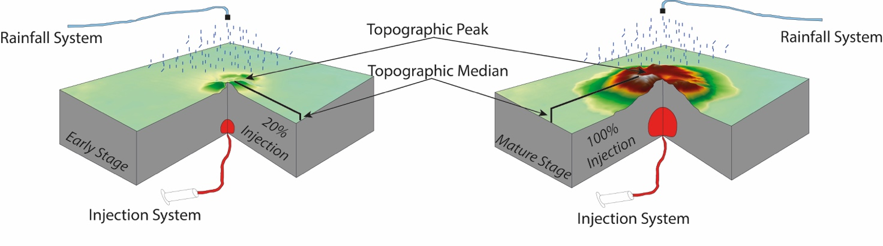

Figure S2: Different scans at different stages of the LowRainr-HighInjectionr model surfaces. Ri=1.9

Figure S3: Different scans at different stages of the MidRainr-HighInjectionr model surfaces. Ri=3.3

Figure S4: Different scans at different stages of the LowRainr-MidInjectionr model surfaces. Ri=7.9

Figure S5: Different scans at different stages of the HighRainr-HighInjectionr model surfaces. Ri=8.1

Figure S6: Different scans at different stages of the MidRainr-MidInjectionr model surfaces. Ri=13.9

Figure S7: Different scans at different stages of the LowRainr-LowInjectionr model surfaces. Ri=21.2

Figure S8: Different scans at different stages of the HighRainr-LowInjectionr model surfaces. Ri=34

